**Spring 2024: CS5720 Neural Networks & Deep Learning - ICP-1**

**Sai Preetham Nagaswaram (700743350)**

GitHub Link:<https://github.com/Saipreethamnagaswaram/Neural-Network-Deep-Learning/tree/main/Assignment1>

Note: Code quality (in terms of time and space complexity) is highly valued

1. Write a python program for the following: – Input the string “Python” as a list of characters from console, delete at least 2 characters, reverse the resultant string and print it.

Sample input:

python

Sample output:

ntyp

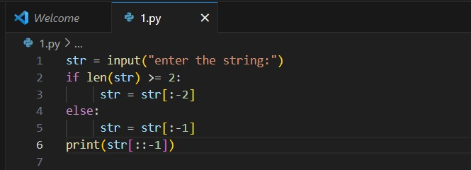

**Output:**

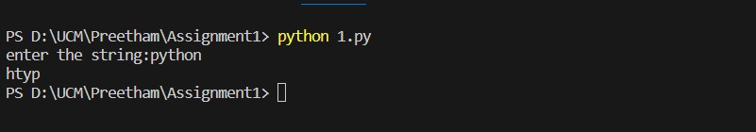

Take two numbers from user and perform at least 4 arithmetic operations on them

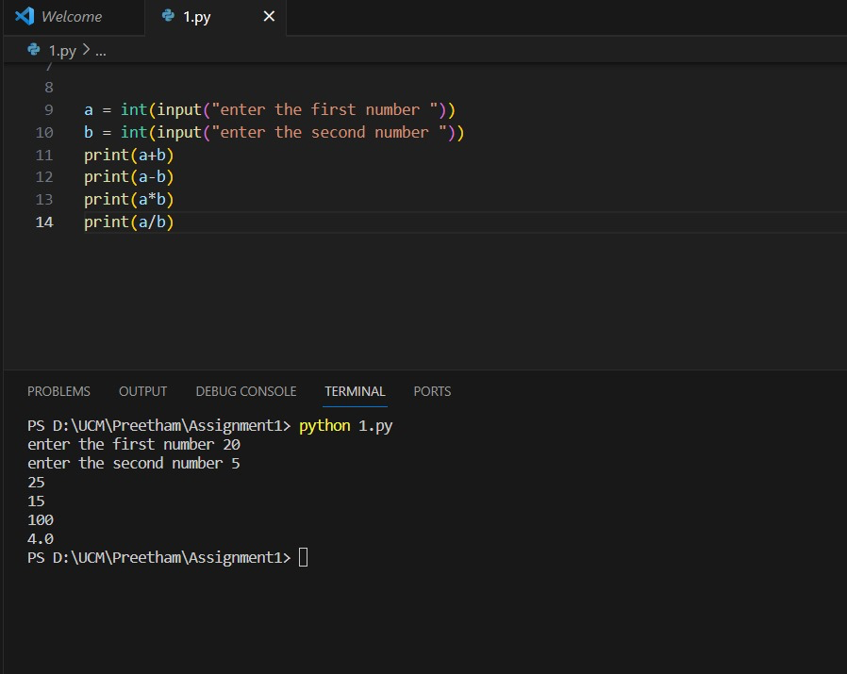

2. Write a program that accepts a sentence and replace each occurrence of ‘python’ with ‘pythons’. •Sample input: •I love playing with python •Sample output: •I love playing with pythons

**Solution:**

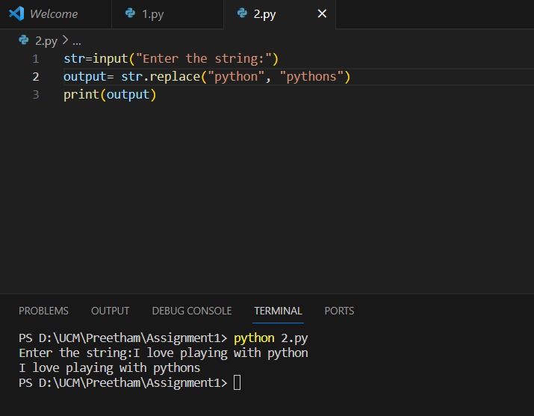

3. Use the if statement conditions to write a program to print the letter grade based on an input class score. Use the grading scheme we are using in this class.

**Solution:**

