SIMATS
OPERATING SYSTEMS LAB RECORD

Name | Saipriya S
Registration Number | 192365065
Department | Computer
Academic Year | 2026–2030
Course | CSA04 – Operating Systems

EXPERIMENT 1
Create a new process and display the process ID and parent process ID using system calls
Aim: To create a new process using fork() and display the process ID and its parent process ID using getpid() and getppid().
Procedure:
1. Include the required header files.
2. Call fork() to create a child process.
3. Check the return value of fork().
4. Display the process ID and parent process ID in the parent and child processes.
5. Wait for the child process to finish.

Program (C)
#include <stdio.h>
#include <unistd.h>
#include <sys/types.h>
#include <sys/wait.h>
int main(void)
{
pid_t pid = fork();
if (pid < 0) {
perror("fork failed");
return 1;
} else if (pid == 0) {
printf("Child Process ID: %d\n", (int)getpid());
printf("Child Parent Process ID: %d\n", (int)getppid());
} else {
printf("Parent Process ID: %d\n", (int)getpid());
printf("Child Process ID returned to parent: %d\n", (int)pid);
wait(NULL);
}
return 0;
}

Sample Output
Parent Process ID: 8225
Child Process ID returned to parent: 8226
Child Process ID: 8226
Child Parent Process ID: 8225

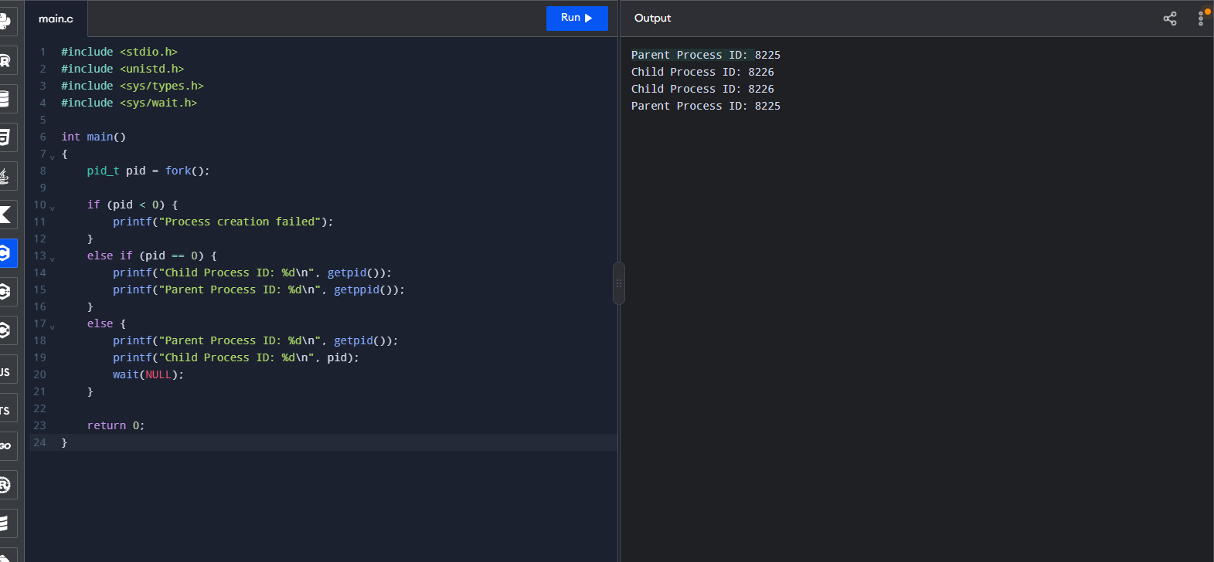

Result: A child process was created using fork(), and process IDs were displayed using getpid() and getppid().

EXPERIMENT 2
Copy the contents of one file to another using system calls
Aim: To copy the contents of a source file to a destination file using the open(), read(), write(), and close() system calls.
Procedure:
1. Create a source file containing sample text.
2. Open the source file for reading and the destination file for writing.
3. Read data into a buffer and write it to the destination file.
4. Close the files.
5. Reopen the destination file and display its contents.

Program (C)
#include <stdio.h>
#include <fcntl.h>
#include <unistd.h>
#include <string.h>
int main(void)
{
int src, dest, n;
char buffer[100];
const char text[] = "Operating Systems Lab\nFile copy using system calls.\n";
src = open("source.txt", O_WRONLY | O_CREAT | O_TRUNC, 0644);
if (src < 0) { perror("source file"); return 1; }
write(src, text, strlen(text));
close(src);
src = open("source.txt", O_RDONLY);
dest = open("destination.txt", O_WRONLY | O_CREAT | O_TRUNC, 0644);
if (src < 0 || dest < 0) { perror("open"); return 1; }
while ((n = read(src, buffer, sizeof(buffer))) > 0)
write(dest, buffer, n);
close(src);
close(dest);
printf("File copied successfully.\n");
dest = open("destination.txt", O_RDONLY);
printf("Destination file contents:\n");
while ((n = read(dest, buffer, sizeof(buffer))) > 0)
write(STDOUT_FILENO, buffer, n);
close(dest);
return 0;
}

Sample Output
File copied successfully.
Destination file contents:
Operating Systems Lab
File copy using system calls.

Include both the 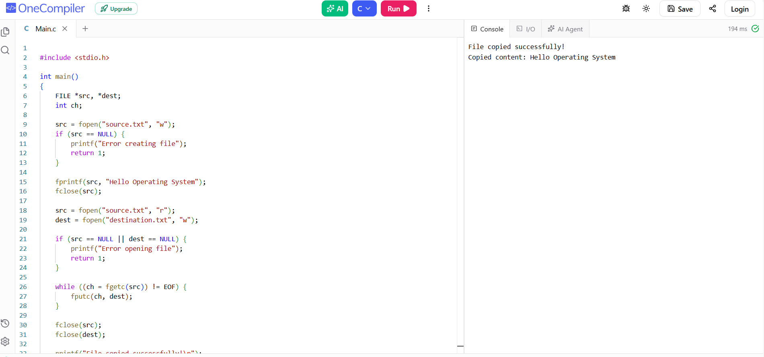code and its output if possible.

Result: The contents of the source file were copied to the destination file using file-related system calls.

EXPERIMENT 3
Implementation of the Producer–Consumer problem using C
Aim: To demonstrate synchronization between producer and consumer threads using a shared buffer, a mutex, and semaphores.
Procedure:
1. Declare a shared one-item buffer.
2. Initialize an empty semaphore, a full semaphore, and a mutex.
3. Create producer and consumer threads.
4. The producer waits for an empty slot, places an item in the buffer, and signals that it is full.
5. The consumer waits for a full slot, consumes the item, and signals that the slot is empty.
6. Join the threads and destroy synchronization objects.

Program (C)
#include <stdio.h>
#include <pthread.h>
#include <semaphore.h>
sem_t empty, full;
pthread_mutex_t mutex;
int buffer;
void *producer(void *arg)
{
for (int i = 1; i <= 5; i++) {
sem_wait(&empty);
pthread_mutex_lock(&mutex);
buffer = i;
printf("Produced: %d\n", buffer);
pthread_mutex_unlock(&mutex);
sem_post(&full);
}
return NULL;
}
void *consumer(void *arg)
{
for (int i = 1; i <= 5; i++) {
sem_wait(&full);
pthread_mutex_lock(&mutex);
printf("Consumed: %d\n", buffer);
pthread_mutex_unlock(&mutex);
sem_post(&empty);
}
return NULL;
}
int main(void)
{
pthread_t p, c;
sem_init(&empty, 0, 1);
sem_init(&full, 0, 0);
pthread_mutex_init(&mutex, NULL);
pthread_create(&p, NULL, producer, NULL);
pthread_create(&c, NULL, consumer, NULL);
pthread_join(p, NULL);
pthread_join(c, NULL);
sem_destroy(&empty);
sem_destroy(&full);
pthread_mutex_destroy(&mutex);
return 0;
}
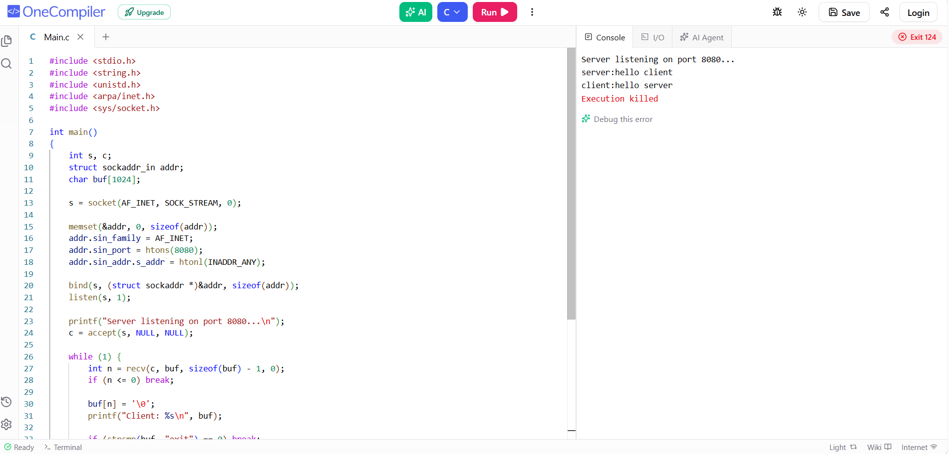

Sample Output
Produced: 1
Consumed: 1
Produced: 2
Consumed: 2
Produced: 3
Consumed: 3
Produced: 4
Consumed: 4
Produced: 5
Consumed: 5

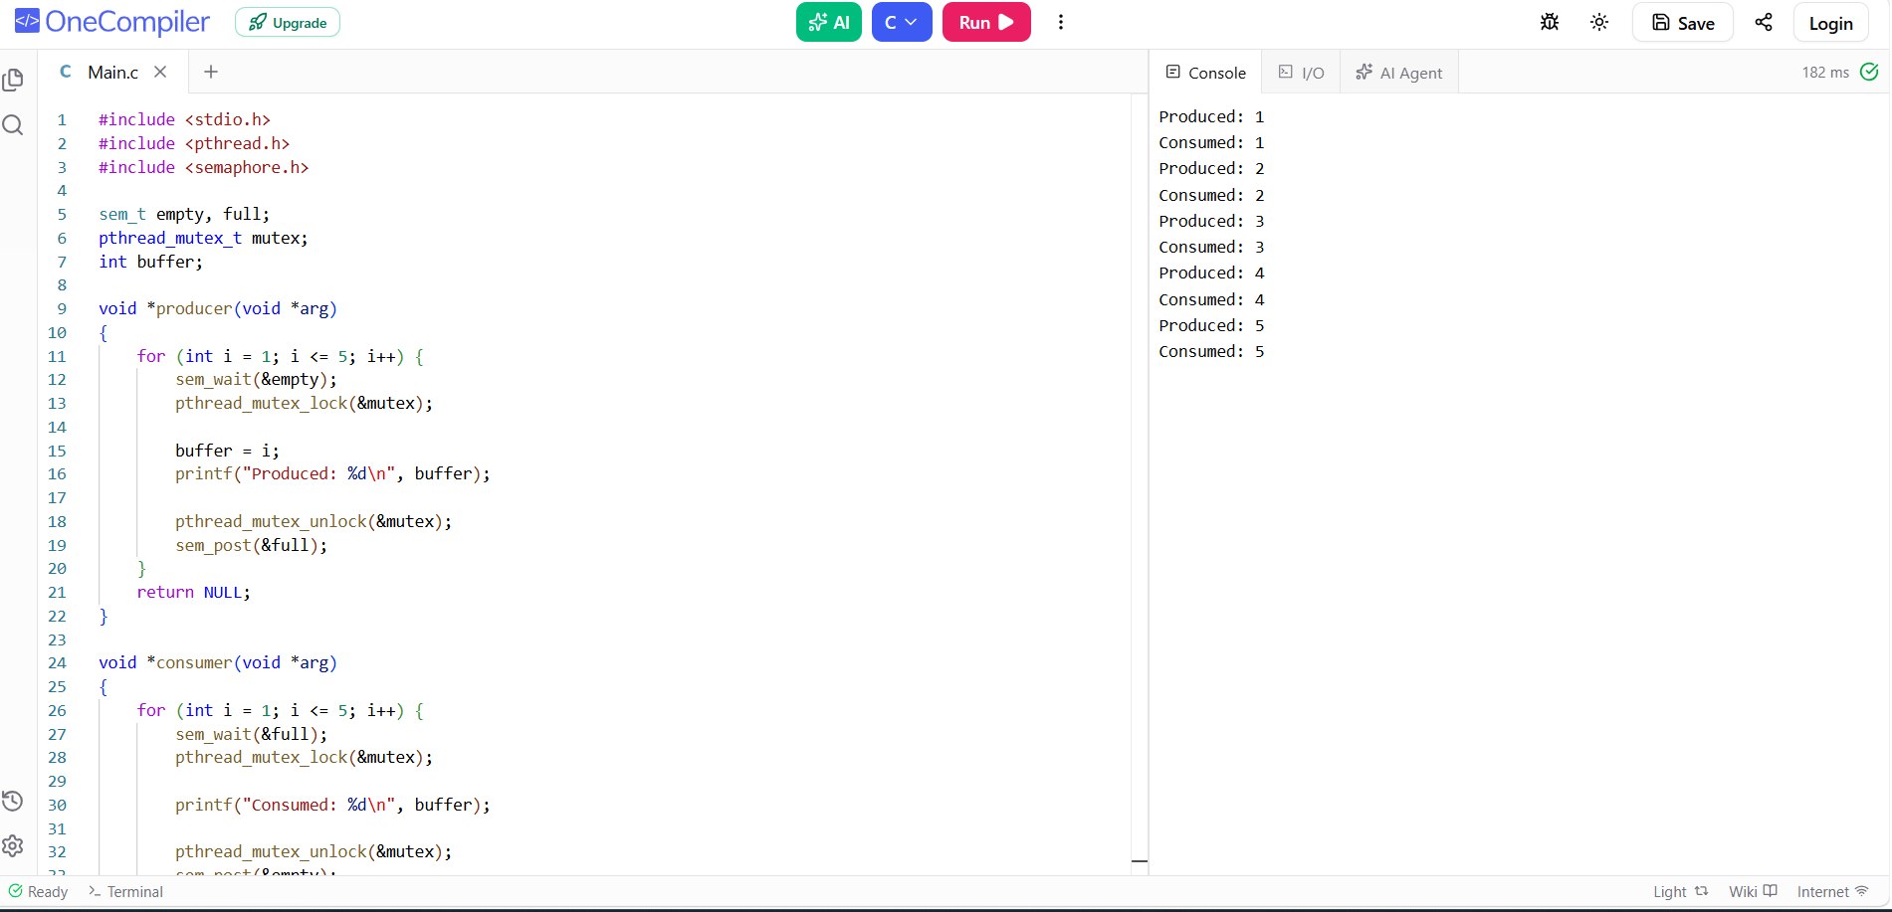

Result: The producer and consumer threads shared a buffer safely using semaphores and a mutex.

EXPERIMENT 4
Implementation of client–server chatting using TCP socket programming
Aim: To establish TCP communication between a server and a client and exchange messages using socket system calls.
Procedure:
1. Compile the server and client programs.
2. Start the server first so it listens on port 8080.
3. Run the client in a second terminal.
4. Type messages at the client; the server receives and prints them, then sends a reply.
5. Type exit to end the chat.

Server Program (server.c)
#include <stdio.h>
#include <string.h>
#include <unistd.h>
#include <arpa/inet.h>
#include <sys/socket.h>
int main(void)
{
int s, c;
struct sockaddr_in addr;
char buf[1024];
s = socket(AF_INET, SOCK_STREAM, 0);
if (s < 0) { perror("socket"); return 1; }
memset(&addr, 0, sizeof(addr));
addr.sin_family = AF_INET;
addr.sin_port = htons(8080);
addr.sin_addr.s_addr = htonl(INADDR_ANY);
if (bind(s, (struct sockaddr *)&addr, sizeof(addr)) < 0) {
perror("bind"); close(s); return 1;
}
if (listen(s, 1) < 0) { perror("listen"); close(s); return 1; }
printf("Server listening on port 8080...\n");
c = accept(s, NULL, NULL);
if (c < 0) { perror("accept"); close(s); return 1; }
while (1) {
int n = recv(c, buf, sizeof(buf) - 1, 0);
if (n <= 0) break;
buf[n] = '\0';
printf("Client: %s\n", buf);
if (strcmp(buf, "exit") == 0) break;
printf("Reply: ");
if (!fgets(buf, sizeof(buf), stdin)) break;
buf[strcspn(buf, "\n")] = '\0';
send(c, buf, strlen(buf), 0);
if (strcmp(buf, "exit") == 0) break;
}
close(c);
close(s);
return 0;
}

Client Program (client.c)
#include <stdio.h>
#include <string.h>
#include <unistd.h>
#include <arpa/inet.h>
#include <sys/socket.h>
int main(void)
{
int s;
struct sockaddr_in addr;
char buf[1024];
s = socket(AF_INET, SOCK_STREAM, 0);
if (s < 0) { perror("socket"); return 1; }
memset(&addr, 0, sizeof(addr));
addr.sin_family = AF_INET;
addr.sin_port = htons(8080);
inet_pton(AF_INET, "127.0.0.1", &addr.sin_addr);
if (connect(s, (struct sockaddr *)&addr, sizeof(addr)) < 0) {
perror("connect"); close(s); return 1;
}
while (1) {
printf("You: ");
if (!fgets(buf, sizeof(buf), stdin)) break;
buf[strcspn(buf, "\n")] = '\0';
send(s, buf, strlen(buf), 0);
if (strcmp(buf, "exit") == 0) break;
int n = recv(s, buf, sizeof(buf) - 1, 0);
if (n <= 0) break;
buf[n] = '\0';
printf("Server: %s\n", buf);
if (strcmp(buf, "exit") == 0) break;
}
close(s);
return 0;
}

Illustrative Conversation
Server terminal:
Server listening on port 8080...
Client: Hello server
Reply: Hello client
Client terminal:
You: Hello server
Server: Hello client
You: exit

Paste your actual s

Result: A TCP connection was established between the client and server, and messages were exchanged.

EXPERIMENT 5
Implement Java programming using multithreading
Aim: To create and execute multiple threads in Java and demonstrate concurrent execution.
Procedure:
1. Create a class that extends Thread.
2. Override the run() method with the task to be performed
. 3. Create two thread objects.
4. Start each thread using start().
5. Wait for both threads using join() and display completion.

Program (Java)
class MyThread extends Thread {
private String message;
MyThread(String message) {
this.message = message;
}
public void run() {
for (int i = 1; i <= 3; i++) {
System.out.println(message + " - " + i);
}
}
}
public class Main {
public static void main(String[] args) throws InterruptedException {
MyThread t1 = new MyThread("Thread 1");
MyThread t2 = new MyThread("Thread 2");
t1.start();
t2.start();
t1.join();
t2.join();
System.out.println("Main thread completed.");
}
}

Sample Output
Thread 1 - 1
Thread 1 - 2
Thread 1 - 3
Thread 2 - 1
Thread 2 - 2
Thread 2 - 3
Main thread completed.

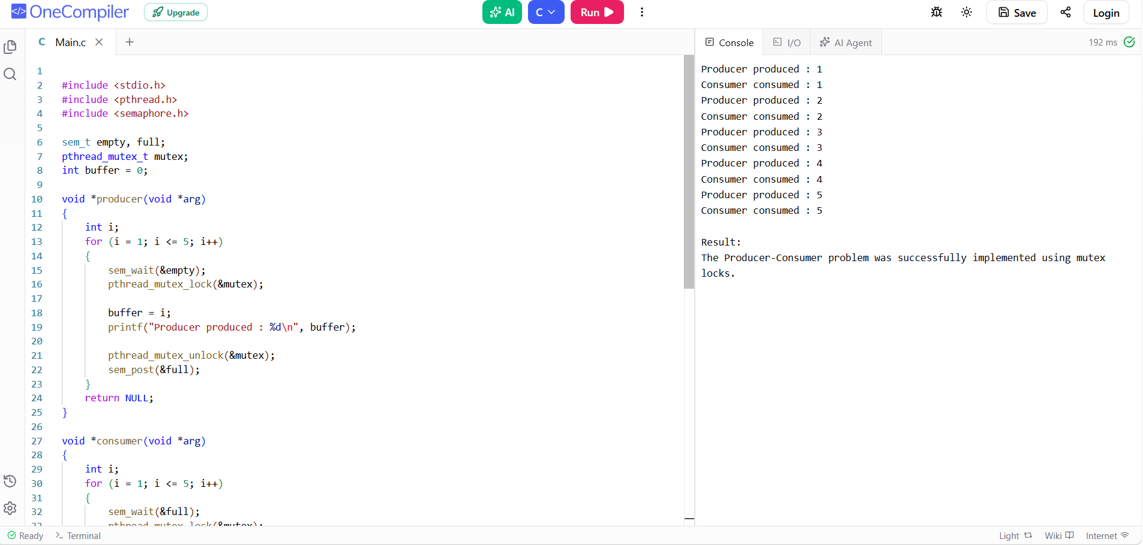

Result: Two Java threads were created and executed concurrently using the Thread class.

EXPERIMENT 6
Design a CPU scheduling program using First Come First Served (FCFS) technique
Aim: To implement the First Come First Served (FCFS) CPU scheduling algorithm and calculate the waiting time and turnaround time of each process. All processes arrive at time 0, and no process waits for I/O.
Procedure:
- Enter the number of processes and the burst time of each process.
- Set the waiting time of the first process to 0.
- Calculate the waiting time of each subsequent process using the previous process's burst time.
- Calculate turnaround time as waiting time plus burst time.
- Display the waiting time, turnaround time, and their averages.
Program (C)
#include <stdio.h>

int main(void) {
int n, bt[20], wt[20], tat[20], i;
float avgwt = 0, avgtat = 0;

printf("Enter number of processes: ");
scanf("%d", &n);

printf("Enter burst times:\n");
for (i = 0; i < n; i++)
scanf("%d", &bt[i]);

wt[0] = 0;
for (i = 1; i < n; i++)
wt[i] = wt[i - 1] + bt[i - 1];

printf("\nProcess\tBurst Time\tWaiting Time\tTurnaround Time\n");
for (i = 0; i < n; i++) {
tat[i] = wt[i] + bt[i];
avgwt += wt[i];
avgtat += tat[i];
printf("P%d\t%d\t\t%d\t\t%d\n", i + 1, bt[i], wt[i], tat[i]);
}

printf("Average Waiting Time = %.2f\n", avgwt / n);
printf("Average Turnaround Time = %.2f\n", avgtat / n);
return 0;
}
Sample Output
Enter number of processes: 3
Enter burst times:
5 3 8

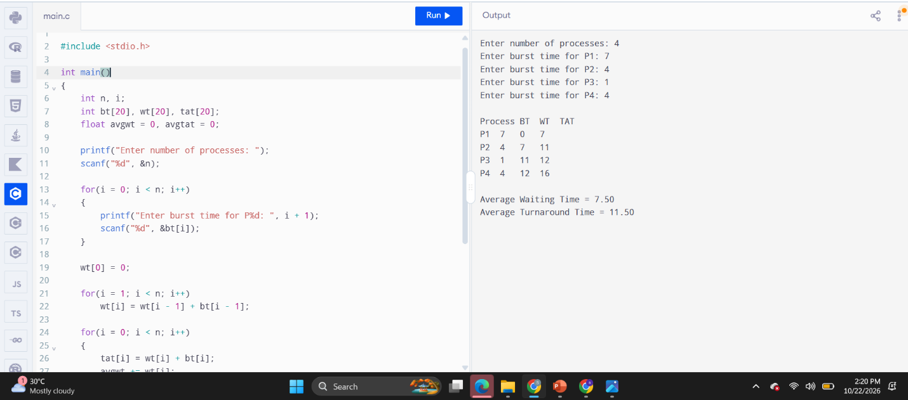

Process Burst Time Waiting Time Turnaround Time
P1 5 0 5
P2 3 5 8
P3 8 8 16
Average Waiting Time = 4.33
Average Turnaround Time = 9.67
Result: The FCFS scheduling algorithm was implemented, and the waiting time and turnaround time were calculated.

EXPERIMENT 7
Implementation of Preemptive Priority Scheduling Algorithm
Aim: To implement the preemptive priority CPU scheduling algorithm and calculate the waiting time and turnaround time of processes. A smaller priority number indicates a higher priority.
Procedure:
- Enter the number of processes, arrival time, burst time, and priority of each process.
- At each time unit, select the arrived process with the highest priority.
- Preempt the running process if a higher-priority process arrives.
- Continue until all processes are completed and record their completion times.
- Calculate turnaround time as completion time minus arrival time, and waiting time as turnaround time minus burst time.
Program (C)
#include <stdio.h>

int main(void) {
int n, at[20], bt[20], rem[20], pr[20], ct[20], tat[20], wt[20];
int i, time = 0, done = 0, best;
float avgwt = 0, avgtat = 0;

printf("Enter number of processes: ");
scanf("%d", &n);

for (i = 0; i < n; i++) {
printf("Enter arrival time, burst time and priority for P%d: ", i + 1);
scanf("%d%d%d", &at[i], &bt[i], &pr[i]);
rem[i] = bt[i];
}

while (done < n) {
best = -1;
for (i = 0; i < n; i++) {
if (at[i] <= time && rem[i] > 0) {
if (best == -1 || pr[i] < pr[best])
best = i;
}
}

if (best == -1) {
time++;
} else {
rem[best]--;
time++;
if (rem[best] == 0) {
ct[best] = time;
done++;
}
}
}

printf("\nProcess\tAT\tBT\tPriority\tWT\tTAT\n");
for (i = 0; i < n; i++) {
tat[i] = ct[i] - at[i];
wt[i] = tat[i] - bt[i];
avgwt += wt[i];
avgtat += tat[i];
printf("P%d\t%d\t%d\t%d\t\t%d\t%d\n",
i + 1, at[i], bt[i], pr[i], wt[i], tat[i]);
}

printf("Average Waiting Time = %.2f\n", avgwt / n);
printf("Average Turnaround Time = %.2f\n", avgtat / n);
return 0;
}
Sample Output
Enter number of processes: 3
Enter arrival time, burst time and priority for P1: 0 7 3
Enter arrival time, burst time and priority for P2: 2 4 1
Enter arrival time, burst time and priority for P3: 3 2 2

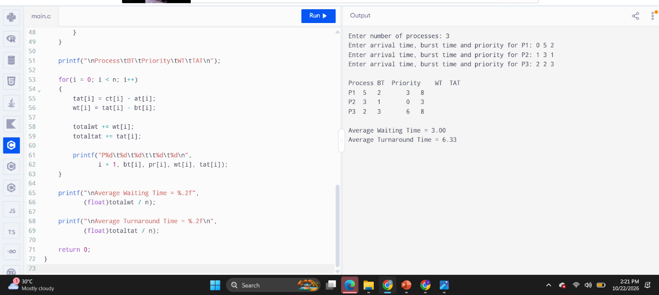

Process AT BT Priority WT TAT
P1 0 7 3 6 13
P2 2 4 1 0 4
P3 3 2 2 4 6
Average Waiting Time = 3.33
Average Turnaround Time = 7.67
Result: The preemptive priority scheduling algorithm was implemented, and the waiting and turnaround times were calculated.

EXPERIMENT 8
Implementation of Non-Preemptive Shortest Job First (SJF) Scheduling Algorithm
Aim: To implement the non-preemptive SJF CPU scheduling algorithm and calculate the waiting time and turnaround time of each process.
Procedure:
- Enter the number of processes, arrival time, and burst time of each process.
- Among the arrived processes, select the process with the shortest burst time.
- Execute the selected process until it completes.
- Repeat the selection until all processes are completed.
- Calculate and display waiting time, turnaround time, and their averages.
Program (C)
#include <stdio.h>

int main(void) {
int n, at[20], bt[20], ct[20], tat[20], wt[20], done[20] = {0};
int i, time = 0, completed = 0, best;
float avgwt = 0, avgtat = 0;

printf("Enter number of processes: ");
scanf("%d", &n);

for (i = 0; i < n; i++) {
printf("Enter arrival time and burst time for P%d: ", i + 1);
scanf("%d%d", &at[i], &bt[i]);
}

while (completed < n) {
best = -1;
for (i = 0; i < n; i++) {
if (!done[i] && at[i] <= time) {
if (best == -1 || bt[i] < bt[best])
best = i;
}
}

if (best == -1) {
time++;
} else {
time += bt[best];
ct[best] = time;
done[best] = 1;
completed++;
}
}

printf("\nProcess\tAT\tBT\tWT\tTAT\n");
for (i = 0; i < n; i++) {
tat[i] = ct[i] - at[i];
wt[i] = tat[i] - bt[i];
avgwt += wt[i];
avgtat += tat[i];
printf("P%d\t%d\t%d\t%d\t%d\n",
i + 1, at[i], bt[i], wt[i], tat[i]);
}

printf("Average Waiting Time = %.2f\n", avgwt / n);
printf("Average Turnaround Time = %.2f\n", avgtat / n);
return 0;
}
Sample Output
Enter number of processes: 3
Enter arrival time and burst time for P1: 0 7
Enter arrival time and burst time for P2: 2 4
Enter arrival time and burst time for P3: 3 2

Process AT BT WT TAT
P1 0 7 0 7
P2 2 4 7 11
P3 3 2 4 6
Average Waiting Time = 3.67
Average Turnaround Time = 8.00

Result: The non-preemptive SJF scheduling algorithm was implemented, and the waiting and turnaround times were calculated.

EXPERIMENT 9
Simulation of Round Robin Scheduling Algorithm using C
Aim: To simulate the Round Robin CPU scheduling algorithm using a time quantum and calculate the waiting time and turnaround time of each process.
Procedure:
- Enter the number of processes, arrival time, and burst time of each process.
- Enter the time quantum.
- Execute each ready process for the time quantum or until it completes.
- If a process is not completed, place it at the end of the ready queue.
- Repeat until all processes finish, then calculate waiting time and turnaround time.
Program (C)
#include <stdio.h>

int main(void) {
int n, at[20], bt[20], rem[20], ct[20], tat[20], wt[20];
int q[1000], front = 0, rear = 0, quantum;
int i, time = 0, done = 0, inq[20] = {0}, p;
float avgwt = 0, avgtat = 0;

printf("Enter number of processes: ");
scanf("%d", &n);

for (i = 0; i < n; i++) {
printf("Enter arrival time and burst time for P%d: ", i + 1);
scanf("%d%d", &at[i], &bt[i]);
rem[i] = bt[i];
}

printf("Enter time quantum: ");
scanf("%d", &quantum);

while (done < n) {
for (i = 0; i < n; i++) {
if (at[i] <= time && rem[i] > 0 && !inq[i]) {
q[rear++] = i;
inq[i] = 1;
}
}

if (front == rear) {
time++;
continue;
}

p = q[front++];
if (rem[p] > quantum) {
time += quantum;
rem[p] -= quantum;
} else {
time += rem[p];
rem[p] = 0;
ct[p] = time;
done++;
}

for (i = 0; i < n; i++) {
if (at[i] <= time && rem[i] > 0 && !inq[i]) {
q[rear++] = i;
inq[i] = 1;
}
}

if (rem[p] > 0) {
q[rear++] = p;
}
}

printf("\nProcess\tAT\tBT\tWT\tTAT\n");
for (i = 0; i < n; i++) {
tat[i] = ct[i] - at[i];
wt[i] = tat[i] - bt[i];
avgwt += wt[i];
avgtat += tat[i];
printf("P%d\t%d\t%d\t%d\t%d\n",
i + 1, at[i], bt[i], wt[i], tat[i]);
}

printf("Average Waiting Time = %.2f\n", avgwt / n);
printf("Average Turnaround Time = %.2f\n", avgtat / n);
return 0;
}
Sample Output
Enter number of processes: 3
Enter arrival time and burst time for P1: 0 5
Enter arrival time and burst time for P2: 1 4
Enter arrival time and burst time for P3: 2 2
Enter time quantum: 2

Process AT BT WT TAT
P1 0 5 4 9
P2 1 4 5 9
P3 2 2 4 6
Average Waiting Time = 4.33
Average Turnaround Time = 8.00

Result: The Round Robin scheduling algorithm was simulated using a time quantum, and the waiting and turnaround times were calculated.

