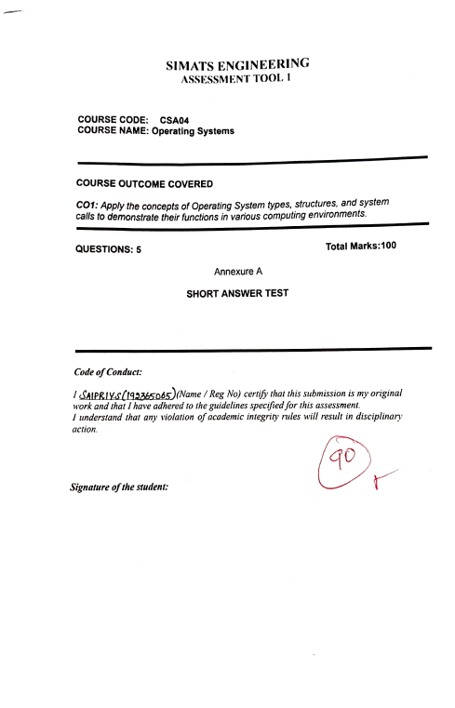

Question 1
(a) Types of Operating Systems and justification
- Multi-user OS: Allows multiple users to access system resources simultaneously.
- Multitasking OS: Executes multiple processes by sharing CPU time.
- Multiprocessing OS: Uses multiple CPUs or CPU cores to execute processes efficiently.
- Time-sharing OS: Allocates CPU time to different users and processes.
Justification: A combination of multi-user, multitasking, and multiprocessing features is suitable for managing shared CPU, memory, and I/O devices. Examples include Linux and UNIX.
(b) Structure of an Operating System

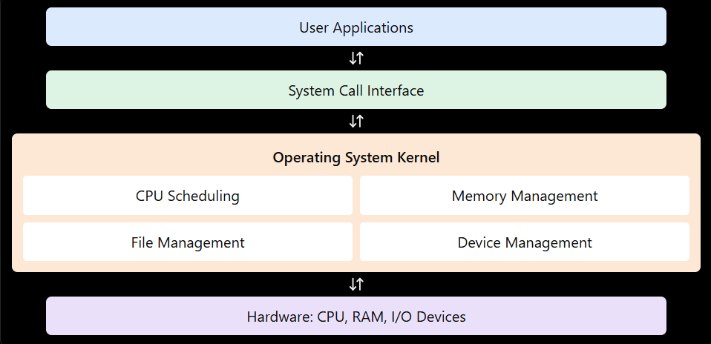

(c) System calls to create and execute a new process
In a UNIX/Linux system, the sequence is:
- fork() – Creates a child process.
- exec() – Loads and executes a new program in the child process.
- wait() – Allows the parent process to wait for the child to finish.
- exit() – Terminates the process.
Question 2
(a) Categories of system calls for file and device management
- File management: open(), read(), write(), close(), unlink().
- Device management: ioctl(), read(), write(), open(), close().
- File information: stat(), fstat().
- Permissions and access: chmod(), access().
(b) Layered structure for file operations
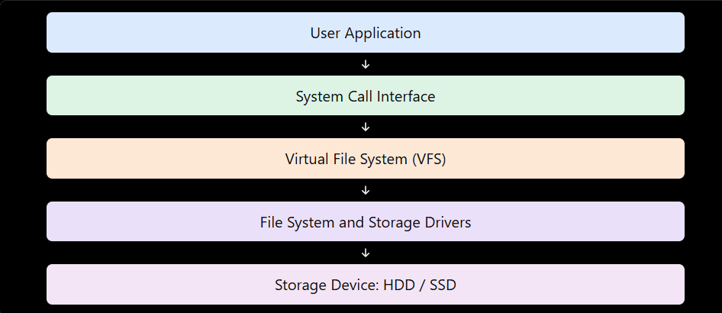
Explanation: The application requests file operations through system calls. The OS file system manages file names, permissions, and storage locations, while device drivers communicate with the storage hardware.
(c) C program to open, read, and close a file
#include <stdio.h>
#include <fcntl.h>
#include <unistd.h>
int main() {
int fd;
char buffer[100];
ssize_t n;
fd = open("sample.txt", O_RDONLY);
if (fd == -1) {
perror("File open failed");
return 1;
}
n = read(fd, buffer, sizeof(buffer) - 1);
if (n >= 0) {
buffer[n] = '\0';
printf("%s", buffer);
}
close(fd);
return 0;
}

System call sequence: open() → read() → close().

Question 3
(a) Type of OS and suitability
A Real-Time Operating System (RTOS) is suitable for controlling industrial machinery because it provides predictable response times and executes critical tasks within specified deadlines.
- Hard RTOS: Missing a deadline is unacceptable for critical operations.
- Soft RTOS: Occasional deadline misses are tolerable, but performance may decrease.
For safety-critical industrial control, a hard RTOS may be required.
(b) Interaction between hardware, kernel, and user processes
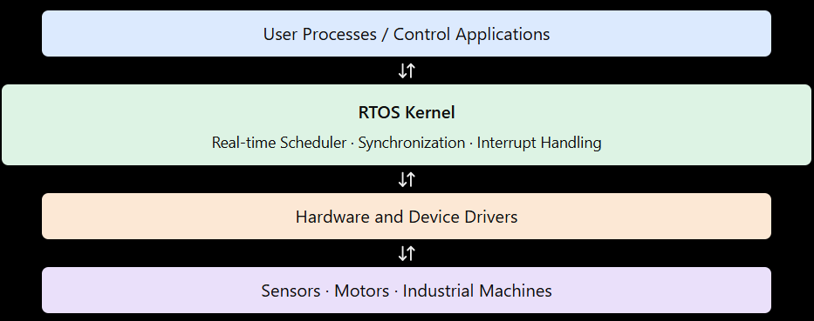
(c) System calls for process synchronization
- sem_wait() – Waits for a semaphore and acquires access when available.
- sem_post() – Releases a semaphore and signals waiting processes.
- pthread_mutex_lock() – Locks a mutex to protect shared resources.
- pthread_mutex_unlock() – Unlocks a mutex after the critical section.
- pthread_cond_wait() – Waits for a condition to become true.
These POSIX functions help synchronize threads and processes. Their availability depends on the RTOS and its supported APIs.
Question 4
(a) Distributed OS and comparison with centralized OS
A Distributed Operating System coordinates multiple interconnected computers and manages their resources to provide a unified computing environment.
Distributed OS | Centralized OS
Uses multiple connected computers. | Mainly manages one central computer.
Resources are distributed across nodes. | Resources are primarily managed centrally.
Can offer better scalability. | Expansion may depend on central capacity.
Can continue operating partially if a node fails, depending on design. | A central failure can affect the entire system.
Requires network communication. | Local resource access is generally simpler.
Examples: Distributed computing environments use systems and frameworks such as Amoeba and Plan 9; centralized OS examples include a conventional standalone Linux or Windows installation.
(b) Architecture of a distributed OS
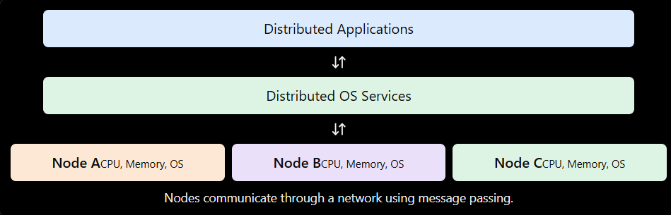(c) System call sequence for IPC
- pipe() 4. read()
- fork() 5. close()
- write()
Question 5
(a) Major functions of an Operating System
- Process scheduling: Selects processes for CPU execution and allocates CPU time.
- Memory management: Allocates and deallocates memory and protects each process's memory space.
- Device management: Uses device drivers to control hardware and coordinates I/O operations.
- Resource allocation: Distributes CPU, memory, and devices among competing processes.
- Protection and security: Controls access to resources and prevents unauthorized operations.
(b) Block diagram of OS components and interactions
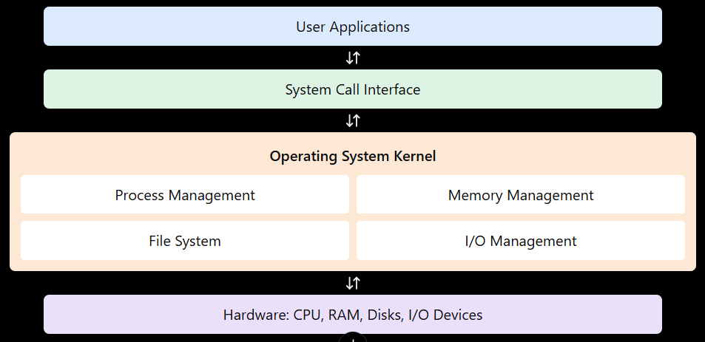
(c) System call examples for memory allocation and device management
Memory management:
- mmap() – Maps memory into a process's address space.
- munmap() – Removes a memory mapping.
- brk() / sbrk() – Adjusts the process heap boundary on systems that support them.
Device management:
- open() – Opens a device file.
- read() – Reads data from a device.
- write() – Sends data to a device.
- ioctl() – Performs device-specific control operations.
- close() – Closes the device file.
Example sequence for device management:
int fd = open("/dev/example", O_RDWR);
if (fd != -1) {
write(fd, "A", 1);
close(fd);
}
/dev/example is a placeholder; the actual device path depends on the hardware and OS.

