Architecture & Pipeline
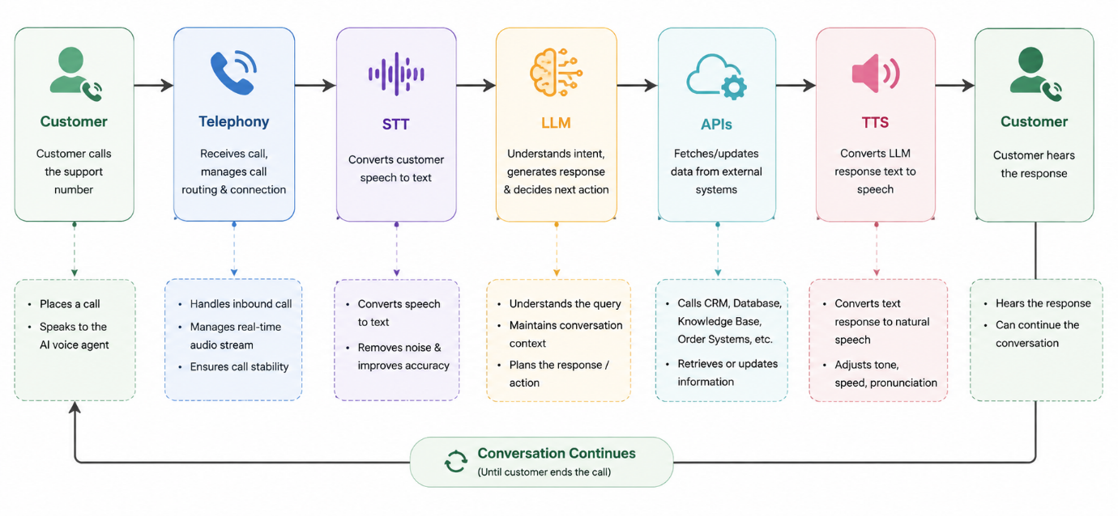
Figure 1: Voicebot Architecture Pipeline This diagram shows how customer speech flows through the system — from telephony to speech recognition, language understanding, API calls, and back to speech output.
Here’s what to write under the diagram:
🧩 Customer
- The customer receives an outbound call from “Maya,” the voicebot.
- They speak naturally — e.g., “Yes, this is Rahul Sharma.”
☎️ Telephony
- Manages call routing and connection.
- Ensures call stability and compliance with permitted hours.
- Passes audio stream to the STT engine.
🗣️ STT (Speech-to-Text)
- Converts the customer’s speech into text.
- Removes noise and improves accuracy.
- Latency target: 300–500 ms.
🧠 LLM (Orchestrator)
- Understands the customer’s intent and context.
- Maintains conversation state (e.g., authentication, payment discussion).
- Decides next action or tool call.
- Latency target: 700–1000 ms.
The architecture ensures low latency (< 2 seconds per turn) and secure data handling. Each stage — from telephony to TTS — is modular, allowing independent optimization and monitoring. This pipeline forms the backbone of the Kapture Finance collections voicebot.z
Latency Budgets:
- STT: 300–500 ms
- LLM: 700–1000 ms
- TTS: 300–500 ms
- Total: <2 s per turn
🔗 APIs
- Fetches or updates data from external systems:
  - verify_customer
  - log_promise_to_pay
  - send_payment_link
- Ensures secure data handling and logging.
🔊 TTS (Text-to-Speech)
- Converts the bot’s text response back into natural speech.
- Adjusts tone, speed, and pronunciation.
- Latency target: 300–500 ms.
🔁 Conversation Continues
- The loop repeats until the customer confirms payment, requests callback, or ends the call.
- Latency Budget Summary
Component | Target (ms)
STT | 300–500
LLM | 700–1000
TTS | 300–500
Total per turn | < 2 s

Conversation Flow / State Machine
State | Description | Transition
0 | Intro/Disclosure | “Hello, this is Maya from Kapture Finance…”
1 | Authentication | Verify DOB or PAN digits before debt disclosure
2 | Debt Disclosure | “Your EMI ₹8,499 is overdue by 12 days.”
3 | Intent Capture | Branch into will-pay, cannot-pay, dispute, etc.
4 | Closing/Disposition | Confirm next step, log outcome

Intents & Entities
Intent | Entities Extracted
will-pay | PTP date, amount
cannot-pay | hardship reason
dispute | dispute details
already-paid | payment confirmation
wrong-person | disposition
callback-request | callback time
hostile | exit gracefully
Tools / API Calls
Tool | Purpose | Inputs | Outputs
get_account_details | Fetch loan info | customer_id | loan details
verify_customer | Verify identity | customer_id, dob/pan_last4 | verified/not
log_promise_to_pay | Record commitment | customer_id, ptp_date, amount | logged
send_payment_link | Send SMS/WhatsApp link | customer_id, channel | sent
escalate_to_agent | Human handoff | customer_id, reason | transferred
mark_disposition | End call outcome | customer_id, outcome | saved

Auth & Data Safety
- No debt disclosure until verification complete.
- Third-party answer → disclose only company name, request callback.
- Secure handling of customer data
Guardrails & Compliance
- Mandatory disclosure of company and purpose.
- Permitted calling hours: 8 AM–8 PM.
- No threats or harassment.
- Opt-out honored immediately.
- Guardrails against hallucination/off-topic.
Edge Cases
- Already paid → mark disposition.
- Dispute → escalate.
- Do-not-call → mark and exit.
- Wrong number → apologize, mark.
- Voicemail/no input → retry, then exit.
- Abusive caller → terminate politely.
- Language switch (EN/HI) → bilingual fallback.
Escalation & Disposition
- Escalate disputes, hardship, hostile cases.
- Every call ends with a logged disposition.
Observability
- Logs: transcripts, intents, tool calls, outcomes.
- Metrics: containment rate, PTP rate, avg latency, drop rate, escalation rate.

