Python Programming Lab Task Sets
Roll number: 2505B02107
Set No.: 3

Set 3
- Q1. Implement a Python class for a stack data structure (`push`, `pop`, `peek`). Use GitHub Copilot to generate code, test its handling of edge cases, and explain any improvements made.
(Each question carries 5 marks)
Prompt:
Implement a Python class for a stack data structure with push, pop, and peek methods.
Include proper error handling for underflow conditions and demonstrate edge-case testing.
Also suggest improvements after generating the code.
Code:
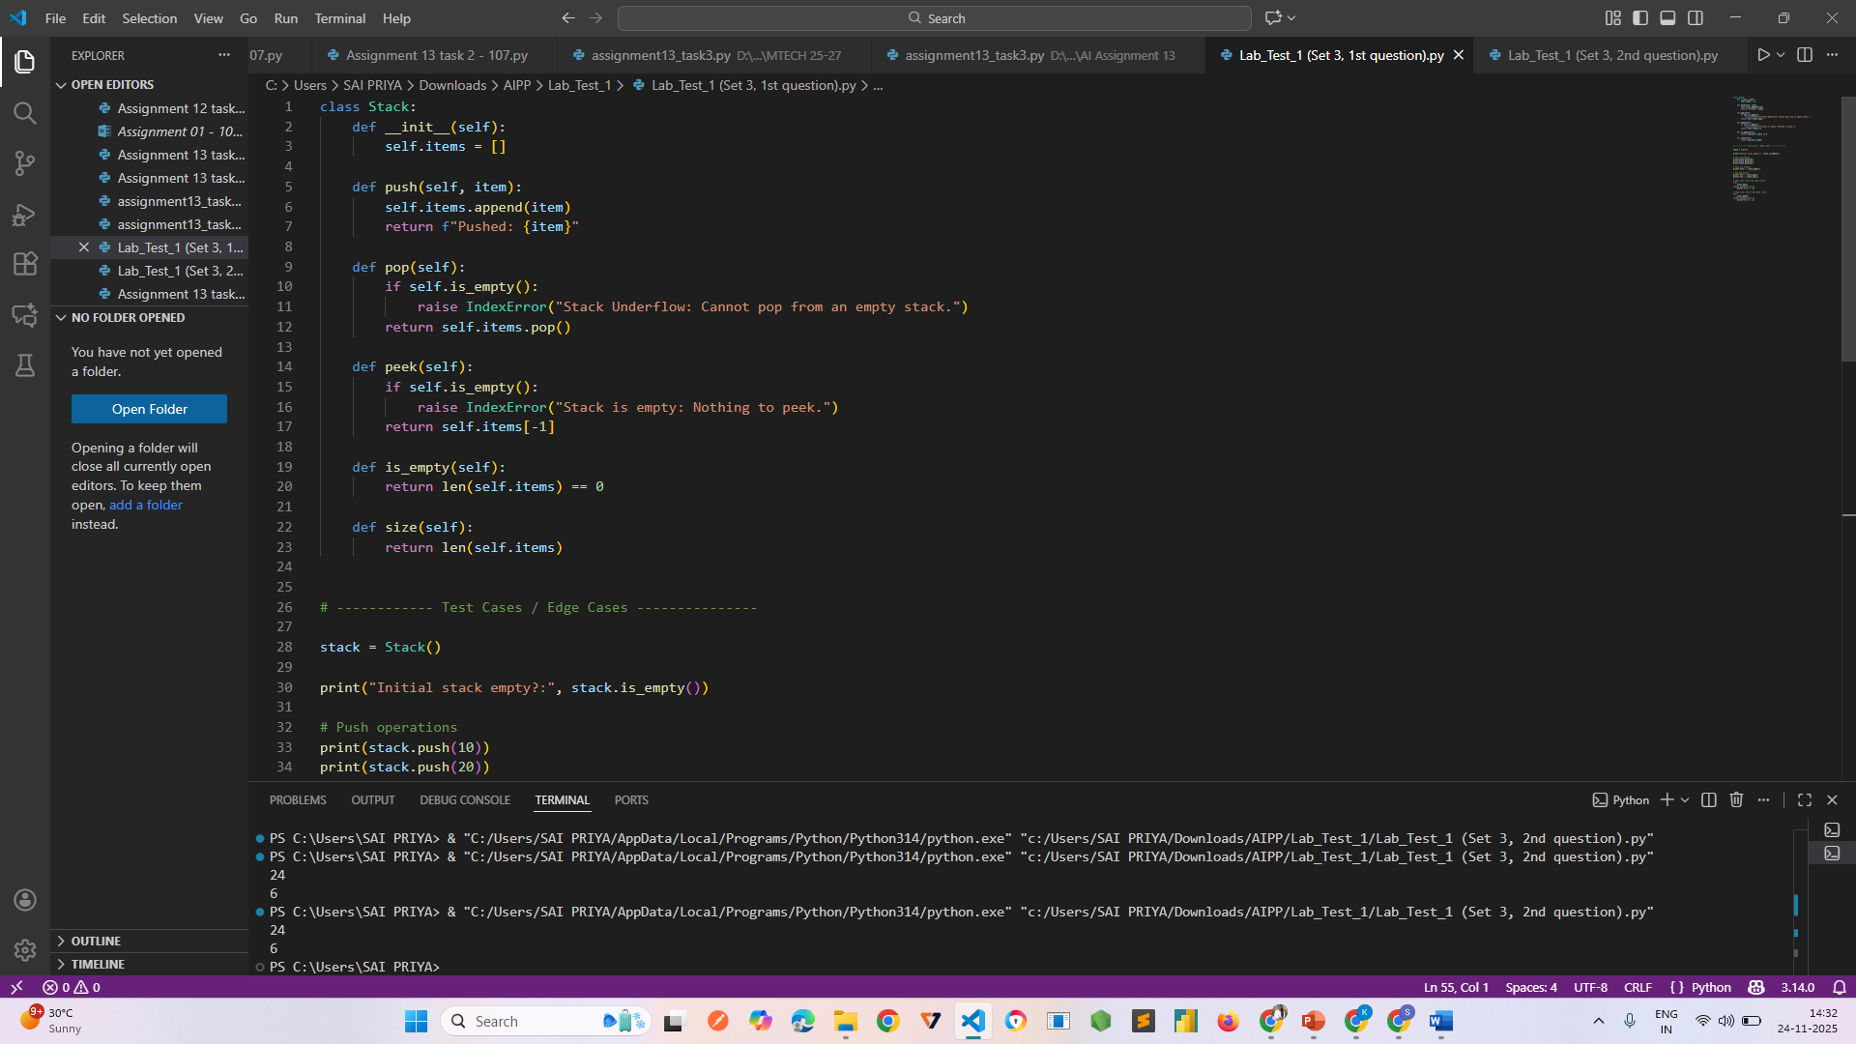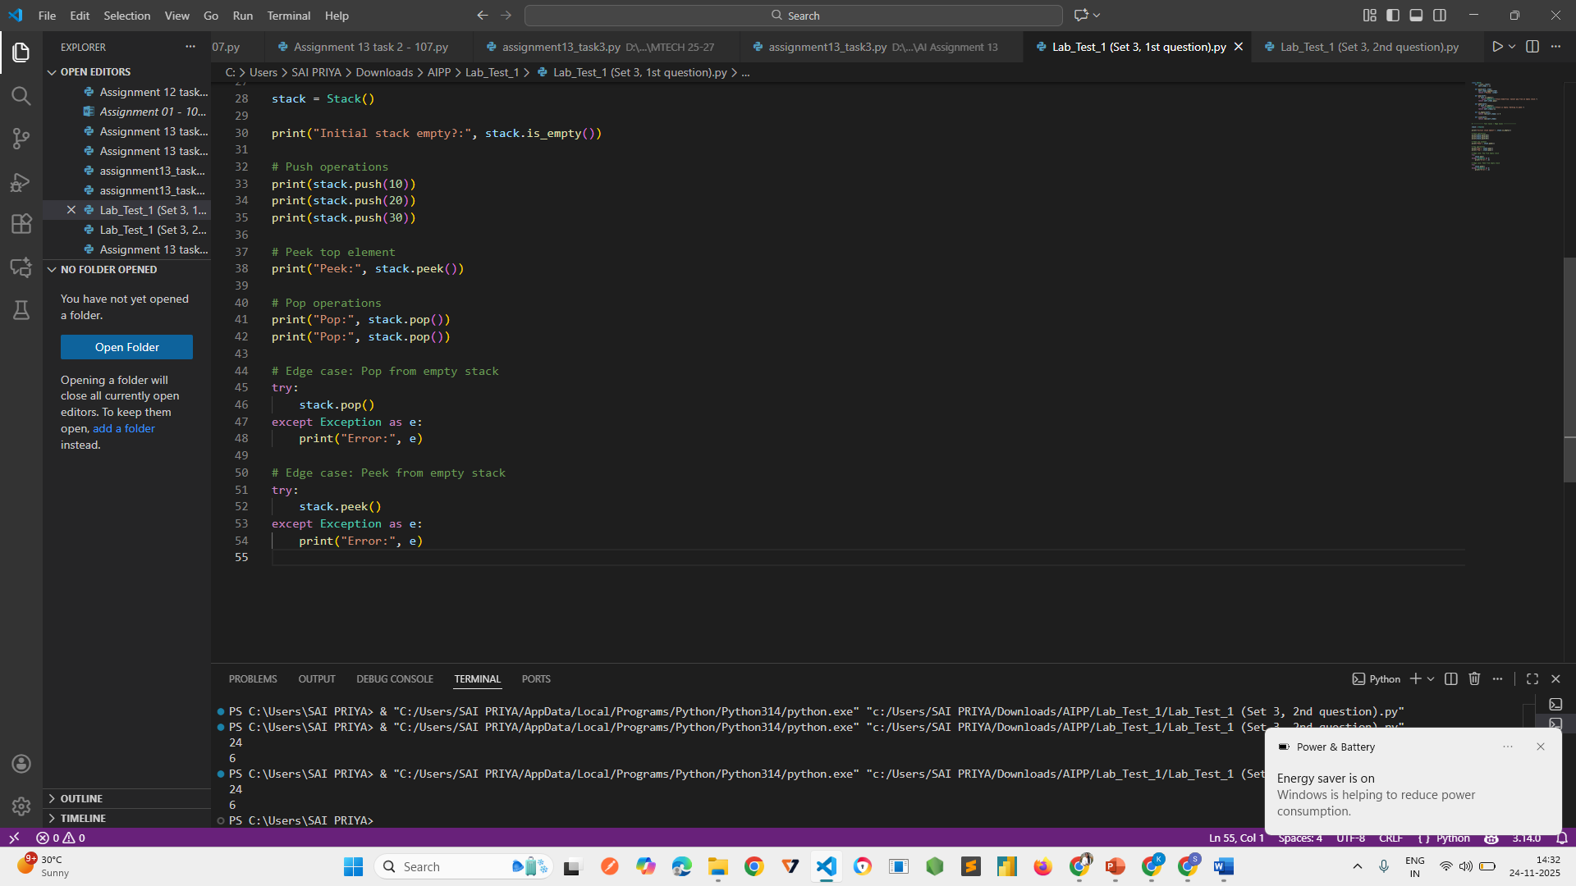
Output:
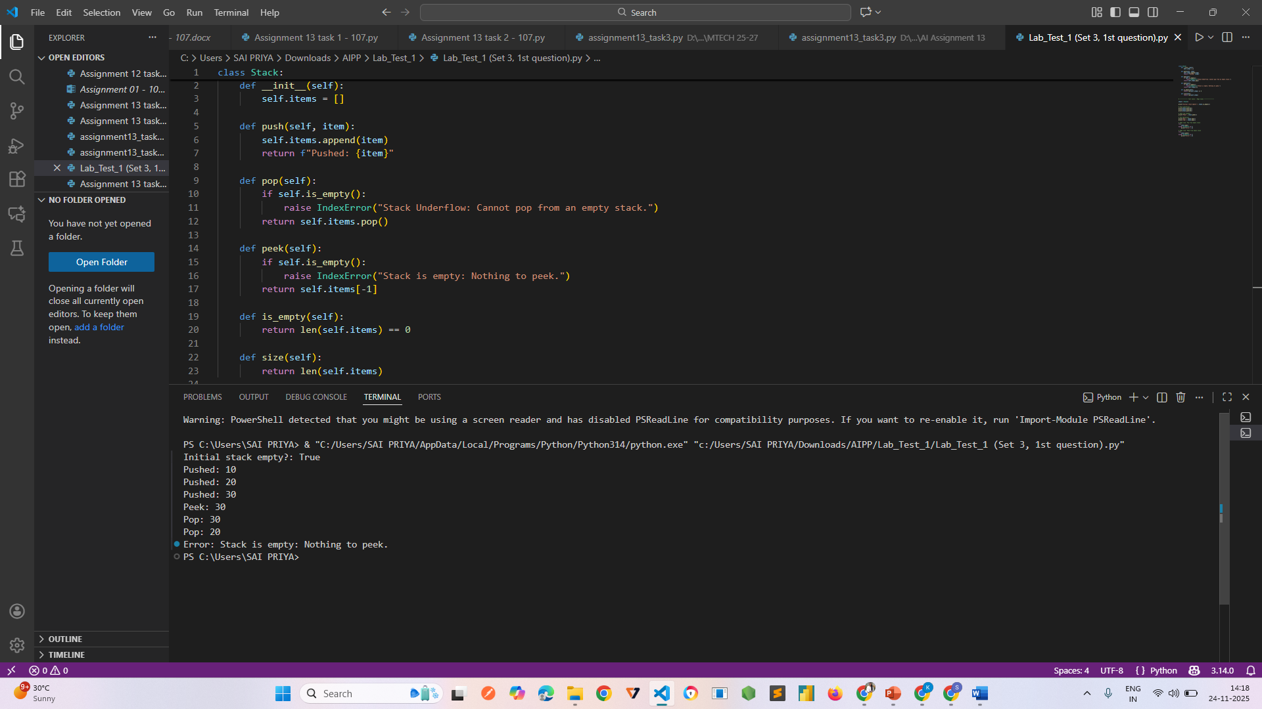

- Q2. Refactor a poorly commented Python function using an AI assistant for automatic documentation. Evaluate clarity and completeness versus manual comments.
(Each question carries 5 marks)
Prompt:
Refactor the following poorly commented Python function by adding clear docstrings
and meaningful inline comments. Improve readability without changing functionality.
After documenting, evaluate whether the AI-generated comments are clearer and more
complete compared to manually written comments.
Code:
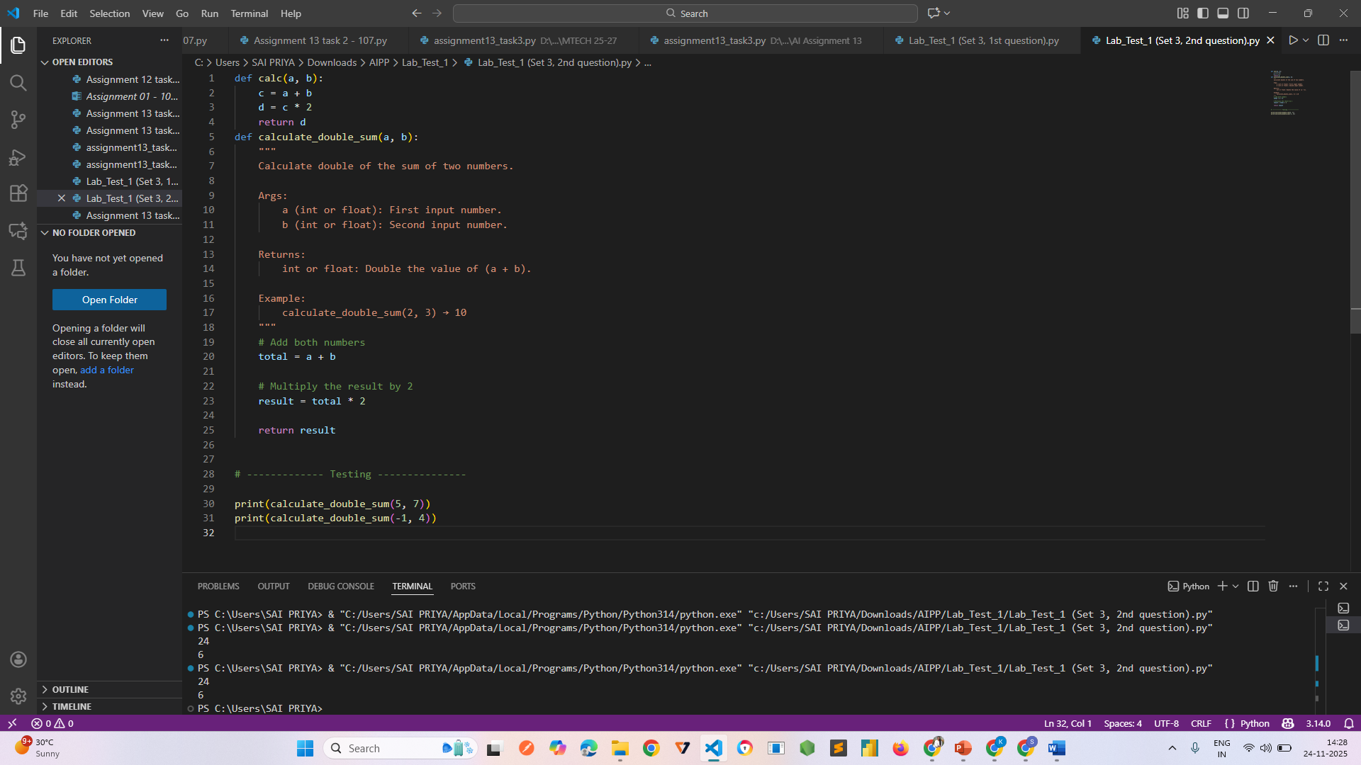
Output:


