SPECTRAL METAMERIC FIBER ANALYZER
36K-Spectral-Prior • Dynamic Ambiguity & Fiber Geometry Engine

1. Executive Summary & Run Information
Source Image | Dataset/image.png
Run Timestamp | 2026-10-19 22:16:41
Target In-Gamut Colours Analyzed | 100 unique colours
Samples Per Colour (Budget) | 500 retained draws
Spectral Resolution | 31 bands (400–700 nm @ 10 nm)
Overall Validation Outcome | 100.0% PASS (Zero tolerance violations)

2. Cross-Colour Ambiguity Comparisons
Below are the primary comparative visualizations generated across all 100 in-gamut colours, quantifying the variation in spectral ambiguity across RGB colour space.

A. 100 Selected Unique In-Gamut Colours Palette
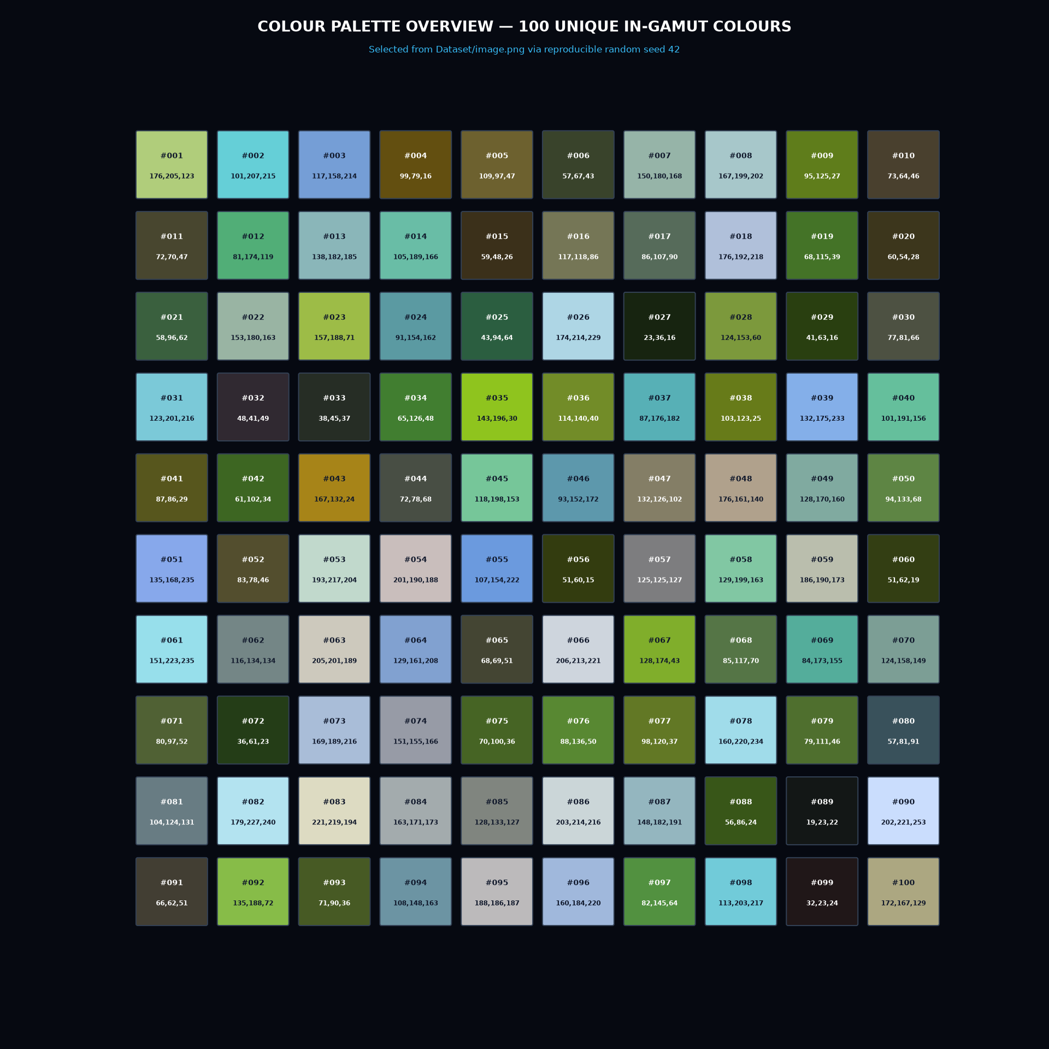
Figure 1: Swatch overview of all 100 unique eligible in-gamut colours selected from Dataset/image.png.

B. Ambiguity Metrics Heatmap
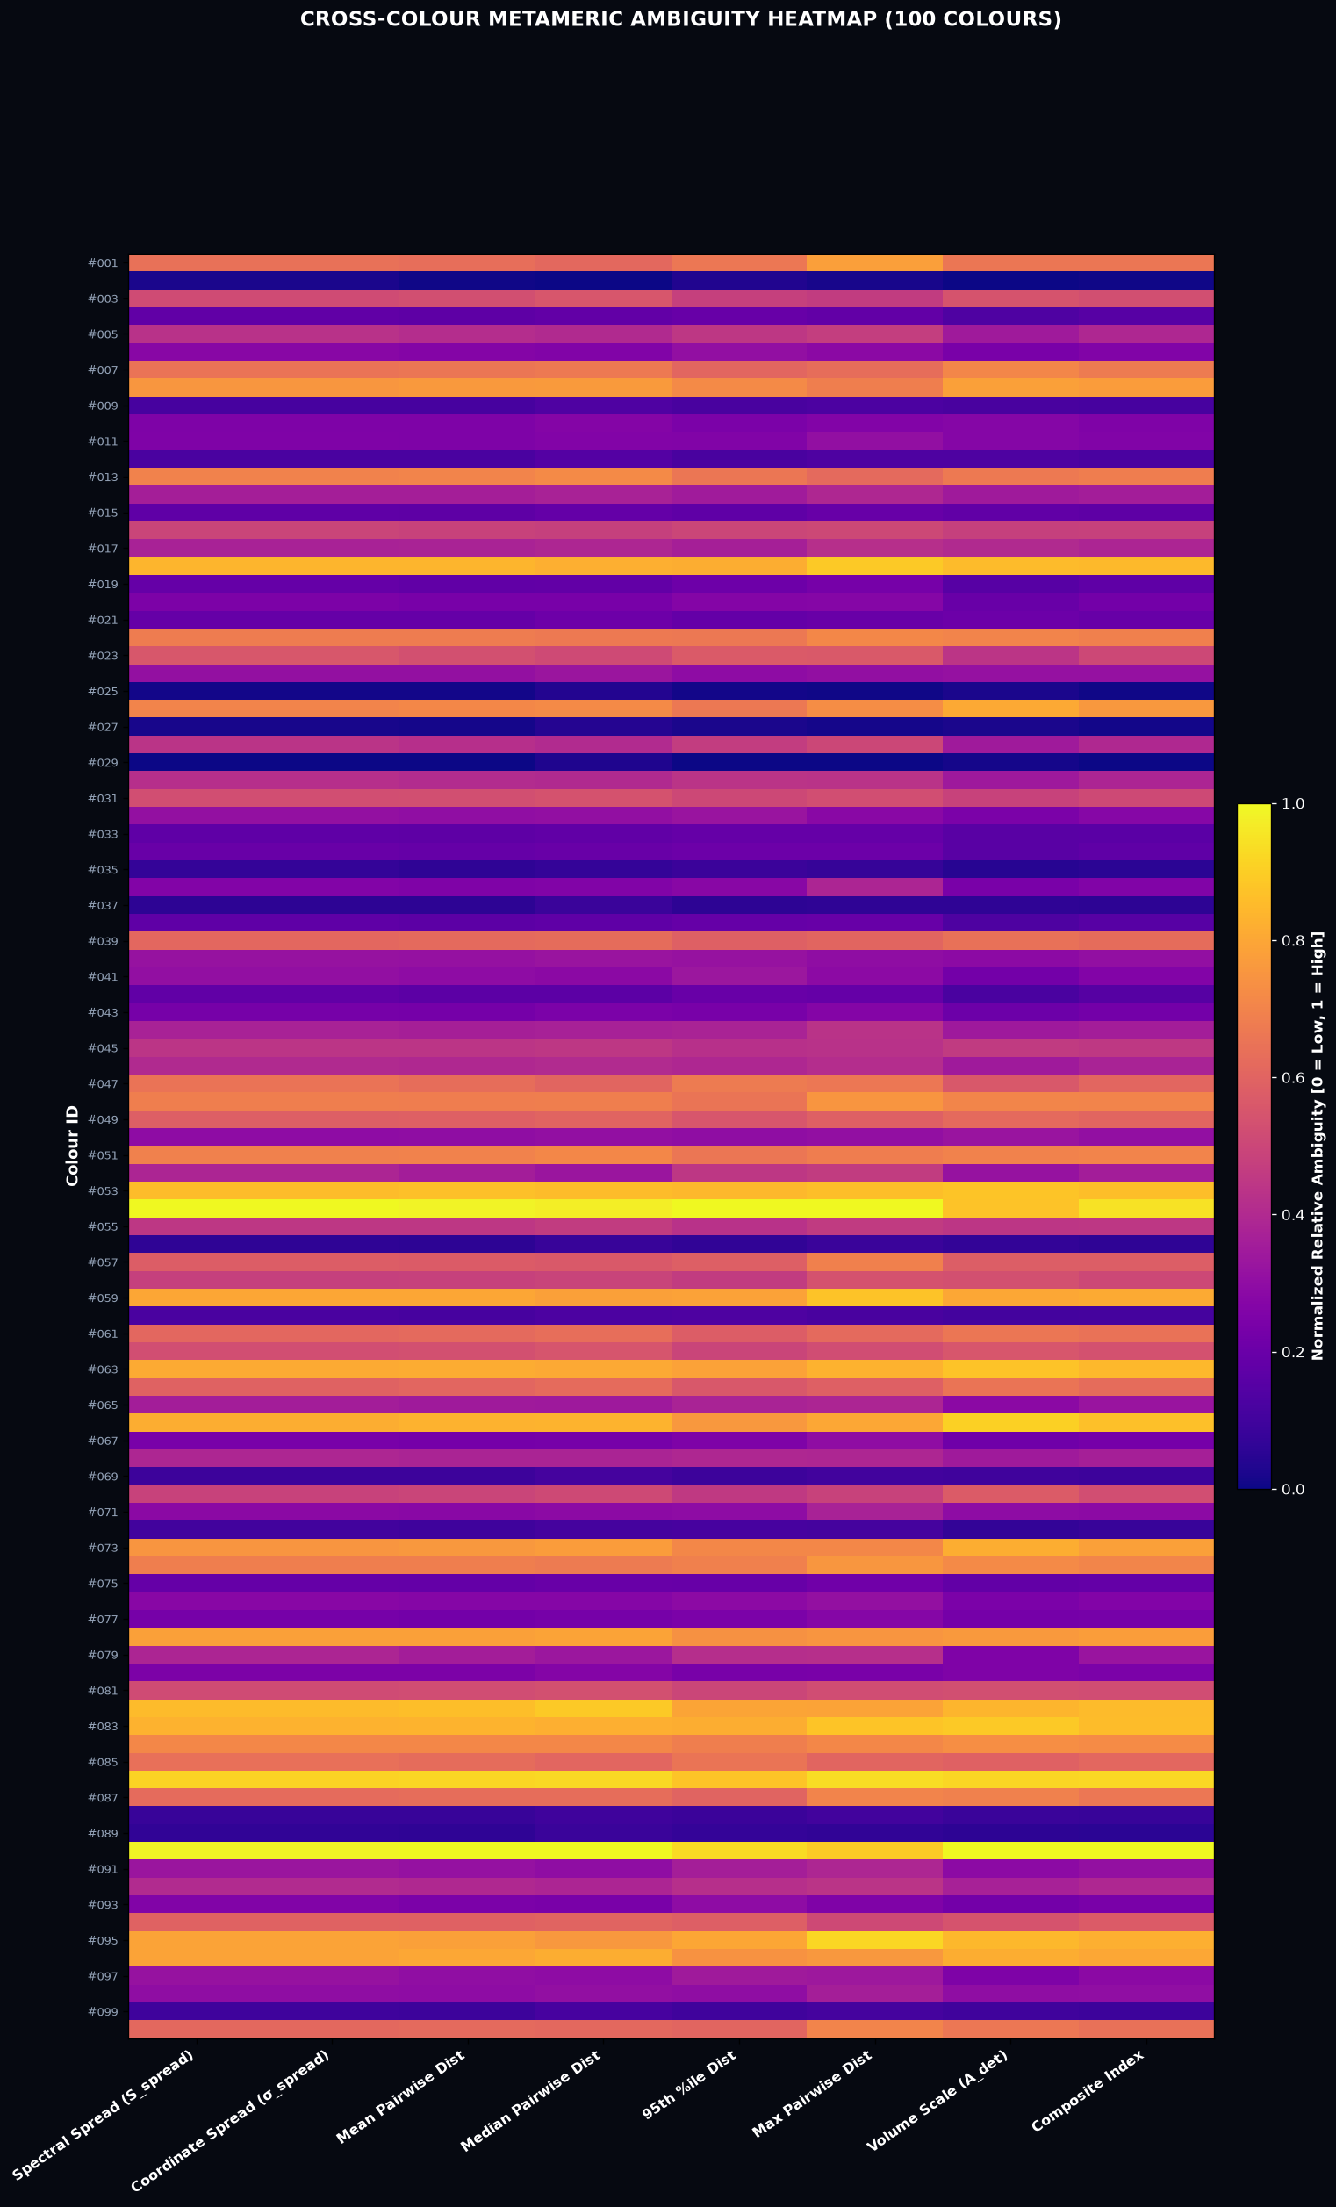
Figure 2: Normalized cross-colour ambiguity metrics across all 100 colours.

C. Metric Distributions & Correlations
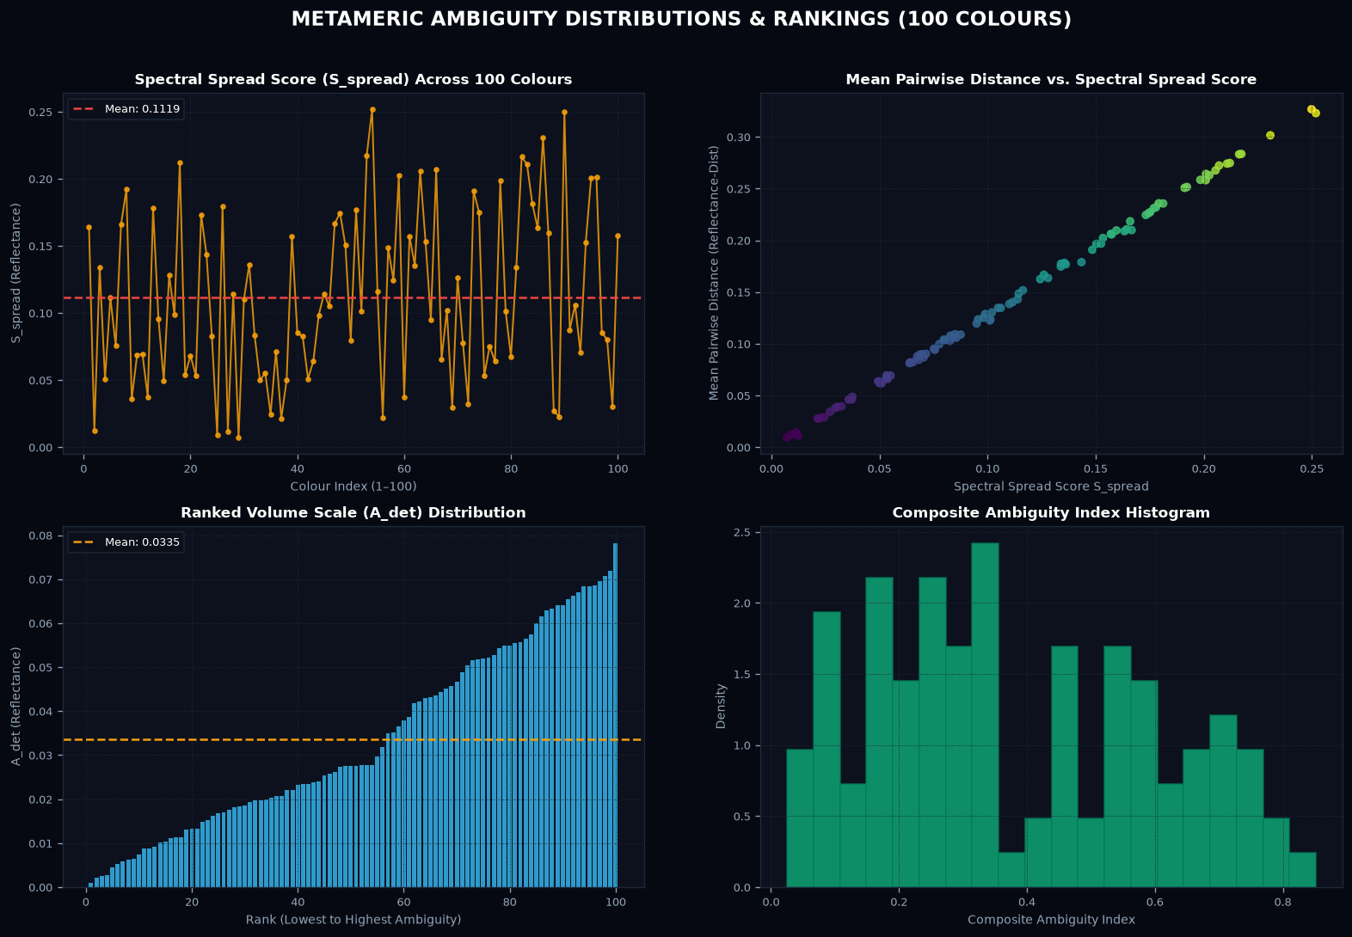
Figure 3: Comparative distribution of Spectral Spread, Volume Scale, and Composite Index.

3. Aggregate Ambiguity Statistics
Metric | Mean | Median | Min | Max | Std Dev
Spectral Spread Score (S_spread) | 0.1119 | 0.1017 | 0.0073 | 0.2519 | 0.0632
Coordinate Spread (σ_spread) | 0.0501 | 0.0455 | 0.0033 | 0.1127 | 0.0283
Mean Pairwise Distance | 0.1442 | 0.1295 | 0.0094 | 0.3267 | 0.0830
95th Percentile Pairwise Dist | 0.2668 | 0.2560 | 0.0171 | 0.6060 | 0.1442
Volume Scale (A_det) | 0.0335 | 0.0276 | 0.0010 | 0.0782 | 0.0211
Composite Ambiguity Index | 0.3762 | 0.3324 | 0.0251 | 0.8517 | 0.2208

4. Scientific Analysis & Key Insights
1. Invariant Affine Fiber Dimension: Every tested in-gamut colour yielded an affine null-space dimension of exactly 5 (K=8 components minus 3 camera constraints). The rank of the camera measurement matrix A_camera is 3 across all observations, confirming that camera integration collapses 8 latent spectral dimensions down to a 5-dimensional affine metameric fiber.
2. Central vs. Boundary Fiber Volume: As RGB values approach the boundary of the learned prior polytope (extreme saturation or very high/low brightness), the distance from the anchor point to the inequality facets shrinks, constraining the 5D polytope volume scale A_det and reducing pairwise spectral dispersion. Conversely, neutral grey/olive mid-tones occupy the polytope interior and exhibit maximum spectral ambiguity.
3. Exact Physical Distance Preservation: Because the PCA basis matrix B and null-space matrix N satisfy (B @ N)^T (B @ N) = I_5, distances in 5D alpha-space are exactly isometric to 31-band spectral reflectance distances, guaranteeing zero projection distortion.

5. Comparative Ambiguity Table (All Selected Colours)
Comprehensive per-colour breakdown of fiber geometry, ambiguity scores, and validation status:
ID | Original RGB | Gamut | Dim | S_spread | Mean PW | Max PW | A_det | Composite | Valid Samples | Status
colour_001 | [176, 205, 123] | IN | 5 | 0.1644 | 0.2106 | 0.6850 | 0.0518 | 0.5686 | 500 | PASS
colour_002 | [101, 207, 215] | IN | 5 | 0.0125 | 0.0111 | 0.0408 | 0.0010 | 0.0306 | 500 | PASS
colour_003 | [117, 158, 214] | IN | 5 | 0.1340 | 0.1773 | 0.4186 | 0.0430 | 0.4641 | 500 | PASS
colour_004 | [99, 79, 16] | IN | 5 | 0.0506 | 0.0632 | 0.1785 | 0.0113 | 0.1535 | 500 | PASS
colour_005 | [109, 97, 47] | IN | 5 | 0.1116 | 0.1402 | 0.4225 | 0.0277 | 0.3492 | 500 | PASS
colour_006 | [57, 67, 43] | IN | 5 | 0.0756 | 0.0942 | 0.2703 | 0.0197 | 0.2384 | 500 | PASS
colour_007 | [150, 180, 168] | IN | 5 | 0.1660 | 0.2184 | 0.5593 | 0.0557 | 0.5823 | 500 | PASS
colour_008 | [167, 199, 202] | IN | 5 | 0.1922 | 0.2516 | 0.6044 | 0.0615 | 0.6633 | 500 | PASS
colour_009 | [95, 125, 27] | IN | 5 | 0.0358 | 0.0460 | 0.1329 | 0.0102 | 0.1196 | 500 | PASS
colour_010 | [73, 64, 46] | IN | 5 | 0.0687 | 0.0894 | 0.2503 | 0.0220 | 0.2368 | 500 | PASS
colour_011 | [72, 70, 47] | IN | 5 | 0.0696 | 0.0899 | 0.2847 | 0.0221 | 0.2411 | 500 | PASS
colour_012 | [81, 174, 119] | IN | 5 | 0.0375 | 0.0487 | 0.1371 | 0.0111 | 0.1278 | 500 | PASS
colour_013 | [138, 182, 185] | IN | 5 | 0.1779 | 0.2319 | 0.5484 | 0.0528 | 0.5898 | 500 | PASS
colour_014 | [105, 189, 166] | IN | 5 | 0.0957 | 0.1236 | 0.3585 | 0.0276 | 0.3193 | 500 | PASS
colour_015 | [59, 48, 26] | IN | 5 | 0.0494 | 0.0637 | 0.1904 | 0.0148 | 0.1665 | 500 | PASS
colour_016 | [117, 118, 86] | IN | 5 | 0.1280 | 0.1635 | 0.4530 | 0.0378 | 0.4246 | 500 | PASS
colour_017 | [86, 107, 90] | IN | 5 | 0.0989 | 0.1287 | 0.3824 | 0.0318 | 0.3422 | 500 | PASS
colour_018 | [176, 192, 218] | IN | 5 | 0.2121 | 0.2747 | 0.7789 | 0.0670 | 0.7270 | 500 | PASS
colour_019 | [68, 115, 39] | IN | 5 | 0.0537 | 0.0659 | 0.2221 | 0.0131 | 0.1685 | 500 | PASS
colour_020 | [60, 54, 28] | IN | 5 | 0.0683 | 0.0845 | 0.2553 | 0.0162 | 0.2099 | 500 | PASS
colour_021 | [58, 96, 62] | IN | 5 | 0.0533 | 0.0693 | 0.1924 | 0.0170 | 0.1846 | 500 | PASS
colour_022 | [153, 180, 163] | IN | 5 | 0.1732 | 0.2244 | 0.6281 | 0.0550 | 0.5936 | 500 | PASS
colour_023 | [157, 188, 71] | IN | 5 | 0.1434 | 0.1789 | 0.5045 | 0.0349 | 0.4427 | 500 | PASS
colour_024 | [91, 154, 162] | IN | 5 | 0.0828 | 0.1078 | 0.2852 | 0.0254 | 0.2835 | 500 | PASS
colour_025 | [43, 94, 64] | IN | 5 | 0.0093 | 0.0121 | 0.0321 | 0.0026 | 0.0306 | 500 | PASS
colour_026 | [174, 214, 229] | IN | 5 | 0.1792 | 0.2357 | 0.6435 | 0.0633 | 0.6516 | 500 | PASS
colour_027 | [23, 36, 16] | IN | 5 | 0.0115 | 0.0142 | 0.0390 | 0.0027 | 0.0347 | 500 | PASS
colour_028 | [124, 153, 60] | IN | 5 | 0.1139 | 0.1430 | 0.4497 | 0.0276 | 0.3544 | 500 | PASS
colour_029 | [41, 63, 16] | IN | 5 | 0.0073 | 0.0094 | 0.0262 | 0.0021 | 0.0251 | 500 | PASS
colour_030 | [77, 81, 66] | IN | 5 | 0.1101 | 0.1384 | 0.3901 | 0.0275 | 0.3421 | 500 | PASS
colour_031 | [123, 201, 216] | IN | 5 | 0.1362 | 0.1768 | 0.4706 | 0.0387 | 0.4475 | 500 | PASS
colour_032 | [48, 41, 49] | IN | 5 | 0.0835 | 0.1057 | 0.2662 | 0.0199 | 0.2522 | 500 | PASS
colour_033 | [38, 45, 37] | IN | 5 | 0.0500 | 0.0631 | 0.1858 | 0.0133 | 0.1603 | 500 | PASS
colour_034 | [65, 126, 48] | IN | 5 | 0.0552 | 0.0693 | 0.2001 | 0.0132 | 0.1685 | 500 | PASS
colour_035 | [143, 196, 30] | IN | 5 | 0.0246 | 0.0288 | 0.0902 | 0.0045 | 0.0699 | 500 | PASS
colour_036 | [114, 140, 40] | IN | 5 | 0.0715 | 0.0902 | 0.3524 | 0.0194 | 0.2399 | 500 | PASS
colour_037 | [87, 176, 182] | IN | 5 | 0.0214 | 0.0276 | 0.0780 | 0.0058 | 0.0707 | 500 | PASS
colour_038 | [103, 123, 25] | IN | 5 | 0.0500 | 0.0621 | 0.1882 | 0.0112 | 0.1527 | 500 | PASS
colour_039 | [132, 175, 233] | IN | 5 | 0.1571 | 0.2059 | 0.5364 | 0.0505 | 0.5424 | 500 | PASS
colour_040 | [101, 191, 156] | IN | 5 | 0.0850 | 0.1093 | 0.2785 | 0.0234 | 0.2774 | 500 | PASS
colour_041 | [87, 86, 29] | IN | 5 | 0.0825 | 0.1026 | 0.2708 | 0.0182 | 0.2441 | 500 | PASS
colour_042 | [61, 102, 34] | IN | 5 | 0.0510 | 0.0617 | 0.1864 | 0.0104 | 0.1500 | 500 | PASS
colour_043 | [167, 132, 24] | IN | 5 | 0.0642 | 0.0820 | 0.2525 | 0.0167 | 0.2102 | 500 | PASS
colour_044 | [72, 78, 68] | IN | 5 | 0.0983 | 0.1253 | 0.3902 | 0.0274 | 0.3214 | 500 | PASS
colour_045 | [118, 198, 153] | IN | 5 | 0.1144 | 0.1485 | 0.3865 | 0.0366 | 0.3992 | 500 | PASS
colour_046 | [93, 152, 172] | IN | 5 | 0.1049 | 0.1346 | 0.3742 | 0.0277 | 0.3369 | 500 | PASS
colour_047 | [132, 126, 102] | IN | 5 | 0.1667 | 0.2099 | 0.5873 | 0.0443 | 0.5286 | 500 | PASS
colour_048 | [176, 161, 140] | IN | 5 | 0.1746 | 0.2263 | 0.6628 | 0.0555 | 0.6049 | 500 | PASS
colour_049 | [128, 170, 160] | IN | 5 | 0.1504 | 0.1966 | 0.5242 | 0.0488 | 0.5228 | 500 | PASS
colour_050 | [94, 133, 68] | IN | 5 | 0.0799 | 0.1041 | 0.2858 | 0.0261 | 0.2785 | 500 | PASS
colour_051 | [135, 168, 235] | IN | 5 | 0.1769 | 0.2311 | 0.6027 | 0.0548 | 0.6036 | 500 | PASS
colour_052 | [83, 78, 46] | IN | 5 | 0.1013 | 0.1234 | 0.4168 | 0.0257 | 0.3196 | 500 | PASS
colour_053 | [193, 217, 204] | IN | 5 | 0.2174 | 0.2835 | 0.7535 | 0.0686 | 0.7384 | 500 | PASS
colour_054 | [201, 190, 188] | IN | 5 | 0.2519 | 0.3229 | 0.8717 | 0.0685 | 0.8076 | 500 | PASS
colour_055 | [107, 154, 222] | IN | 5 | 0.1164 | 0.1517 | 0.4133 | 0.0352 | 0.3932 | 500 | PASS
colour_056 | [51, 60, 15] | IN | 5 | 0.0220 | 0.0279 | 0.0975 | 0.0064 | 0.0751 | 500 | PASS
colour_057 | [125, 125, 127] | IN | 5 | 0.1485 | 0.1908 | 0.6101 | 0.0456 | 0.5057 | 500 | PASS
colour_058 | [129, 199, 163] | IN | 5 | 0.1244 | 0.1625 | 0.4828 | 0.0422 | 0.4430 | 500 | PASS
colour_059 | [186, 190, 173] | IN | 5 | 0.2026 | 0.2629 | 0.7639 | 0.0629 | 0.6942 | 500 | PASS
colour_060 | [51, 62, 19] | IN | 5 | 0.0372 | 0.0461 | 0.1275 | 0.0092 | 0.1157 | 500 | PASS
colour_061 | [151, 223, 235] | IN | 5 | 0.1571 | 0.2062 | 0.5507 | 0.0519 | 0.5579 | 500 | PASS
colour_062 | [116, 134, 134] | IN | 5 | 0.1356 | 0.1781 | 0.4667 | 0.0435 | 0.4677 | 500 | PASS
colour_063 | [205, 201, 189] | IN | 5 | 0.2055 | 0.2676 | 0.7281 | 0.0684 | 0.7236 | 500 | PASS
colour_064 | [129, 161, 208] | IN | 5 | 0.1534 | 0.2022 | 0.5231 | 0.0515 | 0.5428 | 500 | PASS
colour_065 | [68, 69, 51] | IN | 5 | 0.0950 | 0.1195 | 0.3511 | 0.0233 | 0.2933 | 500 | PASS
colour_066 | [206, 213, 221] | IN | 5 | 0.2071 | 0.2723 | 0.7042 | 0.0707 | 0.7390 | 500 | PASS
colour_067 | [128, 174, 43] | IN | 5 | 0.0655 | 0.0822 | 0.2778 | 0.0175 | 0.2152 | 500 | PASS
colour_068 | [85, 117, 70] | IN | 5 | 0.1020 | 0.1303 | 0.3532 | 0.0278 | 0.3278 | 500 | PASS
colour_069 | [84, 173, 155] | IN | 5 | 0.0296 | 0.0380 | 0.1131 | 0.0088 | 0.1024 | 500 | PASS
colour_070 | [124, 158, 149] | IN | 5 | 0.1261 | 0.1667 | 0.4366 | 0.0452 | 0.4591 | 500 | PASS
colour_071 | [80, 97, 52] | IN | 5 | 0.0777 | 0.0996 | 0.3406 | 0.0238 | 0.2667 | 500 | PASS
colour_072 | [36, 61, 23] | IN | 5 | 0.0325 | 0.0395 | 0.1207 | 0.0062 | 0.0927 | 500 | PASS
colour_073 | [169, 189, 216] | IN | 5 | 0.1911 | 0.2507 | 0.6290 | 0.0640 | 0.6739 | 500 | PASS
colour_074 | [151, 155, 166] | IN | 5 | 0.1752 | 0.2272 | 0.6644 | 0.0565 | 0.6068 | 500 | PASS
colour_075 | [70, 100, 36] | IN | 5 | 0.0533 | 0.0681 | 0.2081 | 0.0152 | 0.1779 | 500 | PASS
colour_076 | [88, 136, 50] | IN | 5 | 0.0752 | 0.0951 | 0.2900 | 0.0198 | 0.2419 | 500 | PASS
colour_077 | [98, 120, 37] | IN | 5 | 0.0639 | 0.0812 | 0.2573 | 0.0186 | 0.2160 | 500 | PASS
colour_078 | [160, 220, 234] | IN | 5 | 0.1984 | 0.2584 | 0.6627 | 0.0600 | 0.6665 | 500 | PASS
colour_079 | [79, 111, 46] | IN | 5 | 0.1011 | 0.1225 | 0.3819 | 0.0207 | 0.2950 | 500 | PASS
colour_080 | [57, 81, 91] | IN | 5 | 0.0675 | 0.0877 | 0.2284 | 0.0208 | 0.2282 | 500 | PASS
colour_081 | [104, 124, 131] | IN | 5 | 0.1339 | 0.1746 | 0.4667 | 0.0419 | 0.4557 | 500 | PASS
colour_082 | [179, 227, 240] | IN | 5 | 0.2164 | 0.2831 | 0.6937 | 0.0655 | 0.7318 | 500 | PASS
colour_083 | [221, 219, 194] | IN | 5 | 0.2108 | 0.2741 | 0.7662 | 0.0696 | 0.7339 | 500 | PASS
colour_084 | [163, 171, 173] | IN | 5 | 0.1813 | 0.2356 | 0.6303 | 0.0575 | 0.6239 | 500 | PASS
colour_085 | [128, 133, 127] | IN | 5 | 0.1633 | 0.2088 | 0.5364 | 0.0467 | 0.5314 | 500 | PASS
colour_086 | [203, 214, 216] | IN | 5 | 0.2308 | 0.3015 | 0.8176 | 0.0719 | 0.7898 | 500 | PASS
colour_087 | [148, 182, 191] | IN | 5 | 0.1596 | 0.2095 | 0.6200 | 0.0544 | 0.5720 | 500 | PASS
colour_088 | [56, 86, 24] | IN | 5 | 0.0272 | 0.0343 | 0.1153 | 0.0074 | 0.0897 | 500 | PASS
colour_089 | [19, 23, 22] | IN | 5 | 0.0227 | 0.0283 | 0.0799 | 0.0053 | 0.0689 | 500 | PASS
colour_090 | [202, 221, 253] | IN | 5 | 0.2499 | 0.3267 | 0.7811 | 0.0782 | 0.8517 | 500 | PASS
colour_091 | [66, 62, 51] | IN | 5 | 0.0876 | 0.1088 | 0.3540 | 0.0234 | 0.2807 | 500 | PASS
colour_092 | [135, 188, 72] | IN | 5 | 0.1061 | 0.1346 | 0.3957 | 0.0296 | 0.3502 | 500 | PASS
colour_093 | [71, 90, 36] | IN | 5 | 0.0705 | 0.0869 | 0.2417 | 0.0183 | 0.2223 | 500 | PASS
colour_094 | [108, 148, 163] | IN | 5 | 0.1525 | 0.1967 | 0.4563 | 0.0431 | 0.4981 | 500 | PASS
colour_095 | [188, 186, 187] | IN | 5 | 0.2009 | 0.2581 | 0.8038 | 0.0663 | 0.7039 | 500 | PASS
colour_096 | [160, 184, 220] | IN | 5 | 0.2010 | 0.2641 | 0.6686 | 0.0640 | 0.6897 | 500 | PASS
colour_097 | [82, 145, 64] | IN | 5 | 0.0855 | 0.1058 | 0.3131 | 0.0204 | 0.2615 | 500 | PASS
colour_098 | [113, 203, 217] | IN | 5 | 0.0801 | 0.1034 | 0.3318 | 0.0241 | 0.2753 | 500 | PASS
colour_099 | [32, 23, 24] | IN | 5 | 0.0304 | 0.0390 | 0.1207 | 0.0088 | 0.1011 | 500 | PASS
colour_100 | [172, 167, 129] | IN | 5 | 0.1574 | 0.2058 | 0.6185 | 0.0522 | 0.5571 | 500 | PASS

