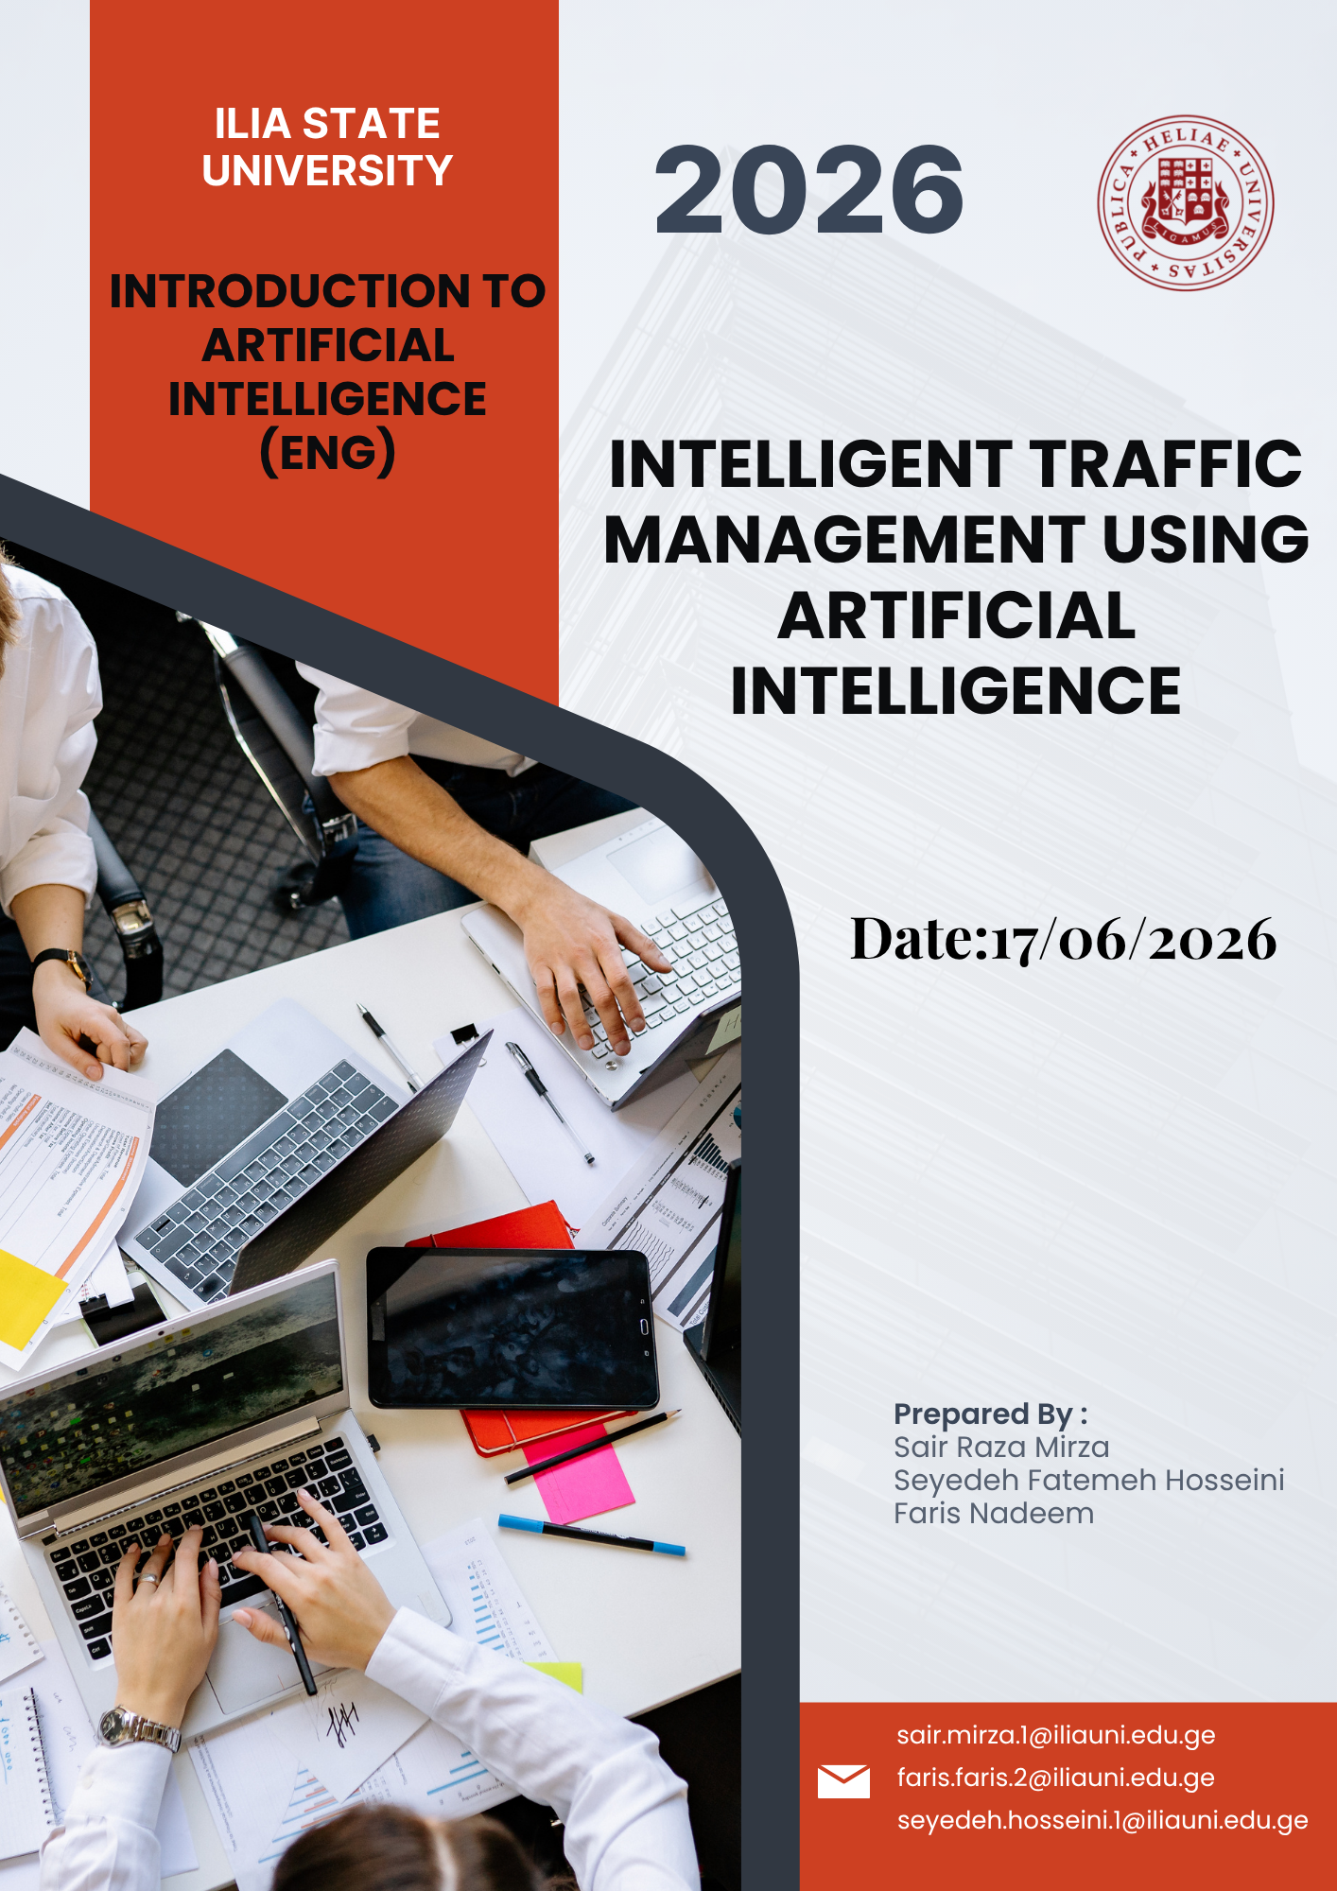

Abstract
Traffic congestion is a problem faced by the modern cities. Computer vision, machine learning, and real-time decision making solutions such as Artificial Intelligence (AI) provide advanced solutions. An AI powered traffic management system can process traffic data, forecast congestion patterns, and adjust light durations and manage traffic flow to boost safety on the road. This report looks at the technology, applications, benefits, challenges and future potential of intelligent traffic management systems.

Introduction
The pressure has been increasingly put on transportation infrastructure due to the urbanization and increase in the number of vehicles. Conventional traffic management approaches are based on predetermined signal durations and manual oversight and monitoring, which may not be able to adapt to traffic fluctuations. Consequently, cities suffer congestion, fuel consumption and pollution, and delays. Artificial Intelligence offers a smarter solution by allowing adaptive traffic control, using real-time data. Cameras, sensors and predictive algorithms are used in intelligent transportation systems, which help optimize traffic and contribute to the development of smart cities.
AI is one of the most vital technologies for the modern transportation system. AI systems can learn from the past and adapt to real-time traffic conditions, unlike traditional traffic management methods. This capability enables traffic management to be more effective and efficient. With the continued growth of urban populations, transportation networks need to become more efficient, as the demand grows.

Artificial Intelligence in Traffic Management
Artificial Intelligence is a technology that allows computers to undertake tasks that normally need the intelligence of a human being. AI is applied in transportation for traffic management, forecasting, optimization, and automation. Together, these algorithms enable computer vision to detect vehicles in camera feeds and machine learning to study trends and predict congestion. Deep learning improves accuracy in object recognition and traffic analysis.
One of the major benefits of AI is its speed in analyzing vast quantities of data within seconds. Data is continuously being produced by traffic cameras, traffic sensors, GPS devices and connected vehicles. This data is then analysed by AI algorithms, which can forecast traffic patterns, predict congestion and make recommendations for traffic management. Machine learning models can be trained using past traffic data to improve its accuracy over time.

AI Technologies Used
Computer Vision can detect vehicles and pedestrians using cameras. The Machine learning solution analyzes traffic patterns and predicts congestion. Deep Learning enhances Recognition. The Internet of Things (IoT) sensors give real-time information about road conditions, vehicle movement etc. Cloud Computing is useful for processing large data sets. These technologies comprise the core of intelligent traffic management systems that can adapt to traffic fluctuations.

AI-Based Smart Traffic Control Process
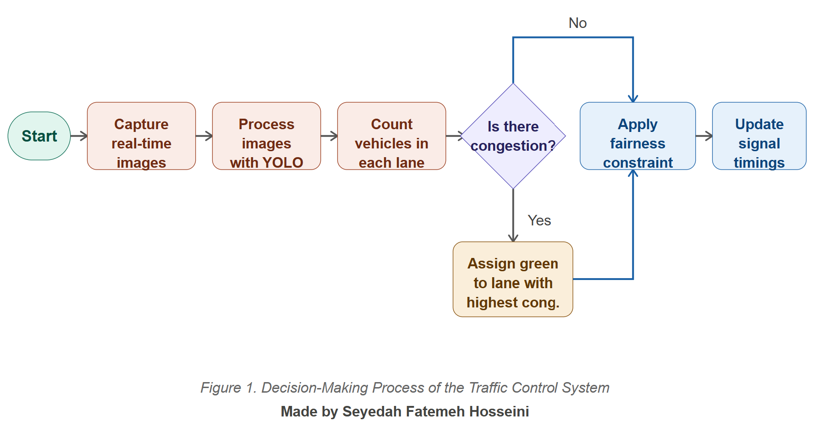
The process of intelligent traffic control system decision making is shown in figure 1. Real time traffic images are captured continuously by the cameras. Vehicle detection algorithms detect and count vehicles in each lane. The system analyzes traffic density and decides whether there is traffic congestion or not. Afterwards, the traffic signals are dynamically adjusted to enhance traffic efficiency.
The process outlined in Figure 1 illustrates the automated decision making by intelligent traffic systems. The AI system continuously assesses traffic density and vehicle movement, rather than depending on human operators. Real time analysis enables traffic lights to respond immediately to changes in traffic.

Applications of Intelligent Traffic Systems
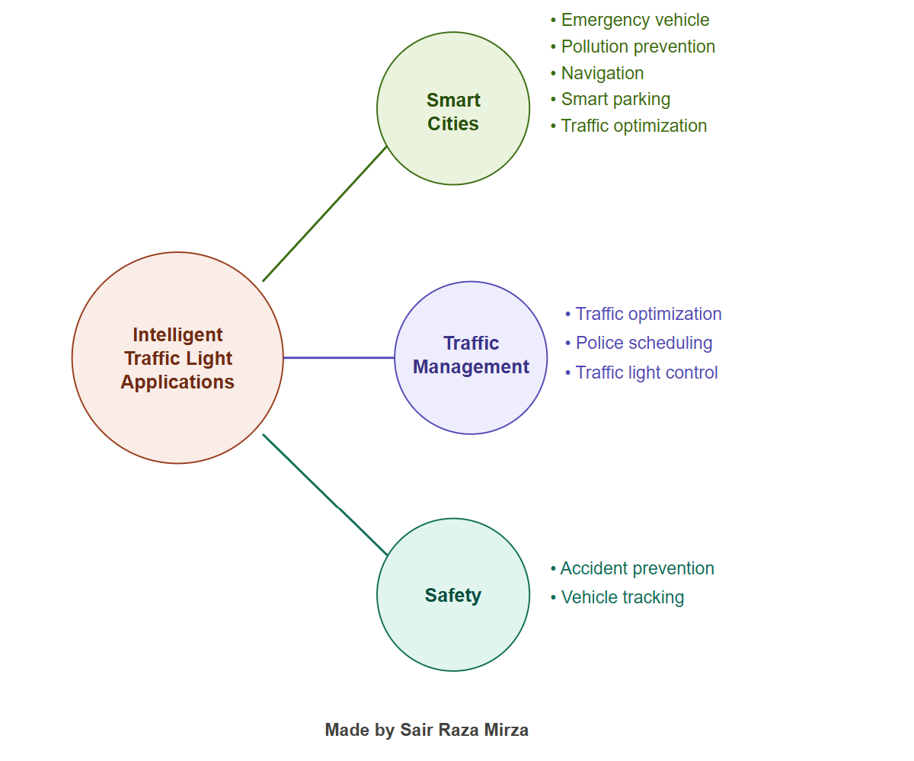

The intelligent traffic systems include traffic optimization, smart parking management, vehicle tracking, prioritization of emergency vehicles, traffic monitoring and pollution reduction.
The wide range of applications of intelligent traffic systems is illustrated with examples in Figure 2. Smart parking systems minimise the parking time drivers spend searching for a parking area and vehicle tracking systems facilitate transportation planning. These capabilities will help cities to optimize mobility and cut down on operational costs.

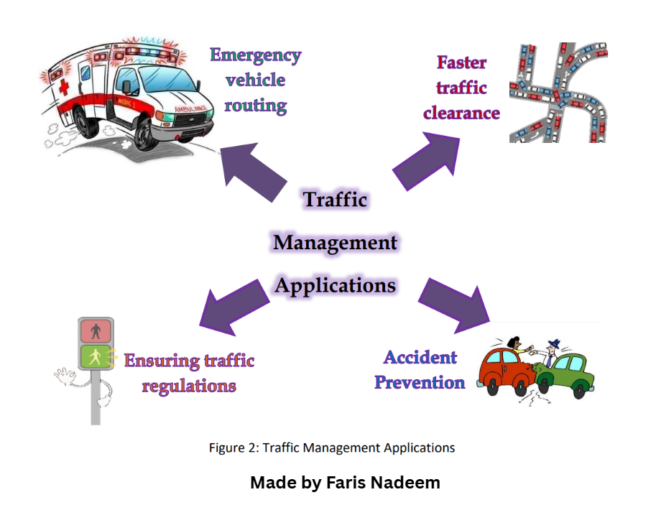
Traffic Management Applications

Figure 3 illustrates several practical applications of AI based traffic management systems, including emergency vehicle routing, accident prevention, traffic regulation, and faster traffic clearance.
Based on the figure, there are several practical implementations of AI traffic management systems, such as: AI systems can learn from traffic patterns and identify unusual situations, potentially preventing accidents from happening. When an ambulance or a fire service are responding to an emergency, they can request traffic signal priority by using the emergency vehicle routing feature which can reduce the response time and increase public safety.

Comparison of Traditional and AI Based Traffic Systems

Traditional Traffic System | AI-Based Traffic System
Fixed signal timings | Dynamic signal timings
Manual monitoring | Automated monitoring
Limited prediction capability | Predictive analytics and forecasting
Slow response to traffic changes | Real-time adaptive response
Higher congestion levels | Reduced congestion levels
Higher fuel consumption | Improved fuel efficiency
Increased emissions | Reduced environmental impact
Limited emergency vehicle support | Emergency vehicle prioritization

(Table 1: Comparison Table)
The differences between traditional traffic management systems and AI based traffic systems are highlighted in Table 1. Conventional systems are based on predetermined signal durations and manual monitoring, whereas AI driven systems leverage real-time data, predictive analysis and adaptive signal control to optimize transportation performance. These capabilities help reduce congestion, improve fuel efficiency, and enhance road safety.

Benefits of AI-Based Traffic Management
The benefits of having traffic management with the help of Artificial Intelligence are numerous. Adaptive traffic control minimises congestion and trip times which also implies to Georgia. Reducing congestion reduces fuel consumption and greenhouse gas emissions. More efficient traffic movement means more productivity, less transportation expenses. AI algorithms can help in preventing accidents on the roads by identifying dangerous situations and assisting in timely interventions.
AI systems also provide significant economic benefits, apart from the transportation improvement. Lower travel times boost efficiency in the supply chain and worker productivity. The overall enhanced transportation system gives enterprises more reliable and more convenient transportation and it gives citizens shorter and less stressful commute times.

Challenges and Limitations
AI driven traffic control has its advantages, but it also has its disadvantages. Installing and maintaining AI based traffic management systems can be expensive. Visual data is collected a lot in traffic systems, which raises privacy concerns. Connected infrastructure must be protected from cybersecurity risk. AI systems depend on the quality and reliability of data and inaccurate or faulty data can affect their performance.

Case Study of Smart Cities
AI is already being analyzed and being used successfully in traffic management in a number of cities around the world. In Singapore, real time monitoring systems, predictive analytics and adaptive traffic control are used to improve transportation efficiency. London has traffic lights that can adapt. Dubai has been deploying a range of smart city technologies including AI enabled transport systems. The examples show that AI powered traffic management solutions are a proven, viable tool that is already making a difference in large cities across the globe.

Future Developments
In the future, intelligent transportation systems will include autonomous vehicles, vehicle to infrastructure communication and 5G networks. Traffic authorities will be able to use advanced predictive analytics to predict congestion before it happens. AI powered transport systems will play a growing role in smart city initiatives that seek to enhance mobility and sustainability.

Conclusion
AI is revolutionising city traffic through real time monitoring, predictive analytics, and adaptive signal control. Smart traffic management systems can alleviate congestion, improve safety, reduce emissions and improve overall efficiency of transportation. As urbanisation continues to expand, AI driven traffic management will become increasingly important in building smarter, more sustainable cities.

References
1. Kamble, V. B., Mundhe, O. N., Walunjkar, C. M., & Kale, G. A. (2025). AI-Driven Smart Traffic Management System: An Adaptive Approach Using YOLO and OpenCV. https://ijmsm.org/ijmsm-v2i2p106.html
2. Elbasha, A. M., & Abdellatif, M. M. (2025). AIoT-based Smart Traffic Management System. https://arxiv.org/abs/2502.02821
3. Intelligent Traffic Management System using Computer Vision and Machine Learning. https://www.researchgate.net/publication/374717408_Intelligent_Traffic_Management_System_using_Computer_Vision_and_Machine_Learning
5. Liu, G., Shi, H., Kiani, A., Khreishah, A., Lee, J. Y., Ansari, N., Liu, C., & Yousef, M. (2021). Smart Traffic Monitoring System using Computer Vision and Edge Computing. https://arxiv.org/abs/2109.03141
6. Goenawan, C. R. (2024). Autonomous Smart Traffic Management System Using Artificial Intelligence CNN and LSTM. https://arxiv.org/abs/2410.10929
7. Samuel, P., & Sharma, P. K. (2025). Intelligent Traffic Management System using Artificial Intelligence and Computer Vision: Review. https://ijrt.org/j/article/view/486
8. Sherifi, S. (2026). Intelligent Traffic Monitoring with YOLOv11: A Case Study in Real-Time Vehicle Detection. https://arxiv.org/abs/2604.04080
9. Artificial Intelligence in Smart Traffic Management Systems. https://www.preprints.org/manuscript/202502.0539

