CloudExify Summer Internship 2026

DROPX — Limited Drop E-Commerce Storefront Project Report
Contents
CloudExify Summer Internship 2026 1
DROPX — Limited Drop E-Commerce Storefront Project Report 1
1. Introduction 1
1.1 Project Background 1
1.2 Project Objectives 1
1.3 Scope of Work 1
2. Project Overview 2
2.1 Project Specifications 2
2.2 Project Requirements 2
2.3 Deliverables 3
3. Technology Stack 3
3.1 HTML5 3
3.2 CSS3 4
3.3 Bootstrap 5.3.3 4
3.4 Vanilla JavaScript 5
3.5 Development Tools 5
4. Development Environment Setup 5
4.1 Project Folder Structure 5
4.2 Development Workflow 6
5. Project Architecture 7
5.1 System Architecture 7
5.2 Data Flow 8
6.1 Available Drop Concepts 8
6.2 Chosen Concept: Streetwear & Sneaker Capsule 8
7. Signature Feature Implementation 9
7.1 Feature 1: Real-Time Countdown Timer 9
7.2 Feature 2: Persistent Shopping Cart with localStorage 10
8. Development Process 10
8.1 Phase 1: Planning and Design 10
8.2 Phase 2: HTML Structure Development 11
8.3 Phase 3: CSS Styling Development 12
8.4 Phase 4: JavaScript Development 12
9. Responsive Design Strategy 13
9.1 Mobile-First Approach 13
9.2 Breakpoints Defined 13
9.3 Responsive Features 14
10. Deployment Strategy 14
10.1 Version Control with Git 14
10.2 GitHub Repository Setup 15
10.3 Vercel Deployment 15
10.4 Post-Deployment Steps 16
11. Testing and Quality Assurance 16
11.1 Testing Checklist 16
11.2 Browser Compatibility Testing 17
11.3 Performance Testing 17
11.4 Manual Testing Scenarios 17
12. Bonus Features 18
12.1 Sort Dropdown 18
12.2 Toast Notifications 18
12.3 Active Filter Tags 18
12.4 Product Detail Modal 18
13. Challenges Faced and Solutions 18
13.1 Cart Synchronization 18
13.2 Countdown Timer Duration 19
13.3 Navbar Scroll Offset 19
13.4 localStorage Parsing Safety 19
13.5 Stock Overselling Prevention 19
13.6 Responsive Image Handling 19
14. Learning Outcomes 20
14.1 Technical Skills Gained 20
14.2 Soft Skills Developed 20
14.3 Key Takeaways 21
15. Future Enhancements 21
15.2 Additional Features 21
15.3 Performance Optimizations 22
16. Conclusion 22
16.1 Project Summary 22
16.2 Key Achievements 22
16.3 Lessons Learned 23
16.4 Final Thoughts 23

1. Introduction

1.1 Project Background
The DROPX E-Commerce Storefront project was undertaken as the second and final project of Month 1 during the CloudExify Summer Internship 2026 program. This project builds upon the foundational skills developed in Project 1, introducing Bootstrap 5 framework integration, dynamic data-driven rendering, and persistent state management using localStorage.

1.2 Project Objectives
The primary objectives of this project were:
- To create a fully functional limited-drop e-commerce storefront
- To implement dynamic product rendering from JavaScript data arrays
- To build persistent shopping cart functionality using localStorage
- To integrate Bootstrap 5 for responsive grid layout and UI components
- To implement combined search, category, and price filtering
- To create a real-time countdown timer for drop mechanics
- To deploy the application live on Vercel

1.3 Scope of Work
The project encompasses:
- Bootstrap 5 responsive grid layout
- Dynamic product catalog (10 products, 3 categories)
- Real-time countdown timer
- Persistent shopping cart with localStorage
- Combined filtering system (search + category + price)
- Product detail modal
- Checkout form with validation
- Toast notification system
- Vercel deployment with auto-deployment

2. Project Overview

2.1 Project Specifications
Aspect | Details
Project Name | DROPX — Limited Drop E-Commerce Storefront
Type | Interactive Frontend Application
Tech Stack | HTML5, Bootstrap 5.3, Vanilla JavaScript, localStorage
Difficulty Level | Intermediate
Time Investment | 10-12 hours
Key Concepts | Dynamic DOM Rendering, Persistent State, Data-Driven UI
Deployment Platform | Vercel (mandatory)
Submission Timeline | End of Month 1 — FINAL

2.2 Project Requirements
The project required adherence to specific guidelines:
- Bootstrap 5 via CDN — no npm or build tools
- Products rendered dynamically from JavaScript data array
- Minimum 8 products across 2-3 categories
- Countdown timer updating every second
- Live stock tracking with color-coded indicators
- Persistent cart surviving page refresh
- Combined search + category + price filtering
- Checkout form with Bootstrap validation
- Mandatory Vercel deployment

2.3 Deliverables
The following deliverables were required:
- Complete source code in GitHub repository
- Live deployment on Vercel
- Comprehensive README.md with documentation
- Minimum two screenshots (desktop + mobile)
- vercel.json configuration file
- WhatsApp submission notification to Project Manager

3. Technology Stack

3.1 HTML5
Purpose: Semantic structure and Bootstrap integration
Key Features Used:
- Semantic section elements with proper IDs
- Bootstrap data attributes for components (modals, offcanvas, collapse)
- Form elements with Bootstrap validation classes
- Meta tags for responsive viewport
- Accessibility attributes for interactive elements

3.2 CSS3
Purpose: Custom styling and theme overrides
Key Features Used:
- CSS Custom Properties for dark theme variables
- Custom animations (pulse, slide-in, fade effects)
- Bootstrap class overrides for brand identity
- Gradient backgrounds and accent colors
- Transitions for hover effects and interactions
- Backdrop-filter for glass morphism effects
- Media queries for responsive breakpoints

3.3 Bootstrap 5.3.3
Purpose: Responsive grid and UI components
Components Used:
- Grid system (container, row, col classes)
- Navbar with responsive collapse
- Modal for product details and success messages
- Offcanvas for shopping cart sidebar
- Form validation with feedback classes
- Button and badge utility classes

3.4 Vanilla JavaScript
Purpose: Core application logic and interactivity
Key Features Used:
- DOM manipulation for dynamic content rendering
- Event delegation for product interactions
- localStorage API for cart persistence
- setInterval for countdown timer
- Array methods (filter, find, sort, reduce, map)
- Template literals for HTML generation
- Bootstrap JS API for modal and offcanvas control

3.5 Development Tools
Tool | Purpose
VS Code | Primary code editor
Git & GitHub | Version control and repository hosting
Vercel | Deployment platform
Chrome DevTools | Debugging and responsive testing
Bootstrap Icons | Icon system

4. Development Environment Setup

4.1 Project Folder Structure
text
cloudexify-web-p2-saira/
├── index.html Main HTML document
├── README.md Project documentation
├── vercel.json Vercel deployment config
├── style.css Custom dark theme styles
├── data.js Product catalog data
├── script.js Application logic
├──OutputScreens/
├── desktop.png Desktop view capture
└── mobile.png Mobile view capture

4.2 Development Workflow
Stage 1: Planning
- Brand concept creation (DROPX — unique name)
- Product catalog design (10 items, 3 categories)
- Dark premium theme conceptualization
- Component mapping and user flow design
Stage 2: Development
- Bootstrap structure and layout
- Product data array creation
- Dynamic rendering implementation
- Cart logic with localStorage
- Filter and search functionality
- Countdown timer implementation
Stage 3: Testing & Deployment
- Cross-browser testing
- Responsive design verification
- Vercel deployment with auto-deployment
- Final quality assurance

5. Project Architecture

5.1 System Architecture
The application follows a client-side architecture with three distinct layers:

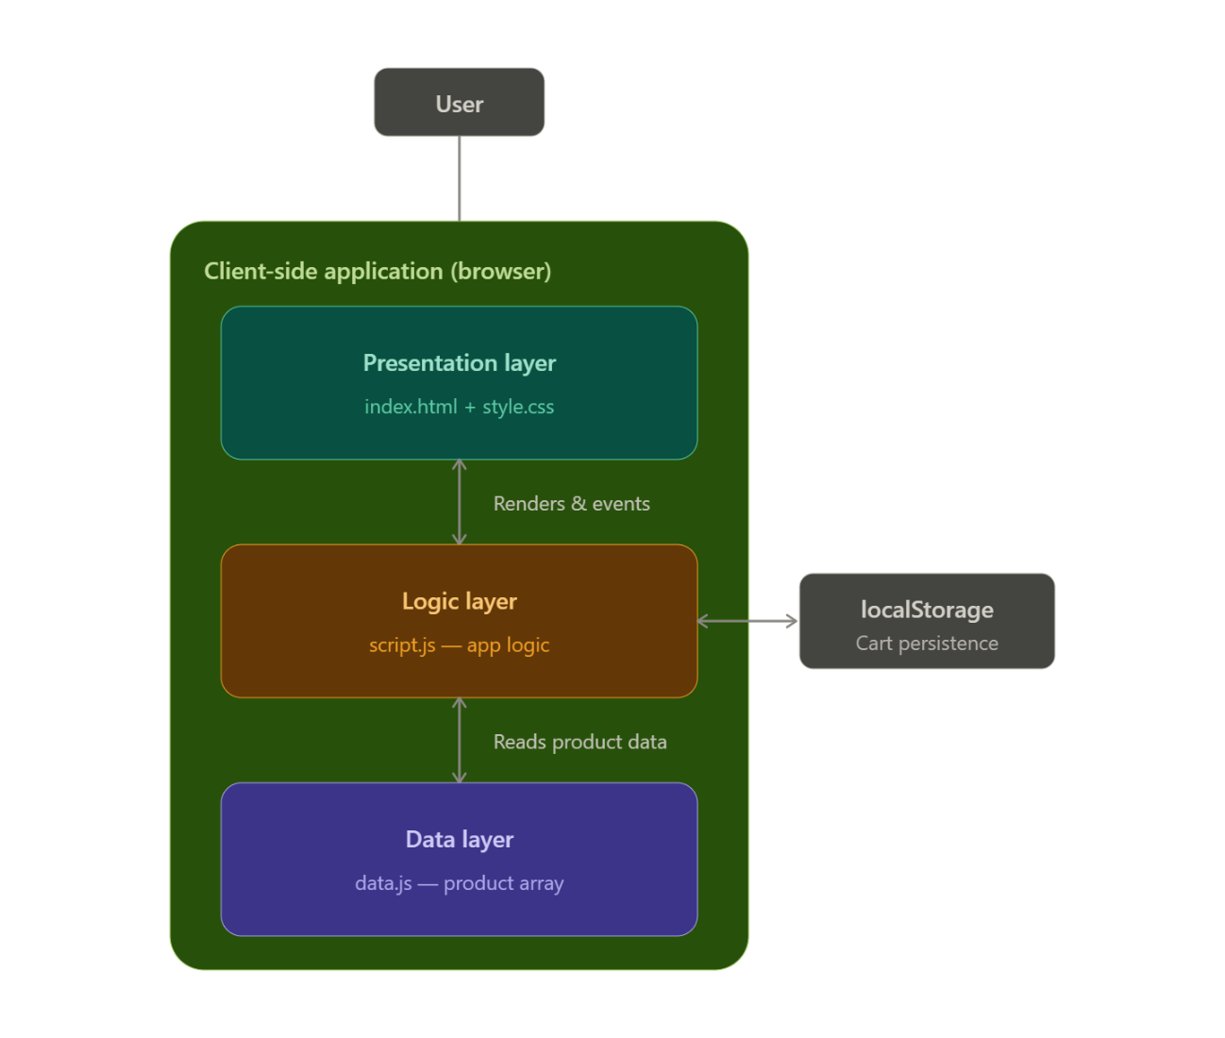
That's the DROPX architecture: presentation layer (Bootstrap UI) talks to the logic layer (script.js), which is the source of truth's gatekeeper — reading the static product data and syncing cart state with localStorage for persistence across refreshes.

Data Layer (data.js)
- PRODUCTS array with 10 items
- DROP_INFO configuration object
- DISCOUNT_CODES object
- Static data serving as mock database
Logic Layer (script.js)
- Cart management (add, remove, update quantity)
- Product filtering and sorting
- Countdown timer management
- Form validation
- State persistence via localStorage
- Bootstrap component control
Presentation Layer (index.html + style.css)
- Bootstrap 5 responsive grid
- Custom dark theme styling
- Dynamic product cards
- Modal and offcanvas components
- Countdown display
- Filter interface

5.2 Data Flow
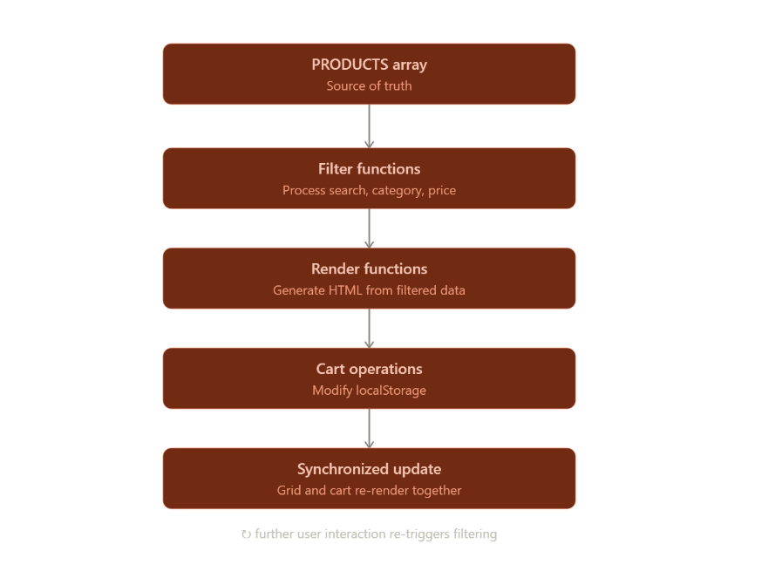
The data flows unidirectionally through the application:
- PRODUCTS array serves as the source of truth
- Filter functions process the array based on user input
- Render functions generate HTML from filtered data
- Cart operations modify localStorage and trigger re-renders
- Both product grid and cart update synchronously
6. Build Track Selection

6.1 Available Drop Concepts

Concept | Products | Vibe
Sneaker Drop | Limited sneakers, sizes, colorways | Hype/Exclusive
Streetwear Capsule | Hoodies, tees, small collections | Fashion/Urban
Indie Tech Gadgets | Keyboards, earbuds, desk gear | Tech/Niche
Anime/Gaming Merch | Figures, posters, collectibles | Fandom/Culture

6.2 Chosen Concept: Streetwear & Sneaker Capsule
Rationale for Selection:
The streetwear and sneaker drop concept was selected for its relevance to current e-commerce trends. Limited drops create urgency and exclusivity — core mechanics required by the project. The aesthetic aligns well with the dark premium theme.

Brand Identity:
- Name: DROPX (Drop + X for exclusive/experimental)
- Tagline: "Cop Before It's Gone"
- Drop: 003 — Winter Collection
- Aesthetic: Dark, bold, premium, urgent
Product Categories:
Category | Items | Price Range
Sneakers | 3 products | ₨9,800 – ₨14,500
Streetwear | 4 products | ₨3,500 – ₨8,500
Accessories | 3 products | ₨1,800 – ₨4,200

7. Signature Feature Implementation

7.1 Feature 1: Real-Time Countdown Timer
Feature Description:
A dynamic countdown displayed in both the hero section and navigation bar, updating every second to create urgency.
Implementation Approach:
The countdown uses setInterval() to update every second. The target date is stored in DROP_INFO.endDate. The function calculates remaining hours, minutes, and seconds, formatting them with leading zeros. When the countdown reaches zero, the interval is cleared and a "DROP ENDED" status is displayed.
Key Features:
- Dual display (hero + navbar)
- Real-time updates every second
- Automatic zero-state handling
- Clean interval cleanup on completion
- Future-dated target for consistent display

7.2 Feature 2: Persistent Shopping Cart with localStorage
Feature Description:
A fully persistent shopping cart that survives page refreshes using localStorage for state management.
Implementation Approach:
Cart operations (add, remove, update quantity) are wrapped in functions that read from and write to localStorage. The getCart() function includes try-catch for safe JSON parsing with empty array fallback. Stock validation prevents adding beyond available inventory. Cart changes trigger simultaneous re-renders of both cart UI and product grid.
Key Features:
- Survives page refresh
- Quantity management with increment/decrement
- Stock-aware (prevents overselling)
- Synchronized product grid updates
- Empty state handling
- Safe localStorage parsing

8. Development Process

8.1 Phase 1: Planning and Design
Activities:
- Brand concept creation and naming
- Product catalog planning (10 items, 3 categories)
- Dark premium theme design
- Component inventory (navbar, hero, filters, grid, modal, offcanvas, checkout)
- User flow mapping (browse → filter → add to cart → checkout)
Deliverables:
- Brand identity document
- Product catalog specification
- Color palette and style guide
- Component hierarchy map

8.2 Phase 2: HTML Structure Development
Step 1: Bootstrap Setup
CDN links for Bootstrap CSS, Bootstrap JS Bundle, and Bootstrap Icons were added. Custom CSS link placed after Bootstrap for overrides.
Step 2: Navbar Component
Fixed-top responsive navbar with brand logo, countdown display, cart button with badge, and mobile toggle. Navigation links with smooth scroll behavior.
Step 3: Hero Section
Full-viewport hero with drop badge, headline, description, CTA buttons, and countdown card with hour/minute/second blocks.
Step 4: Filter Bar
Search input with icon, category dropdown, price range slider with live display, and sort dropdown — all styled consistently with the dark theme.
Step 5: Product Grid
Empty grid container populated dynamically by JavaScript. Bootstrap row/col structure for responsive product cards.
Step 6: Modals and Offcanvas
Product detail modal for expanded view. Success modal for order confirmation. Cart offcanvas for sidebar shopping bag.
Step 7: Checkout Form
Complete form with full name, email, phone, city, and address fields. Bootstrap validation classes and feedback messages.

8.3 Phase 3: CSS Styling Development
Step 1: CSS Variables
Dark theme color palette defined with CSS custom properties: backgrounds, text colors, accent green, borders, shadows.
Step 2: Base Overrides
Bootstrap class overrides for form controls, buttons, selects, and inputs to match the dark premium aesthetic. Focus states with green accent glow.
Step 3: Component Styling
Custom styling for product cards with hover effects, stock badges with color coding, countdown display, filter tags, and cart items.
Step 4: Animations
Pulse animation for live indicator and critical stock. Slide-in animation for toast notifications. Hover transitions on cards and buttons.
Step 5: Responsive Design
Breakpoints at 1400px, 1200px, 992px, 768px, 576px, 480px, and 375px. Adjustments to typography, spacing, grid columns, and component sizing at each breakpoint.

8.4 Phase 4: JavaScript Development
Step 1: Countdown Timer
Implemented with setInterval, future-dated target, and dual display updates.
Step 2: Cart Management
Complete cart CRUD operations with localStorage persistence. Quantity limits enforced against product stock.
Step 3: Dynamic Rendering
Products rendered from PRODUCTS array with stock status badges, ratings, and conditional button states.
Step 4: Filter System
Combined filtering by search query, category, and max price. Sort functionality for price and rating.
Step 5: Modal Integration
Product detail modal populated with full product information. Bootstrap Modal API for show/hide control.
Step 6: Form Validation
Bootstrap validation with preventDefault on invalid submission. Cart emptiness check before order placement.
Step 7: Toast Notifications
Dynamic toast creation with auto-dismiss for add-to-cart, stock warnings, and order confirmation.

9. Responsive Design Strategy

9.1 Mobile-First Approach
The project uses Bootstrap's responsive grid with custom breakpoint adjustments. Base styles use Bootstrap's default responsive classes (col-6, col-md-4, col-lg-3) with additional CSS media queries for fine-tuning.

9.2 Breakpoints Defined
Device | Screen Width | Bootstrap Class | Custom Adjustments
Extra Small | <480px | col-6 → col-12 | Full-width cards
Small Phones | 480-576px | col-6 | Compact spacing
Tablets | 576-768px | col-md-4 | 2-column grid
Large Tablets | 768-992px | col-md-4 | Adjusted padding
Desktops | 992-1200px | col-lg-3 | 4-column grid
Large Desktops | 1200-1400px | col-lg-3 | Optimal spacing
Extra Large | >1400px | col-lg-3 | Max container width
Device | Screen Width | Bootstrap Class | Custom Adjustments

9.3 Responsive Features
Navigation:
- Nav countdown hidden on mobile
- Cart button always visible
- Collapse menu on tablets and below
Hero Section:
- Text centered on mobile
- Countdown card scales down proportionally
- CTA buttons stack vertically on small screens
Product Grid:
- 4 columns on desktop
- 2 columns on tablet
- 1 column on mobile
Filter Bar:
- Full-width search on all devices
- Category and price filters side-by-side on mobile
- Sort dropdown adapts to available space
Checkout Form:
- Two-column fields become single column on mobile
- Full-width submit button on all devices

10. Deployment Strategy

10.1 Version Control with Git

Git Workflow:
- Initialize local repository
- Stage and commit all project files
- Create GitHub repository
- Connect local to remote
- Push to main branch

10.2 GitHub Repository Setup
Repository Configuration:
- Repository Name: cloudexify-web-p2-saira
- Public repository
- Topics: html5, css3, bootstrap5, vanilla-javascript, ecommerce, vercel
- README.md with complete documentation

10.3 Vercel Deployment
Deployment Configuration:
- Framework Preset: Other (static site)
- Build Command: None required
- Output Directory: None required
- Root Directory: ./
Auto-deployment:
- Every git push triggers automatic redeployment
- Preview deployments for pull requests
- Production URL: https://dropx-store.vercel.app

10.4 Post-Deployment Steps
Verification Checklist:
- Site loads on Vercel URL
- Countdown timer functional
- Product grid renders correctly
- Cart persists after refresh
- Filters work correctly
- Checkout form validates
- Responsive on all devices
- No console errors

11. Testing and Quality Assurance

11.1 Testing Checklist
Test Case | Expected Result | Status
Open Vercel link | Site loads correctly | Yes
Countdown timer | Updates every second | Yes
Add to cart | Stock decreases correctly | Yes
Refresh page | Cart contents persist | Yes
Remove item | Cart total recalculates | Yes
Search bar | Filters products in real-time | Yes
Category + price filter | Combined filter works | Yes
Click product image | Modal shows correct details | Yes
Checkout empty form | Validation errors shown | Yes
Test on mobile width | Grid collapses correctly | Yes
Browser console | No JS errors | Yes

11.2 Browser Compatibility Testing
Desktop Browsers Tested:
- Google Chrome (Latest)
- Mozilla Firefox (Latest)
- Microsoft Edge (Latest)
- Safari (Latest)
Mobile Browsers Tested:
- Chrome Mobile (Android)

11.3 Performance Testing
Performance Metrics:
- First Contentful Paint: < 1.5 seconds
- Time to Interactive: < 2 seconds
- No layout shifts during filtering
- Smooth cart operations
- Efficient DOM updates

11.4 Manual Testing Scenarios
Scenario 1: Complete Purchase Flow
- Browse products → 2. Filter by category → 3. Search for specific item → 4. Add to cart → 5. View cart → 6. Adjust quantity → 7. Proceed to checkout → 8. Fill form → 9. Submit order → 10. Success confirmation
Scenario 2: Stock Limit Testing
- Add product with stock 2 to cart → 2. Increase to max quantity → 3. Attempt to add more → 4. Verify stock warning → 5. Verify sold out badge when depleted

Scenario 3: Cart Persistence
- Add items to cart → 2. Refresh page → 3. Verify cart still contains items → 4. Verify stock reflects cart quantities

12. Bonus Features

12.1 Sort Dropdown
Description: Product sorting by price (low-high, high-low) and highest rated.
Implementation: Sort logic integrated into getFilteredProducts() function. Applied after filtering but before rendering.

12.2 Toast Notifications
Description: Visual feedback notifications for add-to-cart actions, stock warnings, and order confirmation.
Implementation: Dynamic toast elements created and auto-dismissed after 2.5 seconds. Color-coded by message type (success/warning).

12.3 Active Filter Tags
Description: Visual filter pills showing currently applied filters with individual clear buttons.
Implementation: Dynamic tag generation based on active filter state. Each tag clickable to clear specific filter.

12.4 Product Detail Modal
Description: Expanded product view with full description, colorway, price, and stock status.
Implementation: Bootstrap Modal component populated dynamically with product data on image click.

13. Challenges Faced and Solutions

13.1 Cart Synchronization
Problem: Product grid stock not updating when cart quantities changed.
Solution: Called renderProducts() after every cart operation to ensure synchronized state between cart and product display.

13.2 Countdown Timer Duration
Problem: Timer showed 23+ hours, not ideal for demonstration.
Solution: Set future date (December 31, 2026) to ensure countdown always displays and never reaches zero during evaluation.

13.3 Navbar Scroll Offset
Problem: Navigation links scrolled to wrong position, hiding section content behind fixed navbar.
Solution: Calculated navbar height dynamically and subtracted it from scroll position with additional 20px padding for clean alignment.

13.4 localStorage Parsing Safety
Problem: Application crashed on first load with no cart data.
Solution: Wrapped JSON.parse in try-catch block with empty array fallback. Default cart state handles first-time visitors gracefully.

13.5 Stock Overselling Prevention
Problem: Users could add items beyond available stock.
Solution: Validated cart quantity against product stock before incrementing. Displayed warning toast when limit reached.

13.6 Responsive Image Handling
Problem: Product images not loading consistently.
Solution: Added onerror fallback to placeholder image. Used consistent Unsplash image URLs with size parameters.

14. Learning Outcomes

14.1 Technical Skills Gained
Bootstrap 5:
- Grid system mastery for responsive layouts
- Component integration (modals, offcanvas, forms, navbar)
- Utility class usage for rapid development
- Form validation implementation
JavaScript:
- Dynamic DOM rendering from data structures
- localStorage API for persistent state
- Array methods for filtering and sorting
- Template literals for HTML generation
- Event delegation for efficient handling
- Timer functions (setInterval, clearInterval)
Data Management:
- Data-driven UI rendering
- State synchronization across components
- Safe localStorage operations
- Mock database design with JavaScript objects

14.2 Soft Skills Developed
- Brand identity creation and naming
- UI/UX design for e-commerce flows
- Problem-solving and debugging
- Documentation writing
- Time management for multi-component project

14.3 Key Takeaways
- Data-Driven Rendering: Separating data from presentation enables dynamic UIs
- State Management: localStorage provides simple but effective persistence
- Bootstrap Integration: Framework accelerates development while allowing customization
- User Feedback: Toast notifications and visual indicators improve UX significantly
- Responsive Testing: Multiple breakpoints ensure consistent experience across devices

15. Future Enhancements
15.1 Backend Integration
- Server-side cart management
- Real payment gateway integration (Stripe/JazzCash)
- Order processing and email confirmation
- User authentication system
- Inventory database with MongoDB

15.2 Additional Features
- Size and color variant selection
- Product image zoom on hover
- Wishlist functionality
- Discount code system
- Product reviews and ratings
- Order history and tracking
- Admin dashboard for product management

15.3 Performance Optimizations
- Image lazy loading
- Debounced search input
- Optimized DOM updates
- Code minification
- CDN for static assets

16. Conclusion

16.1 Project Summary
The DROPX E-Commerce Storefront project successfully demonstrated intermediate frontend development skills by creating a fully functional limited-drop storefront. The project met all requirements including dynamic product rendering, persistent cart, combined filtering, countdown timer, and Bootstrap integration.

16.2 Key Achievements
- Created unique brand identity (DROPX) from concept to deployment
- Implemented complete e-commerce flow (browse → filter → cart → checkout)
- Built persistent cart with localStorage synchronization
- Developed combined filtering system with real-time updates
- Achieved fully responsive design across all device sizes
- Integrated Bootstrap 5 components with custom dark theme
- Successfully deployed on Vercel with auto-deployment

16.3 Lessons Learned
- The importance of separating data from presentation logic
- The effectiveness of Bootstrap for rapid responsive development
- The value of persistent state for user experience
- The power of combined filtering for product discovery
- The benefits of visual feedback (toasts, badges, animations)
- The necessity of thorough cross-device testing

16.4 Final Thoughts
This project represented a significant step up from Project 1, introducing framework integration, persistent state management, and more complex user interactions. The e-commerce context provided real-world applicability, simulating features found in production storefronts. The mandatory Bootstrap requirement ensured familiarity with industry-standard tools while custom CSS maintained brand uniqueness.
The combination of both projects in Month 1 provided comprehensive exposure to modern frontend development — from vanilla JavaScript fundamentals to framework-assisted rapid development.

End of Report

Report prepared for CloudExify Summer Internship 2026
Project: DROPX — Limited Drop E-Commerce Storefront
Date of Submission: July 30, 2026
Author: Saira Sehar
Registration Number: CX-INT-2026-GEN-0488

