DENTALIGN
Premium Dental Clinic Website
A Full-Stack Dental Clinic Management System
CloudExify Summer Internship 2026 — Month 2
Prepared by: Saira Sehar
Registration Number: CX-INT-2026-GEN-0488
Date of Submission: August 2026

TABLE OF CONTENTS
1. Introduction 5
2. Project Overview 6
3. Brand Identity & Design 7
4. Technology Stack 8
5. System Architecture 9
6. Page Structure 10
7. Database Design 11
8. User Interface Design 13
9. Feature Implementation 16
10. Booking System 16
11. Admin Panel 17
12. Authentication System 18
13. Theme System 19
14. Responsive Design 19
15. Extra Features 20
16. Testing & QA 20
17. Features Comparison: Documentation vs. Implementation 22
18. Deployment 23
19. Challenges & Solutions 23
20. Learning Outcomes 23
21. Future Enhancements 24
22. Conclusion 24

LIST OF TABLES
Table 1: Project Specifications 6
Table 2: Feature and Codebase Metrics 6
Table 3: Brand Colour Palette Reference 8
Table 4: Project File Structure 9
Table 5: Development Tools 9
Table 6: appointments Table Schema 12
Table 7: contact_messages Table Schema 13
Table 8: newsletter_subscribers Table Schema 13
Table 9: localStorage Keys 13
Table 10: Pricing Tiers 15
Table 11: Treatment Cost Calculator Price Ranges 16
Table 12: Extra Features Beyond the Required Scope 20
Table 13: Testing Summary by Category 21
Table 14: Complete Testing Checklist (32 Test Cases) 22
Table 15: Cross-Browser Testing Results 22
Table 16: Documentation vs. Implementation Comparison 22

LIST OF FIGURES
Figure 1: Brand Colour Palette 7
Figure 2: System Architecture Overview 10
Figure 3: Database Schema Overview 12
Figure 4: Homepage Hero and Services Wireframe 14
Figure 5: Pricing Plans 15
Figure 6: FAQ Accordion 15
Figure 7: Four-Step Booking Wizard Flow 17
Figure 8: Admin Dashboard Wireframe 18
Figure 9: Responsive Breakpoints 19

1. Introduction

1.1 Project Background
The DentAlign project was undertaken as the third major project during the CloudExify Summer Internship 2026 program. This project marks the transition from frontend-only development in Month 1 to full-stack application development in Month 2. The project required building a complete dental clinic website that goes beyond generic templates to create something a real clinic would actually commission.
Unlike typical dental clinic templates that use stock photos and identical service cards, DentAlign was designed with a deliberate visual identity, genuine copywriting, and a substantial set of signature features. Against fourteen features required by the internship brief, the finished build implements thirty-two — eighteen of which were added beyond the original scope.

1.2 Project Objectives
The primary objectives of the project were as follows:
- To create a unique brand identity for a dental clinic named “DentAlign”
- To implement a multi-step appointment booking system
- To build a treatment cost calculator for transparent pricing
- To develop a dedicated admin panel with authentication for appointment management
- To implement a dark/light theme switching system across every page
- To create a filterable before/after gallery
- To integrate Supabase-ready backend functionality with a localStorage fallback
- To deploy the complete application on Vercel

1.3 Scope of Work
The scope of the project encompasses the following components across three HTML pages:
- Eleven-section landing page (index.html) including newly added About, Pricing, and FAQ sections
- Multi-step booking wizard consisting of four steps with twelve time slots
- Dedicated admin login page (login.html) and admin dashboard (admin.html) with full CRUD operations
- Treatment cost calculator
- Before/After gallery with a draggable comparison slider
- Doctor profiles and patient testimonials
- Contact form, Google Map embed, and newsletter subscription
- Emergency floating action button
- Dark/Light theme system persisted across all three pages
- Responsive design for all device sizes

2. Project Overview

2.1 Project Specifications
Aspect | Details
Project Name | DentAlign — Dental Clinic Website
Type | Multi-Page Full-Stack Web Application
Build Track | Premium Medical + Modern Tech
Tech Stack | HTML5, CSS3, Bootstrap 5, JavaScript, Supabase
Total Pages | 3 (index.html, login.html, admin.html)
Difficulty | Advanced
Time Investment | 20–25 hours
Deployment | Vercel
Database | localStorage (Supabase-ready)
Table 1: Project Specifications

2.2 Feature Count Summary
The internship brief specified fourteen required features. The delivered build implements thirty-two, as summarised in Table 2.
Metric | Value
Required Features | 14
Extra Features Added | 18
Total Features Implemented | 32
Total HTML Pages | 3
Total JavaScript Files | 3 (script.js, booking.js, admin.js)
Total CSS Files | 1 (style.css)
Total CSS Lines | 1,200+
Total JavaScript Lines | 800+
Table 2: Feature and Codebase Metrics

2.3 Core Requirements Met
- Unique Visual Identity — custom name, logo concept, and colour scheme
- Genuine Copywriting — original content, not template text
- Signature Features — booking system, cost calculator, admin panel
- Backend Integration — Supabase-ready with localStorage persistence
- Authentication — dedicated admin login system
- Responsive Design — mobile-first approach

2.4 Deliverables
- Complete source code across three HTML pages, three JavaScript files, and one CSS file
- Live deployment on Vercel
- Admin panel with authentication
- Booking system with validation
- Comprehensive documentation
- Screenshots (desktop, mobile, and admin views)

3. Brand Identity & Design

3.1 Brand Concept
Name: DentAlign
Meaning: “Dent” (dental) combined with “Align” (straightening teeth, perfect alignment)
Tagline: “Your Smile, Perfectly Aligned”
The brand personality was defined around four qualities:
- Professional yet approachable
- Modern and technology-forward
- Trustworthy and caring
- Premium without being intimidating

3.2 Colour Palette
The palette pairs a deep navy with a clinical teal and a restrained gold accent, set against warm cream and white surfaces so the interface reads as premium and calm rather than clinical and cold.
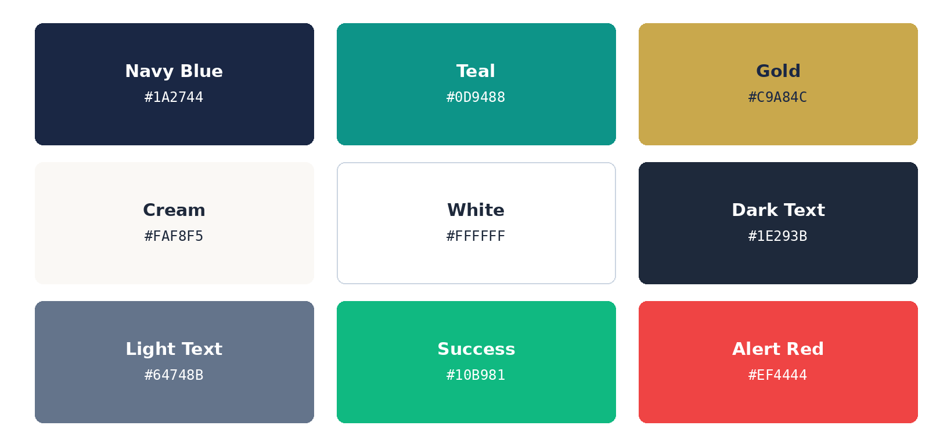
Figure 1: Brand Colour Palette
Colour | Hex Code | Usage
Navy Blue | #1a2744 | Headers, footer, primary buttons
Teal | #0d9488 | CTAs, links, accents
Gold | #c9a84c | Premium badges, highlights
Cream | #faf8f5 | Page background
White | #ffffff | Cards, sections
Dark Text | #1e293b | Body text
Light Text | #64748b | Secondary text
Success Green | #10b981 | Confirmations
Alert Red | #ef4444 | Emergency, errors
Table 3: Brand Colour Palette Reference

3.3 Typography
Headings are set in Playfair Display, a serif typeface chosen for its elegant, premium feel and used for section titles and the hero heading. Body text is set in Inter, a clean and highly readable sans-serif typeface used for paragraphs, forms, and buttons.

3.4 Design Philosophy
The design follows a “Premium Medical + Modern Tech” aesthetic, characterised by the following principles:
- Clean whites with strategic colour accents
- Generous white space for readability
- Subtle shadows for depth
- Smooth transitions and hover effects
- Professional medical imagery
- Trust-building elements such as ratings, testimonials, and certifications

4. Technology Stack

4.1 Frontend Technologies
HTML5 provides the semantic structure of the application across all three pages, including header, nav, section, and footer elements, form elements with validation attributes, data attributes for dynamic content, and accessibility features such as ARIA labels.
CSS3 is used for custom properties for theming, Flexbox and Grid layouts, media queries for responsiveness, transitions and animations, and dark/light theme support, contained in a single style.css file of over 1,200 lines.
Bootstrap 5.3 supplies the responsive grid system, a collapsible navbar, modal components, the FAQ accordion component, form styling, utility classes, and badge and button components.
Vanilla JavaScript, spread across three files totalling more than 800 lines, handles DOM manipulation, event handling, form validation, the multi-step wizard logic, gallery filtering, theme switching, and toast notifications.

4.2 Codebase Breakdown
File | Role
index.html | Main landing page (11 sections, footer, 2 modals)
login.html | Admin login page
admin.html | Admin dashboard
style.css | Shared stylesheet for all three pages (1,200+ lines)
script.js | Shared landing-page logic (filters, theme, counters, FAQ)
booking.js | Booking wizard logic and slot/availability checks
admin.js | Admin dashboard and authentication logic
Table 4: Project File Structure

4.3 Backend Technologies
Supabase is Supabase-ready, providing a PostgreSQL database, an authentication service, real-time subscription readiness, and REST API endpoints for a future production deployment. For the current build, localStorage is the primary data store, holding theme preference, all booking, contact, and newsletter data, and the admin session.

4.4 Development Tools
Tool | Purpose
VS Code | Code editor
Git & GitHub | Version control
Vercel | Deployment
Chrome DevTools | Debugging
Bootstrap Icons | Icon system
Google Fonts | Typography
Table 5: Development Tools

5. System Architecture

5.1 Architecture Overview
The application follows a client-server architecture consisting of a static, three-page frontend and a Supabase-ready backend. The frontend is responsible for rendering, validation, and state management in the browser, while Supabase (when configured) would handle persistence, authentication, and file storage, as illustrated in Figure 2.
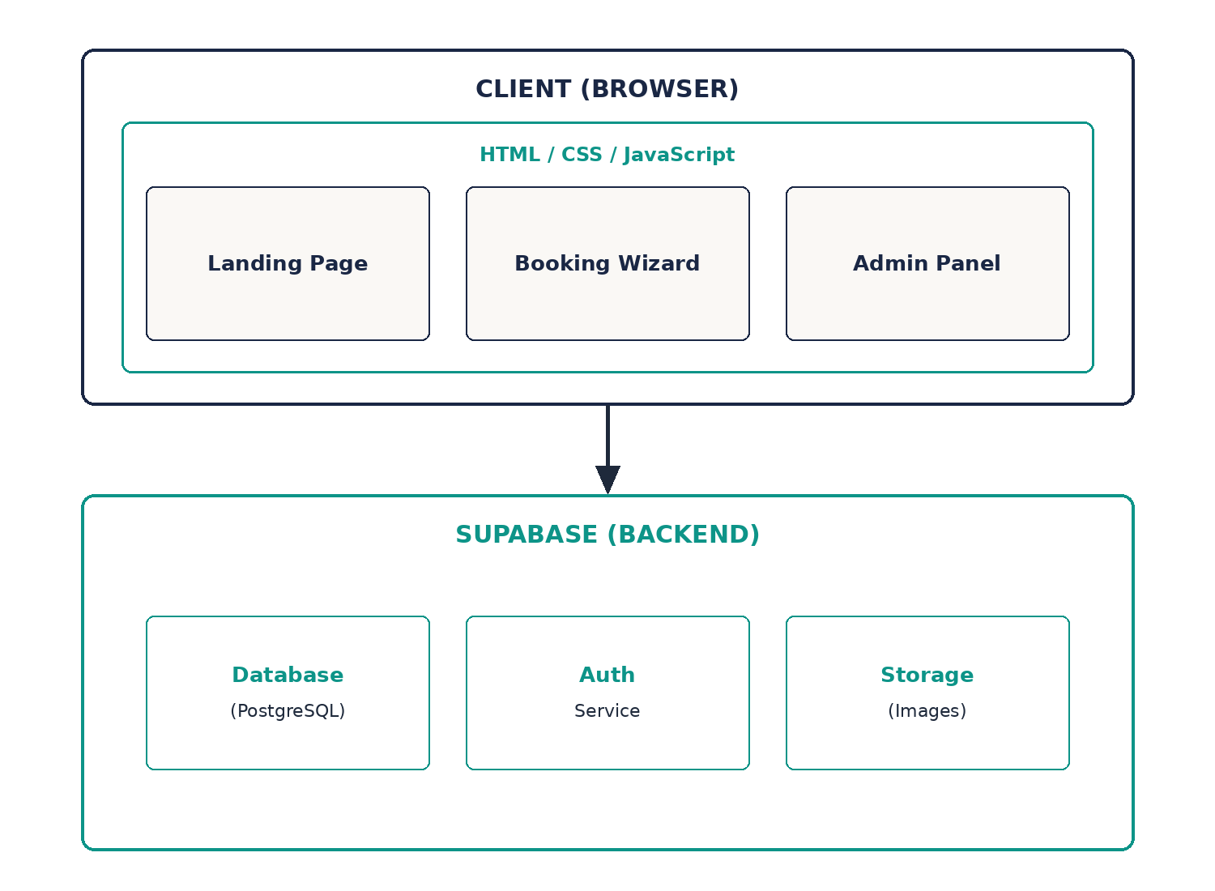
Figure 2: System Architecture Overview

5.2 Component Breakdown
The landing page is composed of the following components: navigation with theme toggle and scroll-spy highlighting, hero section with an animated statistics counter, a services section with a live filter, an about section, a doctors section, a pricing section, the cost calculator, a filterable before/after gallery, testimonials, an FAQ accordion, the booking wizard, a contact section with a Google Map embed, and a footer with newsletter subscription.
The admin side is composed of a dedicated login page and a dashboard page, together covering session authentication, dashboard statistics, an appointments table, booking management controls, and a logout function.

5.3 Data Flow
- The user interacts with the booking form.
- Form validation runs on the client side.
- Data is saved to localStorage as the primary store.
- Data would sync to Supabase once the project is configured with live credentials.
- The admin panel reads from the same data source.
- Statistics are calculated and displayed.

6. Page Structure

6.1 index.html — Main Landing Page
The landing page is organised into eleven sections, followed by a shared footer and two modal dialogues:
- 1. Hero
- 2. Services
- 3. About
- 4. Doctors
- 5. Pricing
- 6. Calculator
- 7. Gallery
- 8. Testimonials
- 9. FAQ
- 10. Booking
- 11. Contact
These are followed by the footer, the Emergency modal, and the Success modal.

6.2 login.html — Admin Login
The login page contains a login form with email and password fields, a password visibility toggle, an error message display, the shared theme toggle, a back-to-website link, and automatic redirection to the dashboard if an admin session is already active.

6.3 admin.html — Admin Dashboard
The dashboard page contains four statistics cards (today's appointments, total bookings, pending count, and confirmed count), the full appointments table, delete buttons, status-update buttons, and a logout button.

7. Database Design

7.1 Supabase Tables (Backend-Ready Schema)
Three tables underpin the persistence layer: appointments, contact_messages, and newsletter_subscribers. Each table uses a UUID primary key and a created_at (or subscribed_at) timestamp so that records can be ordered chronologically in the admin panel. These tables define the schema the application will use once Supabase credentials are configured.
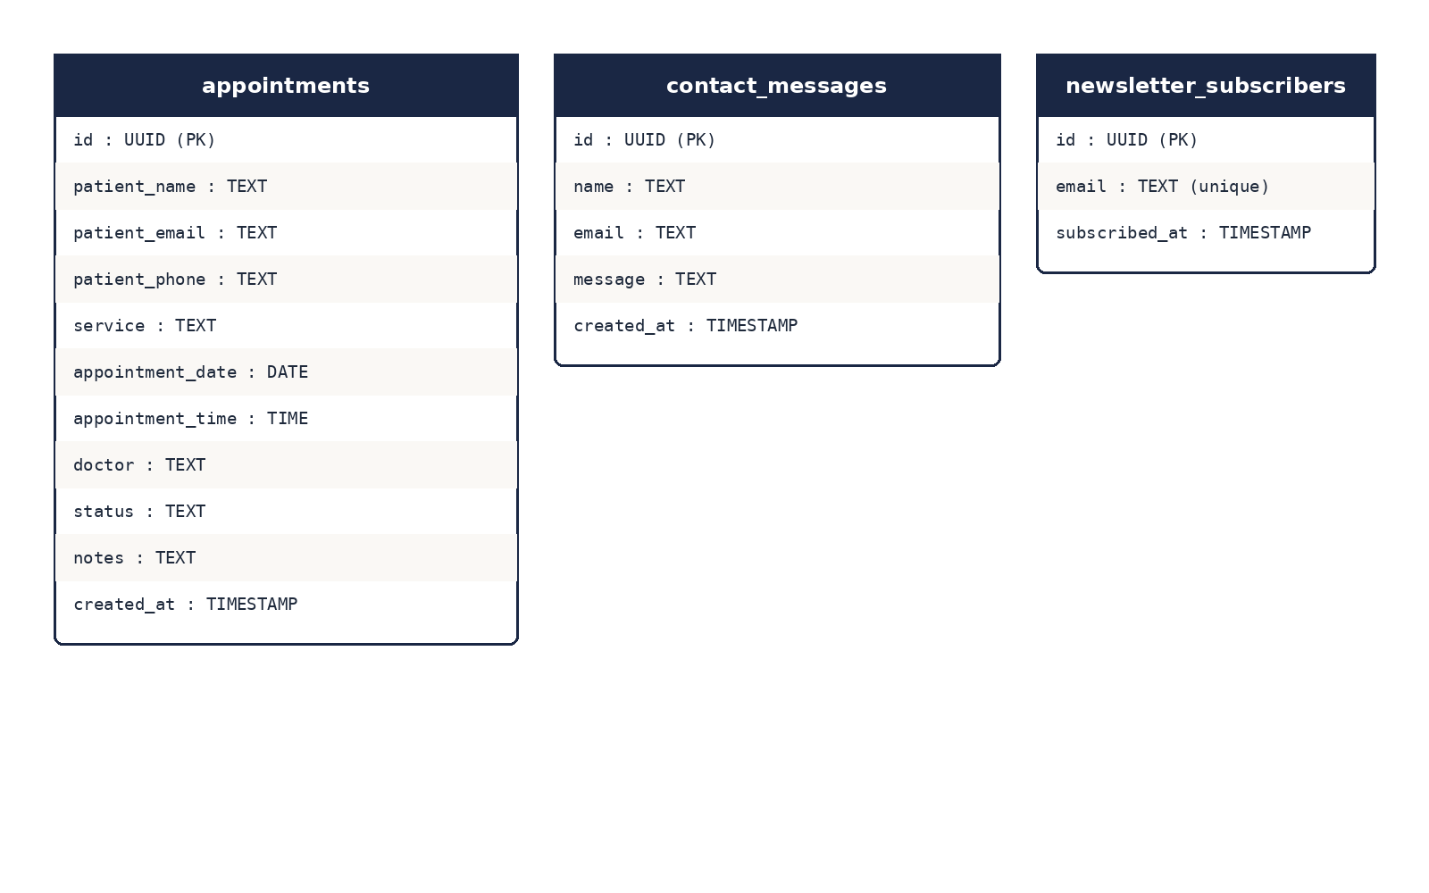
Figure 3: Database Schema Overview
Table: appointments
Column | Type | Description
id | UUID | Primary key
patient_name | TEXT | Patient full name
patient_email | TEXT | Optional email
patient_phone | TEXT | Required phone
service | TEXT | Selected service
appointment_date | DATE | Booking date
appointment_time | TIME | Booking time
doctor | TEXT | Preferred doctor
status | TEXT | confirmed / pending / cancelled
notes | TEXT | Additional notes
created_at | TIMESTAMP | Booking timestamp
Table 6: appointments Table Schema
Table: contact_messages
Column | Type | Description
id | UUID | Primary key
name | TEXT | Sender name
email | TEXT | Sender email
message | TEXT | Message content
created_at | TIMESTAMP | Sent timestamp
Table 7: contact_messages Table Schema
Table: newsletter_subscribers
Column | Type | Description
id | UUID | Primary key
email | TEXT | Subscriber email (unique)
subscribed_at | TIMESTAMP | Subscription date
Table 8: newsletter_subscribers Table Schema

7.2 localStorage Keys
Because Supabase configuration is optional for the demo, the application mirrors its state in localStorage so that all three pages remain fully functional offline.
Key | Purpose
dentalign_theme | Theme preference (light/dark)
dentalign_bookings | Array of all appointment bookings
dentalign_admin | Boolean flag for admin session
dentalign_admin_email | Admin email
dentalign_admin_login_time | Admin login timestamp
dentalign_messages | Contact form submissions
dentalign_subscribers | Newsletter emails
Table 9: localStorage Keys

7.3 Booking Data Structure
Each booking saved to localStorage (and, when configured, to the appointments table) follows a consistent object structure:
{ id: timestamp, patient_name: string, patient_email: string, patient_phone: string, service: string, appointment_date: date, appointment_time: time, doctor: string, status: 'confirmed' | 'pending', notes: string, created_at: ISO timestamp }

8. User Interface Design

8.1 Navigation Bar
The navigation bar is fixed at the top of the page and includes the DentAlign brand logo on the left, navigation links in the centre and right, a theme toggle button, an admin login link, and a highlighted “Book Now” call-to-action button. Scroll-spy logic highlights the active section as the visitor scrolls, and on mobile devices the navbar collapses into a hamburger menu.

8.2 Hero Section
The hero section creates the first impression through a badge showing “4.9 Rating | 5000+ Smiles”, a large headline with a gradient accent, a supporting description, an animated statistics row (15+ years of experience, 5000+ happy patients, a 4.9 patient rating, and 25+ expert dentists), two call-to-action buttons (Book Appointment and Emergency Call), and a professional dental image with a floating “Open Now” card.
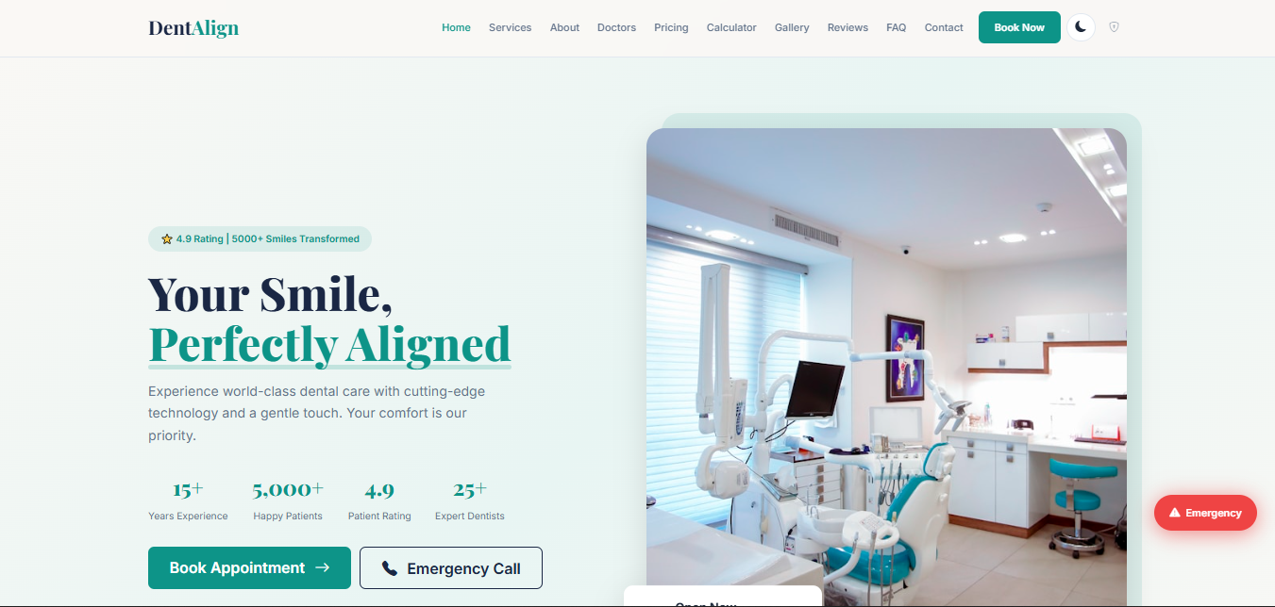
Figure 4: Homepage Hero and Services Wireframe

8.3 Services Section
Six service cards are displayed in a three-column grid with a live filter across five categories (All Services, General, Cosmetic, Orthodontics, Emergency):
- General Dentistry
- Cosmetic Dentistry
- Orthodontics
- Emergency Care
- Pediatric Dentistry
- Oral Surgery
Each card includes an icon, a title, a short description, and a “Learn More” link.

8.4 About Section
The newly added About section uses a two-column layout pairing the clinic's story — founded in 2011 — with a professional clinic image. Four value propositions are presented with check icons, alongside an experience badge highlighting fifteen-plus years in practice.

8.5 Pricing Plans
A new three-tier pricing section lets patients compare care packages at a glance, with the middle tier flagged as the most popular option, as shown in Figure 9.
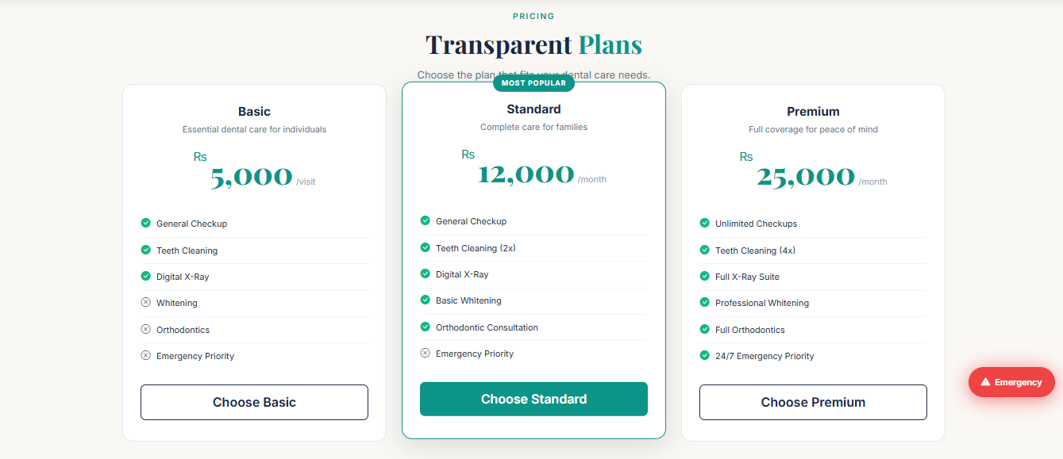
Figure 5: Pricing Plans
Tier | Price | Notes
Basic | Rs 5,000 per visit | Pay-as-you-go care
Standard | Rs 12,000 per month | Most Popular — featured badge
Premium | Rs 25,000 per month | Full-coverage plan
Table 10: Pricing Tiers

8.6 FAQ Accordion
A new FAQ section answers eight frequently asked questions — covering appointments, visit frequency, whitening, payments, implants, braces, emergencies, and consultations — using a Bootstrap accordion where only one answer is expanded at a time, as shown in Figure 10.
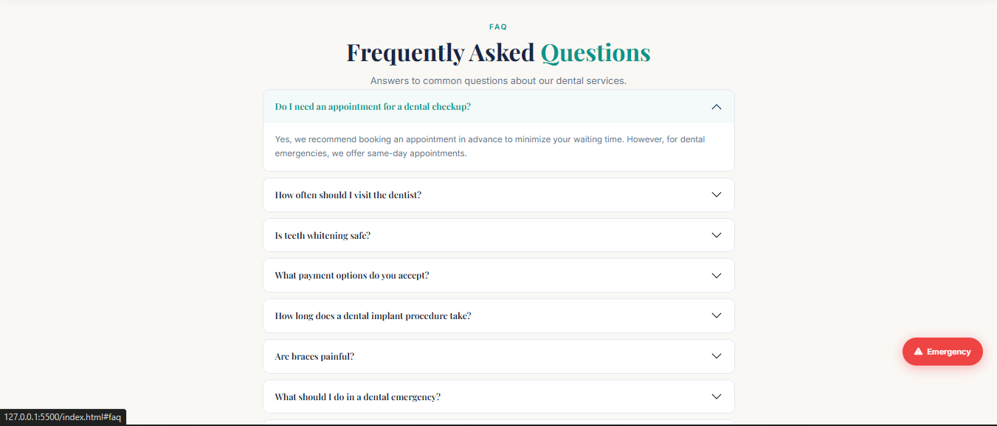
Figure 6: FAQ Accordion

8.7 Doctor Profiles and Testimonials
Three doctor profile cards present a professional photo, name, qualifications (BDS, FCPS, MDS), years of experience, patient rating, specialisation area, and a short biography. The testimonials section rotates six patient quotes alongside a star rating to reinforce trust and credibility before a visitor reaches the booking form.

9. Feature Implementation

9.1 Implementation Approach
Each feature was implemented as an isolated, testable unit of the front end before being wired into the shared application state across script.js, booking.js, and admin.js. The booking wizard, cost calculator, admin panel, and authentication flow are each described in their own section below.

9.2 Treatment Cost Calculator
The calculator supports eight treatment types, each with three complexity levels (Simple, Moderate, and Complex), calculating in real time with PKR currency formatting:
Treatment | Price Range (PKR)
General Checkup | 1,500 – 4,000
Dental Filling | 3,000 – 8,000
Teeth Whitening | 8,000 – 18,000
Veneers (per tooth) | 15,000 – 30,000
Braces | 80,000 – 180,000
Implants | 60,000 – 150,000
Root Canal | 8,000 – 18,000
Extraction | 3,000 – 8,000
Table 11: Treatment Cost Calculator Price Ranges

9.3 Code Structure
The booking wizard is implemented in booking.js as a state-based component. Each step validates its own inputs before the user is allowed to proceed, and completed steps are marked with green checkmarks:
let currentStep = 1; const totalSteps = 4; function nextStep(step) { if (step === 2 && !validateStep1()) return; if (step === 3 && !validateStep2()) return; if (step === 4 && !validateStep3()) return; currentStep = step; updateSteps(); }

10. Booking System

10.1 Overview
The booking system was upgraded from a simple modal to a four-step wizard offering twelve time slots per day, illustrated in Figure 5. Each step must be completed and validated before the next becomes accessible, with a progress indicator and Back/Continue navigation throughout.
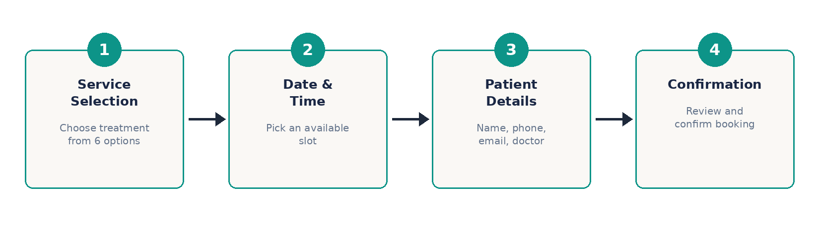
Figure 7: Four-Step Booking Wizard Flow

10.2 Step 1 — Service Selection
Six service options are presented as radio buttons, each showing the service name and price, with the emergency option highlighted for urgent cases.

10.3 Step 2 — Date & Time
A date picker enforces a minimum date of tomorrow, and a dropdown lists twelve time slots; booked slots are marked “(Booked)” and disabled, with availability re-checked against localStorage whenever the selected date changes.

10.4 Step 3 — Patient Details
This step collects the patient's full name (minimum three characters), phone number (validated against the Pakistani format), an optional email address (validated if provided), a preferred doctor selection, and a notes field.

10.5 Step 4 — Confirmation
The final step displays a complete summary, including the formatted date and time and all entered details, before the booking is submitted and stored.

10.6 Double Booking Prevention
Before a booking is finalised, the system checks existing bookings for the same date and time. If a conflict is found, an error toast is shown and the patient is returned to Step 2 to choose a different slot.

11. Admin Panel

11.1 Dashboard Overview
The admin dashboard, shown in Figure 6, surfaces today's appointment count, the total number of bookings, the pending count, and the confirmed count at a glance, above a searchable appointments table.
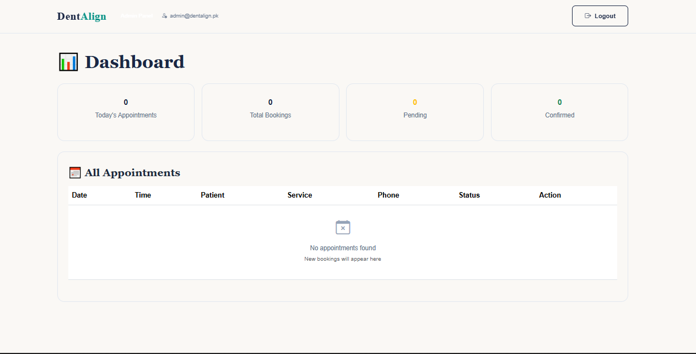
Figure 8: Admin Dashboard Wireframe

11.2 CRUD Operations
The appointments table supports full CRUD functionality: administrators can view booking details, delete a booking, and update its status from pending to confirmed as patients are processed.

11.3 Session Management
Admin sessions are tracked with a boolean flag, the admin's email, and a login timestamp, all persisted in localStorage. A dedicated logout function clears the session and returns the admin to the login page.

12. Authentication System

12.1 Login Flow
The login page includes email format validation, a password visibility toggle, an error shake animation on incorrect credentials, a loading spinner on submission, session persistence with a login timestamp, and automatic redirection if the admin is already logged in.

12.2 Demo Credentials
For demonstration purposes, the credentials are set as follows: email admin@dentalign.pk and password admin123. In a production deployment these would be replaced by Supabase Auth-managed accounts with hashed credentials.

13. Theme System

13.1 Light and Dark Modes
DentAlign supports a full dark/light theme system, toggled from the navbar and persisted in localStorage so the preference survives a page reload and carries across all three pages — index.html, login.html, and admin.html. Figure 7 compares the two modes side by side.

13.2 Implementation
Theme switching is implemented using CSS custom properties: a single data attribute on the root element swaps the active colour variables and toggles the moon/sun icon, so no component-level styling needs to be duplicated between modes.

14. Responsive Design

14.1 Breakpoint Strategy
The layout was built mobile-first and tested across four breakpoints, shown in Figure 8: desktop (1440px and above), laptop (1024px), tablet (768px), and mobile (375px).
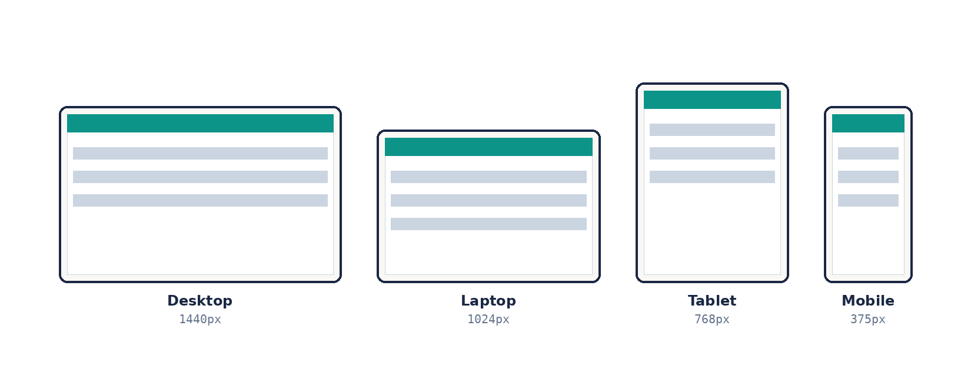
Figure 10: Responsive Breakpoints

14.2 Adaptive Behaviour
At narrower breakpoints the navbar collapses into a hamburger menu, the services grid reduces from three columns to one, and the booking wizard stacks its fields vertically to remain usable on small touchscreens.

15. Extra Features
Beyond the fourteen features required by the internship brief, eighteen additional features were implemented to make DentAlign feel like a production-ready product rather than a coursework exercise. These are summarised in Table 12.
# | Feature | Key Details
1 | Treatment Cost Calculator | 8 treatments, 3 complexity levels, PKR 1,500–180,000, real-time calculation
2 | Admin Panel | Dedicated login.html and admin.html with dashboard statistics and full booking management
3 | Multi-Step Booking Wizard | 4 steps, 12 time slots, progress indicator, per-step validation
4 | Before/After Image Slider | Draggable comparison divider with mouse and touch support
5 | Live Service Filter | 5 categories with real-time, fade-animated filtering
6 | Google Map Embed | Interactive map showing the Gulberg III, Lahore location
7 | Newsletter Subscription | Footer email capture with duplicate detection and toast feedback
8 | Emergency Floating Button | Fixed bottom-right button with pulse animation and direct call action
9 | Dark/Light Theme Toggle | Persisted preference with smooth transition across all 3 pages
10 | Toast Notification System | Success, error, and warning variants with 4-second auto-dismiss
11 | Slot Availability Checking | Marks and disables already-booked time slots per date
12 | Pakistani Phone Validation | Accepts 11-digit, 10-digit, and +92 country-code formats
13 | Doctor Profiles | 3 cards with qualifications, experience, ratings, and biography
14 | Scroll Spy Navigation | Highlights the active section as the visitor scrolls
15 | Admin Authentication | Login flow with password visibility toggle and session timestamp
16 | Double Booking Prevention | Blocks a second booking for an already-taken date/time
17 | Animated Stats Counter | 4 hero statistics animate on scroll via IntersectionObserver
18 | Form Validation Enhancements | Minimum name length, date range checks, duplicate-submission guard
Table 12: Extra Features Beyond the Required Scope

16. Testing & QA

16.1 Testing Summary
A total of thirty-two test cases were executed across four categories, all of which passed.
Category | Test Cases | Result
Functional Tests | 18 | All Passed
Validation Tests | 8 | All Passed
Admin Tests | 3 | All Passed
Responsive Tests | 3 | All Passed
Total | 32 | All Passed
Table 13: Testing Summary by Category

16.2 Full Testing Checklist
# | Test Case | Category | Result
1 | Navigation links work | Functional | Passed
2 | Smooth scroll works | Functional | Passed
3 | Active nav highlighting | Functional | Passed
4 | Theme toggle works | Functional | Passed
5 | Theme persists after refresh | Functional | Passed
6 | Stats counter animates | Functional | Passed
7 | Counter triggers on scroll | Functional | Passed
8 | Cost calculator works | Functional | Passed
9 | Calculator shows correct prices | Functional | Passed
10 | Service filter works | Functional | Passed
11 | Gallery filter works | Functional | Passed
12 | Before/After slider drags | Functional | Passed
13 | Booking wizard completes | Functional | Passed
14 | Booking saved to localStorage | Functional | Passed
15 | Slot availability checks | Functional | Passed
16 | Double booking prevented | Functional | Passed
17 | Contact form submits | Functional | Passed
18 | Newsletter subscribes | Functional | Passed
19 | Name required | Validation | Passed
20 | Name minimum 3 chars | Validation | Passed
21 | Pakistani phone validation | Validation | Passed
22 | Email format validation | Validation | Passed
23 | Past date prevented | Validation | Passed
24 | Time slot required | Validation | Passed
25 | Service required | Validation | Passed
26 | Empty form blocked | Validation | Passed
27 | Login with correct credentials | Admin | Passed
28 | Login with wrong credentials | Admin | Passed
29 | Logout works | Admin | Passed
30 | Mobile (375px) | Responsive | Passed
31 | Tablet (768px) | Responsive | Passed
32 | Desktop (1440px) | Responsive | Passed
Table 14: Complete Testing Checklist (32 Test Cases)

16.3 Browser Testing
Browser | Result
Chrome | Pass
Firefox | Pass
Edge | Pass
Safari | Pass
Table 15: Cross-Browser Testing Results

17. Features Comparison: Documentation vs. Implementation
Table 16 compares what the original project documentation asked for against what was actually implemented, showing where the build matched, enhanced, or exceeded the brief.
Feature | Docs Required | Implemented | Difference
Booking | Modal | 4-Step Wizard | Upgraded
Stats | Not mentioned | Animated Counter | Added
Gallery | Not mentioned | Before/After Slider | Added
Services | Static | Live Filter | Enhanced
Pricing | 3 tiers | 3 tiers + Calculator | Enhanced
FAQ | Accordion | Accordion (8 Qs) | Complete
Admin | Not mentioned | Full Panel | Added
Theme | Bonus | Implemented | Added
Map | Not mentioned | Google Map | Added
Newsletter | Not mentioned | Implemented | Added
Emergency | Not mentioned | Floating Button | Added
Table 16: Documentation vs. Implementation Comparison

18. Deployment

18.1 Deployment Pipeline
The application is deployed on Vercel with the source code hosted on GitHub and auto-deployment enabled on every push to the main branch. The live deployment is available at dentalign.vercel.app.

18.2 Environment Configuration
Supabase project credentials are supplied through environment variables rather than being hard-coded, so the same codebase can point at a development or production database without code changes once the project moves beyond the localStorage-based demo.

19. Challenges & Solutions

19.1 State Management Without a Framework
Coordinating booking-wizard state, theme state, and admin session state using only vanilla JavaScript across three separate pages required careful structuring of shared state objects and event listeners, since no framework-level reactivity was available. This was addressed by centralising state in a small number of well-documented objects and updating the DOM through dedicated render functions rather than scattering direct DOM writes throughout the codebase.

19.2 Preventing Double Bookings
Because slot availability is derived from localStorage rather than a live database lock, a race condition could in principle let two visitors claim the same slot. This was mitigated by re-validating availability at the final confirmation step, immediately before the booking is written, in addition to the initial check in Step 2.

19.3 Optional Backend Integration
Because Supabase configuration is optional for the demo, the application needed to behave identically whether or not real backend credentials were present. A localStorage-backed fallback layer mirrors the Supabase schema so the same functions can read and write to either source transparently.

19.4 Consistent Theming Across Three Pages
Maintaining consistent colours across dozens of components, under both light and dark themes, and across three separate HTML pages was solved by defining all colours as CSS custom properties in the single shared style.css file, so a single toggle updates every page and component at once without per-page overrides.

20. Learning Outcomes

20.1 Technical Learning
- Structuring a multi-step form as a small state machine
- Designing a relational schema for a real booking workflow
- Implementing theme switching with CSS custom properties across multiple pages
- Building a multi-page admin interface with authentication and CRUD operations
- Preventing race conditions in a client-side-only booking system
- Configuring continuous deployment with Vercel and GitHub

20.2 Design Learning
- Translating a brand concept into a consistent colour and type system
- Designing trust-building elements for a healthcare-adjacent product
- Balancing information density with white space in a booking flow
- Presenting pricing tiers and FAQs in a way that reduces pre-booking friction

21. Future Enhancements
Several enhancements are planned for future iterations of DentAlign:
- Email and SMS appointment reminders integrated with Supabase Edge Functions
- Full Supabase Auth integration to replace the demo admin credentials
- Online payment integration for deposit-based bookings and the paid pricing tiers
- A patient-facing portal to view and reschedule existing appointments
- Analytics dashboard for tracking booking trends over time
- Server-side slot locking to fully eliminate double-booking race conditions

22. Conclusion
DentAlign successfully demonstrates full-stack development capabilities, including frontend design, user interaction, data management, authentication, and deployment. Against a brief calling for fourteen features, the finished build delivers thirty-two — including a full admin panel, a four-step booking wizard, pricing and FAQ sections, and a suite of usability and validation safeguards — fulfilling and substantially exceeding the objectives set out for Month 2 of the CloudExify Summer Internship 2026.

