MIZAARA
Restaurant Full-Stack Application
“Where Every Flavor Meets”
A Full-Stack Customer & Admin Restaurant Platform (Pakistani + Italian Fusion)
CloudExify Summer Internship 2026 — Month 2 (Final Project)
Prepared by: Saira Sehar
Registration Number: CX-INT-2026-GEN-0488
Date of Submission: August 2026

TABLE OF CONTENTS
1. Introduction 5
2. Project Overview 5
3. Brand Identity & Design 6
4. Technology Stack 8
5. System Architecture 8
6. Page Structure 9
7. Database Design 10
8. Menu & Categories 11
9. Customer Features 13
10. Admin Features 13
11. Advanced Features Added 14
12. Authentication System 15
13. Discount System 15
14. Operating Hours & Order Restrictions 16
15. Responsive Design 17
16. Order Lifecycle 18
17. Testing & QA 18
18. Deployment 19
19. Learning Outcomes 19
20. Conclusion 20

LIST OF TABLES
Table 1: Project Specifications 6
Table 2: Menu and Feature Scale 6
Table 3: Brand Colour Palette Reference 7
Table 4: Development Tools 8
Table 5: Page Structure and Purpose 10
Table 6: profiles Table Schema 10
Table 7: menu_items Table Schema 11
Table 8: orders Table Schema 11
Table 9: Client-Side Storage Keys 11
Table 10: Menu Category Breakdown 12
Table 11: Customer-Facing Features 13
Table 12: Admin-Facing Features 14
Table 13: Advanced Features Beyond the Baseline 15
Table 14: Welcome Discount Rules 16
Table 15: Restaurant Operating Hours 16
Table 16: Order Restriction Behaviour by Restaurant State 16
Table 17: Operating Hours Feature Summary 17
Table 18: Responsive Breakpoints 18
Table 19: Testing Checklist and Expected Results 19

LIST OF FIGURES
Figure 1: Mizaara Brand Colour Palette 7
Figure 2: System Architecture Overview 9
Figure 3: Mizaara Site Map — 6 Pages 9
Figure 4: Database Schema Overview 10
Figure 5: Menu Items per Category 12
Figure 6: Admin Dashboard Wireframe 14
Figure 7: Cart View When the Restaurant Is Closed 17
Figure 8: Order Status Timeline 18

1. Introduction

1.1 Project Background
Mizaara is the final Month 2 project, a full-stack restaurant platform combining a customer-facing ordering experience with a complete administrative back office. The brand blends Pakistani and Italian cuisine under a single premium identity, moving beyond a static menu page into a working order-management system backed by Supabase.
Where the earlier internship projects focused on a single public-facing site, Mizaara required designing and connecting two distinct panels — a customer panel for browsing, ordering, and tracking, and an admin panel for managing that order flow and the menu itself — across six coordinated pages.

1.2 Project Objectives
- To create a premium, distinctive restaurant brand identity named “Mizaara”
- To build a full customer ordering journey: browse, filter, search, favourite, cart, and checkout
- To implement role-based authentication distinguishing customers from admins
- To persist orders and menu data in a Supabase PostgreSQL backend
- To build an admin dashboard with live statistics, a revenue chart, and order status management
- To layer in advanced UX features — favourites, a welcome discount, delivery-time estimation, and order timelines — beyond a basic menu-and-order flow
- To deploy the complete application on Vercel

1.3 Scope of Work
The scope of the project spans six HTML pages, a three-table Supabase schema, and forty-one menu items across eight categories:
- Customer panel: menu browsing, search, favourites, cart, checkout, and order history
- Admin panel: dashboard statistics, revenue chart, order management, and menu management
- Role-based authentication with a dedicated registration flow
- Automatic welcome discount for first-time customers
- Real-time order updates via Supabase Realtime
- Responsive design across six breakpoints

2. Project Overview

2.1 Project Specifications
Aspect | Details
Project Name | Mizaara — Restaurant Full-Stack Application
Tagline | “Where Every Flavor Meets”
Cuisine | Pakistani + Italian Fusion
Type | Full-Stack (Customer Panel + Admin Panel)
Tech Stack | HTML5, CSS3, Bootstrap 5, JavaScript, Supabase
Total Pages | 6
Deployment | Vercel
Project Phase | Month 2 — Final Project
Table 1: Project Specifications

2.2 Menu Scale at a Glance
Metric | Value
Menu Categories | 8
Total Menu Items | 41
Price Range | Rs 50 – Rs 1,200
Database Tables | 3 (profiles, menu_items, orders)
Advanced Features Added | 12
Table 2: Menu and Feature Scale

2.3 Core Deliverables
- Customer-facing ordering platform across four pages
- Admin dashboard and menu-management platform across two pages
- Supabase-backed authentication, menu, and order data
- Automatic welcome discount and order-tracking system
- Live deployment on Vercel

3. Brand Identity & Design

3.1 Brand Concept
Name: Mizaara — a distinctive, premium restaurant name chosen to avoid the generic feel of typical template branding.
Tagline: “Where Every Flavor Meets”, reflecting the Pakistani and Italian fusion menu.
Theme: Dark Elegant with Gold Accents — an espresso and burgundy palette lifted by a muted gold accent, designed to read as an upscale dining brand rather than a fast-food template.

3.2 Colour Palette
The palette pairs a deep espresso base and burgundy accent with a muted gold highlight colour, set against a warm cream background for light surfaces and a near-black background for dark surfaces and cards.
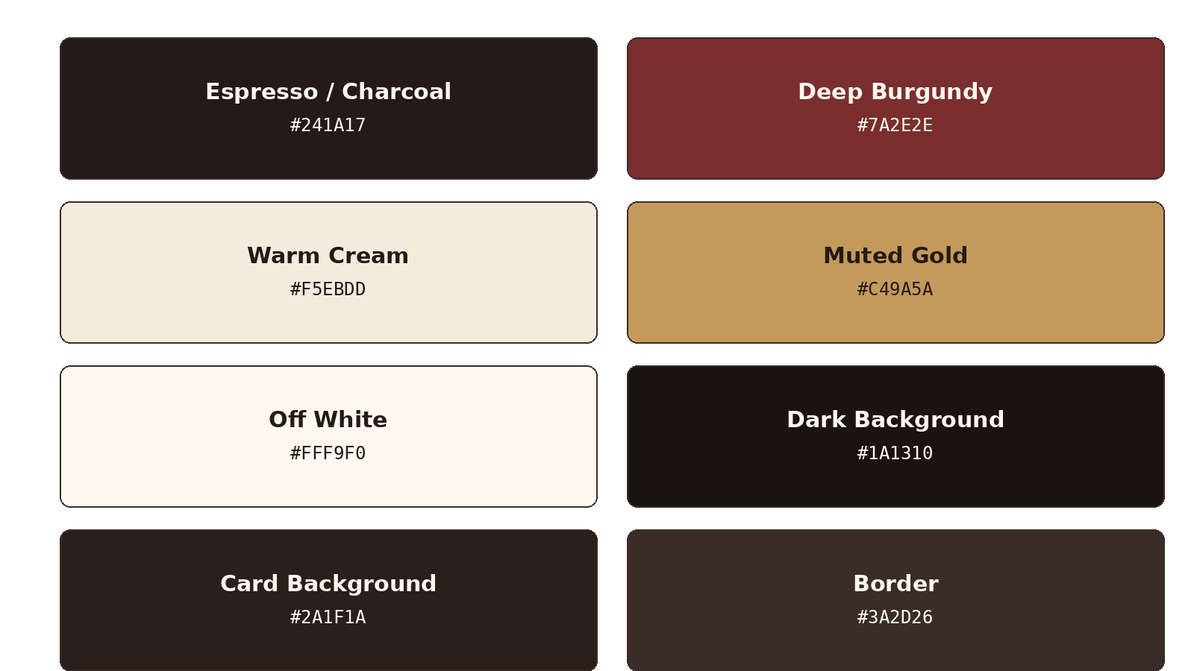
Figure 1: Mizaara Brand Colour Palette
Colour | Hex Code | Usage
Espresso / Charcoal | #241A17 | Primary — headers, navbar, primary text on light
Deep Burgundy | #7A2E2E | Secondary — accents, customer-panel highlights
Warm Cream | #F5EBDD | Background — light surfaces
Muted Gold | #C49A5A | Accent — CTAs, badges, admin-panel highlights
Off White | #FFF9F0 | Text on dark surfaces
Dark Background | #1A1310 | Dark-mode page background
Card Background | #2A1F1A | Dark-mode card surfaces
Border | #3A2D26 | Dividers and outlines
Table 3: Brand Colour Palette Reference

3.3 Typography
Headings are set in Playfair Display, giving the brand an elegant, upscale-restaurant feel, while body text uses Inter for clean readability across menu cards, forms, and tables.

3.4 Design Philosophy
- Dark, elegant surfaces contrasted with warm gold accents
- Clear visual separation between the customer panel and the admin panel
- Menu cards designed for scannability across 41 items and 8 categories
- Consistent iconography for favourites, cart, and order status across every page

4. Technology Stack

4.1 Frontend Technologies
HTML5, CSS3, and Bootstrap 5 provide the structural and responsive foundation across all six pages, while vanilla JavaScript drives menu filtering, search suggestions, cart logic, favourites, and dashboard interactivity.

4.2 Backend Technologies
Supabase provides the full backend: PostgreSQL tables for profiles, menu items, and orders; built-in authentication for customer registration and login; and Supabase Realtime so new orders appear on the admin dashboard without a manual refresh.

4.3 Development Tools
Tool | Purpose
VS Code | Code editor
Git & GitHub | Version control
Vercel | Deployment
Supabase | Database, authentication, and realtime backend
Chrome DevTools | Debugging
Bootstrap Icons | Icon system
Google Fonts | Typography
Table 4: Development Tools

5. System Architecture

5.1 Architecture Overview
Mizaara follows a client-server architecture split across a six-page frontend and a Supabase backend. The frontend divides cleanly into a customer panel and an admin panel, both authenticating against and reading from the same three Supabase tables, as illustrated in Figure 2.
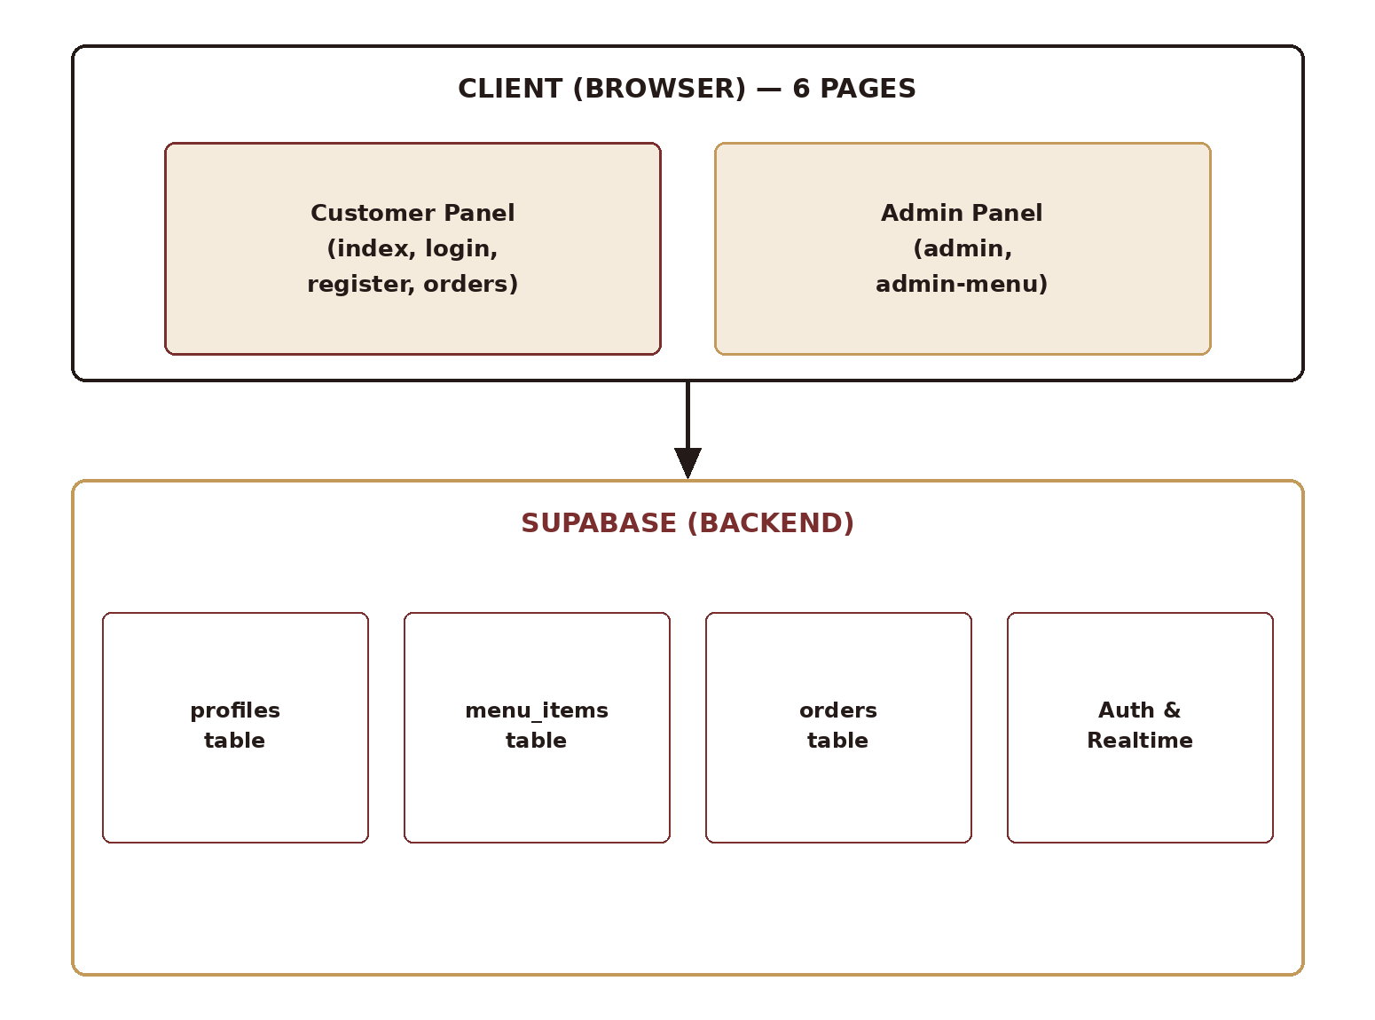
Figure 2: System Architecture Overview

5.2 Data Flow
A customer registers or logs in, browses the menu, adds items to a session-scoped cart, and places an order that is written to Supabase with a status of Pending. The admin panel reads the same orders table, and Supabase Realtime pushes new orders to the dashboard as they arrive. As the admin updates order status, the customer's order-history page reflects the change on its next read.

6. Page Structure

6.1 Site Map
The application is organised into six pages split across a four-page customer panel and a two-page admin panel, as shown in Figure 3.
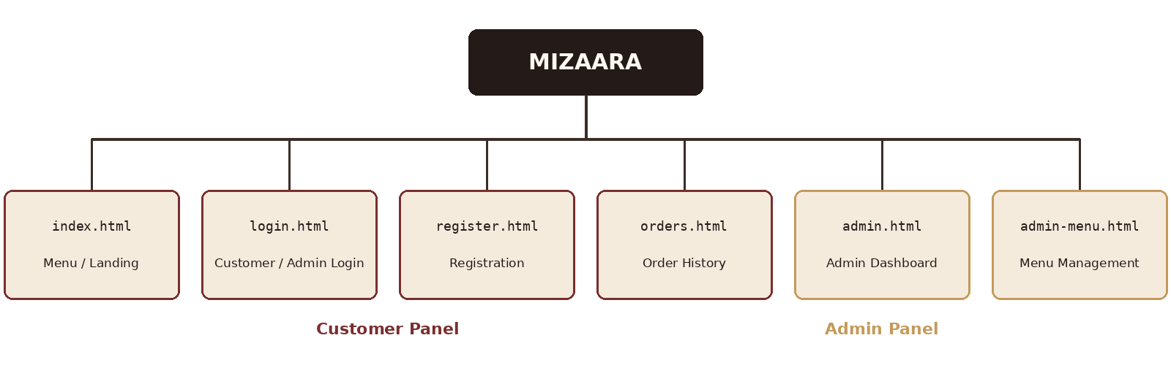
Figure 3: Mizaara Site Map — 6 Pages

6.2 Page Descriptions
Page | Purpose
index.html | Customer menu and landing page
login.html | Combined customer and admin login
register.html | Customer registration
orders.html | Customer order history
admin.html | Admin dashboard
admin-menu.html | Menu management (add, edit, delete, toggle availability)
Table 5: Page Structure and Purpose

7. Database Design

7.1 Supabase Schema
Three tables underpin the application: profiles (linked to Supabase Auth users and carrying a role of customer or admin), menu_items (the 41-item catalogue), and orders (each order's item list, total, and status), as shown in Figure 4.
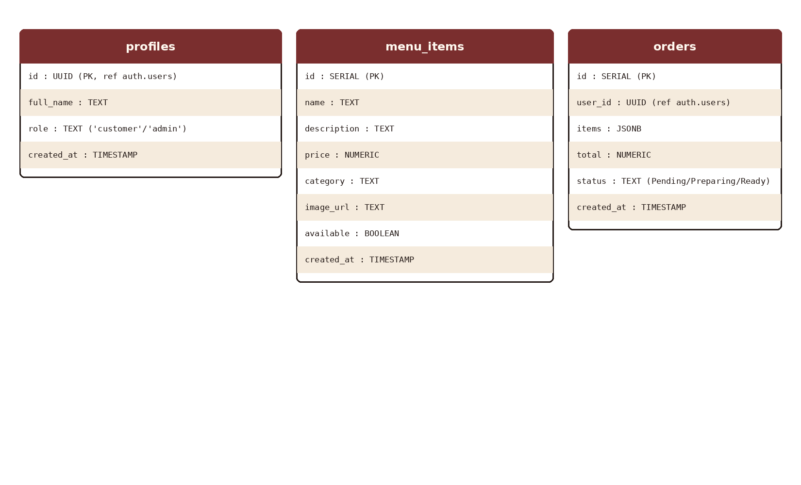
Figure 4: Database Schema Overview
Table: profiles
Column | Type | Description
id | UUID | Primary key, references auth.users
full_name | TEXT | Customer or admin name
role | TEXT | 'customer' or 'admin'
created_at | TIMESTAMP | Account creation time
Table 6: profiles Table Schema
Table: menu_items
Column | Type | Description
id | SERIAL | Primary key
name | TEXT | Menu item name
description | TEXT | Item description
price | NUMERIC | Price in PKR
category | TEXT | One of 8 menu categories
image_url | TEXT | Item image reference
available | BOOLEAN | Availability toggle
created_at | TIMESTAMP | Record creation time
Table 7: menu_items Table Schema
Table: orders
Column | Type | Description
id | SERIAL | Primary key
user_id | UUID | References auth.users
items | JSONB | Ordered items and quantities
total | NUMERIC | Order total in PKR
status | TEXT | 'Pending' / 'Preparing' / 'Ready'
created_at | TIMESTAMP | Order placement time
Table 8: orders Table Schema

7.2 Client-Side Storage Keys
Alongside Supabase, a small set of browser storage keys handles session-scoped and device-local state:
Key | Storage | Purpose
mizaara_cart | sessionStorage | Current cart items
mizaara_favorites | localStorage | Favourited item IDs
mizaara_theme | localStorage | Theme preference
mizaara_admin | localStorage | Admin session flag
Table 9: Client-Side Storage Keys

8. Menu & Categories

8.1 Category Breakdown
The full menu spans 41 items across 8 categories, ranging from Rs 50 plain roti to a Rs 1,200 Chicken Karahi. Figure 5 shows the relative size of each category.
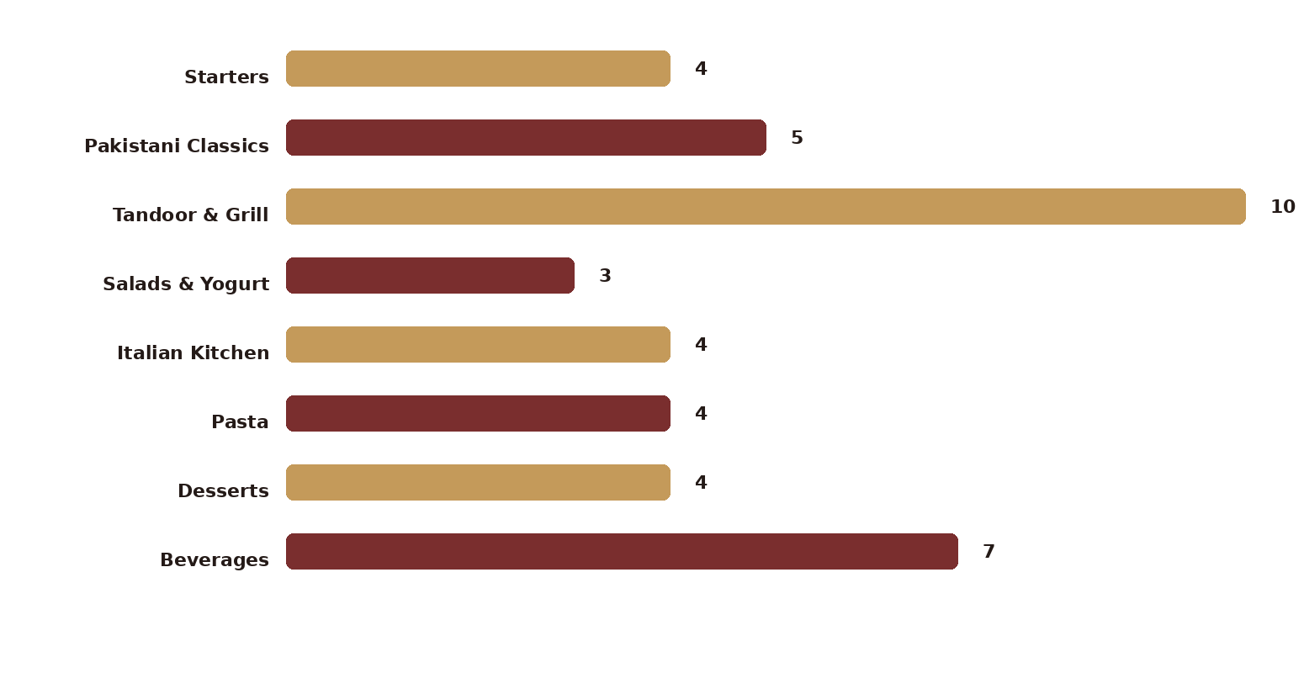
Figure 5: Menu Items per Category
Category | Items | Price Range (PKR)
Starters | 4 | 450 – 750
Pakistani Classics | 5 | 650 – 1,200
Tandoor & Grill | 10 | 50 – 900
Salads & Yogurt | 3 | 200 – 350
Italian Kitchen | 4 | 400 – 1,100
Pasta | 4 | 750 – 900
Desserts | 4 | 250 – 600
Beverages | 7 | 100 – 350
Total | 41 | 50 – 1,200
Table 10: Menu Category Breakdown

8.2 Complete Menu Listing
Starters: Samosa Chaat (Rs 450), Loaded Nachos (Rs 700), Chicken Wings 6pc (Rs 750), Bruschetta (Rs 550).
Pakistani Classics: Chicken Karahi (Rs 1,200), Mutton Biryani (Rs 850), Chicken Biryani (Rs 650), Nihari Special (Rs 950), Haleem (Rs 750).
Tandoor & Grill: Chicken Tikka Skewers (Rs 650), Seekh Kebab (Rs 700), Malai Boti (Rs 800), Tandoori Chicken Half (Rs 900), Grilled Fish Tikka (Rs 850), Plain Roti (Rs 50), Butter Roti (Rs 80), Garlic Naan (Rs 120), Plain Naan (Rs 100), Roghni Naan (Rs 150).
Salads & Yogurt: Fresh Garden Salad (Rs 350), Greek Yogurt Raita (Rs 200), Kachumber Salad (Rs 250).
Italian Kitchen: Margherita Pizza (Rs 1,100), Lasagna (Rs 1,000), Garlic Bread Supreme (Rs 400), Chicken Parmesan (Rs 950).
Pasta: Spaghetti Bolognese (Rs 850), Fettuccine Alfredo (Rs 900), Pasta Arabiata (Rs 750), Penne Pesto (Rs 800).
Desserts: Gulab Jamun 2pc (Rs 250), Kheer (Rs 300), Tiramisu (Rs 550), Chocolate Lava Cake (Rs 600).
Beverages: Kashmiri Chai (Rs 250), Fresh Lime Soda (Rs 200), Mint Margarita (Rs 350), Doodh Patti Chai (Rs 200), Green Tea (Rs 200), Mineral Water 500ml (Rs 100), Mineral Water 1.5L (Rs 200).

9. Customer Features
The customer panel covers the full ordering journey from discovery through to delivery tracking, summarised in Table 11.
Feature | Description
Registration | Name, email, password — creates a profile with role 'customer'
Login | Email/password authentication
Menu Browsing | 41 items across 8 categories
Category Filters | 8 filter buttons
Search | Real-time search with a suggestions dropdown
Popular Badge | Highlighted badge on selected high-demand items
Favorites | Heart icon on cards, saved to localStorage, navbar badge, offcanvas panel
Add to Cart | With quantity tracking
Cart Offcanvas | Shows items, quantities, and total
Welcome Discount | 20% off automatically for first-time customers, first order only
Delivery Time | Estimated delivery time calculation
Place Order | Saves the order to Supabase with status 'Pending'
Order History | View all of the customer's own orders
Order Filters | Filter by All / Pending / Preparing / Ready
Order Timeline | Visual Pending → Preparing → Ready progress
Receipt | Printable receipt without the timeline
Restaurant Status | Open/Closed indicator based on time of day
Daily Special | Chicken Karahi featured with a 20% discount
Table 11: Customer-Facing Features

10. Admin Features
The admin panel gives staff a live operational view of the restaurant, shown in Figure 6.
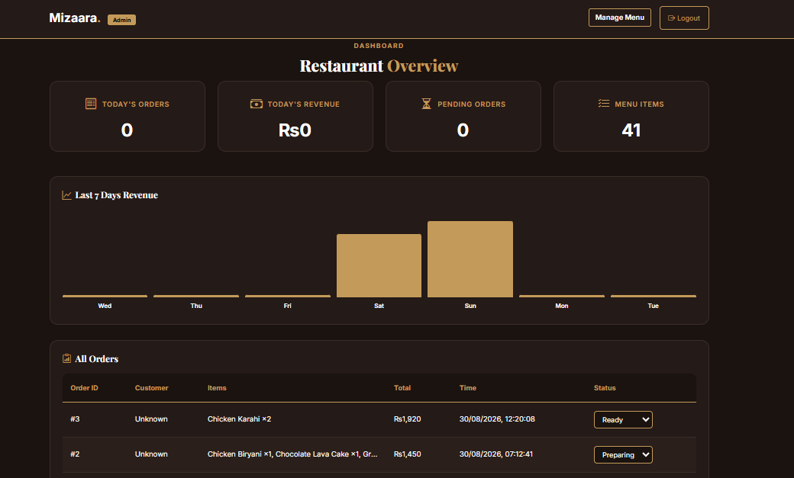
Figure 6: Admin Dashboard Wireframe
Feature | Description
Admin Login | admin@mizaara.pk / admin123
Dashboard | Stats cards for today's orders, revenue, pending count, and menu items
Revenue Chart | Last 7 days' revenue as a bar chart with hover tooltip
Orders Table | All orders with customer information
Status Management | Dropdown: Pending → Preparing → Ready
Menu Management | View, add, edit, and delete menu items
Availability Toggle | Toggle items available/unavailable
Auto-Refresh | Stats refresh every 30 seconds
Real-time Updates | New orders appear automatically via Supabase Realtime
Table 12: Admin-Facing Features

11. Advanced Features Added
Beyond a baseline menu-and-order system, twelve advanced features were added to make Mizaara feel like a genuinely operable restaurant platform, summarised in Table 13.
# | Feature | Implementation
1 | Restaurant Status | Shows Open/Closed based on time (12 PM – 12 AM)
2 | Daily Special | Highlighted section featuring Chicken Karahi
3 | Search Suggestions | Dropdown with matching items as the user types
4 | Popular Badge | Highlight badge on selected items
5 | Favorites | Heart icon, navbar badge, and offcanvas panel
6 | Welcome Discount | Automatic 20% off for first-time customers
7 | Delivery Time | Calculated based on current cart items
8 | Order Filters | Filter order history by status
9 | Order Timeline | Visual progress bar across order stages
10 | Chart Tooltip | Hover reveals revenue and order count
11 | Printable Receipt | Clean receipt view without the timeline
12 | Promo Banner | Displays active discount codes
Table 13: Advanced Features Beyond the Baseline

12. Authentication System

12.1 Roles and Credentials
Customers register with a name, email, and password, which creates a profile with role 'customer'. The admin account uses a fixed demo credential: email admin@mizaara.pk and password admin123, with role 'admin'.

12.2 Authentication Flow
- Register → a profile is created with role 'customer'
- Login → the user's role is checked and they are redirected to the appropriate panel
- Admin guard → non-admin accounts cannot access admin.html
- Logout → the session is cleared and the user is redirected to the login page

13. Discount System

13.1 Welcome Discount
The welcome discount is Mizaara's core retention mechanic: a 20% discount applied automatically for first-time customers — defined as customers with no previous orders — the moment the first item is added to the cart.
Attribute | Detail
Type | Welcome Discount
Eligibility | First-time customers (no previous orders)
Discount | 20% off
Application | Automatic when the first item is added to the cart
Display | Green banner in the cart showing the discount breakdown
After First Order | Never appears again for that customer
Table 14: Welcome Discount Rules

14. Operating Hours & Order Restrictions

14.1 Restaurant Operating Hours
Mizaara enforces day-based operating hours, with slightly later hours on weekends, shown in Table 15.
Day | Opening Time | Closing Time | Order Window
Monday | 12:00 PM | 12:00 AM | 12 hours
Tuesday | 12:00 PM | 12:00 AM | 12 hours
Wednesday | 12:00 PM | 12:00 AM | 12 hours
Thursday | 12:00 PM | 12:00 AM | 12 hours
Friday | 12:00 PM | 12:00 AM | 12 hours
Saturday | 1:00 PM | 1:00 AM (Sunday) | 12 hours
Sunday | 1:00 PM | 1:00 AM (Monday) | 12 hours
Table 15: Restaurant Operating Hours

14.2 Order Restriction System
Menu browsing and adding items to the cart remain available at all times. Placing an order, however, is gated by the restaurant's open/closed status, as summarised in Table 16.
Restaurant State | Browsing | Add to Cart | Place Order | Status Indicator
Open | Allowed | Allowed | Allowed | Green
Closed | Allowed | Allowed | Blocked | Red, with a “Restaurant is Closed” cart banner and disabled Place Order button
Table 16: Order Restriction Behaviour by Restaurant State
When the restaurant is closed, an attempt to place an order is also caught with an error toast, so the restriction is reinforced at both the interface level (disabled button) and the interaction level (blocked submission).

14.3 Status Detection Logic
Open/closed status is evaluated client-side against the current day and hour, with weekend days using a later opening and closing time:
function isRestaurantOpenNow() {
const now = new Date();
const hours = now.getHours();
const day = now.getDay();
let openHour = 12; // Mon-Fri
let closeHour = 24;
if (day === 6 || day === 0) { // Sat/Sun
openHour = 13; // 1 PM
closeHour = 25; // 1 AM next day
}
return hours >= openHour && hours < closeHour;
}

14.4 Cart Behaviour When Closed
When the restaurant is closed, the cart offcanvas surfaces the restriction directly rather than silently blocking the order, as shown in Figure 7: a red closed banner at the top, the items and total displayed as normal, and the Place Order button replaced with a disabled, greyed-out state.
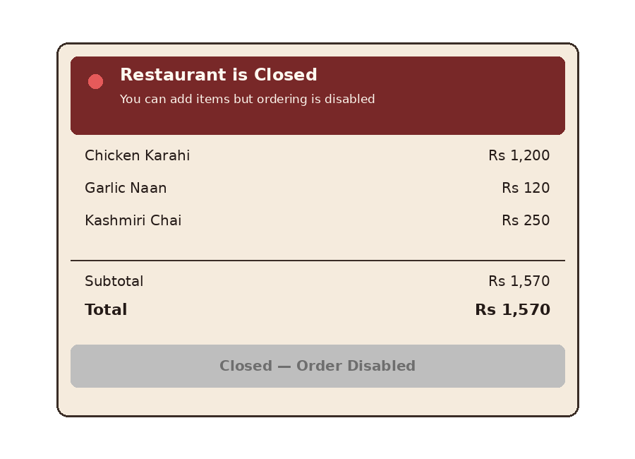
Figure 7: Cart View When the Restaurant Is Closed

14.5 Feature Summary
Feature | Description
Real-time Status | Updates every 60 seconds
Day-based Hours | Different hours for weekends
Cart Restriction | Order blocked when closed
Visual Feedback | Red banner and disabled button
Toast Notification | Error message shown on a blocked attempt
Browse Always Open | Menu remains viewable at all times
Add to Cart Always | Cart continues to function even when closed
Table 17: Operating Hours Feature Summary

15. Responsive Design
Mizaara was tested across six responsive breakpoints, from large desktop screens down to extra-small mobile devices, to ensure the menu grid, cart offcanvas, and admin dashboard all remain usable at every size.
Breakpoint | Range
Desktop | 1200px+
Laptop | 992px – 1199px
Tablet | 768px – 991px
Mobile | 576px – 767px
Small Mobile | 375px – 575px
Extra Small | < 375px
Table 18: Responsive Breakpoints

16. Order Lifecycle
Every order moves through three states, visualised for the customer as a timeline on the order-history page, shown in Figure 8.
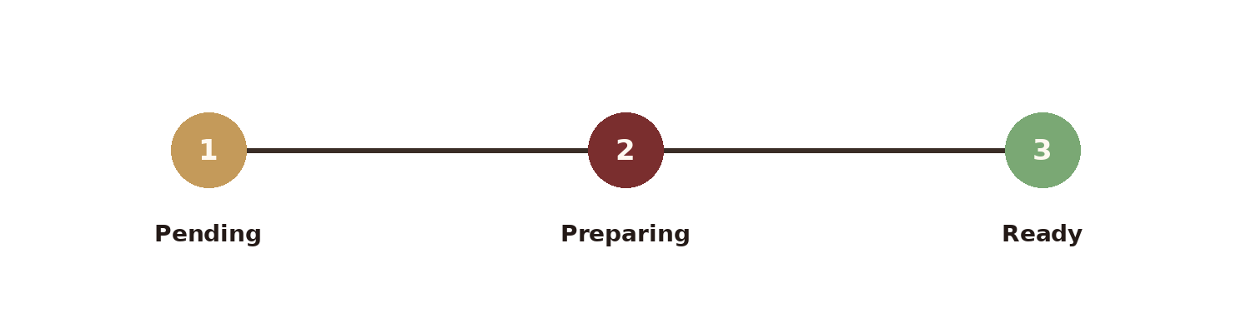
Figure 8: Order Status Timeline
An order is created with status Pending as soon as it is placed. The admin updates it to Preparing once kitchen work begins, and to Ready once it is available for pickup or delivery. The customer's order-history page reflects each status change, and a printable receipt — without the timeline — is available at any stage.

17. Testing & QA
Twenty-three end-to-end test cases were executed across registration, ordering, admin management, and responsiveness, summarised in Table 19.
Test | Expected Result
Register new account | Account created, role = customer
Login customer | Redirect to index.html
Login admin | Redirect to admin.html
Browse menu | 41 items display
Category filter | Filter works correctly
Search | Real-time filtering
Search suggestions | Dropdown appears
Add to cart | Badge count updates
Welcome discount | Shows 20% off for new user
Place order | Saved to Supabase
Order history | Shows own orders
Order filters | Filter by status
Admin dashboard | Stats display
Change status | Updates in database
Customer sees status | Shows updated status
Toggle availability | Menu item status changes
Add menu item | Appears in customer menu
Delete menu item | Removed from menu
Favorites | Heart icon works, badge updates
Receipt | Opens printable window
Restaurant status | Shows Open/Closed
Daily special | Displays correctly
Mobile responsive | All pages work on mobile
Table 19: Testing Checklist and Expected Results

18. Deployment
Mizaara is deployed on Vercel with the source code hosted on GitHub and auto-deployment enabled on every push to the main branch. Supabase project credentials are supplied through environment variables so the same codebase can point at a development or production database without code changes.

19. Learning Outcomes
- Full-stack application development spanning two coordinated panels
- Supabase authentication — register, login, and logout flows
- Role-based access control distinguishing customer and admin accounts
- PostgreSQL database operations (CRUD) via Supabase
- Real-time data fetching with Supabase Realtime
- localStorage for client-side persistence and sessionStorage for cart management
- Responsive design with Bootstrap 5 across six breakpoints
- Advanced JavaScript, including async/await and fetch
- UI/UX design for a restaurant ordering and management application
- Deployment to Vercel

20. Conclusion
Mizaara brings together a 41-item, 8-category menu, a role-based customer and admin authentication system, a Supabase-backed order pipeline, and twelve advanced UX features — from an automatic welcome discount to a live revenue chart — into a single coordinated, six-page platform. As the Month 2 final project, it demonstrates full-stack development across both the customer-facing and operational sides of a real restaurant business, fulfilling and extending the objectives set for the CloudExify Summer Internship 2026.

