Final Lab Exam -23909(Sairaj Patro-1st MSc)

**1.** Wilson Problem: Wilson Manufacturing produces both baseballs and softballs, which it wholesales to vendors around the country. Its facilities permit the manufacture of a maximum of 500 dozen baseballs and a maximum of 500 dozen softballs each day. The cowhide covers for each ball are cut from the same processed cowhide sheets. Each dozen baseballs require five square feet of cowhide (including waste), whereas, one dozen softballs require six square feet of cowhide (including waste). Wilson has 3600 square feet of cowhide sheets available each day. Production of baseballs and softballs includes making the inside core, cutting and sewing the cover, and packaging. It takes about one minute to manufacture a dozen baseballs and two minutes to manufacture a dozen softballs. A total of 960 minutes is available for production daily. The prices for a dozen baseball and a dozen softball are 7 and 10 dollars respectively. Answer the following:

a) Formulate the problem in the Excel file and generate the sensitivity analysis.

b) Write on cost coefficient sensitivity analysis.

c) Write on Right Hand Side Sensitivity Analysis.

1. 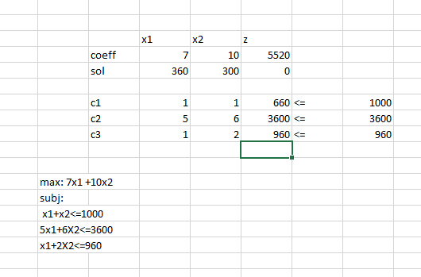

**Sensitivity Analysis:**

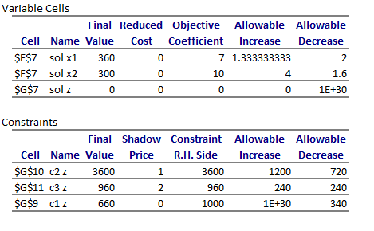

1. Cost Coefficient Sensitivity Analysis:

**For baseball(x1)**: we can increase the revenue by 1.333 and we can decrease it by 2 , and in this there will be no change in the optimal solution,if we are going beyond then only it will affect the optimal solution.

The Final value of this product is 360. And the optimal sol is 5520.

**For Softball(x2)**: we can increase the revenue by 4and we can decrease it by 1.6 , and in this there will be no change in the optimal solution,if we are going beyond then only it will affect the optimal solution.

The Final value of this product is 300. And the optimal sol is 5520.

1. We are having total 3600 and we are using it fully.

We are having 960 total resource and we are using it fully.

The Shadow Price for cowhide sheet is 1 that means if we are increasing it by one unit our profit is going to be increased by 1.

Similarly the shadow price for our third constraints is 2 that means if we are increasing it by 2.

Constraint2

In the case of **cowhide sheet** we can increase it by 1200 (i.e 3600=1200=4800) and reduce it by 720.

If we are increasing it by 1200 then the total profit will be 1200 x 1 = 1200 and this will be added to the our optimal sol(5520+1200=6720).

And if we are decreasing there will be no change in the optimal soln.

Constraint3

In case of **time** we can increase it by 240 mins and decrease it by 240 mins. If we are increasing it by 240 then the total profit will be 240 x 2 = 480 and this will be added to the our optimal soln(5520+480=6000).

Constraint1

In case of balls the allowable decrease is 340.

**2.**Consider the following problem: 𝑓(𝑥1, 𝑥2 ) = 4𝑥1 + 6𝑥2 − 2𝑥1 2 − 2𝑥1𝑥2 − 2𝑥2 2

a) Write a program to visualize the above function.

b) Write an iterative program to maximize the function.

**a)** 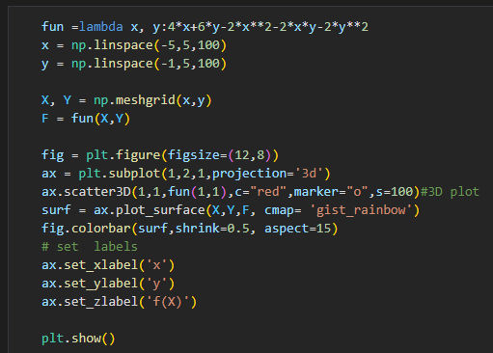

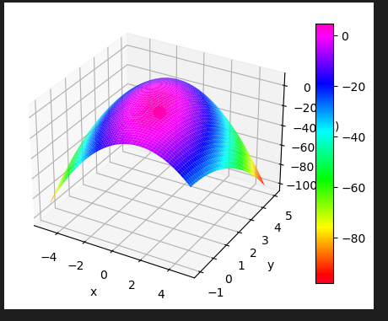

**b)** 