**OT Assignment-23909(sairaj)**

(1) Formulate an LP that describes the production plans that the firm can use to maximize its profits. Write x1 = number of unfurnished tables x2 = number of furnished tables x3 = number of unfurnished chairs x4 = number of furnished chairs Maximize z = 70x1 + 140x2 + 60x3 + 110x4 subject to 40x1 + 40x2 + 30x3 + 30x4 ≤ 40000. 2x1 + 5x2 + 2x3 + 4x4 ≤ 6000.

**Ans:** 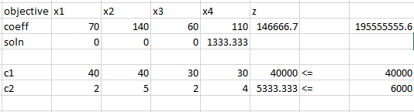

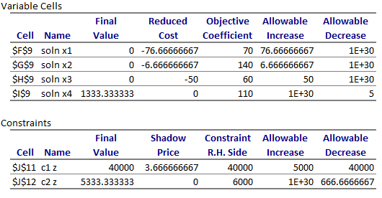**195555555.6**

(2) What would happen if the price of unfinished chairs went up?

**Ans:** There will be no change in the optimal profit till 110(60+50).

(3) What would happen if the price of unfinished tables went up?

**Ans:** There will be no change in the optimal profit till 146.666666667(140+6.66666667).

(4) What if the price of finished chairs fell to $100?

**Ans:** There will be a change in the optimal solution.(profit might be affected (decrease) )

(5) How would profit change if lumber supplies changed?

**Ans:** Here the shadow price is 3.6666667, so if the no of wood pieces increased there will be a increase of 3.6666667 per wood and since the loss is 1 so 2.66666667 will be the profit.

(6) How much would you be willing to pay an additional carpenter?

**Ans:** No Need to pay for additional workers as we are not using our labor fully.

(7) Suppose that industrial regulations complicate the finishing process, so that it takes one extra hour per chair or table to turn an unfinished product into a finished one. How would this change your plans?

**Ans:** As there is a increase in the time we can stop producing the finished chair and we can start producing 1000 tables (from 0 tables earlier).

(8) The owner of the firm comes up with a design for a beautiful hand-crafted cabinet. Each cabinet requires 250 hours of labor (this is 6 weeks of full time work) and uses 50 board feet of lumber. Suppose that the company can sell a cabinet for $200, would it be worthwhile?

**Ans:** : After adding the 200 additional profit and 50 foot woods and 250 hours. We got $146712.3 profit. We can see there is an increase in profit. So, it is recommended to make the hand-crafted cabinet.