Placement Data Analysis Project

Objective
The objective of this placement data analysis project is to gain insights into the placement outcomes of various engineering colleges across multiple years.
We analyze branches, placement rates, average salary packages, student intake distribution, and college performance to derive meaningful conclusions that help improve institutional decision-making and guide students toward better academic choices.

1. Branch-wise Analysis
● Placement Performance by Branch
- Calculate placement rate = Placed Students / Total Students × 100
- Identify high-performing branches (e.g., IT, CSE, Electrical).
- Identify branches needing improvement (e.g., Biomedical, Textile, Civil in some colleges).
● Average Package by Branch
- Analyze salary levels for each branch.
- Determine high-value branches (CSE, IT, ELEX-ENTC).
- Identify branches with low market demand based on package trends.
● Branch Popularity
- Analyze total student intake across branches.
- Determine correlation between popularity and placement outcomes.

2. College-wise Analysis
● Placement Rate per College
- Compare placement percentages across colleges.
- Highlight top performers (e.g., VJTI, SPIT).
- Identify colleges with inconsistent or low placement rates.
● Average Package Trend by College
- Analyze salary outcomes for each college year-wise.
- Identify colleges with upward or downward trends.
● Top College–Branch Combinations
- Determine combinations that yield the best placements and highest packages.
- Useful for student decision-making.

3. Year-wise Trend Analysis
● Placement Trend (2023 → 2024 → 2025)
- Compare yearly changes in average placement rate.
- Understand effects of market conditions.
● Salary Trend over Years
- Track changes in average packages.
- Identify years with higher or lower salary outcomes.

4. Distribution Analysis
● Donut Chart – Branch Distribution per College
- Visualize student strength across branches.
- Understand which branches dominate each college.
● Stacked Bar Chart – Total vs Placed Students
- Shows both absolute student numbers and how many got placed.
- Helps identify high-volume but low-success branches.

5. Heatmap-based Analysis
● Colleges vs Average Package
- Compare college performance across branches.
- Identify branches that yield higher packages in specific institutions.
● Colleges vs Placement Rate
- Identify strong and weak branches inside each college.

6. Combined KPI Dashboard
This section summarizes all major metrics including:
- Total Students by College
- Placed Students by College
- Placement Rate by College
- Average Package by College
This provides a one-page overview of institution performance for quick decision-making.

Dataset Overview
The dataset includes key columns:
Column | Description
College | Name of the engineering college
Field (Branch) | Original branch name from the placement data
Normalized Branch | Clean standardized branch category
Year | Academic year (2023–2025)
Total Students | Number of students enrolled
Placed Students | Number successfully placed
Avg Package (LPA) | Average salary package

Data Cleaning
Before performing the analysis, the following operations were done:
- Cleaning branch names using a normalization dictionary
- Removing MCA (non-engineering) entries
- Merging similar branches (AI/ML/DS, Electronics variants)
- Handling missing or inconsistent values
- Ensuring numeric format for student counts and salary values
This mirrors the cleaning steps shown in the PDF's "Data Cleaning" and “Dataset Overview” sections.

Placement Rate by Branch
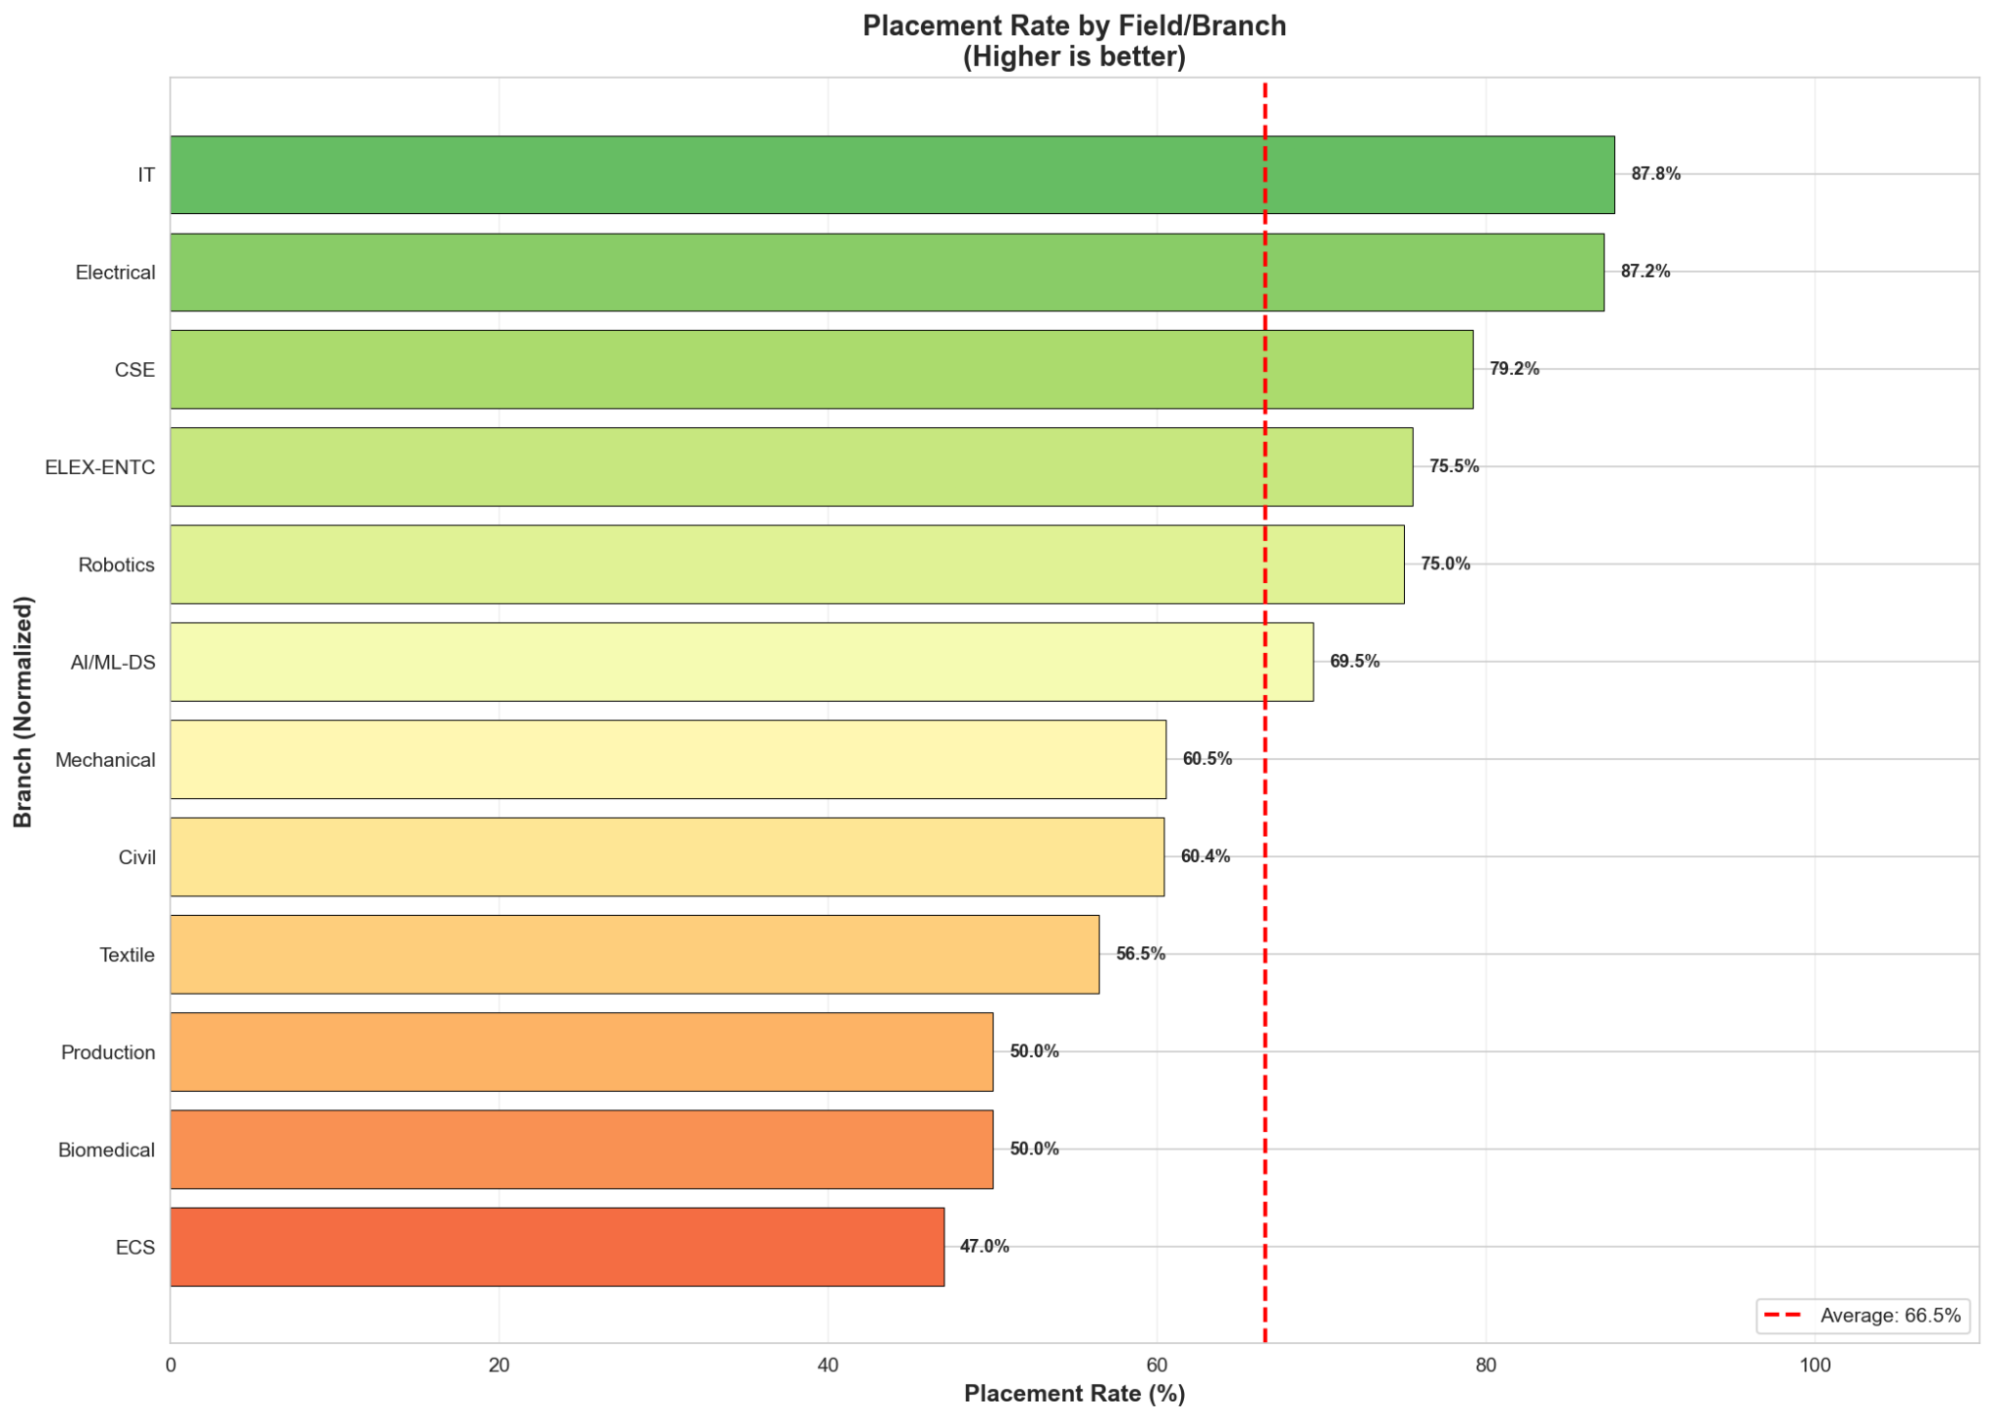

Average Package by Branch
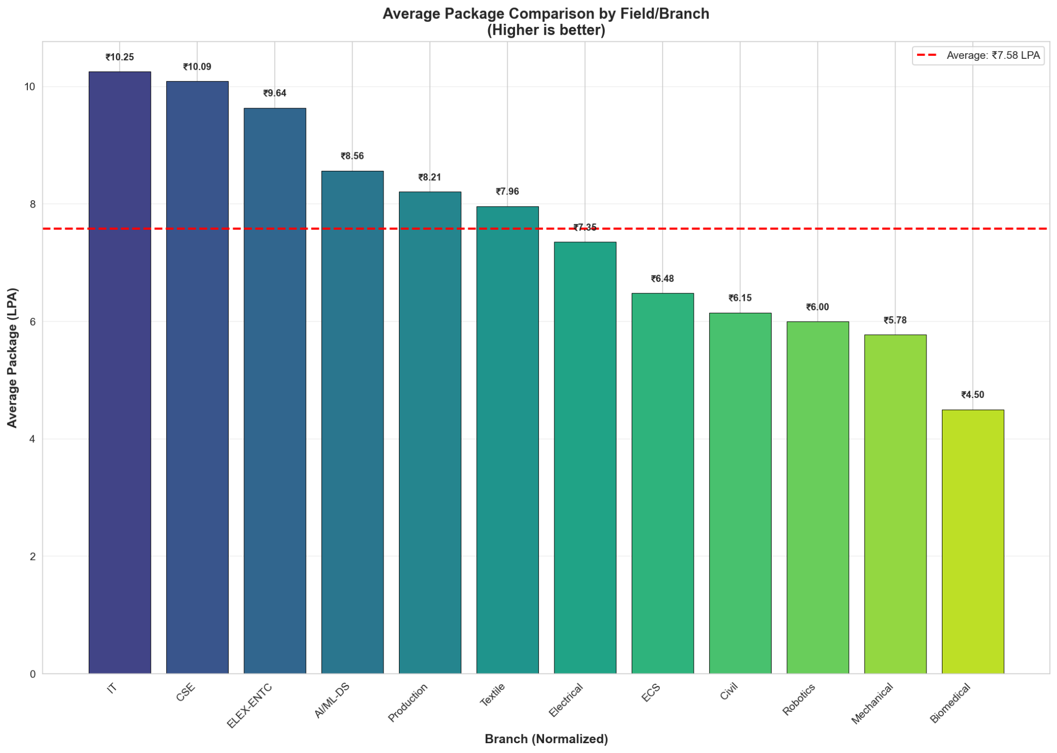

College-wise Placement Rate
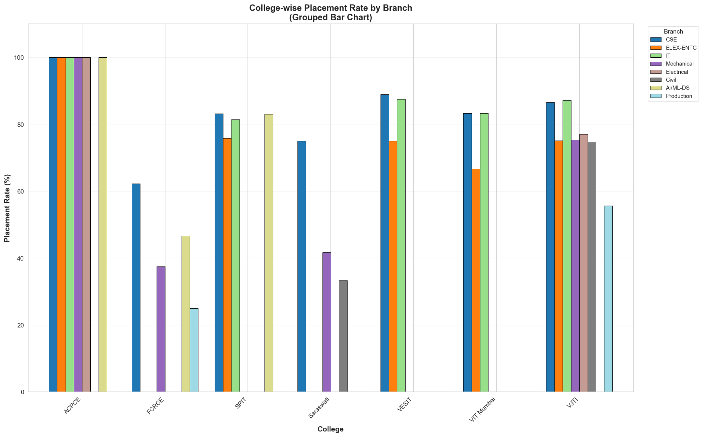

Year-wise Trend Analysis
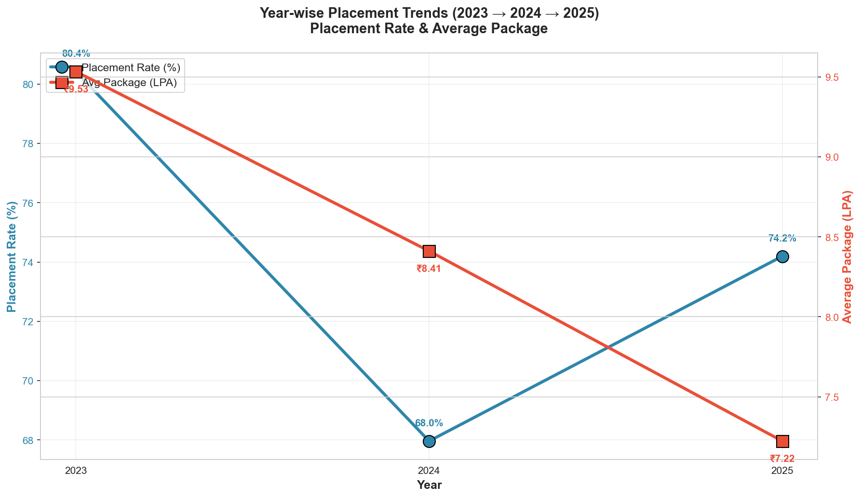

Field Popularity vs Placement Rate
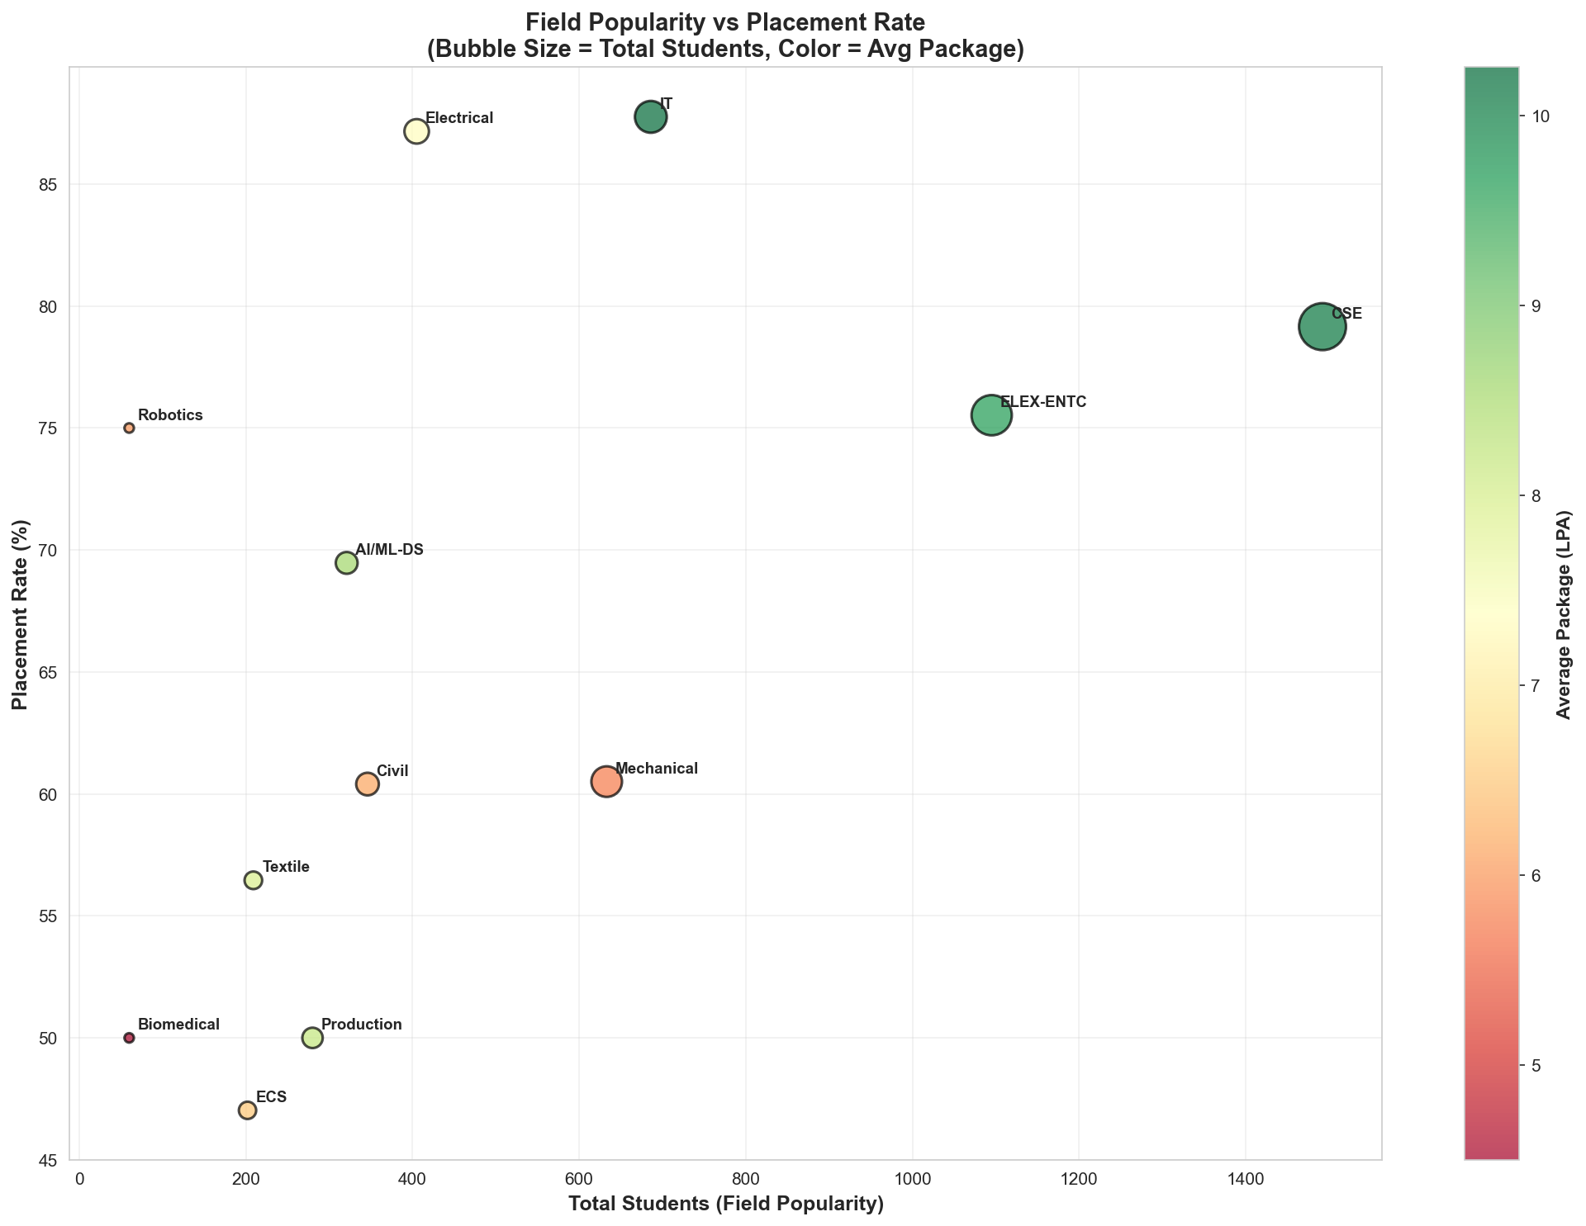

Average Package Trend by College
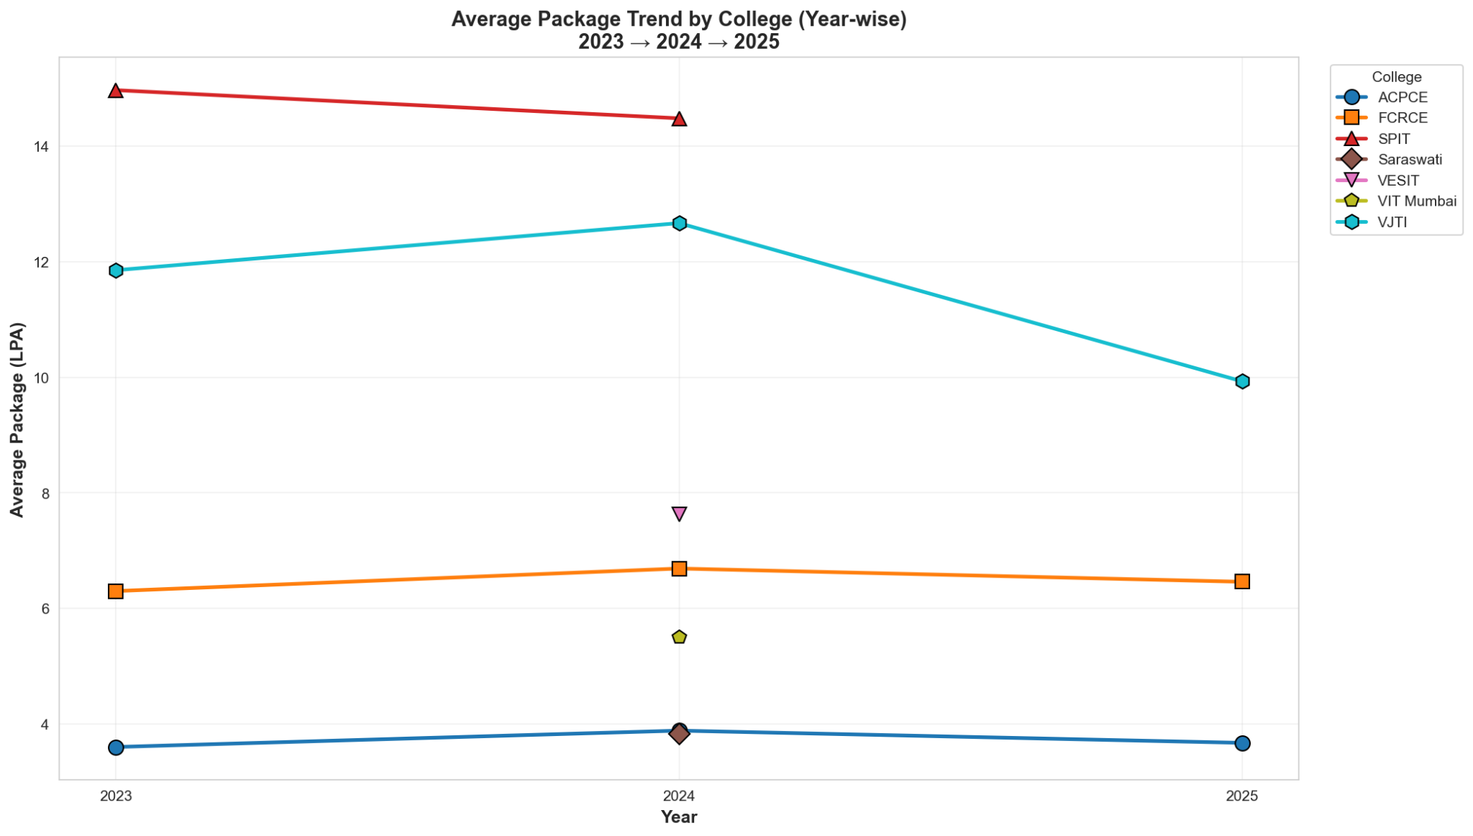

Heatmap: Colleges vs Average Package
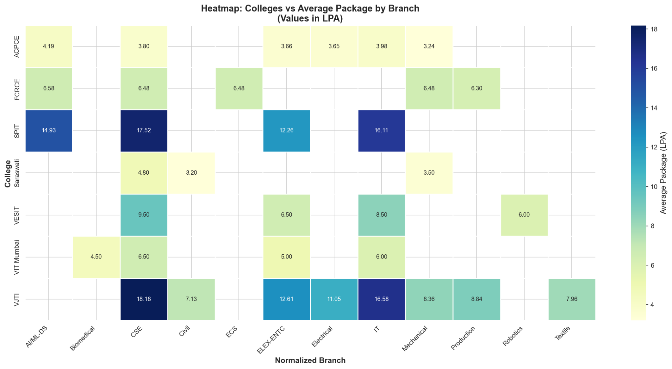

Heatmap: Colleges vs Placement Rate
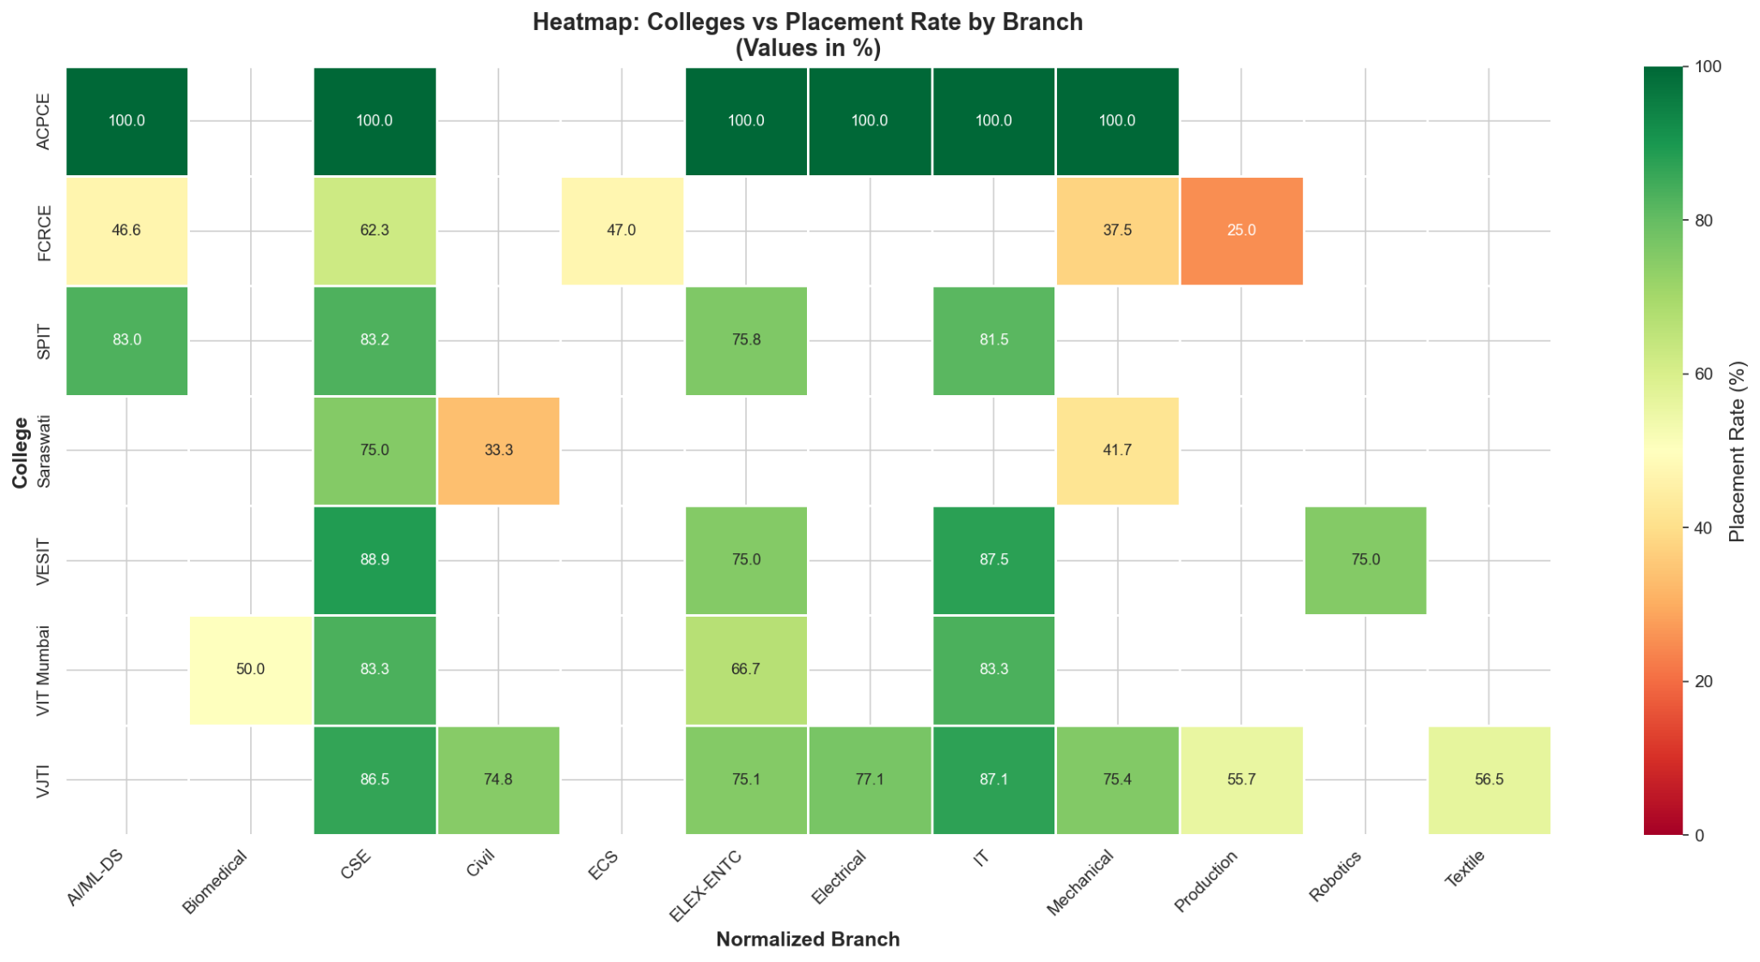

Branch Distribution Donut Charts
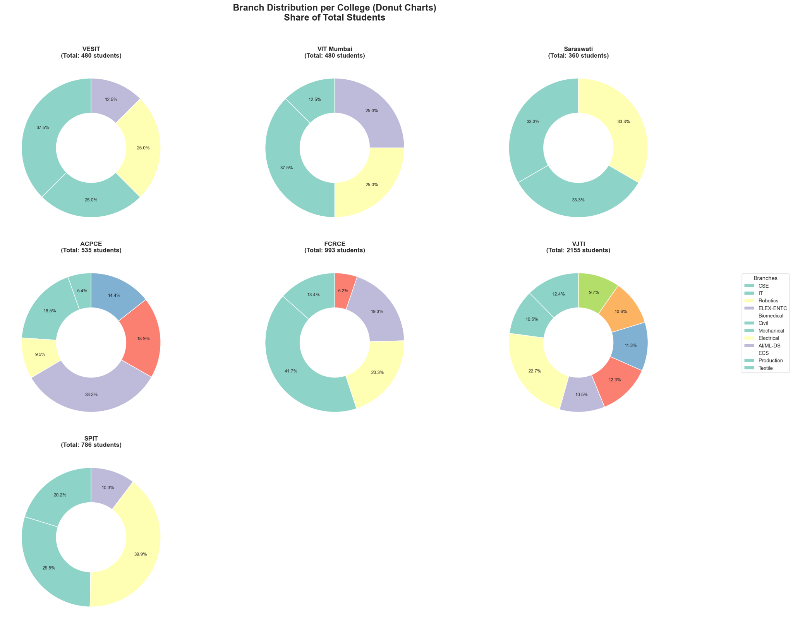

Stacked Bar: Total vs Placed Students
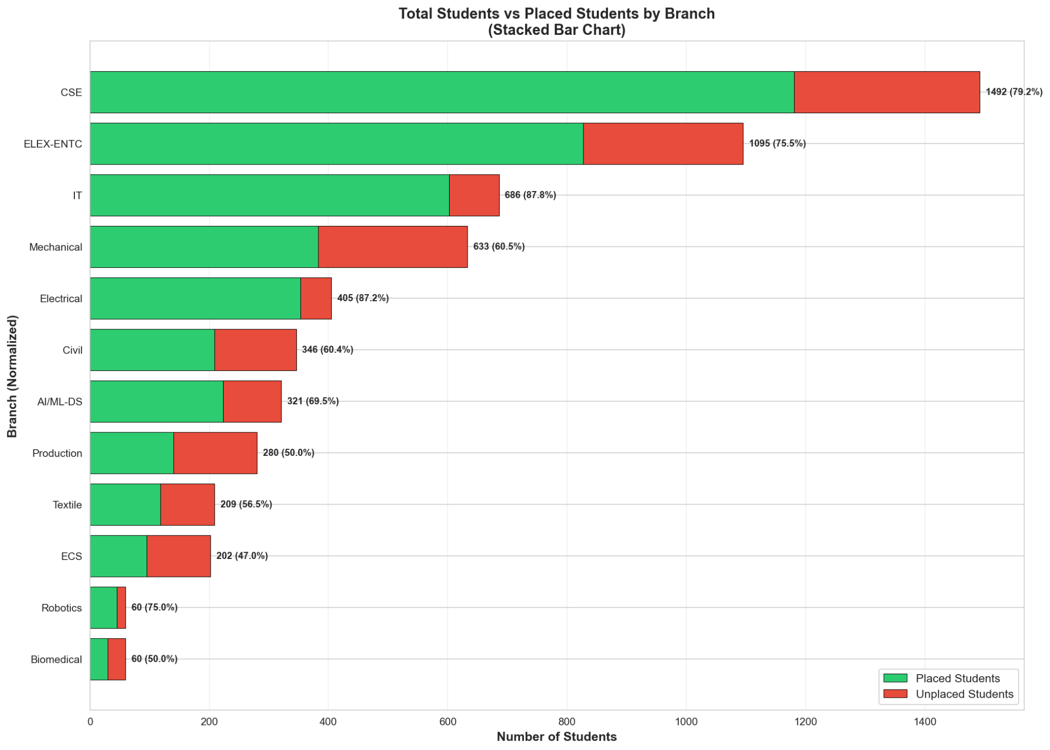

Top 10 College–Branch Combinations
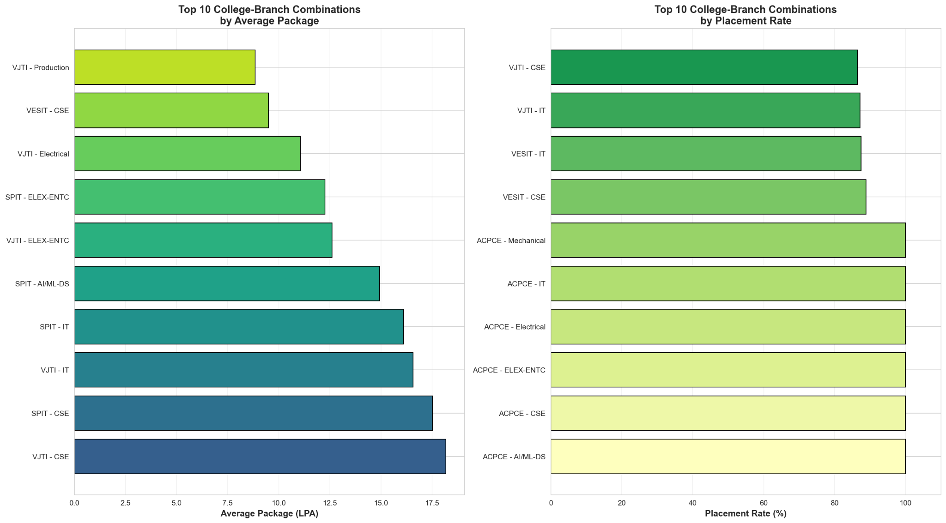

Combined KPI Dashboard
