Lab Assignment : 03

Code :

float x,y,z,temp; void setup()
{

// pinMode(8, INPUT); pinMode(5, OUTPUT); pinMode(6, OUTPUT);
pinMode(A5, INPUT); pinMode(A4, INPUT); Serial.begin(9600);
}

void loop()

{

// x= digitalRead(8); y= analogRead(A5); z= analogRead(A4); Serial.println(x); Serial.println(y); Serial.println(z);
temp = (double)z / 1024; temp = temp * 5;
temp = temp - 0.5; temp = temp * 100;
//if ( (x>0) )

//{

if ((y<550)&&(temp>30))

{

digitalWrite(5, HIGH); digitalWrite(6, HIGH);
}

else if((y<550)&&(temp<30))
{

digitalWrite(5, HIGH);
digitalWrite(6, LOW);
}

else if((y>550)&&(temp>30))

{
digitalWrite(5, LOW); digitalWrite(6, HIGH);
}

else if((y>550)&&(temp<30))

{

digitalWrite(5, LOW); digitalWrite(6, LOW);
}

/*} else
{

digitalWrite(5, LOW); digitalWrite(6, LOW);
}*/

}

Circuit Diagram :

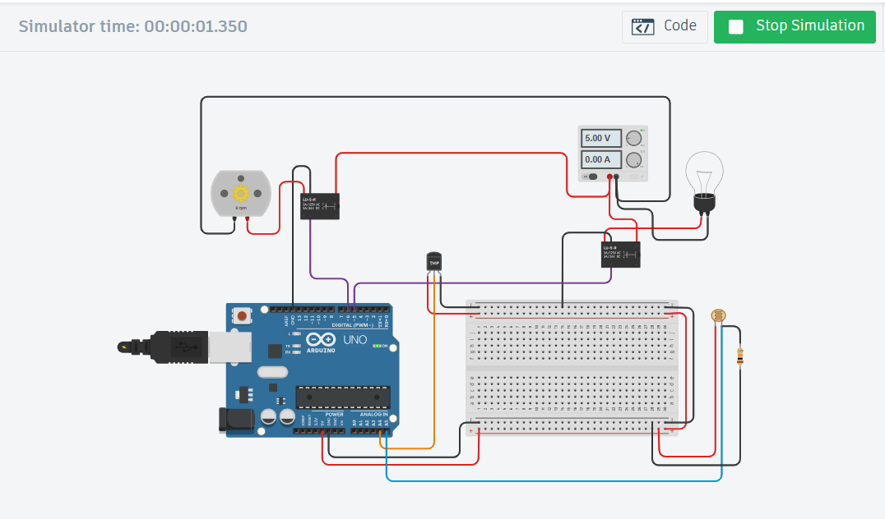

Lab Assignment : 04

Code :

#include <LiquidCrystal.h>

// Initialize the LCD with the pin numbers LiquidCrystal lcd(12, 11, 5, 4, 3, 2);
int V_GasSen = 0;
int V_TempSens = 0;
void setup() {
pinMode(A0, INPUT); // Gas sensor pin pinMode(A1, INPUT); // Temperature sensor pin pinMode(7, OUTPUT); // Buzzer pin pinMode(9, OUTPUT); // LED for gas detection
pinMode(12, OUTPUT); // LED for temperature warning lcd.begin(16, 2); // Initialize the LCD with 16 columns and 2 rows
}
void loop() {

// Read gas sensor value V_GasSen = analogRead(A0);
// Read temperature sensor value and calculate temperature V_TempSens = -40 + 0.488155 * (analogRead(A1) - 20);
// Display temperature and gas status on the LCD lcd.clear(); // Clear the LCD
lcd.setCursor(0, 0); // Set cursor to the first row lcd.print("Temperature: "); // Print temperature label lcd.print(V_TempSens); // Print temperature value lcd.print(" C"); // Print temperature unit lcd.setCursor(0, 1); // Set cursor to the second row lcd.print("Gas: "); // Print gas label
lcd.print(V_GasSen); // Print gas sensor value
// Check for alerts

if (V_GasSen >= 250) {

tone(7, 523, 1000); // Play tone if gas is detected digitalWrite(9, HIGH); // Turn on the gas detection LED lcd.clear();
lcd.setCursor(0, 0); lcd.print("ALERT: Gas Detected");
} else {

digitalWrite(9, LOW); // Turn off the gas detection LED

}
if (V_TempSens >= 70) {

tone(7, 523, 1000); // Play tone if temperature exceeds the threshold digitalWrite(12, HIGH); // Turn on the temperature warning LED lcd.clear();
lcd.setCursor(0, 0); lcd.print("ALERT: Temp High");
} else {

digitalWrite(12, LOW); // Turn off the temperature warning LED

}

delay(1000); // Delay for one second

}

Circuit Diagram :

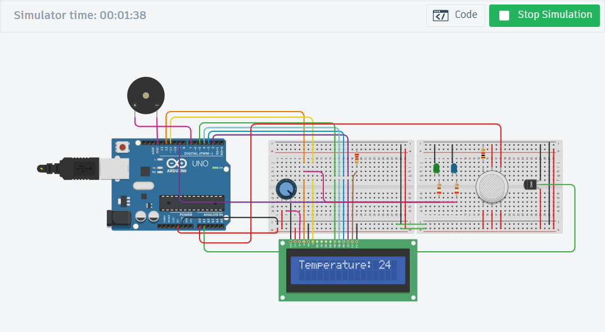

Lab Assignment : 05

Code :

#include <Servo.h>
#include<LiquidCrystal.h>
LiquidCrystal lcd(12,11,5,4,3,2);
Servo myservo;
#define ServoM 7 //Connected to the servo motor.
#define Exit 9 //Pin connected to the EXIT sensor.
#define In 8 //Pin connected to the IN sensor.
#define Pwr 6 //Extra power pin for sensors(Don't connect servo's power to this!)
#define Gnd 10 //Extra groung pin for sensors(Don't connect servo's power to this!)
#define BarLow 90 //Low position of the barrier.
#define BarUp 177 //Up position of the barrier.
#define CAPACITY 24 //Capacity of the parking lot.
void setup(){
myservo.attach(ServoM);
lcd.begin(16,2);
lcd.print(" BatStateU Parking!");
pinMode(Gnd, OUTPUT);
pinMode(Pwr, OUTPUT);
pinMode(Exit, INPUT);
pinMode(In, INPUT);
digitalWrite(Gnd, LOW);
digitalWrite(Pwr, HIGH);
myservo.write(BarLow);
delay(1000);
}
int Available= 24;
void loop(){
if (Available == 1){
lcd.clear();
lcd.setCursor(1,0);
lcd.print("Space left for");
lcd.setCursor(0,1);
lcd.print(" ");
lcd.print(" ");
lcd.print(" ");
lcd.print(" ");
lcd.print(" ");
lcd.print(Available);
lcd.print(" car");
delay(1000);
}else{
if (Available >= 1){
lcd.clear();
lcd.setCursor(1,0);
lcd.print("Space left for");
lcd.setCursor(0,1);
lcd.print(" ");
lcd.print(" ");
lcd.print(" ");
lcd.print(" ");
lcd.print(" ");
lcd.print(Available);
lcd.print(" cars");
}else{
lcd.clear();
lcd.setCursor(1,0);
lcd.print(" Sorry!");
lcd.setCursor(0,1);
lcd.print(" No Place left!");
delay(1000);
}
}
if(digitalRead(In))
{
if(Available != 0){
Available--;
myservo.write(BarUp);
delay(3000);
myservo.write(BarLow);
}
}
if(digitalRead(Exit))
{
if(Available != CAPACITY){
Available++;
myservo.write(BarUp);
delay(3000);
myservo.write(BarLow);
}
}
delay(80);
}

Circuit Diagram :



