1.Start by researching what cyber security means, focusing on confidentiality, integrity, and availability (CIA triad) with real-world examples like banking and social media.
- CIA TRIADS :
  - Confidentiality — ensuring information is only accessible to authorized parties; protects privacy and proprietary secrets.
    - Banking – Confidentiality in the Real World
      - What data must be confidential?
      - Customer account numbers
      - ATM PINs
      - Net banking passwords
      - Credit/debit card details
      - Aadhaar / PAN / KYC documents
      - How banks protect confidentiality
      - Encrypted communication (HTTPS / TLS)
      - Masked account numbers (XXXX-1234)
      - Two-factor authentication (OTP, biometrics)
      - Role-based access for employees
      - Secure data centers and vaults
      - Real-world failure example
If a hacker steals a bank database containing:
      - Account numbers
      - Passwords
      - Card CVVs
      - → Customers may lose money
→ Bank faces legal action
→ Trust is permanently damaged
      - Result: Confidentiality breach = financial loss + legal penalties
    - Social Media – Confidentiality in the Real World
      - What data must be confidential?
      - Private messages (DMs)
      - Email addresses
      - Phone numbers
      - Login credentials
      - Location data
      - How social platforms protect confidentiality
      - Private messaging encryption
      - Account privacy settings
      - Login alerts and MFA
      - Limiting third-party app access
      - Real-world failure example
If user data like emails or phone numbers leaks:
      - Users receive phishing scams
      - Identity theft occurs
      - Fake accounts are created
      - Result: Confidentiality breach = privacy invasion + user mistrust

  - Integrity — ensuring information is accurate, complete, and unmodified except by authorized processes; protects trustworthiness and non-repudiation.
    - Banking – Integrity in the Real World
      - What must remain accurate?
      - Account balances
      - Transaction amounts
      - Loan records
      - Interest calculations
      - How banks maintain integrity
      - Digital signatures on transactions
      - Transaction logs and audit trails
      - Database constraints
      - Reconciliation systems
      - Multi-level approval for transfers
      - Real-world failure example
If an attacker changes:
      - ₹1,000 debit → ₹10,000 debit
      - Loan balance → incorrect amount
      - → Customer disputes
→ Legal issues
→ Financial chaos
      - Result: Integrity failure = loss of trust + incorrect financial records
    - Social Media – Integrity in the Real World
      - What must remain accurate?
      - Posts and comments
      - User profiles
      - Follower counts
      - Verified badges
      - Integrity threats
      - Account hacking
      - Fake posts
      - Altered profile details
      - Deepfake content
      - Real-world example
If someone hacks an account and posts false information:
      - Reputation damage
      - Fake news spread
      - Public confusion
      - Result: Integrity failure = misinformation + social harm
  - Availability — ensuring authorized users can access systems and data when needed (performance, uptime, and resilience).
    - Banking – Availability in the Real World
      - What must always be available?
      - Online banking
      - ATM services
      - Payment gateways
      - UPI / card transactions
      - How banks ensure availability
      - Redundant servers
      - Backup data centers
      - Disaster recovery plans
      - DDoS protection
      - 24/7 monitoring
      - Real-world failure example
If banking servers go down:
      - ATMs stop working
      - Payments fail
      - Businesses suffer
      - Customers panic
      - Result: Availability failure = economic disruption + public anger

2.Identify different types of attackers such as script kiddies, insiders, hacktivists, and nationstate actors by reading credible security blogs.
- Cyber attackers differ widely in skill level, motivation, resources, and impact.
Security professionals classify attackers so they can predict behavior, assess risk, and design defenses.
  - 1. Script Kiddies
    - Who they are
      - Script kiddies are low-skill attackers who use ready-made tools, scripts, and exploits created by others.
They do not usually understand the internal working of the attacks they launch.
    - Skill & knowledge level
      - Very basic technical knowledge
      - No deep understanding of networking, operating systems, or cryptography
      - Depend on tutorials, copied code, and automated tools
    - Motivation
      - Curiosity
      - Fun or boredom
      - Online recognition
      - Proving “I hacked something”
      - They usually do not have a specific target and attack whatever is easiest.
    - Common tools used
      - Automated vulnerability scanners
      - Password brute-force tools
      - Public exploit kits
      - DDoS-for-hire services
      - SQL injection tools with preloaded payloads
    - Typical attacks
      - Website defacement
      - Basic DDoS attacks
      - Exploiting known vulnerabilities
      - Attacking weak login pages
    - Real-world impact
      - Small businesses
      - College websites
      - Personal blogs
      - Poorly secured servers
    - Threat level
      - Low individually
      - Moderate at scale
    - Key insight
      - Script kiddies succeed because of poor security hygiene, not advanced hacking.

  - 2. Insider Threats
    - Who they are
      - Insiders are people with legitimate access to systems, networks, or data.
      - They include:
      - Employees
      - Contractors
      - Vendors
      - Ex-employees with active credentials
    - Why insiders are dangerous
      - They are trusted by the system
      - Firewalls and IDS often do not block them
      - They already know internal processes
    - Types of insiders
      - a) Malicious insiders
        - Intentionally steal or damage data
        - Motivated by revenge, money, or ideology
      - b) Negligent insiders
        - Make mistakes
        - Click phishing links
        - Use weak passwords
        - Upload data to personal cloud accounts
      - c) Compromised insiders
        - Accounts hijacked by external attackers
        - Attacker acts “as a trusted user”
    - Typical attacks
      - Data theft using valid credentials
      - Privilege abuse
      - Sabotaging systems
      - Leaking confidential files
    - Real-world impact
      - Customer data leaks
      - Intellectual property theft
      - Financial fraud
      - Reputation damage
    - Threat level
      - High
      - Very hard to detect
      - Often discovered months later
    - Key insight
      - Insiders don’t break security — they bypass it using trust.
  - 3. Hacktivists
    - Who they are
      - Hacktivists are attackers driven by political, social, religious, or ideological beliefs.
      - They use hacking as a form of:
      - Protest
      - Digital activism
      - Public exposure
    - Motivation
      - Political protest
      - Social justice
      - Nationalism
      - Ideological opposition
      - Embarrassing a target
      - They usually do not seek money.
    - Common targets
      - Government websites
      - Law enforcement agencies
      - Corporations
      - Political parties
      - Media organizations
    - Typical attacks
      - Website defacement with slogans
      - DDoS attacks during protests
      - Leaking emails or documents
      - Account hijacking to spread messages
    - Real-world impact
      - Public embarrassment
      - Reputation damage
      - Loss of user trust
      - Temporary service outages
    - Threat level
      - Medium to High
      - Impact is more reputational than financial
    - Key insight
      - Hacktivists attack visibility and symbolism, not just systems.
  - 4. Nation-State Actors
    - Who they are
      - Nation-state attackers are government-sponsored cyber groups.
      - They are also known as:
      - Advanced Persistent Threats (APTs)
    - Skill & resources
      - Extremely skilled
      - Large budgets
      - Access to zero-day exploits
      - Teams of researchers and developers
    - Motivation
      - Espionage
      - National security
      - Cyber warfare
      - Economic advantage
      - Surveillance
    - Typical attacks
      - Long-term espionage
      - Supply-chain attacks
      - Zero-day exploitation
      - Infrastructure sabotage
      - Election interference
    - Common targets
      - Government agencies
      - Defense contractors
      - Power grids
      - Banks
      - Telecom providers
      - Research institutions
    - Real-world impact
      - National security threats
      - Economic damage
      - Infrastructure disruption
      - Global political consequences
    - Threat level
      - Critical
      - Hardest to detect and defend against
    - Key insight
      - Nation-state attackers play the long game — sometimes for years.

- Comparison Table
Attacker Type | Skill Level | Motivation | Resources | Detection Difficulty
Script Kiddies | Low | Fun / Ego | Very Low | Easy
Insiders | Medium–High | Personal / Financial | Medium | Very Hard
Hacktivists | Medium | Ideological | Medium | Medium
Nation-State | Very High | Strategic / Political | Very High | Extremely Hard

3.Explore common attack surfaces like web applications, mobile apps, APIs, networks, and cloud infrastructure

- An attack surface is any point where an attacker can try to enter, interact with, or extract data from a system.

- In simple words:

  - If something is exposed, connected, or accessible — it is an attack surface.
  - The larger the attack surface, the higher the risk.

  - 1. Web Application Attack Surface
    - What it includes
      - Web applications are one of the most attacked surfaces because they are publicly accessible.
      - Attack surface includes:
      - Login forms
      - Registration pages
      - Search boxes
      - File upload features
      - Admin dashboards
      - Cookies & sessions
      - URLs and parameters
      - Databases behind the app
    - Why attackers target web apps
      - Always exposed to the internet
      - Direct access to user data
      - Often poorly validated inputs
      - Frequent coding mistakes
    - Common attacks
      - SQL Injection
      - Cross-Site Scripting (XSS)
      - Cross-Site Request Forgery (CSRF)
      - Broken authentication
      - File upload vulnerabilities
      - Session hijacking
    - Real-world example
      - If a login form does not sanitize input:
      - ' OR '1'='1
      - An attacker may bypass authentication and access the database.
    - Impact
      - Data theft
      - Account takeover
      - Website defacement
      - Financial fraud
    - Key security lesson
      - Every input field is a potential entry point.

  - 2. Mobile Application Attack Surface
    - What it includes
      - Mobile apps communicate continuously with servers and devices.
      - Attack surface includes:
      - App binaries (APK / IPA files)
      - Local storage on device
      - API calls made by the app
      - Permissions (camera, storage, contacts)
      - Authentication tokens
      - Push notification services
    - Why attackers target mobile apps
      - Apps can be reverse-engineered
      - Users install apps blindly
      - Sensitive data stored on devices
      - Weak backend security
    - Common attacks
      - Reverse engineering the app
      - Stealing hardcoded API keys
      - Token hijacking
      - Insecure local storage
      - Fake or modified apps
      - Man-in-the-middle attacks on app traffic
    - Real-world example
      - An attacker extracts an APK file and finds:
      - API keys
      - URLs
      - Authentication logic
      - They then attack the backend directly.
    - Impact
      - Account compromise
      - Unauthorized transactions
      - Privacy violations
    - Key security lesson
      - Mobile apps are not trusted environments — servers must enforce security.

    - 3. API Attack Surface
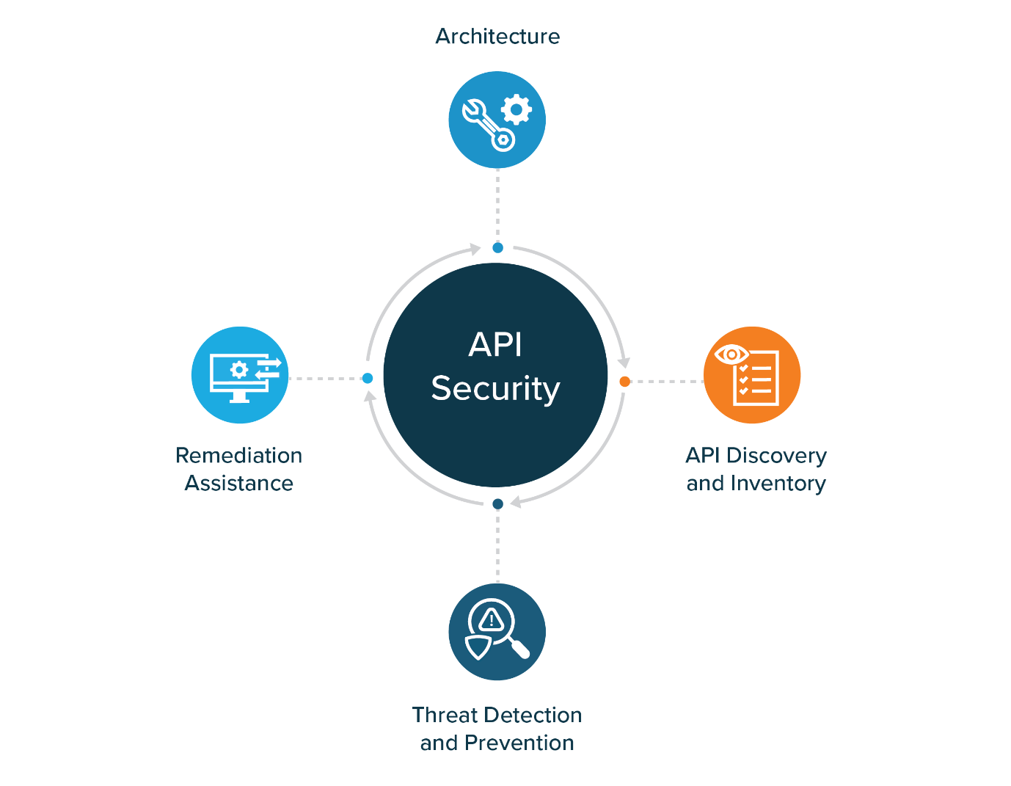
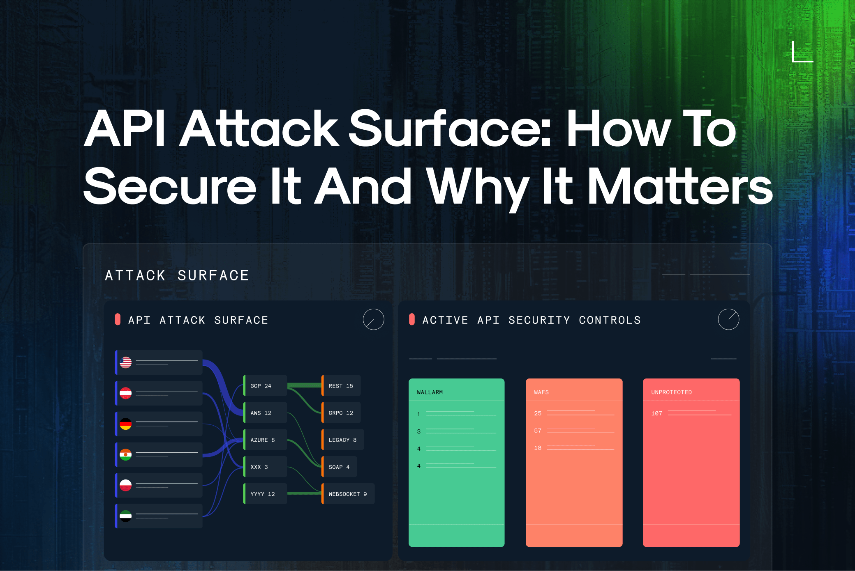
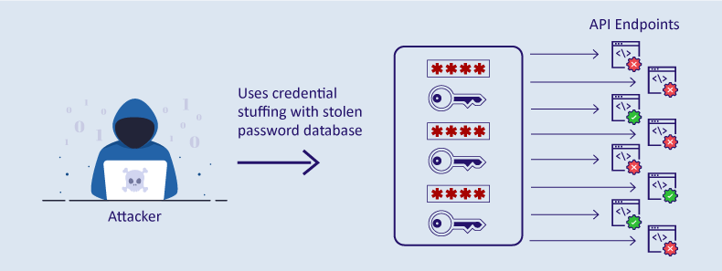
    - What it includes
      - APIs connect:
      - Web apps
      - Mobile apps
      - Third-party services
      - Attack surface includes:
      - API endpoints (URLs)
      - HTTP methods (GET, POST, PUT, DELETE)
      - Authentication tokens
      - Rate limits
      - Input parameters
      - Versioned APIs
    - Why APIs are high-risk
      - Exposed directly to the internet
      - Often lack proper authentication
      - Trusted blindly by applications
      - Difficult to monitor
    - Common attacks
      - Broken Object Level Authorization (BOLA)
      - Excessive data exposure
      - API key abuse
      - Mass assignment attacks
      - Rate-limit bypass
      - Parameter tampering
    - Real-world example
      - An API endpoint:
      - /api/users/123
      - If authorization is missing, an attacker changes 123 to 124 and accesses another user’s data.
    - Impact
      - Large-scale data leaks
      - Business logic abuse
      - Automation attacks
    - Key security lesson
      - APIs should never trust the client.

  - 4. Network Attack Surface
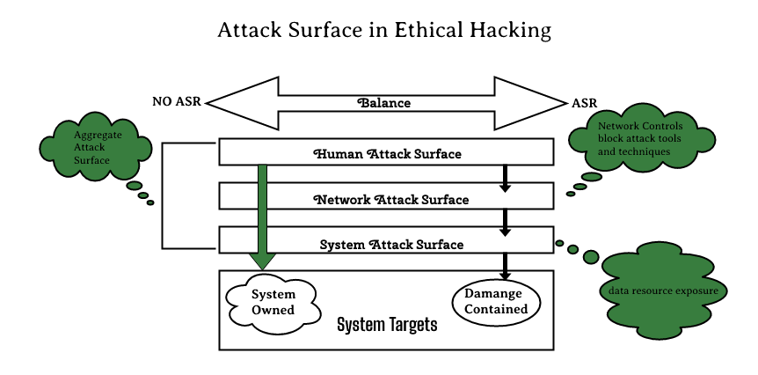
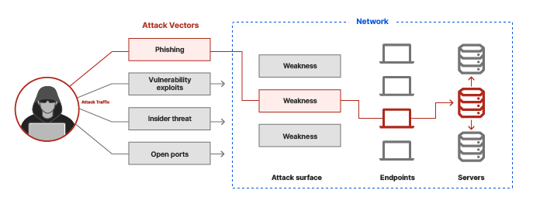
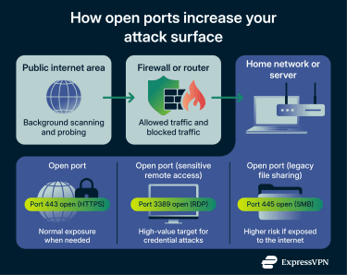
    - What it includes
      - Networks form the backbone of IT systems.
      - Attack surface includes:
      - Open ports
      - Routers and switches
      - Firewalls
      - VPN gateways
      - DNS servers
      - Wi-Fi networks
    - Why attackers target networks
      - Direct access to internal systems
      - Often misconfigured
      - Legacy devices remain unpatched
    - Common attacks
      - Port scanning
      - Man-in-the-middle attacks
      - DNS poisoning
      - ARP spoofing
      - Network sniffing
      - DDoS attacks
    - Real-world example
      - If port 3389 (Remote Desktop) is open:
      - Attackers brute-force login
      - Gain full system control
    - Impact
      - System takeover
      - Data interception
      - Service outages
    - Key security lesson
      - Every open port is a door — lock what you don’t need.

  - 5. Cloud Infrastructure Attack Surface
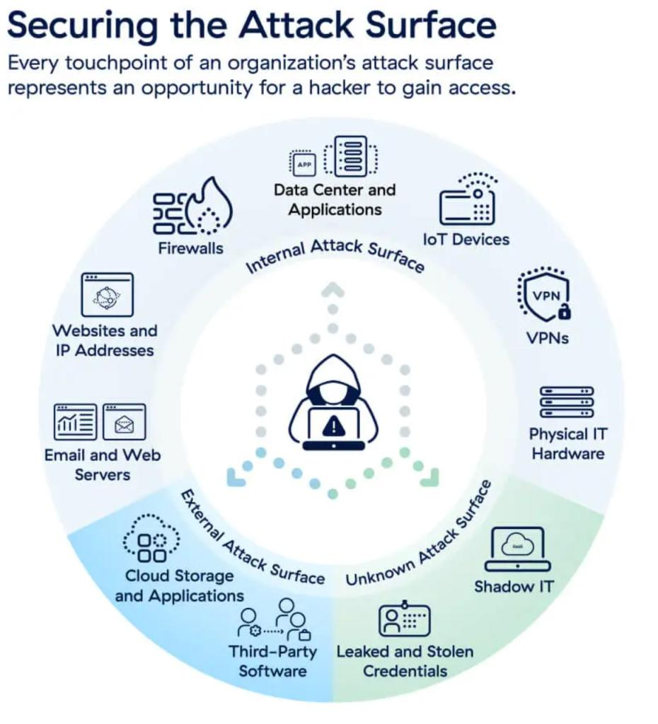
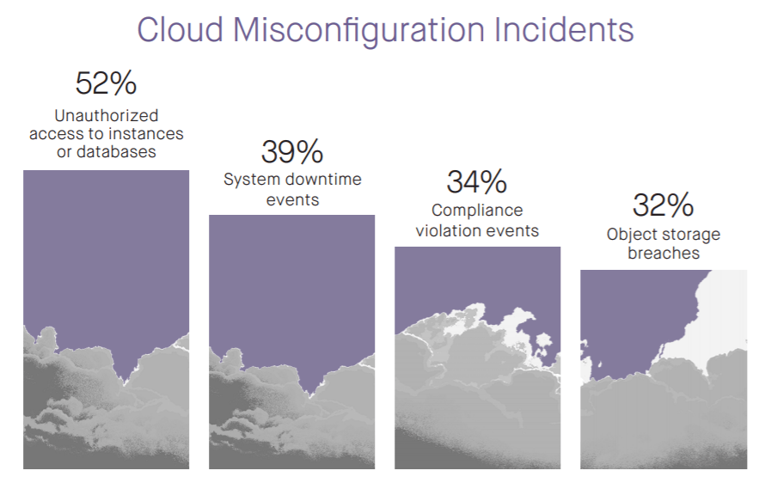
    - What it includes
      - Cloud systems are powerful but complex.
      - Attack surface includes:
      - Public cloud storage buckets
      - Virtual machines
      - IAM roles and permissions
      - Management consoles
      - APIs and automation scripts
      - CI/CD pipelines
    - Why cloud attacks happen
      - Misconfigurations
      - Over-permissioned IAM roles
      - Weak credentials
      - Shared responsibility misunderstanding
    - Common attacks
      - Publicly exposed storage buckets
      - Privilege escalation
      - Credential theft
      - Supply chain attacks
      - Lateral movement inside cloud accounts
    - Real-world example
      - A storage bucket configured as “public” exposes:
      - Customer data
      - Backups
      - Logs
      - Anyone with the link can download the data.
    - Impact
      - Massive data breaches
      - Compliance violations
      - Financial penalties
    - Key security lesson
      - In the cloud, misconfiguration is the #1 enemy.
Attack Surface | Common Weakness | Typical Impact
Web Apps | Input validation | Data breaches
Mobile Apps | Hardcoded secrets | Account takeover
APIs | Broken authorization | Mass data leaks
Networks | Open ports | System compromise
Cloud | Misconfiguration | Large-scale breaches

4.Visit OWASP Top 10 and carefully read each vulnerability description to understand why they are dangerous.
- OWASP Top 10 Vulnerabilities
Introduction
The OWASP Top 10 is a globally accepted list of the most critical security risks affecting web applications. It is created by the Open Web Application Security Project (OWASP) based on real-world attack data, security research, and industry reports.
These vulnerabilities highlight common weaknesses that attackers exploit to gain unauthorized access, steal data, or disrupt services. Understanding why these vulnerabilities are dangerous helps developers and security professionals design secure systems.

1. Broken Access Control
Broken Access Control occurs when users can access resources or perform actions beyond their intended permissions.
Why it is dangerous
- Allows attackers to view or modify other users’ data
- Enables privilege escalation
- Can expose administrative functions
Example
A normal user manually changes a URL parameter to access another user’s account or admin panel.
Impact
- Data breaches
- Account takeover
- Legal and compliance issues

2. Cryptographic Failures (Sensitive Data Exposure)
Cryptographic failures happen when sensitive data is not properly protected using encryption or secure storage mechanisms.
Why it is dangerous
- Exposes passwords, credit card details, and personal data
- Enables identity theft and financial fraud
Example
Passwords stored in plain text or data transmitted over HTTP instead of HTTPS.
Impact
- Financial loss
- Privacy violations
- Regulatory penalties

3. Injection
Injection vulnerabilities occur when untrusted user input is sent directly to an interpreter such as SQL, NoSQL, or operating system commands.
Why it is dangerous
- Attackers can execute arbitrary commands
- Databases can be read, modified, or deleted
Example
SQL Injection used to bypass login authentication.
Impact
- Complete database compromise
- Loss or manipulation of data

4. Insecure Design
Insecure Design refers to weaknesses introduced due to poor system architecture or lack of security consideration during the design phase.
Why it is dangerous
- Cannot be fixed easily by patches
- Enables business logic abuse
Example
No limit on login attempts or no verification step before money transfer.
Impact
- Fraud
- Abuse of application functionality

5. Security Misconfiguration
Security Misconfiguration occurs when systems are deployed with insecure default settings or incorrect configurations.
Why it is dangerous
- Exposes internal systems
- Makes attacks easier
Example
Default admin passwords, open cloud storage, debug mode enabled in production.
Impact
- Unauthorized access
- Data leakage

6. Vulnerable and Outdated Components
This vulnerability arises when applications use libraries, frameworks, or software components with known security flaws.
Why it is dangerous
- Public exploits are already available
- Attackers do not need advanced skills
Example
Using outdated server software or third-party libraries with known vulnerabilities.
Impact
- Large-scale attacks
- Supply-chain compromise

7. Identification and Authentication Failures
Authentication failures occur when login systems, password policies, or session handling are weak.
Why it is dangerous
- Attackers can impersonate users
- Enables account takeover
Example
Weak passwords, no account lockout, reused session IDs.
Impact
- Unauthorized transactions
- Loss of user trust

8. Software and Data Integrity Failures
These failures occur when applications trust software updates, plugins, or data without proper verification.
Why it is dangerous
- Allows malicious code injection
- Enables supply-chain attacks
Example
Unsigned software updates or compromised CI/CD pipelines.
Impact
- Widespread system compromise
- Hidden backdoors

9. Security Logging and Monitoring Failures
This vulnerability exists when systems do not properly log or monitor security events.
Why it is dangerous
- Attacks remain undetected
- Delayed response increases damage
Example
No alerts for repeated failed login attempts or admin access.
Impact
- Long-term breaches
- Greater financial and reputational loss

10. Server-Side Request Forgery (SSRF)
SSRF occurs when attackers trick a server into making unauthorized requests to internal or external systems.
Why it is dangerous
- Exposes internal services
- Can compromise cloud infrastructure
Example
Server forced to access internal admin URLs or cloud metadata services.
Impact
- Internal network exposure
- Cloud account takeover

Conclusion
The OWASP Top 10 represents the most common and dangerous web application security risks. Most real-world cyber attacks exploit one or more of these vulnerabilities.
Understanding these risks helps:
- Developers build secure applications
- Organizations reduce attack surfaces
- Security teams prioritize defenses

5.Map daily-used applications (email, WhatsApp, banking apps) to possible attack surfaces.

- Mapping Daily-Used Applications to Possible Attack Surfaces
Introduction
Daily-used applications such as email services, messaging applications like WhatsApp, and banking apps are essential parts of modern digital life. These applications interact with users, devices, networks, servers, and cloud infrastructure. Each interaction point creates an attack surface that attackers may exploit to gain unauthorized access, steal data, or disrupt services.
Understanding how these applications map to different attack surfaces helps in identifying potential security risks and applying suitable protections.

1. Email Applications (Gmail, Outlook, Yahoo Mail)
Purpose of Email Applications
- Communication through messages
- Sharing documents and links
- Account recovery for other online services
Possible Attack Surfaces
- Login and Authentication Interface
  - Username and password fields
  - Two-factor authentication mechanisms
- Email Attachments
  - PDF, Word, ZIP, and executable files
  - Malware hidden inside attachments
- Email Links
  - Phishing links
  - Fake websites imitating real login pages
- Email Servers and Protocols
  - SMTP, IMAP, and POP services
  - Email APIs used by third-party applications
- User Devices
  - Web browsers and mobile email apps
  - Stored cookies and session tokens
Example
A phishing email tricks a user into clicking a fake login link. When credentials are entered, the attacker gains access to the email account and can reset passwords for other services.

2. Messaging Applications (WhatsApp, Telegram, Signal)
Purpose of Messaging Applications
- Instant messaging
- Voice and video calls
- Media and document sharing
Possible Attack Surfaces
- Mobile Application
  - Application code that can be reverse engineered
  - Insecure storage of messages or tokens
- Authentication Process
  - OTP-based login
  - SIM-swap attacks
- Network Communication
  - Public Wi-Fi networks
  - Man-in-the-middle attacks
- Media and File Sharing
  - Images, videos, documents
  - Malicious files disguised as normal media
- Cloud Backups
  - Chat backups stored on cloud platforms
  - Weak or disabled encryption for backups
Example
An attacker performs a SIM-swap attack and receives the OTP, taking control of the victim’s WhatsApp account and accessing private conversations.

3. Banking Applications (Mobile Banking, UPI, Wallet Apps)
Purpose of Banking Applications
- Checking account balances
- Transferring money
- Paying bills and merchants
Possible Attack Surfaces
- Login and Authentication Screens
  - User IDs, passwords, PINs
  - Biometric authentication
  - OTP-based verification
- Mobile Application
  - Hardcoded API keys
  - Insecure local data storage
- Backend APIs
  - Fund transfer APIs
  - Balance enquiry APIs
- Network Layer
  - Internet connections
  - Public or insecure Wi-Fi networks
- Device Security
  - Rooted or jailbroken devices
  - Malware installed on user devices
Example
If malware is installed on a user’s phone, it can capture OTPs or screen activity, allowing attackers to perform unauthorized transactions.

Application Type | Major Attack Surfaces | Possible Impact
Email Apps | Login pages, attachments, links | Account takeover
Messaging Apps | OTP login, media files, backups | Privacy breaches
Banking Apps | Authentication, APIs, device security | Financial loss

6.Document how data flows from user → application → server → database.

- Data Flow from User → Application → Server → Database
Introduction
In any modern digital system such as a web application, mobile app, or banking platform, data flows through multiple layers before it is stored or retrieved. Understanding how data flows from the user to the application, then to the server, and finally to the database is essential for system design, performance optimization, and cybersecurity analysis.
This data flow helps identify where processing happens, where security controls are applied, and where attacks may occur.

1. User Layer
Role of the User
- Initiates actions such as login, data entry, or requests
- Interacts through a web browser or mobile application
Data Generated by the User
- Login credentials
- Form inputs
- Search queries
- Transaction details
Example
A user enters a username and password on a login screen and clicks the submit button.

2. Application Layer (Client Side)
Role of the Application
- Acts as an interface between the user and the server
- Collects and formats user input
- Sends requests to the server
Data Processing at This Layer
- Input validation (basic checks)
- UI rendering
- Session handling (cookies or tokens)
Example
A web or mobile application packages the login credentials into a request format such as JSON and sends it securely to the server.

3. Server Layer
Role of the Server
- Receives requests from the application
- Applies business logic
- Enforces authentication and authorization
Data Processing at This Layer
- Validates user credentials
- Checks permissions
- Applies security rules
- Prepares database queries
Example
The server verifies the login details and decides whether the user is authorized to access the system.

4. Database Layer
Role of the Database
- Stores persistent data
- Maintains records securely
- Handles data retrieval and updates
Data Operations
- Read operations (SELECT)
- Write operations (INSERT)
- Update operations (UPDATE)
- Delete operations (DELETE)
Example
The database checks whether the username and password match stored records and returns the result to the server.

5. Reverse Data Flow (Database → Server → Application → User)
From Database to Server
- Database returns requested data
- Server processes and formats the response
From Server to Application
- Server sends a success or failure message
- Includes required data or error information
From Application to User
- Application displays the result
- Shows login success, error message, or requested data
Example
If login is successful, the user is redirected to the dashboard. If not, an error message is displayed.

Complete Data Flow Example (Login Scenario)
- User enters login credentials
- Application captures the input
- Application sends data to the server
- Server validates the credentials
- Server queries the database
- Database returns verification result
- Server sends response to application
- Application displays result to the user

Importance of Understanding Data Flow
- Helps in identifying security risks
- Improves system performance
- Aids in debugging and maintenance
- Essential for designing secure architectures

Conclusion
The data flow from user → application → server → database represents the core operation of most digital systems. Each layer plays a specific role in processing, validating, and storing data. A clear understanding of this flow is crucial for building secure, reliable, and efficient applications.

7.Identify where attacks can happen during this flow.

- Identifying Where Attacks Can Happen During the Data Flow
(User → Application → Server → Database)
Introduction
In a typical system, data flows from the user to the application, then to the server, and finally to the database. At each stage of this flow, there are opportunities for attackers to exploit weaknesses. Identifying where attacks can happen helps in designing strong security controls and preventing data breaches.

1. Attacks at the User Level
Where Attacks Can Occur
- User credentials
- User devices
- User behavior
Common Attacks
- Phishing attacks to steal login credentials
- Social engineering to trick users into revealing sensitive data
- Malware or keyloggers on user devices
Example
A user enters login credentials on a fake website created by an attacker, allowing the attacker to capture the credentials before they reach the real application.

2. Attacks at the Application Level (Client Side)
Where Attacks Can Occur
- Input fields
- Client-side validation logic
- Session storage (cookies or tokens)
Common Attacks
- Cross-Site Scripting (XSS)
- Manipulation of client-side code
- Session hijacking
Example
An attacker injects malicious JavaScript into an input field that executes when another user loads the page.

3. Attacks During Data Transmission
Where Attacks Can Occur
- Network connections
- Public or insecure Wi-Fi
- Communication channels between application and server
Common Attacks
- Man-in-the-middle attacks
- Packet sniffing
- Session replay attacks
Example
An attacker intercepts unencrypted network traffic on a public Wi-Fi network and steals session cookies.

4. Attacks at the Server Level
Where Attacks Can Occur
- Authentication and authorization logic
- Business logic processing
- Server configurations
Common Attacks
- Broken access control
- Authentication bypass
- Remote code execution
- Privilege escalation
Example
An attacker accesses an admin endpoint due to missing authorization checks on the server.

5. Attacks at the Database Level
Where Attacks Can Occur
- Database queries
- Stored procedures
- Database credentials
Common Attacks
- SQL injection
- Unauthorized data modification
- Database privilege abuse
Example
An attacker injects malicious SQL commands through user input to retrieve or delete sensitive data.

6. Attacks During Data Storage
Where Attacks Can Occur
- Stored user data
- Backup files
- Logs
Common Attacks
- Data theft from exposed backups
- Unauthorized access to logs
- Ransomware attacks
Example
A misconfigured database backup is publicly accessible, allowing attackers to download sensitive data.

7. Attacks During Response Flow
(Database → Server → Application → User)
Where Attacks Can Occur
- Server responses
- Error messages
- Output rendering
Common Attacks
- Information leakage through error messages
- Reflected XSS
- Manipulation of response data
Example
Detailed error messages reveal database structure or internal system details to attackers.

Conclusion
Attacks can occur at every stage of the data flow, from the user’s device to the database and back. Each layer presents unique risks that attackers can exploit. By identifying where attacks can happen, organizations can implement appropriate security controls such as input validation, encryption, authentication, access control, and monitoring to protect the system.

8.Summarize the entire understanding in your own words for clarity.

- Summary of Cybersecurity
  - Cybersecurity is the practice of protecting computer systems, networks, applications, and data from unauthorized access, misuse, and attacks. As daily activities such as banking, communication, and social interaction depend on digital platforms, cybersecurity plays a vital role in ensuring trust and safety.
  - The core principles of cybersecurity are explained by the CIA Triad, which includes Confidentiality, Integrity, and Availability.
  - Confidentiality ensures that sensitive information is accessed only by authorized users. In banking systems, confidentiality protects customer account numbers, ATM PINs, online banking passwords, card details, and identity documents. Banks use encryption, two-factor authentication, masked data, and role-based access to protect confidentiality. In social media platforms, confidentiality protects private messages, email addresses, phone numbers, and login credentials. A breach of confidentiality can lead to financial loss, identity theft, and loss of user trust.
  - Integrity ensures that data remains accurate and unaltered except by authorized actions. In banking, integrity is essential for account balances, transaction records, and loan details. Banks maintain integrity using audit logs, digital signatures, and verification systems. In social media, integrity ensures that posts, profiles, and follower counts are not tampered with. Integrity failures lead to misinformation, disputes, and loss of trust.
  - Availability ensures that systems and services are accessible when needed. In banking, availability is required for ATMs, online banking, and digital payments. Banks use backup servers, disaster recovery plans, and DDoS protection to maintain availability. If availability fails, services stop, businesses suffer, and users panic.
  - Cyber attackers differ based on skill and motivation. Script kiddies use ready-made tools and attack weak systems. Insiders misuse trusted access and are difficult to detect. Hacktivists attack for political or social reasons. Nation-state attackers are highly skilled and conduct long-term cyber operations for national interests.
  - An attack surface is any point where an attacker can interact with a system. Common attack surfaces include web applications, mobile apps, APIs, networks, and cloud infrastructure. Larger attack surfaces increase the risk of attacks.
  - The OWASP Top 10 highlights the most dangerous web application vulnerabilities, such as broken access control, injection attacks, insecure design, and security misconfiguration. Most real-world cyber attacks exploit these vulnerabilities.
  - Daily-used applications such as email, WhatsApp, and banking apps interact with users, devices, networks, servers, and databases. Email applications are vulnerable through login pages, attachments, phishing links, servers, and user devices. Messaging apps face risks through OTP authentication, SIM-swap attacks, media sharing, cloud backups, and insecure networks. Banking apps are exposed through authentication screens, mobile app vulnerabilities, backend APIs, network connections, and compromised user devices.
  - Understanding data flow is also critical. Data flows from the user to the application, then to the server, and finally to the database. The database sends responses back through the server and application to the user. At every stage of this flow, attacks can occur. Users can be attacked through phishing or malware, applications through XSS or session hijacking, networks through man-in-the-middle attacks, servers through broken access control or misconfiguration, and databases through SQL injection or exposed backups.
  - In conclusion, cybersecurity is about protecting data, systems, and users by understanding how data flows, where attacks can happen, who the attackers are, and what vulnerabilities exist. By applying the CIA Triad, reducing attack surfaces, addressing OWASP Top 10 risks, and monitoring every layer of the system, organizations can build secure, reliable, and trustworthy digital systems.

