Developing Web Applications and Services

Class code: CSIS44563 – 01; ASSIGNMENT-01

Name: Sairakesh Gajavalli

ID number: 919642075

SID: S566399

Slot- 01:00PM- 1:50PM

**Screen shot1 shows GitHub repo firstrepo and README.**

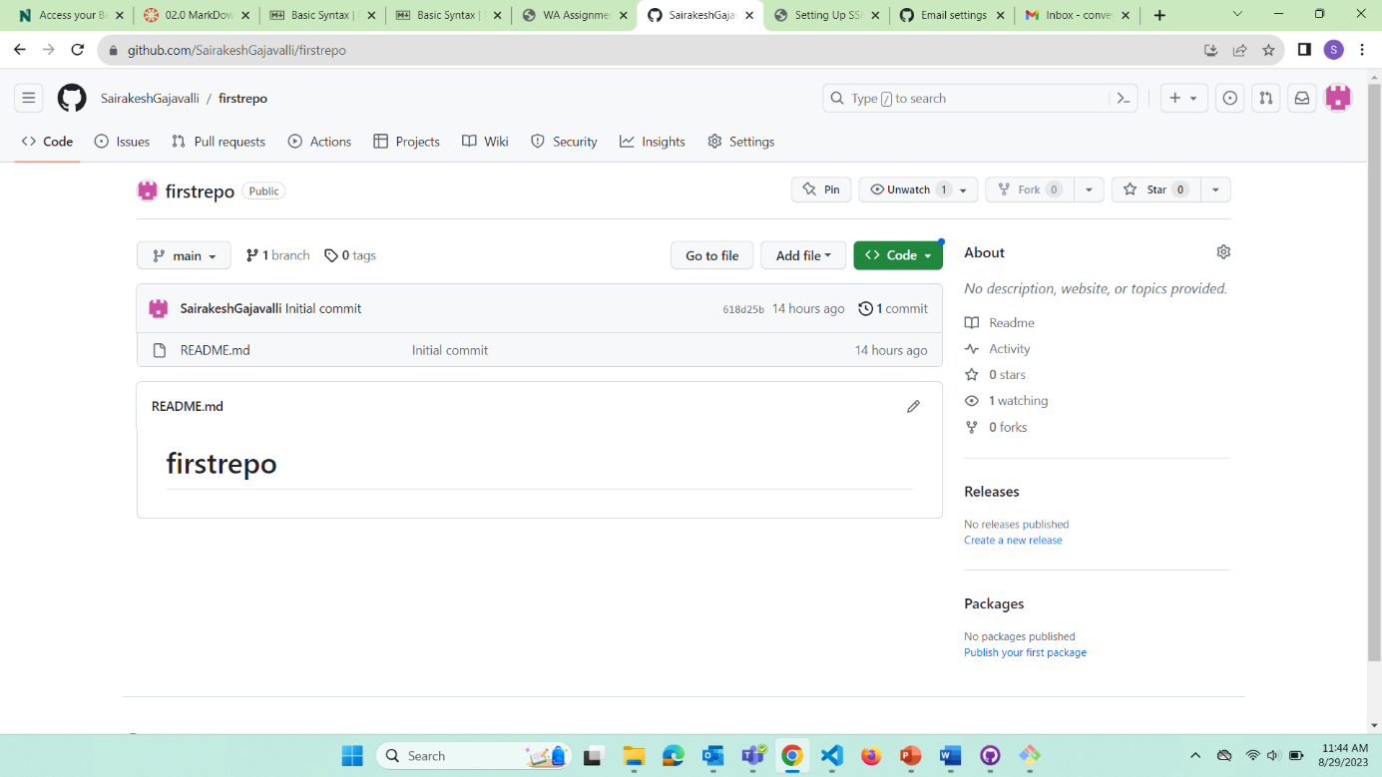

**Screen shot -2 shows second commit and updated markdown render of README.**

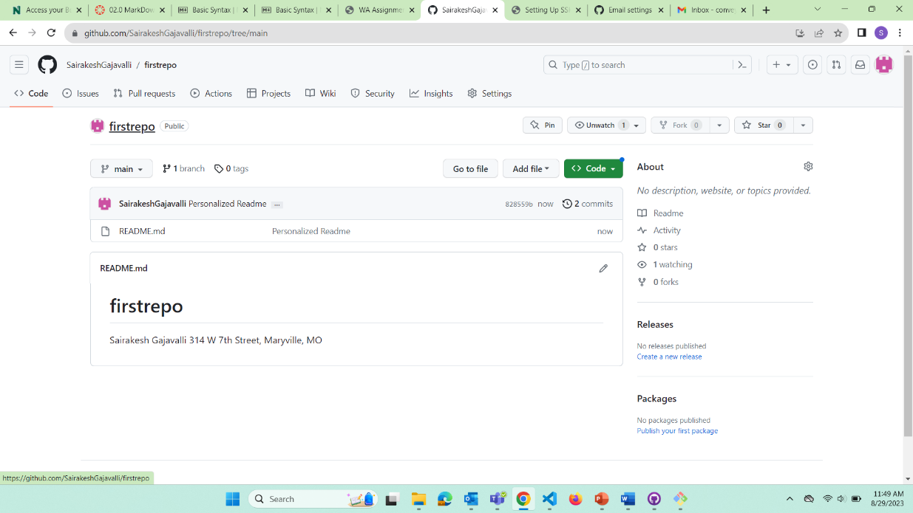

**Screen shot3 shows repo on VScode for submission.**

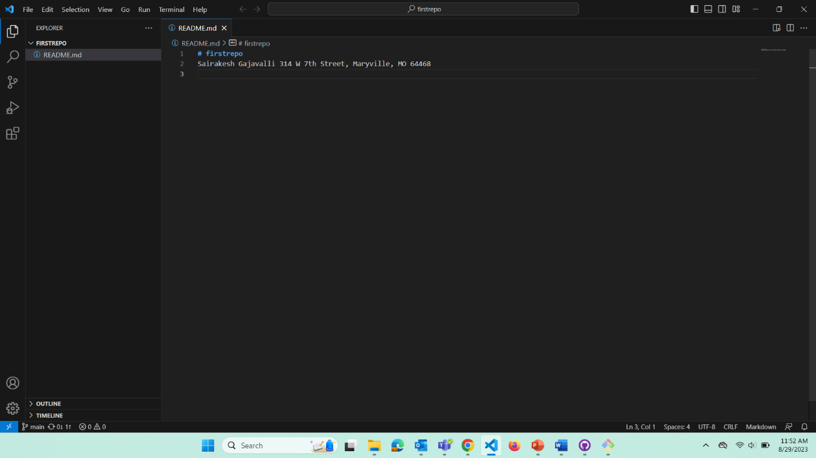

**Screen shot4 shows gitbash with alternative branch creation and checkout.**

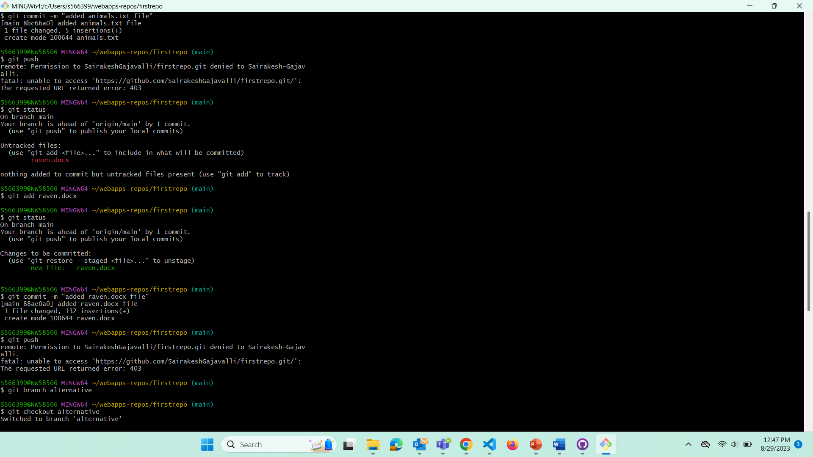

**Screen shot5 shows gitbash window where we dealt with the binary merge conflict.**

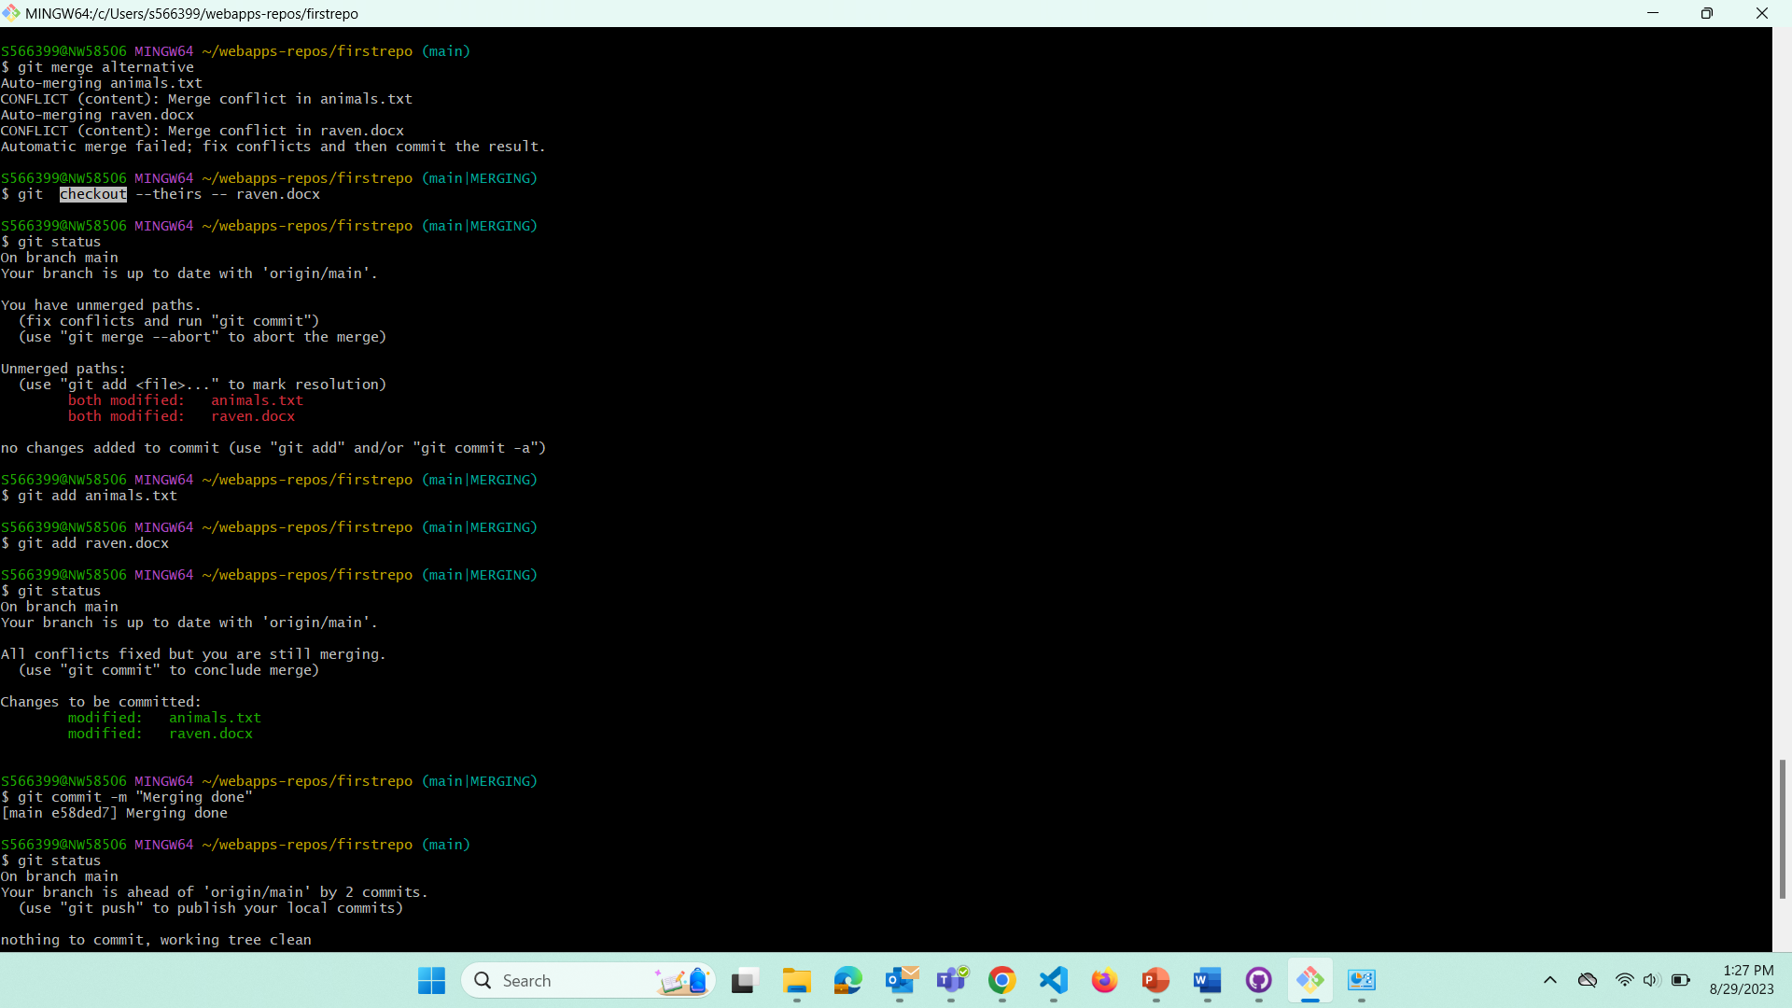

**Screen shot6 shows repo on github.**

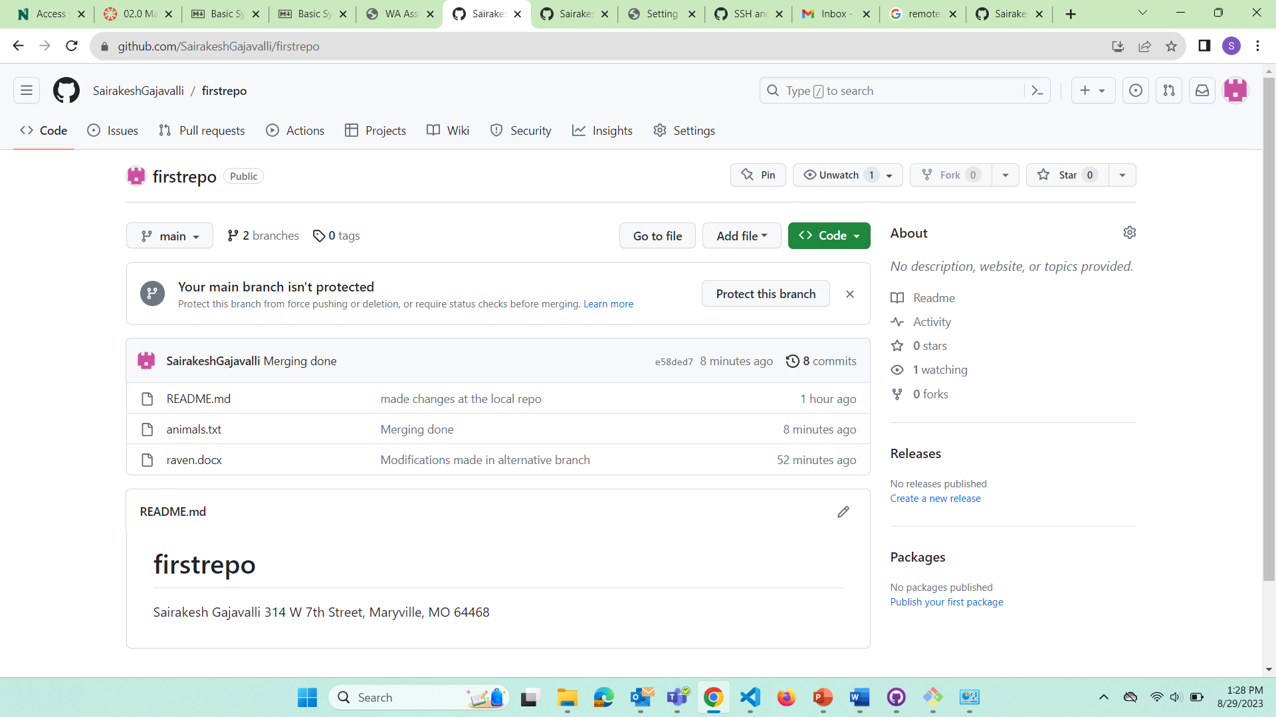

**Screen shot7 shows local repo on github desktop.**

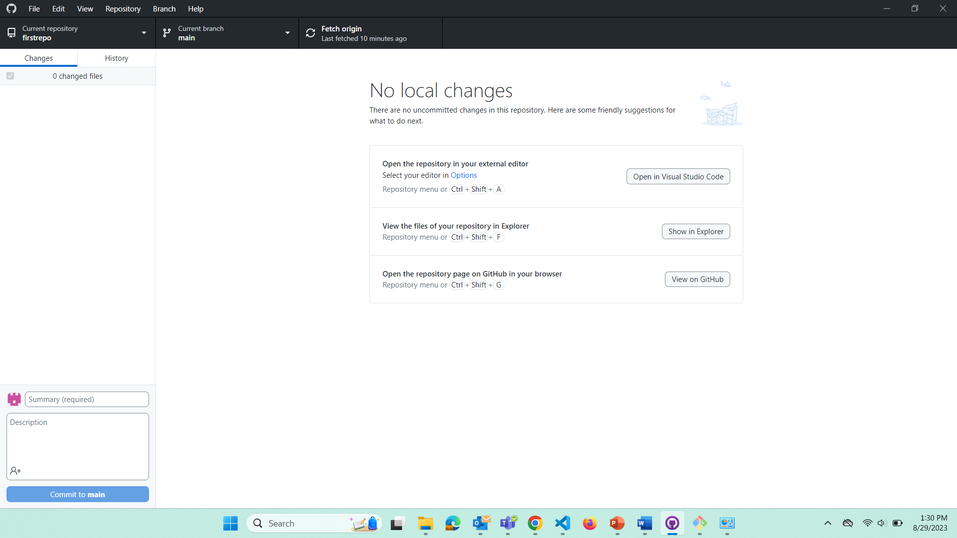

**working link to repo:-**<https://github.com/SairakeshGajavalli/firstrepo>