**Lab Assignment 01**

**Screen shot shows GitHub repo firstrepo and README.**

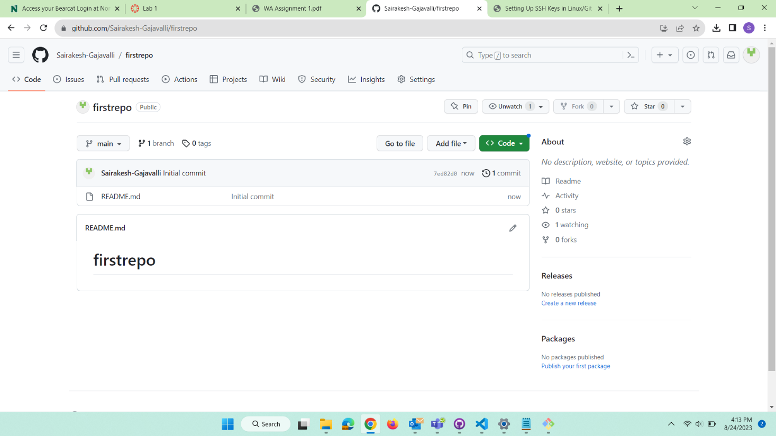

**Screen shot shows second commit and updated markdown render of README.**

