Assignment- 02

Sairakesh Gajavalli

S566399

ID- 919642075

Github link:- <https://github.com/SairakeshGajavalli/my2-Gajavalli>

Screenshot-1

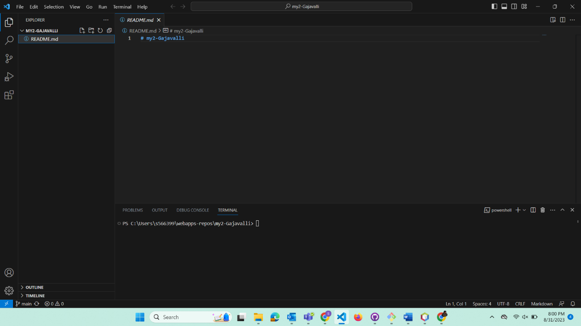

Screen shot-2

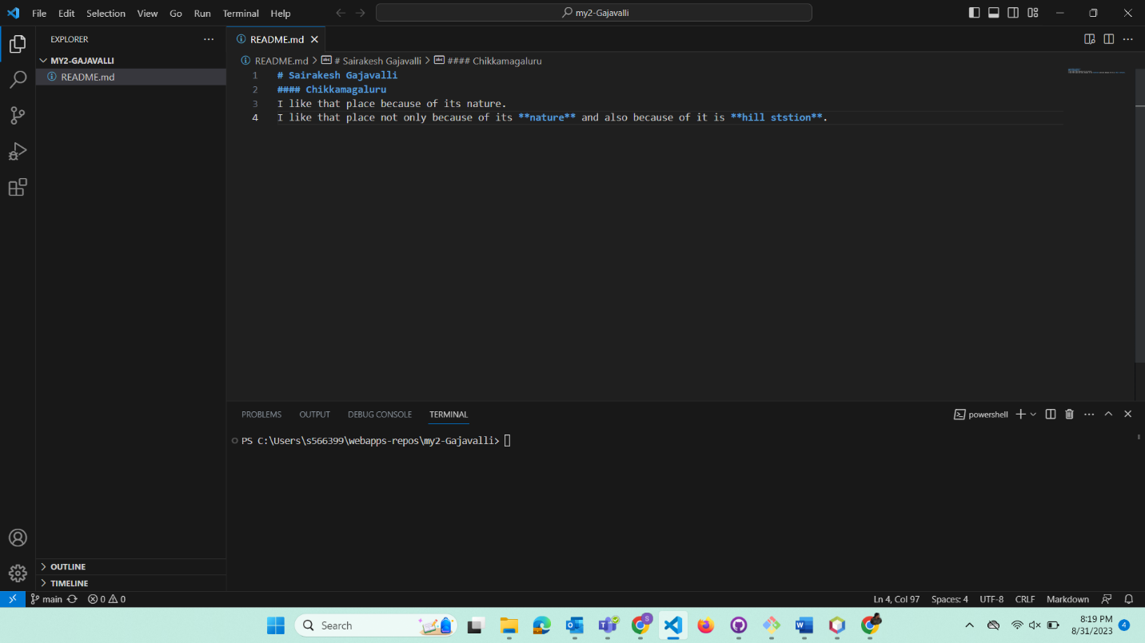

Screen shot-3

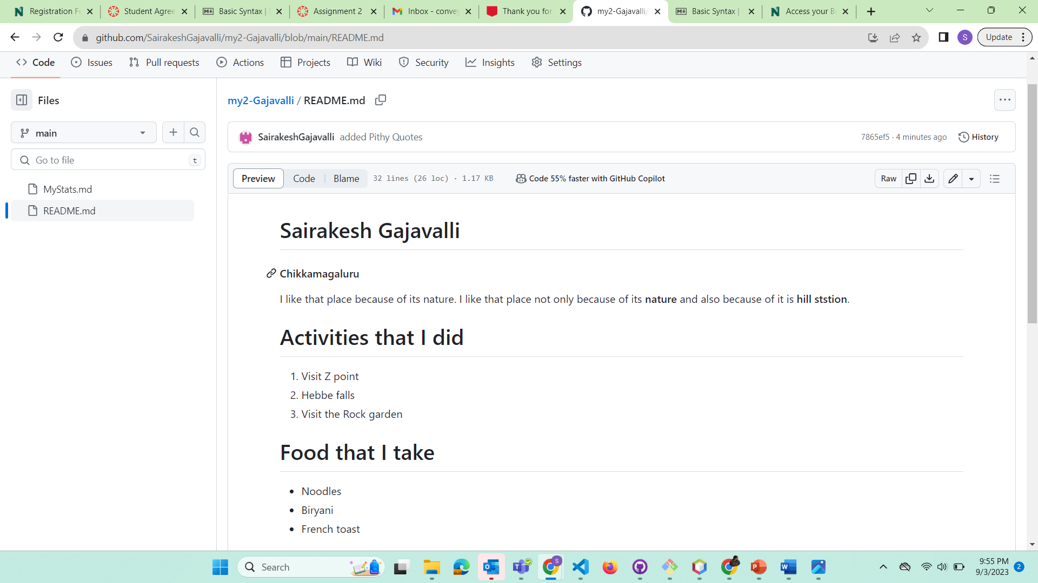

Screen shot-4

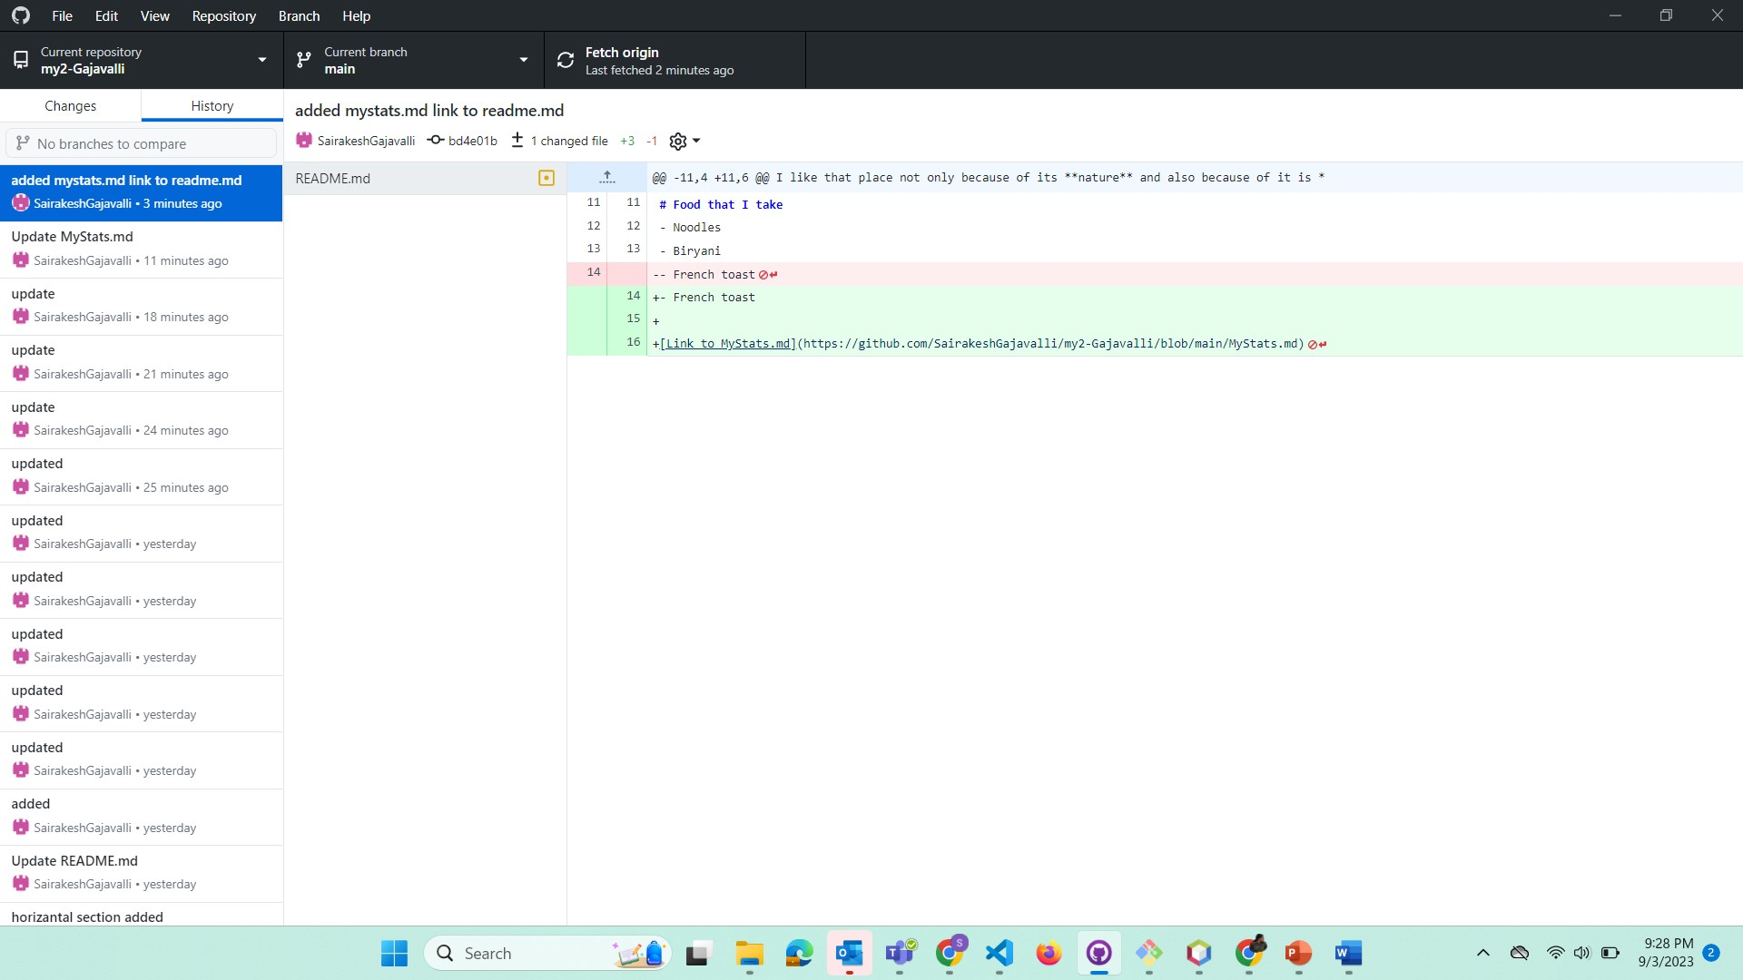

Screen shot-5

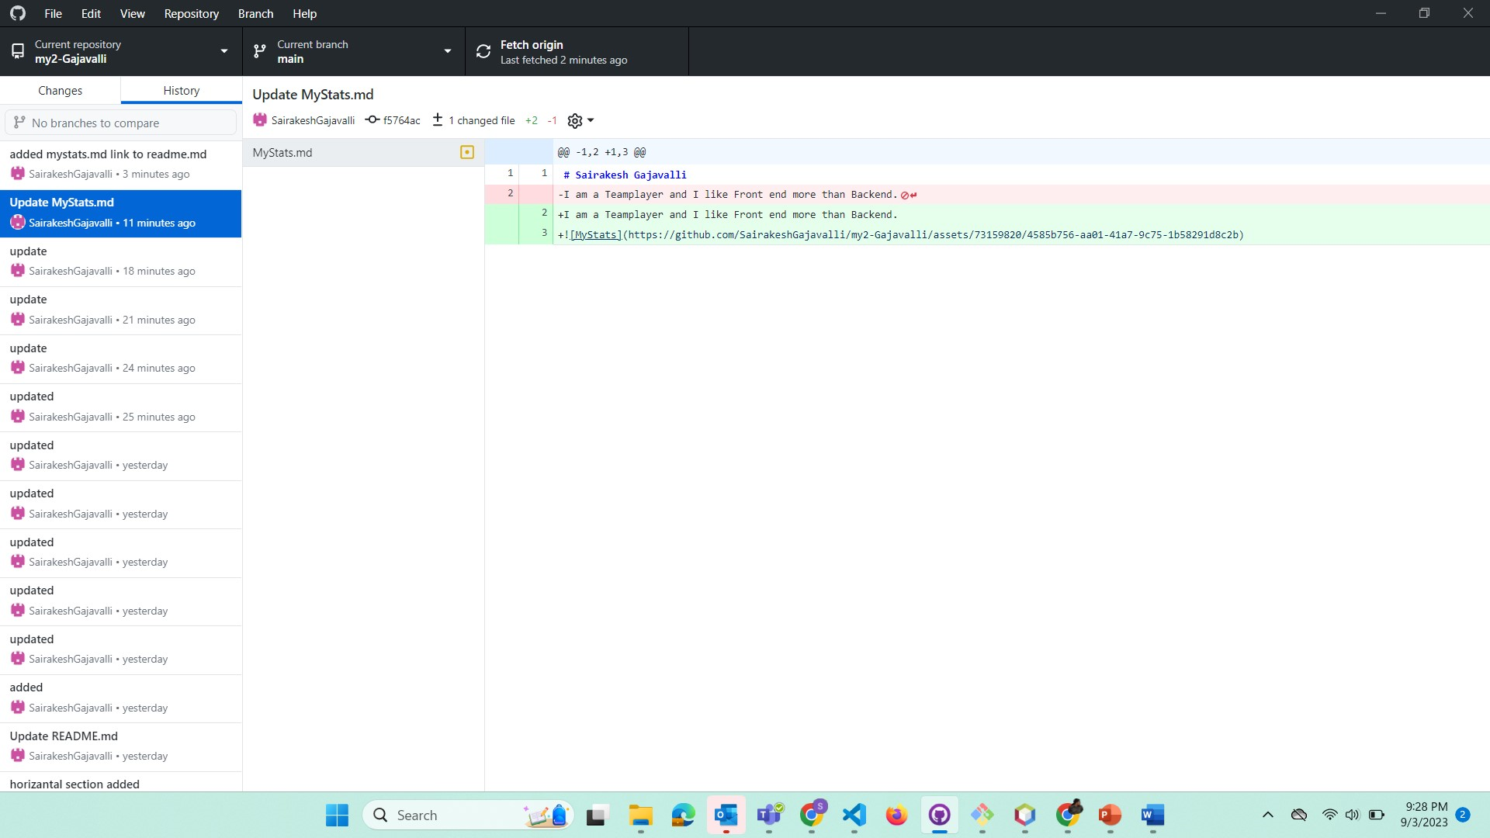

Screen shot-6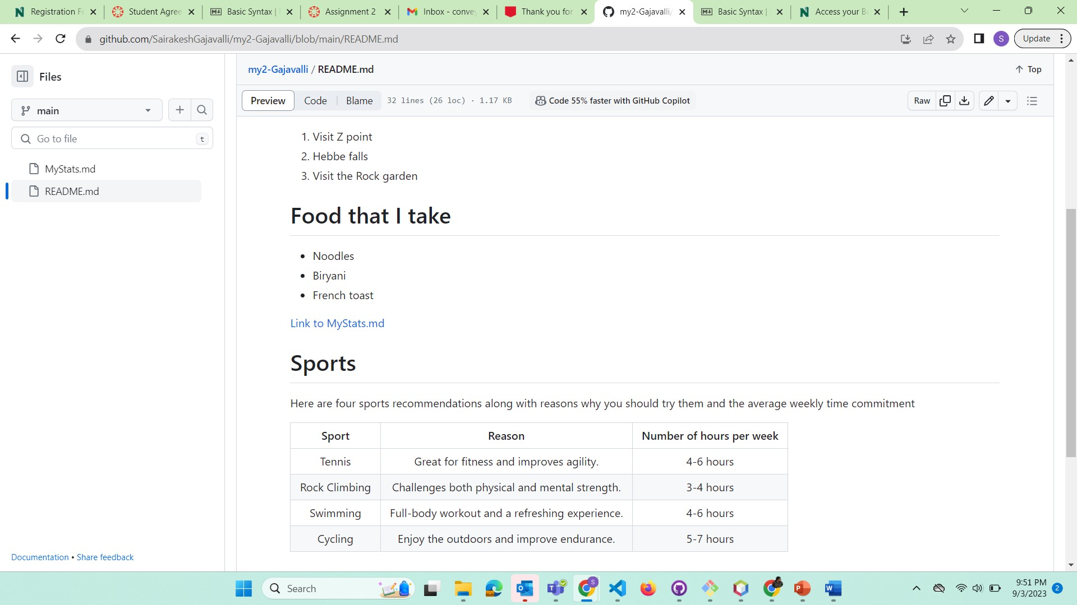

Screen shot-7

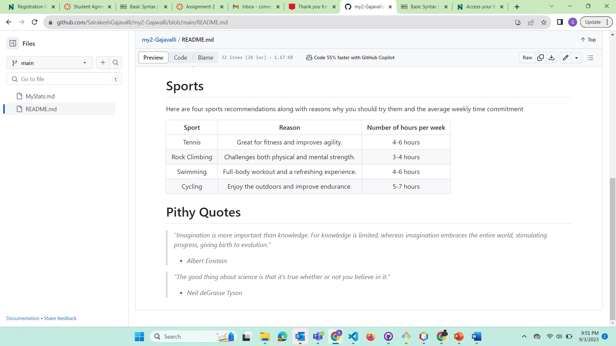

Screen shot- 8

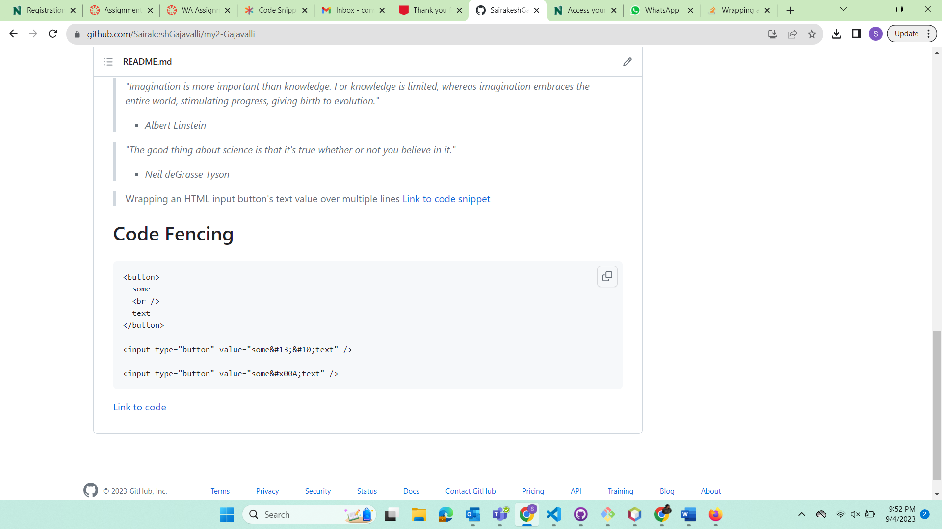

GitHub profile link:- <https://github.com/SairakeshGajavalli>

