**Lab Assignment 02**

**Screen shot1 of repo on VS Code for submission**

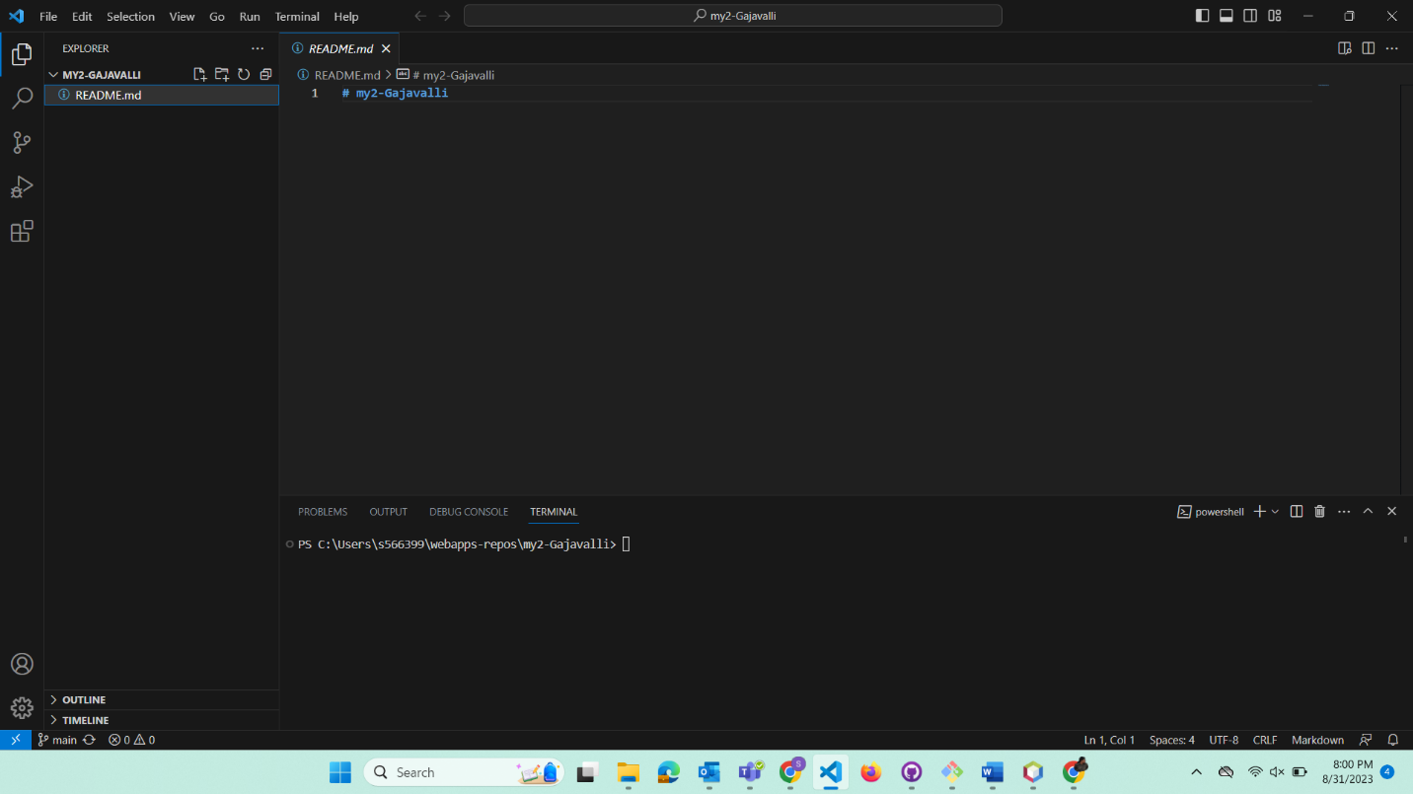

**Screen shot2 on VS Code of edited README**

