A
Summer Internship Report
On
Classifying Objects or Faces in Images and Videos for Identity Verification
Submitted for partial fulfilment of the requirements for the award of the degree of

BACHELOR OF ENGINEERING
In
INFORMATION TECHNOLOGY
By
A Sai Ram Goud – (2451-22-737-023)
Under the guidance of
K Ramya Madhavi



MATURI VENKATA SUBBA RAO (M.V.S.R) ENGINEERING COLLEGE
(An Autonomous Institution)
Department of Information Technology
(Affiliated to Osmania University & Recognized by AICTE)
Nadergul, Saroor Nagar Mandal, Hyderabad – 501 510
AY: 2023-24

Contents
1.Introduction
2. Objective
3.Problem Statement
4. Key Components of the System
5. Workflow
6.Applications
7. Challenges
8. Future Scope
9.Conclusion

Introduction
Object and face classification in images and videos is a critical technology used for identity verification across sectors like banking, healthcare, security, and retail. This case study explores the methodology, challenges, and applications of such systems, focusing on their effectiveness and areas for improvement.

Objective
To classify and verify faces and objects in images or videos accurately, ensuring security and convenience in various real-world applications.

Problem Statement
- Security Threats:
  - Traditional methods like PINs or passwords are prone to hacking or theft, making them less reliable for identity verification.
- Accuracy Issues:
  - Existing systems often struggle with variations in lighting, occlusions (e.g., masks, glasses), and pose differences, leading to inaccurate results.
- Scalability Challenges:
  - Real-time verification in high-traffic environments like airports or retail stores demands fast and scalable solutions.
- Privacy Concerns:
  - Storing and processing biometric data raises issues about data security and compliance with privacy laws.

Key Components of the System
- Data Collection
  - Images and videos collected through cameras or pre-built datasets.
  - High-quality, diverse datasets labeled for training.
- Preprocessing
  - Standardizing images through resizing, noise removal, and normalization.
  - Data augmentation for generalization to unseen scenarios.
- Feature Extraction
  - Algorithms for detecting and extracting relevant features:
    - HOG (Histogram of Oriented Gradients): Captures edge and shape details.
    - Facial Landmarks Detection: Focuses on key features like eyes and mouth.
    - Deep Learning Methods: Uses CNN for feature extraction.
- Classification
  - Machine learning or deep learning models:
    - Support Vector Machines (SVM)
    - Convolutional Neural Networks (CNN)
  - Determines probabilities of a match between input and stored identities.
- Verification
  - Matches detected features against stored templates for identity confirmation.
Workflow
- Input Acquisition:
  - Capture images/videos via camera or upload them manually.
- Preprocessing:
  - Clean and standardize the data for accurate classification.
- Classification:
  - Use pre-trained models like VGGFace or OpenCV to detect faces or objects.
- Verification:
  - Compare the detected face or object with database entries.
- Output:
  - Grant or deny access based on match confidence.

Applications
- Banking:
  - Biometric authentication for secure financial transactions.
- Healthcare:
  - Verifying patient identities for personalized care.
- Security:
  - Facial recognition for access control in sensitive locations.
- Retail:
  - Identifying frequent customers for tailored shopping experiences.
- Law Enforcement:
  - Tracking suspects or missing individuals using surveillance footage.
Challenges
- Lighting Variations:
  - Poor illumination impacts detection accuracy.
- Occlusions:
  - Masks, glasses, or other obstructions hinder proper classification.
- Pose Variations:
  - Faces at unusual angles may not be identified correctly.
- Large-Scale Data:
  - High volumes of real-time data processing demand efficient systems.
- Privacy and Compliance:
  - Adhering to regulations like GDPR while managing sensitive biometric data.

Example: Airport Security System
Problem:
- Manual identity checks at airport security are time-consuming and error-prone.
Solution:
- Deploy a facial recognition system integrated with government databases for automated identity verification.
Outcome:
- Reduced passenger processing time by 50%.
- Enhanced security by detecting flagged individuals in real time.

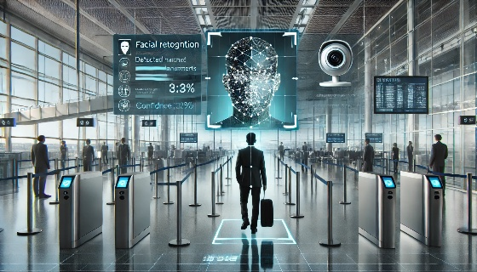

Future Scope
- Synthetic Data Generation:
  - Using Generative AI to create diverse training datasets for improved accuracy.
- Edge Computing:
  - Enabling low-latency real-time processing at the device level.
- Explainable AI:
  - Providing transparency in decision-making to build trust among users.

Conclusion
Classifying objects or faces in images and videos for identity verification addresses the growing need for secure and efficient systems. Despite challenges like accuracy and privacy, advancements in deep learning and hardware make these systems increasingly reliable and scalable, ensuring their broad applicability across various industries.

