A
Summer Internship Report
On

Age and Gender Detection

Submitted for partial fulfilment of the requirements for the award of the degree of

BACHELOR OF ENGINEERING

In
INFORMATION TECHNOLOGY

By

Oggu Pooja – (2451-20-737-139)
B Hari Priya – (2451-20-737-156)
S Nishith Reddy – (2451-20-737-180)
Under the guidance of
Dr CH Samson

AWS
(Duration: May 17th, 2023 to July 14th,2023)



MATURI VENKATA SUBBA RAO (M.V.S.R) ENGINEERING COLLEGE
(An Autonomous Institution)
Department of Information Technology
(Affiliated to Osmania University & Recognized by AICTE)
Nadergul, Saroor Nagar Mandal, Hyderabad – 501 510
AY: 2023-24


CERTIFICATE

This is to certify that the summer internship report entitled “Age and Gender detection using deep learning” is a bonafide work carried out by Mr.A.Sai Ram Goud (2451-22-737-023),Mr.G.Sai Vihan(2451-22-737-048),Mr.N.Narean(2451-22-737-308) in partial fulfilment of the requirements for the award of degree of Bachelor of Engineering in Information Technology from Maturi Venkata Subba Rao (M.V.S.R.) Engineering College of Atonomous Institution, affiliated to Osmania University Hyderabad, during
the Academic Year 2024-2025 at Hyderabad.

The results embodied in this report have not been submitted to any other university or institute for the award of any degree or diploma.

Summer Internship Co-ordinator HOD
Dr.CH.Samson Dr. K. VenugopalaRao
Professor Dean – Academics, Professor, Head
Department of IT Department of IT
MVSREC MVSREC

External Examiner





DECLARATION

This is to certify that the work reported in the present Summer Internship entitled “Reuniting Paws Website” is a record of bonafide work done by us in the Department of Information Technology, Maturi Venkata Subba Rao (M.V.S.R.) Engineering College, an Autonomous Institution, affiliated to Osmania University. The reports are based on the project work done entirely by us and not copied from any other source. The results embodied in this project report have not been submitted to any other University or Institute for the award of any degree or diploma to the best of our knowledge and belief.

A Sai Ram Goud (2451-22-737-023)
G Sai Vihan(2451-22-737-048)
N Narean(2451-22-737-308)

ACKNOWLEDGEMENT

We would like to express our sincere gratitude to Dr CH Samson for giving me the opportunity and to do an internship within the organization and giving valuable suggestions and interest throughout the course of this work.
We would like to express our sincere gratitude and indebtedness to our Summer Internship Co-ordinator Dr.CH.Samson, Professor, for their valued recommendations and attention throughout the course of this project.
We are also thankful to our Principal Dr. G. Kanaka Durga, Professor and Dr. K.
Venugopala Rao, Professor and Head - Department of Information Technology, Dean Academics, Maturi Venkata Subba Rao Engineering College, for providing excellent infrastructure for completing this project successfully as a part of our B.E. (IT).
Finally, we would like to take this opportunity to thank our family for their support through the work. We sincerely acknowledge and thank all those who gave directly or indirectly their support in completion of this work.

A Sai Ram Goud (2451-22-737-023)
G Sai Vihan(2451-22-737-048)
N Narean(2451-22-737-308)

VISION & MISSION,

PROGRAM EDUCATIONAL OUTCOMES

Vision of the Department:
To impart technical education producing competent and socially responsible engineering professionals in the field of Information Technology
Mission of the Department:
To make the teaching-learning process effective and stimulating.
To provide fundamental knowledge of sciences and IT with a positive attitude.
To create an environment that enhances industry-relevant skills.
Program Educational Objectives:
Graduates of the Information Technology program are expected to achieve the following within 3–4 years of graduation
- Core Knowledge and Application
  - Utilize a strong foundation in mathematics, computing, and core engineering principles to solve real-world problems.
  - Apply IT knowledge to design, develop, and implement efficient and innovative solutions in multidisciplinary fields.
- Professionalism and Ethics
  - Exhibit professional and ethical behavior in their careers, adhering to societal and environmental responsibilities.
  - Promote inclusivity and ethical decision-making in the workplace.
- Effective Communication and Teamwork
  - Communicate effectively with diverse teams and stakeholders through verbal, written, and digital means.
  - Lead or work collaboratively in teams to manage projects in a dynamic, global environment.
- Continuous Learning and Development
  - Pursue lifelong learning to adapt to the evolving technology landscape, acquiring new skills, certifications, or higher education.
  - Stay updated with emerging trends in IT and related industries to maintain relevance in their professional careers.
- Innovation and Entrepreneurship
  - Foster creativity and innovation in solving complex problems, driving technological advancements, or initiating entrepreneurial ventures.
  - Identify opportunities for societal betterment through technological innovations.

PROGRAM OUTCOMES & PROGRAM SPECIFIC OUTCOMES

PROGRAM OUTCOMES (POs)

Engineering Graduates will be able to:

1.Engineering Knowledge
Apply knowledge of mathematics, science, and engineering fundamentals to design and implement a website that reunites lost pets with their owners.
2.Problem Analysis
Identify, analyze, and define the requirements of the Reuniting Paws platform to address real-world challenges related to pet recovery.
3.Design/Development of Solutions
Design and develop a responsive and user-friendly website that meets the specified needs for efficient pet recovery while ensuring usability and accessibility.
4.Modern Tool Usage
Use modern tools like web development frameworks, APIs, and image recognition libraries to create an effective platform.
5.The Engineer and Society
Assess societal needs and develop a system that fosters community involvement and raises awareness about lost pets.
6.Environment and Sustainability
Develop a sustainable solution by leveraging cloud resources and optimizing the website's efficiency to reduce environmental impact.
7.Ethics
Adhere to ethical principles by ensuring data privacy and security for users and their information.
8.Communication
Facilitate effective communication by creating an intuitive interface and clear instructions for users.
9.Teamwork
Collaborate effectively in teams during development phases, ensuring smooth integration of modules like geolocation, notifications, and image recognition.
10.Project Management and Finance
Apply project management principles to handle time, resources, and budgeting for developing and deploying the Reuniting Paws platform.
11.Life-long Learning
Recognize the need for continuous improvement by updating the website with emerging technologies and features to stay relevant.

PROGRAM SPECIFIC OUTCOMES (PSOs):

1.Web Development and Design
Ability to analyze, design, and implement a scalable, visually appealing, and user-friendly web platform to address the challenge of reuniting lost pets with their owners.
2.Image Recognition and Geolocation
Utilize advanced technologies like image recognition and geolocation APIs to enable efficient pet identification and tracking.
3.Community Engagement
Foster community participation through features like real-time notifications, sharing on social media, and interactive user interfaces to enhance the platform’s effectiveness.
4.Data Security and Privacy
Implement robust security mechanisms to protect user data and ensure privacy, adhering to ethical and legal standards.

COURSE OBJECTIVES & COURSE OUTCOMES

COURSE OBJECTIVES
1.Problem-Solving Skills
Develop the ability to identify and analyze challenges associated with lost pet recovery and propose efficient technological solutions.
2.Web Development Proficiency
Gain hands-on experience in designing and implementing a functional and responsive web platform for real-world applications.
3.Technological Integration
Understand and utilize modern tools and technologies such as image recognition APIs, geolocation services, and cloud storage in web development.
4.Community-Oriented Design
Create a user-friendly system that fosters community engagement and addresses societal concerns effectively.
5.Ethical and Secure Practices
Ensure ethical development practices, focusing on user data privacy, security, and system reliability.

COURSE OUTCOMES

CO1
Formulate and analyze the requirements of a web-based solution to address the real-world issue of lost pets.
CO2
Design and develop a responsive and interactive website with features like reporting lost pets, uploading images, and real-time notifications.
CO3
Integrate technologies like image recognition and geolocation APIs into the platform to enhance functionality and efficiency.
CO4
Implement secure and privacy-compliant solutions for user data and pet information to ensure trustworthiness.
CO5
Evaluate the performance of the website by testing for usability, responsiveness, and accuracy, ensuring it meets predefined objectives.
CO6
Demonstrate an understanding of the impact of technology on society and sustainability through this community-driven project.
criteria

WEEKLY OVERVIEW OF INTERNSHIP ACTIVITIES

1st  WEEK | DATE | DAY | NAME OF THE TOPIC/MODULE  COMPLETED
 | 17/05/23 | Wednesday | Introduction to the project: understanding the requirements and scope of the website.
 | 18/05/23 | Thursday | Research on existing solutions for pet recovery platforms and identifying gaps.
 | 20/05/23 | Saturday | Setting up the project folder structure with HTML, CSS, Node.js, and a JSON file.

2nd  WEEK | DATE | DAY | NAME OF THE TOPIC/MODULE COMPLETED
 | 05/06/23 | Monday | Designing the homepage layout with navigation links using HTML and CSS.
 | 06/06/23 | Tuesday | Creating the pet reporting form to accept input data and images.
 | 10/06/23 | Saturday | Writing Node.js scripts to handle form submissions and store data in a JSON file.

3rd  WEEK | DATE | DAY | NAME OF THE TOPIC/MODULE COMPLETED
 | 22/06/23 | Thursday | Developing the "Found Pets" page to dynamically display data from the JSON file.
 | 23/06/23 | Friday | Adding functionality for filtering and searching pets based on input criteria.
 | 24/06/23 | Saturday | Testing the JSON file integration and ensuring data is correctly saved and retrieved.

4th  WEEK | DATE | DAY | NAME OF THE TOPIC/MODULE COMPLETED
 | 03/07/23 | Monday | Styling the website for responsiveness and accessibility using CSS
 | 04/07/23 | Tuesday | Conducting final tests to ensure all features function correctly, fixing any bugs.
 | 07/07/23 | Friday | Deploying the website locally and preparing project documentation.

ABSTRACT

Reuniting Paws is a user-friendly website aimed at helping pet owners and animal enthusiasts reunite lost pets with their families. The platform provides a space for users to report missing pets and search for animals that have been found. By allowing pet owners to upload essential information such as photos, breed, and location, Reunite Paws enhances the chances of quick identification and recovery. The website features an interactive map that helps track sightings and the last known locations of lost pets, making the search process more efficient. Additionally, Reunite Paws offers educational resources, including tips on what to do if a pet goes missing, how to safely approach a found pet, and ways to spread the word through social media and local networks. The website also encourages community involvement by providing a platform for users to share updates, success stories, and offer support to others going through similar experiences. By creating a compassionate and accessible environment, Reunite Paws ensures that lost pets have a better chance of being safely reunited with their families

TABLE OF CONTENTS

CONTENTS PAGE NO
Certificate i
Certificate (Organization) ii
Declaration ii
Acknowledgement iii
Vision & Mission, PEOs iv
POs and PSOs v-vi
Course Objectives & Outcomes vii
Weekly Overview Of Internship Activities viii
Abstract ix
Table of Contents x
List of Figures xi
List of Tables xii
List of Abbreviations xiii
Chapters
- Introduction 1 - 2
  - Problem statement
  - Existing system
  - Proposed system
  - Scope
- System Requirement Specifications 3
  - Software Requirements
  - Hardware Requirements
  - System Architecture / Block Diagram
- Design & Implementation 4 - 8
  - Features
  - Environmental Setup
- Test & Results 9 - 11
  - Test cases
  - Results
- Conclusion & Future Enhancements 12
References 13
Appendix 14-18
A: source/pseudo code

xi

LIST OF FIGURES

Figure No. | Figure Name | Page No.
2.3.1 | System Architecture | 2
3.2.1 | Downloading Anaconda | 3
3.2.2 | Anaconda Install | 4
3.2.3 | Open Anaconda Navigator | 4
3.2.4 | Launch Jupyter Notebook | 5
3.2.5 | Verifying python | 5
4.2.2 | Analysing results for graphs | 9
4.2.3 | Finding accuracy | 9
4.2.4 | Result analysis | 10

xii

LIST OF TABLES

Table No. | Table Name | Page No.
4.1.1 | Test cases | 8

xiii

LIST OF ABBREVIATIONS

CNN | Convolutional Neural Network
FA | Finding accuracy
API | Application Programming Interface
Python IDLE | Python Integrated Development and Learning Environment

INTRODUCTION

Reuniting Paws is a website designed to make it easier for pet owners to find their lost pets and for people who find stray animals to reconnect them with their families. Losing a pet can be stressful, so the platform provides a simple way to report missing pets by uploading photos, descriptions, and the last seen location. Similarly, those who find stray animals can share their details to help locate the owners.
The site also has helpful features like a map to track where pets have been spotted and tips on how to search for lost pets or handle found ones safely. It’s not just a tool for pet recovery; Reunite Paws creates a caring community of animal lovers who support one another and work together to bring pets home. The goal is to give every lost pet the best chance of being reunited with its family.

1.1 PROBLEM STATEMENT
The Reuniting Paws website helps locate lost pets by using image recognition, geolocation, and real-time notifications for efficient recovery.
1.2 EXISTING SYSTEM
Currently, pet owners face challenges in finding their lost pets due to the lack of a centralized system. They rely on scattered approaches such as posting on social media platforms like Facebook, Instagram, or WhatsApp groups, creating physical posters, or reaching out to local shelters and animal control. While these methods can help, they are often slow and inefficient, leading to a delay in finding pets.
On the other hand, individuals who find stray animals often post about them on social media or bring them to local shelters, but without a dedicated platform, the process of reconnecting lost pets with their owners remains disorganized. Additionally, these methods don't always ensure that the right person is reached or that the pet is safely returned.
The existing system lacks coordination, making it harder for pet owners and finders to communicate effectively. This fragmentation leads to missed opportunities, longer search times, and often increased stress for pet owners. A more streamlined, centralized platform is needed to efficiently bring lost pets and their owners together.

1.3 PROPOSED SYSTEM

The proposed Reuniting Paws website is a user-friendly platform designed to help pet owners report and track lost pets efficiently. It incorporates features such as image recognition, which allows users to upload pet photos and match them against a database to identify potential matches. Geolocation services enable tagging the last known location of a lost pet and receiving updates about nearby sightings. Real-time notifications alert users in the vicinity when a pet is reported lost or found. Additionally, the platform encourages community engagement by allowing pet profiles to be shared on social media to expand search efforts. With secure data management practices, the system ensures user privacy and reliable storage of pet information. This platform leverages technology and community-driven efforts to streamline the pet recovery process.

PROPOSED SYSTEM ADVANTAGES
1.Efficient Pet Recovery: Uses image recognition and geolocation to speed up the process of locating lost pets.
2.Community Engagement: Encourages collaboration by allowing users to share pet profiles on social media for wider reach.
3.Real-Time Updates: Keeps pet owners informed through instant notifications about sightings and updates.
4.User-Friendly Design: Simplified interface ensures accessibility for all users, including non-technical individuals.
5.Privacy and Security: Safeguards user data and pet information with secure storage and encryption practices.
6.Scalable Solution: Can be expanded to include additional features like integration with shelters or veterinary services.
1.4 Scope

Age and gender detection using deep learning offers a broad scope across various industries and applications. With the advancement of deep learning techniques, including convolutional neural networks (CNNs) and recurrent neural networks (RNNs), accurate age and gender prediction from images or videos has become feasible. This technology finds applications in personalized advertising, targeted marketing, healthcare diagnostics, security surveillance, and entertainment. Additionally, its integration into mobile and IoT devices enables real-time and on-device processing, enhancing privacy and efficiency. Despite its promising potential, ethical considerations regarding privacy, bias, and data protection must be addressed to ensure responsible deployment and mitigate potential risks associated with misuse or algorithmic biases.

SYSTEM REQUIREMENT SPECIFICATIONS

SOFTWARE REQUIREMENTS

- Web Browser: Chrome, Firefox, Safari, or Edge for accessing the site
- Text Editor/IDE: Visual Studio Code, Sublime Text, or Atom for coding
- Node.js: For running the backend server
- JSON file:For data storage

HARDWARE REQUIREMENTS
- Ram: 16GB Ram
- Hard Disk: 5GB
- Processor: Dual core

2.3 SYSTEM ARCHITECTURE/BLOCK DIAGRAM

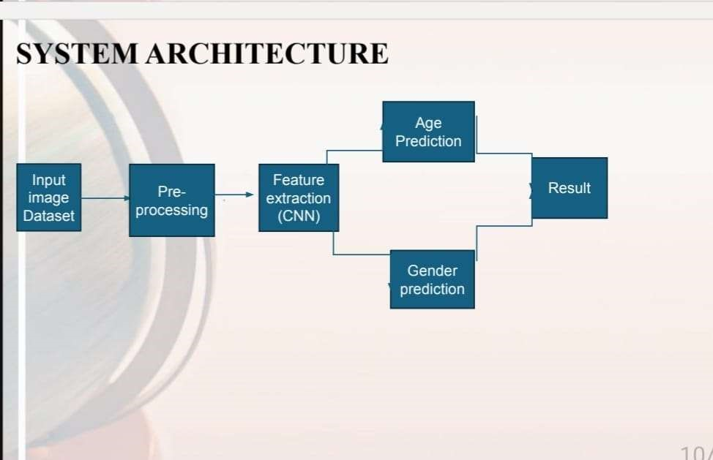
Fig no:2.3.1

DESIGN & IMPLEMENTATION
Here’s a design and implementation breakdown for the "Reuniting Paws" website:
1. Frontend Design:
- HTML: Structure the website with the following key pages:
  - Home Page: Introduction to the website, its purpose, and an option to add new pet listings.
  - Lost Pets Listing Page: Display a list of pets that need to be reunited with their owners. Include details like pet name, description, and location.
  - Pet Submission Page: Form to submit a pet listing (name, description, location, and contact details).
- CSS:
  - Use a simple, clean layout.
  - Ensure the design is mobile-friendly and visually appealing.
  - Utilize a pet-friendly color scheme (light pastels, earthy tones).
  - Add styling for buttons, form inputs, and navigation.
- JavaScript:
  - Interactivity: Handle adding new pet listings by dynamically updating the page after submission.
  - Form Validation: Ensure users enter necessary data (e.g., pet name and description).
  - Pet Listings: Display existing pet listings from the JSON file.
2. Backend Design:
- Node.js:
  - Set up a server with Node.js using Express.js to handle HTTP requests.
  - Use routing for different pages (e.g., /home, /pets, /submit-pet).
- Express.js:
  - Handle form submissions via POST requests and store data in a JSON file.
  - Serve the homepage and pet listings dynamically by reading the JSON file and displaying the content on the webpage.
- JSON File:
Store pet listing data (name, description, location) in a simple JSON file.
Example data format:
[
{
"name": "Buddy",
"description": "Golden Retriever, lost near city park.",
"location": "Dilsukhnagar"
}
]
3. Data Flow:

- Pet Listing Submission: When a user submits a new pet listing via the form, the details are sent to the backend and saved to the JSON file.
- Display Listings: On the homepage, the server reads the JSON file and displays the list of pets dynamically.
- No Search/Filter: The pet listings will be shown as they are, without any filter or search functionality.
4. Design Considerations:
- Responsive Layout: Ensure the website works well on both desktop and mobile devices.
- Simplicity: The design should be straightforward, with clear instructions for users to add or view pet listings.
- Accessibility: Ensure the website is accessible to all users by following basic accessibility standards (e.g., using proper HTML tags for navigation and headings).

Implementation Example:

1. Setup Node.js and Express:
npm init -y
npm install express

2. Create the app.js file:

const express = require('express');
const fs = require('fs');
const app = express();
app.use(express.json());
app.use(express.urlencoded({ extended: true }));

// Serve static files (like CSS)
app.use(express.static('public'));

// Home page route
app.get('/', (req, res) => {
fs.readFile('pets.json', 'utf-8', (err, data) => {
if (err) {
res.status(500).send('Error reading pet data');
} else {
const pets = JSON.parse(data);
res.send(`
<h1>Reuniting Paws</h1>
<ul>
${pets.map(pet => `<li>${pet.name} - ${pet.description} - ${pet.location}</li>`).join('')}
</ul>
<a href="/submit-pet">Submit a Pet</a>
`);
}
});
});

// Submit pet route
app.get('/submit-pet', (req, res) => {
res.send(`
<h1>Submit a Pet</h1>
<form action="/submit-pet" method="POST">
<input type="text" name="name" placeholder="Pet Name" required /><br />
<textarea name="description" placeholder="Pet Description" required></textarea><br />
<input type="text" name="location" placeholder="Location" required /><br />
<button type="submit">Submit</button>
</form>
`);
});

// Handle pet submission
app.post('/submit-pet', (req, res) => {
const newPet = {
name: req.body.name,
description: req.body.description,
location: req.body.location
};

fs.readFile('pets.json', 'utf-8', (err, data) => {
if (err) {
res.status(500).send('Error reading pet data');
} else {
const pets = JSON.parse(data);
pets.push(newPet);
fs.writeFile('pets.json', JSON.stringify(pets, null, 2), (err) => {
if (err) {
res.status(500).send('Error saving pet data');
} else {
res.redirect('/');
}
});
}
});
});

// Start the server
app.listen(3000, () => {
console.log('Server is running on port 3000');
});

3. Create the pets.json file: []

5. Testing and Deployment:
- Local Testing: Run the Node.js app on your local machine (node app.js) and test submitting pet listings.
- Deployment: Deploy the app on platforms like Heroku or any server that supports Node.js.
Let me know if you need further clarification or assistance with the implementation!

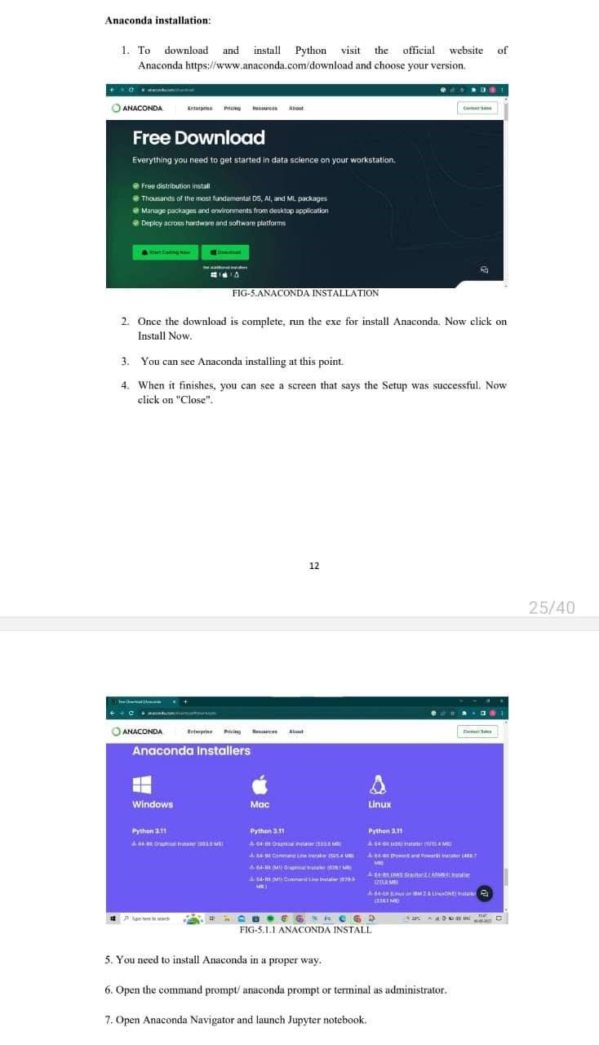 Fig no:3.2.2
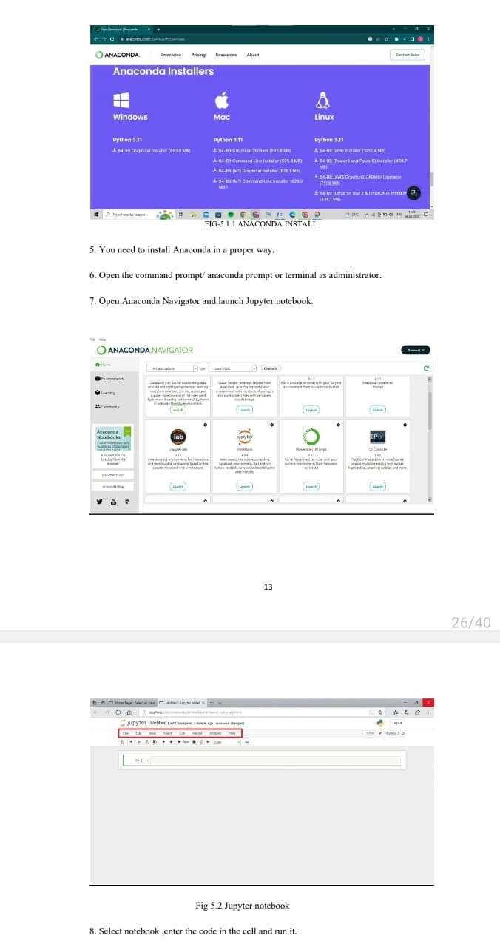 Fig no:3.2.3 and fig no:3.2.4
4. TESTS AND RESULTS

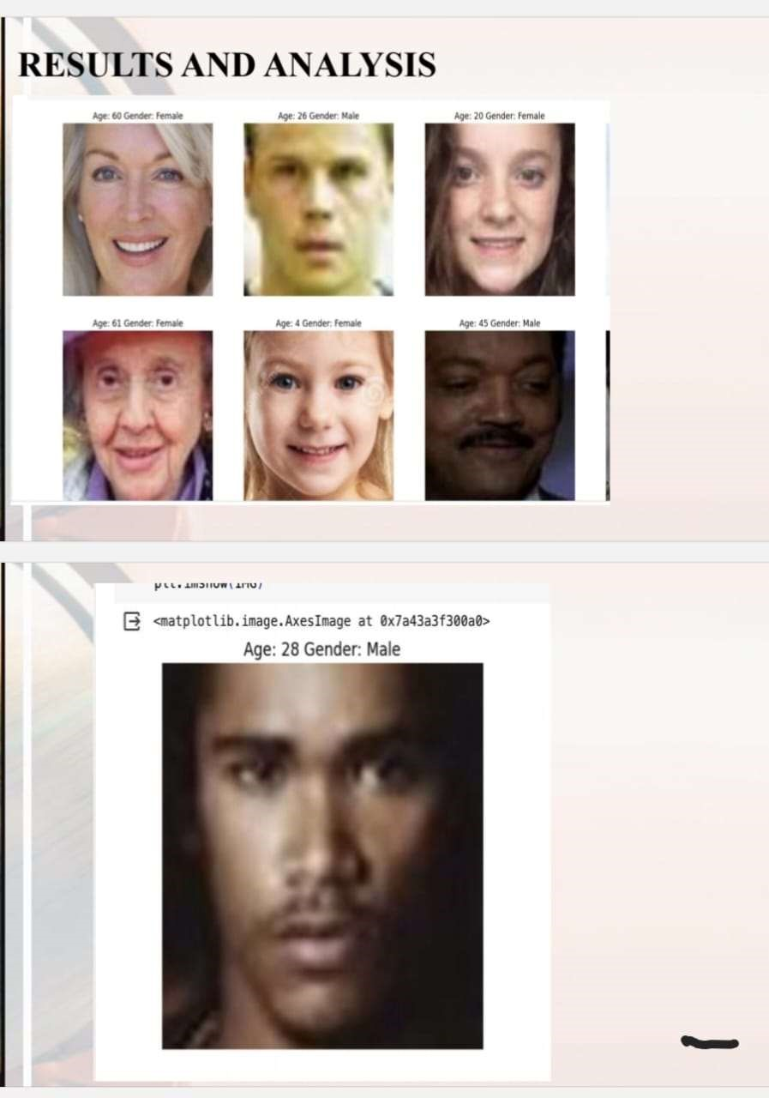
Fig no:4.2.4

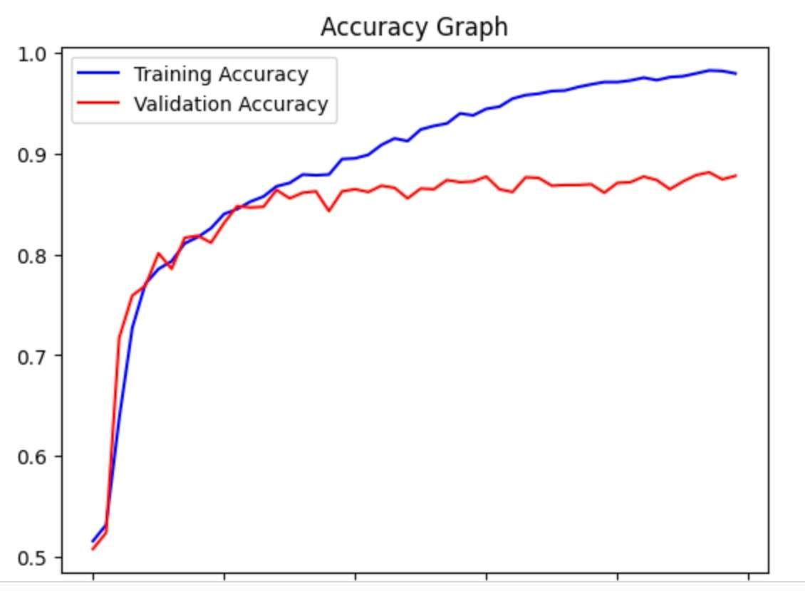
Fig no:4.2.3
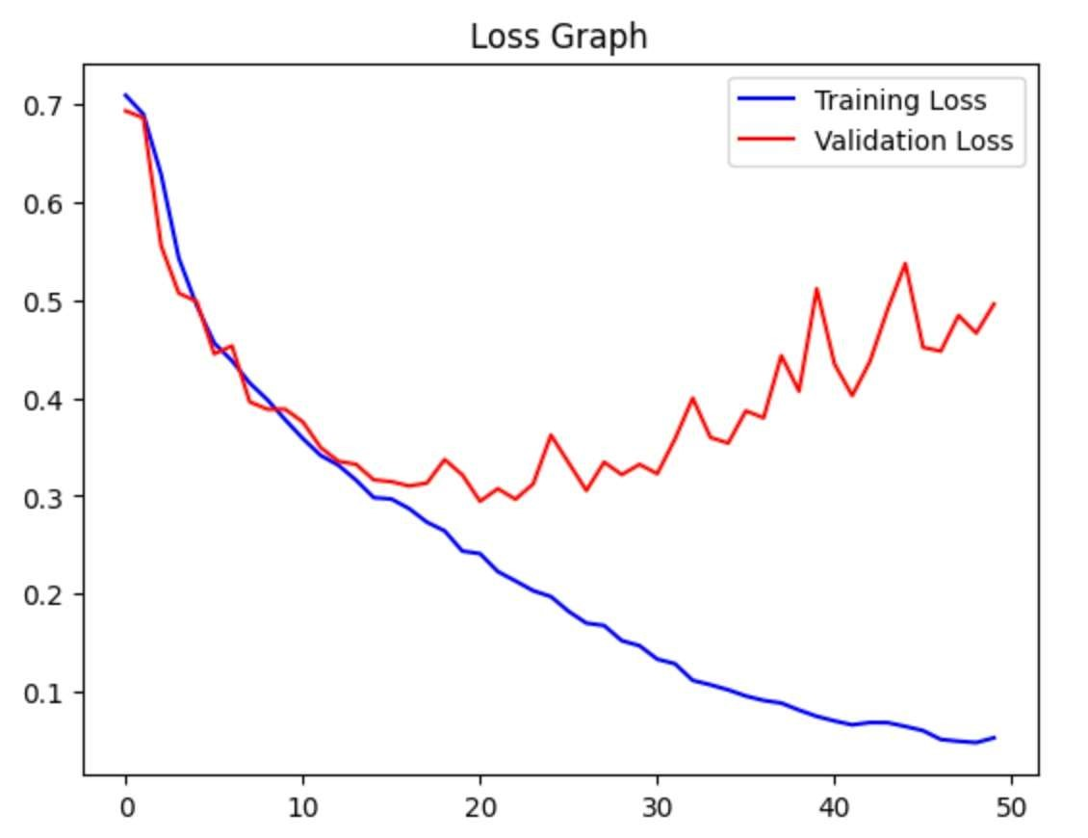
Fig no:4.2.2

CONCLUSION AND FUTURE ENHANCEMENT

Conclusion
The "Reuniting Paws" website provides a simple and effective platform for listing and finding lost pets. With its lightweight design using Node.js, HTML, CSS, and JSON for data storage, the system is cost-effective, easy to manage, and user-friendly. Although it currently lacks advanced features like search filters or contact forms, it successfully fulfills its primary goal of connecting pet owners with their lost pets.
Future Enhancements
- Search and Filter Functionality: Add features to filter pets by location, type, or name for better user convenience.
- Contact Form Integration: Include a contact form to enable users to connect directly with pet owners.
- Image Uploads: Allow users to upload pet photos to improve identification.
- Database Integration: Switch from JSON files to a database like MongoDB or MySQL for scalability.
- Mobile App Development: Expand the website’s reach by developing a mobile application.
- Notifications System: Send email or SMS alerts to users when pets matching their criteria are added.
- User Accounts: Enable users to create accounts for managing their listings and receiving updates.

REFERENCES

- Social Impact: The project addresses a real-world issue of reuniting lost pets with their owners, promoting community welfare.
- Feasibility: The website’s development is achievable using basic web technologies like HTML, CSS, Node.js, and JSON, making it ideal for a student project.
- Relevance: The growing concern for animal welfare and the increasing number of lost pet cases highlight the need for such platforms.
- Simplicity: The project is manageable without requiring complex systems, databases, or frameworks.
These factors make "Reuniting Paws" an ideal choice for practical implementation and societal contribution.

APPENDIX

SOURCE CODE

Jupyter Notebook Code

# Import necessary modules first.
import tensorflow as tf from tensorflow.keras.utils import load_img from keras.models import Sequential, Model
from keras.layers import Dense, Conv2D, Dropout, Flatten, MaxPooling2D, Input import numpy as np import random import matplotlib.pyplot as plt import os import seaborn as sns import warnings from tqdm.notebook import tqdm warnings.filterwarnings('ignore')
%matplotlib inline

from google.colab import drive drive.mount('/content/drive')

BASE_DIR = '/content/drive/MyDrive/images/face images/UTKFace' age_labels = [] gender_labels = [] image_paths = []

image_filenames = os.listdir(BASE_DIR) random.shuffle(image_filenames)

for image in tqdm(image_filenames): image_path = os.path.join(BASE_DIR, image) img_components = image.split('_') age_label = int(img_components[0]) gender_label = int(img_components[1])

# Append the image_path, age_label, and gender_label age_labels.append(age_label) gender_labels.append(gender_label) image_paths.append(image_path)

print(f'Number of age_labels: {len(age_labels)}, Number of gender_labels: {len(gender_labels)}, Number of image_paths: {len(image_paths)}')gender_mapping = {
1: 'Female',
0: 'Male'
} import pandas as pd df = pd.DataFrame() df['image_path'], df['age'], df['gender'] = image_paths, age_labels, gender_labels df.head(5)

from PIL import Image

rand_index = random.randint(0, len(image_paths)) age = df['age'][rand_index] gender = df['gender'][rand_index]
IMG = Image.open(df['image_path'][rand_index]) plt.title(f'Age: {age} Gender: {gender_mapping[gender]}') plt.axis('off')
plt.imshow(IMG)
[13:59, 08/02/2024] Pooja Mvsr: # Age distribution sns.distplot(df['age'])sns.countplot(df['gender'])
[13:59, 08/02/2024] Pooja Mvsr: plt.figure(figsize=(20, 20)) samples = df.iloc[0:16]

for index, sample, age, gender in samples.itertuples():
plt.subplot(4, 4, index + 1) img = load_img(sample) img = np.array(img) plt.axis('off')
plt.title(f'Age: {age} Gender: {gender_mapping[gender]}') plt.imshow(img)
[13:59, 08/02/2024] Pooja Mvsr: def extract_image_features(images): features = list()

for image in tqdm(images):
img = load_img(image, grayscale=True) img = img.resize((128, 128), Image.ANTIALIAS) img = np.array(img) features.append(img)

features = np.array(features) features = features.reshape(len(features), 128, 128, 1) return features
[14:00, 08/02/2024] Pooja Mvsr: X = extract_image_features(df['image_path'])
[14:00, 08/02/2024] Pooja Mvsr: X.shape
[14:00, 08/02/2024] Pooja Mvsr: y_gender = np.array(df['gender']) y_age = np.array(df['age'])
[14:01, 08/02/2024] Pooja Mvsr: input_shape = (128, 128, 1) [14:01, 08/02/2024] Pooja Mvsr: inputs = Input((input_shape)) conv_1 = Conv2D(32, kernel_size=(3, 3), activation='relu')(inputs) max_1 = MaxPooling2D(pool_size=(2, 2))(conv_1) conv_2 = Conv2D(64, kernel_size=(3, 3), activation='relu')(max_1) max_2 = MaxPooling2D(pool_size=(2, 2))(conv_2) conv_3 = Conv2D(128, kernel_size=(3, 3), activation='relu')(max_2) max_3 = MaxPooling2D(pool_size=(2, 2))(conv_3) conv_4 = Conv2D(256, kernel_size=(3, 3), activation='relu')(max_3) max_4 = MaxPooling2D(pool_size=(2, 2))(conv_4)

flatten = Flatten()(max_4)

# fully connected layers dense_1 = Dense(256, activation='relu')(flatten) dense_2 = Dense(256, activation='relu')(flatten)

dropout_1 = Dropout(0.3)(dense_1) dropout_2 = Dropout(0.3)(dense_2)

output_1 = Dense(1, activation='sigmoid', name='gender_out') (dropout_1) output_2 = Dense(1, activation='relu', name='age_out')(dropout_2)

model = Model(inputs=[inputs], outputs=[output_1, output_2])

model.compile(loss=['binary_crossentropy', 'mae'], optimizer='adam', metrics=['accuracy'])

# plot results for gender
acc = history.history['gender_out_accuracy'] val_acc = history.history['val_gender_out_accuracy'] epochs = range(len(acc))

plt.plot(epochs, acc, 'b', label='Training Accuracy') plt.plot(epochs, val_acc, 'r', label='Validation Accuracy') plt.title('Accuracy Graph') plt.legend() plt.figure()

loss = history.history['gender_out_loss']
val_loss = history.history['val_gender_out_loss']

plt.plot(epochs, loss, 'b', label='Training Loss') plt.plot(epochs, val_loss, 'r', label='Validation Loss') plt.title('Loss Graph') plt.legend() plt.show()

