FruitPilot

Project Overview
FRUITPILOT aims to develop an autonomous drone system capable of detecting, locating, and navigating towards fruits for automated harvesting. The system integrates computer vision, machine learning, and autonomous navigation to enhance efficiency in fruit plucking operations.

Scope
Fruit Detection via Computer Vision
- Use YOLO-based deep learning model for identifying fruits in real-time.
- Process camera feed from the drone to detect fruit location in the frame.
- Output bounding boxes and confidence scores for detected fruits.
Autonomous Navigation
- Use GPS and onboard sensors to navigate in an orchard or defined test field.
- Control drone movement towards detected fruits using detection coordinates.
Simulation Testing
- Full drone simulation using Mission Planner SITL to test flight logic before real deployment.
- Simulated fruit positions for navigation testing.
Web-Based Drone Control
- Frontend: User-friendly control panel to send commands.
- Backend (Flask): Receives user inputs, triggers DroneKit scripts, and streams detection results.
Jetson Nano Integration
- Running the fruit detection AI model onboard for real-time inference.
- Camera initialization and data processing directly on Jetson Nano.
Hardware components:

- Jetson nano - Onboard AI processing for fruit detection.
- GoPro 9 - Capture high-resolution video for accurate fruit detection.
- Pixhawk - Execute flight commands and handle navigation.

Object detection

- Used YOLOv8 (Ultralytics) for its improved accuracy, speed, and ease of deployment.
- Collected a custom mango dataset from field images and online sources, including different maturity stages, lighting conditions, and angles.
- Labeled each image with bounding boxes using CVAT iin YOLO format (.txt files for each image).
- Trained YOLOv8 on the custom dataset using a GPU-enabled environment; tuned parameters like image size, batch size, and learning rate for better detection of mango shapes and colors.

Final output:
- Autonomous Drone System capable of detecting ripe mangoes in real-time using the onboard YOLOv8 mango detection model running on a Jetson Nano.
- Web-based Control Interface where a user can connect to the drone, arm it, start fruit detection, and monitor detection results live from a browser.
- Real-time Detection Feed showing camera view with bounding boxes around detected mangoes along with detection confidence percentages.
- Autonomous Navigation where the drone can adjust its position to center a detected mango in its frame and navigate towards it in simulation.
- Mission Planner SITL Simulation Results demonstrating takeoff, detection, navigation, and safe landing based on visual inputs.

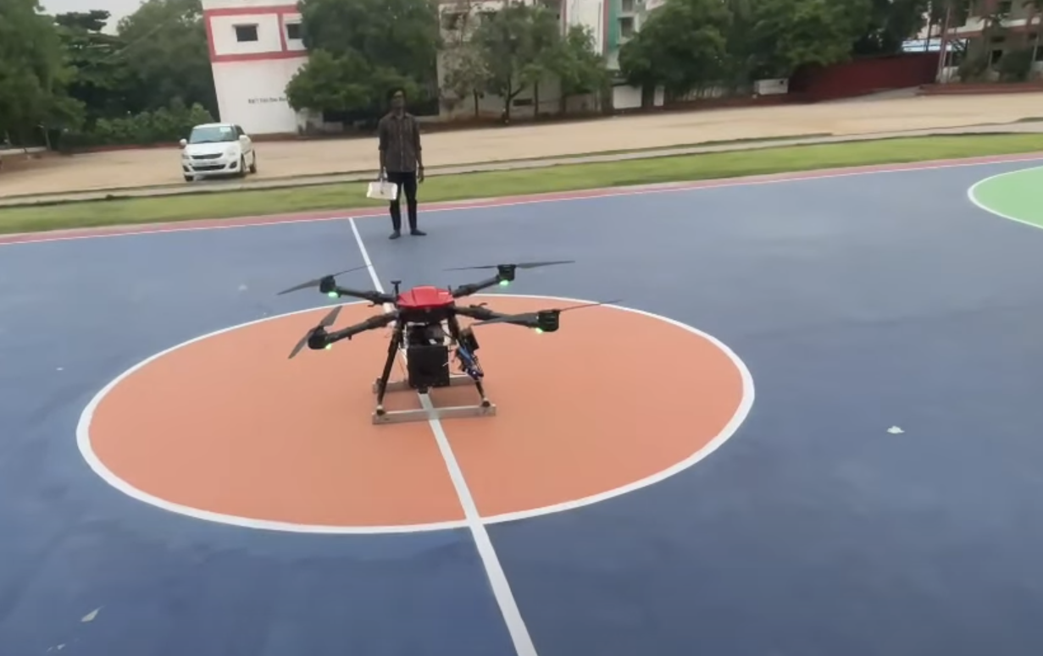
Drone

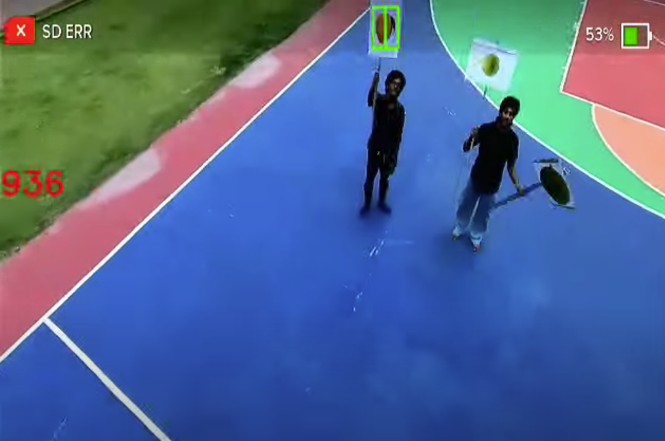

Drone-feed

