Commands:

1. **Whoami:** Displays the current username.

1. **Hostname:** Displays the system’s host name.

1. **Echo “Hello, world”:** Print characters to screen.

1. **Echo $HOME:** Displays the path of current user’s home directory.

1. **Echo my login is $(whoami):** replaces $(xx) with program output.

1. **Date**: prints current date/time.

1. **Cal**: prints this month’s calender.

1. **Shazam**: bad command.

**Selected text processing utilities**

1. **awk:** Used for pattern scanning and performing action based on it.

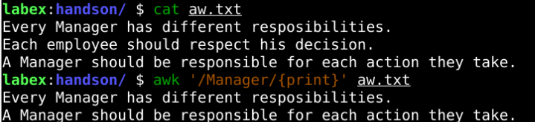

1. **cat:** To display files

1. **cut:** To extract selected fields by position of each line of a file

1. **diff:** To compare two files

1. **grep:** Searches and gives number of lines matches with the pattern

1. **head:** To display the starting of files

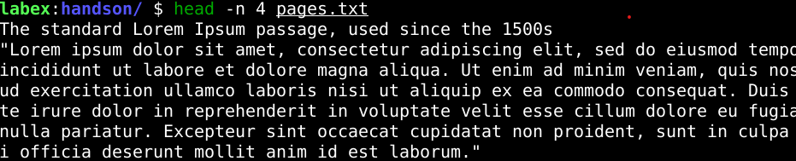

1. **tail:** To display ending text of file

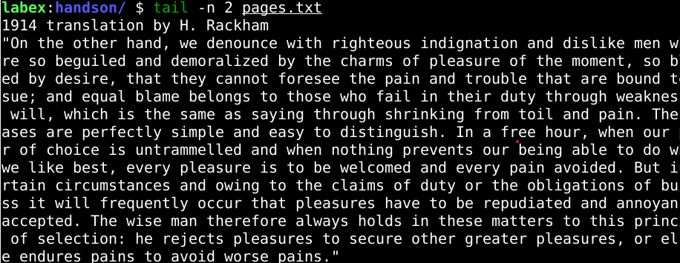

1. **sed:** To search and replace text in a file.

1. **less:** To display the large file txt in form of pages.



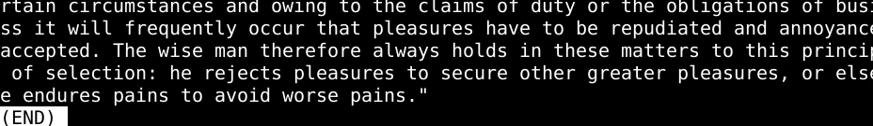

Creating a file: touch command



Adding text to the file:

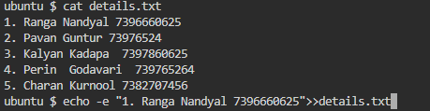

1. **Wc:** To count number of lines, words and characters in a file



1. **split:** Used to split large files into different files

1. **sort :** Used to sort the text in files

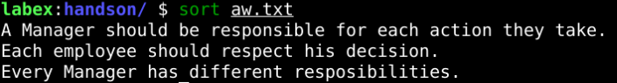

1. **tr:** To translate the text according to required pattern



1. **uniq:** To remove duplicate and display unique in file

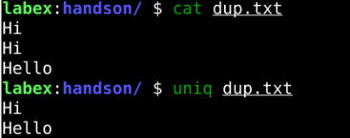

1. **rm:** To remove files from the directory

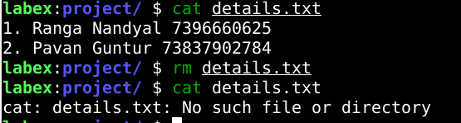

1. **cp:** To copy one file contents to other.

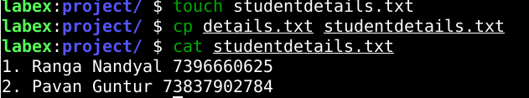

1. **mv:** To movie files or directories from one location to specified location.

