**Project Title:**

Common Platform For Ports, Terminals And Other Custodians.

ABSTRACT

Ports and terminals are critical components of the global supply chain, connecting producers, suppliers, and consumers across the world. However, managing ports and terminals is a complex and challenging task, involving multiple stakeholders with their own processes and systems. To address these challenges, a common platform for ports, terminals, and other custodians is proposed. This platform aims to streamline the flow of cargo and vessel movements through the port ecosystem, providing real-time visibility and tracking, improving collaboration and communication among stakeholders, and enhancing data accuracy, integrity, and security. The platform will be developed using the latest technologies, including cloud computing, big data analytics, artificial intelligence, and blockchain, and will be designed to be scalable, flexible, and adaptable. The project has the potential to transform the port ecosystem, improving efficiency, productivity, and security, and delivering significant benefits to all stakeholders.

DESIGN REQUIREMENTS:

1. Vessel Table
2. Cargo Table
3. Booking Table
4. User Table
5. Event Table

ATTRIBUTES AND DOMAIN TYPES:

**Vessel table:**

VesselID: integer (primary key)

VesselName: varchar(50)

RegistrationNumber: varchar(20)

VesselSize: integer

VesselType: varchar(20)

**Cargo table:**

CargoID: integer (primary key)

CargoType: varchar(50)

CargoWeight: decimal(10,2)

CargoVolume: decimal(10,2)

Destination: varchar(50)

**Booking table:**

BookingID: integer (primary key)

CargoID: integer (foreign key to Cargo table)

VesselID: integer (foreign key to Vessel table)

BookingTime: datetime

ExpectedArrivalTime: datetime

ExpectedDepartureTime: datetime

**User table:**

UserID: integer (primary key)

Username: varchar(50)

Password: varchar(50)

Role: varchar(20)

**Event table:**

EventID: integer (primary key)

EventType: varchar(50)

EventTime: datetime

VesselID: integer (foreign key to Vessel table)

CargoID: integer (foreign key to Cargo table)

Remarks: varchar(200)

ER DIAGRAM

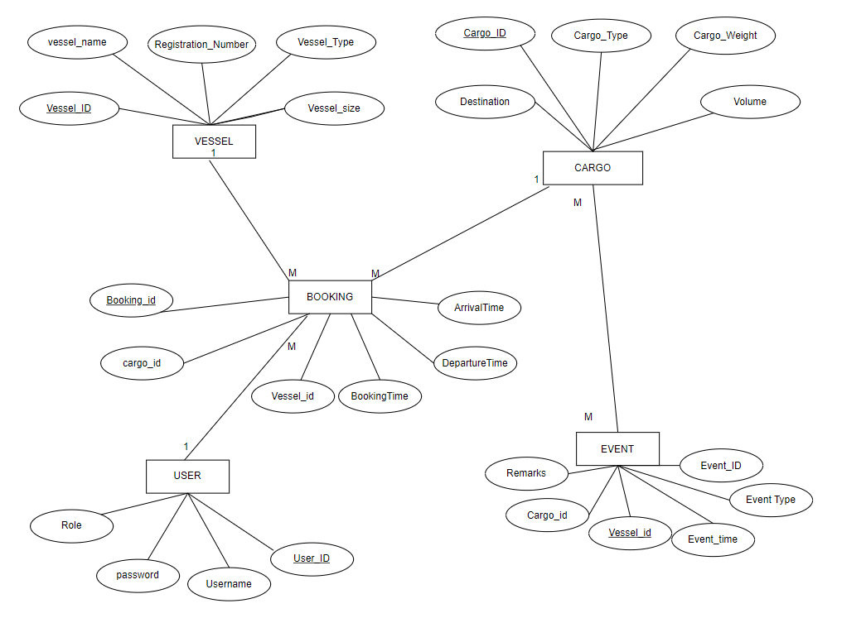

RELATIONAL MODEL and DML Operations

Vessel Table:

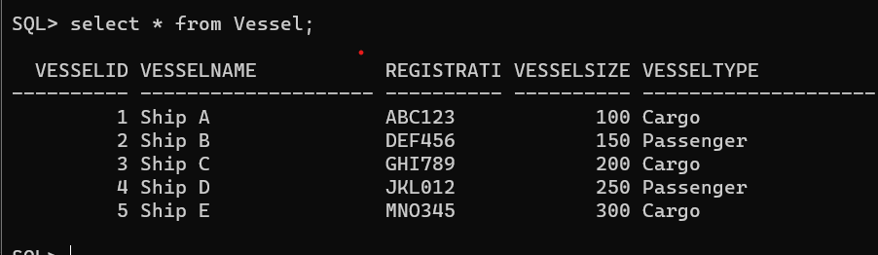

Query:

Create:

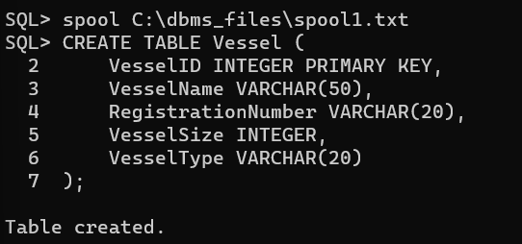

Insert:

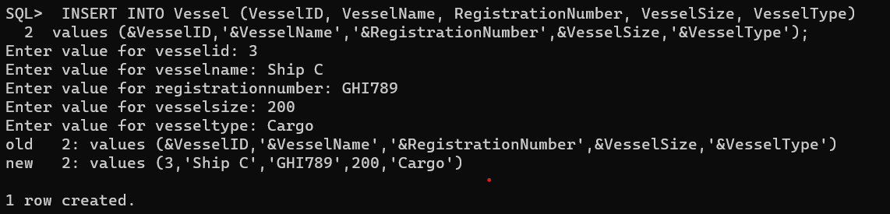

Cargo Table:

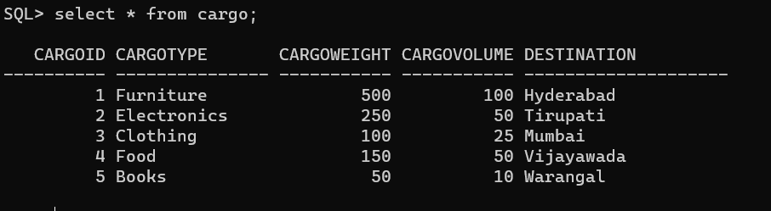

Query

Create

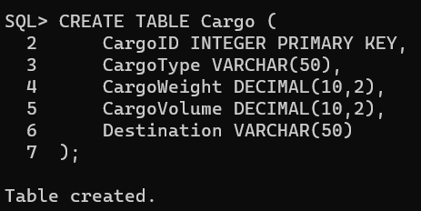

Insert:

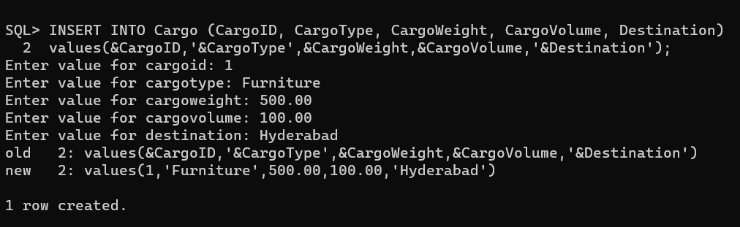

Booking Table:

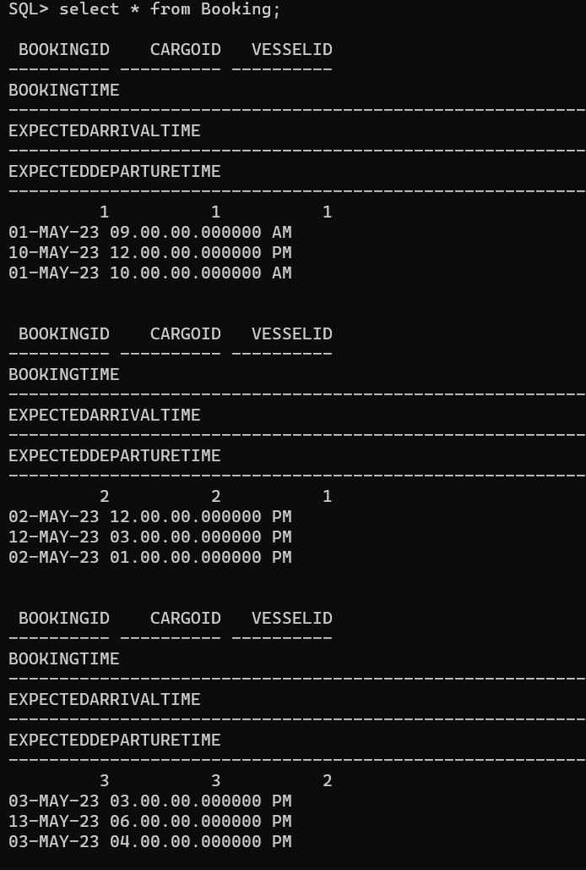

Query:

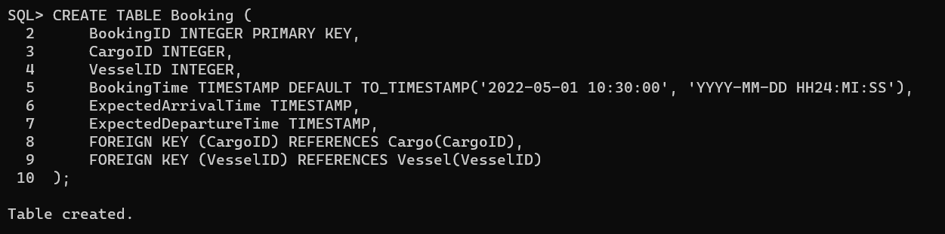



USERS TABLE:

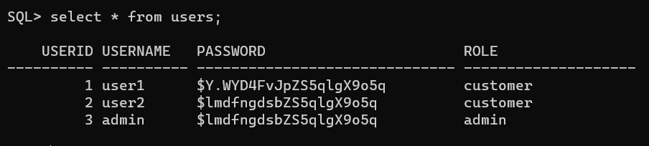

Query:

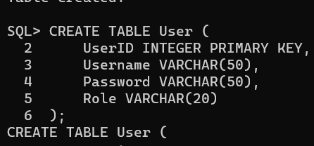

EVENT TABLE:

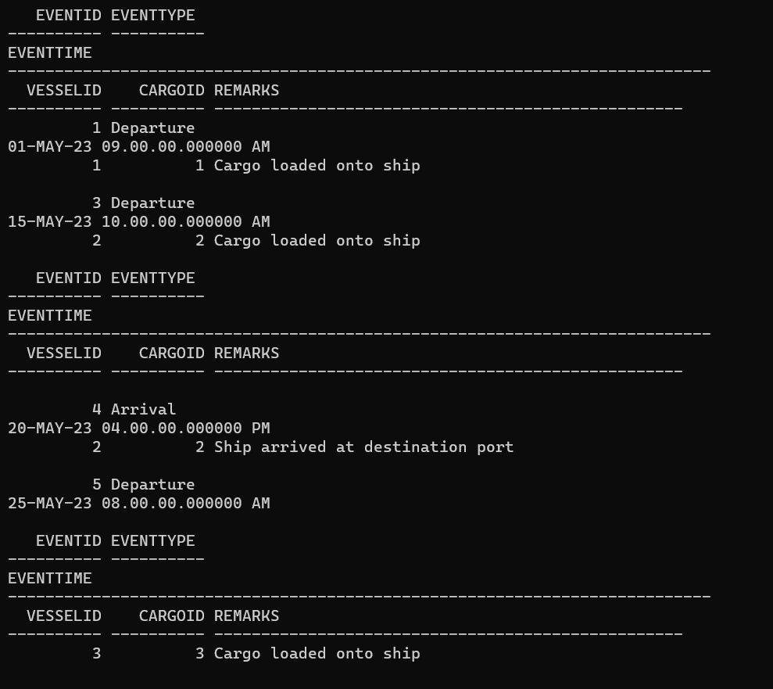

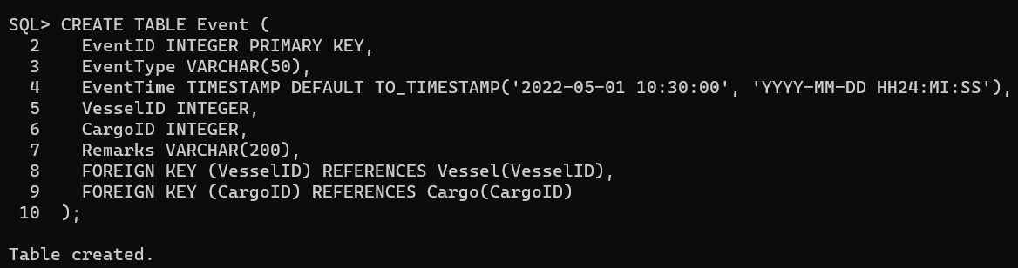

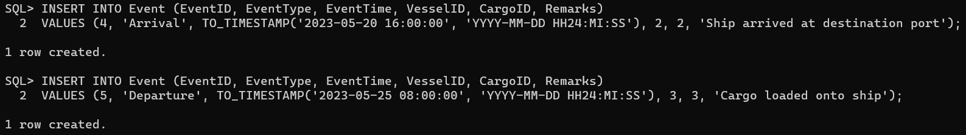

DELETION

