Week 2 Documentation
Implementation of Responsive Web Design
Project: Ridgeline Trail Club website | Files: index.html, styles.css, images/, screenshots/

1. Summary
I built a one-page website for an imaginary hiking club and made it adapt from a 320px phone up to a 2560px monitor. I chose content that tends to break on small screens: photo cards, a four-column data table, a gallery, a form and a navigation menu. This report explains the methods I used, how the layout changes on each device, and, in more detail than my last report, the test results behind my claims. Every number in section 6 was measured by a script I ran against the finished page, and I list the bugs those tests caught.

2. Responsive strategy
I wrote the phone layout first and used min-width media queries to add to it as the screen grew. The base CSS contains no media queries and describes one column, so small screens load the simplest rules and larger screens only add. I found the breakpoints (560, 760 and 960px) by dragging the browser wider and noting where the layout began to look stretched, not by copying device sizes. Two things went beyond viewport width: container queries, so a card responds to the space it is given, and preference queries for hover, reduced motion, print and short landscape screens.

3. Methods used
Technique | Where | Why
Mobile-first min-width queries | Header, table, hero, grids | Simple base styles, nothing to undo later
clamp() fluid type and spacing | h1, h2, section padding, gaps | Smooth scaling with no jumps between sizes
Grid auto-fit + minmax(min(100%,260px),1fr) | Trail cards | Columns appear as space allows; never overflows at 320px
Container queries (@container) | Trail cards | A card goes horizontal when its own width passes 480px
picture + source media | Hero | Square crop on desktop, wide banner on phones
aspect-ratio + object-fit + width/height attrs | All images | Constant shape, no layout shift while loading
Table to labelled cards | Schedule | Four columns cannot fit 320px; data-label + ::before names each value
CSS-only hamburger (checkbox + label) | Header | Works with no JavaScript, keyboard operable
overflow-wrap and minmax(0,1fr) | Body, grids, cells | Long words and big text cannot force sideways scroll
hover, prefers-reduced-motion, print, max-height landscape | Cards, motion, print, header | Adapts to how the device is used, not just its width

4. How the layout changes by device
Part | Phone (below 760px) | Tablet (760–959px) | Desktop (960px+)
Navigation | Hamburger, full-width list | Horizontal bar | Horizontal bar
Hero | Text, then wide banner | Same, wider | Two columns, square image
Trail cards | 1 column; card turns horizontal if its width passes 480px | 2 columns | Featured card full row, 3 below
Schedule | Each row a labelled card | Real table | Real table
Gallery | 2 columns | 3 columns | 3 columns
FAQ and form | 1 column | 2 columns | 2 columns

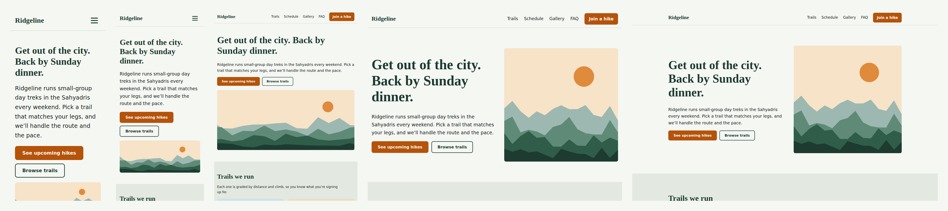
Figure 1: The top of the page at 320, 375, 768, 1024 and 1440px.
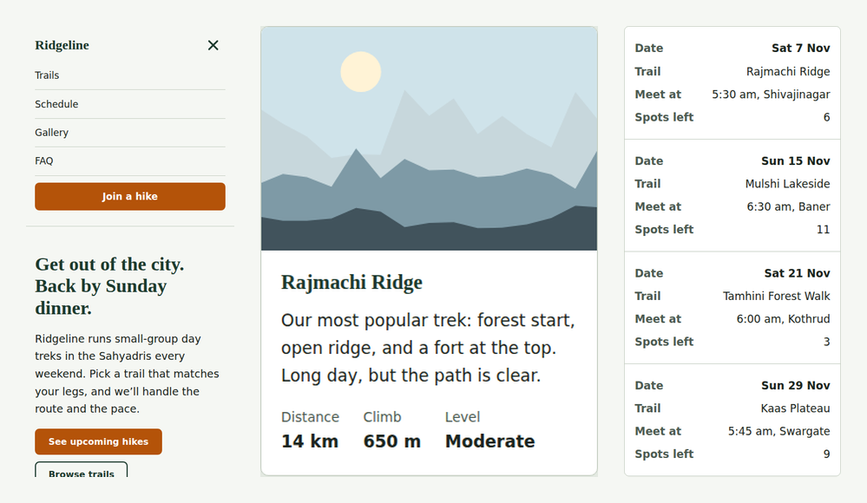
Figure 2: At 375px: open menu, the featured card stacked, and the schedule as cards.
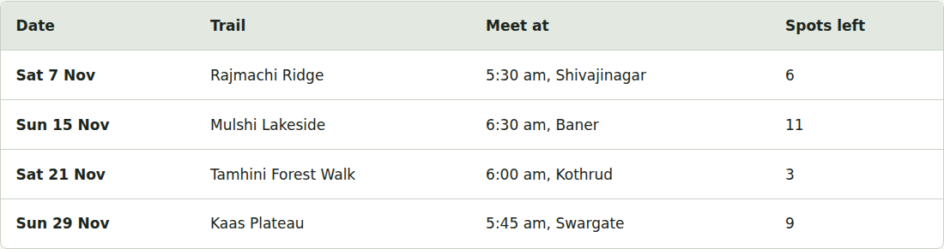
Figure 3: The same schedule data as a real table at 1440px.
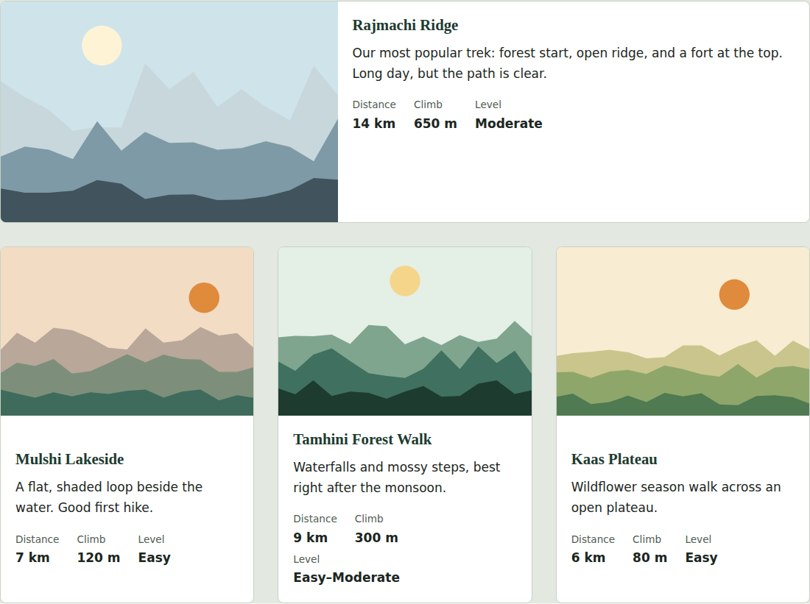
Figure 4: At 1440px the featured card spans the row, and its container query makes it horizontal.

5. Testing method
I tested in three ways: a script that loads the page in Chromium at 16 viewport sizes and measures it, automated checkers for HTML, CSS and accessibility, and manual checks of the menu and the print and reduced-motion modes. The tools were Playwright, html-validate, stylelint and axe-core. I did not test on physical phones or in Firefox or Safari, so those remain untested.

6. Test results

6.1 Viewport matrix
For each width the script recorded which layout was active and how far the page overflowed the screen. The sizes cover small phones, common phones, tablet portrait and landscape, laptops, a full HD monitor, a 2560px monitor and a short landscape phone (740×360).
Viewport | Menu | Hero image | Trail cards | Gallery | Schedule | Overflow
320×568 | hamburger | hero-banner | 1 col | 2 col | cards | 0 px
360×740 | hamburger | hero-banner | 1 col | 2 col | cards | 0 px
375×667 | hamburger | hero-banner | 1 col | 2 col | cards | 0 px
390×844 | hamburger | hero-banner | 1 col | 2 col | cards | 0 px
414×896 | hamburger | hero-banner | 1 col | 2 col | cards | 0 px
540×720 | hamburger | hero-banner | 1 col (wide card) | 2 col | cards | 0 px
600×960 | hamburger | hero-banner | 2 col | 3 col | cards | 0 px
700×900 | hamburger | hero-banner | 2 col | 3 col | cards | 0 px
768×1024 | full bar | hero-banner | 2 col | 3 col | table | 0 px
820×1180 | full bar | hero-banner | 2 col | 3 col | table | 0 px
1024×768 | full bar | hero-square | 3 col (wide card) | 3 col | table | 0 px
1280×800 | full bar | hero-square | 3 col (wide card) | 3 col | table | 0 px
1440×900 | full bar | hero-square | 3 col (wide card) | 3 col | table | 0 px
1920×1080 | full bar | hero-square | 3 col (wide card) | 3 col | table | 0 px
2560×1440 | full bar | hero-square | 3 col (wide card) | 3 col | table | 0 px
740×360 | hamburger | hero-banner | 2 col | 3 col | cards | 0 px

Result: horizontal overflow was 0px at all 16 sizes, no image failed to load, and no element extended past the screen edge. The hero switches from banner to square at 960px as designed. At 540px the featured card is horizontal, because the card has become wide enough in a single column; at 600px it is stacked again because two columns make it narrow. That is the container query reacting to space instead of screen width.

6.2 Automated and manual checks
Check | Result | Tool
HTML validity | 0 errors, recommended ruleset | html-validate
CSS quality | 0 errors after fixes (78 before) | stylelint
Accessibility (WCAG 2.2 AA + best practice) | 0 violations at 360, 768 and 1280px; 49 rules passed at each | axe-core
Text zoom: 150%, 200%, 300%, 400% on a 320px screen | Overflow 0, 0, 0, 0 px | Playwright
Smallest tap target | 27px high (WCAG minimum is 24px); 0 below 24px | Playwright
Smallest text | 13.6px (the Level / Distance labels) | Playwright
Keyboard: Tab to the menu button, press Space | Menu opened | Playwright
Print stylesheet | Header and sign-up form hidden | Playwright
Reduced motion | Smooth scrolling turned off | Playwright
Colour contrast, white on button orange | 5.02:1 (AA needs 4.5:1) | Calculated
Colour contrast, body text on background | 14.49:1 | Calculated

Contrast ratios were computed with the WCAG luminance formula, and axe independently confirmed them.

7. Problems the tests found and how I fixed them
Several of these I would not have found by eye. The tests found them, and I fixed them in this order.
Problem | Evidence | Fix | After
Button contrast too low | axe: serious, 3 buttons. White on my orange measured 3.94:1. I had assumed it was fine. | Darkened --sun to #b45309 | 5.02:1, 0 axe contrast errors
Unlabelled form control | axe: critical. At 760px+ the hidden menu checkbox had no label because its label was display:none. | Hide the checkbox itself at 760px+ | 0 critical errors
Tiny footer links | 3 links only 20px tall (below 24px minimum) | display:inline-block; padding-block 0.5rem | Smallest target 27px
Trail stats overflowed under zoom | 200% text zoom at 320px: 116px sideways scroll | Stats use flex-wrap; card column minmax(0,1fr) | 0px
Schedule table forced width | Table min-content widened the page in card mode | Table and tbody display:block on mobile; real table restored at 760px | 0px
Long words at 300–400% text size | 94px and 231px overflow | Grids use minmax(0,1fr); overflow-wrap on body and table cells | 0px at all zoom levels
Empty grid slots (found earlier by eye) | Featured card spanning 2 of 3 columns left a hole; gallery last row had a gap | Fixed 3-column desktop grid; featured card takes the full row | Even rows
Uneven gallery row | Wide image kept 4:3, twice as tall as neighbours | Wide images aspect-ratio 8:3, object-position 65% | Heights equal
Deprecated clip property | stylelint warning | clip-path: inset(50%) for visually-hidden | 0 lint errors

One test failure was my own testing error: my first script clicked the hidden checkbox directly and the menu did not open, because real users click the label. I switched the test to click the label.

8. Limitations and planned improvements
These are the changes I would make next, with the approach for each and how I would check it worked.

8.1 Keep the menu state in sync for screen readers
The CSS-only menu works by keyboard, but screen readers are not told whether it is open. I would add a button, with a small script that sets aria-expanded and closes the menu on Escape:
<button class="nav-toggle" aria-expanded="false" aria-controls="primary-nav">Menu</button>

const btn = document.querySelector('.nav-toggle');
const nav = document.getElementById('primary-nav');
btn.addEventListener('click', () => {
const open = btn.getAttribute('aria-expanded') === 'true';
btn.setAttribute('aria-expanded', String(!open));
nav.hidden = open;
});
document.addEventListener('keydown', e => {
if (e.key === 'Escape') { btn.setAttribute('aria-expanded', 'false'); nav.hidden = true; }
});
To verify: add a Playwright assertion that aria-expanded flips on click and Escape, and re-run axe.

8.2 Real photographs with responsive sources
The images are small SVG illustrations. For photographs I would export 480, 800 and 1280px widths in WebP with a JPEG fallback, and let the browser choose:
<picture>
<source type="image/webp" sizes="(min-width: 960px) 33vw, 100vw"
srcset="trail-480.webp 480w, trail-800.webp 800w, trail-1280.webp 1280w">
<img src="trail-800.jpg" width="800" height="533" alt="..." loading="lazy">
</picture>
To verify: check in DevTools Network which file loads at 360px and at 1440px, and compare total transfer size.

8.3 Automate these tests so regressions are caught
My test script lives on my machine. I would put it and axe into a GitHub Actions workflow so every push is checked for horizontal overflow and accessibility, and fails the build on any violation:
name: responsive-checks
on: [push, pull_request]
jobs:
test:
runs-on: ubuntu-latest
steps:
- uses: actions/checkout@v4
- run: npm ci && npx playwright install --with-deps chromium
- run: npx html-validate index.html && npx stylelint styles.css
- run: python tests/suite.py # fails if overflow > 0 or axe has violations

8.4 Test on real devices and other browsers
Chromium is not everything. I would run the page in Firefox and WebKit through Playwright (npx playwright test --project=firefox,webkit), then open it on a real iPhone and Android phone over my local network and check touch targets, the sticky header with the on-screen keyboard open, and notch handling. If I find problems, I would add viewport-fit=cover and env(safe-area-inset-*) padding.

8.5 Graceful fallbacks for newer CSS
Container queries and clip-path are well supported now, but older browsers exist. I would wrap the container rules in @supports (container-type: inline-size) and keep a media query version of the card layout as the fallback, then test by temporarily disabling the feature in DevTools.

8.6 Performance score
I have not run Lighthouse. My plan is to run it in mobile mode, aim for 90+ in performance and 100 in accessibility, self-host the two fonts as WOFF2 with font-display: swap, and preload the hero image.

9. Project structure and how to run it
week2/
index.html page structure
styles.css all styling and media queries
images/ SVG illustrations
screenshots/ evidence at 320, 375, 768, 1024, 1440px
Week2_Documentation.docx
Open index.html in any browser, no build step needed. To see the responsive behaviour, drag the window narrower or use DevTools device mode.

