RAGcast
Product Requirements Document
Ask anything from every podcast you’ve heard.
Field | Detail
Target Release | Q3 2025
Document Status | Complete
Document Owner | Saish Shetty
Designer | Claude Design
Tech Lead | Claude Code
QA | User

1. Overview

Problem Statement
Podcast listeners — especially those consuming knowledge-heavy content (business, tech, self-improvement) — face three persistent problems:

- Context gaps during episodes: guests reference terms, frameworks, or ideas (e.g. SQL, MQL, OKRs) that the host does not explain. Listeners have no quick way to clarify without leaving the episode.
- Lost recommendations: books, tools, and people suggested by guests are forgotten within hours. There is no passive system that captures them.
- No searchable memory: after listening to dozens of episodes, the knowledge is gone. There is no way to ask “What did that guest say about compounding?”

Existing tools like NotebookLM allow transcript-based Q&A but do not save chat history, do not auto-extract structured insights (books, people), and do not fall back to the web when the answer is not in the transcript.

Proposed Solution
RAGcast is an AI-powered podcast notetaker that turns any podcast transcript into a persistent, queryable knowledge base. Users paste a YouTube URL or transcript, and RAGcast automatically:

- Answers questions using RAG against the transcript, with web search fallback for terms not covered.
- Generates a 200–250 word episode summary as the first message in every new chat.
- Auto-extracts all books and people mentioned, displayed as rich cards with metadata.
- Preserves timestamps so every answer and every card can be traced back to the exact moment in the episode.
- Saves all chat history per episode so users can return and continue where they left off.

Target Audience
Primary: Tech-savvy podcast listeners in India aged 22–40 who regularly consume knowledge-heavy podcasts (business, technology, self-improvement, finance) and struggle to retain and act on what they hear.

Secondary: Students, researchers, and content creators who use podcasts as a primary learning medium and need structured notes from long-form audio content.

Market Opportunity
Podcast listenership in India grew to over 200 million listeners in 2024, with knowledge and education formats being the fastest-growing category. The global podcast analytics and tools market is projected to exceed $4B by 2027.

The immediate gap: no product in the market combines transcript-based RAG Q&A + persistent chat history + auto-generated episode summary + structured extraction (books, people) + web fallback in a single, clean interface. RAGcast targets this exact white space.

2. Objectives

RAGcast v1.0 aims to establish a loyal base of active users who use the product as their default podcast companion. Success in 6 months means users are returning to episodes they created weeks ago, their personal library is growing, and they are recommending the product to other podcast listeners.

Goals & Success Metrics

Goal | Metric | Target (6 months)
Activate users on core Q&A | Users who ask 3+ questions per episode | 60% of active users
Drive episode creation | Episodes created per active user per month | 4+ episodes/user/month
Retain users week-over-week | Week-2 retention rate | 35%+
Validate summary feature | Users who read summary before asking first question | 70% of sessions
Validate book extraction value | Amazon India link click-through rate | 15%+ of book cards
Grow organically | Referral signups / word-of-mouth | 30% of new signups

3. User Interface

Design Language
RAGcast follows a dark, bold, premium design system inspired by Reliance Jio’s visual identity. The interface is built for clarity and speed — every screen is focused on a single task.

Token | Value | Usage
--bg | #0A0A0A | App background, chat area
--panel | #111111 | Sidebar and context panel background
--card | #1A1A1A | Book cards, people cards, input bar
--blue | #0066FF | Primary accent — CTAs, active states, badges
--green | #00C48C | "From Transcript" source badge
--amazon | #FF9900 | Amazon buy link button
--text | #F4F6FA | Primary text
--muted | #8A8F98 | Secondary / supporting text

- Typography: Inter (400–900) for body and UI; Space Grotesk (500–700) for wordmark, headings, and section titles.
- Radius: 13–16px on cards; 18px on chat bubbles and input bar; 24px on the sign-in card.
- Shadows: soft, dark, blue-tinted drop shadows on interactive cards and the sign-in card.
- Borders: 1px hairline (#222222) on all cards and panels; blue glow ring on focused inputs and active episode items.

Key Screens

Screen 1 — Sign In
- Full dark background (#0A0A0A) with a faint dotted grid and a large radial blue glow behind the card.
- Centered card (440px wide): RAGcast wordmark in Space Grotesk bold, tagline “Ask anything from every podcast you’ve heard.” in muted grey.
- Single CTA: “Continue with Google” — dark button with Google “G” icon, blue border, white text. Hover: blue glow, 1px lift.
- Fine print: “By continuing you agree to our Terms and Privacy Policy.”
- No email/password fields — Google OAuth only in v1.0.

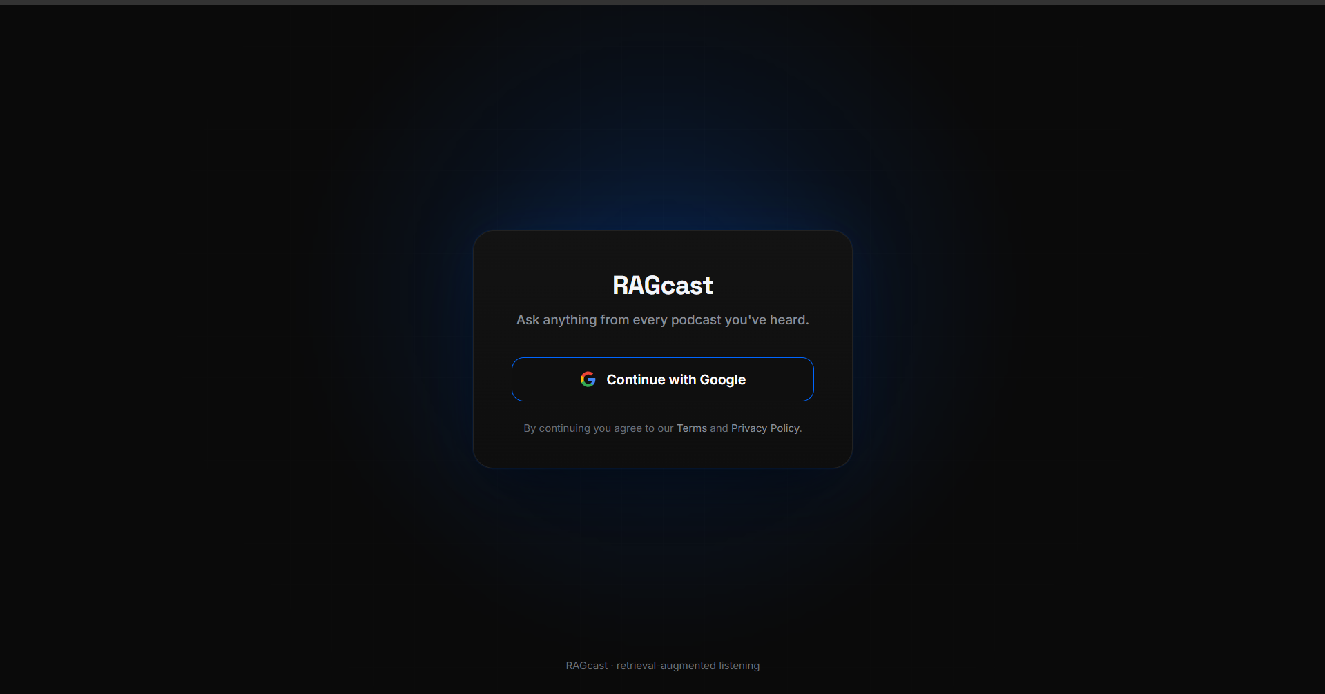

Screen 2 — Main App
- Three-column layout: Sidebar (280px) | Chat Area (flex) | Context Panel (344px default, resizable 264–560px).

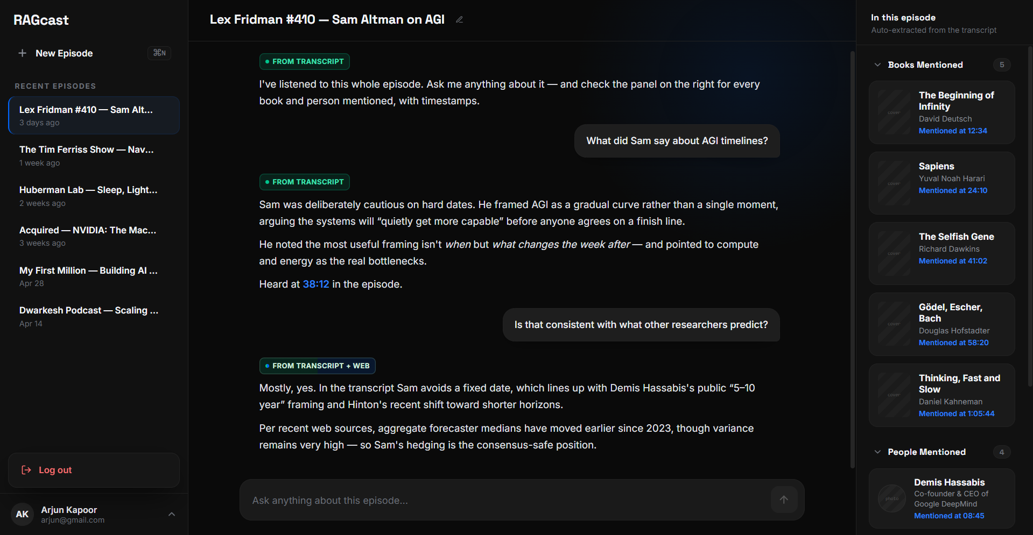

Sidebar (#111111):
- RAGcast wordmark at top (Space Grotesk 21px bold).
- New Episode row: ghost list row with plus icon, "New Episode" label, and ⌘N keycap. Active state: blue text and inset blue ring.
- "Recent Episodes" section label in muted uppercase.
- Episode list: each item shows episode name (truncated) + relative date. Active item: blue left border + lighter background. Pencil rename icon fades in on hover.
- Account footer: avatar, name, email, chevron. Clicking opens an upward account menu with Log Out.

Chat Area (#0A0A0A):
- Decorative blue radial glow bleeds in from top-right.
- Chat header: episode title (Space Grotesk 19px bold) + pencil rename icon. Divider below.
- First message on episode load: Episode Summary card — labelled with a purple "Episode Summary" badge, 200–250 word summary of the podcast in plain text.
- Subsequent messages: user bubbles right-aligned (#1E1E1E, radius 18 18 6 18); RAGcast answers left-aligned, no bubble, plain text. Source badge above each answer.
- Source badges: "From Transcript" (green), "From Web" (blue), "From Transcript + Web" (split green/blue).
- Inline timestamp citations rendered in bright blue as clickable links (e.g. "Mentioned at 34:12").
- Input bar at bottom: dark card (#1A1A1A), auto-growing textarea, blue send button. Blue glow on focus.

Context Panel (#111111):
- Drag handle on left edge; width persists across sessions (264–560px).
- "In this episode" header with "Auto-extracted from the transcript" subtext.
- "Books Mentioned" section: collapsible, count pill, book rows (cover placeholder, title, author, timestamp, Amazon link).
- "People Mentioned" section: collapsible, count pill, person rows (avatar placeholder, name, bio, timestamp).
- Empty states shown when no books or people are detected.

Screen 3 — New Episode
- Replaces the chat area when New Episode is clicked; sidebar remains visible.
- H1: “Start a New Episode” (Space Grotesk 30px bold). Subtext: “Drop in a link or a transcript — RAGcast does the rest.”
- Two equal cards side by side separated by a vertical “or” divider:
- Card 1 — Paste YouTube URL: URL input + Fetch Transcript button (blue filled).
- Card 2 — Paste Transcript Manually: textarea + Episode Name input + Save Episode button.
- Note below cards (italic, muted): “RAGcast will automatically extract books, people and timestamps from your transcript.”

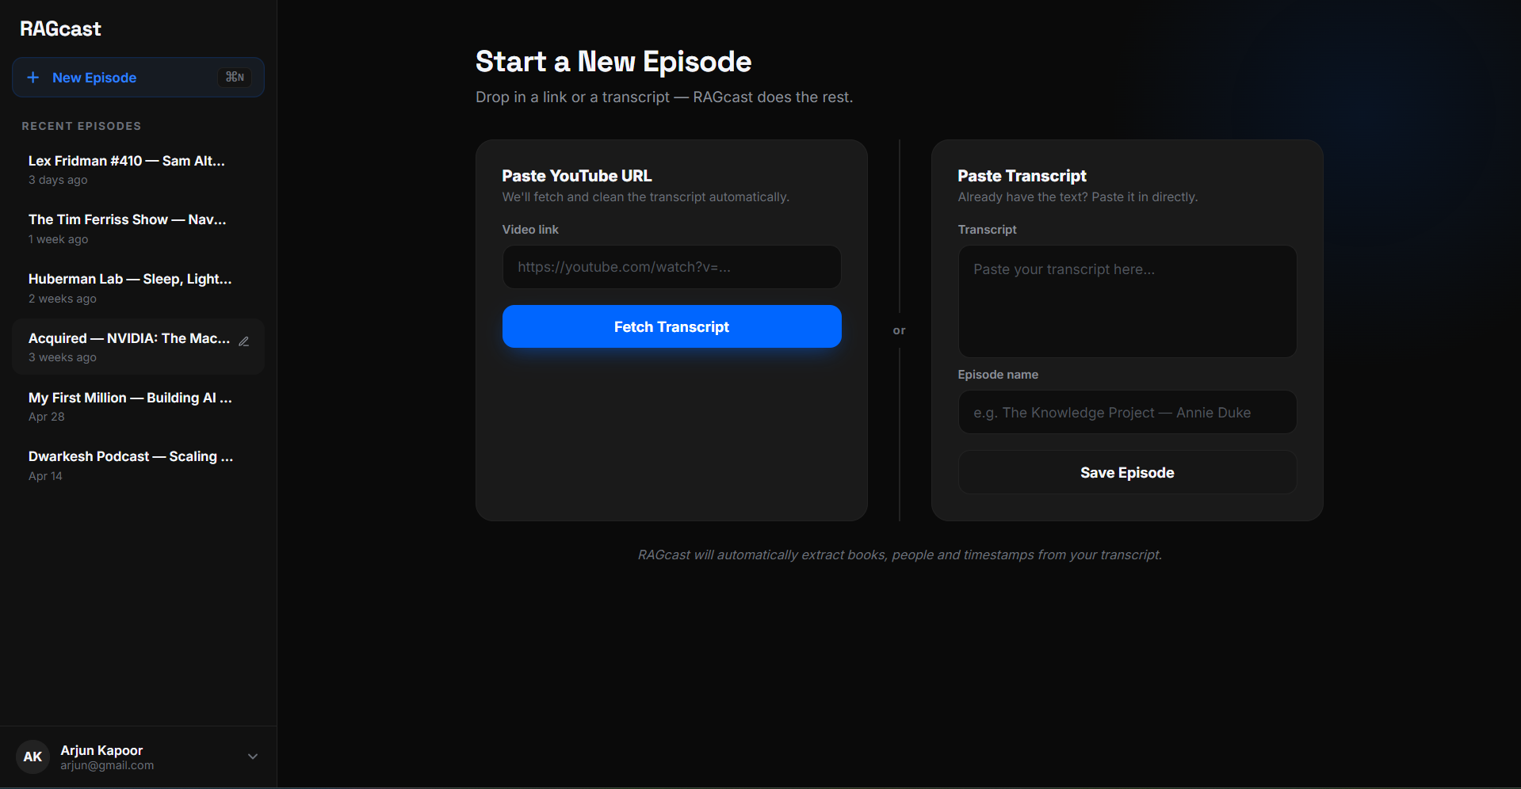

User Flow — Primary Happy Path

Step | Action | System Response
1 | User signs in via Google | Authenticated; lands on Main App with empty state
2 | Clicks New Episode | New Episode screen replaces chat area
3 | Pastes YouTube URL or transcript | System fetches or accepts transcript
4 | Episode is processed | Transcript chunked & indexed; books & people auto-extracted; summary generated
5 | Lands on Chat of new episode | First message: Episode Summary (200–250 words) with purple "Episode Summary" badge
6 | Books & People cards appear | Context panel populated with extracted books and people
7 | User types a question | RAGcast searches transcript; falls back to web if needed
8 | Answer returned with source badge | "From Transcript" (green) or "From Web" (blue) or split badge
9 | User returns later | Full chat history preserved; summary remains as first message

4. Key Features

Feature ID | Feature | Description | Priority
C1 | YouTube URL Ingestion | Paste a YouTube link → auto-fetch transcript via YouTube transcript API | P0
C2 | Manual Transcript Paste | Fallback for videos without captions or non-YouTube sources | P0
C3 | Timestamp Detection | Detect and preserve timestamps on ingestion | P0
C4 | Episode Creation & Naming | Auto-populate episode name from video title; user can edit anytime | P0
C5 | Transcript Chunking & Indexing | Split transcript into overlapping chunks, embed for RAG retrieval | P0
C6 | Persistent Storage | Episodes, chats, extracted data saved across sessions | P0
Q1 | Transcript-first Retrieval | Embed query → retrieve top-k relevant transcript chunks | P0
Q2 | Confidence Scoring | If retrieval score below threshold → flag as not found in transcript | P0
Q3 | Web Search Fallback | Auto-trigger web search when confidence is low | P0
Q4 | Source Labelling | Every answer tagged: From Transcript (green) or From Web (blue) | P0
Q5 | Persistent Chat History | Full chat saved per episode, resumable anytime | P0
Q6 | Hybrid Answer | Partial transcript + web gap filled — both sources shown | P1
Q7 | Episode Summary Message | On new episode creation, first chat message is an auto-generated summary of the podcast, strictly 200–250 words, labelled with an "Episode Summary" badge | P0
B1 | Auto Book Detection | LLM extracts book titles and authors on ingestion | P0
B2 | Books Display in Chat | Books surface as cards in the chat context panel | P0
B3 | Book Cards | Card: cover image, title, author, one-line description | P1
B4 | Book Metadata Enrichment | Fetch cover, author, description via Google Books API | P1
B5 | Amazon India Link | One-click buy link to Amazon India on each book card | P1
B6 | Book Timestamp Reference | Show "Mentioned at 23:45" on each book card | P1
B7 | Master Books Library | Aggregate all books across all episodes (global view) | P2
P1 | Auto People Detection | LLM extracts names mentioned on ingestion | P0
P2 | People Display in Chat | People surface as cards in the chat context panel | P0
P3 | People Cards | Card: avatar, name, who they are, what they’re known for | P1
P4 | People Metadata Enrichment | Fetch name, photo, bio via web for each person | P1
P5 | People Context Snippet | Show what was said about this person + timestamp on card | P1
T1 | Timestamp Preservation | Keep timestamp metadata attached to each chunk during indexing | P0
T2 | Timestamp Citation in Answers | Cite "Mentioned at 34:12" when sourced from transcript | P0
T3 | Multiple Timestamp References | Cite all timestamps if topic spans multiple moments | P1
T4 | Graceful Degradation | Skip citation silently if no timestamps in transcript | P0

5. Functional Requirements

FR-1: Transcript Ingestion
- System must accept a YouTube URL and auto-fetch the transcript using YouTube’s transcript/caption API.
- System must accept raw pasted transcript text as a fallback input method.
- On ingestion, system must detect whether timestamps are present in the transcript and preserve them for downstream use.
- Episode name must be auto-populated from the YouTube video title when URL ingestion is used; user must be able to rename at any time via an editable field.
- If YouTube URL has no available transcript, system must display a clear error and prompt the user to paste manually.

FR-2: Episode Summary Message
- On every new episode creation, the system must automatically generate a summary of the podcast transcript.
- The summary must be strictly between 200 and 250 words. Summaries shorter than 200 or longer than 250 words must be regenerated automatically.
- The summary must appear as the first message in the chat thread, posted by RAGcast (left-aligned, no user bubble).
- The summary message must be labelled with a distinct "Episode Summary" badge — styled in purple to differentiate it from source badges (green = transcript, blue = web).
- The summary must cover: main topic of the episode, key themes discussed, notable guests or personalities mentioned, and the most important takeaways.
- The summary must be generated from the full transcript, not just the first chunk.
- If summary generation fails, the system must display a graceful error message in place of the summary and allow the user to proceed to Q&A regardless.
- The summary is static once generated — it is not regenerated on subsequent visits to the episode.

FR-3: RAG Q&A with Web Fallback
- System must chunk and embed the transcript on episode creation and store vectors for retrieval.
- On each user query, system must retrieve the top-k most semantically relevant chunks from the transcript.
- System must evaluate a confidence score for each retrieval result.
- If score is above threshold → answer from transcript, badge: "From Transcript" (green).
- If score is below threshold → trigger web search, badge: "From Web" (blue).
- If partial match found + web supplements → badge: "From Transcript + Web" (split).
- All answers sourced from the transcript must include a timestamp citation where timestamps are available (e.g. "Mentioned at 34:12").
- If multiple relevant timestamps exist for a topic, all must be cited.
- Chat history must be persisted per episode and fully restored when the user reopens the episode.
- Pressing Enter (without Shift) must submit the message. Shift+Enter must add a newline.

FR-4: Books Extractor
- On transcript ingestion, system must run an LLM extraction pass to identify all book titles and authors mentioned.
- Extracted books must be displayed as cards in the right-hand context panel under "Books Mentioned."
- Each book card must display: cover image (fetched via Google Books API), title, author, one-line description, timestamp of mention.
- Each book card must include an Amazon India buy link that opens in a new tab.
- If no books are detected, section must show an empty state: "No books detected in this transcript yet."
- Books section must be collapsible with a count pill showing the number of books.

FR-5: People & Personalities Extractor
- On transcript ingestion, system must run an LLM extraction pass to identify all names mentioned (guests, referenced personalities, authors).
- Extracted people must be displayed as cards in the right-hand context panel under "People Mentioned."
- Each person card must display: avatar/photo (web-fetched), name, one-line bio, context snippet from the podcast, timestamp of mention.
- If no people are detected, section must show an empty state: "No people detected in this transcript yet."
- People section must be collapsible with a count pill showing the number of people.

FR-6: Authentication
- User must sign in via Google OAuth before accessing any feature.
- No email/password authentication in v1.0.
- Session must persist across browser refreshes.
- User must be able to log out from the account footer menu.

FR-7: Episode Management
- Each episode must be listed in the sidebar sorted by most recent first.
- Episode name must be editable via a pencil icon in both the sidebar and the chat header.
- Clicking an episode in the sidebar must load its chat history, context panel (books + people), and transcript data.
- New Episode action must replace the chat area (sidebar remains visible).

6. Non-Functional Requirements

Category | Requirement
Performance | YouTube transcript fetch must complete within 5 seconds. Episode summary must be generated within 8 seconds of transcript ingestion. RAG retrieval and response must return within 4 seconds on a standard broadband connection. Book/People extraction must complete within 10 seconds of transcript ingestion.
Scalability | System must support up to 10,000 concurrent users at v1.0 launch. Transcript indexing pipeline must handle transcripts up to 3 hours in length (~50,000 words).
Security | All user data encrypted in transit (TLS 1.2+) and at rest. Google OAuth tokens must never be stored in plaintext. No transcript data shared between user accounts.
Reliability | 99.5% uptime SLA. Graceful degradation: if web search service is unavailable, system must respond with transcript-only answer and surface a clear notice to the user. If summary generation fails, chat must still be accessible.
Usability | Core task (paste URL → read summary → ask first question) must be completable in under 90 seconds. UI must be functional on Chrome, Safari, Firefox (latest 2 versions). Responsive down to 1280px viewport width.
Data Privacy | Transcripts and chat history are private to the authenticated user. No transcript content is used for model training without explicit user consent.

7. Constraints & Dependencies

Constraints
- Technical: YouTube transcript availability depends on the video having auto-captions or manually uploaded subtitles. RAGcast cannot fetch transcripts from videos where captions are disabled by the uploader.
- Technical: Episode summary generation requires passing the full transcript to the LLM. Very long transcripts (3h+) may need to be summarised in chunks and then synthesised.
- Technical: Book cover and people photo enrichment depend on third-party APIs (Google Books, web search). Missing metadata must degrade gracefully to placeholder visuals.
- Timeline: MVP must ship all P0 features including Q7 (Episode Summary). P1 features must follow within 4 weeks of MVP.
- Budget: Web search fallback and LLM summary API costs must be monitored per user; rate-limiting may be required for free-tier users.
- Platform: v1.0 is web-only. Mobile responsiveness below 1280px is out of scope.

Dependencies
- Internal: Vector embedding pipeline must be set up before transcript chunking & indexing can be tested.
- External: YouTube Data API / transcript extraction library (e.g. youtube-transcript-api) must be evaluated and integrated.
- External: LLM API (e.g. Anthropic Claude or OpenAI) for episode summary generation, book extraction, and people extraction.
- External: Google Books API for book metadata enrichment.
- External: Google OAuth for authentication.
- External: Web search API (e.g. Serper, Tavily, or Bing Search API) for Q&A fallback.
- Cross-team: Design system tokens and mockup screens delivered — development must implement pixel-accurately.

8. Open Questions & Risks

Question / Risk | Owner | Resolution / ETA
What confidence threshold should trigger the web fallback? Too low → over-reliance on web. Too high → hallucination risk. | Tech Lead | Calibrate during internal alpha — Week 2
YouTube transcript API rate limits: what happens when a user pastes a URL and captions are unavailable or blocked? | Tech Lead | Define fallback UX by Week 1
Episode summary word count enforcement: how do we guarantee the LLM outputs exactly 200–250 words reliably? | Tech Lead | Prompt engineering + post-generation word count check with retry — Week 1
People extraction accuracy: LLMs may confuse guest names with referenced personalities or misattribute quotes. | Tech Lead / QA | Manual review of extraction quality in alpha — Week 3
Amazon India affiliate program: should book links include an affiliate tag for monetisation? | Product Manager | Decision needed before P1 launch
Risk: Web search and LLM API costs at scale may exceed budget if fallback and summary generation trigger frequently. | Tech Lead / PM | Set per-user daily cap; review post-alpha
What is the maximum transcript length the system should support? Very long podcasts (3h+) may exceed context/cost limits. | Tech Lead | Define cap during architecture review — Week 1

9. Appendices

Competitive Analysis

Product | Q&A on Transcript | Chat History | Episode Summary | Books Extraction | People Extraction | Web Fallback | Timestamps
NotebookLM | ✓ | ✗ | Partial | ✗ | ✗ | ✗ | Partial
Snipd | ✗ | ✓ | ✓ | ✗ | ✗ | ✗ | ✓
Podwise | Partial | ✗ | ✓ | ✓ | ✓ | ✗ | ✓
RAGcast v1.0 | ✓ | ✓ | ✓ | ✓ | ✓ | ✓ | ✓

Analytics & Instrumentation
The following events must be tracked at launch (suggested platform: Mixpanel or Amplitude):

- episode_created — source: youtube_url | manual_paste
- summary_viewed — episode_id, word_count
- question_asked — episode_id, answer_source: transcript | web | hybrid
- book_card_clicked — book_title, episode_id
- amazon_link_clicked — book_title, episode_id
- people_card_viewed — person_name, episode_id
- episode_renamed — episode_id
- session_resumed — episode_id, messages_in_history
- web_fallback_triggered — query_text, episode_id
- sign_in — method: google
- sign_out

Release Plan

Phase | Scope | Duration | Go/No-Go Criteria
Internal Alpha | All P0 features including summary generation | Week 1–2 | Core Q&A + summary works end-to-end; no critical bugs
Closed Beta | P0 + P1 features; 20–50 real users | Week 3–5 | Episode creation < 90s; summary word count 200–250 verified; Week-1 retention > 40%
MVP Launch | All P0 + P1 features; public access | Week 6 | No P0 bugs; performance NFRs met; analytics live
P2 Rollout | Master Books Library; cross-episode features | Week 8+ | Post-launch usage data supports prioritisation

Glossary

Term | Definition
RAG | Retrieval-Augmented Generation — a technique where an LLM answers questions by first retrieving relevant context from a document, then generating a grounded response.
Episode Summary | A 200–250 word auto-generated overview of a podcast episode, produced by the LLM from the full transcript and displayed as the first message in every new chat.
Chunking | The process of splitting a long transcript into smaller, overlapping segments for vector embedding and retrieval.
Embedding | A numerical vector representation of text that captures semantic meaning, used to find relevant chunks during retrieval.
Confidence Score | A similarity score (0–1) returned by the vector search. Below a set threshold, the system falls back to web search.
Web Fallback | When the transcript does not contain sufficient information to answer a query, the system automatically searches the web.
Context Panel | The right-hand resizable panel in the main app that shows Books and People extracted from the current episode.
P0 / P1 / P2 | Priority tiers: P0 = must-have for MVP launch; P1 = ships within 4 weeks of MVP; P2 = future iteration.
Source Badge | A pill label on every RAGcast answer indicating origin: From Transcript (green), From Web (blue), or From Transcript + Web (split badge).
Episode Summary Badge | A distinct purple pill label on the auto-generated summary message, differentiating it from Q&A source badges.

CONFIDENTIAL | RAGcast v1.0 | For internal review only

