Mutual Fund Overview & Insights
Data Analytics Project: Finding High-Return, Low-Risk Fund Schemes
[Your Name]
[Date]

Stage 0: Goal and problem statement
- The goal of this project is to take a big list of mutual funds, clean it, give every fund a score and pick the best 30 funds with good return and low risk. It helps beginner investors who do not know how to choose a fund.
- If we only look at the highest return we can choose a risky fund. Bank of India Credit Risk Fund has a 1 year return of 130.8%, but its 5 year return is -4.1%, so it is not a good choice. In my data, funds with higher return also have higher risk (correlation 0.81), so I check both together.
- My objectives were:
  - clean the data
  - study it with statistics and plots
  - scale the columns to the same range
  - make a score and rank the funds
  - save the Top 30 in Excel and build a Power BI dashboard
- Python is used for cleaning and scoring. Excel is used to keep the final Top 30 list. Power BI is used to show the result in charts and filters so that anyone can understand it.

Stage 1: Data cleaning
- The data has 814 rows and 20 columns. The main columns are 1, 3 and 5 year returns, expense ratio, risk level (1 to 6), fund age, fund size (AUM in crore), AMC, category, sub category, fund manager, rating, minimum SIP and minimum lump sum. There is no fund type column, so I used category as fund type.
- I removed sortino, alpha and beta. I do not use them and each has many missing values (23 to 42).
- 21 funds (2.6%) have no 3 year return and 167 funds (20.5%) have no 5 year return. These funds are only 2 to 3 years old, so the value does not exist. I did not fill them. Funds with no 3 year return are left out of the ranking.
- The columns sortino, alpha, sd, beta and sharpe had “-” in some rows, so they were read as text. I changed them to numbers with pd.to_numeric.
I also found 14 funds of different types with exactly the same 1, 3 and 5 year returns (for example 1.7, 32.4 and 13.3 for 9 funds, including an overnight fund). This cannot be right, so I removed the returns of these 14 funds. 779 funds were left for ranking.

Stage 2: Understanding the data
- Summary of the main columns:
Column | Mean | Median | Mode | Min | Max | Std
1 year return % | 3.98 | 4.40 | 5.60 | -19.7 | 130.8 | 6.72
3 year return % | 18.27 | 18.10 | 3.90 | 3.3 | 71.4 | 12.06
5 year return % | 9.42 | 8.80 | 5.30 | -4.1 | 23.2 | 3.72
Expense ratio % | 0.71 | 0.62 | 0.21 | 0.00 | 2.59 | 0.48
AUM (crore) | 3,813 | 940 | 90 | 2.4 | 57,052 | 7,181
Fund age (years) | 8.3 | 10 | 10 | 1 | 17 | 2.64
Risk level | 4.4 | 6 | 6 | 1 | 6 | 1.81
A normal fund gives around 18% in 3 years, charges about 0.7%, is about 10 years old and has high risk. The mean AUM is much bigger than the median because a few funds are very large.
- The 3 year returns have two groups: 178 funds are below 6% and 240 funds are between 25% and 40%. Risk is not balanced, 418 funds (51%) are at level 6. 508 funds (62%) are exactly 10 years old, so I think the data stops counting at 10. AUM is skewed to the right (skew 3.6).
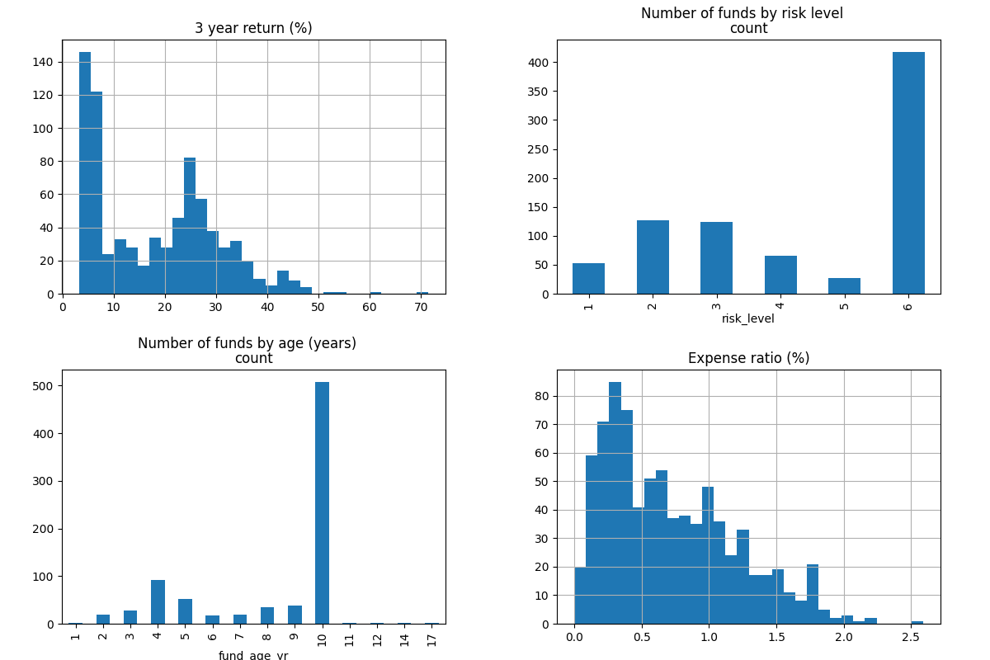
Distribution plots
- The biggest outlier is the 130.8% 1 year return of Bank of India Credit Risk Fund. Its 5 year return is negative, so it was probably a one time event. Also about 15% of funds had a 1 year return of 0 or less.

Stage 3: Normalisation
- The columns have very different sizes. Returns go up to 71, expense ratio is below 3 and risk is 1 to 6. If I add them directly the column with big numbers will control the score.
- I used MinMaxScaler on 3 year return, expense ratio and risk level, because these are the columns used in my score. The formula is (value - min) / (max - min), so every value is between 0 and 1.
- After scaling I can compare them directly. ICICI Pru Equity Savings Fund has a scaled return of 0.14 and a scaled expense ratio of 0.21. So it is cheap, but its return is low compared with the best funds.

Stage 4: Scoring and ranking
- My formula is:
- Score = 100 x (0.40 x Return + 0.15 x (1 - Expense) + 0.10 x Age score + 0.10 x Positive 1 year + 0.25 x (1 - Risk))
  - Return, Expense and Risk are the scaled values.
  - Age score = 1 - |age - 7| / 6 (minimum 0). I took 7 years as the best age, not too new and not too old.
  - Positive 1 year is 1 if the 1 year return is above 0, otherwise 0.
  - The brief gives 4 factors. I added risk as a fifth, because the aim is good return with low risk.
- Return is better when it is high, so I use it as it is. Expense and risk are better when low, so I use 1 minus the scaled value.
- I gave the most weight to return (40%) because it is the main aim, then risk (25%), expense (15%), age (10%) and positive 1 year (10%). A different weighting does change the ranking a lot. With 45/15/10/10/20 only 8 funds stayed in the Top 30 and 26 of the 30 were equity funds. With more weight on safety (25/15/10/10/40) 23 funds stayed. This happens because return and risk go together in this data.
- I ranked all 779 funds. The parts closest to the final score are positive 1 year return (0.70), low risk (0.70) and low expense (0.59). Return is -0.26, because high return funds also have high risk.

Stage 5: Top 30 funds
- The Top 30 is saved in Top_30_Mutual_Funds.xlsx.
- 15 of the 30 are Debt, 9 are Hybrid and 6 are Equity. 22 have risk level 1. 12 are overnight funds and 8 are arbitrage funds. The average expense ratio is 0.34% (all funds 0.71%) and no AMC has more than 3 funds. So with my weights, safe and cheap funds win. Most of them give only 4 to 5% return. Rank 1 (Sundaram Emerging Small Cap Series III) is a small cap fund with risk level 2, which looks strange.
- ICICI Pru Equity Savings Fund is at rank 12 with score 55.73. Its 3 year return is 12.7%, 1 year return is 6.2% (positive), expense ratio is 0.54%, age is 8 years and risk level is 2. So it has a fair return with low risk and low cost.

Stage 6: Power BI dashboard
My dashboard has 3 pages. Page 1 (Overview) and page 2 (Fund Analysis) have 5 charts each, and page 3 shows the Top 30 table. The same filters are on every page.
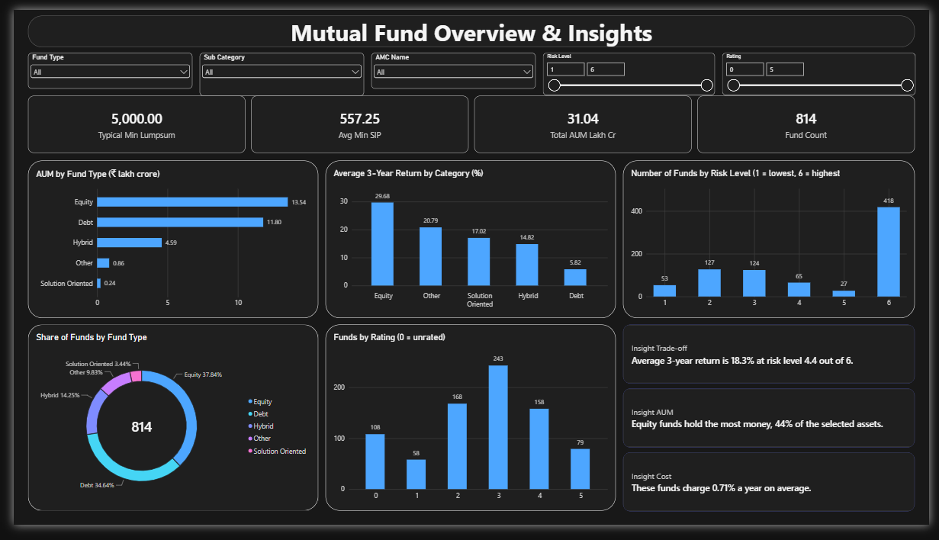
Page 1: Overview
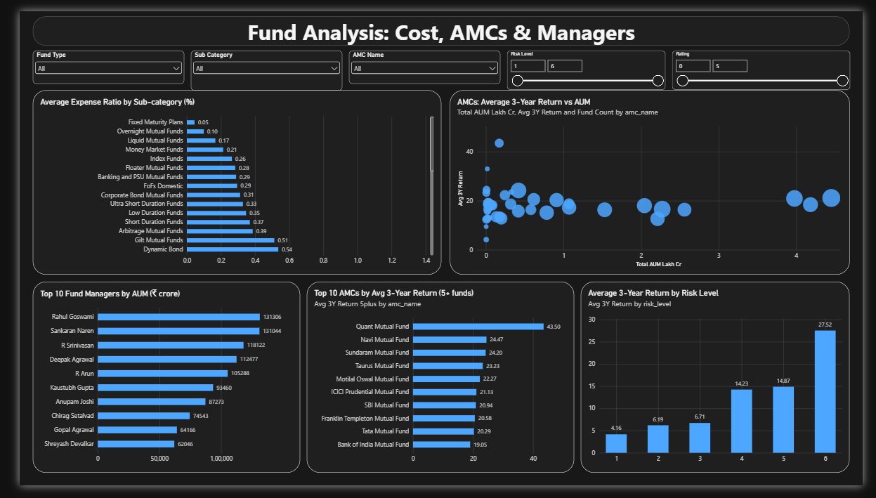
Page 2: Fund Analysis
Filters: Fund Type, Sub Category, AMC Name, Risk Level and Rating. Fund Type is the same as category.
Visual | Chart | Reason
AUM by fund type | Bar | 5 types, easy to compare
3 year return by category | Column | easy to compare. A donut is not good because averages do not add to a whole
Funds by risk level | Column | shows how many funds are at each level
Share of funds by type | Donut | the shares add to 100%
Funds by rating | Column | shows how many funds have each rating
SIP and lump sum | Cards | one main number each
Expense ratio by sub category | Bar | 38 names fit better on the side
AMC return vs AUM | Scatter | shows size and return together
Top 10 fund managers by AUM | Bar | a ranking
Top 10 AMCs by 3 year return | Bar | only AMCs with 5 or more funds
3 year return by risk level | Column | shows the risk and return trade-off
Top 30 funds | Table | shows the result of my score
Insight cards | Text cards | short sentences that change with filters
Layout: every page has the title and filters on top, then the cards and the charts, so it reads from top to bottom. Page 1 is the overview, page 2 has more detail and page 3 has the final Top 30.
The most useful visual for an investor is 3 year return by risk level. Return goes from 4.16% at risk level 1 to 27.52% at level 6, so it shows the trade-off in one chart.

Stage 7: Insights
- Equity has the largest AUM, 13.54 lakh crore (43.6%). It is about 1.74 lakh crore more than Debt (11.80 lakh crore).
- Rahul Goswami manages the most AUM, about 1.31 lakh crore. Sankaran Naren is almost the same.
- Debt has the lowest expense ratio by type (0.36% average). By sub category it is Fixed Maturity Plans (about 0.05%).
- The best 1 year return is Bank of India Credit Risk Fund (130.8%), but it looks like a one time event.
- The average minimum SIP is 528 rupees (557 if I leave out funds with 0). The typical minimum lump sum is 5,000 rupees.
- 3 year return: Equity 29.7%, Hybrid 14.8%, Debt 5.8%. Risk goes up in the same order, so more return means more risk.
- Insight cards:
  - Equity gave about 30% a year over 3 years, but its value moves up and down about 8 times more than debt.
  - Debt funds charge about 0.36% a year and equity funds about 1.05%. Over many years this adds up.
  - Half of the funds are at the highest risk level.

Final reflection
A first time investor who wants low risk and steady growth should start with low cost debt or hybrid funds, and add equity slowly later. One high 1 year return is not a good reason to pick a fund.
Python helped me clean and score 814 funds. Excel keeps the final list in one simple file. Power BI shows the result in charts, so I could answer from the data and not guess. This is a class project, not investment advice.

