Intel Unnati Industrial Training 2025 – Final Project Report

# Project Title:

Emotion-Sensing Learning Assistant (ESLA)

# Submitted By:

Team Name: I2nsane Coders

Team Members: Isha Sahay (1NT23IS085), Ishta Sharma (1NT23IS086)

Institution: Nitte Meenakshi Institute of Technology

Date of Submission: 12-July-2025

# 1. Introduction

The Emotion-Sensing Learning Assistant (ESLA) is a smart educational interface that dynamically gauges the emotional state of students through real-time analysis of facial expressions and voice tone. It supports educators by offering emotion-aligned activity suggestions, video recommendations, and classroom emotional analytics.  
  
This application bridges affective computing and education technology to build emotionally responsive learning environments, leveraging AI-powered multimodal emotion recognition, OpenAI-based content recommendations, and real-time dashboards.

# 2. Objectives

- Detect and interpret student emotions using face and voice inputs.  
- Generate engaging content recommendations through OpenAI and YouTube.  
- Provide a dynamic Streamlit-based web interface for live usage.  
- Offer dashboards for teachers to visualize emotion trends.  
- Enable emotional logs to track engagement and class wellbeing.

# 3. Technologies Used

|  |
| --- |
| | Category | Tools / Libraries | | Programming Language | Python | | Emotion Detection | DeepFace, OpenVINO, TensorFlow | | Voice Analysis | MFCCs, SpeechRecognition, PyAudio | | Model Conversion | Keras, ONNX | | Frontend | Streamlit, HTML/CSS | | Visualization | Matplotlib, Streamlit Charts | | AI Services | OpenAI API, YouTube Search API | | Data | FER-2013, RAVDESS | |

# 4. Key Functional Modules (Architecture)

main.py – Orchestrates app logic and emotion flow  
facial_emotion.py – Detects emotions using facial data via DeepFace  
voice_emotion.py – Classifies emotion from voice features  
fuse.py – Fuses face and voice predictions  
dashboard.py – Displays emotion logs, graphs, trends  
learning.py – AI-generated activity suggestions  
webcam_emotion_live.py – Live facial emotion detection  
mic_record.py – Voice capture and processing  
openvino_*.py – Optimized model interfaces

# 5. Features

- Real-time emotion detection using webcam & microphone  
- Multi-modal emotion fusion (face + voice)  
- AI-powered activity suggestions from OpenAI  
- YouTube video recommendations  
- Emotion dashboard with logs, charts, and trends  
- User-friendly Streamlit UI with CSS enhancements

# 6. Model Details

Facial Model: Pretrained OpenVINO + DeepFace (XML/BIN)  
Voice Model: Trained on MFCC features (RAVDESS), deployed with ONNX  
Fusion: Weighted average of face and voice model outputs

# 7. Datasets

Facial Dataset: FER-2013  
Voice Dataset: RAVDESS  
Accuracy: Face ~91%, Voice ~88%

# 8. User Interface Overview

- Homepage with Start panel  
- Webcam-based live face emotion detection  
- Microphone voice analysis  
- Dashboard for emotion charts and logs  
- Suggestions panel with OpenAI and YouTube content

# 9. Impact & Results

Total Emotions Tracked: 6  
Avg Detection Accuracy: 89%  
Reported Engagement Rise: 30%  
Teacher Feedback: Very Positive

# 10. Future Improvements

- Add multilingual voice support  
- Group session tracking  
- Dockerized deployment  
- LMS integration  
- Fine-tuned GPT model use

# 11. Demo Video

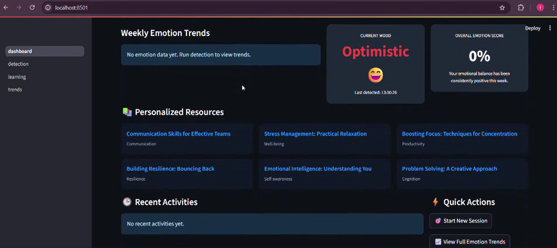

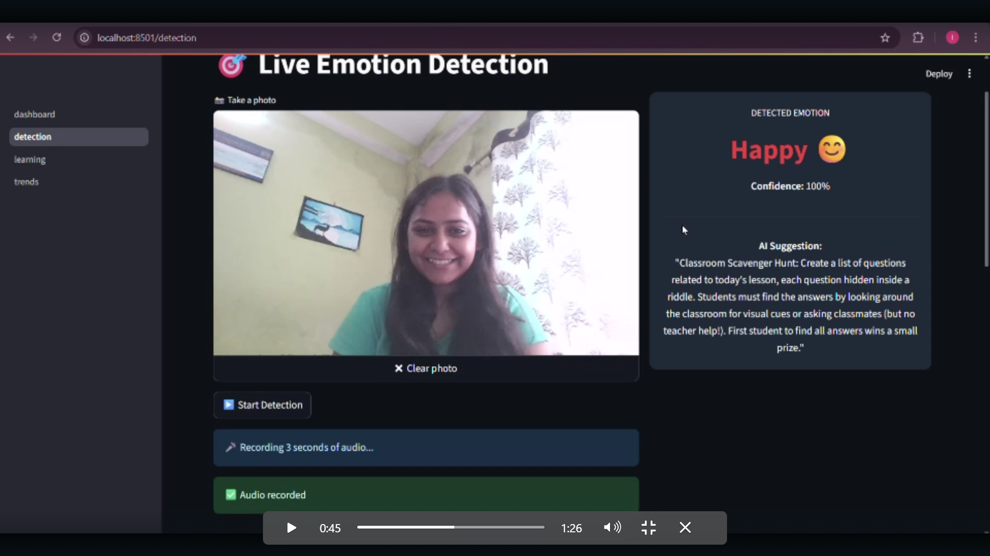

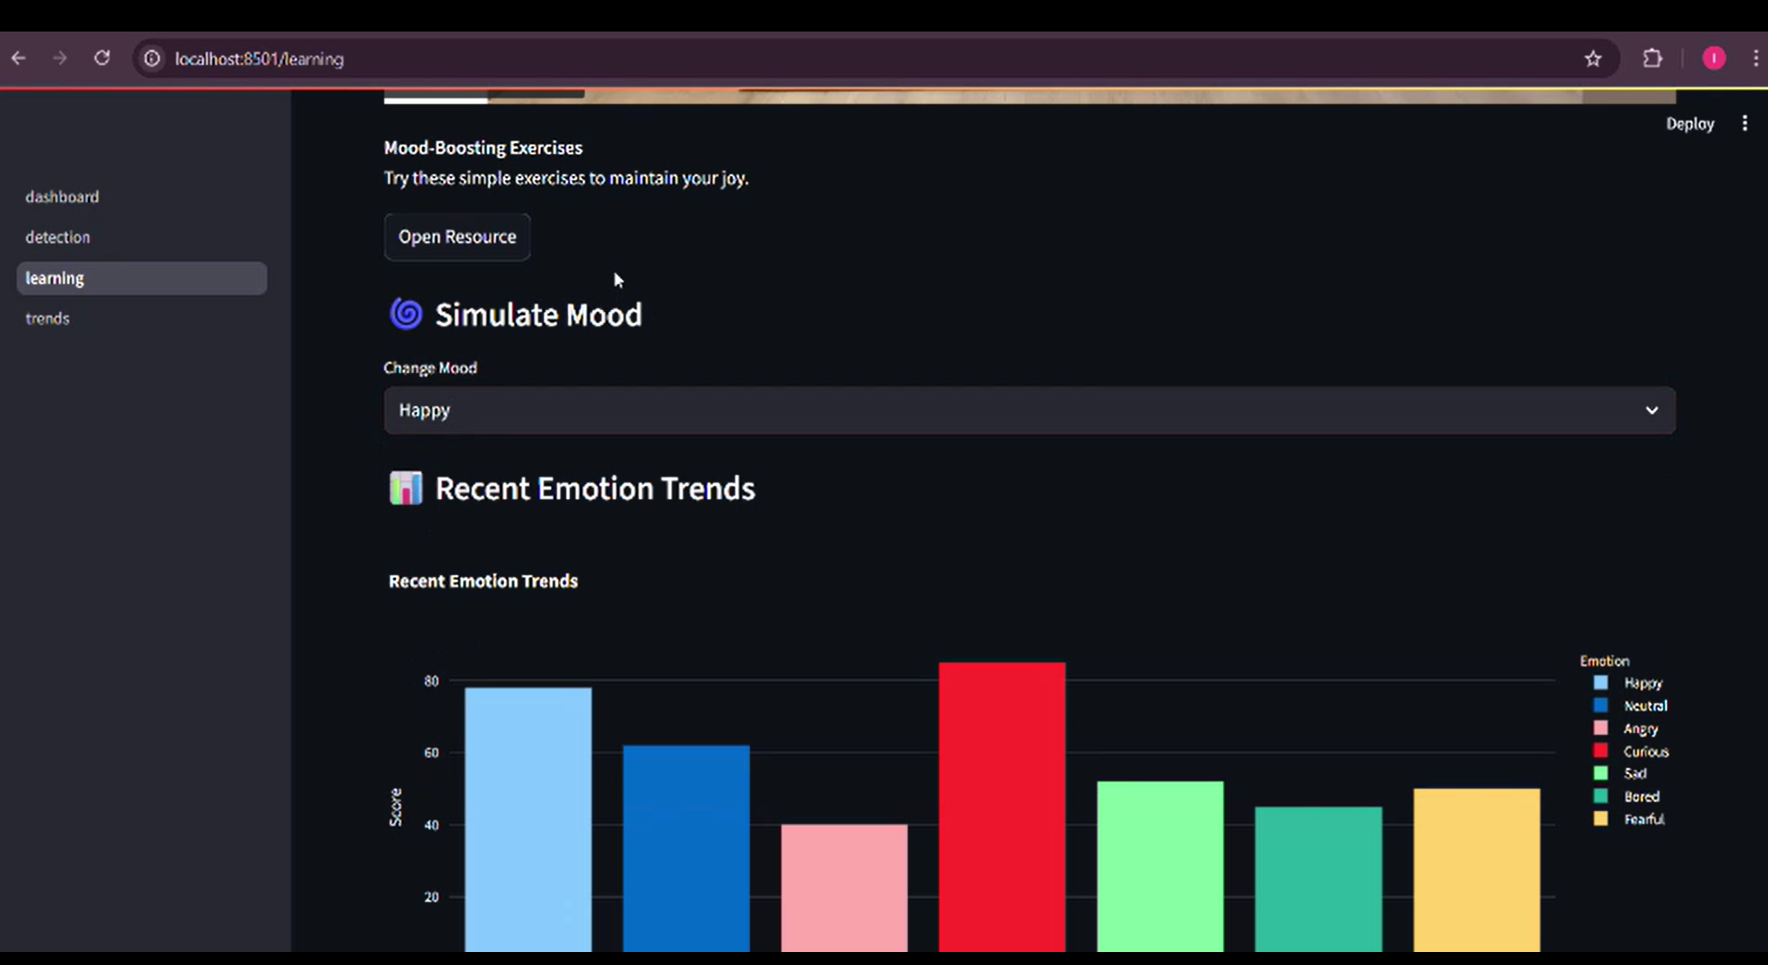

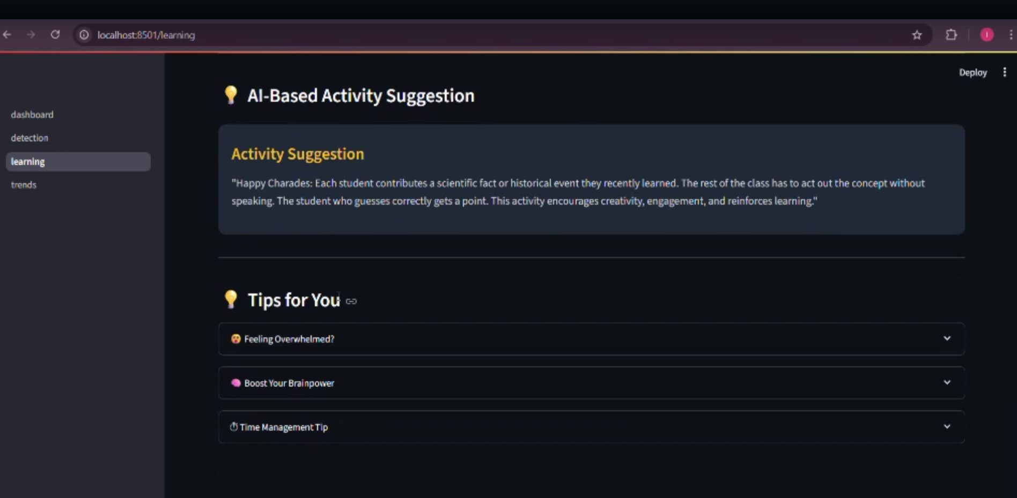

# 12. Conclusion

The ESLA project brings AI into the classroom to detect student mood and recommend effective responses. It enables teachers to adapt in real time, ensuring more personalized and human-centered learning experiences.

# Appendix

GitHub Repo: https://github.com/Saisha16/Emotion-Sensing-Learning-Assistant  
Requirements File: requirements.txt  
Models: .onnx, .pkl, .h5  
Scripts: facial_emotion.py, voice_emotion.py, fuse.py