SE ASSIGNMENT (TEAM-4)

1. HOME PAGE

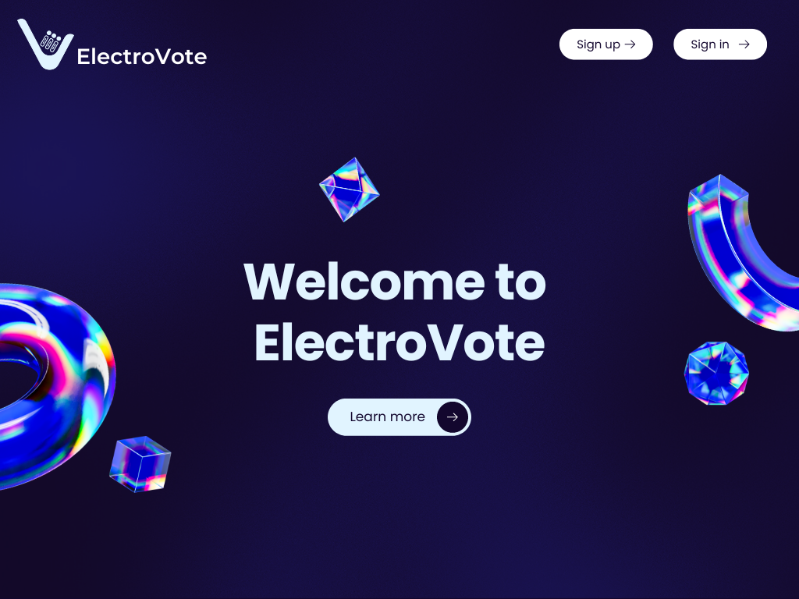

**Sample code**

<!DOCTYPE html>

<html lang="en">

<head>

<meta charset="UTF-8">

<meta name="viewport" content="width=device-width, initial-scale=1.0">

<title>ElectroVote</title>

<link rel="stylesheet" href="1stpage.css">

</head>

<body>

<div class="container">

<img src="logo.png" alt="ElectroVote Logo" style="width: 150px;">

<h1>Welcome to ElectroVote</h1>

<button class="learn-more-btn">Learn more</button>

<div class="btn-container">

<button class="btn">Sign up</button>

<button class="btn">Sign in</button>

</div>

</div>

<div class="shapes">

<img src="shape1.png" class="shape-1" alt="Shape 1">

<img src="shape2.png" class="shape-2" alt="Shape 2">

<img src="shape3.png" class="shape-3" alt="Shape 3">

<img src="shape4.png" class="shape-4" alt="Shape 4">

</div>

</body>

</html>

1. Login page

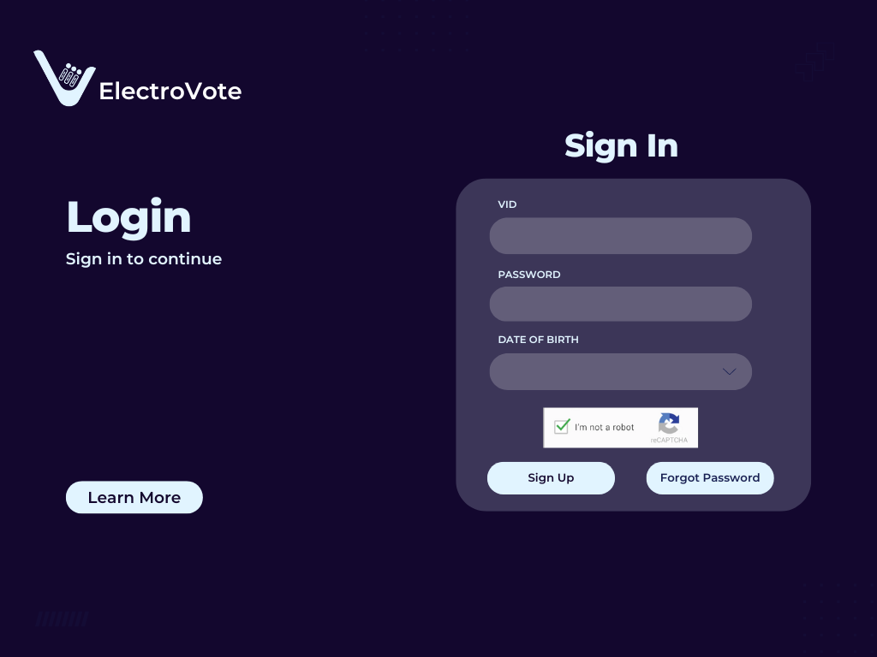

1. Forget password

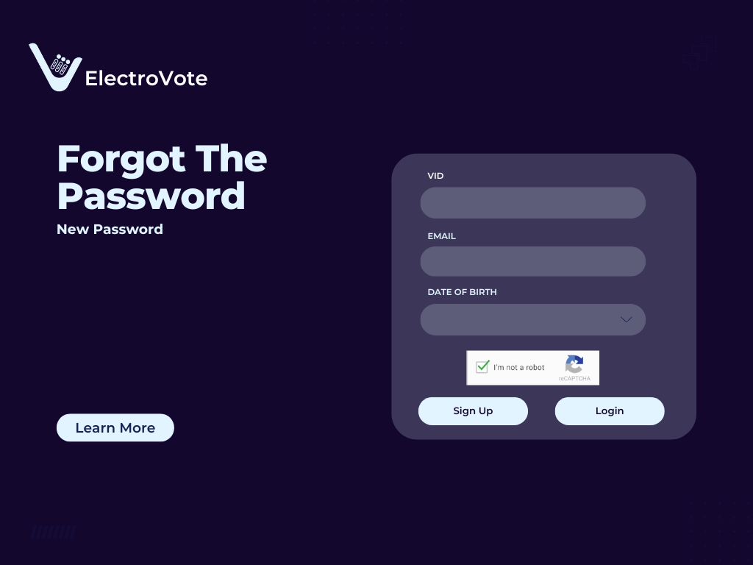

Sample code:

<!DOCTYPE html>

<html lang="en">

<head>

<meta charset="UTF-8">

<meta name="viewport" content="width=device-width, initial-scale=1.0">

<title>ElectroVote - Forgot Password</title>

<link rel="stylesheet" href="3rdpage.css">

</head>

<body>

<div class="container">

<!-- Left section for title and button -->

<div class="left-section">

<img src="logo.png" alt="ElectroVote Logo" class="logo">

<h1>Forgot The Password</h1>

<p>New Password</p>

<button class="learn-more-btn">Learn More</button>

1. Signup page

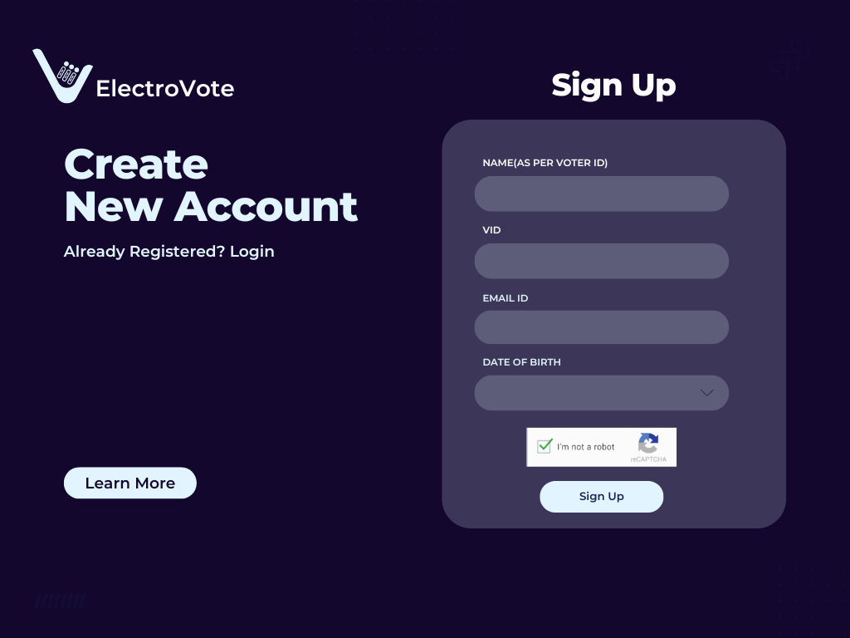

Sample code

<!DOCTYPE html>

<html lang="en">

<head>

<meta charset="UTF-8">

<meta name="viewport" content="width=device-width, initial-scale=1.0">

<title>ElectroVote Sign Up</title>

<link rel="stylesheet" href="4thpage.css">

</head>

<body>

<div class="container">

<div class="left">

<div class="logo">

<h1>ElectroVote</h1>

</div>

<h2>Create New Account</h2>

<p>Already Registered? <a href="#">Login</a></p>

<button class="learn-more">Learn More</button>

1. Selection Page

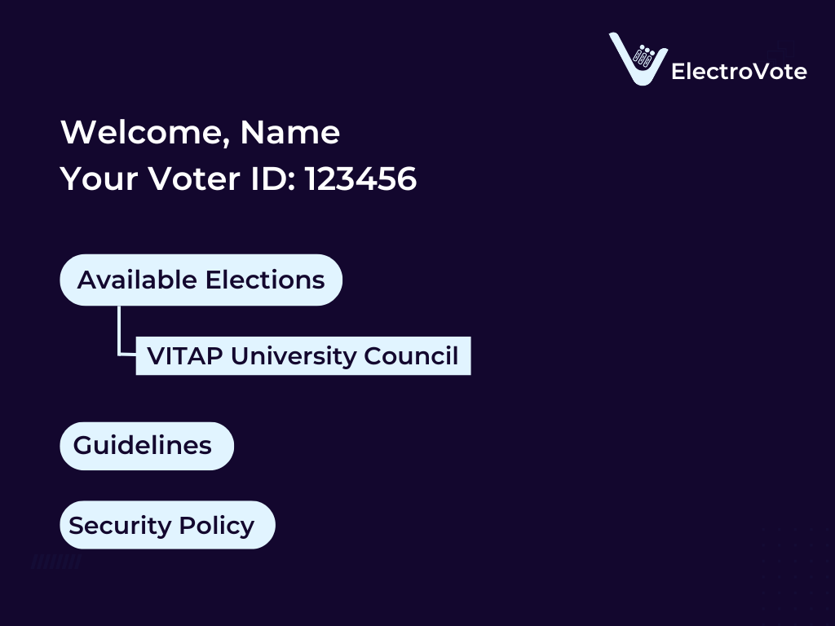

Sample code

<!DOCTYPE html>

<html lang="en">

<head>

<meta charset="UTF-8">

<meta name="viewport" content="width=device-width, initial-scale=1.0">

<title>ElectroVote Dashboard</title>

<link rel="stylesheet" href="5thpage.css">

</head>

<body>

<div class="dashboard-container">

<div class="header">

<h1>Welcome, Name</h1>

<p>Your Voter ID: 123456</p>

</div>

1. Voting page

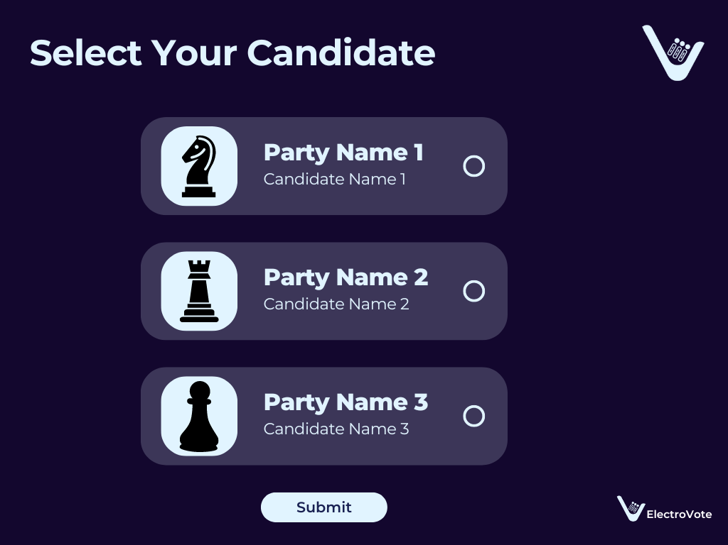

Sample code

<!DOCTYPE html>

<html lang="en">

<head>

<meta charset="UTF-8">

<meta name="viewport" content="width=device-width, initial-scale=1.0">

<title>Select Your Candidate</title>

<link rel="stylesheet" href="6thpage.css">

</head>

<body>

<div class="container">

<h1>Select Your Candidate</h1>

<div class="candidates">

<div class="candidate">

<img src="knight.png" alt="Knight" class="candidate-icon">

<div class="candidate-info">

<h2>Party Name 1</h2>

<p>Candidate Name 1</p>

</div>

1. Confirmation page

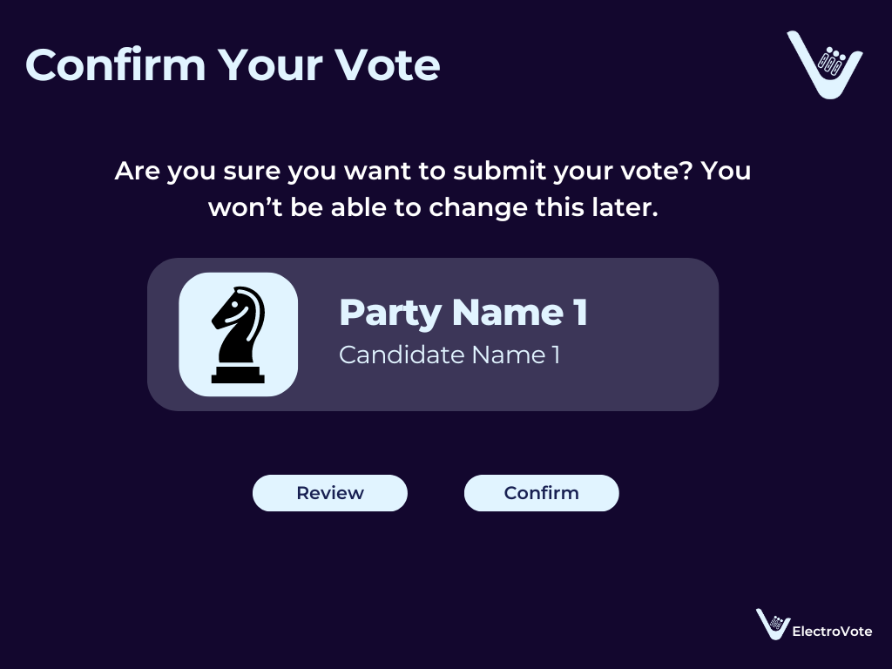

Sample code

<!DOCTYPE html>

<html lang="en">

<head>

<meta charset="UTF-8">

<meta name="viewport" content="width=device-width, initial-scale=1.0">

<title>Confirm Your Vote</title>

<link rel="stylesheet" href="7thpage.css">

</head>

<body>

<div class="container">

<h1>Confirm Your Vote</h1>

<p>Are you sure you want to submit your vote? You won’t be able to change this later.</p>

<div class="vote-card">

<div class="party-icon">

<img src="knight-icon.png" alt="Party Icon">

</div>

1. Thanking page

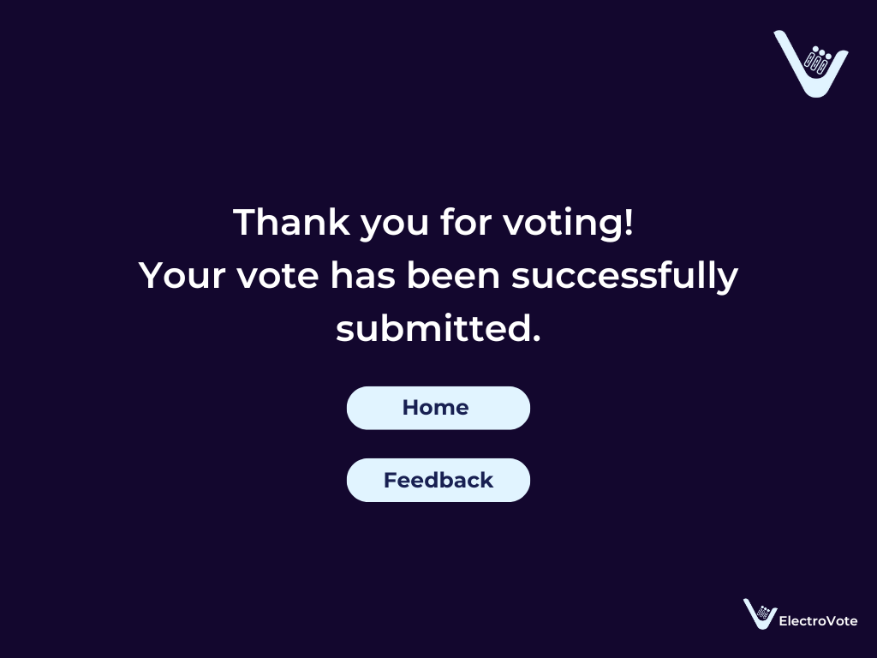

Sample code

<!DOCTYPE html>

<html lang="en">

<head>

<meta charset="UTF-8">

<meta name="viewport" content="width=device-width, initial-scale=1.0">

<title>Thank You for Voting</title>

<link rel="stylesheet" href="8thpage.css">

</head>

<body>

<div class="container">

<h1>Thank you for voting!</h1>

<p>Your vote has been successfully submitted.</p>

<div class="buttons">

<button class="home-btn">Home</button>

<button class="feedback-btn">Feedback</button>

</div>

1. Feedback form

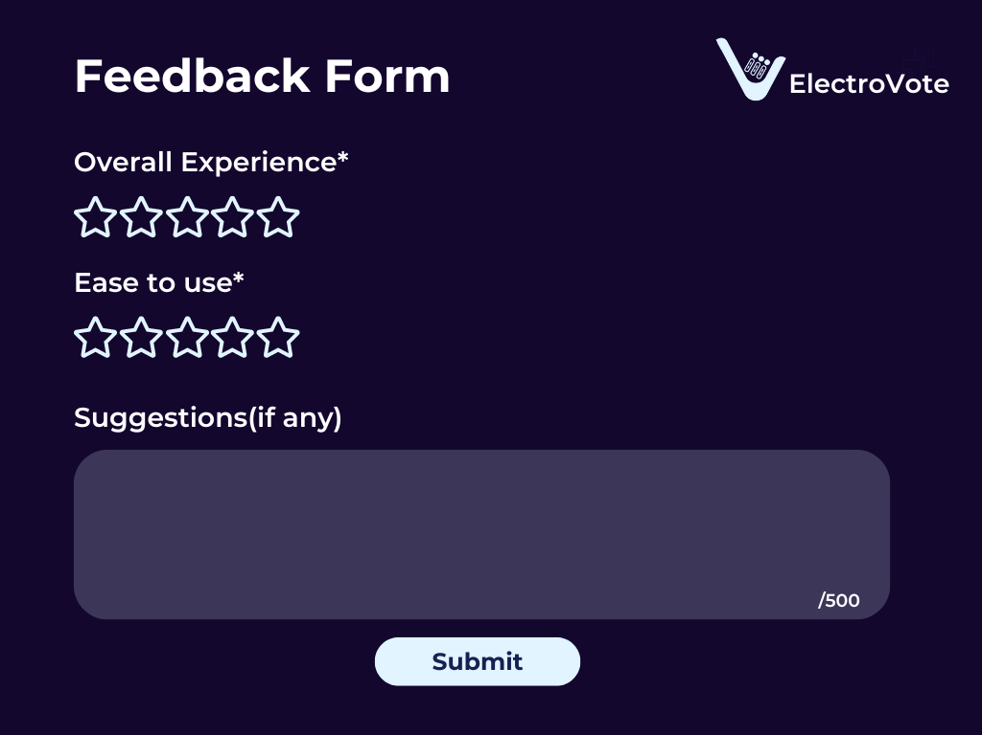

Sample code

<!DOCTYPE html>

<html lang="en">

<head>

<meta charset="UTF-8">

<meta name="viewport" content="width=device-width, initial-scale=1.0">

<title>Feedback Form</title>

<link rel="stylesheet" href="9thpage.css">

</head>

<body>

<div class="container">

<h1>Feedback Form</h1>

<form action="#" method="post">

<div class="rating-section">

<label for="overall">Overall Experience*</label>

<div class="stars" id="overall">

<span>☆</span><span>☆</span><span>☆</span><span>☆</span><span>☆</span>

</div>

</div>

1. Admin panel

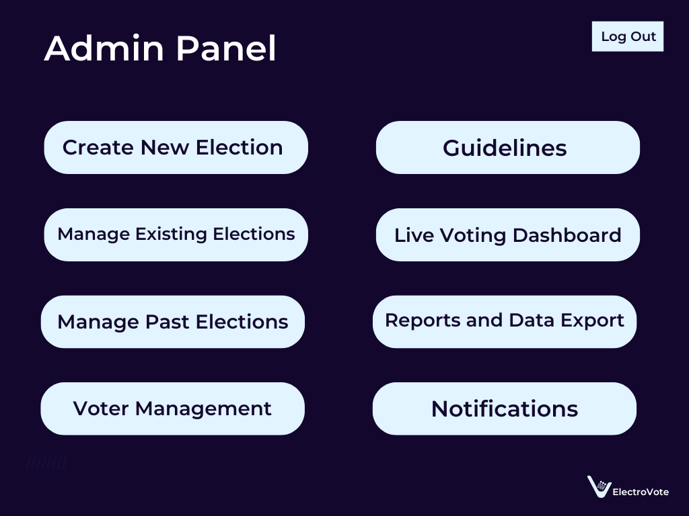

Sample code

<!DOCTYPE html>

<html lang="en">

<head>

<meta charset="UTF-8">

<meta name="viewport" content="width=device-width, initial-scale=1.0">

<title>Admin Panel</title>

<link rel="stylesheet" href="10thpage.css">

</head>

<body>

<div class="container">

<div class="header">

<h1>Admin Panel</h1>

<button class="logout-button">Log Out</button>

</div>

<div class="button-grid">

<button class="button">Create New Election</button>

<button class="button">Guidelines</button>

<button class="button">Manage Existing Elections</button>

<button class="button">Live Voting Dashboard</button>

<button class="button">Manage Past Elections</button>

<button class="button">Reports and Data Export</button>

<button class="button">Voter Management</button>

<button class="button">Notifications</button>

</div>

1. Live voting Dashboard

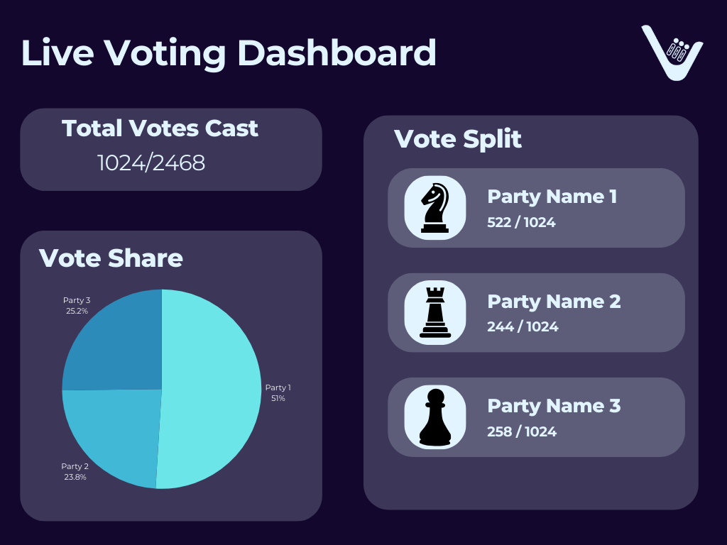

Sample code

<!DOCTYPE html>

<html lang="en">

<head>

<meta charset="UTF-8">

<meta name="viewport" content="width=device-width, initial-scale=1.0">

<title>Live Voting Dashboard</title>

<link rel="stylesheet" href="11thpage.css">

</head>

<body>

<div class="dashboard-container">

<header>

<h1>Live Voting Dashboard</h1>

<div class="logo">V</div>

</header>

<div class="grid-container">

<!-- Total Votes Cast -->

<div class="card total-votes">

<h2>Total Votes Cast</h2>

<p>1024/2468</p>

</div>

GITHUB LINK: https://github.com/Saisharad/Electrovote.git