Big Mountain Resort, a ski resort located in Montana, has recently installed an additional chair lift to help increase the distribution of visitors across the mountain. This additional chair increases their operating costs by $1,540,000, so they are trying to charge a premium above the average price of resorts in its market segment which was their best approach. So in-order to compensate for the additional costs, they needed us to come up with a strategy to decide a nominal pricing of the tickets and utilize the facilities to their maximum effort or decrease the usage of facilities, which in return reduces the operational costs, and put these suggestions into effect this season.

Depending upon the facilities in the resort, we came up with four scenarios, which the resort was planning to do, and calculated the price based on them. The first is closing down up to 10 of the least used runs, second is to increase the vertical drop by adding a run to a point 150 feet and installing an additional chair lift to bring skiers back up, third one would be adding 2 acres of snow making and finally fourth one is increasing the longest run by .2 miles and guaranteeing its snow coverage by adding 4 acres of snow making capability.

Modeling the closing of 10 least used runs shows that the ticket price and revenue don’t gets affected (if 1 run is closed) and closing up to 3-5 runs constitutes no difference in ticket prices and thus revenue is not affected. Closing of more than 5 runs, shows a sharp drop in ticket price and revenue, which can be seen from figure 1.(showing the change in ticket price, when runs are closed and change in revenue when the runs are closed). So, closing of more than 6 runs would affect the revenue by $ 2.2 million (approx.), and further closing of runs results in lower ticket prices and almost $ 3 million loss of revenue.

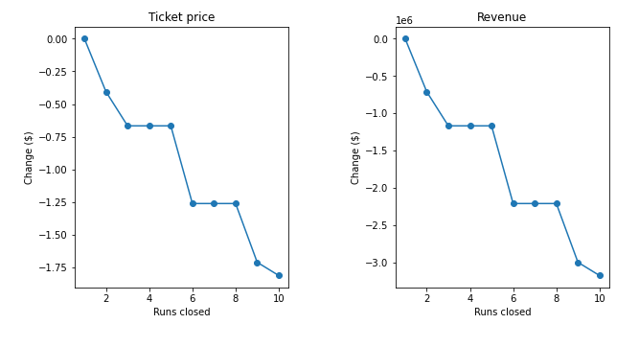

Figure 1 Analysis of closing runs with change in ticket price (left) and runs with change in revenue (right).

Modeling scenario 2 (increase in vertical drop by 150ft and adding additional chair lift) increases support for ticket price by $ 8.61 and over the season, the revenue generated would be $15 million, with an increase of $3 million. The 3rd scenario adding snow making to 2 acres along with adding scenario 2 supports the increase for ticket price by $ 9.9 and over the season, the revenue generated would be $17 million, with an increase of $3.465 million. The final scenario of increasing longest run by .2 miles and adding snow making made no difference.

So, from these scenarios, the best option would be to consider scenario 2 as the revenue would be increase to $3 million and with scenario 3, since we don’t know the cost for adding snow to 2 acres, it would be an option for consideration if we know the operating costs for snow making. So, further analysis should be performed with extra data for snow operating costs, which would have incur fewer expenses (operating costs) to consider scenario 3, so as to accommodate all people across the resort with the additional snow area.