The average housing prices in London borough- Barking & Dagenham has an exponential growth from 1995 to 2020, as this can be seen from the average pricing-line plot.

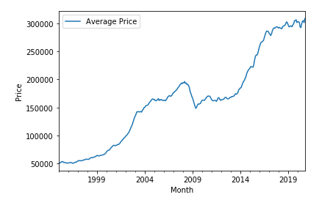

As you can see from the bar plot, Hackney borough has seen the greatest change in average housing prices in the last 20 years, with an average increase of 6.198 times (in 2018) the average price value in 1998.

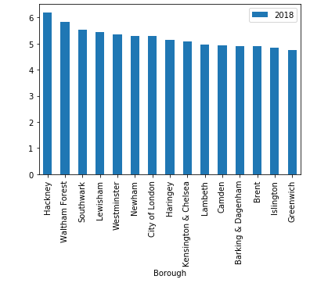

I would like to investigate housing prices during recession times (early 2000's and 2008) to see which borough was effected the most during these times and see which borough recovered the housing prices from 2008 to 2020.