|  |
| --- |
| Seminar Report 2021 Medical Diagnostic Systems Using AI    **MEDICAL DIAGNOSTIC SYSTEMS USING**  **ARTIFICIAL INTELLIGENCE**      **A SEMINAR REPORT**      *Submitted by*  **CHANDANA SHAJI**  **VML18EC013**  to    the APJ Abdul Kalam Technological University  in partial fulfillment of the requirements for the award of the Degree    Bachelor of Technology  In  ELECTRONICS AND COMMUNICATION ENGINEERING        **Department of Electronics and Communication Engineering**  VIMAL JYOTHI ENGINEERING COLLEGE  CHEMPERI NOVEMBER 2021  i VJEC |

|  |
| --- |
| Seminar Report 2021 Medical Diagnostic Systems Using AI      **MEDICAL DIAGNOSTIC SYSTEMS USING**  **ARTIFICIAL INTELLIGENCE**      **A SEMINAR REPORT**      *Submitted by*  **CHANDANA SHAJI**  **VML18EC013**  to    the APJ Abdul Kalam Technological University  in partial fulfillment of the requirements for the award of the Degree    Bachelor of Technology  In  ELECTRONICS AND COMMUNICATION ENGINEERING        **Department of Electronics and Communication Engineering**  VIMAL JYOTHI ENGINEERING COLLEGE  CHEMPERI  NOVEMBER 2021 |

|  |
| --- |
| Seminar Report 2021 Medical Diagnostic Systems Using AI        **DEPARTMENT OF ELECTRONICS AND COMMUNICATION ENGINEERING**  **VIMAL JYOTHI ENGINEERING COLLEGE, CHEMPERI**      **CERTIFICATE**    This is to certify that the seminar report entitled **“MEDICAL DIAGNOSTIC SYSTEMS USING ARTIFICIAL INTELLIGENCE**” is a bona fide record of the EC451 Seminar & Project Preliminary done by **CHANDANA SHAJI (VML18EC013)** under our guidance towards the partial fulfilment of the requirements for the award of the Degree of Bachelor of technology in Electronics & communication Engineering of the APJ Abdul Kalam Technological University through Vimal Jyothi Engineering College, Chemperi.        **SUPERVISOR HEAD OF DEPARTMENT**  **Mr. ADARSH K S Dr. D ANTO SAHAYA DHAS**  Assistant professor Professor & Head of Department  Department of ECE Department of ECE  VJEC, Chemperi VJEC, Chemperi |

|  |
| --- |
| Seminar Report 2021 Medical Diagnostic Systems Using AI        **ACKNOWLEDGMENT**      The satisfactions that accompany the successful completion of any task would be incomplete without mention of people who made it possible. I take this humble opportunity to thank all those who have inspired and motivated me to make my seminar success.  To begin with, I am submitting this seminar in divine feet of almighty for blessing me with his wisdom for surpassing every difficulty during my seminar. I express my sincere thanks to our Principal **Dr. Benny Joseph** as he is the leading head of the institution. I would like to thank our H.O.D **Dr. D Anto Sahayadhas** for his support and kind help.  I have great pleasure in expressing my deep sense of gratitude and indebtedness to our seminar coordinators **Mr. Adarsh K S** & **Mrs**. **Ann Mathew**, Assistant Professors, Department of Electronics and Communication Engineering, Vimal Jyothi Engineering College, Chemperi, Kannur for their valuable guidance through every stage of my work and timely advice. Now I take my time to thank all teachers and lab staffs of the college and my entire batch mates for their support and encouragement. |

|  |
| --- |
| Seminar Report 2021 Medical Diagnostic Systems Using AI            **ABSTRACT**    Disease diagnosis is the identification of an health issue, disease, disorder, or other condition that a person may have. Disease diagnoses could be sometimes very easy tasks, while others may be a bit trickier. There are large data sets available; however, there is a limitation of tools that can accurately determine the patterns and make predictions. The traditional methods which are used to diagnose a disease are manual and error-prone. Usage of Artificial Intelligence (AI) predictive techniques enables auto diagnosis and reduces detection errors compared to exclusive human expertise. In this paper, we have reviewed the current literature for the last 10 years, from January 2009 to December 2019. The study considered eight most frequently used databases, in which a total of 105 articles were found. A detailed analysis of those articles was conducted in order to classify most used AI techniques for medical diagnostic systems. We further discuss various diseases along with corresponding techniques of AI, including Fuzzy Logic, Machine Learning, and Deep Learning. This research paper aims to reveal some important insights into current and previous different AI techniques in the medical field used in today’s medical research, particularly in heart disease prediction, brain disease, prostate, liver disease, and kidney disease. Finally, the paper also provides some avenues for future research on AI-based diagnostics systems based on a set of open problems and challenges. |

|  |
| --- |
| Seminar Report 2021 Medical Diagnostic Systems Using AI  **CONTENTS**          **Chapter Title Page**  **No. No.**    List of figures iv    List of tables v     1. Introduction 1      1. Medical Diagnosis Expert System 2      1. Artificial Intelligence In Health Care 4      1. Fuzzy Logic 5      * 1. Existing Works Using Fuzzy Logic 6      * 1. Process Of Fuzzy Logic 10      1. Method Review 12      1. Conclusion 14     References 15 |

|  |
| --- |
| Seminar Report 2021 Medical Diagnostic Systems Using AI  **LIST OF FIGURES**          **Figure Title Page**  **No. No.**    2.1 Functional Block Diagram Of Medical Diagnosis 2  Expert System    3.1 AI In Health Care 4    4.1 Flow Chart Of Fuzzy Logic 5    4.1.1 Process Of Fuzzy Logic 6 |

|  |
| --- |
| Seminar Report 2021 Medical Diagnostic Systems Using AI  **LIST OF TABLES**        **Table No. Title Page No.**    5.1 Fuzzy Logic Method Review 12    5.2 Fuzzy logic Method Review 13 |

|  |
| --- |
| Seminar Report 2021 Medical Diagnostic Systems Using AI        **CHAPTER 1**      **INTRODUCTION**    In the field of healthcare, the study of disease diagnosis plays a vital role. Any cause or circumstances that lead to pain, illness, dysfunction, or eventually, a human being’s death is called a disease. Diseases may affect a person physically and mentally, and it considerably manipulates the living style of the affected person. The causal study of disease is called the pathological process. A disease is made by signs or symptoms that are interpreted by clinical experts. Diagnosis has been defined as the method of identifying a disease from its signs and symptoms to conclude its pathology. Diagnosis can also be defined as the method of figuring out which disease is based on an individual’s symptoms and signs. The data gathered from medical history physical examination of the individual having medical pathology constitutes the knowledge required for diagnosis. Often, at least one diagnostic procedure, such as medical tests, is done during this procedure. To form an honest diagnosis, a medical doctor will perform a process that involves several steps, allowing them to collect the maximum amount of information as possible. Diagnosis of diseases is the most challenging process at the same time, a very pivotal phenomenon for a medical care professional as before reaching the conclusion. |

Seminar Report 2021

Medical Diagnostic Systems Using AI

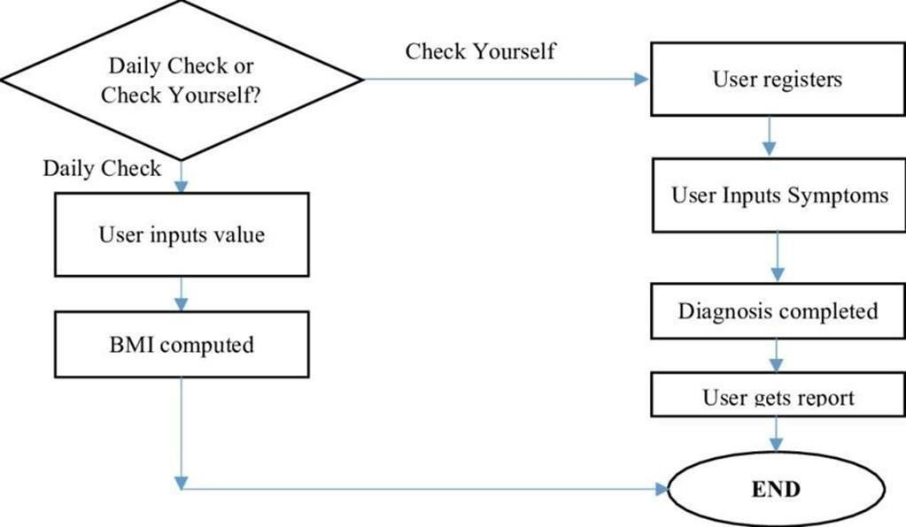

**CHAPTER 2**

**MEDICAL DIAGNOSIS EXPERT SYSTEM**

FUNCTIONAL BLOCK DIAGRAM

Fig.2.1 Functional Block Diagram Of Medical Diagnosis Expert System

A medical expert system is a computer program that, when well

-

crafted, gives

decision support in the form of accurate diagnostic information or,

less

commonly, suggests treatment or prognosis. Expert systems can perform routine

expert tasks such as the reg

ular analysis of information or routine diagnosis of

symptoms.

The

expert,

relieved

of

these

tasks

can

spend

more

time

on

the

difficult

analyses. There is a need for tools which can store and reason with medical

expertise

taken

from

a

number

of

experts.

A

Diagnosis

expert

system

(

DExS

)

can

help

a

great

deal

in

identifying

those

diseases

and

describing

methods

of

treatment

|  |
| --- |
| Seminar Report 2021 Medical Diagnostic Systems Using AI  to be carried out taking into account the user capability in order to deal and interact with expert system easily and clearly. Expert systems do not have human capabilities. They use a knowledge base of a particular domain and bring that knowledge to bear on the facts of the particular situation at hand. The knowledge base of an ES also contains heuristic knowledge - rules of thumb used by human experts who work in the domain. |

Seminar Report 2021

Medical Diagnostic Systems Using AI

**CHAPTER 3**

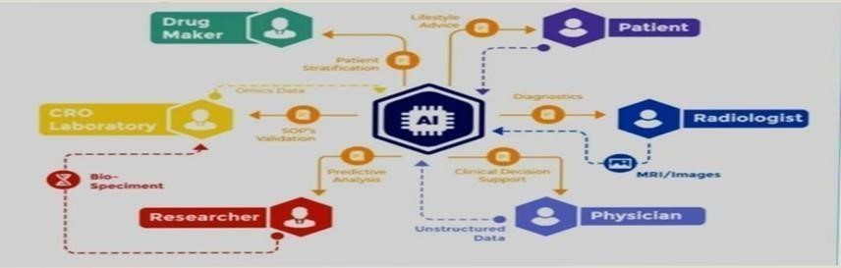

**ARTIFICIAL INTELLIGENCE IN HEALTH CARE**

Fig 3.1. AI in health

care

Artificial intelligence in healthcare is an overarching term used to

describe the

use

of

machine

-

learning

algorithms

and

software,

or

artificial

intelligence

(

AI),

to

mimic human cognition in the analysis, presentation, and comprehension of

complex medical and health care data. A common use of artificial intelligence in

hea

lthcare involves NLP applications that can understand and classify clinical

documentation. NLP systems can analyze unstructured clinical notes on patients,

giving incredible insight into understanding quality, improving methods, and

better results for

pati

ents.

Seminar Report 2021

Medical Diagnostic Systems Using AI

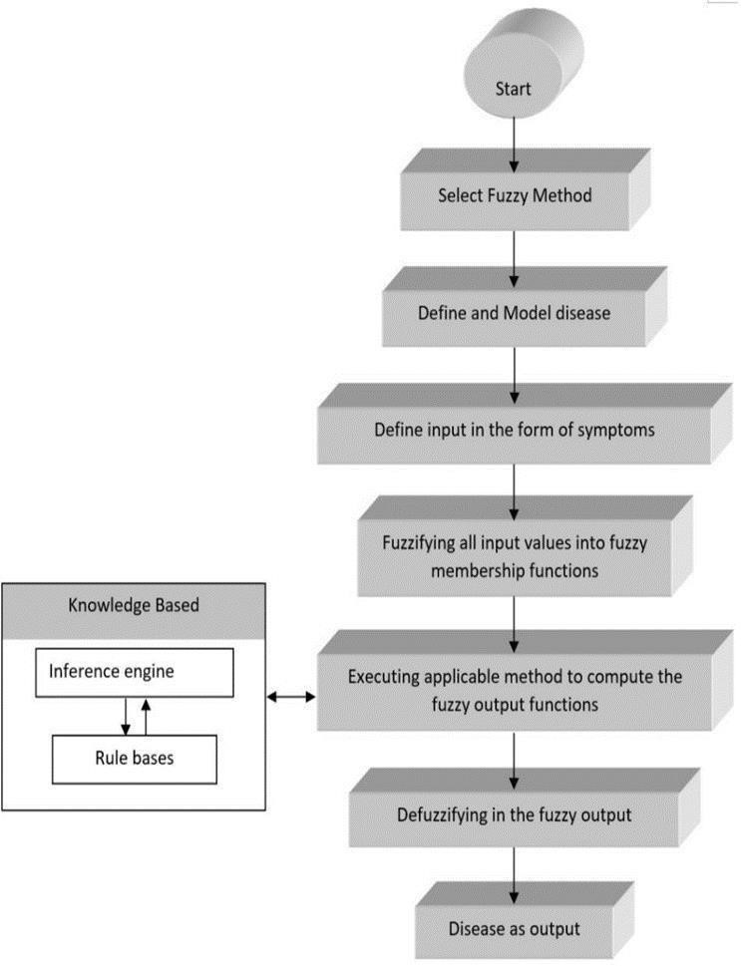

**CHAPTER 4**

**FUZZY LOGIC**

Fuzzy logic is an approach to computing based on "degrees of truth"

rather than

the usual "true or false" (1 or 0) Boolean logic on which the modern computer is

based.

Fig 4.1. Flow chart of Fuzzy Logic

Seminar Report 2021

Medical

Diagnostic Systems Using AI

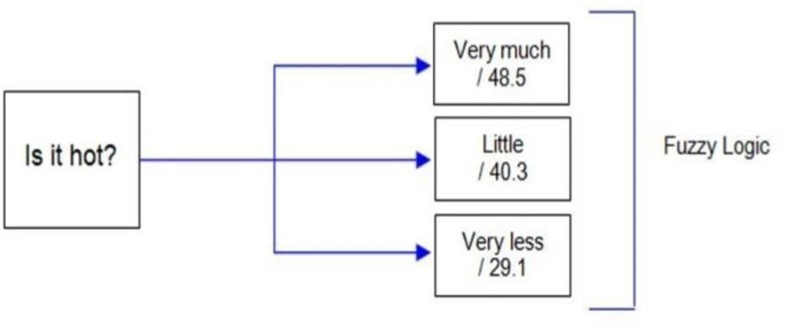

**4.1**

**Existing Works Using Fuzzy**

**Method**

Fuzzy logic provides dynamic methods that deal with difficult problems. Fuzzy

logic is assumed to be a solid tool for decision

-

making systems, such as expert

systems or Pa

ttern classification system. Fuzzy logic plays a vital role in the

medical evaluation as it provides an exact examination report. These sorts of

frameworks provide an instant and straightforward strategy for clinical

assessment. They are also useful where

an expert or clinical specialist is absent.

These frameworks give an outcome depending on the knowledgebase

incorporated within or from specialists or experts in the field. Various clinical

diagnoses systems created depend on the fuzzy set model and applie

d in the

medical

field.

The

word

fuzzy

refers

to

things

that

are

ambiguous.

Sometimes

we

face a circumstance when we are uncertain about whether the state is valid or

invalid, where in fuzzy logic provides reasoning for such conditions as depicted

in fig 4

. It is a rule

-

based method. Fuzzy Rule Based System (FRBS) is a

frequently

used

technique

in

healthcare

that

drives

from

Fuzzy

Inference

Systems

(

FIS

).

Fig 4.1.1. Process of Fuzzy Logic

|  |
| --- |
| Seminar Report 2021 Medical Diagnostic Systems Using AI  Ebola Virus FRBS applies IF-THEN rules for information portrayal. Besides this, clustering and classifying techniques are also used in the medical domain. Also, FIS and FDSS are determined as the most common techniques in the area of medicine. The main feature of fuzzy logic is that it can allocate the inaccuracies and uncertainties of any situation. There is no logic for the absolute valid and absolute invalid value, but partially true and partially false intermediate value exists in a fuzzy logic system. Let’s take the following example to show how fuzzy logic works. In the past few years, Fuzzy logic is consistently gaining popularity in diagnosing disease based on different parameters. For instance, coronary illness is a sort of malady caused due to a damage or blockage of veins in the heart, thus influencing less oxygen supply to heart organs. Common heart diseases are heart failure, artery blockage, heart attack, stroke, etc. Fuzzy logic is continually developing to distinguish heart patients all through the world with the assistance of growing new AI techniques.  Lots of articles have been published to detect coronary disease by utilizing Fuzzy logic. Sari and Gupta discussed coronary disease detection using a neuron-fuzzy integrated system and their results reached a similar level of doctor’s opinion in case of high/low cardiac risk. Junior et al. presented a cardiovascular arrhythmia grouping framework utilizing fuzzy classifiers to recognize the particular point of the electroencephalogram utilizing network fuzzy Rules. In their system, the total time of ECG signal processing is reduced by a sequence of samples, without any essential loss. The ECG signals are imposed into the framework that implements cleaning, and afterward utilizes a clustering algorithm “Gustafson– Kassel fuzzy” for the signal classification and correlation. Their study suggested that common heart diseases like myocardial infarct, arterial coronaria and angina diseases can easily be detected by their system. According to the obtained results, their method provided better disease diagnosis for Pulse Pressure Variation compared to other reported systems. Ebola Virus Disease is a fatal infectious disease also known as the “Ebola haemorrhagic fever”. |

|  |
| --- |
| Seminar Report 2021 Medical Diagnostic Systems Using AI    Hence, a secure method of diagnosis has been investigated. Oleagenin et al. described that Ebola fuzzy informatics system was designed to diagnose EVD. They utilized fuzzy logic as its inference engine along with a collection of rules. A knowledgebase was created to help provide a diagnosis of the Disease (EVD). The method used as a fuzzy inference method was Root Sum Square. According to the performance of their system, we can say that their system is a valuable addition to fight against Ebola. BRAIN DISEASE or disorder is a condition where a person loses the capability of reasoning, loss of memory; change personality, mild seizures, and twitching are common symptoms. The brain is the central control of the body. When brain problems occur, the results can be devastating. Brain diseases such as stroke, brain tumours, Alzheimer’s disease can cause problems like vision loss, weakness, and paralysis, etc. Early detection of these problems is very necessary for a doctor as well as a patient in order for the treatment to be started. Gopal and Karnan proposed a system for diagnosing Brain Tumour. A system designed to diagnose brain tumours using MRI images by the use of the Fuzzy C Means clustering algorithm.  The tools used along with Fuzzy C means algorithms are Genetic Algorithm and Particle Swarm Optimization. The suspicious block is fragmented by the use of two algorithms GA and PSO. Computer-aided System is then utilized for verification and correlation of brain tumour in the diagnosis algorithm. Fuzzy C Means helped to determine the adaptive threshold for brain tumour fragmentation. The results of previous techniques were compared with existing outcomes. Their results indicated that it improves the overall performances of the fragmentation and can find the optimal solution. Another representation was given by Chen et al. to introduce a productive brain problem detection system by the use of fuzzy k-closest neighbour or SVM for Parkinson’s disease diagnosis. A comparative analysis was performed between SVM and FKNN. The experimental outcome showed that the FKNN technique worked better over the SVM classifier. The accuracy obtained by the FKNN was 96.07 which is more than the SVM method. |

|  |
| --- |
| Seminar Report 2021 Medical Diagnostic Systems Using AI      Different diseases such as neuro diseases, cancer, diabetes, heart diseases, thyroid disorder, asthma disease were also diagnosed by using various ANN mechanisms. The neurofuzzy model has been proposed by Patra and Thakur for the proper diagnosis of adult Asthma disease. The dataset was collected from various hospitals. Three learning algorithms were used: ANN with Self Organizing Maps (SOM), ANN with Learning Vector Quantization (LVQ) and ANN with Backpropagation Algorithm along with NF tool to produce accurate results. Fuzzy inference was then used to classified data to diagnosis a disease. Fuzzy logic is also capable to detect dangerous diseases like cancer, especially BREAST CANCER. Breast cancer is a sort of sickness caused by bumps found in the breast that frames the cells. Cancer appears when cells start to grow out of control. Miranda and Felipe inter-operated on the Fuzzy Omega algorithm, an automated tool to detect breast lesions. The user availed elements like contour, size, and density and the system suggested the BI-RADS classification. Their method achieved an accuracy of 76.6 % for nodules and 83.34% for calcifications. Another approach was given by Nilashi for early diagnosis to tackle the disease. The authors designed an information-based architecture for the classification of breast cancer diseases using Clustering, and classification approaches. They used Maximization for clustering the data. Fuzzy extracted from Classification and Regression Trees were used for the classification of breast cancer disease. Their method can be used as a decision support system for disease diagnosis. The liver ailment is also a sort of hepatic sickness that makes the liver stop its working partially or completely. Most of the factors of liver ailment are due to an alcoholic or hereditary nature. The most well- known kind of liver illness is fatty liver. In order to diagnose, a liver disease, Satarkar S.L, and Ali M.S worked to form an expert system that cooperated with fuzzy logic. According to the authors, the portrayal was provided by the Mamdani approach to recognize the risk factors. Their system could be used to make predictions of cirrhosis and avoid the need for liver biopsy . DIABETES is a kind of sickness which is caused by the increase of blood glucose levels in the body. |

|  |
| --- |
| Seminar Report 2021 Medical Diagnostic Systems Using AI      Apart from that, this disease decreases insulin level in body cells and cause type 1, type 2, or gestational diabetes. An excessive amount of sugar level in the body prompts different issues like harming the kidney and nerves. Kalpana and kumar focused on developing a model to analyse diabetes malady using a fuzzy determination mechanism. To decide whether a person has the possibility of diabetic or not, the author used the fuzzy determination system to asses rules with the fuzzy operator in their study and portray knowledge with descriptions.  Lukmanto proposed an intelligence system by using a fuzzy hierarchical model that can perform initial diagnosis against diabetes. The proposed model was implemented on 311 relevant data and acquired an accuracy of 87.46 % as equivalent to a medical doctor’s statement. Another proposal was given by Rajeswari et al. on diabetic diagnosis using an associative classification method based on fuzzy logic to tackle the problem of the boundary value confusion while partitioning risks. Tooth Decay, Periodontal Disease, Gingivitis, Dental Plaque, etc are diseases that occur in teeth, and are commonly termed as DENTAL DISEASES. Allahverdi and Akcan analyzed based on periodontal dental disease around 164 fuzzy rules taken with some inputs. The prime goal of their study was to decrease the time taken for early recognition of dental disease . Son et al. designed a system called Dental Diagnosis System to find out dental problems which depend on the hybrid technique of fragmentation, classification and decision making. They investigated that the accuracy of DDS in dental problem detection is 92 % approximately that is higher than any other systems like fuzzy inference system (89%), fuzzy k-nearest neighbour (80%), prim spanning tree (58%) and Kruskal spanning tree (58%). Bacterial diseases like Cholera arises after swallowing polluted or infected water.    **4.2 Medical Diagnosis process Using Fuzzy Logic**      Fuzzy logic has the ability to portray information and outcomes in the form of semantic articulation. It tends to be valuable since most diagnosis processes have been performed based on the probability of medical findings. |

|  |
| --- |
| Seminar Report 2021 Medical Diagnostic Systems Using AI  The power of human thinking and decision-making ability develop a clinical proof-based theory to make the process of diagnosis better. Due to the demonstrated viability of applying fuzzy methods in the field of healthcare to display uncertainty, it has been used in the finding procedure with various applications as per the kind of illness and targets of the researchers . The main rule of this framework in medical science has two major elements in which symptoms are used as input and the disease as output. Generally, the Fuzzy logic process to disease diagnosis as described in Fig 3 is made by the following steps:      •Fuzzifier: The Fuzzification process is done by a Fuzzifier. It is a process of changing a crisp input value to the fuzzy set. Hence Fuzzifier is used as a mapping from observing input to fuzzy values.   * Inference engine: After completing the fuzzification process, fuzzy value processed by the inference engine using a set of rules act as a collection of rules to the knowledge base. * Knowledgebase: This is the main component of the fuzzy logic system. The overall fuzzy system depends on the knowledge base. Basically, it consists of rules, structured and unstructured data also named the database. * Defuzzifier: The process of converting the output from the inference engine into crisp logic. Fuzzy value is an input to the defuzzification that maps fuzzy value to crisp value.   Fuzzy Logic is taken into account among the techniques for AI, where intelligent behaviour is achieved by creating fuzzy classes of some parameters. The rules and criteria are understandable by humans. These rules and the fuzzy classes are defined by a domain expert mostly. Therefore, great deal of human intervention is required in fuzzy logic. The actual processing of data basically provides a presentation of the information in fuzzy logic. The statistical model used for estimation is not capable to produce good performance results. Statistical models fail to detect missing values, large data values and hold categorical data. All the above-mentioned reasons can be achieved through machine learning (ML). |

Seminar Report 2021

Medical

Diagnostic Systems Using AI

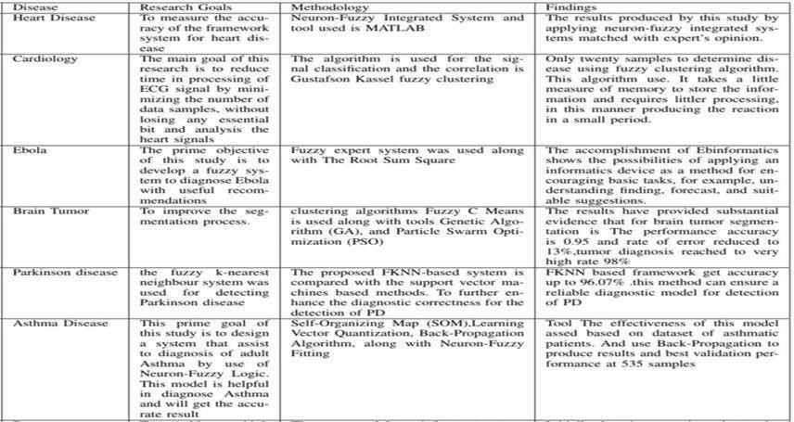

**CHAPTER 5**

**METHOD**

**REVIEW**

TABLE 5.1. FUZZY LOGIC METHOD

REVIEW

Seminar Report 2021

Medical

Diagnostic Systems Using AI

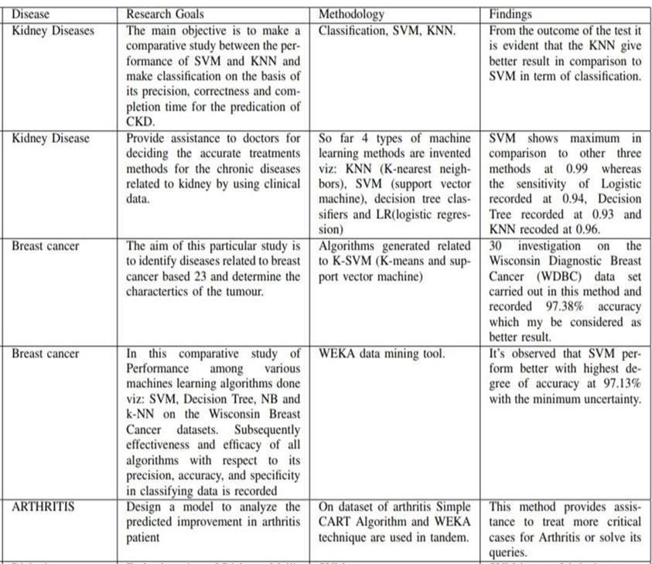

TABLE 5.2. FUZZY LOGIC METHOD REVIEW

|  |
| --- |
| Seminar Report 2021 Medical Diagnostic Systems Using AI  **CHAPTER 6**    **CONCLUSION**      Recent advancements in AI techniques lead to successful applications of AI in healthcare. Even it has become a hot topic of discussion whether AI expert systems will eventually replace human doctors. Still, we consider the fact the AI expert system can assist the human doctor to make a better decision or even replace human judgment in some cases. Different AI techniques can help to find out relevant information from a large amount of clinical data. Also, AI methods are trained in such a way that can have the ability of self- learning, error- correcting, and they produce results with high accuracy. This survey is about the use of three AI approaches in disease diagnosis. In this review, we assess the impact of the AI methods and their constancy on disease diagnosis to minimize the errors in misdiagnosis prism ,with the PRISMA method. |

|  |
| --- |
| Seminar Report 2021 Medical Diagnostic Systems Using AI    **REFERENCES**       1. J. L. Scully, “What is a disease?” EMBO reports, vol. 5, no. 7, pp. 650–653, 2004. 2. R. Leaman, R. Islamaj Dogan, and Z. Lu, “Dnorm: disease name normalization with pairwise learning to rank,” Bioinformatics, vol. 29, no. 22,pp. 2909–2917, 2013. 3. N. Armstrong and P. Hilton, “Doing diagnosis: whether and how clini- cians use a diagnostic tool of uncertain clinical utility,” Social Science & Medicine, vol. 120, pp. 208–214, 2014. 4. A.-L. Barabási, N. Gulbahce, and J. Loscalzo, “Network medicine: a network- based approach to human disease,” Nature reviews genetics, vol. 12, no. 1, pp. 56–68, 2011. 5. R. H. Scheuermann, W. Ceusters, and B. Smith, “Toward anontological treatment of disease and diagnosis,” Summit on translational bioinfor- matics, vol. 2009, p. 116, 2009. 6. P. Croft, D. G. Altman, J. J. Deeks, K. M. Dunn, A. D. Hay, H. Hemingway,   L. LeResche, G. Peat, P. Perel, S. E. Petersen et al., “The science of clinical practice: disease diagnosis or patient prognosis? evidence about “what is likely to happen” should shape clinical practice,” BMC medicine, vol. 13, no. 1, p. 20, 2015. **7.** E. Choi, M. T. Bahadori, A. Schuetz, W. F. Stewart, and J. Sun, “Doctor ai:  Predicting clinical events via recurrent neural networks,” in Machine Learning for Healthcare Conference, 2016, pp. 301–318. |