CFD SIMULATION FOR ENERGY SYSTEMS · SS 2026
Task C — Fluidized Bed Reactor
Complete Tutorial and Workflow
Ansys Rocky DEM ↔ Ansys Fluent, two-way coupled
Two Reynolds numbers: Re = 500 and Re = 2000
Course | CFD Simulation for Energy Systems, SS 2026
Institution | Technische Universität München — Campus Straubing  Professur für Regenerative Energiesysteme
Supervisors | Bernhard Huber, M.Sc.; Sahib Abdullayev, M.Sc.
Project | Task C — Gas–Solid Fluidized Bed
Source task sheet | CFD_SS2026_Project_Update_FBR.pdf (slides 6-2 and 6-3)
Base tutorial | Rocky Tutorial Guide 2025 R2, Chapter 14: Tutorial — Fluidized Bed (pp. 693–739)
Primary software | Ansys Rocky 2025 R2 + Ansys Fluent 2025 R2 (v252), two-way coupled
Secondary software | Ansys SpaceClaim / DesignModeler, Ansys Meshing
Column geometry | 0.28 (W) × 0.04 (D) × 1.00 (H) m rectangular slab
Particles | dₚ = 4 mm monodisperse, ρₚ = 1500 kg/m³, ≈ 80,200 particles, 4.032 kg
Initial bed | H₀ = 0.40 m at αₚ = 0.60
Gas | Air, ρ = 1.2 kg/m³, μ = 1.8×10⁻⁵ Pa·s
Case A | Re = 500 → U₀ = 1.875 m/s → bubbling fluidization
Case B | Re = 2000 → U₀ = 7.500 m/s → turbulent fluidization
Revision | Rev. 2 — supersedes Fluent_3D_Fluidized_Bed_Workflow.docx

Figures reproduced from the Ansys Rocky Tutorial Guide 2025 R2, Chapter 14, for internal study use.

Contents

0. What This Revision Changes
Read this page first if you already worked from the previous document. Everything else in this file is self-contained — you do not need the old one open.
The previous workflow document covered a single operating point using Fluent's Eulerian–Granular model. The task requires the flow regime to be varied with Reynolds number, and the group has been assigned two Reynolds numbers, Re = 500 and Re = 2000. That changes more than just the inlet velocity: it changes the particle diameter you should choose, the mesh, the time step, the run length, and — most importantly — what the deliverable actually is. A two-case study is a comparison, not two isolated simulations.
Item | Previous document (Rev. 1) | This document (Rev. 2)
Operating points | One case, chosen from the assigned regime | Two cases: Re = 500 and Re = 2000, run and compared side by side
Particle diameter | dₚ = 3 mm | dₚ = 4 mm — chosen so that both Re values land on clean, sustainable regimes (§2.4)
Inlet velocity | 1.5 m/s (bubbling) | 1.875 m/s (Case A) and 7.500 m/s (Case B), fixed by the Re specification (§2.3)
Primary simulation route | Fluent Eulerian–Granular (TFM) only | Rocky DEM ↔ Fluent two-way coupling, following the tutorial the task sheet actually links to. The TFM route is retained in full as Appendix D
Baseline / “initial work” | Not covered | Part I walks the Rocky Chapter 14 tutorial end to end, with the tutorial's own figures, so the baseline is reproducible before any project changes
Vertical axis | y | z — matching Rocky Chapter 14 (gravity = −9.81 m/s² in Z), so every coordinate in the tutorial tables transfers directly
Particle temperature (sub-task f) | Interpreted as granular temperature Θₛ; no true thermal field available | A real thermal field. Rocky's thermal model is on, particles start at 363 K in 293.15 K air, exactly as in the tutorial — sub-task (f) is satisfied literally
Pressure drop (sub-task g) | Fluent surface report | Two-cube method from the tutorial, plus a Fluent inlet report as a cross-check (§8.1)
Ergun comparison | Sweep in U₀ | Sweep expressed in Re, so it plots on the same axis as the two production cases (§8.2)

The one-line summary of the update
For dₚ = 4 mm, the characteristic Reynolds numbers of this bed are Re_mf = 332, Re_c = 586 and Re_tr = 2856. That places Re = 500 squarely in the bubbling regime and Re = 2000 squarely in the turbulent regime, with no blow-out and no need for a solids recycle loop. The two assigned Reynolds numbers therefore bracket the bubbling→turbulent transition — which is precisely the question the task sheet asks you to answer.

1. Orientation

1.1 What the task actually asks, and where each part is answered
Sub-tasks (a) to (j) from slide 6-3 of the task sheet, mapped onto this document. Work through the sections in order and every sub-task is covered.
Sub-task | Requirement (abbreviated) | Where
(a) | Transient solver; geometry scaled to metres; inlet, outlet and wall zones identified and renamed | §5.2, §5.4
(b) | Multiphase gas–solid; k-ε turbulence on the gas; granular solid phase, dₚ = 3–5 mm, ρₚ = 1500 kg/m³ | §5.4, §5.5, and §1.2 on how the coupled route satisfies this; Appendix D for the literal Fluent-multiphase reading
(c) | Explain minimum fluidization velocity; estimate it for your case | §3 — complete, with two independent correlations and a self-consistency check
(d) | Gas inlet velocity U₀; pressure outlet; no-slip walls; initialize packed bed at αₚ = 0.60 up to H₀ = 0.40 m | §5.4 (boundary conditions), §5.5–§5.6 (building and settling the bed)
(e) | Run at least one assigned case | §6 — two cases, Re = 500 and Re = 2000
(f) | Plot time-averaged solid volume fraction, gas velocity vectors and particle temperature at start / middle / end | §7 — the full 18-plot matrix plus the comparison figures
(g) | Pressure-drop curve compared against Ergun for the packed-bed region | §8
(h) | 1-way / 2-way / 4-way coupling; Rocky vs Fluent particle modelling; why not FVM for particles | §9 — written out in full
(i) | Different parameters allowed, but report the exact values used | Appendix A — the parameter sheet; fill it in as you go
(j) | Own tests are welcome | §10 — five suggestions, ranked by effort

1.2 Which software route — and why this document changed its mind
The task sheet links to .../v252/en/dem_tut/dem_tut_14.html. The dem_tut path is the Rocky DEM Tutorial Guide, Chapter 14 of which is “Tutorial — Fluidized Bed”. The previous revision of this workflow treated that link as probably mistaken and followed Fluent's Eulerian–Granular model instead, because sub-task (b) uses Fluent multiphase vocabulary. Reading Chapter 14 in full settles the question the other way:
Evidence | What it points to
Sub-task (f) asks for solid volume fraction, gas velocity and particle temperature | Rocky Chapter 14 Part C produces exactly these three, in exactly this order (§14.3.10 particle temperature, §14.3.12 solid volume fraction, §14.3.13 fluid velocity)
Sub-task (g) asks for a pressure drop | Rocky Chapter 14 §14.3.11 is titled “Pressure Drop” and gives the two-cube method
The image on task slide 6-2 — a bed of red-to-blue particles with a bubble, scaled in °C | Is the figure from Rocky Chapter 14 page 730 (reproduced as Figure 24 in this document)
Task Details ask you to pick dₚ “for a reasonable total number of particles” | A particle count only exists in a DEM simulation. In an Eulerian model the solids are a continuum and there is no such number
Sub-task (h) asks how Rocky differs from Fluent for particle modelling | Makes little sense as a question unless you have used Rocky

So what about sub-task (b), which says “Eulerian multiphase”?
In the coupled route the Fluent side is single-phase (air only, k-ε) and the granular phase lives in Rocky as real particles. That satisfies the physics of (b) — a gas–solid system, k-ε on the gas, a granular solid phase at dₚ = 4 mm and ρₚ = 1500 kg/m³ — but not its literal Fluent-menu wording.
Recommendation: do both, and say so. The coupled Rocky run is your primary result. Then run the Fluent Eulerian–Granular case from Appendix D as well — in 2D it costs a few hours, not days. You then have the literal reading of (b) covered, and, far more valuable, a direct DEM-versus-TFM comparison of the same bed at the same two Reynolds numbers. That comparison is the single strongest possible answer to sub-task (h), because you will have measured the difference rather than described it.
One confirming email to the supervisors is still worth sending. Ask: “Should Task C be built on Rocky Chapter 14 with two-way Fluent coupling, or on Fluent's Eulerian–Granular model?” Either answer leaves this document usable.

1.3 What you need before you start
Requirement | Detail
Licences | Ansys Rocky 2025 R2 and Ansys Fluent 2025 R2, valid on the same machine. Rocky validates the Fluent mesh at import, so the Fluent licence must be reachable even before the coupled run starts
Tutorial files | dem_tut14_files.zip from the Ansys documentation. Contains mesh/tutorial_14_mesh.msh, a ready-made Fluent/fluidized_bed.cas.h5, and the pre-built Rocky restart project. You need these for Part I
Hardware | Rocky will use a GPU if one is present while Fluent uses the CPU cores — this is the recommended split and is roughly an order of magnitude faster than CPU-only Rocky. 4+ CPU cores, 16 GB RAM
Disk | Budget ≈ 20 GB. At 80,000 particles and 0.02 s output intervals an 8 s run writes a few hundred output times
Prior tutorials | Chapter 14 is flagged ADVANCED. If you have never opened Rocky, work Tutorials 1–5 first — roughly half a day, and it will save you more than that

1.4 The plan: two stages
Do not start by building the project geometry. Reproduce the tutorial first, unchanged. It takes an afternoon, it verifies that your licences, GPU and coupling actually work, and it gives you a known-good reference to compare against when your own case misbehaves — which it will.
Stage | What you do | Sections | Effort | Gate before moving on
Stage 1  Baseline | Run Rocky Chapter 14 exactly as written: Fluent case setup, Rocky project, coupled run, all post-processing | Part I — §4 | ≈ half a day | You have a pressure-drop plot, a particle-temperature plot and a solid-volume-fraction contour from the tutorial geometry
Stage 2  Project | Rebuild at project dimensions and properties; run Case A and Case B; post-process and compare | Parts II–V — §5 to §10 | ≈ 5–7 days | Both cases complete, all sub-task (f) plots produced, parameter sheet filled in

Why the baseline is worth an afternoon
Almost everything that goes wrong in a coupled DEM–CFD run goes wrong in the coupling, not in the physics: a licence that is not visible to both programs, a mesh Rocky refuses to validate, a Fluent version mismatch, a transient formulation left on second order. In the tutorial case those failures take minutes to diagnose because the answer is known. In your own case, with a geometry you built yourself, the same failures look like physics problems and can cost days.

2. The Reynolds Specification — Re = 500 and Re = 2000
This section is the core of the revision. It fixes the particle diameter, both inlet velocities, and the physical claim the whole report will rest on.

2.1 Which Reynolds number is meant
The task sheet says only “Reynolds regimes varied via inlet velocity U₀”. Two definitions are possible, and only one of them is usable.
particle Reynolds number Re_p = rho_g * U0 * d_p / mu
column Reynolds number Re_D = rho_g * U0 * W / mu (W = 0.28 m)
Test them against the numbers. If Re meant the column Reynolds number, then Re = 500 and Re = 2000 would require:
Definition | U₀ at Re = 500 | U₀ at Re = 2000 | Verdict
Column, Re_D = ρU₀W/μ | 0.027 m/s | 0.107 m/s | Impossible. Both are far below U_mf = 1.25 m/s. The bed would never leave the fixed-bed state, and there would be no “regime change with Re” to report at all
Particle, Re_p = ρU₀dₚ/μ | 1.875 m/s (at dₚ = 4 mm) | 7.500 m/s (at dₚ = 4 mm) | Correct. Straddles minimum fluidization and produces two genuinely different, well-separated regimes

Conclusion — state this explicitly in your report
Throughout this document Re means the particle Reynolds number based on the superficial gas velocity:

Re = ρ_g U₀ dₚ / μ

This is the standard definition in the fluidization literature (Kunii & Levenspiel; Bi & Grace) and the only one that makes the assigned values meaningful. Because ρ_g, μ and dₚ are all fixed, Re and U₀ are interchangeable — specifying Re is specifying the inlet velocity. Say this in one sentence in your methodology and the rest of the report follows cleanly.

2.2 Mapping Re to inlet velocity
With ρ_g = 1.2 kg/m³ and μ = 1.8×10⁻⁵ Pa·s, U₀ = Re · μ / (ρ_g dₚ). The particle diameter is therefore not a free choice once Re is fixed — it sets both velocities at once.
dₚ  [mm] | U₀ at  Re = 500 | U₀ at  Re = 2000 | U_mf  [m/s] | U_c  [m/s] | U_tr  [m/s] | U_t  [m/s] | Where Re = 500  lands | Where Re = 2000  lands
1 | 7.500 | 30.000 | 0.387 | 1.293 | 5.356 | 5.239 | above U_t — blow-out | far above U_t — pneumatic transport
2 | 3.750 | 15.000 | 0.773 | 1.686 | 7.574 | 8.007 | turbulent | far above U_t — blow-out
3 | 2.500 | 10.000 | 1.038 | 1.969 | 9.276 | 10.007 | just into turbulent | at U_t — blow-out, needs recycle
4 | 1.875 | 7.500 | 1.246 | 2.198 | 10.711 | 11.655 | bubbling | turbulent
5 | 1.500 | 6.000 | 1.422 | 2.394 | 11.975 | 13.091 | marginal — only 1.06 U_mf | turbulent
U_mf is from the Ergun force balance (§3.2); U_c, the onset of turbulent fluidization, from Bi & Grace (1995); U_tr, the transport velocity marking the onset of fast fluidization, from Re_tr = 1.53·Ar⁰·⁵; U_t, the single-particle terminal velocity, from Haider & Levenspiel (1989).

2.3 Choosing dₚ = 4 mm
Read down the table above and the choice makes itself. Only dₚ = 4 mm puts one assigned Reynolds number in the bubbling regime and the other in the turbulent regime, with both sustainable in a 1 m column.
dₚ | Why not / why yes
1–2 mm | Re = 2000 lands at 15–30 m/s, several times the terminal velocity. The bed is ejected from the column in well under a second. Not a fluidized bed simulation, and not what the task asks for
3 mm | Workable at Re = 500, but Re = 2000 gives U₀ = 10.0 m/s against U_t = 10.007 m/s. You would be sitting exactly on the terminal velocity: continuous elutriation, an emptying bed, and a case that needs a solids recycle loop to mean anything. It sits inside the 3–5 mm band, but it is the worst point in that band for this particular pair of Reynolds numbers
4 mm — use this | Re = 500 → 1.51 U_mf, comfortably bubbling. Re = 2000 → 6.02 U_mf, comfortably turbulent and still 36 % below U_t so the particles cannot be carried out. Sits inside the 3–5 mm range that sub-task (b) specifies. Gives ≈ 80,200 particles — a very comfortable DEM size
5 mm | Re = 500 gives only 1.06 U_mf — barely above incipient fluidization, so “Case A” would be an almost motionless bed and the comparison would lose most of its content. Re = 2000 is fine. A reasonable fallback if you need fewer particles (≈ 41,000)

Sub-task (i) covers this choice
“Using slightly different parameters than given here is allowed. However, always report what exact values were used in your simulations.” The Details block permits 1–5 mm and sub-task (b) narrows it to 3–5 mm. 4 mm is inside both. Record it in Appendix A and add one sentence of justification — that dₚ was chosen so the two assigned Reynolds numbers straddle the bubbling–turbulent transition. That is a stronger methodology statement than accepting a default would have been.

2.4 The two cases
 | Case A | Case B
Reynolds number | Re = 500 | Re = 2000
Inlet superficial velocity U₀ | 1.875 m/s | 7.500 m/s
U₀ / U_mf | 1.51 | 6.02
U₀ / U_c | 0.85 — below the turbulent onset | 3.41 — well above it
U₀ / U_t | 0.16 | 0.64 — still below terminal, so no sustained elutriation
Expected regime | Bubbling fluidization | Turbulent fluidization
Volumetric flow Q | 0.0210 m³/s (75.6 m³/h) | 0.0840 m³/s (302.4 m³/h)
Air mass flow ṁ = ρU₀A | 0.02520 kg/s | 0.10080 kg/s
Gas transit time through 1 m column | 0.53 s | 0.13 s
What you should see | Discrete bubbles nucleating at the distributor, rising, coalescing, and bursting at a clearly defined bed surface. Bed expands to roughly 0.5–0.6 m | No discrete bubbles. Voids are irregular, stretched and short-lived; the bed surface becomes diffuse and the dense phase mixes violently with the freeboard
Fluent time step | 5×10⁻⁴ s | 2×10⁻⁴ s
Physical run length | 8 s | 6 s
Time-averaging window | 2–8 s | 1.5–6 s

2.5 The regime map on a Reynolds axis
This is the figure that answers the task's first question — “How does the flow regime change with Re?” — and it is worth drawing by hand in your report, with your two cases marked on it. For dₚ = 4 mm, ρₚ = 1500 kg/m³ and Ar = 3.485×10⁶:
Re = 0 332 586 2856 3108
|----------------|------------|------------------------|------|------> Re
| FIXED BED | BUBBLING | TURBULENT | FAST | PNEUM.
| | | | | TRANSP.
Re_mf Re_c Re_tr Re_t
(1.246 m/s) (2.198 m/s) (10.71 m/s)(11.66 m/s)

A B
Re=500 Re=2000
U0=1.875 m/s U0=7.500 m/s
Boundary | Re | U₀ [m/s] | Physical meaning
Re_mf | 332 | 1.246 | Drag on the bed equals its buoyant weight. Below this the bed is a fixed packed bed and Δp follows Ergun; above it Δp is constant
Re = 500 — Case A | 500 | 1.875 | 1.5× Re_mf. Excess gas above minimum fluidization travels as discrete bubbles
Re_c | 586 | 2.198 | Bi & Grace: pressure-fluctuation amplitude peaks. Bubbles lose their identity; the bubbling→turbulent transition
Re = 2000 — Case B | 2000 | 7.500 | Deep inside the turbulent regime, 3.4× Re_c, and still below Re_tr so the bed is retained
Re_tr | 2856 | 10.711 | Transport velocity. Above it solids must be recirculated externally — fast fluidization
Re_t | 3108 | 11.655 | Terminal velocity of a single 4 mm particle. Above it a lone particle is carried out of the column

The claim your report should make, and then defend with data
Increasing Re from 500 to 2000 moves the bed across the bubbling→turbulent transition at Re_c = 586. The observable consequences, each of which you can measure:
1. Voidage structure. Discrete, roughly spherical, coalescing bubbles at Re = 500 give way to irregular, stretched, short-lived voids at Re = 2000. Visible in the solid-volume-fraction contours (§7.1).
2. Bed surface. Sharp and well-defined at Re = 500; diffuse, with no single identifiable surface, at Re = 2000. Visible in the axial αₛ profile (§7.2).
3. Pressure fluctuations. Large, regular, low-frequency at Re = 500 (each peak is a bubble erupting); smaller in relative amplitude and much higher in frequency at Re = 2000. Visible in the Δp time trace (§8.1) — and this is exactly the signal Bi & Grace used to define U_c, so you are reproducing the criterion itself.
4. Mean pressure drop. Essentially unchanged at ≈ 3529 Pa in both cases. This is the point most groups miss: the regime changes completely while the mean Δp does not move, because Δp is set by the bed weight, not by the gas velocity.
5. Heat transfer. Particles cool measurably faster at Re = 2000 — more gas, better mixing, higher convective coefficient. Free with the thermal model (§7.4).

3. Reference Calculations (sub-task c)
Everything in this section is hand calculation. Do it before you simulate anything — these numbers are what you validate the simulation against, and sub-task (c) asks for them directly.

3.1 What minimum fluidization velocity is
U_mf is the superficial gas velocity at which the upward drag force exerted by the gas on the bed exactly balances the net, buoyancy-corrected weight of the particles.
Below U_mf the particles rest on one another. The bed is a fixed porous medium, the gas percolates through it, and the pressure drop rises with velocity following the Ergun equation. At U_mf the particles are just supported by the gas: the inter-particle contact force falls to zero and the bed is on the point of becoming mobile. Above U_mf the pressure drop stops rising. It cannot — the bed can only ever weigh what it weighs, so Δp is pinned at the buoyant bed weight per unit area for every higher velocity. Any additional gas beyond that needed for minimum fluidization has to pass through the bed some other way, and it does so as bubbles.
That plateau is the defining signature of a fluidized bed, and it is your single most important validation target.

3.2 Estimating U_mf for this case
Set the Ergun packed-bed pressure gradient equal to the buoyant bed weight per unit height. In dimensionless form, with ε_mf = 0.40 (αₚ = 0.60) and sphericity φₛ = 1:
1.75 2 150 (1 - eps_mf)
------------ * Re_mf + ----------------- * Re_mf = Ar
eps_mf^3 phi eps_mf^3 phi^2

where Ar = d_p^3 rho_g (rho_p - rho_g) g / mu^2 (Archimedes number)
Re_mf = d_p U_mf rho_g / mu

Substituting d_p = 0.004 m, rho_p = 1500, rho_g = 1.2, mu = 1.8e-5, g = 9.81 :

Ar = 3.485e6
Re_mf = 332.2
U_mf = 332.2 * 1.8e-5 / (1.2 * 0.004) = 1.246 m/s

Self-consistency check
At U = U_mf = 1.2458 m/s the Ergun equation must return exactly the required pressure gradient, since that is how U_mf was defined. It does:
Ergun: viscous 1182.6 Pa/m + inertial 7639.4 Pa/m = 8821.9 Pa/m
Required: (rho_p - rho_g)(1 - eps) g = 1498.8 * 0.60 * 9.81 = 8821.9 Pa/m
Exact agreement, as it must be. Include this check — it demonstrates the derivation rather than just quoting a result.

Independent cross-check: Wen & Yu (1966)
Re_mf = sqrt( 33.7^2 + 0.0408 * Ar ) - 33.7
= sqrt( 1135.7 + 142,196 ) - 33.7 = 344.9
U_mf = 1.293 m/s (+3.8 % against the Ergun force balance)
Report both. Agreement to within 4 % between two independently derived correlations is a genuine validation point, and it costs you two lines.

The pressure-drop plateau
dP_plateau = (rho_p - rho_g) (1 - eps) g H0
= (1500 - 1.2) * 0.60 * 9.81 * 0.40
= 3529 Pa

This number is independent of almost everything
Δp_plateau does not depend on the particle diameter, on the inlet velocity (provided U₀ > U_mf), on the slab depth, or on which Reynolds number you are running. It is the same 3529 Pa in Case A and Case B. If your simulated bed pressure drop does not settle near 3.5 kPa in both cases, something is wrong with the bed inventory, the boundary conditions or the measurement locations — not with the physics.
It is also the first thing to check in the Stage 1 baseline: the tutorial's own pressure-drop plot (Figure 26) settles at roughly 450–550 Pa, and the tutorial's bed is far shallower and lighter than yours. Confirm the same calculation predicts the tutorial's value before you trust it for your own.

3.3 Complete reference table
Quantity | Symbol | Value | Source
Archimedes number | Ar | 3.485×10⁶ | dₚ³ρ_g(ρₚ−ρ_g)g/μ²
Minimum fluidization Reynolds number | Re_mf | 332.2 | Ergun force balance
Minimum fluidization velocity | U_mf | 1.246 m/s | Ergun force balance
Minimum fluidization velocity (check) | U_mf | 1.293 m/s | Wen & Yu (1966)
Turbulent-onset Reynolds number | Re_c | 586 | Re_c = 0.565 Ar⁰·⁴⁶¹, Bi & Grace (1995)
Turbulent-onset velocity | U_c | 2.198 m/s | as above
Transport Reynolds number | Re_tr | 2856 | Re_tr = 1.53 Ar⁰·⁵
Transport velocity | U_tr | 10.711 m/s | as above
Terminal Reynolds number | Re_t | 3108 | Haider & Levenspiel (1989)
Terminal velocity | U_t | 11.655 m/s | Haider & Levenspiel (1989)
Fluidized pressure-drop plateau | Δp | 3529 Pa | (ρₚ−ρ_g)(1−ε)gH₀
Ergun gradient at U_mf | Δp/L | 8822 Pa/m | 1182.6 viscous + 7639.4 inertial
Inertial share of Ergun at U_mf | — | 87 % | 7639.4 / 8821.9
Geldart classification | — | Group D | dₚ = 4 mm, ρₚ−ρ_g = 1499 kg/m³

Two physical points that will set your report apart
The inertial term dominates the Ergun equation here — 87 % of it at U_mf. For fine Geldart A powders the viscous term dominates instead. This is a direct consequence of working with coarse, dense particles at Re_p in the hundreds, and it explains why your packed-bed Δp curve is close to quadratic in U₀ rather than linear. Most groups will plot the curve without noticing which branch of Ergun they are on.
These are Geldart Group D particles — large, dense and spoutable. Group D beds channel and spout readily, produce coarse bubbles, and have a narrow bubbling window: U_c/U_mf = 1.76 here, against 5–10 for a fine Group A powder. That narrow window is precisely why Re = 500 and Re = 2000 land in different regimes despite being only a factor of four apart, and it is worth one sentence in the discussion.
PART I
Stage 1 — Reproduce the Baseline Tutorial
Rocky Tutorial Guide 2025 R2, Chapter 14 — unchanged

4. Stage 1 — The Rocky Chapter 14 Baseline
This is the “initial work” the project builds on. Run it exactly as written, with the tutorial's own geometry and numbers. Do not substitute your project values yet — that is Stage 2.
Chapter 14 is in three parts and this section follows the same division:
- Part A (§4.2) — set up a single-phase CFD case with heat transfer in Fluent and save it as a .cas.h5 file. You do not solve it.
- Part B (§4.3) — build the Rocky project, generate and settle the particle bed, save for restart, then enable 2-Way Fluent coupling and run the coupled simulation.
- Part C (§4.4) — post-process in Rocky: segregation, mixing, particle temperature, pressure drop, solid volume fraction, fluid velocity.

4.1 Get the tutorial files
- Download dem_tut14_files.zip from the Ansys documentation for Chapter 14.
- Unzip it into your working directory. You now have mesh/tutorial_14_mesh.msh, a folder Fluent/ containing a ready-made fluidized_bed.cas.h5, and tutorial_14_B_pre-processing-rocky/ containing a pre-built Rocky restart project.
- Confirm both licences are visible on the machine you will run on. Rocky validates the Fluent mesh at import, so Fluent must be reachable before the coupled run even begins.
The tutorial geometry is a tall, thin rectangular slab — the same topology you will build for the project, only smaller. From the tutorial's own cube coordinates it is approximately 0.1 m wide × 0.02 m deep × 0.5 m tall, with the inlet at the bottom face and the outlet at the top. Note that the tutorial itself uses a quasi-2D slab, which is the standard configuration for validating fluidized-bed DEM against experimental beds, and it is why the project geometry in Stage 2 is also a slab.
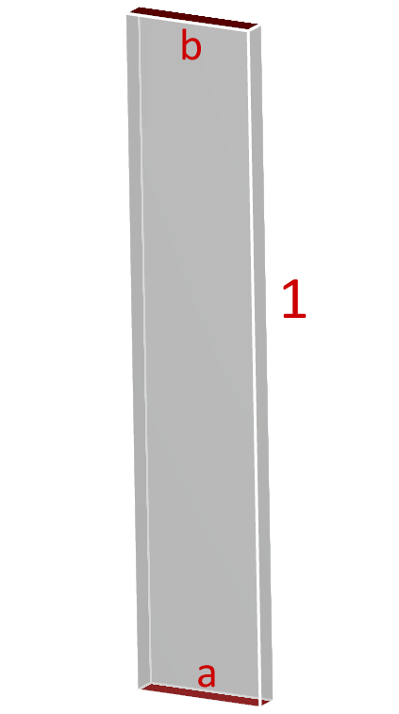
Figure 1 — Tutorial geometry: (1) the walls body, containing (a) the inlet at the bottom and (b) the outlet at the top. All three come from the Fluent .cas file. [Rocky Tutorial Guide, p. 694]

4.2 Part A — Fluent case setup
The purpose of Part A is only to produce a .cas.h5 file. Nothing is solved here.

4.2.1 Launch and import
- Open Ansys Fluent. In the Fluent Launcher set Dimension = 3D and tick Double Precision.
- Click Start.
- File → Read → Mesh. In the file dialog set *Files of type* to All Mesh Files (*.msh* *.MSH*), then open dem_tut14_files/mesh/tutorial_14_mesh.msh.

3D and Double Precision are mandatory
Rocky's Fluent coupling will not accept a 2D or single-precision case. This constraint carries straight through to your own project — it is the reason Stage 2 builds a 3D slab rather than a 2D planar domain, even though a 2D Fluent-only case would be far cheaper.
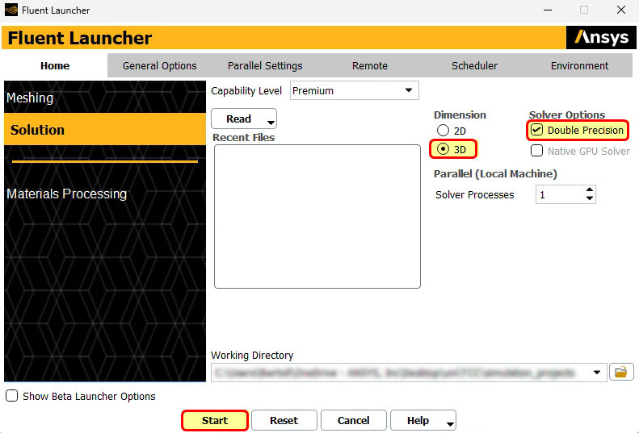
Figure 2 — Fluent Launcher. Dimension = 3D and Options → Double Precision are both required for coupling with Rocky. [Rocky Tutorial Guide, p. 695]

4.2.2 General, models and boundary conditions
Work through the following in order. This reproduces the tutorial's tables §14.1.6 to §14.1.11.
# | Location | Item | Setting
A | Setup → General | Mesh | Display (inlet, outlet, walls), then Check
A | Setup → General | Time | Transient
A | Setup → General | Gravity | Enabled; Gravitational Acceleration = −9.81 m/s² in Z
B | Setup → Models | Multiphase | Off — leave it alone. The solids live in Rocky, not in Fluent
B | Setup → Models → Energy | Energy Equation | Enabled
B | Setup → Models → Viscous | Model | k-epsilon (2 eqn)
B | Setup → Models → Viscous | Near-Wall Treatment | Scalable Wall Functions
C | Setup → Materials | Fluid | Default air properties — no change
D | Setup → Boundary Conditions → inlet | Momentum → Velocity Magnitude | 2 m/s
D | …inlet → Momentum | Turbulence → Specification Method | Intensity and Hydraulic Diameter
D | …inlet → Momentum | Turbulence → Hydraulic Diameter | 0.1 m
D | …inlet → Thermal | Temperature | 293.15 K
E | Setup → Boundary Conditions → outlet | Thermal → Backflow Total Temperature | 293.15 K
F | Setup → Boundary Conditions → walls | — | Default adiabatic wall — no change
G | Solution → Methods | Pressure-Velocity Coupling → Scheme | SIMPLE
G | Solution → Methods | Transient Formulation | First Order Implicit
H | Solution → Initialization | Method | Standard Initialization, Compute from all-zones, then Initialize
I | Solution → Run Calculation | Time Advancement → Type | Fixed
I | Solution → Run Calculation | Time Step Size | 0.001 s

Three settings that are not optional for coupling
Transient. A two-way coupled run cannot be steady. Fluent and Rocky exchange forces and volume displacement once per time step; there is no steady handshake.
First Order Implicit transient formulation. Required for all two-way coupled simulations. Second-order will either be rejected or will silently corrupt the exchange.
Fixed time advancement. Adaptive time stepping breaks the lock-step with Rocky's own time integration.
Note also that with the single-phase approach there is no restriction on the pressure-velocity coupling scheme — SIMPLE here, but Coupled would be equally valid. That freedom disappears in the Eulerian–Granular route (Appendix D), where Phase Coupled SIMPLE is the only option.
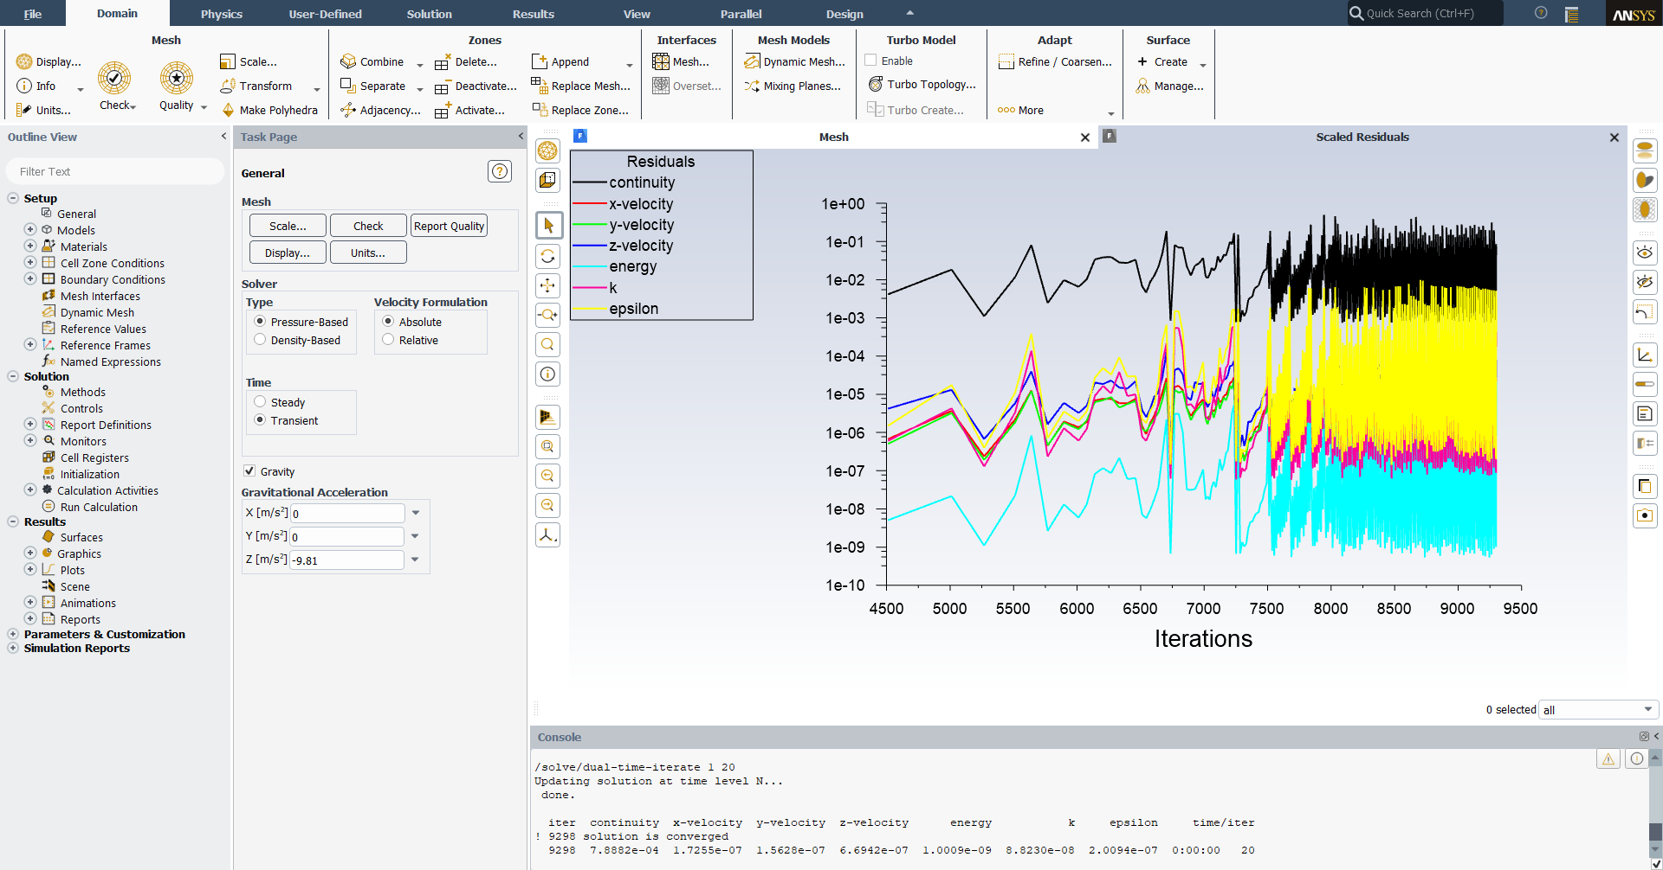
Figure 3 — The Fluent General task page during the coupled run. Note Time = Transient, Gravity ticked, and Z = −9.81 m/s². The right-hand pane shows the scaled residuals converging each time step during the coupled solve. [Rocky Tutorial Guide, p. 717]

4.2.3 Save the case — do not solve
- File → Write → Case.
- Choose a folder and enter the name fluidized_bed.cas.h5. Click OK.
- Leave Fluent open or close it — either is fine. Rocky will relaunch it automatically when the coupled run starts.
Part A is complete. You have produced a single-phase, transient, heat-transfer-enabled CFD case that Rocky can attach to.

4.3 Part B — Rocky project setup and the coupled run

4.3.1 Create the project and set the physics
Open Rocky 2025 R2, create a new project, and save the empty project somewhere convenient. Then work through the tutorial's §14.2.5 table:
# | Data entity | Editor | Parameter | Setting
A | Study | Study | Study Name | Fluidized Bed
B | Physics | Gravity | Y-direction | 0 m/s²
B | Physics | Gravity | Z-direction | −9.81 m/s²
B | Physics | Momentum | Numerical Softening Factor | 0.1
B | Physics | Thermal | Enable Thermal | Enabled
B | Physics | Thermal | Conduction Correction Model | Morris et al. Area+Time
C | Geometries | — | Import Wall Geometries | fluidized_bed.cas.h5, with m as the Import Unit
D | Geometries → walls | Wall → Thermal | Thermal Boundary Type | Adiabatic (may already be set)
E | Materials → Default Particles | Material | Use Bulk Density | Cleared
E | Materials → Default Particles | Material | Density | 1500 kg/m³
E | Materials → Default Particles | Material | Young's Modulus | 1×10⁷ N/m²
E | Materials → Default Particles | Material | Thermal Conductivity | 1.4 W/m·K
E | Materials → Default Particles | Material | Specific Heat | 800 J/kg·K
F | Particles | — | Create Particle | Name it smaller
G | Particles → Particle<01> | Particles → Size | Size | 0.003 m @ 100 %
H | Particles | — | Create Particle | Name it bigger
I | Particles → Particle<01> | Particles → Size | Size | 0.005 m @ 100 %

Two settings worth understanding rather than just copying
Young's Modulus = 1×10⁷ N/m². This is roughly three orders of magnitude softer than real sand or glass. It is deliberate: the DEM time step scales as √(ρ/E) through the Rayleigh time, so a realistic modulus would make the run about 30 times slower for almost no change in bulk behaviour. Softening the contact stiffness is standard DEM practice for dense, slow flows. At E = 10⁷ Pa and dₚ = 4 mm the Rayleigh time is 1.34×10⁻⁴ s, and Rocky will pick an internal time step near 20 % of that, ≈ 2.7×10⁻⁵ s. Report the modulus you used — it is a modelling assumption, not a material property.
Numerical Softening Factor = 0.1 in the Momentum editor does the same job from the other direction, damping the contact response so the integration stays stable at a usable time step.

4.3.2 Create the particle bed with a Volumetric Inlet
A Volumetric Inlet fills a defined box with particles at t = 0, rather than feeding them in through a boundary. Where you put the seed point and how you bound the box controls the shape of the resulting pile.
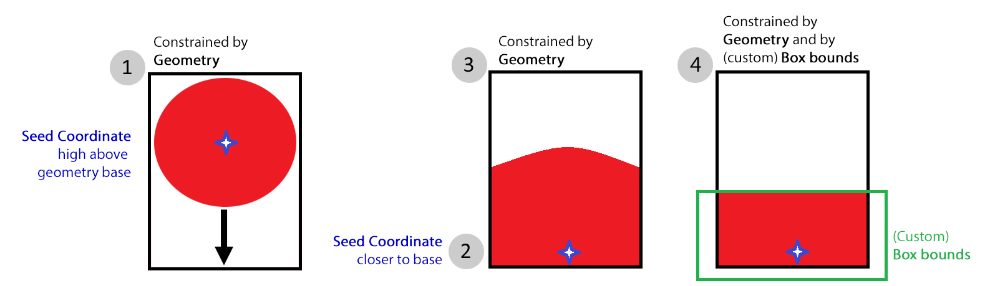
Figure 4 — How seeding controls the pile. (1) A seed placed too high above the base makes particles fall. (2) A seed near the base gives a settled pile. (3) Letting the box bounds be computed from the geometry gives a rounded pile. (4) Defining your own box bounds gives the flat pile you want for a fluidized bed. [Rocky Tutorial Guide, p. 704]
# | Data entity | Editor | Parameter | Setting
A | Inlets and Outlets | — | Create Volumetric Inlet | —
B | Inputs → Volumetric Inlet<01> | Volumetric Inlet → Particles | Add 2 entry rows | (1) smaller @ 0.06 kg & 363 K  (2) bigger @ 0.06 kg & 363 K
B | Inputs → Volumetric Inlet<01> | Volumetric Inlet → Region | Seed Coordinates | 0, 0, 0.01 m
B | Inputs → Volumetric Inlet<01> | Volumetric Inlet → Region | Geometries | All enabled (“Check All”)
B | Inputs → Volumetric Inlet<01> | Volumetric Inlet → Region | Box bounds → Center Coordinates | 0, 0, 0.025 m
B | Inputs → Volumetric Inlet<01> | Volumetric Inlet → Region | Box bounds → Dimensions | 0.1, 0.1, 0.1 m
Open a 3D View to check the placement. The seed appears as a blue dot and the box bounds as a blue cube. The seed must lie inside the box. You can drag the coloured handles to move and resize the box, but the seed can only be moved by typing coordinates.
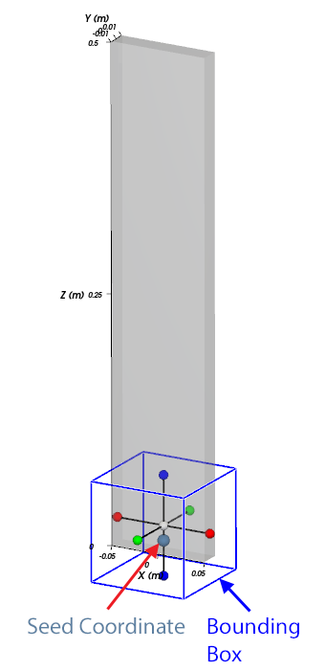
Figure 5 — The Seed Coordinate (blue dot) and Box bounds (blue cube) shown in the 3D View. [Rocky Tutorial Guide, p. 706]

4.3.3 Solver settings for the settling run
This first run is not the fluidization simulation. Its only job is to drop the particles and let them settle into a stable bed.
Data entity | Editor | Parameter | Setting
Solver | Solver → Time | Simulation Duration | 0.1 s
Solver | Solver → Time | Output Settings → Time Interval | 0.02 s
Solver | Solver → General | Simulation Target | CPU
With a 3D View open, your Data panel and workspace should look like Figure 6. Then, from the Solver entity, click Start. The Simulation Summary screen (Figure 7) appears and processing begins. Tick Auto Refresh if you want to watch the bed form.
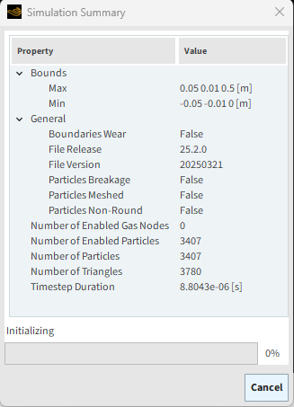
Figure 6 — Setup confirmation: the Data panel and workspace before the first run. [Rocky Tutorial Guide, p. 709]
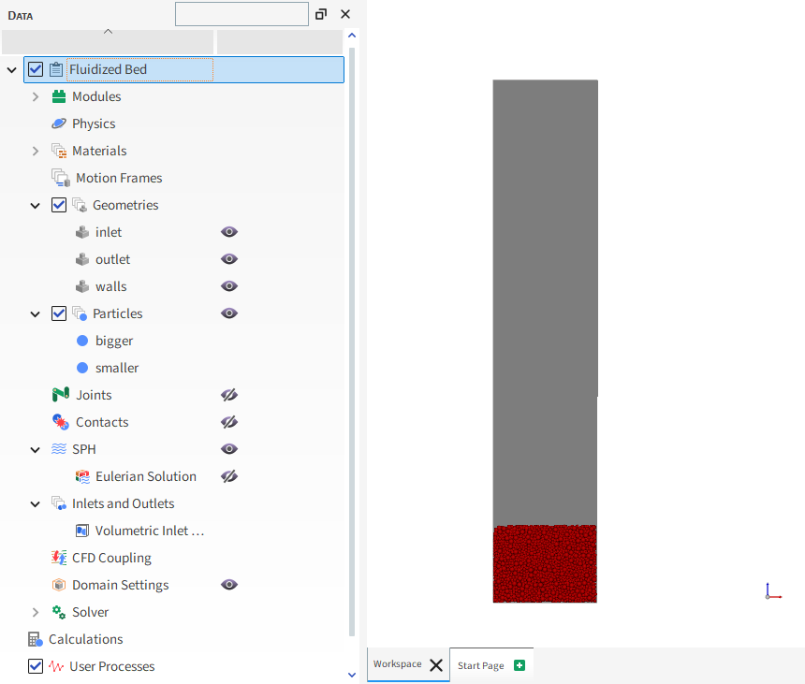
Figure 7 — The Simulation Summary screen that appears when you click Start. [Rocky Tutorial Guide, p. 708]

4.3.4 Inspect and save for restart
- From the Coloring service toolbar, colour the Particles by Velocity : Translational : Absolute.
- Use the Time toolbar to play through the output times. You will see the pile settle slightly under gravity.
- Pause, then click Last timestep. This state — a settled, motionless bed — is the initial condition for the coupled run.
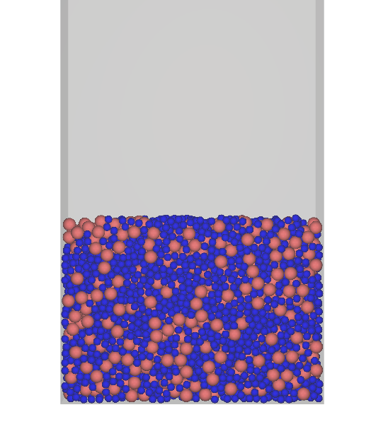
Figure 8 — The settled bed at the last output time, coloured by absolute translational velocity. Everything is blue: the bed is at rest and ready to be used as an initial condition. [Rocky Tutorial Guide, p. 710]
- File → Save project as…
- In the Save As dialog choose the third option, Save as a New Project for Restart, then click OK.
- Choose a location and file name, then Save.
The new project has the same setup and the same particle positions, but with the clock reset to zero. This is the project you will couple with Fluent.
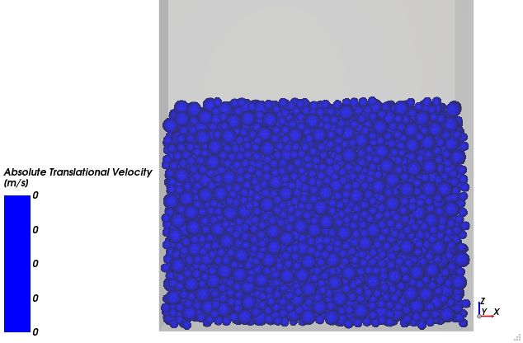
Figure 9 — Save Options. Option 3, “Save as a New Project for Restart”, keeps the particle configuration at the selected time and resets the simulation clock. [Rocky Tutorial Guide, p. 711]

Why the settle-then-restart pattern matters for your own case
This two-step pattern — generate and settle the bed in a cheap DEM-only run, then restart from it for the expensive coupled run — is how you will build the project bed in §5.6 too. It has a second benefit that the tutorial does not mention: the settled bed is where you measure your actual initial solids fraction. In a DEM simulation you cannot patch αₚ = 0.60 the way you can in a Eulerian model. You specify a particle mass, let gravity do the packing, and then measure what you got. See §5.6.

4.3.5 Enable 2-Way Fluent coupling
- From Study, click Enable CFD Coupling and select 2-Way Fluent from the Coupling Mode list.
- In the Select Fluent CAS file dialog, choose the same fluidized_bed.cas.h5 you used to import the geometries, and click Open. A mesh validation step runs immediately — this needs a valid Fluent licence on the same machine.
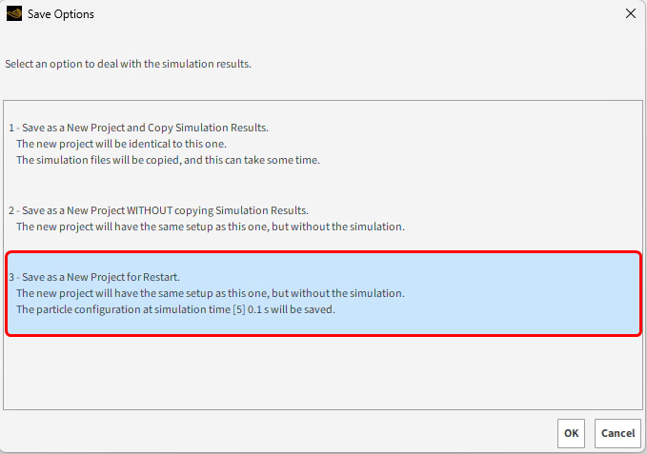
Figure 10 — Study → Enable CFD Coupling, with Coupling Mode set to 2-Way Fluent. This mode applies fluid forces to the particles and passes particle information back to Fluent. [Rocky Tutorial Guide, p. 712]
Selecting the new 2-Way Fluent entity in the Data panel reveals five sub-tabs:
Sub-tab | What it controls
Interactions | The particle–fluid correlations: drag law, lift, torque, turbulent dispersion, and the convective heat transfer law
Coupling | Fluent calculation mapping method and sub-stepping options
Zones and Interfaces | How fluid cell zones and interfaces are treated in the coupled calculation
Fluent | Solver options for the Fluent side: version, file retention
Variables | Any additional variables Fluent should receive from Rocky
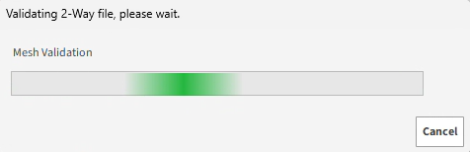
Figure 11 — The five 2-Way Fluent sub-tabs. The tutorial uses only Interactions and Fluent. [Rocky Tutorial Guide, p. 713]
- On the Interactions sub-tab, under Particle, multi-select both particle groups and define the Convective Heat Transfer Law. This is what allows the hot particles to lose heat to the cold gas — without it, the thermal model has nothing to do.
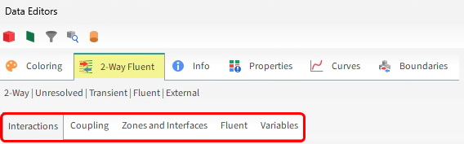
Figure 12 — The Interactions sub-tab with both particle groups selected and the Convective Heat Transfer Law defined. [Rocky Tutorial Guide, p. 714]
- On the Fluent sub-tab: pick your Fluent Version from the list; clear the *Keep all files* checkbox; set Files to keep = 2.

Change this one setting for your own runs
The tutorial clears *Keep all files* to save disk space. For your project cases, tick it. Retaining the Fluent .dat files is what lets you post-process the gas field in Fluent afterwards — contours, vectors, surface reports, the inlet pressure history for sub-task (g). If you clear it you can only ever look at the fluid through Rocky's Eulerian Statistics tool, which is good but far more limited. Disk is cheaper than a re-run.
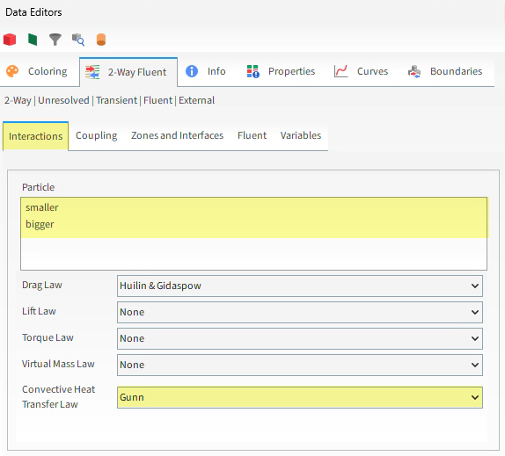
Figure 13 — The Fluent sub-tab: version selection and file retention. Clear “Keep all files” for the tutorial; tick it for your own cases. [Rocky Tutorial Guide, p. 715]

4.3.6 Run the coupled simulation
Data entity | Editor | Parameter | Setting
Solver | Solver → Time | Simulation Duration | 3 s
Solver | Solver → General | Simulation Target | CPU — or GPU if you have one, while Fluent uses the CPU cores
Click Start. The Simulation Summary appears again, Fluent launches automatically, and both programs begin processing. Fluent updates its display without any refresh; in Rocky, use the Refresh button or tick Auto Refresh.
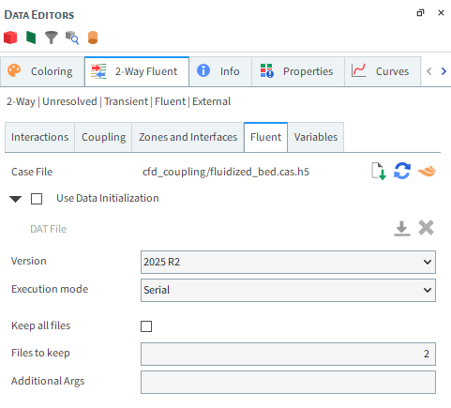
Figure 14 — Solver settings for the coupled run: 3 s duration. [Rocky Tutorial Guide, p. 716]

4.4 Part C — Post-processing in Rocky
Every technique in this section is used again in Stage 2 with your own numbers. Learn them here, where the answers are known.

4.4.1 Segregation
Open a new 3D View, select Particles, and on the Coloring tab set Nodes → Property to Particle Group. Step through time with the Time toolbar.
The bigger 5 mm particles settle toward the bottom while the smaller 3 mm particles rise. This is size segregation, and it is something a Eulerian two-fluid model cannot show you at all without adding a separate phase per size class.
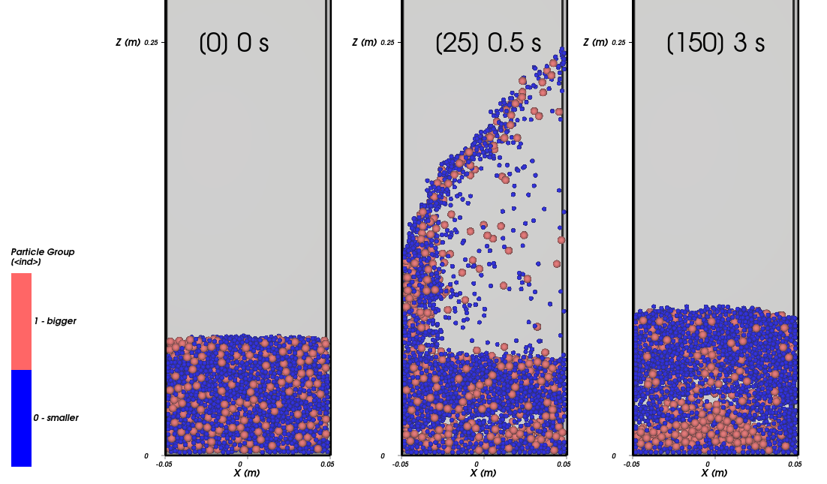
Figure 15 — Particles coloured by Particle Group. The larger particles sink and the smaller ones rise: size segregation, resolved directly by DEM. [Rocky Tutorial Guide, p. 720]

4.4.2 Mixing — Divisions Tagging
Divisions Tagging labels each particle by the region it started in, so you can watch mixing directly. Go to the first output time (0.00 s) before setting this up — the tags are assigned from the positions at the current time.
# | Data entity | Editor | Parameter | Setting
A | Particles | — | Create a Cube User Process | —
B | User Processes → Cube<01> | Cube | Center | 0, 0, 0.04 m
B | User Processes → Cube<01> | Cube | Magnitude | 0.1, 0.02, 0.08 m
C | Calculations → Particles Calculations | — | Create a Divisions Tagging on Cube<01> | —
D | Calculations → Divisions Tagging (Cube<01>) | Tagging | Height Divisions | 1
D | Calculations → Divisions Tagging (Cube<01>) | Tagging | Depth Divisions | 5
E | Particles | Coloring | Faces → Property | Divisions Tagging (Cube<01>)
Hide Divisions Tagging and the Cube, show Particles, and advance in time. The particles are now coloured by the axial layer they occupied at t = 0, so you can see how thoroughly the bed turns over.
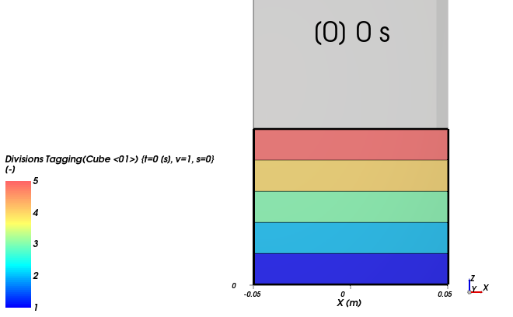
Figure 16 — Divisions Tagging: particles inside Cube<01> split into five axial divisions by their position at t = 0. [Rocky Tutorial Guide, p. 721]
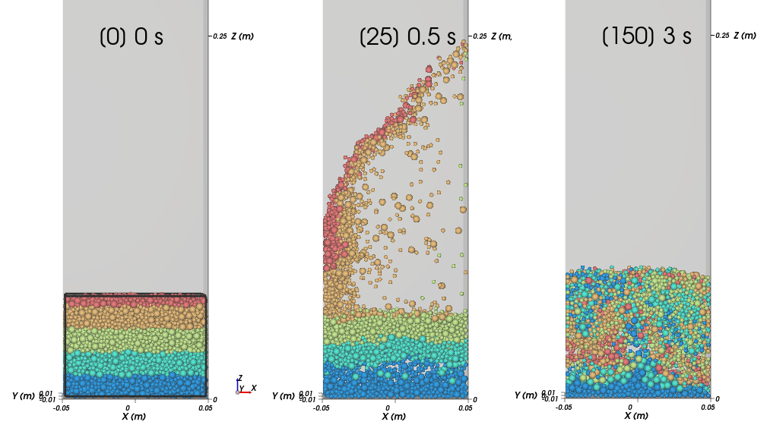
Figure 17 — The same particles later in the run. Colours that started as clean horizontal bands are now intermingled — that intermingling is the mixing. [Rocky Tutorial Guide, p. 722]

4.4.3 Quantifying mixing — a second cube, a histogram and a filter
Rather than judging mixing by eye, focus on one segment and count. Return to t = 0.00 s, then create a second cube around the fourth axial division:
Data entity | Editor | Parameter | Setting
User Processes → Cube<02> | Cube | Center | 0, 0, 0.056 m
User Processes → Cube<02> | Cube | Magnitude | 0.1, 0.02, 0.0155 m
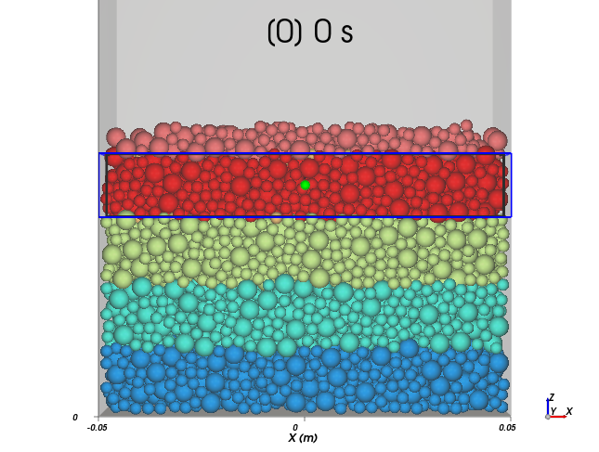
Figure 18 — Cube<02> encompassing the 4th axial division. At t = 0 it should contain only particles tagged 4. [Rocky Tutorial Guide, p. 723]
Now build a histogram of the tag values inside that cube:
# | Item | Parameter | Setting
A | User Processes → Cube<02> | — | Show in new Histogram by Divisions Tagging (Cube<01>)
B | Histogram window | — | Click Configure histogram
C | Configure Histogram dialog | Number of Bins | 5
C | Configure Histogram dialog | Percent Values | Enabled
C | Configure Histogram dialog | Properties | Select Divisions Tagging (Cube<01>)
C | Configure Histogram dialog | User Defined Limits | Min 1, Max 5
At t = 0 the fourth bin holds 100 % of the particles, as it must. Advance in time and watch that fraction fall as particles from other layers move in.
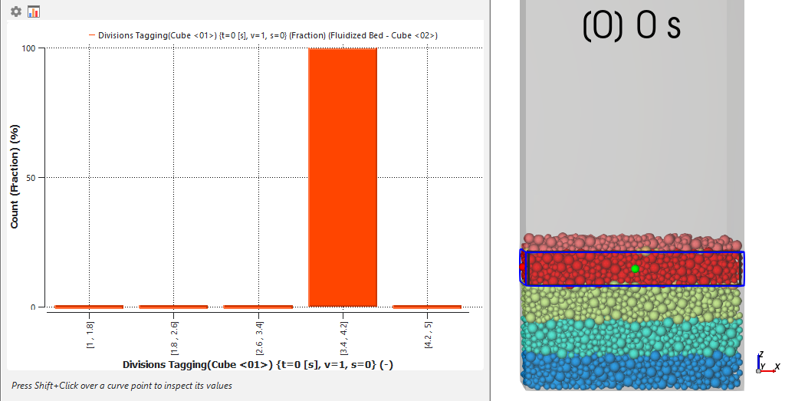
Figure 19 — Histogram at t = 0 s: 100 % of the particles inside Cube<02> carry tag 4. [Rocky Tutorial Guide, p. 724]
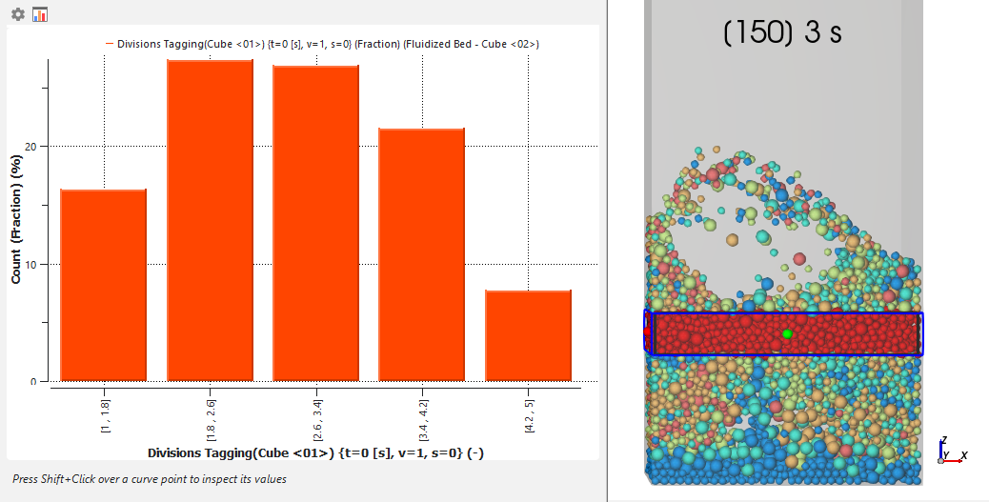
Figure 20 — Histogram at the final time, 3 s. Particles from every original division are now present in the 4th segment. [Rocky Tutorial Guide, p. 725]
To turn this into a single number against time, add a Filter and plot mass:
# | Data entity | Editor | Parameter | Setting
A | User Processes → Cube<02> | — | Create a Filter User Process | —
B | User Processes → Filter<01> | Property | Property | Divisions Tagging (Cube<01>)
B | User Processes → Filter<01> | Property | Cut Value | 4
C | User Processes → Cube<02> | — | Show in New Time Plot by Particle Mass | —
D | User Processes → Filter<01> | — | Show in Current Time Plot by Particle Mass | —
E | Time Plot<01> → Table tab | Add Expression | Curve Caption | Tagging 4 mass fraction
E | Time Plot<01> → Table tab | Add Expression | Curve Expression | C/B
Switch to the Plot tab. The green curve is the ratio of tagged-4 mass to total mass inside Cube<02> — a clean, quantitative mixing index. It drops sharply as fluidization starts, then partially recovers as particles circulate back.
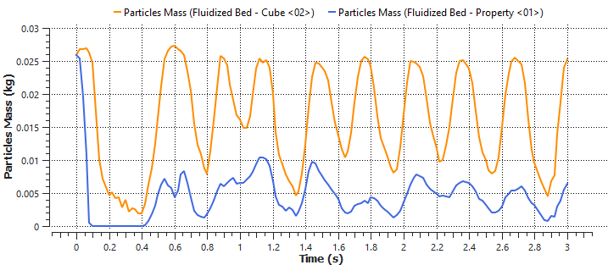
Figure 21 — Time plot: total mass inside Cube<02> (orange), mass still carrying tag 4 (blue), and their ratio (green). [Rocky Tutorial Guide, p. 726]

4.4.4 Particle temperature (this is sub-task f)
Create a new Time Plot. Drag Particles → Properties → Temperature onto it. In the *Select The Statistics To Plot* dialog enable Min, Max and Average. Right-click the grid, then Axes Layout → By Quantity.
The average particle temperature falls with time as the 363 K particles give up heat to the 293.15 K air. The spread between Min and Max tells you how uniformly the bed is cooling — a narrow band means good mixing.
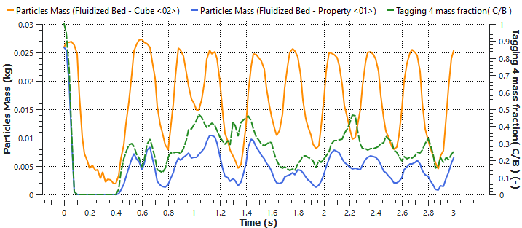
Figure 22 — Minimum, maximum and average particle temperature against time. The average falls steadily as the bed cools. [Rocky Tutorial Guide, p. 727]
To see the same information spatially, create another 3D View:
# | Item | Editor | Parameter | Setting
A | Window menu | — | — | Create a New 3D View
B | Fit menu | — | — | Select Camera Preset −Y
C | Geometries → walls | Coloring | Transparency | Enabled
D | Particles | Coloring | Nodes | Enabled
D | Particles | Coloring | Nodes → Property | Temperature
E | Coloring → Color Scales → Temperature | Coloring | Limit options | User Defined
E | Coloring → Color Scales → Temperature | Coloring | Limits | 293.15, 363 K
E | Coloring → Color Scales → Temperature | Coloring | Color-scale unit | degC
F | CFD Coupling → 2-Way Fluent | Coloring | Nodes | Enabled
F | CFD Coupling → 2-Way Fluent | Coloring | Nodes → Property | Fluid Temperature
F | CFD Coupling → 2-Way Fluent | Coloring | Nodes → Point size | 6
G | Coloring → Color Scales → Fluid Temperature | Coloring | Limits | Same 293.15, 363 K as the particles

Set both colour scales to the same limits
The tutorial says this as a tip; treat it as a rule. If the particle and fluid temperature scales auto-range independently, the two fields will look similar even when they differ by 60 K, and your figures will be actively misleading. Fix the limits, use the same limits everywhere, and use the same limits at every output time you plot — otherwise your start / middle / end comparison for sub-task (f) compares nothing.
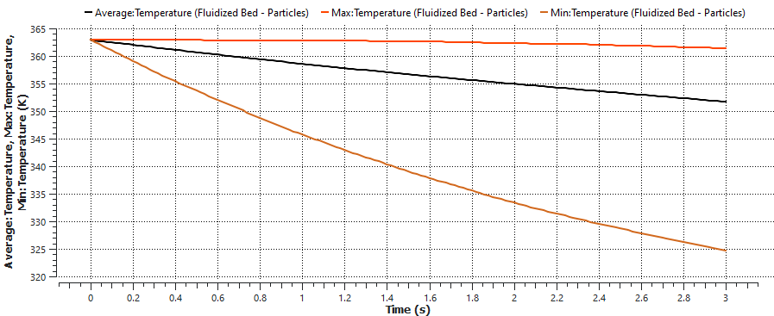
Figure 23 — Particles coloured by temperature in the 3D View. [Rocky Tutorial Guide, p. 728]
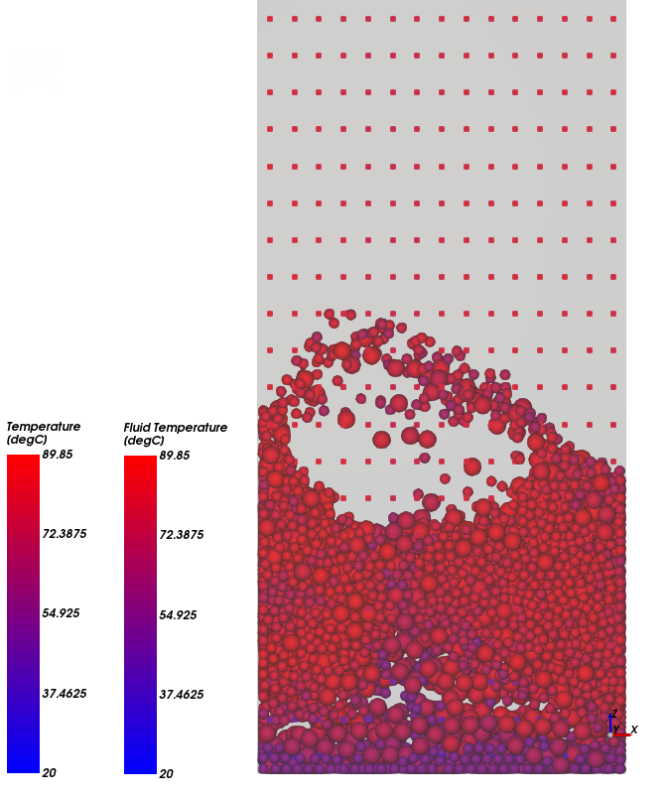
Figure 24 — Particle temperature and fluid temperature displayed together on a common colour scale. Note the bubble in the upper part of the bed and the cool (blue) gas entering at the bottom. This is the figure reproduced on slide 6-2 of the task sheet. [Rocky Tutorial Guide, p. 730]

4.4.5 Pressure drop (this is sub-task g)
Rocky measures pressure drop by sampling the fluid static pressure in two cubes — one just above the inlet, one near the outlet — and subtracting.
# | Data entity | Editor | Parameter | Setting
A | CFD Coupling → 2-Way Fluent | — | Create a Cube User Process | —
B | User Processes → Cube<03> | Cube | Name | bottom
B | User Processes → Cube<03> | Cube | Center | 0, 0, 0.008 m
B | User Processes → Cube<03> | Cube | Magnitude | 0.1, 0.02, 0.0155 m
C | User Processes → bottom | — | Create a Duplicate | —
D | User Processes → bottom<01> | Cube | Name | top
D | User Processes → bottom<01> | Cube | Center | 0, 0, 0.492 m
E | User Processes → top | — | Show in New Time Plot by Average | Properties → Static Pressure
F | User Processes → bottom | — | Show in Selected Time Plot by Average | Properties → Static Pressure
G | Time Plot<03> → Table tab | Add Expression | Curve Caption | Pressure Drop
G | Time Plot<03> → Table tab | Add Expression | Curve Expression | C − B
Select the Plot tab, right-click the grid → Axes Layout → By Quantity, and click the two Average legend entries to hide them so only the difference remains.
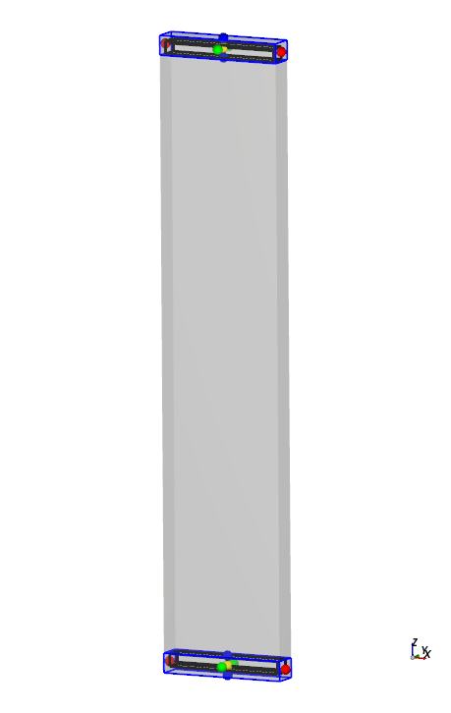
Figure 25 — The bottom and top sampling cubes at either end of the container. [Rocky Tutorial Guide, p. 732]
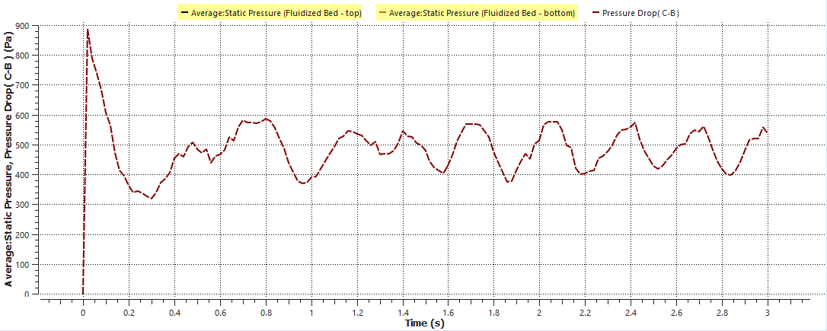
Figure 26 — Pressure drop against time. A large startup spike, then a stable mean with regular fluctuations from about 1 s onward. Average over the stable period only. [Rocky Tutorial Guide, p. 733]

Read Figure 26 carefully — it tells you three things you will need
The startup spike is not physics you should report. The pressure jumps to ≈ 880 Pa in the first 0.05 s as the gas field establishes itself against a static packed bed. Discard it.
The system stabilises after roughly 1 s. That is why the tutorial's time-averaging window in §14.3.13 is [1 s, 3 s] and not [0 s, 3 s]. Your own averaging windows in §6 follow the same logic.
The fluctuations are the bubbles. Each peak-to-trough excursion is a bubble growing, rising and erupting at the surface. The amplitude and frequency of that signal is the quantitative fingerprint of the flow regime — and comparing it between Re = 500 and Re = 2000 is one of the strongest results in your report (§8.1).

4.4.6 Solid volume fraction and fluid velocity (also sub-task f)
Eulerian Statistics divides a region into a grid of blocks and computes fluid-side statistics over the CFD cells inside each block. Solid Volume Fraction is the ratio of particle volume inside a CFD cell to the volume of that cell — exactly the αₛ the task asks you to plot.
# | Data entity | Editor | Parameter | Setting
A | CFD Coupling → 2-Way Fluent | — | Create a Cube User Process | —
B | User Processes → Cube<03> | — | Create a Eulerian Statistics User Process | —
C | User Processes → Eulerian Statistics<01> | Eulerian Statistics | Height Divisions | 3
C | User Processes → Eulerian Statistics<01> | Eulerian Statistics | Depth Divisions | 20
C | User Processes → Eulerian Statistics<01> | Coloring → Faces | Property | Solid Volume Fraction
C | User Processes → Eulerian Statistics<01> | Coloring → Faces | Show on Node? | Enabled
Hide the Particles entity and all Geometries so only the statistics grid is visible, then press Shift+Y to look along the flow direction. Drag the Time toolbar slider to watch αₛ evolve.
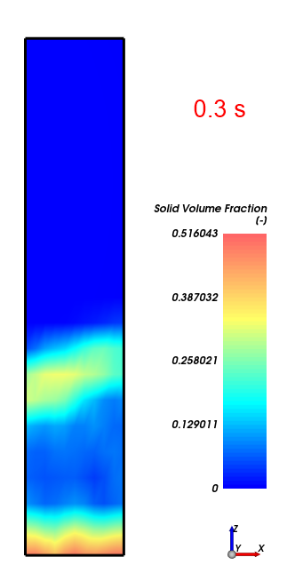
Figure 27 — Instantaneous Solid Volume Fraction from Eulerian Statistics, viewed along the flow direction. [Rocky Tutorial Guide, p. 735]
For the gas field, change the same entity's Coloring → Property to Local Z-Velocity. Because Z is the flow direction, this is the axial gas velocity.
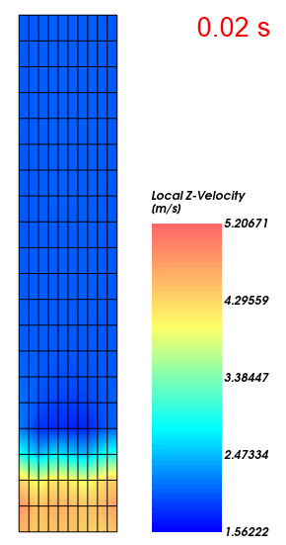
Figure 28 — Instantaneous fluid Local Z-Velocity early in the run. The gas accelerates where particles are present, because the particles reduce the free flow area. [Rocky Tutorial Guide, p. 736]
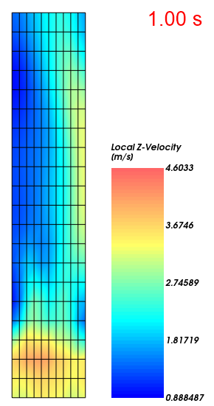
Figure 29 — The same field at a later time. Comparing successive times shows how strongly the fluid field responds to the moving bed — this is the two-way coupling made visible. [Rocky Tutorial Guide, p. 736]
Instantaneous fields are noisy. For anything you intend to compare — and sub-task (f) explicitly asks for time-averaged solid volume fraction — use Rocky's time-statistics tool:
# | Item | Parameter | Setting
A | User Processes → Eulerian Statistics<01> → Properties | — | Click Add and edit time statistics properties
B | Edit time statistics properties dialog | — | Click Add
C | Add time statistics properties dialog | Start time | 1 s
C | Add time statistics properties dialog | Stop time | 3 s
C | Add time statistics properties dialog | Operations → Average | Enabled
C | Add time statistics properties dialog | Properties → Local Z-Velocity | Enabled
D | User Processes → Eulerian Statistics<01> | Coloring → Faces → Property | Average of Local Z-Velocity [1s, 3s]
The window [1 s, 3 s] is chosen because the system has reached a statistically steady state by 1 s — the pressure-drop plot in Figure 26 is what tells you that. Choose your own averaging windows the same way: look at the Δp trace first, then average over the stationary part only.
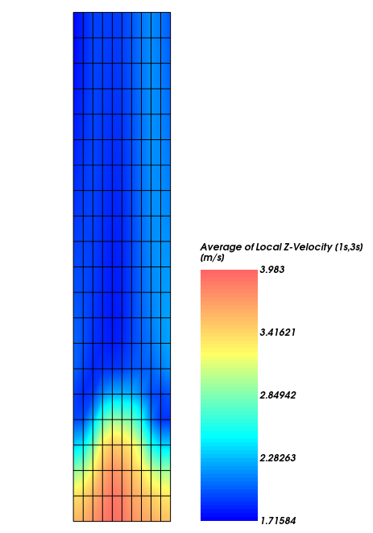
Figure 30 — Time-averaged fluid Local Z-Velocity over [1 s, 3 s]. On average the gas moves fastest through the particle region; above the bed the profile is nearly uniform. [Rocky Tutorial Guide, p. 738]

4.5 What to record from Stage 1
Before moving on, capture the following. It is a page of your report — the “initial work” — and it is also your reference when your own case misbehaves.
Record | Why
Screenshot of the settled bed (Figure 8 equivalent) with the particle count Rocky reports | Establishes the DEM bed generation worked, and gives you a feel for what a “reasonable number of particles” means in practice
The pressure-drop time plot, with the stabilised mean value read off it | Your first Δp measurement. Check it against (ρₚ−ρ_g)(1−ε)gH₀ for the tutorial's own bed depth
The particle-temperature plot (min/max/average) | Proves the thermal model and the convective heat transfer law are actually active
The solid-volume-fraction and Local-Z-Velocity contours | Confirms Eulerian Statistics is configured and that the coupling is exchanging data both ways
Wall-clock time for the 3 s coupled run, and whether you used CPU or GPU for Rocky | This is your only calibration for estimating the project run times in §6.3. Write it down
Any licence, version or mesh-validation errors and how you fixed them | They will recur in Stage 2, and you will have forgotten the fix

Gate: do not start Stage 2 until all of these pass
The coupled run completed 3 s without Fluent or Rocky crashing.
The pressure-drop plot shows a startup spike followed by a stable fluctuating mean.
The average particle temperature decreases monotonically from 363 K.
The Eulerian Statistics grid shows a dense region at the bottom and a dilute region above.
You know your own machine's wall-clock cost per second of coupled physics.
PART II
Stage 2 — Build the Project Case
Same workflow, project geometry and properties

5. Building the Project Case
From here on, every setting differs from the tutorial. The procedure does not — if you completed Stage 1 you already know where every button is.

5.1 Coordinate system
Fix this now and use it everywhere. Z is vertical, matching Rocky Chapter 14, so every cube coordinate and gravity setting from the tutorial transfers without reinterpretation. The column is centred on the origin in X and Y so that cube centres are simply (0, 0, z).
x : -0.14 -> +0.14 m WIDTH (0.28 m across the bed)
y : -0.02 -> +0.02 m DEPTH (0.04 m slab thickness)
z : 0.00 -> 1.00 m HEIGHT (vertical, flow direction)

gravity : ( 0, 0, -9.81 ) m/s2

z = 1.00 +---------------------+ <- outlet (top face)
| |
| freeboard |
| |
| |
z = 0.40 +---------------------+ <- initial bed surface
|ooooooooooooooooooooo|
|oo packed bed ooooo| alpha_p = 0.60
|ooo H0 = 0.40 m ooo| 4.032 kg, ~80,200 particles
z = 0.00 +---------------------+ <- inlet (bottom face)
x=-0.14 x=+0.14

5.2 Geometry (sub-task a)

5.2.1 The third dimension
The task gives only two dimensions, 0.28 m (W) × 1.0 m (H). A DEM simulation is inherently three-dimensional, so you must supply a depth. This choice dominates the entire compute budget because it sets the particle count.
Variant | Depth | Particles at dₚ = 4 mm | Verdict
A — Thin slab (use this) | 0.04 m = 10 dₚ | ≈ 80,200 | Genuine 3D physics, tractable on a single GPU. Standard practice for validating fluidized-bed DEM against quasi-2D experimental beds. The Rocky tutorial itself uses a 0.02 m slab — this is the configuration Chapter 14 was written for
B — Full rectangular | 0.28 m | ≈ 561,000 | Physically the most complete, but 7× the particles and 7× the cells, for two cases. A week of compute, minimum
C — Cylindrical | Ø 0.28 m | ≈ 441,000 | Most realistic for a real reactor, but the task says “W”, implying rectangular, and it needs an O-grid mesh. Extra work for no extra credit

State the slab depth and justify it — sub-task (i)
Write one sentence: “The bed was modelled as a 0.04 m deep quasi-2D slab (10 particle diameters), the standard configuration for fluidized-bed DEM and the same configuration used in the Rocky Chapter 14 tutorial, chosen for computational tractability.” Then note the known consequence: a slab suppresses the third velocity component and constrains bubble growth in the depth direction, so bubbles are somewhat more two-dimensional than in a full 3D bed. Naming a limitation you understood is worth more than pretending there isn't one.

5.2.2 Build it
In SpaceClaim (recommended) or DesignModeler:
- Set units to metres before drawing anything. SpaceClaim: File → SpaceClaim Options → Units → Length = Meter.
- Sketch a rectangle on the XY plane from (−0.14, −0.02) to (+0.14, +0.02). Type the numbers into the dimension boxes; do not drag.
- Return to 3D mode, select the face, and Pull along +Z by 1.00 m.
- Confirm in the Structure tree that you have exactly one Solid body, not a surface. A surface produces shell elements and Fluent will refuse the case.

5.2.3 Named selections (sub-task a)
Create these in the mesher, not afterwards in Fluent. Identify each face by its coordinate, not by eye.
Name | Face | Purpose
inlet | z = 0 (bottom) | Gas enters — this is the distributor plane
outlet | z = 1.00 (top) | Pressure outlet to atmosphere
wall-left / wall-right | x = −0.14 / x = +0.14 | The narrow side walls
wall-front / wall-back | y = −0.02 / y = +0.02 | The two large slab faces. Keep them separate so you can test free-slip on them later (§10)

Why front and back deserve their own names
In a 0.04 m slab the two large faces are by far the dominant wall surfaces by area, and in a DEM simulation they exert real frictional forces on individual particles. Keeping them as separate named selections lets you switch them to frictionless later and quantify how much the slab is damping your bed. That comparison costs nothing to set up now and makes a strong sub-task (j) extra.

5.3 The fluid mesh — different rules from a Eulerian model
This is the step where DEM–CFD coupling departs most sharply from the two-fluid model, and getting it wrong is a common and quiet failure.
Model | Cell-size rule | Reason
Fluent Eulerian–Granular (TFM) | 2 ≤ Δx/dₚ ≤ 10 | The cell must be large against a particle but small against a bubble, so the continuum closures are valid
Rocky ↔ Fluent (unresolved DEM–CFD) | Δx ≳ 2–3 dₚ, and cell volume ≫ particle volume | Rocky maps each particle's volume and drag onto the cell it occupies. If a particle is comparable in size to a cell, the local void fraction swings between 0 and 1 from one time step to the next, the drag source term becomes noise, and the coupled solution oscillates or diverges
Δx | Divisions (x × y × z) | Cells | Δx / dₚ | Cell vol / particle vol | Verdict
8 mm | 35 × 5 × 125 | 21,875 | 2.0 | 15 | Marginal for coupling. Only if you want a mesh-sensitivity point
10 mm | 28 × 4 × 100 | 11,200 | 2.5 | 30 | Use this. Comfortably above the coupling limit, cheap, and divides all three dimensions into whole numbers
14 mm | 20 × 3 × 71 | 4,260 | 3.5 | 82 | Very safe and very cheap. Good coarse point for the mesh check

Meshing procedure
- Open Mesh. Set Physics Preference = CFD, Solver Preference = Fluent.
- Insert a Method: select the body, Method = MultiZone, Mapped Mesh Type = Hexa, Free Mesh Type = Not Allowed.
- Insert a Sizing: select the body, Element Size = 0.010 m, Behavior = Hard.
- Turn inflation off — Details of Mesh → Inflation → Use Automatic Inflation = None. Boundary layers are meaningless here and will wreck your cell aspect ratios.
- Generate. Confirm the Statistics panel reports 11,200 elements, all hexahedra, with minimum orthogonal quality ≈ 1.0.
- Rename the body to fluid so Fluent creates a sensibly named cell zone.

Mesh independence for a coupled run
Run the 14 mm mesh for 2 s at Re = 500 and compare the time-averaged pressure drop and bed height against the 10 mm baseline. That is your mesh-independence study, and it costs about a quarter of a production run.
Add one sentence most groups will not write: refining the fluid mesh indefinitely does not converge toward truth in an unresolved DEM–CFD coupling. Once Δx approaches dₚ the volume-mapping assumption underlying the coupling breaks down. The model converges to the solution of an averaged formulation that presumes Δx ≫ dₚ. This is a real, citable limitation of the method, and stating it demonstrates that you understand what you are running.

5.4 The Fluent case (Part A with project values)
Repeat §4.2 with these values. Everything not listed is unchanged from the tutorial.
Location | Item | Case A — Re = 500 | Case B — Re = 2000
General | Solver / Time | Pressure-Based, Transient, Absolute | same
General | Gravity | Z = −9.81 m/s² | same
Models | Multiphase | Off (single phase) | same
Models | Energy | On | same
Models | Viscous | k-epsilon (2 eqn), Scalable Wall Functions | same
Materials → air | Density | 1.2 kg/m³ constant — not ideal-gas | same
Materials → air | Viscosity | 1.8×10⁻⁵ kg/m·s | same
BC → inlet | Velocity Magnitude | 1.875 m/s | 7.500 m/s
BC → inlet | Turbulence | Intensity 5 %, Hydraulic Diameter 0.07 m | same
BC → inlet | Temperature | 293.15 K | same
BC → outlet | Type / Gauge Pressure | pressure-outlet, 0 Pa | same
BC → outlet | Backflow Total Temperature | 293.15 K | same
BC → walls | Momentum / Thermal | No slip, stationary; adiabatic | same
Methods | Scheme | SIMPLE | same
Methods | Transient Formulation | First Order Implicit (mandatory) | same
Initialization | Method | Standard, Compute from all-zones | same
Run Calculation | Time Advancement Type | Fixed (mandatory) | same
Run Calculation | Time Step Size | 5×10⁻⁴ s | 2×10⁻⁴ s
File → Write → Case | Name | fbr_Re500.cas.h5 | fbr_Re2000.cas.h5

Do not reuse one .cas file for both cases
It is tempting to build one case and just retype the inlet velocity. Don't. The time step differs between the two cases, the two runs will be post-processed side by side, and a single stray setting carried across from one case to the other is very hard to spot afterwards. Two files, two names, two folders.

Why the hydraulic diameter is 0.07 m and not 0.28 m
A = 0.28 * 0.04 = 0.0112 m2
P = 2 * (0.28 + 0.04) = 0.64 m
D_h = 4A / P = 4 * 0.0112 / 0.64 = 0.070 m
Using the width instead is a common slip and mis-sets the inlet turbulence length scale by a factor of four.

Time step: where the two numbers come from
dt <= CFL * dx / U_max with CFL ~ 0.5, dx = 0.010 m

Case A: U_max ~ 3 * 1.875 = 5.6 m/s -> dt <= 8.9e-4 s -> use 5e-4 s
Case B: U_max ~ 3 * 7.500 = 22.5 m/s -> dt <= 2.2e-4 s -> use 2e-4 s
The factor of three allows for local acceleration through the constricted gaps between particles and in the jets above bursting bubbles — the interstitial velocity is always well above the superficial value. Rocky runs its own, much smaller DEM time step internally (≈ 2.7×10⁻⁵ s here, from the Rayleigh criterion) and sub-steps between fluid exchanges; you do not set it directly.

5.5 The Rocky project (Part B with project values)
Data entity | Editor | Parameter | Setting
Study | Study | Study Name | FBR Re500 / FBR Re2000
Physics | Gravity | Y / Z direction | 0 / −9.81 m/s²
Physics | Momentum | Numerical Softening Factor | 0.1
Physics | Thermal | Enable Thermal | Enabled
Physics | Thermal | Conduction Correction Model | Morris et al. Area+Time
Geometries | — | Import Wall Geometries | Your fbr_ReXXX.cas.h5, Import Unit m
Geometries → walls | Wall → Thermal | Thermal Boundary Type | Adiabatic
Materials → Default Particles | Material | Use Bulk Density | Cleared
Materials → Default Particles | Material | Density | 1500 kg/m³ ← task value
Materials → Default Particles | Material | Young's Modulus | 1×10⁷ N/m² (report this)
Materials → Default Particles | Material | Thermal Conductivity | 1.4 W/m·K
Materials → Default Particles | Material | Specific Heat | 800 J/kg·K
Particles → Particle<01> | Particles → Size | Name / Size | sand4mm / 0.004 m @ 100 %

One particle size, not two — and why
The tutorial uses two groups (3 mm and 5 mm) to demonstrate segregation. Use a single 4 mm group for both production cases. The whole study is built on a specified Reynolds number, and Re = ρ_g U₀ dₚ/μ is only single-valued if dₚ is. A bidisperse bed at “Re = 500” would actually be running at Re = 375 and Re = 625 simultaneously, and the central claim of the report would be muddied.
Then run the bidisperse case anyway, once, as a sub-task (j) extra (§10): 3 mm and 5 mm in equal mass, mean 4 mm, at Re = 500. You get the segregation analysis of Figure 15 on your own geometry, and a genuinely interesting question to discuss — whether the mean diameter is enough to characterise the bed, or whether the two sizes fluidize differently within the same column.

5.5.1 Building the bed to H₀ = 0.40 m at αₚ = 0.60 (sub-task d)
This is the step that has no direct equivalent in the tutorial, and it works differently from the Eulerian route. In a two-fluid model you patch αₛ = 0.60 into a region and the bed is exactly what you asked for. In DEM you cannot. You specify a particle mass, drop it, and gravity decides the packing. So you dial in the mass that corresponds to the target and then measure what you actually got.
target solids volume V_s = W * D * H0 * alpha_p
= 0.28 * 0.04 * 0.40 * 0.60 = 0.002688 m3
target particle mass m = V_s * rho_p = 0.002688 * 1500 = 4.032 kg
particle volume = pi * 0.004^3 / 6 = 3.351e-8 m3
particle count N = 0.002688 / 3.351e-8 ~ 80,200
Data entity | Editor | Parameter | Setting
Inlets and Outlets | — | Create Volumetric Inlet | —
Inputs → Volumetric Inlet<01> | Volumetric Inlet → Particles | One entry row | sand4mm @ 4.032 kg & 363 K
Inputs → Volumetric Inlet<01> | Volumetric Inlet → Region | Seed Coordinates | 0, 0, 0.02 m
Inputs → Volumetric Inlet<01> | Volumetric Inlet → Region | Geometries | All enabled
Inputs → Volumetric Inlet<01> | Volumetric Inlet → Region | Box bounds → Center | 0, 0, 0.22 m
Inputs → Volumetric Inlet<01> | Volumetric Inlet → Region | Box bounds → Dimensions | 0.28, 0.04, 0.44 m
Solver | Solver → Time | Simulation Duration | 0.5 s (settling only)
Solver | Solver → Time | Output Time Interval | 0.05 s
The box is made slightly taller than the target bed (0.44 m rather than 0.40 m) and centred at z = 0.22 m so the particles have room to be placed before they settle. The seed sits near the base, following the guidance in Figure 4, so the pile forms flat rather than falling from height.
Run the 0.5 s settling simulation, then verify:
Check | How | Expected | If it is off
Particle count | Rocky reports it in the Simulation Summary | ≈ 80,200 | If far fewer, the box bounds were too small to place the requested mass — enlarge the box and rerun
Settled bed height H | Read the top of the bed in the 3D View, or place a Cube and find where the particles stop | 0.38 – 0.42 m | This is data, not an error. Record it
Actual αₚ | αₚ = 0.002688 / (0.28 × 0.04 × H) | 0.60 – 0.63 | Report the measured value in Appendix A alongside the 0.60 target
Bed is at rest | Colour by Velocity : Translational : Absolute — should be uniformly at the bottom of the scale | ≈ 0 m/s | Extend the settling run to 1 s

Report the measured αₚ, not the target — this is a real result
If the bed settles to H = 0.385 m, then αₚ = 0.002688/(0.28 × 0.04 × 0.385) = 0.623, not 0.60. That is not a mistake; it is what random close packing of monodisperse spheres under gravity actually gives (0.60–0.64), and it is one of the more interesting things DEM tells you that a two-fluid model simply assumes.
Sub-task (i) asks for the exact values used. Write both: “target αₚ = 0.60 as specified; the DEM bed settled at αₚ = 0.62, consistent with random close packing.” Then note the consequence — Δp_plateau scales with the solids mass, not with αₚ, so 3529 Pa is unaffected. The bed is slightly shorter and slightly denser; it weighs the same.

5.5.2 Save for restart
Exactly as in §4.3.4: go to the last output time, File → Save project as… → Save as a New Project for Restart. Do this once and use the same settled bed as the starting point for both Case A and Case B.

Both cases must start from the same bed
If you generate the bed twice, the two runs start from two different random packings, and any difference you measure between Re = 500 and Re = 2000 is contaminated by that. Generate once, restart twice. It is the same argument as using the same random seed for two runs of a stochastic experiment, and it is worth a sentence in the methodology.

5.5.3 Enable coupling and set the interactions
- Study → Enable CFD Coupling → 2-Way Fluent, then select the case file for the run you are setting up.
- Interactions sub-tab: select the particle group and define the Convective Heat Transfer Law (required for the particle-temperature deliverable).
- On the same sub-tab, check the drag law. The default is appropriate for most beds, but record which one you used — it is a modelling choice on the same footing as the Gidaspow choice in the Eulerian route, and sub-task (i) asks for it.
- Fluent sub-tab: select your Fluent version, and tick Keep all files so the .dat files survive for post-processing (this is the one place you deviate from the tutorial).

5.6 Solver settings for the production runs
Parameter | Case A — Re = 500 | Case B — Re = 2000 | Reasoning
Simulation Duration | 8 s | 6 s | Long enough for the startup transient to decay and still leave a long statistically stationary window. Case B develops faster because the gas transit time is 4× shorter
Output Time Interval | 0.02 s | 0.02 s | 400 and 300 output times. Enough for smooth animation of bubble coalescence
Fluent Time Step | 5×10⁻⁴ s | 2×10⁻⁴ s | CFL, §5.4
Fluent time steps total | 16,000 | 30,000 | —
Simulation Target | GPU if available | GPU if available | Rocky on the GPU, Fluent on the CPU cores, is the recommended split
Time-averaging window | 2 – 8 s | 1.5 – 6 s | Set these *after* looking at the Δp trace, exactly as the tutorial sets [1 s, 3 s] from its own plot (§4.4.5)

6. The Two Production Runs (sub-task e)

6.1 Case A — Re = 500, bubbling fluidization
Parameter | Value
Reynolds number | Re = 500
Inlet superficial velocity U₀ | 1.875 m/s
U₀ / U_mf | 1.51
Air volumetric flow | 0.0210 m³/s (75.6 m³/h)
Air mass flow | 0.02520 kg/s
Expected regime | Bubbling
Expected mean Δp | ≈ 3529 Pa
Expected expanded bed height | ≈ 0.50 – 0.60 m (two-phase estimate: 0.55 m), leaving ample freeboard
Run length / averaging window | 8 s / 2 – 8 s
What you should see. Within the first half second the packed bed lifts, the pressure drop spikes and then settles. Discrete bubbles nucleate near the distributor, rise, grow by coalescence as they climb, and burst at a clearly defined bed surface, throwing particles into the freeboard. Solids circulate upward in the bubble wakes and downward near the walls. The pressure signal shows large, fairly regular oscillations — one per bubble eruption.

6.2 Case B — Re = 2000, turbulent fluidization
Parameter | Value
Reynolds number | Re = 2000
Inlet superficial velocity U₀ | 7.500 m/s
U₀ / U_mf | 6.02
U₀ / U_c | 3.41 — well past the turbulent onset
U₀ / U_t | 0.64 — below terminal, so particles are not individually carried out
Air volumetric flow | 0.0840 m³/s (302.4 m³/h)
Air mass flow | 0.10080 kg/s
Expected regime | Turbulent
Expected mean Δp | ≈ 3529 Pa — the same as Case A
Expected bed structure | Diffuse; dense lower region, no sharp surface, significant solids in the freeboard
Run length / averaging window | 6 s / 1.5 – 6 s
What you should see. No discrete bubbles. Voids form, stretch, split and vanish; the bed surface disappears as a recognisable feature and is replaced by a gradual decay of solids concentration with height. Particle velocities are much higher and mixing is far more vigorous, so the particles cool measurably faster than in Case A. The pressure signal fluctuates at higher frequency and lower relative amplitude.

Two things to watch in Case B
Bed expansion. Simple two-phase theory predicts H/H₀ ≈ 4.8 at this velocity, which would fill the entire column. Do not report that number — two-phase theory assumes a discrete bubble phase and is simply not valid in the turbulent regime. But treat it as a warning: the bed will be tall and diffuse. Check where the top of the solids reaches, because it determines whether your upper pressure-sampling cube is still in clean gas (§8.1).
Particle losses through the outlet. U₀ = 7.5 m/s is below U_t = 11.66 m/s, so a 4 mm particle cannot be steadily entrained and the bed should be retained. Splashing can still eject a few particles. Monitor the particle count. A loss of well under 1 % is cosmetic; a steady decline means something is wrong — check that U₀ was entered as 7.5 and not 75, and that the outlet is a pressure outlet.
If losses are genuinely significant, the honest options are (a) report the elutriation rate as a result and compare it against U_t, or (b) extend the column to 1.5 m as an “own test” under sub-task (j) and state the change. Do not quietly reduce U₀ — that would break the Re = 2000 specification you were given.

6.3 Run matrix and budget
Run | Purpose | Physical time | Fluent steps | Priority
Bed generation | Settle the packed bed once, shared by both cases | 0.5 s (DEM only) | — | Required
Case A — Re = 500 | Production, bubbling | 8 s | 16,000 | Required
Case B — Re = 2000 | Production, turbulent | 6 s | 30,000 | Required
Δp sweep | 9 further short runs for the Ergun curve (§8.2) | ≈ 11 s total | ≈ 25,000 | Required for (g)
Mesh check | 14 mm mesh, Re = 500 | 2 s | 4,000 | Recommended
Fluent TFM cases | Appendix D, both Re, 2D | 2 × 10 s | — | Recommended
Bidisperse | 3 + 5 mm segregation, Re = 500 | 4 s | 8,000 | Optional (j)

Estimate your own wall-clock time — do not trust a generic figure
Coupled DEM–CFD cost depends on GPU model, core count, licence and the coupling overhead, and varies by more than an order of magnitude between machines. You measured the only number that matters in Stage 1 (§4.5): the wall-clock time for 3 s of coupled physics on the tutorial case.
Scale it: your case has roughly 6× the tutorial's particles and a comparable cell count, and Case B uses a time step 5× smaller than the tutorial's. Multiply accordingly, then confirm by running 100 time steps of Case A and reading the actual time per step before you commit to an overnight run. Ten minutes spent benchmarking has saved more projects than any other single habit.

6.4 What to monitor while the runs proceed
Monitor | Healthy behaviour | Warning sign
Pressure drop (two-cube plot, §8.1) | Sharp spike, then a stable fluctuating mean near 3529 Pa | Drifting steadily up or down; settling far from 3529 Pa
Particle count | Constant | Falling — solids leaving through the outlet
Average particle temperature | Falling smoothly from 363 K toward 293.15 K | Flat — the convective heat transfer law was never defined
Fluent residuals | Converging within the iteration limit each time step | Hitting the limit every step — the time step is too large
3D View | Bubbles or voids visibly forming and rising | A motionless bed — check gravity direction and inlet velocity
PART III
Results, Analysis and Written Answers
Sub-tasks (f), (g), (h) and (j)

7. Post-Processing Both Cases (sub-task f)
Sub-task (f): “Plot time-averaged solid volume fraction, gas velocity vectors, and particle temperature. Report these at least at a) start b) middle c) end of the simulation. Make sure all phenomena of interest are captured in these plots.” With two Reynolds numbers this becomes a matrix, and the comparison between the two columns of that matrix is the real deliverable.

7.1 Solid volume fraction
Set up Eulerian Statistics exactly as in §4.4.6, with divisions scaled to your column:
Data entity | Editor | Parameter | Setting | Note
CFD Coupling → 2-Way Fluent | — | Create a Cube User Process | Center 0, 0, 0.50 m  Magnitude 0.28, 0.04, 1.00 m | Covers the whole column
User Processes → Cube | — | Create Eulerian Statistics | — | —
Eulerian Statistics<01> | Eulerian Statistics | Width Divisions | 28 | One per fluid cell across the width
Eulerian Statistics<01> | Eulerian Statistics | Depth Divisions | 1 | The slab is one block deep — average across it
Eulerian Statistics<01> | Eulerian Statistics | Height Divisions | 100 | One per fluid cell in height
Eulerian Statistics<01> | Coloring → Faces | Property | Solid Volume Fraction | —
Eulerian Statistics<01> | Coloring → Faces | Show on Node? | Enabled | Smooths the block edges
Then add the time-averaged version, which is what sub-task (f) actually asks for:
Item | Setting | Case A | Case B
Add time statistics properties | Start time | 2 s | 1.5 s
Add time statistics properties | Stop time | 8 s | 6 s
Add time statistics properties | Operations → Average | Enabled | Enabled
Add time statistics properties | Properties | Solid Volume Fraction, Local Z-Velocity | same

Fix the colour scale before you export a single image
Set User Defined Limits, 0 to 0.63, on the Solid Volume Fraction colour scale, and use the same limits for every image in both cases. If you let the scale auto-range, Case A and Case B will look almost identical — because each will be normalised to its own maximum — and the entire comparison you are trying to make will be invisible. This is the single most common way a correct simulation produces misleading figures.

7.2 Axial solid volume fraction profile
This directly answers the third question on the task sheet — “How is the solid volume fraction distributed axially?” — and it is the plot that shows the regime change most clearly of all.
- On the Eulerian Statistics entity set Width Divisions = 1 and Height Divisions = 40 (a second Eulerian Statistics process, kept alongside the first). Each block is now a 25 mm horizontal slice spanning the full cross-section.
- Plot the time-averaged Solid Volume Fraction of each block against its height. Export the block values from Rocky and plot in Python or Excel with αₛ on the horizontal axis and z on the vertical.
- Overlay both cases on one set of axes. This single figure is worth more than any pair of contour plots.
Feature | Case A — Re = 500 (bubbling) | Case B — Re = 2000 (turbulent)
Dense-bed value of αₛ | ≈ 0.45 – 0.55 | Lower, ≈ 0.25 – 0.40 — the same solids spread over more height
Bed surface | A sharp drop over ≈ 0.05 m | A gradual decay over several tenths of a metre — no identifiable surface
Freeboard | αₛ < 0.02, essentially clean gas | Measurably non-zero — solids are thrown well above the dense region
Expanded bed height (αₛ = half the dense value) | ≈ 0.55 m | Substantially higher, possibly most of the column
Integral of αₛ over height | Identical in both cases — it is the conserved solids inventory | Identical — use this as a check that your profile extraction is right

7.3 Gas velocity
Sub-task (f) asks specifically for gas velocity vectors. You have two routes, and they answer slightly different questions — produce both.
Route | How | Gives you
In Rocky | Eulerian Statistics → Coloring → Property = Local Z-Velocity, plus its time-averaged variant over the same window as αₛ | A contour of the axial gas velocity on the same grid as the solid volume fraction, so the two overlay perfectly. Best for showing that gas accelerates through the dense regions
In Fluent | Open a retained .dat file (this is why you ticked *Keep all files*). Results → Graphics → Vectors, on a mid-depth plane at y = 0 | True velocity vectors with direction as well as magnitude — the literal reading of sub-task (f). Shows recirculation, downflow at the walls, and the jets above bursting bubbles
What to point out in the figures: fast upward gas through the voids, slow percolation through the dense emulsion, and downward solids circulation at the walls in Case A. In Case B the field is far less organised — that lack of organisation is itself the result.

7.4 Particle temperature
This is where the Rocky route pays off. In the Eulerian–Granular model there is no thermal field unless you build one, and the usual fallback is to plot granular temperature Θₛ instead and explain the substitution. Here you have a genuine thermodynamic temperature, because the tutorial's thermal setup carries straight over.
Setting | Value | Where
Initial particle temperature | 363 K (89.85 °C) | Volumetric Inlet → Particles → Temperature
Inlet gas temperature | 293.15 K (20 °C) | Fluent BC → inlet → Thermal
Wall thermal boundary | Adiabatic | Rocky Geometries → walls → Thermal, and the Fluent wall BC
Heat transfer mechanism | Convective Heat Transfer Law (particle ↔ fluid) plus Morris et al. Area+Time conduction correction (particle ↔ particle) | 2-Way Fluent → Interactions; Physics → Thermal
Particle specific heat / conductivity | 800 J/kg·K / 1.4 W/m·K | Materials → Default Particles
Produce, for each case:
- A time plot of minimum, maximum and average particle temperature (§4.4.4).
- 3D views coloured by particle temperature at start, middle and end, with User Defined limits 293.15 – 363 K in both cases.
- A combined view with the fluid temperature displayed alongside the particles on the same scale — the equivalent of Figure 24 on your own geometry.

A result the two-Reynolds design gives you for free
Plot the average particle temperature against time for both cases on one set of axes. Case B should cool distinctly faster than Case A, for three compounding reasons: four times the gas mass flow, a higher convective heat transfer coefficient at higher particle Reynolds number, and far more vigorous mixing so no particle stays sheltered in the bed interior for long.
Fit an exponential to each curve and quote the two time constants. That converts a qualitative observation into a number, and it directly demonstrates the point the tutorial makes in its own introduction — that fluidized beds are used industrially precisely because of their enhanced heat and mass transfer. Nothing in the task sheet asks for this. Include it anyway — it is the clearest possible evidence that you understood what you were simulating rather than following a procedure.

7.5 The required plot matrix
Sub-task (f) asks for three fields at three times. With two cases that is eighteen plots, plus the comparison figures. Produce them systematically and label the times consistently.
Field | Case | Start | Middle | End | Time-averaged
Solid volume fraction | A (Re = 500) | 1 s | 4 s | 8 s | 2 – 8 s ← required by (f)
Solid volume fraction | B (Re = 2000) | 1 s | 3 s | 6 s | 1.5 – 6 s ← required by (f)
Gas velocity (contour + vectors) | A | 1 s | 4 s | 8 s | 2 – 8 s
Gas velocity (contour + vectors) | B | 1 s | 3 s | 6 s | 1.5 – 6 s
Particle temperature | A | 1 s | 4 s | 8 s | time plot, full history
Particle temperature | B | 1 s | 3 s | 6 s | time plot, full history
Plus these comparison figures, which are what actually answer the task's questions:
Figure | Answers
Axial αₛ profile, both cases overlaid | “How is the solid volume fraction distributed axially?” and “How does the flow regime change with Re?”
Δp time trace, both cases overlaid | The regime change, via fluctuation amplitude and frequency (§8.1)
Average particle temperature vs time, both cases overlaid | The heat-transfer consequence of the regime change (§7.4)
A 4–5 frame time sequence of αₛ in Case A, 0.1 s apart, following one pair of bubbles | “Where do bubbles form and how do they coalesce?”
Δp vs Re against Ergun, with both cases marked | Sub-task (g), and it places the two cases on the regime map (§8)

7.6 Bubble formation and coalescence
The second question on the task sheet. Answer it from Case A, where bubbles exist as discrete objects; then state explicitly that in Case B they do not, and that this absence is the defining feature of the turbulent regime.
- Where they form. At the distributor, where the gas first meets the packed bed. In a uniform velocity-inlet model, nucleation sites are distributed across the whole bottom face rather than at discrete orifices — say so, and note that a real perforated distributor would produce jets at fixed locations.
- How they grow. By coalescence as they rise. Bubble diameter increases with height while bubble count decreases. Show this with a time sequence of αₛ contours 0.1 s apart, and follow one merging pair through the frames.
- Where they end. They burst at the bed surface, throwing particles into the freeboard. Each eruption is one of the peaks in your pressure trace — link the two figures explicitly.
- A DEM-only observation worth making. Because you are tracking individual particles, you can show the solids circulation around a bubble directly: colour by particle velocity and point out the wake carrying particles upward behind the bubble while the emulsion moves down around it. A two-fluid model gives you the same circulation as a smeared field; DEM gives you the particles.

8. Pressure Drop and the Ergun Comparison (sub-task g)

8.1 Measuring Δp
Two independent methods. Set up both — they cross-check each other, and one of them can fail silently in Case B.

Method 1 — the two-cube method from the tutorial
Data entity | Editor | Parameter | Setting
CFD Coupling → 2-Way Fluent | — | Create a Cube User Process | Name bottom
User Processes → bottom | Cube | Center / Magnitude | 0, 0, 0.02 m / 0.28, 0.04, 0.04 m
User Processes → bottom | — | Create a Duplicate | Name top
User Processes → top | Cube | Center | 0, 0, 0.96 m
User Processes → top | — | Show in New Time Plot by Average | Properties → Static Pressure
User Processes → bottom | — | Show in Selected Time Plot by Average | Properties → Static Pressure
Time Plot → Table tab | Add Expression | Caption / Expression | Pressure Drop / C − B

The trap in Case B
The two-cube method assumes the upper cube sits in clean gas above the bed. In Case A, with the bed surface near 0.55 m, a cube centred at 0.96 m is safely clear. In Case B the bed may reach that high. If the upper cube contains solids, you are measuring the pressure difference across only part of the bed and you will under-report Δp — quite possibly by enough to make it look as though the plateau is not there.
Check it: display the upper cube in the 3D View at several output times and confirm it contains no particles. If it does, fall back on Method 2, which does not care where the bed surface is.

Method 2 — a Fluent surface report (more robust)
Because the outlet is held at 0 Pa gauge, the area-weighted average static pressure at the inlet is the pressure drop across the whole column. Set this up in the .cas file before you start the coupled run and it writes throughout:
- Solution → Report Definitions → New → Surface Report → Area-Weighted Average.
- Field Variable = Pressure → Static Pressure; Surface = inlet; Name = dp_bed.
- Tick Report File and Report Plot. The report file is written every time step during the coupled run and is a plain text file you can plot directly.
Method 2 measures inlet-to-outlet, so it includes the (negligible) freeboard gas friction. Methods 1 and 2 should agree to within a few percent. Quote both, and if they disagree, work out why before going further.

Reading the two traces against each other
Quantity to extract | Case A — Re = 500 | Case B — Re = 2000 | What it demonstrates
Mean Δp over the averaging window | ≈ 3529 Pa | ≈ 3529 Pa | The plateau. Δp is set by bed weight, not by gas velocity — this is the central result of sub-task (g)
Standard deviation of Δp | Large | Smaller relative to the mean | Bi & Grace defined U_c by the peak in this quantity. You are reproducing the criterion
Dominant fluctuation frequency | Low — one peak per bubble eruption | High and broadband | Discrete bubbles versus continuous, irregular voids
Startup overshoot | Present | Present, larger | The packed structure must be broken before the bed can move. Physical, worth noting, but excluded from the averages

8.2 The Δp–Re curve
Sub-task (g) needs Δp measured across a range of velocities spanning both sides of minimum fluidization. Express the sweep in Reynolds number so it plots on the same axis as your two production cases.

Do not ramp the velocity inside one run
A fluidized bed shows hysteresis: a bed being defluidized follows a different Δp path from one being fluidized, because the packed structure has to be broken on the way up but reforms only gradually on the way down. A velocity ramp inside a single transient run smears the two branches together and gives a curve you cannot interpret. Use separate runs, each restarted from the same settled bed.
Re | U₀ [m/s] | Ergun Δp over 0.40 m [Pa] | Run length | Regime
50 | 0.1875 | 140 | 0.5 s | Fixed bed
100 | 0.3750 | 419 | 0.5 s | Fixed bed
200 | 0.7500 | 1,392 | 0.5 s | Fixed bed
300 | 1.1250 | 2,919 | 0.5 s | Fixed bed, near incipient
332 = Re_mf | 1.2458 | 3,524 | 0.5 s | Incipient fluidization — Ergun meets the plateau
400 | 1.5000 | 4,999 *(not physical)* | 2 s | Bubbling — measured Δp plateaus at 3529
500 — Case A | 1.8750 | 7,633 *(not physical)* | 8 s | Bubbling
750 | 2.8125 | 16,641 *(not physical)* | 2 s | Turbulent
1000 | 3.7500 | 29,109 *(not physical)* | 2 s | Turbulent
1500 | 5.6250 | 64,428 *(not physical)* | 2 s | Turbulent
2000 — Case B | 7.5000 | 113,590 *(not physical)* | 6 s | Turbulent
The Ergun values above Re_mf are printed deliberately. Ergun applies only to a fixed bed. Above minimum fluidization the correlation carries on rising steeply while the real bed pressure drop stays flat at 3529 Pa — by Re = 2000 the Ergun value is more than thirty times the truth. Plotting both curves and showing where they part company is exactly what sub-task (g) is asking you to demonstrate.

The Ergun equation
dP 150 mu (1-eps)^2 U0 1.75 rho_g (1-eps) U0^2
---- = -------------------- + ------------------------
L eps^3 d_p^2 eps^3 d_p
\____ viscous, linear ___/ \___ inertial, quadratic __/

with L = H0 = 0.40 m, eps = 0.40, d_p = 0.004 m
Which branch dominates matters. At U_mf the viscous term contributes 1183 Pa/m and the inertial term 7639 Pa/m — the inertial term is 87 % of the total. This is a direct consequence of coarse Geldart D particles operating at Re_p in the hundreds. For a fine Group A powder the viscous term would dominate instead and the packed-bed curve would be nearly linear. Yours is close to quadratic. State this; it is a real physical point and most groups will plot the curve without noticing.

Running the sweep economically
Points | Method | Cost
Re < 332 (fixed bed) | Restart from the settled bed, run 0.5 s each. The particles barely move — the bed is genuinely static — so the run reaches steady state almost immediately. Average Δp over the last 0.2 s | Cheap. Five points ≈ 2.5 s of coupled physics
Re > 332 (fluidized) | Restart from the settled bed, run 2 s each, average over the last 1 s so the bubbling is statistically stationary | Four points ≈ 8 s of coupled physics ≈ one production run
Re = 500 and 2000 | Already have them — use the production runs | Free
Automate this. Rocky is scriptable in Python from the command line, and the sweep is a loop over inlet velocity: edit the .cas inlet velocity, restart from the saved bed, run, write the report file, repeat. Roughly thirty lines, and it runs unattended overnight.

What the finished plot should show
Branch | Behaviour | Validation
Re < Re_mf | Quadratic rise, inertially dominated | Should follow Ergun within ≈ 10 %
Re ≈ Re_mf | Possible small overshoot at the transition | Physical — the packed structure must break. Note it if you capture it
Re > Re_mf | Flat plateau, independent of Re | 3529 Pa, and equal in Case A and Case B

Lead your report with this validation
The intersection of the Ergun branch with the plateau line gives you U_mf graphically, purely from simulation data. Compare it against the 1.246 m/s you calculated by hand in §3.2 and the 1.293 m/s from Wen & Yu. Agreement between an analytical force balance, an independent empirical correlation, and a coupled DEM–CFD simulation is the strongest validation statement available to you in this project. Put it early and state it plainly.

9. Written Answers (sub-task h)

9.1 One-way, two-way and four-way coupling
The classification is due to Elghobashi (1994) and is based on the solids volume fraction αₛ — that is, on how much of the flow the particles actually occupy.
Coupling | αₛ range | What is modelled | Typical applications
1-way | αₛ < 10⁻⁶ | The fluid moves the particles. The particles do not affect the fluid at all — the flow field is computed once and the particles are passive tracers within it | Dilute tracers, aerosols, spray dispersion, visualisation of streamlines
2-way | 10⁻⁶ – 10⁻³ | Momentum is exchanged in both directions: the drag on each particle appears as an equal and opposite source term in the fluid momentum equation. Particles still do not interact with one another | Dilute sprays, pneumatic transport, particle-laden jets
4-way | > 10⁻³ | Two-way coupling plus particle–particle and particle–wall collisions and sustained contacts | Dense flows: fluidized beds, hoppers, packed beds, risers, mixers
Your bed at αₚ = 0.60 is firmly four-way — roughly six hundred times above the threshold, and about six orders of magnitude above the two-way limit. Every one of the ≈ 80,200 particles is in contact with several neighbours for most of the simulation.
It is worth being precise about where the four-way physics lives in each of the two modelling routes, because it is the same physics implemented in completely different places:
Route | Where the particle–particle interaction is handled
Rocky ↔ Fluent (this project) | Rocky resolves every contact explicitly with a contact force law. The Rocky–Fluent link itself is labelled “2-Way” because that describes the fluid–particle exchange — but the overall simulation is four-way, because Rocky handles the particle–particle side internally. This distinction is worth spelling out; the menu label alone is misleading
Fluent Eulerian–Granular (Appendix D) | The KTGF closures — solids pressure, granular viscosity, radial distribution function — are the continuum representation of particle–particle collisions. Remove them and the solids phase would compress to a point, because nothing would resist compaction. The coupling is inherently four-way through those closure terms

9.2 Rocky DEM versus Fluent Eulerian–Granular
This is the heart of sub-task (h), and if you have followed the recommendation in §1.2 you will have run both on the same bed and can answer it from measurement rather than from a textbook.
Aspect | Fluent Eulerian–Granular (TFM) | Ansys Rocky (DEM)
Frame of reference | Eulerian — the solids are an interpenetrating continuum sharing the gas mesh | Lagrangian — every particle is tracked individually
Governing equations | PDEs: mass and momentum per phase, discretised by the finite volume method | Newton–Euler ODEs per particle (m dv/dt = ΣF, I dω/dt = ΣT), integrated explicitly
Collisions | Modelled statistically through KTGF closures | Resolved through contact laws (Hertz–Mindlin, linear spring–dashpot) with real stiffness, damping and friction
Particle shape | Spheres only, one diameter — or a few discrete size bins, each requiring an additional Eulerian phase | Arbitrary: polyhedra, fibres, flexible and breakable particles
Size distribution | Awkward and expensive — one extra phase per size class | Native polydispersity (the tutorial mixes 3 mm and 5 mm in one line)
Cost scaling | Independent of particle count; scales with cell count | Scales with particle count; ≈ 10⁵–10⁷ particles feasible on a GPU
Industrial scale | Yes — full reactors are routine | Lab scale, or coarse particles only
What you can extract | Averaged fields: αₛ, phase velocities, granular temperature | Everything per particle: contact forces, residence time, wear, attrition, segregation by size or shape, individual trajectories
Time step | Set by the fluid CFL condition — here 5×10⁻⁴ s | Set by the Rayleigh time of the contact — here ≈ 2.7×10⁻⁵ s, twenty times smaller, and it scales as √(ρ/E)
Coupling | Inherently four-way through the closures | Four-way, resolved directly; couples to Fluent 1-way, 2-way, or 2-way with volume displacement
In one sentence: the two-fluid model trades particle-level fidelity for scalability. It cannot tell you contact forces, shape segregation, attrition, or what any individual particle did — but it will run a full industrial reactor overnight. DEM gives you all of that, but its cost scales with particle count, which confines it to laboratory scale or to coarse particles.
Concrete illustration from this project, at αₚ = 0.60 and H₀ = 0.40 m:
Domain | dₚ = 3 mm | dₚ = 4 mm | dₚ = 5 mm
Full 3D (0.28 × 0.28 × 0.40 m) | ≈ 1,331,000 particles | ≈ 561,000 | ≈ 287,000
Our slab (0.28 × 0.04 × 0.40 m) | ≈ 190,000 | ≈ 80,200 | ≈ 41,000
Our DEM run cost is set by that 80,200. The equivalent TFM run does not care about the number at all — its cost is fixed by 11,200 cells and would be identical if the particles were 1 mm or 10 mm. That contrast is the clearest possible answer to the question, and it also explains the “reasonable total number of particles” hint in the task Details, which constrains a DEM simulation and nothing else.

9.3 Why not use finite volume methods for particle modelling?
FVM is a continuum discretisation. It integrates conservation PDEs over control volumes and requires the field variables to be well-defined continuum quantities across each cell. That fails for particles on three separate counts.
- The governing equations are the wrong type. A particle obeys Newton–Euler ordinary differential equations — six per particle, coupled through discrete, instantaneous contact events. There is no partial differential equation to discretise over a mesh in the first place. FVM is a method for solving PDEs; applying it here would mean first inventing a PDE that does not exist.
- Contacts are non-smooth. Collisions produce impulsive force changes over microsecond timescales, with discontinuous derivatives. FVM's implicit time-marching and flux-based spatial discretisation are built for smooth fields; they are structurally unsuited to event-driven contact mechanics. This is also why DEM uses explicit integration at a time step set by the Rayleigh time rather than by any flow scale.
- Resolving particles with FVM is prohibitively expensive. It can be done — particle-resolved DNS with immersed boundaries — but it needs roughly twenty or more cells across each particle diameter, plus moving and deforming boundaries. For our slab that is ≈ 80,200 particles × ≈ 10⁴ cells each ≈ 10⁹ cells with moving interfaces, for a few seconds of physics. Compare that with the 11,200 cells this project actually uses: a factor of about 10⁵.
So the field splits cleanly. FVM handles the fluid, which is a genuine continuum. The solids are handled either by DEM — track each particle and resolve the contacts — or by a continuum granular closure (TFM with KTGF: treat the solids as a fluid and model the collisions statistically). Rocky takes the first route, Fluent's Eulerian–Granular model the second. The coupled simulation in this project uses FVM for exactly the part of the problem it is suited to, and DEM for the part it is not.

9.4 What the two-Reynolds design adds to this answer
If you ran both routes as recommended in §1.2, you can close sub-task (h) with something better than a table copied from a manual: a measured comparison of the two methods on the same bed, at the same two Reynolds numbers. Points worth making:
- Both methods should give the same mean pressure drop — 3529 Pa — because that number follows from bed weight alone and neither method can get it wrong without being broken. Agreement here validates both setups.
- The TFM will predict smoother, more regular bubbles. It has no mechanism for the individual-particle fluctuations that roughen real bubble boundaries.
- The DEM run gives you segregation, contact forces and individual trajectories. The TFM gives you none of these, at perhaps a hundredth of the cost.
- Wall-clock time for each, on the same hardware, for the same physical duration. Quote it. It is the single most persuasive number in the whole comparison.

10. Own Tests (sub-task j)
Ranked by value per unit of effort. Two or three of these, done properly and discussed, are worth more than all seven attempted superficially.
Test | What to do | What it shows | Effort
1. Bidisperse segregation | Rerun Case A with 3 mm and 5 mm particles in equal mass (mean 4 mm), and apply the Particle Group colouring from §4.4.1 | Size segregation — larger particles sink, smaller rise. Something a two-fluid model cannot produce without an extra phase per size class. Discuss whether the mean diameter adequately characterises the bed | Low — one 4 s run
2. Frictionless slab walls | Set wall-front and wall-back to frictionless in Rocky and rerun Case A | How much the quasi-2D slab is damping your bed. Quantifies a known limitation of the geometry choice rather than merely admitting it | Low — one 4 s run
3. DEM versus TFM | Run Appendix D at both Reynolds numbers and compare against the coupled runs | The strongest possible sub-task (h) answer, backed by measurement. Also covers the literal Fluent-multiphase reading of sub-task (b) | Medium — two 2D runs
4. A third Reynolds number | Add Re = 300 (below Re_mf = 332, a fixed bed) or Re = 1000 | Re = 300 anchors the fixed-bed end of the Δp curve with a full simulation rather than a correlation. Re = 1000 fills in the middle of the turbulent range and turns two points into a trend | Low — reuse the sweep runs
5. Mesh sensitivity | Rerun Case A on the 14 mm mesh | Mesh independence, plus the argument in §5.3 about why refinement does not converge to truth in an unresolved coupling | Low — one 2 s run
6. Contact stiffness | Rerun Case A with Young's modulus 10⁶ Pa and 10⁸ Pa | How sensitive the bulk behaviour is to a parameter you softened for numerical reasons. If Δp and bed height barely move, the softening was justified — and now you can prove it | Medium — two 3 s runs
7. Perforated distributor | Split the inlet face into alternating velocity-inlet and wall strips | Real jets and fixed bubble nucleation sites instead of the uniform-inlet idealisation. Changes the effective open area, so quote both the superficial and the orifice velocity | High — geometry and mesh rework
PART IV
Appendices
Parameter sheet, checklist, troubleshooting, and the alternative Fluent route

Appendix A — Parameter Sheet (sub-task i)

Sub-task (i) requires this table
“Using slightly different parameters than given here is allowed. However, always report what exact values were used in your simulations.” Fill this in as you build the case, not from memory afterwards, and put it at the front of your report. Where a value differs from the task sheet, the “Task specified” column shows what was asked and the note explains why you deviated.

A.1 Geometry and mesh
Parameter | Value used | Task specified | Note
Width W | 0.28 m | 0.28 m | —
Height H | 1.00 m | 1.0 m | —
Depth D | 0.04 m | not specified | Quasi-2D slab, 10 dₚ. Standard for fluidized-bed DEM; the Rocky Chapter 14 tutorial uses 0.02 m
Cross-sectional area A | 0.0112 m² | — | 0.28 × 0.04
Hydraulic diameter D_h | 0.070 m | — | 4A/P
Coordinate convention | X width, Y depth, Z vertical | — | Matches Rocky Chapter 14
Fluid mesh type | Uniform hexahedral (MultiZone) | — | —
Fluid cell size Δx | 10 mm | — | Δx/dₚ = 2.5; cell volume ≈ 30× particle volume
Fluid cell count | 11,200 (28 × 4 × 100) | — | —

A.2 Physical parameters
Parameter | Value used | Task specified | Note
Particle diameter dₚ | 4 mm, monodisperse | 1–5 mm (b: 3–5 mm) | Chosen so Re = 500 and Re = 2000 straddle the bubbling–turbulent transition (§2.3)
Particle density ρₚ | 1500 kg/m³ | 1500 kg/m³ | —
Particle shape | Sphere | — | —
Gas density ρ_g | 1.2 kg/m³ constant | 1.2 kg/m³ | Constant, not ideal-gas
Gas viscosity μ | 1.8×10⁻⁵ Pa·s | 1.8×10⁻⁵ Pa·s | —
Initial bed height H₀ | 0.40 m (target) | 0.40 m | Measure the settled height and report it
Initial solids fraction αₚ | 0.60 target; measured: ______ | 0.60 | DEM packs to random close packing, typically 0.60–0.63. Report the measured value (§5.5.1)
Solids inventory | 4.032 kg | — | Vₛ × ρₚ = 0.002688 × 1500
Particle count N | ≈ 80,200; actual: ______ | “reasonable total number” | Read from the Rocky Simulation Summary
Young's modulus | 1×10⁷ N/m² | — | Softened for time-step economy — a modelling assumption, not a material property
Thermal conductivity | 1.4 W/m·K | — | Tutorial value
Specific heat | 800 J/kg·K | — | Tutorial value
Initial particle temperature | 363 K | — | Tutorial value — enables the sub-task (f) temperature plot
Inlet gas temperature | 293.15 K | — | Tutorial value
Numerical softening factor | 0.1 | — | Tutorial value

A.3 Derived quantities
Parameter | Value | Source
Archimedes number Ar | 3.485×10⁶ | dₚ³ρ_g(ρₚ−ρ_g)g/μ²
Re_mf / U_mf | 332 / 1.246 m/s | Ergun force balance
U_mf cross-check | 1.293 m/s | Wen & Yu (1966), +3.8 %
Re_c / U_c | 586 / 2.198 m/s | Bi & Grace (1995)
Re_tr / U_tr | 2856 / 10.711 m/s | Re_tr = 1.53 Ar⁰·⁵
Re_t / U_t | 3108 / 11.655 m/s | Haider & Levenspiel (1989)
Δp plateau | 3529 Pa | (ρₚ−ρ_g)(1−ε)gH₀ — same for both cases
Ergun gradient at U_mf | 8822 Pa/m (1183 viscous + 7639 inertial) | 87 % inertial
Geldart group | D | Large, dense, spoutable

A.4 Operating conditions
Parameter | Case A | Case B
Reynolds number Re = ρ_g U₀ dₚ/μ | 500 | 2000
Inlet superficial velocity U₀ | 1.875 m/s | 7.500 m/s
U₀ / U_mf | 1.51 | 6.02
Volumetric flow | 0.0210 m³/s | 0.0840 m³/s
Air mass flow | 0.02520 kg/s | 0.10080 kg/s
Expected regime | Bubbling | Turbulent
Fluent time step | 5×10⁻⁴ s | 2×10⁻⁴ s
Physical duration | 8 s | 6 s
Output interval | 0.02 s | 0.02 s
Time-averaging window | 2 – 8 s | 1.5 – 6 s
Measured mean Δp | ______ Pa | ______ Pa
Measured expanded bed height | ______ m | ______ m

A.5 Numerical settings
Parameter | Value
Simulation approach | Rocky DEM ↔ Ansys Fluent, 2-Way coupled
Fluent solver | Pressure-based, transient, 3D, double precision
Fluent multiphase | Off — single phase (air). The granular phase is resolved in Rocky
Turbulence | Standard k-ε (2 eqn), scalable wall functions
Energy equation | On
Pressure–velocity coupling | SIMPLE
Transient formulation | First Order Implicit (mandatory for coupling)
Time advancement | Fixed (mandatory for coupling)
Rocky contact model / drag law | ______ (record the defaults you used)
Heat transfer | Convective Heat Transfer Law (particle–fluid); Morris et al. Area+Time conduction correction (particle–particle)
Rocky DEM time step | Automatic, ≈ 2.7×10⁻⁵ s (Rayleigh criterion at E = 10⁷ Pa)
Convergence criterion | 1×10⁻³ on all residuals — the task's stated minimum

Appendix B — Checklist and Schedule

B.1 Suggested schedule
Day | Activity | Output
1 | Hand-calculate U_mf, Ar, U_c, U_t and the Δp plateau. Confirm the Re definition and the dₚ choice with the supervisors. Download the tutorial files | Sub-task (c) written; §2 and §3 verified independently
2 | Stage 1 — run Rocky Chapter 14 end to end | Working coupled workflow; a wall-clock benchmark
3 | Build the project geometry and mesh. Set up both Fluent cases. Generate and settle the bed; save for restart | A settled bed with a measured αₚ, and two .cas files
4 | Launch Case A (Re = 500) overnight | 8 s of bubbling data
5 | Launch Case B (Re = 2000) overnight. Post-process Case A while it runs | 6 s of turbulent data; Case A figures
6 | Δp sweep, unattended. Post-process Case B; produce all comparison figures | Sub-tasks (f) and (g) complete
7 | Write-up: sub-task (h), the parameter sheet, discussion | Draft report
8 | Buffer — mesh check, the Fluent TFM comparison, sub-task (j) extras | Final report

B.2 Execution checklist
Preparation
- Re confirmed as the particle Reynolds number; dₚ = 4 mm justified and recorded — §2
- U_mf hand-calculated by two methods and written up (sub-task c) — §3
- Both licences confirmed on the run machine; dem_tut14_files.zip downloaded — §4.1
Stage 1 — baseline
- Fluent case built and saved as .cas.h5, unsolved — §4.2
- Rocky bed generated, settled, saved for restart — §4.3
- Coupled 3 s run completed; pressure drop, particle temperature, solid volume fraction and fluid velocity all produced — §4.4
- Wall-clock benchmark recorded — §4.5
Stage 2 — build
- Geometry 0.28 × 0.04 × 1.00 m, verified in metres, one solid body — §5.2
- Six named selections created before meshing — §5.2.3
- Mesh: 11,200 hex cells at 10 mm; Δx/dₚ = 2.5 verified — §5.3
- Transient, gravity Z = −9.81, First Order Implicit, Fixed time advancement — §5.4
- Air set to ρ = 1.2 constant and μ = 1.8×10⁻⁵ — §5.4
- Inlet D_h = 0.07 m, not 0.28 m — §5.4
- Particles: 4 mm, ρ = 1500 kg/m³, 4.032 kg, ≈ 80,200 — §5.5
- Bed settled once; measured αₚ and H recorded; both cases restart from the same bed — §5.5.1
- *Keep all files* ticked on the Fluent sub-tab — §5.5.3
- Convective Heat Transfer Law defined — otherwise there is no temperature result — §5.5.3
Stage 2 — run and analyse
- Case A (Re = 500, U₀ = 1.875 m/s) complete, 8 s — §6.1
- Case B (Re = 2000, U₀ = 7.500 m/s) complete, 6 s; particle count checked for losses — §6.2
- Δp measured by both methods; upper cube verified clear of solids in Case B — §8.1
- Mean Δp ≈ 3529 Pa in both cases — §8.1
- Colour scales fixed and identical across every figure — §7.1
- Full 18-plot matrix produced (sub-task f) — §7.5
- Axial αₛ profiles overlaid for both cases — §7.2
- Bubble coalescence time sequence from Case A — §7.6
- Δp–Re sweep run and plotted against Ergun; U_mf recovered graphically — §8.2
- Average particle temperature vs time, both cases overlaid — §7.4
- Sub-task (h) written: coupling, Rocky vs Fluent, why not FVM — §9
- Parameter sheet completed with measured values, not just targets — Appendix A
- At least two sub-task (j) extras done and discussed — §10

Appendix C — Troubleshooting

C.1 Coupling and setup
Symptom | Likely cause | Fix
Rocky rejects the .cas file, or mesh validation fails | No Fluent licence visible on the Rocky machine, or the case is 2D or single precision | Both licences must be on the same machine. Rebuild the case as 3D + Double Precision — §4.2.1
Coupling refuses to start | Transient formulation is second order, or time advancement is adaptive | Set First Order Implicit and Fixed — §4.2.2
Fluent opens but nothing exchanges | Fluent version mismatch on the Fluent sub-tab | Select the exact installed version — §4.3.5
Cannot post-process the gas field afterwards | *Keep all files* was cleared | Tick it before running. There is no way to recover the .dat files afterwards — §5.5.3
Geometry imports at 1000× the size | Import Unit left as mm | Set Import Unit to m — §4.3.1

C.2 Bed behaviour
Symptom | Likely cause | Fix
Bed never moves | Gravity not enabled, or set on the wrong axis | Gravity must be Z = −9.81 in *both* Fluent and Rocky — §5.4, §5.5
Bed falls through the floor | Gravity sign positive, or geometry not imported as walls | Check the sign; confirm walls imported as a wall geometry
Bed is ejected within a second | U₀ entered as a Reynolds number, or a decimal slip (75 instead of 7.5) | Case A = 1.875 m/s, Case B = 7.500 m/s. Check against U_t = 11.66 m/s
Fewer particles than expected | Volumetric inlet box too small to place the requested mass | Enlarge the box bounds and regenerate — §5.5.1
Settled bed height well below 0.40 m | Not an error — DEM packs denser than αₚ = 0.60 | Measure and report the actual αₚ. Δp is unaffected — §5.5.1
Particle count falls steadily in Case B | Solids leaving through the outlet | Expected only above U_t. Check U₀; if losses exceed a few percent, see §6.2

C.3 Numerics and results
Symptom | Likely cause | Fix
Coupled run diverges in the first few hundred steps | Fluid time step too large, or fluid cells too close to the particle size | Halve dt; confirm Δx ≥ 2.5 dₚ — §5.3, §5.4
Solution oscillates without diverging | Fluid cells too small relative to particles — void fraction swinging cell to cell | Coarsen to 14 mm — §5.3
Fluent hits its iteration limit every step | dt too large for the flow | Halve dt
Δp far below 3529 Pa | Upper sampling cube is inside the bed (Case B), or bed inventory wrong | Check the cube visually; cross-check with the Fluent inlet report — §8.1
Δp ≈ 0 | The bed was never generated, or the restart lost it | Confirm the restart project contains particles at t = 0
Particle temperature is flat at 363 K | Convective Heat Transfer Law never defined on the Interactions sub-tab | §4.3.5, §5.5.3
Time-averaged plots look like instantaneous ones | Time statistics never added, or the window starts at 0 s | Add the statistics property with a start time after the transient — §4.4.6
Case A and Case B contours look identical | Colour scales auto-ranging independently | Fix User Defined limits, 0 – 0.63, everywhere — §7.1
Ergun curve does not match the simulation below U_mf | Wrong ε, or the wrong bed height in the correlation | Use the measured ε and H, not the targets — §5.5.1

Appendix D — Alternative Route: Fluent Eulerian–Granular
Run this as well as the coupled case, not instead of it. It covers the literal Fluent-multiphase wording of sub-task (b), it is cheap in 2D, and the comparison against the DEM result is the strongest available answer to sub-task (h).

D.1 When to use this route
- As a comparison against the coupled DEM run at both Reynolds numbers — the recommended use.
- As the Δp sweep engine. Eleven 2D TFM runs cost a fraction of eleven coupled runs. Anchor the sweep with the two DEM points and say what you did.
- As the primary route, if the supervisors confirm that Fluent's Eulerian–Granular model was intended. Everything below is complete enough to stand alone.

D.2 Geometry, mesh and general settings
Do this in 2D planar unless the supervisors require 3D. A 2D bed is standard for two-fluid fluidization studies and runs roughly a hundred times faster. Note in the report that 2D over-predicts bubble size somewhat and suppresses the third velocity component.
Setting | Value | Note
Domain | 0.28 m (x) × 1.00 m (y) | y is vertical in this route — the Fluent-only convention
Mesh | 10 mm uniform quads, 28 × 100 = 2,800 cells | Δx/dₚ = 2.5, matching the coupled case's fluid mesh so the comparison isolates the model rather than the mesh
Named selections | inlet (y = 0), outlet (y = 1.0), wall-left, wall-right | —
Launch | 2D, Double Precision | The volume fraction saturates near 0.63 and is sensitive
Solver | Pressure-based, Transient, Planar, Absolute | Sub-task (a)
Gravity | Y = −9.81 m/s² | The most common single failure in this route

D.3 Models, materials and phases (sub-task b)
Item | Setting | Reason
Multiphase | Eulerian, 2 phases; Dense DPM off | The only Fluent model valid at αₛ = 0.60
Viscous | Standard k-ε, standard wall functions, Mixture multiphase turbulence | Mixture is robust and standard for dense beds. Per Phase matches the task wording “k-ε for the gas phase” literally but is ≈ 30 % slower and less stable. Do not use Dispersed — it assumes αₛ ≪ 1
Energy | Off | No thermal boundary conditions are specified in this route, so it would return a uniform field. This is precisely why the coupled route is better for sub-task (f)
Material air | ρ = 1.2 kg/m³ constant, μ = 1.8×10⁻⁵ kg/m·s | Constant, not ideal-gas
Material sand | ρ = 1500 kg/m³ | Only density matters with energy off
Primary phase | air, granular unticked | The primary phase must be the continuous one
Secondary phase | solids, material sand, Granular ticked | —
Granular sub-models for the solids phase — these are the KTGF closures, and they are the continuum stand-in for the particle–particle collisions Rocky resolves explicitly:
Property | Setting | Represents
Diameter | 0.004 m | dₚ — must match the DEM case for the comparison to mean anything
Granular Viscosity | gidaspow | Shear stress from particle collisions and streaming
Granular Bulk Viscosity | lun-et-al | Resistance to compression of the granular phase
Frictional Viscosity | schaeffer | Sustained-contact stress near packing. Without it the bed over-compacts
Frictional Pressure | based-ktgf | Normal stress in the frictional regime
Friction Packing Limit | 0.61 | αₛ at which frictional stresses switch on
Angle of Internal Friction | 30° | Standard for sand-like material
Solids Pressure | lun-et-al | Particle-phase normal stress from collisions
Radial Distribution | lun-et-al | Collision-frequency correction as αₛ approaches packing
Granular Temperature Model | Algebraic (or PDE) | Local balance of fluctuation energy. Use PDE if you want a proper Θₛ field to plot
Packing Limit | 0.63 | Random close packing of spheres — a hard ceiling on αₛ
Phase Interaction → Drag | gidaspow | Blends Ergun below αg = 0.8 with Wen–Yu above. Your bed spans both. Note the direct link to sub-task (g): the same Ergun equation you compare against is embedded in the drag law
Restitution coefficient | 0.9 | Fraction of kinetic energy retained in a collision

D.4 Boundary and initial conditions (sub-task d)
Zone | Type | Case A — Re = 500 | Case B — Re = 2000
inlet | velocity-inlet | air: 1.875 m/s normal to boundary  solids: velocity 0, volume fraction 0  mixture: intensity 5 %, D_h 0.28 m | air: 7.500 m/s  otherwise identical
outlet | pressure-outlet | 0 Pa gauge; backflow solids volume fraction 0, intensity 5 %, D_h 0.28 m | same
walls | wall | air: no slip; solids: no slip (as the task specifies) | same
Note that D_h is 0.28 m here, not 0.07 m — a 2D planar domain has no depth, so the hydraulic diameter is the width.

Two settings that silently break this route
Inlet solids volume fraction must be 0. Leave it blank or non-zero and you are injecting sand with the air: the bed inventory grows without bound and Δp climbs forever.
Backflow solids volume fraction at the outlet must be 0. Bubbles bursting at the surface cause brief reverse flow at the outlet. If backflow αₛ is non-zero, Fluent pulls phantom solids back in through the top.

Patching the packed bed
Unlike DEM, the two-fluid model lets you set αₛ = 0.60 exactly. Order matters — patching before initialising does nothing.
- Domain → Adapt → Cell Registers → New → Region (not Refinement Criteria). Shape Hex; X 0 → 0.28, Y 0 → 0.40. Name it bed. Click Save, then Display, and confirm the highlighted block is the bottom 40 % of the column.
- Solution → Initialization → Standard (not Hybrid — Hybrid mishandles multiphase volume fractions). Compute From inlet. Confirm solids volume fraction reads 0. Initialize.
- Solution → Initialization → Patch: Phase solids, Variable Volume Fraction, Value 0.6, Register bed. Patch.
- Verify. Contour solids Volume Fraction with Node Values *off*, range 0 – 0.63. You must see a sharp block of exactly 0.6 up to y = 0.40 and exactly 0 above. Then check Reports → Volume Integrals → Volume Integral of solids volume fraction: for the 2D case this is an area, 0.28 × 0.40 × 0.60 = 0.0672 m².

D.5 Numerics
Setting | Value | Note
Scheme | Phase Coupled SIMPLE | The only pressure–velocity coupling valid for Eulerian multiphase
Momentum | First Order Upwind → Second Order Upwind after ≈ 0.5 s | —
Volume Fraction | First Order Upwind → QUICK after startup | The most important switch. First order smears the bed interface into mush; QUICK preserves it
Transient Formulation | First Order Implicit | Bounded and stable for volume fraction
Time step | 5×10⁻⁴ s (Case A) / 2×10⁻⁴ s (Case B) | Same CFL argument as §5.4
Max iterations / time step | 40 | Routinely hitting 40 means dt is too large
Residual criteria | 1×10⁻³ on all | The task's stated minimum
Under-relaxation factor | Startup | Once stable
Pressure | 0.3 | 0.5
Momentum | 0.2 | 0.4
Volume Fraction | 0.2 | 0.5
Granular Temperature | 0.2 | 0.2
Turbulent KE / Dissipation | 0.5 | 0.8

D.6 Monitors and post-processing
- dp_bed — Report Definitions → Surface Report → Area-Weighted Average of Static Pressure (phase: mixture) on inlet. Tick Report File and Report Plot. With the outlet at 0 Pa gauge this is the bed pressure drop. Target ≈ 3529 Pa.
- solids_inventory — Volume Report → Volume Integral of solids volume fraction. Must stay at 0.0672 m² (2D). A steady decline means solids are leaving through the outlet.
- Data Sampling for Time Statistics — enable it only *after* the startup transient has decayed (≈ 2 s), then run to the end. This creates the Mean Volume Fraction and Mean Velocity fields that sub-task (f) requires.
- Autosave every 1000 time steps, and a Solution Animation of the solids volume fraction contour every 100 steps for the bubble-coalescence sequence.
- “Particle temperature” in this route. With the energy equation off there is no thermal field, so plot the granular temperature Θₛ instead (Contours → Phases → Granular Temperature, phase = solids) and state the substitution in one sentence. Θₛ is the KTGF measure of particle velocity fluctuation — high in the vigorous bubble wakes, low in the dense emulsion. This is exactly the compromise the coupled route avoids, and pointing that out is itself a good answer to sub-task (h).

D.7 What to compare between the two routes
Quantity | Expectation
Mean Δp | Both ≈ 3529 Pa. If they agree, both setups are sound; if not, one is broken
Expanded bed height | Comparable. The TFM often expands slightly more, since it lacks the frictional locking that discrete contacts provide near packing
Bubble appearance | The TFM gives smoother, more regular bubbles — it has no mechanism for individual-particle fluctuations at the interface
Axial αₛ profile | Similar shape; the TFM interface is typically sharper if QUICK is used, more diffuse if not
Segregation | TFM: none available. DEM: resolved directly. This is the clearest single difference
Wall-clock time | Quote both, for the same physical duration on the same hardware. This number carries the argument

References
Correlations and theory
- Ergun, S. (1952). Fluid flow through packed columns. *Chemical Engineering Progress*, 48(2), 89–94.
- Wen, C. Y. & Yu, Y. H. (1966). A generalized method for predicting the minimum fluidization velocity. *AIChE Journal*, 12(3), 610–612.
- Geldart, D. (1973). Types of gas fluidization. *Powder Technology*, 7(5), 285–292.
- Lun, C. K. K., Savage, S. B., Jeffrey, D. J. & Chepurniy, N. (1984). Kinetic theories for granular flow. *Journal of Fluid Mechanics*, 140, 223–256.
- Haider, A. & Levenspiel, O. (1989). Drag coefficient and terminal velocity of spherical and nonspherical particles. *Powder Technology*, 58(1), 63–70.
- Kunii, D. & Levenspiel, O. (1991). *Fluidization Engineering*, 2nd ed. Butterworth-Heinemann.
- Elghobashi, S. (1994). On predicting particle-laden turbulent flows. *Applied Scientific Research*, 52, 309–329. — the 1-way / 2-way / 4-way classification.
- Gidaspow, D. (1994). *Multiphase Flow and Fluidization: Continuum and Kinetic Theory Descriptions*. Academic Press.
- Bi, H. T. & Grace, J. R. (1995). Flow regime diagrams for gas–solid fluidization and upward transport. *International Journal of Multiphase Flow*, 21(6), 1229–1236. — the U_c and U_tr correlations used in §2 and §3.
- Cundall, P. A. & Strack, O. D. L. (1979). A discrete numerical model for granular assemblies. *Géotechnique*, 29(1), 47–65. — the origin of DEM.
Software documentation
- Ansys Rocky Tutorial Guide 2025 R2, Chapter 14: Tutorial — Fluidized Bed, pp. 693–739. — the base tutorial; source of all figures in Part I.
- Ansys Rocky CFD Coupling Technical Manual — DEM–CFD coupling methods, mesh requirements, and the multiphase coupling approach. Reachable from the Rocky Help menu → Manuals.
- Ansys Rocky User Manual — User Processes, Eulerian Statistics, Divisions Tagging, time statistics.
- Ansys Fluent Theory Guide, Chapter 17 — Multiphase Flows: the Eulerian model, KTGF closures and drag laws (Appendix D).
- Ansys Fluent User's Guide — cell registers, patching, data sampling for time statistics (Appendix D).
Course material
- Huber, B. & Abdullayev, S. (2026). *CFD Simulation for Energy Systems — FBR Project Task Update*, slides 6-1 to 6-3. TUM Campus Straubing.

