Industrial Internship Report on
Forcasting traffic patterns in smart city
Prepared by
Saismith Sahoo

Executive Summary
This report provides details of the Industrial Internship provided by upskill Campus and The IoT Academy in collaboration with Industrial Partner UniConverge Technologies Pvt Ltd (UCT).
This internship was focused on a project/problem statement provided by UCT. We had to finish the project including the report in 6 weeks’ time.
My project was (Tell about ur Project)
This internship gave me a very good opportunity to get exposure to Industrial problems and design/implement solution for that. It was an overall great experience to have this internship.

TABLE OF CONTENTS
1 Preface 3
2 Introduction 4
2.1 About UniConverge Technologies Pvt Ltd 4
2.2 About upskill Campus 8
2.3 Objective 9
2.4 Reference 9
2.5 Glossary 10
3 Problem Statement 11
4 Existing and Proposed solution 12
5 Proposed Design/ Model 13
5.1 High Level Diagram (if applicable) 13
5.2 Low Level Diagram (if applicable) 13
5.3 Interfaces (if applicable) 13
6 Performance Test 14
6.1 Test Plan/ Test Cases 14
6.2 Test Procedure 14
6.3 Performance Outcome 14
7 My learnings 15
8 Future work scope 16

Preface
Summary of the whole 6 weeks’ work.
About need of relevant Internship in career development.
Brief about Your project/problem statement.
Opportunity given by USC/UCT.
How Program was planned
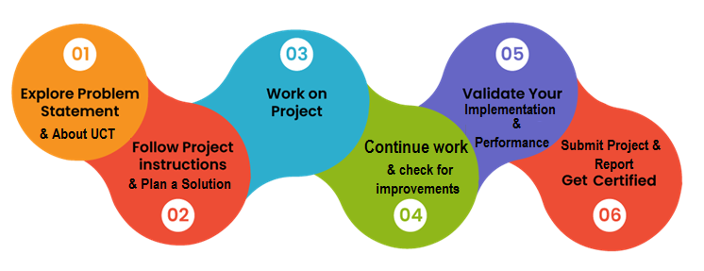
Your Learnings and overall experience.
Thank to all (with names), who have helped you directly or indirectly.
Your message to your juniors and peers.

Introduction

About UniConverge Technologies Pvt Ltd
A company established in 2013 and working in Digital Transformation domain and providing Industrial solutions with prime focus on sustainability and RoI.
For developing its products and solutions it is leveraging various Cutting Edge Technologies e.g. Internet of Things (IoT), Cyber Security, Cloud computing (AWS, Azure), Machine Learning, Communication Technologies (4G/5G/LoRaWAN), Java Full Stack, Python, Front end etc.
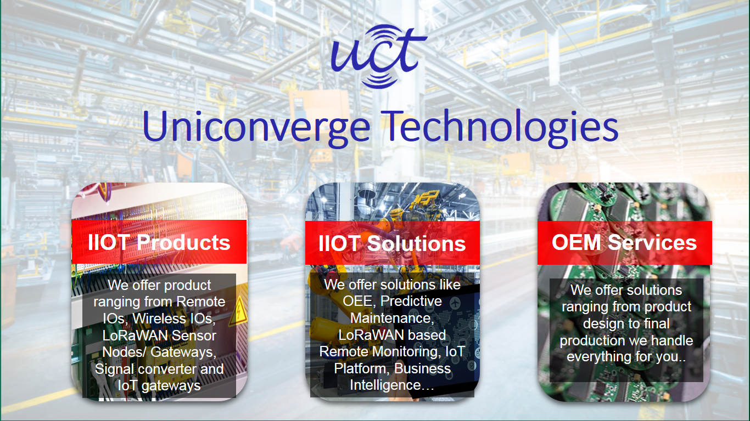
- UCT IoT Platform ()
UCT Insight is an IOT platform designed for quick deployment of IOT applications on the same time providing valuable “insight” for your process/business. It has been built in Java for backend and ReactJS for Front end. It has support for MySQL and various NoSql Databases.
- It enables device connectivity via industry standard IoT protocols - MQTT, CoAP, HTTP, Modbus TCP, OPC UA
- It supports both cloud and on-premises deployments.
It has features to
• Build Your own dashboard
• Analytics and Reporting
• Alert and Notification
• Integration with third party application(Power BI, SAP, ERP)
• Rule Engine

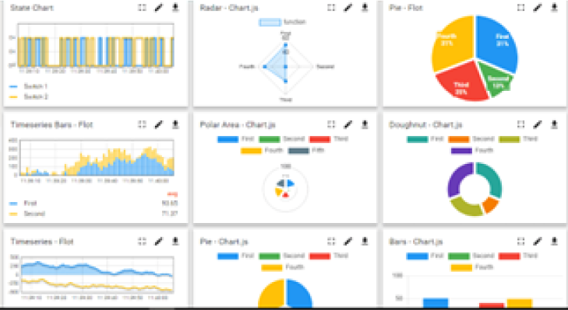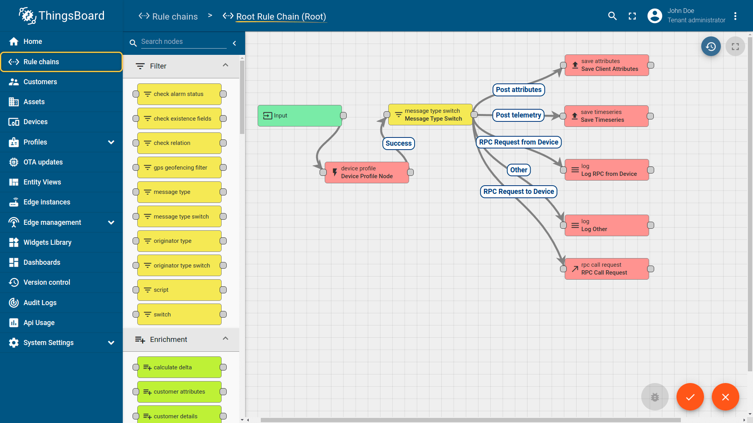

- Smart Factory Platform ()
Factory watch is a platform for smart factory needs.
It provides Users/ Factory
- with a scalable solution for their Production and asset monitoring
- OEE and predictive maintenance solution scaling up to digital twin for your assets.
- to unleased the true potential of the data that their machines are generating and helps to identify the KPIs and also improve them.
- A modular architecture that allows users to choose the service that they what to start and then can scale to more complex solutions as per their demands.
Its unique SaaS model helps users to save time, cost and money.
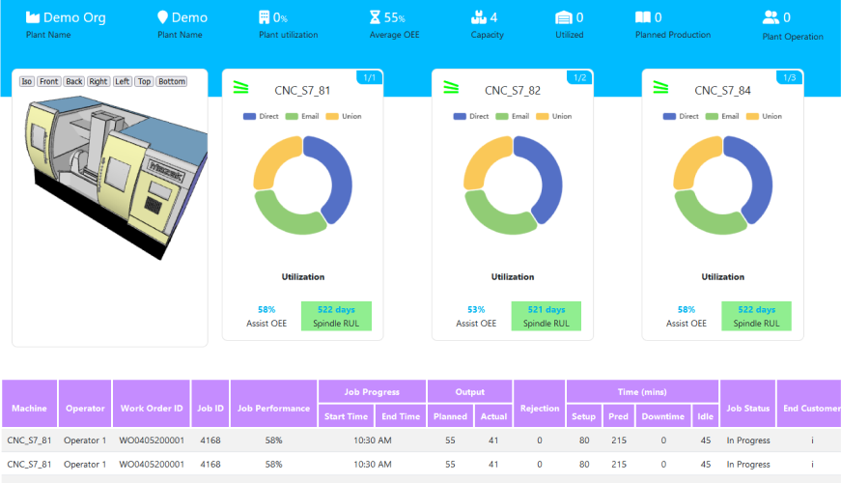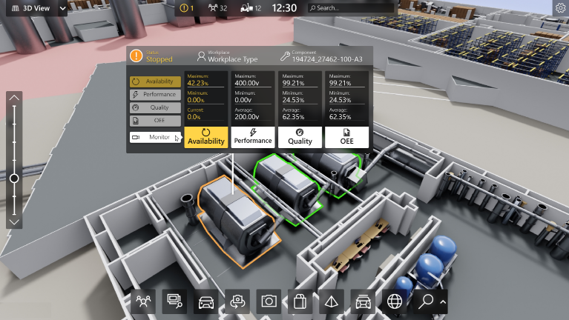

- 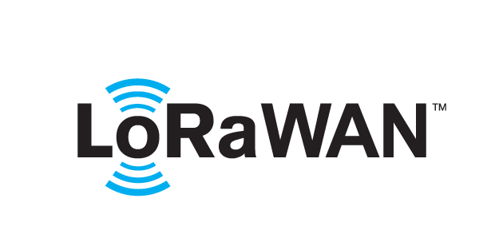 based Solution
UCT is one of the early adopters of LoRAWAN teschnology and providing solution in Agritech, Smart cities, Industrial Monitoring, Smart Street Light, Smart Water/ Gas/ Electricity metering solutions etc.
- Predictive Maintenance
UCT is providing Industrial Machine health monitoring and Predictive maintenance solution leveraging Embedded system, Industrial IoT and Machine Learning Technologies by finding Remaining useful life time of various Machines used in production process.
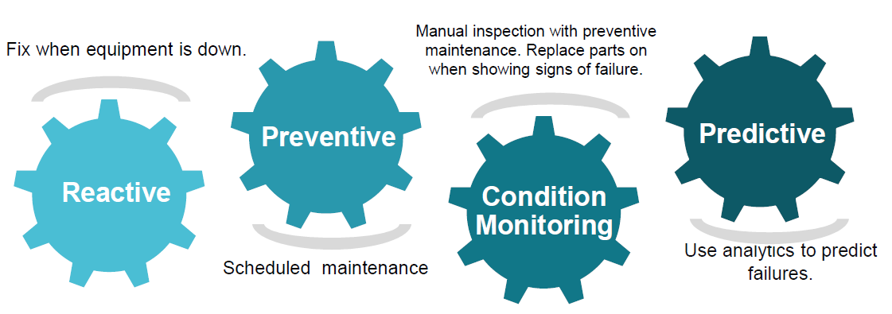

About upskill Campus (USC)
upskill Campus along with The IoT Academy and in association with Uniconverge technologies has facilitated the smooth execution of the complete internship process.
USC is a career development platform that delivers personalized executive coaching in a more affordable, scalable and measurable way.




Seeing need of upskilling in self paced manner along-with additional support services e.g. Internship, projects, interaction with Industry experts, Career growth Services
https://www.upskillcampus.com/
upSkill Campus aiming to upskill 1 million learners in next 5 year

The IoT Academy
The IoT academy is EdTech Division of UCT that is running long executive certification programs in collaboration with EICT Academy, IITK, IITR and IITG in multiple domains.

Objectives of this Internship program
The objective for this internship program was to
☛ get practical experience of working in the industry.
☛ to solve real world problems.
☛ to have improved job prospects.
☛ to have Improved understanding of our field and its applications.
☛ to have Personal growth like better communication and problem solving.

Reference
[1]
[2]
[3]

Glossary
Terms | Acronym

Problem Statement
Traffic congestion is a major challenge in modern smart cities. Increasing vehicle density often leads to delays, fuel wastage, environmental pollution, and inefficient transportation management. Traditional traffic management systems are reactive and struggle to predict future traffic conditions accurately.
The objective of this project is to develop a Machine Learning-based Traffic Forecasting System that can analyze historical traffic data and predict future traffic volume at different city junctions. Accurate traffic forecasting can help traffic authorities optimize signal timings, improve traffic flow, and support smart city planning initiatives.

Existing and Proposed solution

- Existing Solution
Traditional traffic monitoring systems rely on manual observations, fixed traffic rules, and basic statistical methods. While these approaches provide useful information, they often fail to capture complex traffic patterns and changing traffic conditions.
- Limitations of Existing Systems
- Limited prediction capability.
- Inability to analyze large-scale traffic datasets efficiently.
- Poor adaptability to changing traffic conditions.
- Dependence on manual monitoring and intervention.
- Proposed Solution
The proposed system uses Machine Learning techniques to forecast traffic volume using historical traffic data. The system extracts useful features such as year, month, day, hour, and junction information from traffic records.
Machine learning models including Random Forest Regressor and LightGBM Regressor are trained on historical traffic data to predict future vehicle counts.
- Value Addition
- Automated traffic prediction.
- Better understanding of traffic patterns.
- Data-driven traffic management.
- Support for smart city infrastructure planning.
- Improved traffic flow and congestion management.

Code submission (Github link)
Project9_smart-city-traffic-patterns/Forecasting of Smart city traffic patterns.py

Report submission (Github link) : first make placeholder, copy the link.

Proposed Design/ Model

The system follows the workflow shown below:
Traffic Dataset Collection
↓
Data Cleaning and Preprocessing
↓
Feature Extraction from DateTime
↓
Exploratory Data Analysis
↓
Model Training
↓
Model Evaluation
↓
Traffic Forecast Generation
- 5.1 High Level Diagram
Traffic Data
↓
Data Preprocessing
↓
Feature Engineering
↓
Machine Learning Models
↓
Traffic Volume Prediction
↓
Result Visualization
- 5.2 Low Level Diagram
- Load training and testing datasets.
- Remove duplicates and handle missing values.
- Convert DateTime into Year, Month, Day, and Hour features.
- Perform One-Hot Encoding for categorical variables.
- Split data into training and testing sets.
- Train Random Forest and LightGBM models.
- Evaluate model performance.
- Generate traffic predictions and visualizations.
- 5.3 Interfaces
The system provides:
- Traffic trend visualizations.
- Junction-wise traffic analysis.
- Correlation heatmaps.
- Predicted traffic volume outputs.
- Model performance comparison charts.

Performance Test

The system was evaluated using standard regression metrics to measure prediction performance.
- 6.1 Test Plan / Test Cases
- Load traffic dataset.
- Extract time-based features.
- Train machine learning models.
- Test models on unseen data.
- Compare actual and predicted traffic values.
- Evaluate model accuracy and error rates.
- 6.2 Test Procedure
- Import traffic datasets.
- Perform preprocessing and feature engineering.
- Split dataset into training and testing sets.
- Train Random Forest and LightGBM models.
- Generate predictions on test data.
- Calculate evaluation metrics.
- Compare model performance.
- 6.3 Performance Outcome
Performance was evaluated using:
- Mean Absolute Error (MAE)
- Mean Squared Error (MSE)
- R-Squared Score (R²)
The models successfully learned traffic patterns and generated reliable traffic forecasts. Random Forest and LightGBM demonstrated good prediction performance and effectively captured variations in vehicle counts across different junctions and time periods.

My learnings

Through this internship project, I gained practical experience in Data Science and Machine Learning.
Key learnings include:
- Working with real-world traffic datasets.
- Data cleaning and preprocessing techniques.
- Feature engineering from date and time data.
- Exploratory Data Analysis and visualization.
- Training and evaluating machine learning models.
- Understanding regression algorithms such as Random Forest and LightGBM.
- Using Python libraries including Pandas, NumPy, Matplotlib, Seaborn, and Scikit-Learn.
This project improved my analytical thinking, problem-solving ability, and practical implementation skills in Machine Learning.

Future work scope

The project can be enhanced further by incorporating additional data sources such as:
- Weather conditions
- Road construction information
- Public events and holidays
- Real-time traffic sensor data
- GPS-based vehicle tracking
Advanced techniques such as Deep Learning, LSTM Networks, and Real-Time Traffic Monitoring Systems can also be implemented to improve forecasting accuracy and support intelligent transportation systems for future smart cities.

