This project employs knowledge of convolution to sketch images.

**Convolution:**

Mathematically, it is defined as mathematical operation on two functions f and g to produce a third function (f*g) .It has multiple applications but the one I am interested in is image processing.

Consider an image in which its pixels are represented as 2D matrix and another 2D matrix as follows:

**Note**: The pixel values would be numbers in real life, alphabets are considered here for ease of explanation

|  |  |  |  |  |  |  |
| --- | --- | --- | --- | --- | --- | --- |
| a | b | c | d |  | w | x |
| e | f | g | h |  | y | z |
| i | j | k | l |  |  | b] |

a]

Upon convolution, the resultant matrix obtained would be (moving the b] matrix over a] and taking a weighted sum):

|  |  |  |
| --- | --- | --- |
| a*w+b*x+e*y+f*z | b*w+c*x+f*y+g*z | c*w+d*x+g*y+h*z |
| e*w+f*x+i*y+j*z | f*w+g*x+j*y+k*z | g*w+h*x+k*y+l*z |

This b] matrix is termed as kernel wrt image processing.

If you observe, we have used the next immediate neighbours (next row and next column) of the pixel but not the previous neighbours to it(previous row and previous column) **,** but the typical convolution operation considers the pixels surrounding the pixel in mind.

**The intuitive explanation**:

Consider the below kernel placed over the image as show below (x marks the pixel in mind)

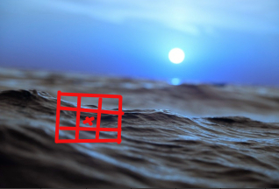

|  |  |  |
| --- | --- | --- |
| 1/9 | 1/9 | 1/9 |
| 1/9 | 1/9 | 1/9 |
| 1/9 | 1/9 | 1/9 |

If you observe, we are altering the pixel value with a value that is an average of its neighbors.

So, what does it do? It smoothens the image out by taking the sharpness of the pixel away by providing equal importance to its neighboring pixels( some free real philosophy )

Thus we obtain the below result :

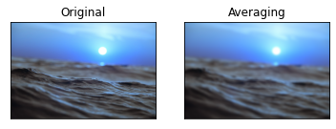

I leveraged this knowledge of convolution into my notebook.I was particularly interested in sketching the image (youtube inspired) and the kernel weights are very specific to the image. I hope the intuition helps in understanding the reason for kernel weights.