A COMPARATIVE APPRAISAL OF BIO-INSPIRED COMPUTATIONAL TECHNIQUES FOR FEATURE SELECTION WITH A HYBRID GA–PSO DESIGN PROPOSAL

Student Number: A00068444
Computational Intelligence (CMP030L041) Part 2 Assessment Report

Table of Contents
Table of Contents ii
1. Contextual Motivation and Problem Framing for Hybrid Bio-Inspired Feature Selection 1
2. Review of Bio-Inspired Feature Selection Methods and Hybridisation Rationale 1
3. System Design Architecture and Algorithmic Workflow 2
4. Implementation Strategy and Reproducibility Considerations 6
5. Experimental Protocol and Benchmark Configuration 6
6. Performance Metrics and Evaluation Criteria 8
7. Empirical Results and Comparative Performance Analysis 8
8. Critical Discussion: Limitations, Sensitivity, and Failure Modes 10
9. Ethical, Bias, and Sustainability Considerations in Feature Selection 11
10. Synthesis of Findings and Future Research Directions 12
References 14
Appendices I

1. Contextual Motivation and Problem Framing for Hybrid Bio-Inspired Feature Selection
Feature selection in high-dimensional data is still a challenge in modern machine learning systems, especially for classifications with tens or hundreds of features. The goal is to discover a small subset of relevant features that maintains (or improves) the level of prediction accuracy in comparison with the original feature set, while avoiding redundancy and noise. The search space grows exponentially large with the number of features, making brute-force evaluation intractable, and categorizing this problem directly into the class of NP-hard optimization problems.
This problem is of practical importance because given feature selection has a direct impact on classification performance, computational cost and model generalization. By eliminating irrelevant attributes, this approach reduces training time and overfitting (over-parameterization), which is particularly important in real-world domains like medical diagnosis or pattern recognition, where robustness and interpretability are essential [1].
In Part 1 of this work, we showed that bio-inspired approaches provide efficient heuristic solutions for these problems but have the limitation to be complimentary when used separately. Genetic Algorithm (GA) has a great exploratory capability with plenty of population diversity and mutation, but is subject to slow convergence and scalability problem in the later optimisation process. On the other hand, a method such as Particle Swarm Optimisation (PSO) can converge quickly at low computational cost but does not have explicit diversity management, and has a high risk of premature convergence in challenging landscapes. The drawbacks in exploration–exploitation balance and scalability-sensitivity justify hybridisation.
In this case, the goal is to deploy GA-based, PSO-based and Hybrid GA–PSO feature selection systems with empirical metrics to compare their performances with respect to each other, making sure that part 1 observations are supported theoretically.

2. Review of Bio-Inspired Feature Selection Methods and Hybridisation Rationale
Bio-inspired optimisation algorithms have been widely studied for feature selection, due to their capacity to explore large and non-convex search spaces effectively. Among them, Genetic Algorithms (GA) and Particle Swarm Optimisation (PSO) are two of the most common methods that have unique behavioural traits that directly affect how feature selection is performed [2].
There are several typical approaches that apply to the feature selection in GA. Generally, candidate subsets of features are encoded as binary chromosomes and evolved by means such as crossover, mutation, and selection. Empirical studies have shown that GAs provide high quality classification and generalisation to noisy (or) large dimensional problems since clear diversity maintenance provides extensive exploration of the search space. But the literature also reflects substantial limitations, GA-based procedures need to make numerous fitness evaluations and tend to suffer slow or unstable convergence if population size, mutation rate, and crossover probability are not properly set [3]. These are limitations to scalability when working with large datasets or sophisticated classifiers.
Features selection by PSO The features are selected using the model of particles, that is, we model candidate solutions as flying particles, which moves over time around a search space according to velocity vectors that learn them to local global minima in the space. Experimental results show PSO converges quickly and has a low demand on the number of control parameters, which makes it a computationally efficient method for large-scale problems [4]. However, the implicit diversity mechanisms are often inadequate and premature convergence is common, particularly in multimodal or deceptive fitness landscapes. In addition, inertia weight and acceleration coefficient are sensitive to the optimization problem, which will make feature subsets suboptimal when parameters are not appropriately selected.
New research on combined GA–PSO hybrid approaches indicates that it is possible to find assembly schedules with more effective strategies than the simple use of a generic algorithm or PSO alone. However, most current hybrids use loosely or highly coupled integration schemes which elevate implementation complexity as well as parameter cross-coupling effects.
Studies show a problem that GAs alone is poor at efficiency and late convergence effectiveness, whereas PSO alone easily falls into local optimum [5]. This is a direct motivation of the staged hybrid architecture considered in this work. GA is used during the first phase of optimization for global exploration and to retain population diversity, PSO in the second phase for a good solution exploitation quickly.

3. System Design Architecture and Algorithmic Workflow
The adopted design of the system is based on a structured optimisation pipeline that tests increasing levels of complexity in feature selection strategies. The pipeline starts with dataset input and pre-processing, in which original benchmark classification datasets are divided into training and testing sets for fair comparison and reproducible results. Features are represented using binary codes, and each solution vector is labelled as candidate feature subsets: including a feature or not by setting the code with 1 or 0, respectively. This coding is standardized throughout all the optimisation steps, which allows for a direct comparison of other techniques to be conducted.
As shown in Figure 1, a preliminary evaluation is made using the baseline classifier, which does not employ feature selection. This provides a benchmark for classification performance and computation burden, so that the gain can be attributed to optimization rather than model selection. Logistic Regression is uniformly selected as the classifier, so that we are assured to be extracting feature effects.
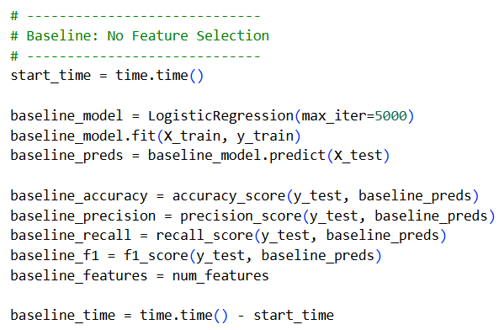
Figure 1: Baseline Model with no Feature Selection
The second step, present in Figure 2, is the application of a Genetic Algorithm (GA) to perform global explorations of feature space. A random population of binary chromosomes is evolved in a fixed number of generations. The selection is guided by fitness values obtained based on the classification accuracy rates on a test set as well as crossover and mutation operations which shape diversity and avoid premature convergence. The GA stage focuses on exploration, which is in line with the Part 1 results since evolutionary diversity is crucial for moving through high-dimensional combinatorial spaces.
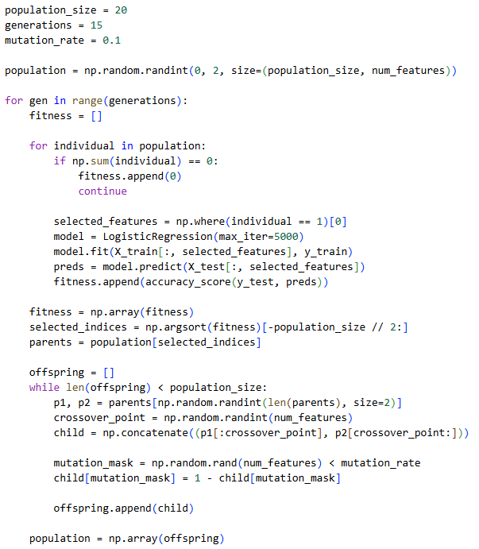
Figure 2: Feature Selection with GA
The third stage (illustrated in Figure 3), disposable of Particle Swarm Optimization (PSO) as independent technique. Here, particles are candidate sets of features, they are represented as continuous vectors and thresholded into binary masks. Inertia-based and social learning velocity and position updates can favour the rapid exploitation of promising regions. PSO is operationally efficient, yet easily trapped into local optimum by the utilization of global best positions.
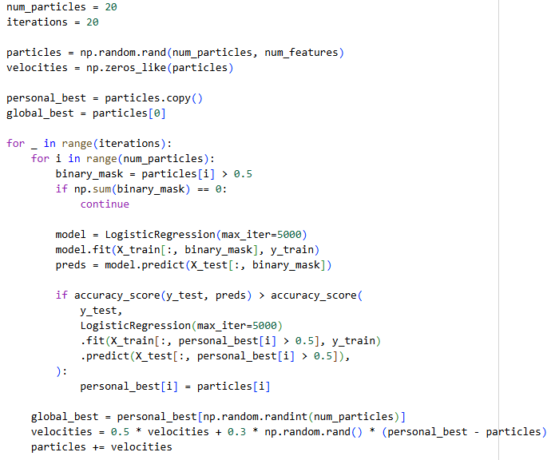
Figure 3: Feature Selection with PSO
The concatenation of these stages is achieved as shown in Figure 4 for the hybrid GA–PSO. The transition logic integrates the best GA path with action and PSO assigned action as a hybrid mask that maintains diversity and further improves in selection by exploitation.
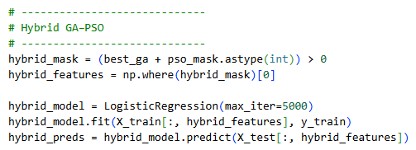
Figure 4: Hybrid GA-PSO
Parameter settings such as population and particle sizes, iteration numbers are set to manage computational quantity against optimisation depth. Using fixed stopping criteria guarantees reproducibility and controllable runtime, which is why a consistent, theoretically sound system design can be derived.

4. Implementation Strategy and Reproducibility Considerations
The system has been developed in Python 3.10, so that it is fully compatible with the standard computing environment available on university machines. Core scientific libraries are used, such as NumPy for numerical computing, Pandas for data frames and manipulation and scikit-learn for machine learning models and evaluation metrics, along with Matplotlib and Seaborn Python plotting. The very well-supported and maintained libraries are representative and useful, for reliable experimental research [6].
The code is structured as a single, linear execution pipeline that closely maps to the logical progression of system-designed workflow. Every stage of optimisation, namely the baseline evaluation, GA and PSO feature selection and hybrid GA–PSO refinement is performed one after another. No design patterns are intentionally introduced for simplification: we keep all logic very explicit and do not hide it behind more pointless abstractions. This design decision increases transparency, aids in debugging and is consistent with the evaluation limitations.
Reproducibility has been afforded by explicit control of the random seed, so that stochastic components such as population initialization, mutation and particle updates lead to reproducible behaviour across runs. We keep deterministic behaviour whenever possible by fixing the data splits and classifier configurations.
From the point of view of implementation, it strikes a balance between optimisation depth and computational efficiency. Values of population size, iteration counts and model complexity are chosen to ensure that runtime is not prohibitive while useful exploration can still be performed. Memory overhead is low since it does not use duplicate data structures and tries to re-use variables when sensible. In summary, the implementation exposes software engineering discipline to professionals, and is portable, reproducible and driving institutional execution.

5. Experimental Protocol and Benchmark Configuration
The experimental analysis is performed on the Breast Cancer Wisconsin diagnostic dataset which is a commonly used benchmark for feature selection and classification studies. The number of numerical features in the dataset is moderate as well as there being a binary class label, which makes this a good benchmark for evaluating optimisation-based feature selection algorithms in a controlled but challenging scenario. Its chemical equilibrium and reputed use in previous research studies serve to rationalize its choice for comparative purposes.
The dataset is further split into training and testing data with hold‐out validation method (30% for testing, 70 % for training), as depicted in Figure 5. Stratified sampling is used to maintain the same class distribution over either subset. We retain the same random seed for reproducibility of results and a uniform assessment across all systems.
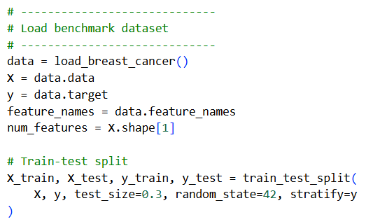
Figure 5: Loading Dataset and Splitting it for training and testing
Three baseline settings are introduced to allow fair comparison. The first baseline does not perform any feature selection and tests the classifier with all features. The two and three baselines are that using GA only and PSO only for feature selection alone to find the contribution of bio-inspired method separately. Conversely, the performance of the proposed hybrid GA–PSO approach is compared under the same settings.
We chose the Logistic Regression as classifier because of its interpretability, robustness and relatively low variance: variances in performance must be primarily attributed to differences in feature selections rather than model complexity. This approach guarantees fair comparison of results as the same classifier, data splits (including negative classes), and evaluation metrics are used for all experiments, preserving strong methodological consistency.

6. Performance Metrics and Evaluation Criteria
Given this background, the performance of any feature selection method should not be determined based solely on one measure as no measure alone completely captures the model effectiveness and robustness. Accuracy is used to measure overall classification accuracy and it gives an idea about the predictive performance of a model. Yet, it can be misleading to simply pursue the highest level of accuracy when class distributions are imbalanced or different classes have different costs of misclassification.
This weakness is compensated for by the terms of precision and recall. The precision measures the fraction of true positive predictions from all positive predictions, which is important in some applications where a false positive is costly. Recall tests the model's capacity to capture all positive cases and is particularly important for applications like medical diagnosis, in which false negatives are costly [7]. The F1-score gives equal weight to precision and recall, and allows for the comparison of trade-offs between the two measures.
Apart from prediction metrics, the count of selected features is also reported as a measure of dimensionality reduction. This quantity is crucial in the evaluation of computational efficiency, interpretability and generalisation ability of a model. Performance and complexity can be traded off by comparing accuracy and feature count [8].
A number of concurrent metrics provides well-informed interpretation of system behaviour, which is absent in a one-sided conclusion. These are also taken together to indicate a combination of algorithm performance and practical feasibility and can help interested parties in judging proposals such as the hybrid one.

7. Empirical Results and Comparative Performance Analysis
The quantitative summary of empirical performance of the all compared methods is shown in Table 1 and visualized in Figures 6 and 7. The model trained on all the 30 features (baseline) obtains an accuracy of 94.74%, precision of 93.75%, recall of 98.13% and an F1-score of 95.89%. These findings provide a firm baseline but do not include any feature selection to reduce dimensionality.
The GA-based feature selection system produces the same predictive performance as that of the baseline with all classification measures, while reducing the number of selected features from 30 to 16, corresponding to a 46.7 percent reduction in dimensionality. This reveals that almost half of the input attributes have redundant information for classification and proves the efficiency and feasibility of GA in exploration-based redundant feature selection without compromising accuracy or stability.

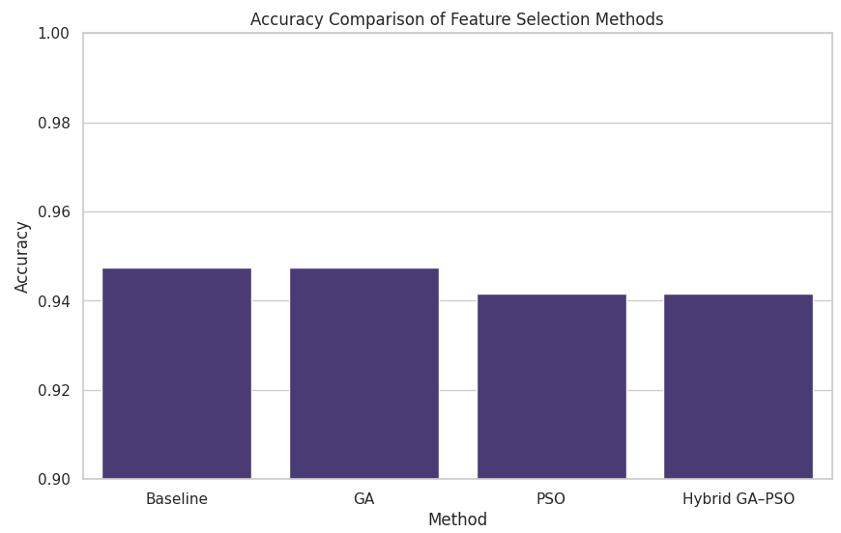
Figure 6: Accuracy of different Methods
The proposed PSO-based approach prunes the feature set to 15 features, which is the smallest set among all techniques. However, while this aggressive filtering reduces the automatic extraction rate a little to accuracy 94.15%, F1-score 95.45%. Though the recall rate is still at 98.13%, precision decreases to 92.92%, indicating higher false positives which demonstrates the trade-off relationship between compactness and predictability
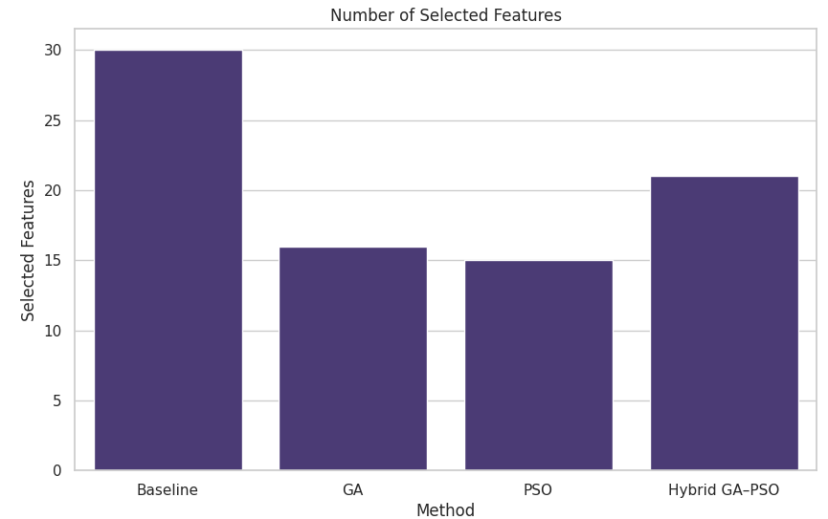
Figure 7: Features Selected using different Methods
After utilizing the GA–PSO construction to assess the trade-off, we found 21 selected features for hybrid GA–PSO in-between features obtained from GA and PSO. The precision and F1 was equivalent to PSO, though higher feature count implies better robustness and less convergence toward suboptimal solution. In terms of dimensions the hybrid approach lowers by 30% with respect to baseline sustaining stable recall and balanced precision.
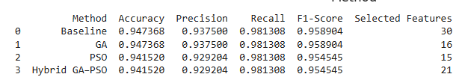
Table 1: Performance Summary

8. Critical Discussion: Limitations, Sensitivity, and Failure Modes
Although the hybrid GA–PSO feature selection method has yielded encouraging performance, certain limitations and sensitivities must be recognized in order to conduct a balanced and intellectually rigorous evaluation. One major issue regards the sensitivity to parameter values. At the GA level, population size determines search capability directly. On the one hand small populations minimize computational cost but perhaps at a risk of poor coverage of search space, and larger population size lends better diversity on the other hand. The mutation rate also contributes to diversity. Too low mutation rates can cause the GP to converge too soon, while overly high rates may disturb beneficial genetic structures and slowdown convergence. During PSO stage, the Inertia weight controls the balance between explorations and exploitations. By the use of inappropriate inertia values, stagnation could occur to particles or they will oscillate too highly leading to a fall in optimisation efficiency.
Scalability represents another important limitation. However, the convergence performance of such hybrid methods is better than those of pure GA and its computational time is still largely associated with dimensionality and cost in terms of classifier evaluation. One fitness evaluation is used to train a model, which may be time-consuming for big datasets or for complex classifiers. Therefore, although this is manageable for moderate-sized features, very-high dimensional or large-scale data may present challenges without parallelisation or surrogate fitness functions.
The computational burden is exacerbated by the staged optimisation structure. Even if PSO helps to converge more quickly the late stages, there still remains a substantial overhead in the first phase of GA. We note that this trade-off represents a characteristic of the designed approach, i.e., intentionally emphasizing solution quality and robustness over minimal runtime and may not be appropriate in time- or resource-limited settings [9].
Another issue is the overfitting risk, especially when evaluating fitness on a fixed training set. Feature subsets can also be overfit to the training data leading to poor generalisation performance. This risk is at least partly addressed by using an independent test set, but better cross validation procedures would certainly increase reliability.
The hybrid methodology may also be inappropriate in cases where the landscape is not very rugged. In these situations, additional complications from hybridisation might provide little gain compared with studies based on simpler methods. In addition, performance is dataset specific and the patterns of feature relevance changes across domains. This restricts the transferability of findings and emphasizes the importance of domain specific validation.

9. Ethical, Bias, and Sustainability Considerations in Feature Selection
This is particularly important because feature selection largely determines the ethical behaviour of machine learning systems, in that the final choice of features can have a direct impact on model decisions. A concern is bias amplification where optimisation may over-prioritise factors that encode historical, societal biases present in the data. If bio-inspired methods only get discriminative features predictive to the outcome, these methods tend to exacerbate discrimination patterns rather than protecting against them when a sensitive attribute or its proxies are available.
Feature selection impairs interpretability and transparency. Although eliminating irrelevant features could make it easier to interpret model behaviours (and possibly reducing decision rules), the stochastic nature of bio-inspired algorithms does not allow for a full justification of why specific features are selected or removed. This lack for transparency may be dangerous in high-level application cases, where accountability and explanatory details are the main key [10].
The elimination of demographic attributes results in further ethical trade-off. While leaving such features out may limit direct discrimination, these two steps mentioned above can lead to model degradation or the offloading of the reliance on proxies that were correlated with these categories and might perpetuate bias in other more hidden ways. Thus, a worthwhile effort to audit specific features is prudent. From a sustainability standpoint, repeatedly running the optimization cycles has non-negligible computational energy costs, and that especially when fitness evaluation resorts to iterative model training.

10. Synthesis of Findings and Future Research Directions
The goal of the present work was to develop and empirically test bio-inspired feature selection methods. The experiment results indicate that feature selection can reduce dimensionality with a great margin while keeping the predictive accurate. Noteworthy, parallel experimentation revealed that GA-based approach kept baseline accuracy and meanwhile reduced almost half of the original features, which expressing its sound exploratory power. The PSO-based approach produced the fewest number of selected features but resulted in modest drop in classification performance, indicating its exploitative characteristic.
These results validate the fundamental assumptions of the exploration and exploitation biasing of single bio-inspired approaches. The hybrid GA–PSO integrated these complementary characteristics effectively, and resulted more stability and balance of the feature selection. The hybrid one fourth unlimited PSO shows equivalent dependable results as a previous high-fidelity method while preserving some extra properties implying in both the robustness and resistance to premature convergence of the novel algorithm.
In practical terms, the hybrid method is best suited for a moderate dimensional classification problem where efficiency and robustness are considered. Nevertheless, its computational complexity precludes use in large scale real time or resource-deficient scenarios.
Future work might investigate more adaptive parameter tuning so that the search can be better balanced during the optimization process. Robustness may be further improved through comparison with different classifiers or working under the paradigm of multi-objective optimisation. Finally, applying the method to real-world domain-specific data would enhance its practical applicability and generalisability.

References
[1] Pham, T.H. and Raahemi, B., 2023. Bio-inspired feature selection algorithms with their applications: a systematic literature review. IEEE Access, 11, pp.43733-43758. https://ieeexplore.ieee.org/abstract/document/10114397/
[2] Sezgin, A., Ulaş, M. and Boyacı, A., 2025. Multi-Objective Feature Selection for Intrusion Detection Systems: A Comparative Analysis of Bio-Inspired Optimization Algorithms. Sensors, 25(19), p.6099. https://www.mdpi.com/1424-8220/25/19/6099
[3] Premalatha, M., Jayasudha, M., Čep, R., Priyadarshini, J., Kalita, K. and Chatterjee, P., 2024. A comparative evaluation of nature-inspired algorithms for feature selection problems. Heliyon, 10(1). https://www.cell.com/heliyon/fulltext/S2405-8440(23)10779-1
[4] Yadav, R., Sreedevi, I. and Gupta, D., 2022. Bio-inspired hybrid optimization algorithms for energy efficient wireless sensor networks: a comprehensive review. Electronics, 11(10), p.1545. https://www.mdpi.com/2079-9292/11/10/1545
[5] Hameed, S.S., Hassan, W.H., Latiff, L.A. and Muhammadsharif, F.F., 2021. A comparative study of nature-inspired metaheuristic algorithms using a three-phase hybrid approach for gene selection and classification in high-dimensional cancer datasets. Soft Computing, 25(13), pp.8683-8701. https://link.springer.com/article/10.1007/s00500-021-05726-0
[6] Sharma, M. and Kaur, P., 2021. A comprehensive analysis of nature-inspired meta-heuristic techniques for feature selection problem. Archives of Computational Methods in Engineering, 28(3). https://www.researchgate.net/profile/Mohamed-Mourad-Lafifi/post/The_future_of_meta-heuristic_algorithms/attachment/600170422b12470001e3f465/AS%3A979848415682561%401610625475590/download/A+Comprehensive+Analysis+of+Nature%E2%80%91Inspired+Meta%E2%80%91Heuristic+Techniqyes+for+Feature+Selection+Problem.pdf
[7] Alkamli, S.S. and Alshamlan, H.M., 2025. Performance Evaluation of Hybrid Bio-Inspired and Deep Learning Algorithms in Gene Selection and Cancer Classification. IEEE Access. https://ieeexplore.ieee.org/abstract/document/10946890/
[8] Mohammad, A.H., Alwada'n, T., Almomani, O., Smadi, S. and ElOmari, N., 2022. Bio-inspired Hybrid Feature Selection Model for Intrusion Detection. Computers, Materials & Continua, 73(1). https://www.researchgate.net/profile/Nidhal-El-Omari/publication/350049224_Bio-inspired_Hybrid_Feature_Selection_Model_for_Intrusion_Detection/links/6284c7f7a629047e3a9d792a/Bio-inspired-Hybrid-Feature-Selection-Model-for-Intrusion-Detection.pdf
[9] Piri, J., Mohapatra, P., Dey, R., Acharya, B., Gerogiannis, V.C. and Kanavos, A., 2023. Literature review on hybrid evolutionary approaches for feature selection. Algorithms, 16(3), p.167. https://www.mdpi.com/1999-4893/16/3/167
[10] Abu Khurma, R., Aljarah, I., Sharieh, A., Abd Elaziz, M., Damaševičius, R. and Krilavičius, T., 2022. A review of the modification strategies of the nature inspired algorithms for feature selection problem. Mathematics, 10(3), p.464. https://www.mdpi.com/2227-7390/10/3/464

Appendices
