Contents

IETE: 2

EVENTS LIST 3

1.REPUBLIC DAY 5

1.1 POSTER 5

1.2 PARTICIPANTS 6

1.3 REPORT 7

1.4 PHOTOS 8

2.MATH DAY 9

2.1 POSTER 9

2.2 PARTICIPANTS 10

2.3. REPORT 11

2.4 PHOTOS 13

3.TEACHERS DAY 14

3.1 POSTER 14

3.2 PARTICIPANTS 15

3.3 REPORT 16

3.4 PHOTOS 17

# IETE:

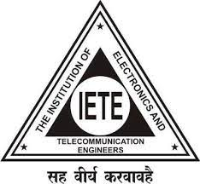The Institution of Electronics and Telecommunication Engineers (IETE) is India's leading recognized professional society devoted to the advancement of Science and Technology of Electronics, Telecommunication & IT. The objectives of IETE focus on advancing electro-technology. The IETE conducts and sponsors technical meetings, conferences, symposia, and exhibitions all over India, publishes technical journals and provides continuing education as well as career advancement opportunities to its members. The IETE focuses on advancement of the Science and Technology of Electronics, Telecommunication, Computers, Information Technology and related areas. It promotes and conducts basic Electronics and Telecommunication Engineering and continuing technical education programs on these subjects for human resource development. Towards this end the Institution promotes and conducts basic engineering and continuing technical education programs for human resource development.

IETE STUDENT FORUM was established at VNR VJIET in the year 2010 for the improvement of engineers in the field of electronics, telecommunications and computers which have been improving gradually in the number of registrations every year. Now we have members from all the four years of B.Tech. With the immense hard work of the Executive Committee, we are able to train our members in various skills and are also successful in organizing various events. Students who are part of IETE get opportunities to participate in events and attend events that are taking place across the country. Benefits of IETE Membership helps the students in finding a mentor, to attend free webinars, will have access to special panels at conferences and also have networking opportunities.

On an average of 200 students and faculty from the department are continuously engaged in IETE activities and also have memberships.

# EVENTS LIST

|  |  |
| --- | --- |
| Academic Year | 2018-2019 |
| Professional Chapter | Student Branch |
| Events | Republic day parade 2018  Math Day  Teachers Day |
|  |  |
|  |  |

Professional Chapter- IETE Student Branch(2018-2019)

|  |  |  |  |  |
| --- | --- | --- | --- | --- |
| S.No | Name of the event | Date | Resource Person Name & Designation | No. of students benefited |
| 1 | Republic Day | 26-01-2018 | Mr. Abhinav IETE Member. | 100 |
| 2 | Math day | 22-12-2018 | Mr.Dr.T.Jayashree  Professor & HOD | 105 |
| 3 | Teacher’s day | 12-12-2018 | Mr. Chandu Mysakshi, Student Ece, VNRVJIET | 50 |

# 1.REPUBLIC DAY

## 1.1 POSTER

## 

|  |  |  |
| --- | --- | --- |
| S.No | Name | Roll number |
| 1 | VISHAL | 18071A0234 |
| 2 | KIRAN | 18071A0353 |
| 3 | PRAVALIKA | 18071A0421 |
| 4 | SATYA | 18071A0433 |
| 5 | RITHIK | 18071A0344 |
| 6 | SREERAM | 18071A0123 |
| 7 | HARISH | 18071A0565 |
| 8 | HARSHITHA | 18071A05G5 |
| 9 | PRANAV | 18071A0421 |
| 10 | LIKITHA | 18071A0422 |
| 11 | GEETHIKA | 18071A0334 |
| 12 | RAMESH | 18071A1543 |
| 13 | NIKESH | 18071A1054 |
| 14 | TARUN | 18071A1001 |
| 15 | KALYANI | 18071A1004 |
| 16 | KRUTHIKA | 18071A0334 |
| 17 | RISHITHA | 18071A0533 |
| 18 | TEJA | 18075A0142 |
| 19 | AKSHAYA | 18071A05G1 |

## 1.2 PARTICIPANTS

## 

## 1.3 REPORT

On January 26, in honour of Republic Day, the IETE Student Forum-VNR VJIET, in partnership with student chapters, clubs, and students from all branches, planned a parade to reflect societal challenges in India and to highlight the creativity and brilliance of today's youth.

All of the student chapters, clubs, and individuals shared their opinions on social issues and emphasised the obligations all citizens have to the country. The "TRIBUTE TO INDIAN ARMY" topic was chosen by the IETE Student Chapter as a very significant societal concern. All of the IETE Team members marched with slogans, displayed information on banners and placards, and painted on charts to share their opinions and ideas. The faculty coordinators served as the team's leaders.

A soldier is hurt in battle for every breath we take. Ambushes claim the lives of hundreds of soldiers, and we are completely unaware of it. Though we are unaware of it, it is the degree of their significance in our lives similar to breathing. The stories of extraordinary bravery displayed by our Army and internal security forces in the face of terror have come to light, demonstrating that despite the efforts of anti-elements to undermine the peace and security that currently exists, human nobility, spirit, and bravery will always triumph over it and shine through the smallest gaps to illuminate the world.

If you idolise a cricket player or a Bollywood star, stop for a moment and consider the thousands of border residents who are far more deserving of your worship. We must thank them for their sacrifice and ensure that their deaths are either forgotten or ignored.

## 1.4PHOTOS

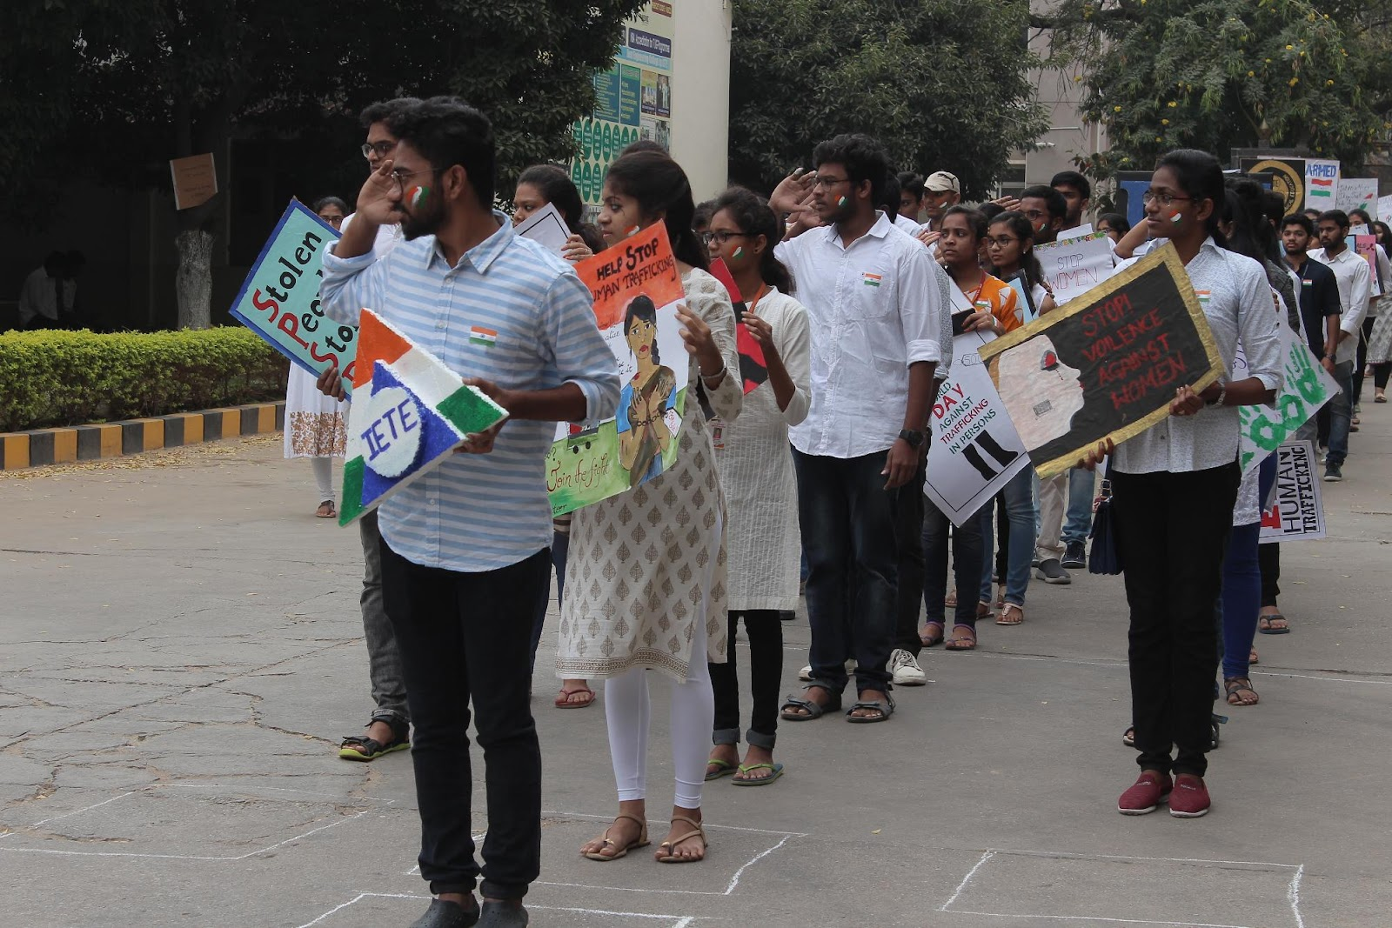

# 2.MATH DAY

## 2.1 POSTER

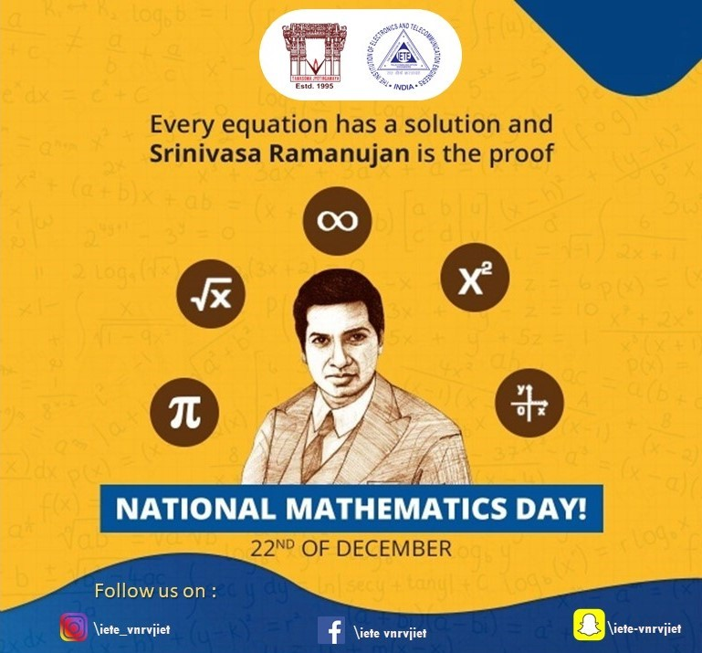

## 2.2 PARTICIPANTS

|  |  |  |
| --- | --- | --- |
| S.No | Name | Roll number |
| 1 | VISHAL | 18071A0234 |
| 2 | KIRAN | 18071A0353 |
| 3 | PRAVALIKA | 18071A0421 |
| 4 | SATYA | 18071A0433 |
| 5 | RITHIK | 18071A0344 |
| 6 | SREERAM | 18071A0123 |
| 7 | HARISH | 18071A0565 |
| 8 | HARSHITHA | 18071A05G5 |
| 9 | PRANAV | 18071A0421 |
| 10 | LIKITHA | 18071A0422 |
| 11 | GEETHIKA | 18071A0334 |
| 12 | RAMESH | 18071A1543 |
| 13 | NIKESH | 18071A1054 |
| 14 | TARUN | 18071A1001 |
| 15 | KALYANI | 18071A1004 |
| 16 | KRUTHIKA | 18071A0334 |
| 17 | RISHITHA | 18071A0533 |
| 18 | TEJA | 18075A0142 |
| 19 | AKSHAYA | 18071A05G1 |

## 2.3.REPORT

On December 22, 2018, Team IETE celebrated National Mathematics Day in conjunction with the Health and Safety department.

The primary goals of the celebration were to honour Sir Ramanujam on his birthday and to help kids understand how important mathematics is to every single person's everyday existence.A diya was lit by Dr.Jayasree mam, HOD of H&S Department, to commemorate the birthday of Sir Ramanujam to kick off the celebration.

Consequently, there were two events.

EVENT1: Presentation on the Importance of Mathematics in Engineering

The students were first instructed to prepare a poster and four slides for their presentation. Participants were already instructed to choose a math-related application. Each group had three members of their own choosing, and practically everyone gave a well-done presentation of a really fascinating and varied application that is actually quite valuable but is still little recognised. A total of 30 students representing various branches took part in the activity.

The judges gave instructions to everyone once the presentations were over outlining what should happen next.

EVENT 2: A quiz contest

There were three rounds total.

First round: Each participant was placed in a team of two, and a series of standard math problems were presented. The team that earned the highest marks in a reasonable amount of time—10 minutes—has been recognised. Four elite teams were chosen for the second round.

Second round: Equation spinner. One team member was blindfolded, and a number was revealed; the player's task was to create an equation to reveal the number as the solution. A stack of cups with some numbers and operators inscribed on them are being held by the individual who has their eyes covered. The other person instructs the person who is blindfolded to rotate their glasses in order to obtain the proper equation.

Three teams that performed better were chosen for the final round.

Third round: MARSH MELLOW REPLICA

A polygon, quadrilateral, or other shape was displayed for the participants to recreate using marsh mellows. The winning team was the one who completed the task quickly and correctly.

Padma Sai and Chenna Keshav Sir provided advice and ideas as the event came to a close. The pupils were inspired by this and received understanding about the value of mathematics for engineers.

## 2.4 PHOTOS

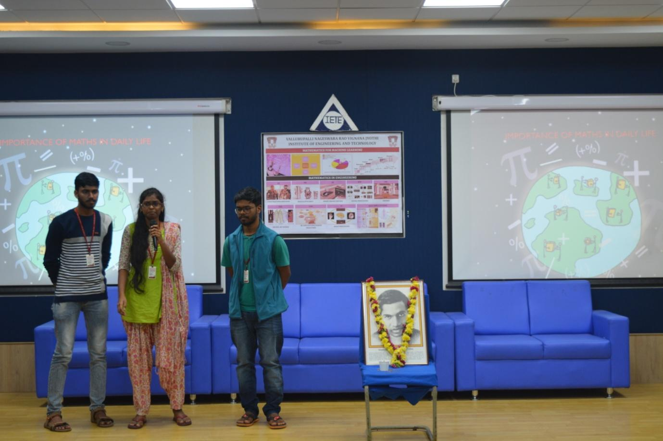

# 3.TEACHER’S DAY

## 3.1 POSTER

## 3.2 PARTICIPANTS

|  |  |
| --- | --- |
| NAME | Roll Numbers |
| Sumanth | 17071A04M9 |
| Shresta | 17071A04I8 |
| Pavani Rao | 17071A0485 |
| Vaishnavi | 17071A0414 |
| Sai Eeshwar | 17071A04M0 |
| Laxmi Narasimha | 17071A04L4 |
| Gayatri | 17071A04L5 |
| Chandana | 17071A04O0 |
| Geetha | 17071A04I7 |

## 3.3 REPORT

December 12, 2018: Teachers Day is a special occasion for us to express our gratitude to teachers. It ceremonies to honour them for their outstanding accomplishments could also be included in a particular line of work. The IETE team celebrated Teachers' Day on September 5, 2017 a gift of plants to the dean, coordinator, and the entire ECE faculty prestigious principal.We should always be grateful to our teachers for their valuable time because they are so patient and helpful.

## 3.4 PHOTOS

