Contents

IETE: 2

COUNCIL MEMBERS (2019 -2020) 3

EVENTS LIST 4

1.TECHVISION 5

1.1 POSTER 5

1.2 PARTICIPANTS 6

1.3 REPORT 7

1.4 PHOTOS 8

2.MATH DAY 9

2.1 POSTER 9

2.2 PARTICIPANTS 10

2.3 REPORT 11

2.4 PHOTOS 16

# IETE:

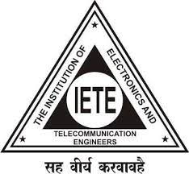The Institution of Electronics and Telecommunication Engineers (IETE) is India's leading recognized professional society devoted to the advancement of Science and Technology of Electronics, Telecommunication & IT. The objectives of IETE focus on advancing electro-technology. The IETE conducts and sponsors technical meetings, conferences, symposia, and exhibitions all over India, publishes technical journals and provides continuing education as well as career advancement opportunities to its members. The IETE focuses on advancement of the Science and Technology of Electronics, Telecommunication, Computers, Information Technology and related areas. It promotes and conducts basic Electronics and Telecommunication Engineering and continuing technical education programs on these subjects for human resource development. Towards this end the Institution promotes and conducts basic engineering and continuing technical education programs for human resource development.

IETE STUDENT FORUM was established at VNR VJIET in the year 2010 for the improvement of engineers in the field of electronics, telecommunications and computers which have been improving gradually in the number of registrations every year. Now we have members from all the four years of B.Tech. With the immense hard work of the Executive Committee, we are able to train our members in various skills and are also successful in organizing various events. Students who are part of IETE get opportunities to participate in events and attend events that are taking place across the country. Benefits of IETE Membership helps the students in finding a mentor, to attend free webinars, will have access to special panels at conferences and also have networking opportunities.

On an average of 200 students and faculty from the department are continuously engaged in IETE activities and also have memberships.

# COUNCIL MEMBERS (2019 -2020)

|  |  |  |  |
| --- | --- | --- | --- |
| NAME | YEAR | DESIGNATION | Roll Numbers |
| Chandu Mysakshi | IV | Chairman | 16071A04G2 |
| Ravi Chandra.M | IV | General Secretary | 16071A04F5 |
| Akhil Patel.K | IV | President | 16071A04E4 |
| Shiva Sai.M | IV | Treasurer | 16071A04G1 |
| Pavan.M | IV | Event Head | 16071A04H2 |
| Srininvas.L | IV | Inventory Head | 16071A04F4 |
| Chaitanya Krishna | IV | Tech Head | 16071A04G6 |
| Sri Laxmi.M | IV | Student Coordinator | 16071A04F8 |

# EVENTS LIST

|  |  |
| --- | --- |
| Academic Year | 2019-2020 |
| Professional Chapter | IETE Student Branch |
| Events | Mathematics day celebration |
|  | Techvison |
|  |  |
|  |  |

Professional Chapter- IETE Student Branch (2019-2020)

|  |  |  |  |  |
| --- | --- | --- | --- | --- |
| S.No | Name of the event | Date | Resource Person Name & Designation | No. of students benefited |
| 1 | Techvision | 31-01-2019 | Mr. sumanth IETE Member. | 100 |
| 2 | Math day | 22-12-2020 | Mr.Dr.T.Jayashree  Professor & HOD | 105 |

# 1.TECHVISION

## 1.1 POSTER

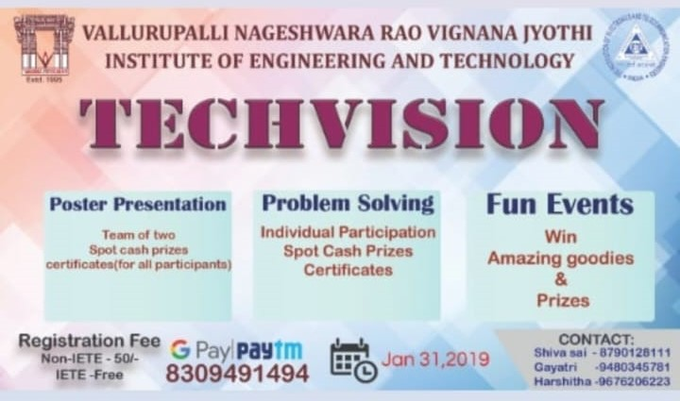

## 1.2 PARTICIPANTS

|  |  |  |
| --- | --- | --- |
| S.No | Name | Roll number |
| 1 | RISHI | 17071A0232 |
| 2 | PRAVEEN | 18071A0454 |
| 3 | HITESH | 17071A0123 |
| 4 | RAJKUMAR | 17071A1001 |
| 5 | ANISH | 18071A0144 |
| 6 | GOPAL | 18071A0141 |
| 7 | SUHAS | 17071A0111 |
| 8 | HARSHA | 18071A04M1 |
| 9 | SAKSHI | 17071A0451 |
| 10 | SANDEEP | 18071A0120 |
| 11 | HARHSA | 17071A0553 |
| 12 | PRASHANT | 17071A1521 |
| 13 | NITHESH | 18071A1042 |
| 14 | BHANU | 17071A1009 |
| 15 | SRISTI | 17071A0341 |
| 16 | BHARATH | 18071A0424 |
| 17 | UDAY | 18071A0333 |
| 18 | BHUVAN | 17071A0141 |
| 19 | ROHITH | 18071A05F6 |
| 20 | AARTHI | 18071A0413 |
| 21 | DISHA | 18071A0114 |
| 22 | SOWMYA | 17071A0152 |
| 23 | TANUJA | 17071A1002 |
| 24 | ANANYA | 18071A0563 |
| 25 | MITHUN | 18075A0144 |
| 26 | RITHVIK | 18071A0134 |
| 27 | VARUN | 17071A1021 |
| 28 | SURAJ | 17071A0413 |
| 29 | AVINASH | 17071A0211 |
| 30 | SRAVANI | 17071A0302 |

## 1.3 REPORT

Team IETE conducted a quiz on 31st January 2019to help students develop and improve good qualities like communication, interaction, etc. The main motto of the event was to interact with the freshmen and to break the ice. The event lasted for 2 hours. The technical presentation and the event solutions encouraged the students to develop different qualities like time management, communication skills, and content delivery and mainly overcome stage fear.

The event started with a lecture given by Dr.Y.Padma Sai, Head of the Department of the Ece branch. The lecture was about the growth of the electronic department and its impact on the future. It lasted for half an hour. The lecture was followed by the start of the event

First, the students were informed to get a single slide or poster regarding the topic they are presenting. Participants were already told to select any current trending technologies or technical related topics. Every group consisted of 2 people of their own choice and almost everyone presented very interesting and different topics very well which are truly very useful and still not known by everyone.

With the completion of technical presentations everyone were guided by the judges regarding the things that to be followed in a technical presentation. It was followed by second event problem-solutions. Everyone has come up with great ideas which are really very useful to solve many problems in our society in many ways both technically and socially.

The event ended with guidance and suggestions regarding different domains. With this, the students were motivated, gained knowledge and experienced about different.

## 1.4 PHOTOS

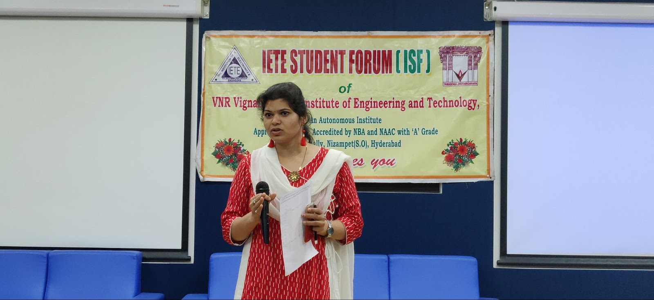

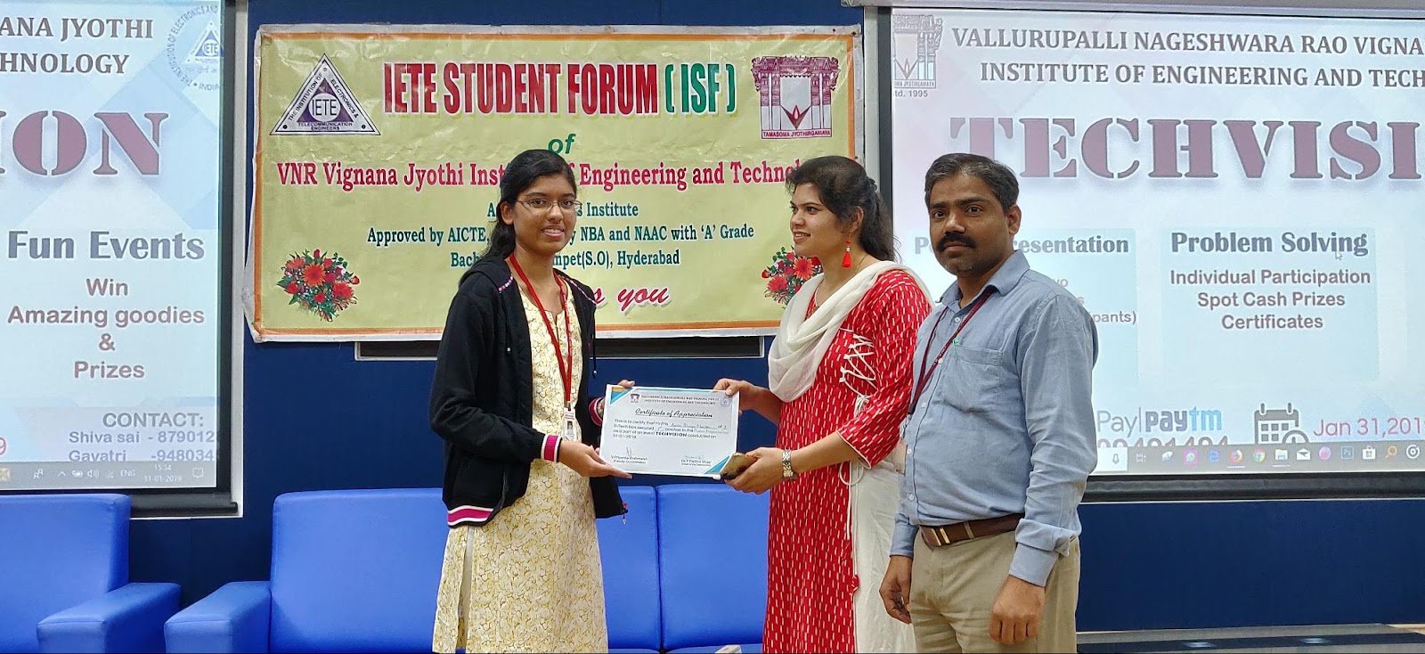

# 

# 2.MATH DAY

## 2.1 POSTER

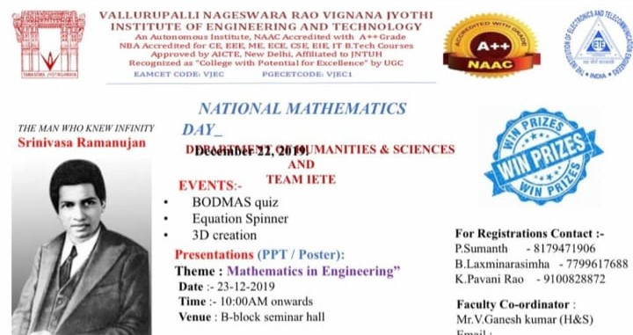

## 2.2 PARTICIPANTS

|  |  |  |
| --- | --- | --- |
| S.NO | NAME | ROLL NUMBER |
| 1 | RISHI | 17071A0232 |
| 2 | SREERAM | 18071A05G4 |
| 3 | SAHITI | 18071A0548 |
| 4 | GREESHMA | 17071A1001 |
| 5 | SAI RAM | 18071A0144 |
| 6 | VYBHAV | 18071A0141 |
| 7 | LOHITH | 17071A0111 |
| 8 | ADITYA | 18071A0475 |
| 9 | ROHIT | 18071A0465 |
| 10 | GEETHIKA | 18071A0576 |
| 11 | SUJITH | 18071A04P1 |
| 12 | PRASHANTH | 18071A04Q9 |
| 13 | PRASANNA | 18071A04N2 |
| 14 | VENKAT SAI | 18071A05H9 |
| 15 | VISHNU | 18071A0540 |
| 16 | AHMED | 18071A05F4 |
| 17 | LIKITHA | 18071A0333 |
| 18 | ANESH | 17071A0141 |
| 19 | PRANITHA | 18071A0582 |
| 20 | AARTHI | 18071A0413 |
| 21 | DISHA | 18071A0114 |
| 22 | SOWMYA | 17071A0152 |
| 23 | DEEPAK | 17071A1012 |
| 24 | ANANYA | 18071A0563 |
| 25 | ROHAN | 18075A0234 |
| 26 | ABHIRAM | 17071A0244 |
| 27 | VARUN | 17071A1021 |
| 28 | KIRAN | 18071A0421 |
| 29 | MOHAN | 18071A0242 |

## 2.3 REPORT

On NATIONAL MATHEMATICS DAY Team IETE in collaboration with H&S department celebrated it on 23rd December 2019.The main motto of the event was to celebrate Sir Ramanujan’s birthday and make students realise the practical and daily life application of Mathematics In each and everyone's life.  The event started by remembering the birthday of sir Ramanujan’s birthday and a diya was lighted by the Sirisha mam, Faculty of H&S Department. Thus, two events were conducted.

EVENT 1: Presentation on the topic: Importance of Mathematics in Engineering.

First, the students were informed to get four slides and a poster regarding the topic they are presenting. Participants were already told to select any application related to math. Every group consisted of 3people of their own choice and almost everyone presented very interesting and different applications very well which are truly very useful and still not known by many. Around 30 students from different branches participated in the event.

The following were the participants of ppt presentations: -

1.Sreeram Koushik- 18071A05G4 Koushal. Sreeram@gmail.com

2.Sahiti Vesang- 18071A0548 sahitiv78789@gmail.com

Their presentation was about importance of mathematics in engineering like its applications in every branch of detailly-In CSE we use matrices, In ECE we use Laplace and Fourier transform, In CIVIL we use calculus and concluded by stating "today in this merge of technology trend to run behind it but often forget the beauty of mathematics behind it's creation. They also presented about the contributions of Dr. Srinivasa Ramanujan and Shakuntala Devi towards mathematics.

3.Sri Aditya - 18071A0475  gsriaditya@gmail.com

4.Badri Rohit -   18071A0465 rohithbadri04@gmail.com

MOBIUS STRIP:  Their presentation was about a mathematical property of being unorientable that is Mobius strip. They stated that about its advantages, disadvantages and its area of applications as follows

a.It is a form of infinite loop

b.It is used to transform points

4.Greeshma Nethrika, Likhitha Reddy

They presented about the importance of learning mathematics practically and also it's important in different fields and branches of engineering Being Engineers we realised the importance of the math to break the complexity of the problem and to create the better world

5.Bhavani ,Priyanka Varma, Yashswee

i.How the math is involved in the image processing

6.Geethika 18071A0576, Pranitha -18071A0582

They gave an introduction about mathematics in engineering and and stated that Engineering Mathematics is the branch where we apply its techniques and methods in the field of industries and engineering. Also about different applications of maths in engineering. They also gave a brief note on the mathematicians who played major role.

7.Sujith Simha 18071A04P1 ECE

Prashanth 18071A04Q9 prashanthveeraboina111@gmail.com

Prasanna 18071A04N2 prasanna6401@gmail.com

The presentation comprised of how math is applied in the solving mystery case using Differential equations in different fields of engineering.

8.Venkat Sai Suchandra18071A05H9 vssvemuri@gmail.com

9.Vishnu Vardhan Reddy 18071A0540 vishureddynoni11@gmail.com

10.Mohammed Ahmed Khan 18071A05F4 mak8135@gmail.com

i.Math plays an important in a human life it’s not just a topic in school or college it is a simple part of the humans life from the start day of life to the end day of life everywhere math is involved in life

ii.Relation algebra in relation database, Boolean algebra in Logic gates

With the completion of presentations everyone was guided by the judges regarding the things that to be followed after presentation.

The prize winners were awarded by HOD OF ECE Padma Sai mam and Director in technology and advancement DR. CHENNAKESHAV RAO sir.

WINNERS OF PPT PRESENTATIONS

1)Greeshma nethrika, Likitha Reddy EIE 3RD YR

2)Sai Suchandra, Vishnu vardhan, Mohammad Ahmed khan CSE 3RD YR.

EVENT 2: QUIZ COMPETITION:

It comprised of 3 rounds.

1st round: All the participants were divided into teams of 2 and a set of typical maths questions were displayed. A time limit of 10 minutes was given the team which scored maximum marks in a comparatively less time has been awarded. 4 top teams were selected to the second round

2nd round: Equation spinner: There were two players in the team in which one was blind folded and a number was displayed with which he has to form an equation to get that number as the solution. The person who is blind folded holds a stack of cups in which some numbers and operators were written. The other person tells the blind folded one accordingly to spin the glasses to get the correct equation

Three teams who is preformed faster were selected to the last round.

3rd round: MARSH MELLOW REPLICA: A polygon, quadrilateral or some kind of shaped were displayed from which the participants have to make a replica of it using marsh mellows. Finally, the team which has done it correct and fast was awarded.

WINNERS FOR QUIZ EVENT

1)Vybhav,Sai ram 3rd yr ECE

2)Lohith, Anesh 3rd yr IT

The event ended with guidance’s and suggestions given by Padma Sai and Chenna Keshav sir. With this, the students were motivated, gained knowledge and experienced about importance of Mathematics in Engineers.

Finally all the faculty of HUMANITIES AND SCIENCE DEPT. were gifted by the students for their immense love and support.

## 2.4 PHOTOS

