**Technologies**

**Spring Boot, Maven, H2, Postman**

Below endpoint will create sample data in H2.

<http://localhost:8080/createTestData>

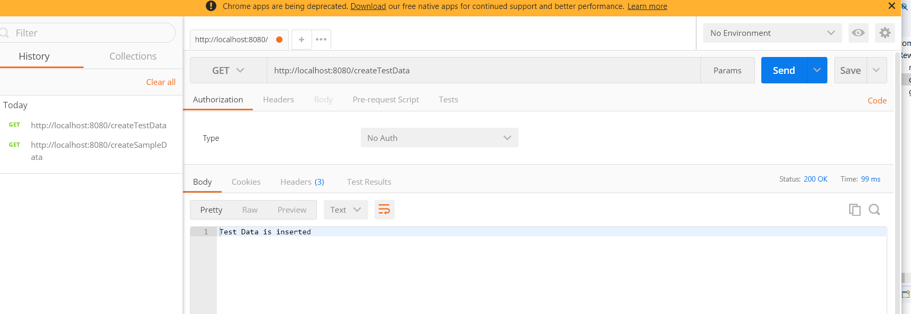

Get the customer total earning points and monthly wise total earning points

<http://localhost:8080/getRewards?name=customer1>

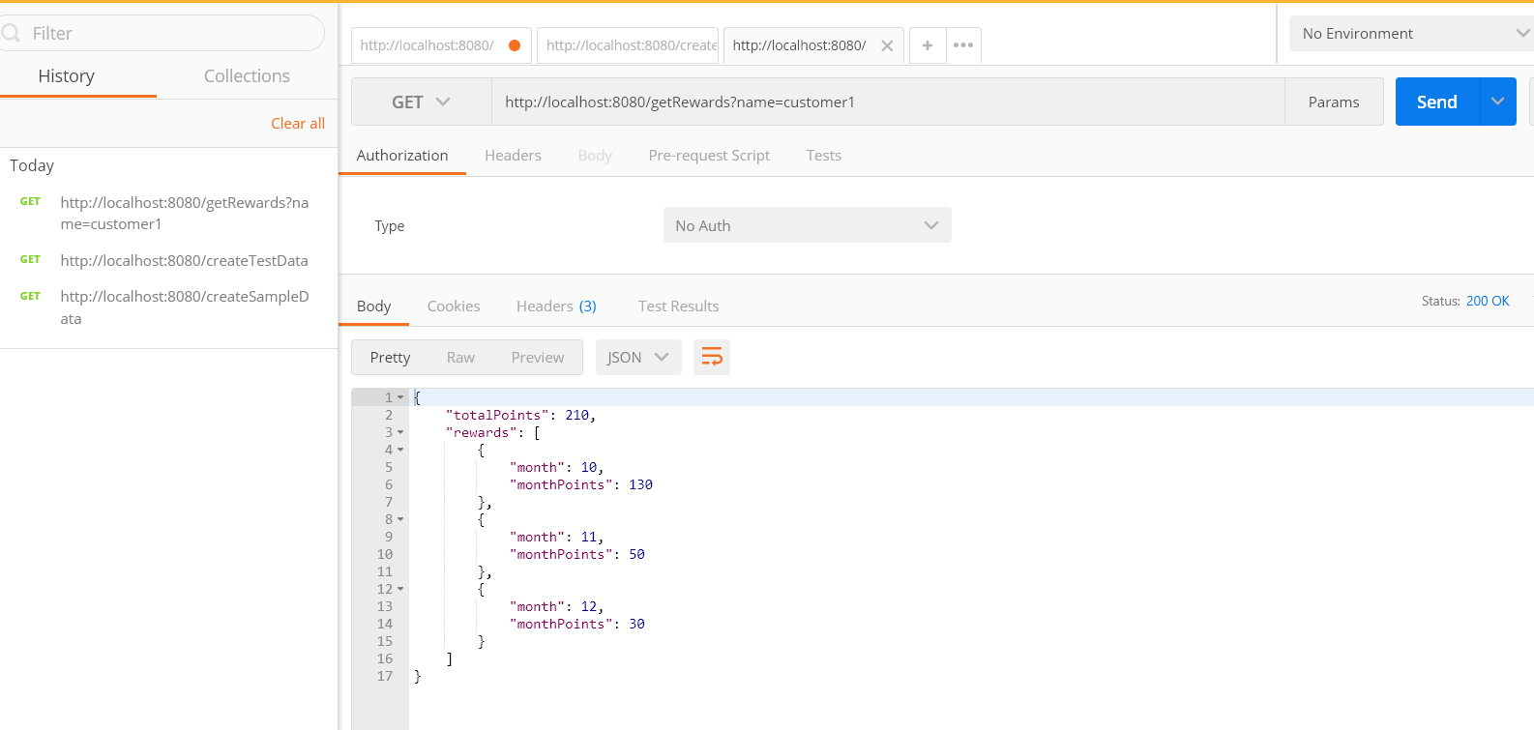

Get the customer total earning points and monthly wise total earning points

[http://localhost:8080/getRewards?name=customer](http://localhost:8080/getRewards?name=customer1)2

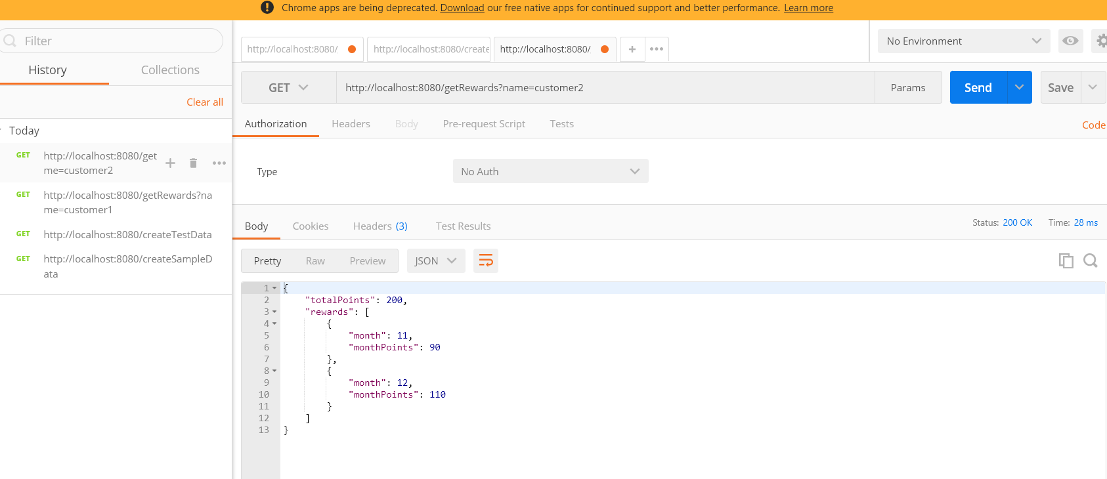

Incase of user is not found

<http://localhost:8080/getRewards?name=customer10>

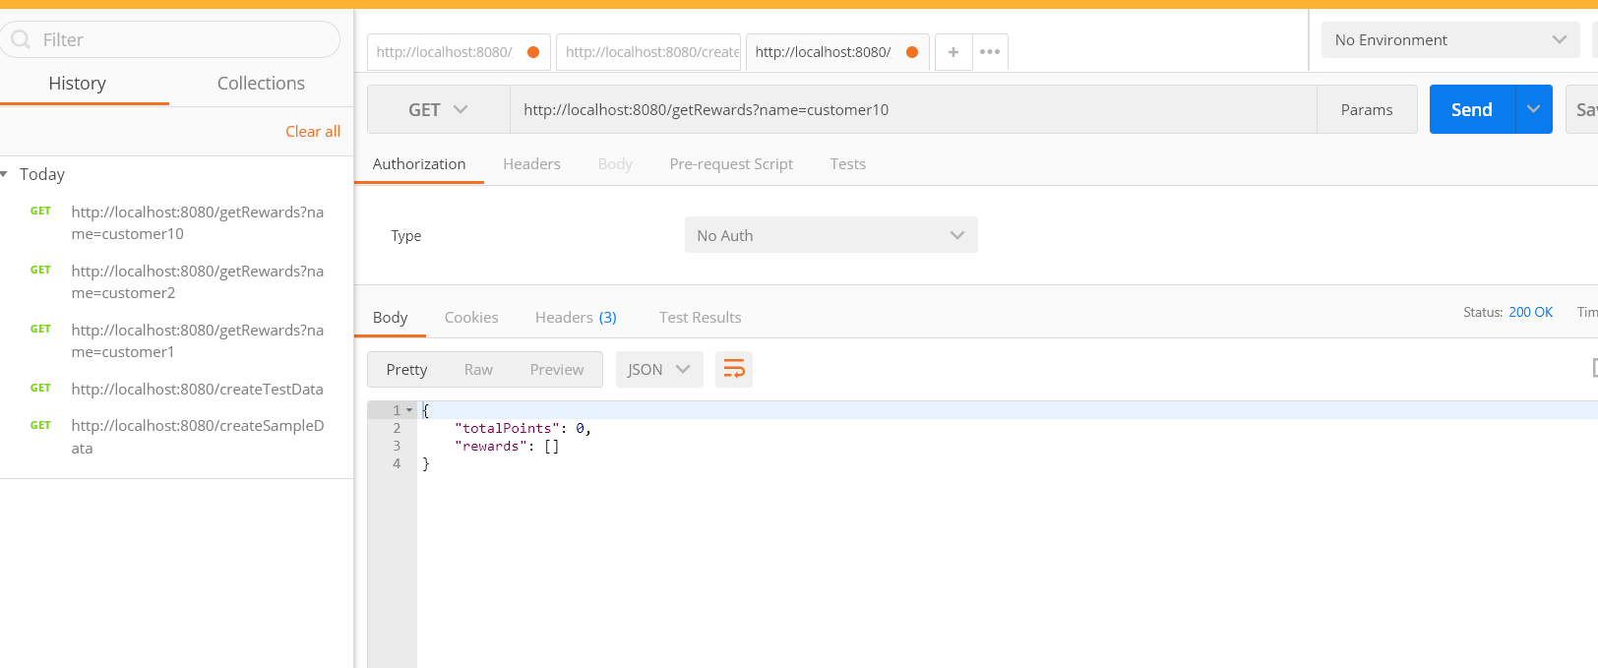

**Unit Testing 🡪 Junit (run com.points.PointsServiceTest.java class)**

