DAY-4
The Software Development Life Cycle (SDLC) is a step-by-step process used to plan, build, test, deploy, and maintain software.
It ensures the software meets client requirements, works correctly, and is easy to maintain.
Phases of SDLC
1. Requirement Analysis
- Understand client needs
- Gather requirements
- Analyze feasibility
2. Design
- Plan system architecture
- Design UI and database
- Define workflows
3. Development
- Write code
- Implement logic
- Build application
4. Testing
- Identify bugs
- Verify functionality
- Ensure quality
5. Deployment
- Release software
- Move to production
- Make application live
6. Maintenance
- Fix issues
- Update features
- Improve performance
Roles in SDLC (3 Points Each)
1. Functional Consultant / Business Analyst
- Interacts with client
- Prepares requirement documents
- Shares approved documents with developers
2. Developer / Programmer
- Writes code
- Prepares technical specifications
- Sends build to QA team
3. Tester / QA Team
- Prepares test cases and scripts
- Executes testing and records results
- Reports bugs or approves release
4. Administrator / Operations Team
- Manages servers
- Handles deployment
- Maintains system stability
Servers Used in Company (3 Points Each)
Development Server
- Used for coding
- Initial testing done
- Developer environment
QA Server
- Used for testing
- Bug verification
- Quality validation
Production Server
- Live application
- Used by end users
- Final environment
5. Project Manager / Product Manager
- Manages project
- Leads teams
- Ensures timely delivery
6. Sales Team
- Sells product
- Handles clients
- Closes deals
Marketing Team
- Promotes product
- Builds brand awareness
- Generates leads
7. Human Resources (HR) Team
- Hiring employees
- Manages payroll
- Handles policies
8. Documentation Team
- Prepares technical documents
- Maintains records
- Updates manuals
9. Support Team
- Handles user issues
- Provides system support
- Acts as backup team

1. Functional Specification Document (FSD)
- Describes client requirements
- Explains system functionality
- Prepared by Business Analyst
2. Technical Specification Document (TSD)
- Explains technical design
- Contains logic and architecture
- Prepared by Developer
3. Test Scripts / Test Cases
- Steps to test application
- Covers all functionalities
- Prepared by QA team
4. Test Results / Test Reports
- Records pass or fail status
- Lists bugs and issues
- Prepared by QA team
Waterfall Model
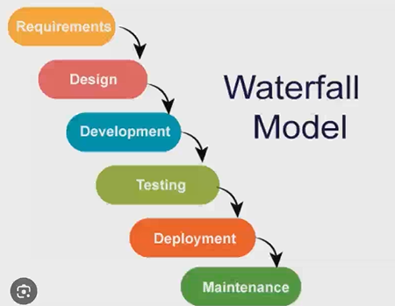
he Waterfall Model is a linear and sequential development model.
It is an old method mainly used for small and fixed projects.
Stages of Waterfall Model
1 Requirement Analysis – Understanding and documenting client needs.
2 System Design – Planning the system structure and architecture.
3 Implementation (Development) – Writing code to build the software.
4 Testing – Checking the software for bugs and errors.
5 Deployment – Releasing the software to users.
6 Maintenance – Fixing issues and updating the system after release.
Usage
- Small projects
- Fixed requirements
- Less flexibility
Agile Methodology
The Agile Methodology is the most commonly used model in companies today.
It focuses on flexibility, speed, and continuous improvement.

Roles in Agile
1. Product Owner
- Represents client
- Manages requirements
- Prioritizes work
2. Scrum Master
- Conducts scrum meetings
- Removes obstacles
- Guides the team
3. Development Team
- Develops features
- Tests continuously
- Delivers increments
Daily Scrum Meeting
- Discuss work done
- Plan next tasks
- Identify blockers

