INFOSYS INTERNSHIP
DAY -1
Overview
The first day of the virtual internship began with an orientation session designed to introduce us to the internship program, mentor, and overall expectations. The session helped us understand the structure of the internship and the responsibilities we need to take up during the course of the program.
Introduction to the Mentor
During the session, our mentor introduced themselves and shared their professional background, experience, and role in guiding us throughout the internship. The mentor explained how they would support us during the learning process and encouraged us to actively communicate in case of doubts or difficulties.
Internship Guidelines and Responsibilities
The mentor clearly explained the rules and responsibilities of the internship. We were informed about:
- Maintaining discipline and professionalism throughout the internship
- Completing assigned tasks within the given deadlines
- Actively participating in sessions and activities
- Taking responsibility for our learning and progress
- Maintaining regular communication with the mentor
The importance of self-learning, consistency, and time management was strongly emphasized.
Orientation Highlights
- Overview of the internship objectives
- Explanation of the learning roadmap and tasks
- Guidelines for attendance and task submission
- Importance of ethical behavior and teamwork
- Encouragement to be proactive and ask questions

DAY -2
Overview
The second day of the virtual internship focused on team formation and introducing collaborative work practices. The session helped us understand how we would work in teams and manage our project files efficiently.
Team Allocation
During the session, interns were divided into four teams:
- Team A
- Team B
- Team C
- Team D
I was assigned to Team C. Each team was provided with a team lead who would coordinate tasks, guide the team members, and act as a point of contact with the mentor.
Introduction to Team Leads
The mentor introduced the team leads for each group and explained their roles and responsibilities. The team leads are responsible for:
- Coordinating team activities
- Assigning tasks to team members
- Ensuring timely completion of work
- Maintaining communication within the team
GitHub Repository Creation
We were instructed to create a GitHub repository to store all internship-related files, tasks, and project work. The mentor explained the importance of using GitHub for:
- Version control
- Team collaboration
- Secure storage of project files
- Tracking changes and progress
Each team member was guided to create or use their GitHub account and maintain their work in the repository regularly.
DAY 3
What is Git/Git Hub/Git Lab?
Git is a version control tool used to save code and track changes. It helps developers manage code and work together.
GitHub is an online platform used to store Git repositories and share code with others.
GitLab is similar to GitHub. It stores Git repositories and provides project management and CI/CD tools.

Git Commands
- git add . → Add all files
- git add app.py → Add single file
- git commit -m "message" → Save changes
- git push → Upload code to remote
- git pull → Download latest code
- git branch → Show local branches
- git branch --all → Show all branches
- git fetch --all → Fetch updates only
- git stash → Temporarily save changes
- git checkout -b newbranchname → Create and switch branch
- git checkout branchname → Switch branch

What is Python Virtual Environment?
A Python virtual environment is an isolated environment used to manage project-specific packages.
Command to create virtual environment
python -m venv venv
• Activation → Starts the virtual environment ->shakthi/script/activate
• Deactivation → Stops the virtual environment->deactivate
DAY-4
The Software Development Life Cycle (SDLC) is a step-by-step process used to plan, build, test, deploy, and maintain software.
It ensures the software meets client requirements, works correctly, and is easy to maintain.
Phases of SDLC
1. Requirement Analysis
- Understand client needs
- Gather requirements
- Analyze feasibility
2. Design
- Plan system architecture
- Design UI and database
- Define workflows
3. Development
- Write code
- Implement logic
- Build application
4. Testing
- Identify bugs
- Verify functionality
- Ensure quality
5. Deployment
- Release software
- Move to production
- Make application live
6. Maintenance
- Fix issues
- Update features
- Improve performance
Roles in SDLC (3 Points Each)
1. Functional Consultant / Business Analyst
- Interacts with client
- Prepares requirement documents
- Shares approved documents with developers
2. Developer / Programmer
- Writes code
- Prepares technical specifications
- Sends build to QA team
3. Tester / QA Team
- Prepares test cases and scripts
- Executes testing and records results
- Reports bugs or approves release
4. Administrator / Operations Team
- Manages servers
- Handles deployment
- Maintains system stability
Servers Used in Company (3 Points Each)
Development Server
- Used for coding
- Initial testing done
- Developer environment
QA Server
- Used for testing
- Bug verification
- Quality validation
Production Server
- Live application
- Used by end users
- Final environment
5. Project Manager / Product Manager
- Manages project
- Leads teams
- Ensures timely delivery
6. Sales Team
- Sells product
- Handles clients
- Closes deals
Marketing Team
- Promotes product
- Builds brand awareness
- Generates leads
7. Human Resources (HR) Team
- Hiring employees
- Manages payroll
- Handles policies
8. Documentation Team
- Prepares technical documents
- Maintains records
- Updates manuals
9. Support Team
- Handles user issues
- Provides system support
- Acts as backup team
1. Functional Specification Document (FSD)
- Describes client requirements
- Explains system functionality
- Prepared by Business Analyst
2. Technical Specification Document (TSD)
- Explains technical design
- Contains logic and architecture
- Prepared by Developer
3. Test Scripts / Test Cases
- Steps to test application
- Covers all functionalities
- Prepared by QA team
4. Test Results / Test Reports
- Records pass or fail status
- Lists bugs and issues
- Prepared by QA team
- Waterfall Model
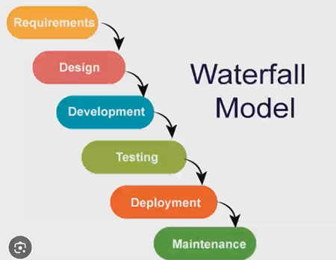
Waterfall Model is a linear and sequential development model.
It is an old method mainly used for small and fixed projects.
Stages of Waterfall Model
1 Requirement Analysis – Understanding and documenting client needs.
2 System Design – Planning the system structure and architecture.
3 Implementation (Development) – Writing code to build the software.
4 Testing – Checking the software for bugs and errors.
5 Deployment – Releasing the software to users.
6 Maintenance – Fixing issues and updating the system after release.
UsageSmall projects
- Fixed requirements
- Less flexibility
Agile Methodology
The Agile Methodology is the most commonly used model in companies today.
It focuses on flexibility, speed, and continuous improvement.
Roles in Agile
1. Product Owner
- Represents client
- Manages requirements
- Prioritizes work
2. Scrum Master
- Conducts scrum meetings
- Removes obstacles
- Guides the team
3. Development Team
- Develops features
- Tests continuously
- Delivers increments
Daily Scrum Meeting-Discuss work done,Plan next tasks,Identify blockers
Day 5 – API Development using Flask & FastAPI
What is an API?
API (Application Programming Interface) is a medium that allows frontend and backend to communicate.
- Frontend → sends request (data)
- Backend → processes request
- Backend → sends response (JSON)
Why do we need APIs?
- To connect frontend with backend
- To send and receive data
- To build web and mobile applications
What is a Request & Response?
- Request: Data sent from frontend to backend
- Response: Data sent from backend to frontend
Data is usually in JSON format.
Flask Framework
Flask is a lightweight Python web framework used to create APIs easily.

Flask Code Explanation
Flask Code
from flask import Flask, request, jsonify

app = Flask(__name__)

@app.route("/project/firstendpoint", methods=["GET"])
def home():
return jsonify({
"message": "Flask API is working" })
if __name__ == "__main__":
app.run(debug=True)
Line-by-Line Explanation
- from flask import Flask → imports Flask framework
- request → used to read data sent by frontend
- jsonify → converts data into JSON format
- app = Flask(__name__) → creates Flask application
- @app.route() → creates API endpoint (URL)
- methods=["GET"] → specifies request type
- jsonify() → sends response to frontend
- app.run() → starts the server
FastAPI Framework
FastAPI is a modern and faster Python framework used for API development.

FastAPI Code Explanation
FastAPI Code
from fastapi import FastAPI

app = FastAPI()

@app.get("/")
async def home():
return {
"message": "FastAPI is running successfully"
}
Line-by-Line Explanation
- from fastapi import FastAPI → imports FastAPI framework
- app = FastAPI() → creates FastAPI app
- @app.get("/") → defines GET request API
- async def → allows asynchronous execution
- return {} → sends JSON response

Why FastAPI is Advanced Compared to Flask
- Faster performance
- Supports async functions
- Automatic API documentation
- Better validation

HTTP & HTTPS
- HTTP: Used for client-server communication
- HTTPS: Secure version of HTTP
- APIs mostly use HTTPS for security

WebSocket
- Used for real-time communication
- Two-way data transfer
- Used in chat apps and live updates

Assignment 1
- Create a Python API
- Use Flask or FastAPI
- API should return a JSON response

Day 6 – Project Overview (Simple Notes)
Project Overview
- We have to build a chatbot application
- The project includes login and registration
- Project carries 25% marks
- The project has 3 parts:
  - Frontend
  - Backend
  - Database
- The chatbot should support multiple languages like English, Hindi, Telugu, etc.
Backend
- Backend must be done in Python (mandatory)
- We can use:
  - Flask API
  - FastAPI
- Backend work:
  - User registration
  - User login
  - Authentication
Frontend
- Used to create user interface
- Options:
  - React
  - HTML & CSS
  - Streamlit
- Frontend sends data to backend
Database
- Used to store user details
- Options:
  - SQLite
  - MySQL
  - MongoDB
- Database stores:
  - User ID
  - Username
  - Encrypted password
Registration
- User enters:
  - Name
  - Email
  - Language preference
  - Password
- Password must be encrypted
- Do not store plain passwords
Login
- User logs in using email and password
- Backend checks user details
- If correct, login is successful
- Backend generates JWT token
- JWT token is used for authentication
JWT Token
- Used to identify logged-in user
- Secures APIs
- Prevents unauthorized access
API
- API connects frontend and backend
- Frontend sends request
- Backend sends response
Tools Used
- GitHub – store code
- Postman – test APIs
Assignment 1
- Create simple API using:
  - Flask or
  - FastAPI
- API should return a message
Presentations
Individual
- Each student must create PPT
- Push code to personal GitHub
Group
- One group PPT
- Combine all code
- All members must present
Important Notes
- Python backend is compulsory
- JWT class will be conducted
- Practice presentation before final day

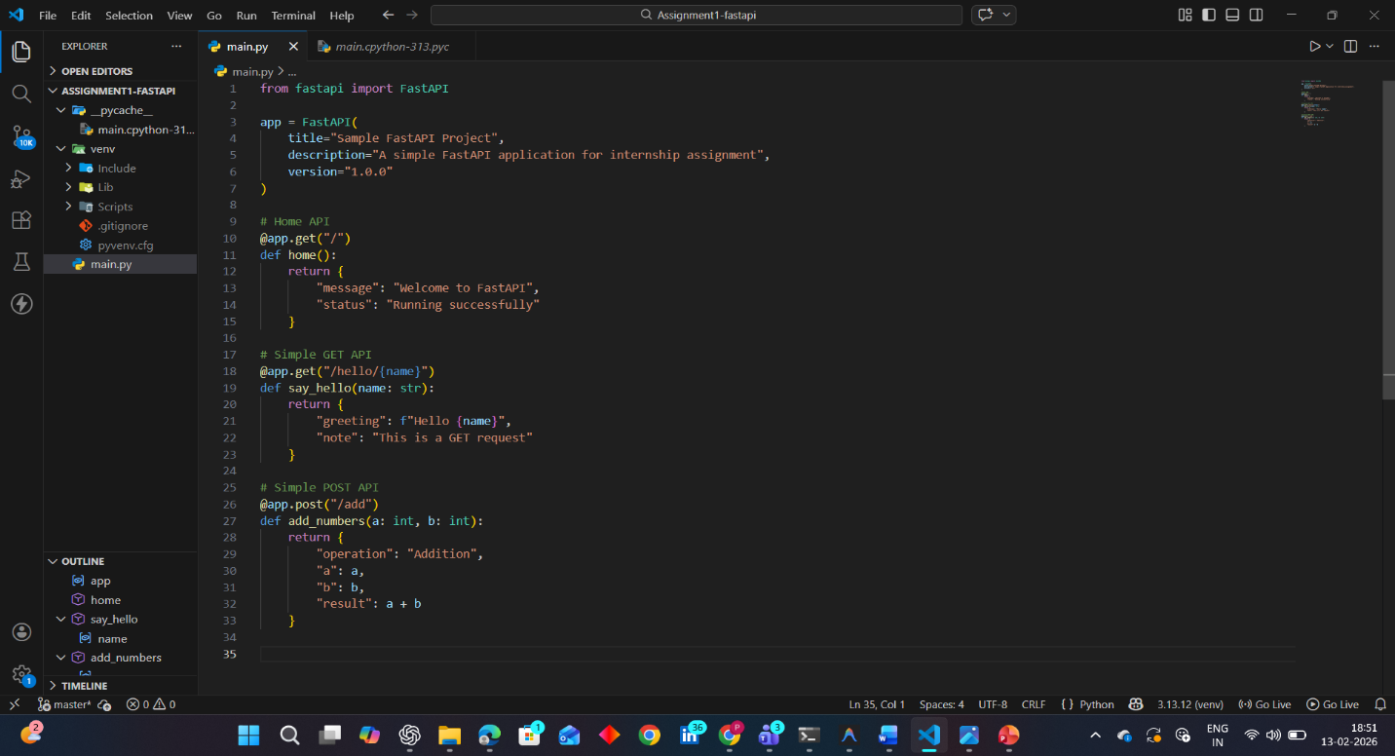

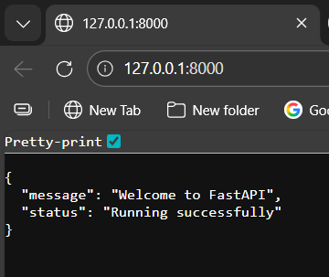

DAY-7
SQL Basics
SELECT Command-Used to fetch data from a table
Syntax:
SELECT * FROM tablename;
INSERT Command-Used to add new data into a table
Syntax:
INSERT INTO tablename VALUES (1, "harika", 20);
UPDATE Command
- Used to modify existing data in a table
Example:
UPDATE tablename
SET age = 21
WHERE id = 1;
DELETE Command
- Used to remove data from a table
Example:
DELETE FROM tablename
WHERE id = 1;
CREATE Command
- Used to create a new table
Example:
CREATE TABLE students (
id INT,
name VARCHAR(50),
age INT
);
ALTER Command
- Used to change table structure
Examples:
ALTER TABLE students ADD marks INT;
DROP Command
- Used to delete table permanently
DROP TABLE students;
RENAME Command
- Used to rename table or column
RENAME TABLE students TO student_details;
TRUNCATE Command
- Used to delete all data from a table
TRUNCATE TABLE students;
DISTINCT Keyword
- Used to remove duplicate values
SELECT DISTINCT name FROM students;
WHERE Clause
- Used to apply condition
SELECT * FROM students WHERE age = 20;
SQL Operators
Used to compare values in conditions:
- = → equal to
- != or <> → not equal to
- < → less than
- > → greater than
- <= → less than or equal to
- >= → greater than or equal to
Match Multiple Values
Used to check multiple values at once.
SELECT * FROM students WHERE age IN (18, 20, 22);

BETWEEN
- Used to check range of values
SELECT * FROM students
WHERE age BETWEEN 18 AND 25;
LIKE
- Used for pattern matching
- Works with % and _
Examples of LIKE
- a% → starts with a
- %a → ends with a
- %a% → contains a
- A_ → starts with A and has 2 letters
- A%o → starts with A and ends with o
LIKE Examples
SELECT * FROM students WHERE name LIKE 's%';
👉 Names starting with s
IS NULL
- Used to check empty (NULL) values
SELECT * FROM students WHERE email IS NULL;
UNION
- Combines results from two tables
- Removes duplicate records
SELECT name FROM table1
UNION
SELECT name FROM table2;
UNION ALL
- Combines results
- Allows duplicate records
SELECT name FROM table1
UNION ALL
SELECT name FROM table2;
INTERSECT
- Returns common records from both tables
SELECT name FROM table1
INTERSECT
SELECT name FROM table2;

EXCEPT
- Returns records present in first table but not in second
SELECT name FROM table1
EXCEPT
SELECT name FROM table2;
Logical Operators
- AND – both conditions must be true
- OR – any one condition true
- NOT – reverses condition
- IN – matches multiple values
Example:
SELECT * FROM students
WHERE age >= 18 AND age <= 25;
SQL Aggregate Functions
Aggregate functions are used to perform calculations on data in a table.

MIN()
- Returns the smallest value
SELECT MIN(age) FROM students;

MAX()
- Returns the largest value
SELECT MAX(age) FROM students;

COUNT()
- Returns the number of rows
SELECT COUNT(*) FROM students;

AVG()
- Returns the average value
SELECT AVG(age) FROM students;

Example
SELECT MIN(age), MAX(age), COUNT(*), AVG(age)
FROM students;
SQL JOINs
JOINs are used to combine data from two tables.

INNER JOIN (Only Matching Records)
- Returns only matching records from both tables
SELECT *
FROM students
INNER JOIN marks
ON students.id = marks.id;

LEFT JOIN
- Returns all records from left table
- Plus matching records from right table
SELECT *
FROM students
LEFT JOIN marks
ON students.id = marks.id;

RIGHT JOIN
- Returns all records from right table
- Plus matching records from left table
SELECT *
FROM students
RIGHT JOIN marks
ON students.id = marks.id;

CROSS JOIN
- Returns all possible combinations
SELECT *
FROM students
CROSS JOIN courses;

Summary
- INNER JOIN → only matching records
- LEFT JOIN → all left table records
- RIGHT JOIN → all right table records
- CROSS JOIN → all combinations

Assignment-2
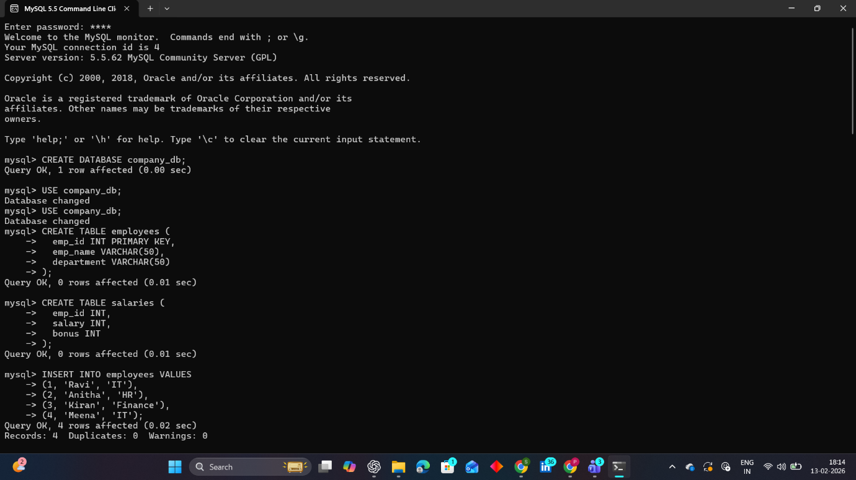
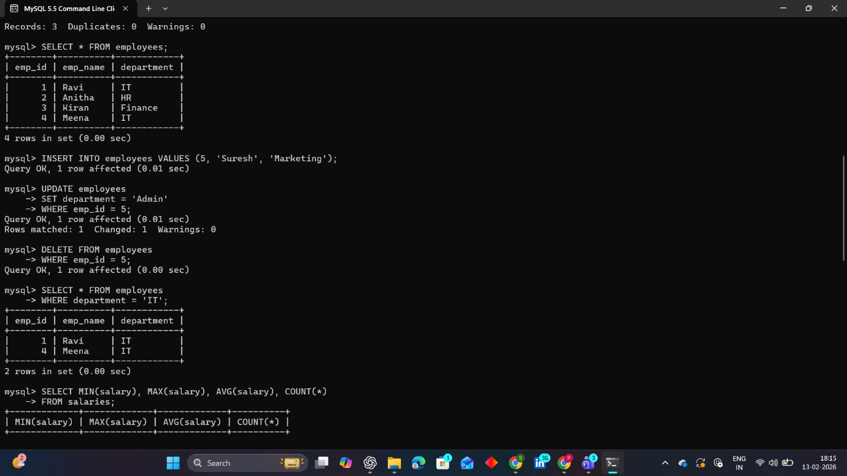
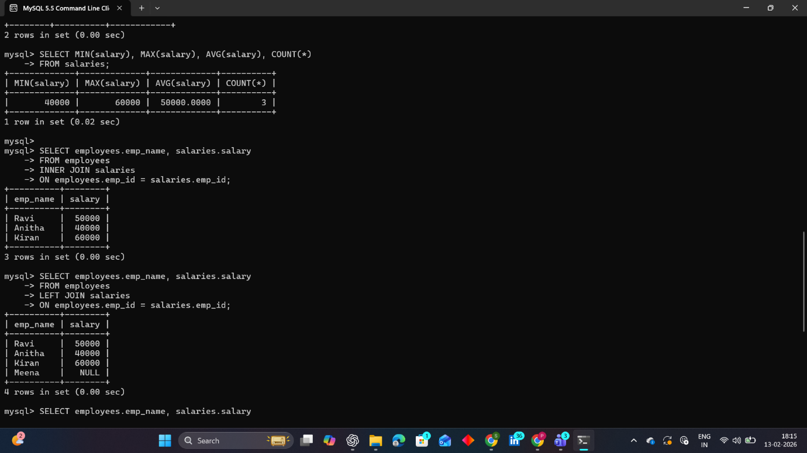

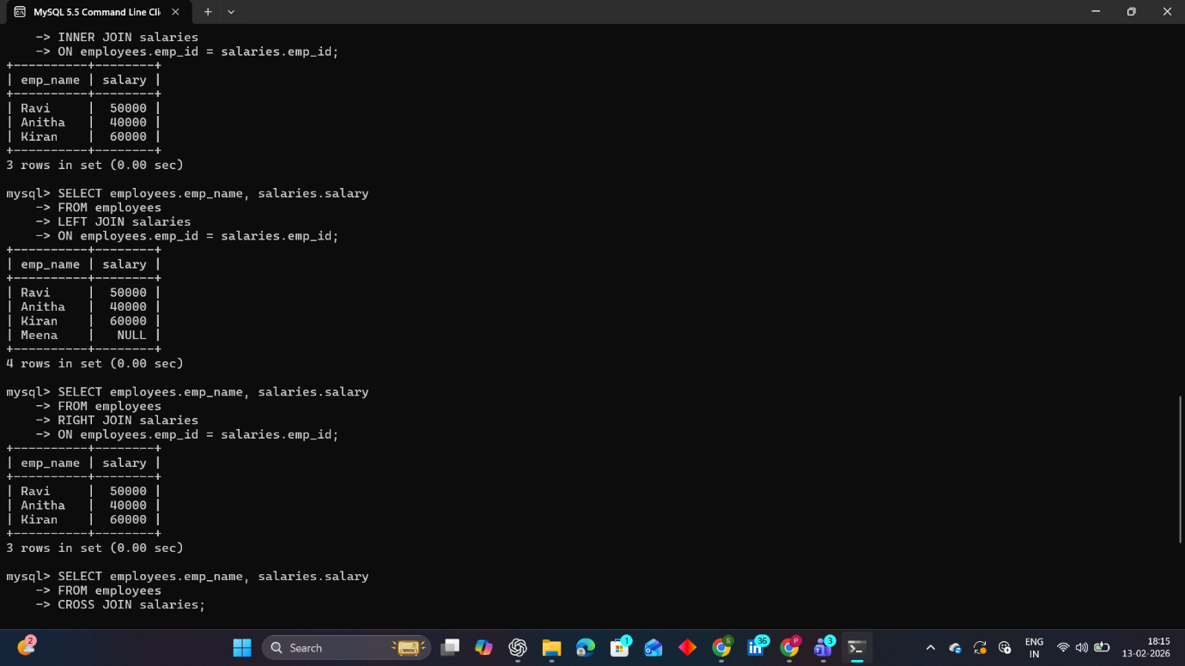

Day - 8 Python Notes

PART 1: bcrypt (Password Hashing) – SIMPLE EXPLANATION
🔐 What is Hashing?
Hashing means converting a password into a secret coded format.
We do this so hackers cannot see the real password.
Example:
Password: python123
Hashed Password: b'$2b$12$ksdjfhskdjfhskdjfhskdjfh'
Even if someone sees the hashed value, they cannot know the original password.
Step 1: Install bcrypt (Only One Time)
Type this in Terminal:
pip install bcrypt
Output:
Successfully installed bcrypt
Step 2: Import bcrypt
import bcrypt
Wrong: import bcrpt
Correct: import bcrypt
Step 3: Convert String to Bytes
bcrypt works only with BYTES (not normal strings).
Sample Input:
password = "python123"
Convert to bytes:
password_bytes = password.encode()
print(password_bytes)
Output:
b'python123'
Step 4: Generate Salt
Salt adds extra security to password.
salt = bcrypt.gensalt()
print(salt)
Sample Output:
b'$2b$12$ksdjfhskdjfhskdjfhskdjf'
Step 5: Hash the Password
hashed_password = bcrypt.hashpw(password_bytes, salt)
print(hashed_password)
Sample Output:
b'$2b$12$ksdjfhskdjfhskdjfhskdjfhsd23423'
Step 6: Complete Simple Program
import bcrypt
password = "python123"
password_bytes = password.encode()
salt = bcrypt.gensalt()
hashed = bcrypt.hashpw(password_bytes, salt)
print("Original Password:", password)
print("Hashed Password:", hashed)
🎯 Important Points to Remember:
- bcrypt is used for password security
- Always convert string to bytes using .encode()
- gensalt() creates random security salt
- hashpw() creates final hashed password
- The hashed password is NOT reversible
PART 2: BUILT-IN STRING METHODS
strip()
Removes spaces from both sides.
Sample Input:
text = " shakthi "
print(text.strip())
Output:
shakthi
join()
Joins elements using a string.
Sample Input:
words = ["I", "like", "python"]
result = " ".join(words)
print(result)
Output:
I like python
replace()
Sample Input:
text = "I like Java"
print(text.replace("Java", "Python"))
Output:
I like Python
startswith()
Sample Input:
"python".startswith("py")
Output:
True
endswith()
Sample Input:
"python".endswith("on")
Output:
True
find()
Sample Input:
"programming".find("gram")
Output:
3
If not found:
"python".find("x")
Output:
-1
isdigit()
Sample Input:
"1234".isdigit()
Output:
True
"12a4".isdigit()
Output:
False
isalpha()
Sample Input:
"python".isalpha()
Output:
True
"python123".isalpha()
Output:
Fals
DICTIONARY METHODS
Sample Dictionary:
student = {"name": "Shakthi", "age": 20}
get()
Sample Input:
student.get("name")
Output:
Shakthi
student.get("city", "Not Found")
Output:
Not Found
keys()
Sample Input:
student.keys()
Output:
dict_keys(['name', 'age']values()
Sample Input:
student.values()
Output:
dict_values(['Shakthi', 20])
items()
Sample Input:
student.items()
Output:
dict_items([('name', 'Shakthi'), ('age', 20)])
update()
Sample Input:
student.update({"city": "Hyderabad"})
print(student)
Output:
{'name': 'Shakthi', 'age': 20, 'city': 'Hyderabad'}
pop()
Sample Input:
student.pop("age")
print(student)
Output:
{'name': 'Shakthi', 'city': 'Hyderabad'}
popitem()
Sample Input:
student.popitem()
print(student)
Output:
Removes last inserted item
clear()
Sample Input:
student.clear()
print(student)
Output: End of Day - 8 Notes with Sample Input & Output
Practice each example at least 3 times.

Day - 9 Documentation
What Happened on Day - 9
On Day - 9, ma'am gave us time to work on:
- Completing our documentation
- Finishing pending assignments
- Working on our project code
- Clearing and organizing previous day doubts
It was a practice and productivity day where we focused on:
- Improving our coding practice
- Completing unfinished tasks
- Updating our project files properly
- Organizing notes and documentation

DAY-10- MILESTONE 1
DAY 11-MILESTONE -1
DAY 12
Python Built-in Functions, File Handling, Exception Handling & Nested Functions
File I/O Methods (File Handling)
File handling is used to read and write data in files.
🔹 open()
Opens a file and returns a file object.
file = open("data.txt", "r")
Modes:
- "r" – Read
- "w" – Write
- "a" – Append
- "x" – Create
- "b" – Binary
- read()
Reads entire file.
content = file.read()
readline()
Reads one line.
line = file.readline()
readlines()
Reads all lines as list.
lines = file.readlines()
write()
Writes data into file.
file.write("Hello")
writelines()
Writes multiple line
file.writelines(["Hi\n", "Python\n"])
🔹 close()
Closes the file.
file.close()

Important Built-in Functions
len()
Returns length.
len([1,2,3]) # 3
range()
Generates numbers.
range(1,5)
print()
Displays output.
type()
Returns datatype.
id()
Returns memory address.
sorted()
Sorts data.
sorted([3,1,2]) # [1,2,3]

enumerate() Function
Definition
The enumerate() function adds an index number to an iterable and returns index-value pairs.
Syntax
enumerate(iterable, start=0)
Example
fruits = ["Apple", "Banana", "Cherry"]

for index, value in enumerate(fruits):
print(index, value)
Output:
0 Apple
1 Banana
2 Cherry
Example with Start Value
for index, value in enumerate(fruits, start=1):
print(index, value)

zip() Function
Combines multiple iterables.
list(zip([1,2], ["a","b"]))
# [(1,'a'), (2,'b')]

Type Conversion Functions
Function | Example
int() | int("10") → 10
float() | float("5.5") → 5.5
str() | str(100) → "100"
list() | list((1,2)) → [1,2]
tuple() | tuple([1,2]) → (1,2)
set() | set([1,1,2]) → {1,2}
dict() | dict([(1,"a")])

Mathematical Functions
Function | Example
abs() | abs(-10) → 10
sum() | sum([1,2,3]) → 6
min() | min(5,2,9) → 2
max() | max(5,2,9) → 9
pow() | pow(2,3) → 8
round() | round(4.6) → 5

Class & Object Related Functions
🔹 getattr()
Gets attribute value.
🔹 setattr()
Sets attribute.
🔹 hasattr()
Checks attribute.
🔹 delattr()
Deletes attribute.
🔹 isinstance()
Checks object type.
isinstance(10, int) # True
🔹 issubclass()
Checks class inheritance.
issubclass(bool, int) # True
Exception Handling
Used to handle runtime errors.
try
Contains risky code.
except
Handles error.
finally
Always executes.
Example
try:
x = 10/0
except:
print("Error occurred")
finally:
print("Done")

Memory Management
del
Deletes variable.
del x
gc.collect()
Forces garbage collection.
import gc
gc.collect()

Dynamic Code Execution
🔹 eval()
Executes single expression.
eval("10+5") # 15
exec()
Executes multiple lines.
exec("a=5\nb=6\nprint(a+b)")

Nested Function
Definition
A nested function is a function defined inside another function.
Example
def outer():
def inner():
print("Hello")
inner()

outer()
Output:
Hello

DAY-13
AI Models, Google Gemini, OpenAI GPT, Groq, Microsoft AI & Creating APIs
What are AI Models?
Artificial Intelligence (AI) models are computer programs trained on large amounts of data to perform tasks like:
- Text generation (Chatbots)
- Image generation
- Code generation
- Speech recognition
- Translation
- Data analysis
Most modern AI tools are based on LLMs (Large Language Models).
Examples:
- ChatGPT
- Google Gemini
- Microsoft Copilot

OpenAI GPT Models

4
Company: OpenAI
Models: GPT-3.5, GPT-4, GPT-4o
What is GPT?
GPT = Generative Pre-trained Transformer
It is trained on large datasets to:
- Answer questions
- Write essays
- Generate code
- Create content
- Build chatbots
Features:
- Strong reasoning
- Coding support
- API integration
- Multimodal (text + image in GPT-4o)
Example Uses:
- ChatGPT
- AI coding assistant
- Virtual assistant
- Customer support bots
Google Gemini Models


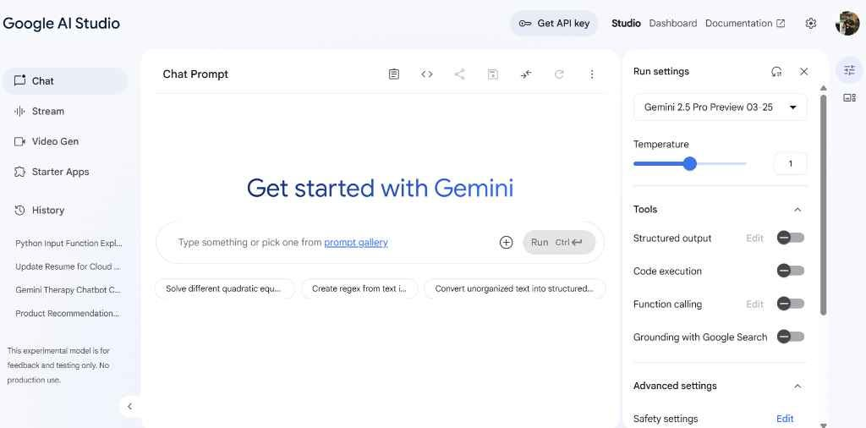
4
Company: Google
Model Name: Gemini (Previously Bard)
Features:
- Multimodal (text, image, video understanding)
- Integrated with Google services
- Fast performance
- Used in Android & Google Workspace
Versions:
- Gemini 1.5
- Gemini Pro
- Gemini Flash (faster & lightweight)
Uses:
- AI chat assistant
- Research help
- Image understanding
- Google Cloud AI apps
Groq AI

4
Company: Groq
Groq is different from OpenAI and Google.
It focuses on:
- AI hardware (LPU – Language Processing Unit)
- Ultra-fast AI inference
- Low latency AI responses
Why Important?
- Faster than GPUs in some AI tasks
- Used to run LLMs at very high speed

Microsoft AI Models

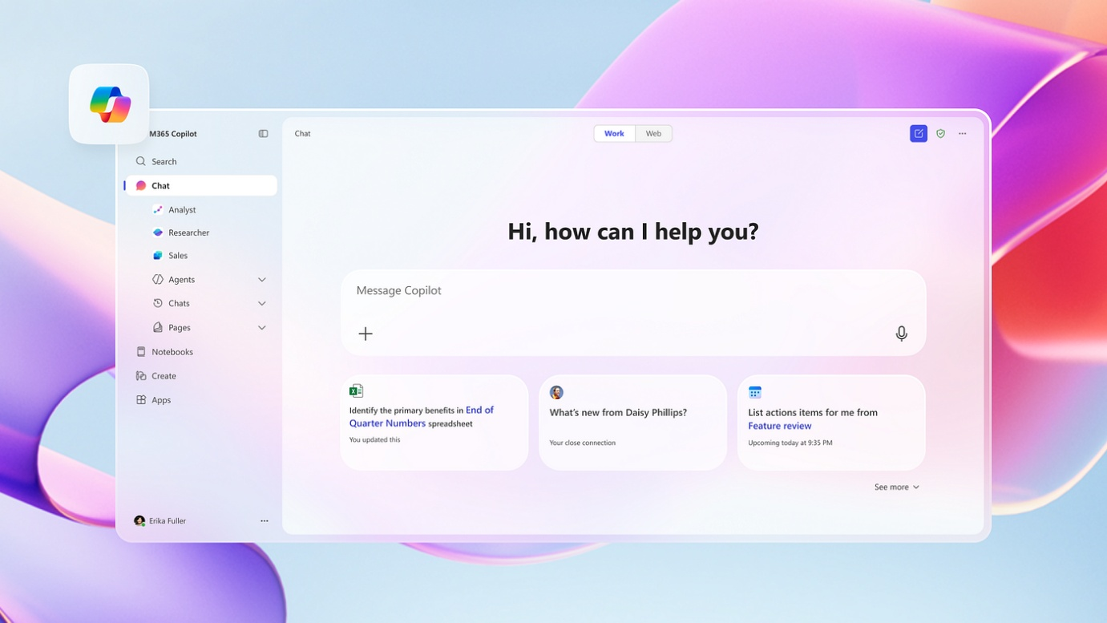

4
Company: Microsoft
Microsoft works closely with OpenAI.
Products:
- Microsoft Copilot
- Azure OpenAI Service
- AI integration in Word, Excel, PowerPoint
Features:
- Cloud-based AI
- Enterprise-level AI solutions
- Secure business applications

What is an API?
API = Application Programming Interface
It allows:
- One software to communicate with another software.
Example:
Your website → sends request → OpenAI API → returns AI response.

How to Create an API (Basic Steps)
There are 2 meanings:
A) Using AI API (like OpenAI or Gemini)
Step 1: Create Account
- Go to OpenAI / Google AI Studio
Step 2: Generate API Key
- After login → Go to API Keys section
- Click "Create new key"
- Copy the key (Important!)
Step 3: Install Required Library (Python Example)
pip install openai
Step 4: Use API in Python
from openai import OpenAI
client = OpenAI(api_key="your_api_key")

response = client.chat.completions.create(
model="gpt-4o-mini",
messages=[{"role": "user", "content": "Hello"}]
)

print(response.choices[0].message.content)

B) Creating Your Own API (Backend API)
You can create your own API using:
- Python (Flask / FastAPI)
- Node.js (Express)
- Django
Example using Flask:
from flask import Flask, jsonify

app = Flask(__name__)

@app.route('/hello', methods=['GET'])
def hello():
return jsonify({"message": "Hello World"})

if __name__ == '__main__':
app.run(debug=True)
Assignemnt -3
1. enumerate()
enumerate() is a built-in Python function that adds a counter (index) to an iterable (like list, tuple, string) and returns it as an enumerate object.
Syntax:
enumerate(iterable, start=0)
- iterable → list, tuple, string, etc.
- start → optional starting index (default is 0)
Example:
fruits = ["apple", "banana", "mango"]
for index, value in enumerate(fruits):
print(index, value)
Output:
0 apple
1 banana
2 mango
2. isinstance()
isinstance() is used to check whether an object belongs to a particular class (data type).
Syntax:
isinstance(object, class)
Example:
x = 10
print(isinstance(x, int))
print(isinstance(x, str))
Output:
True
False
3. gc.collect()
gc.collect() is used to manually trigger Python’s Garbage Collector to free unused memory.
Python automatically manages memory, but sometimes we force garbage collection using this function.

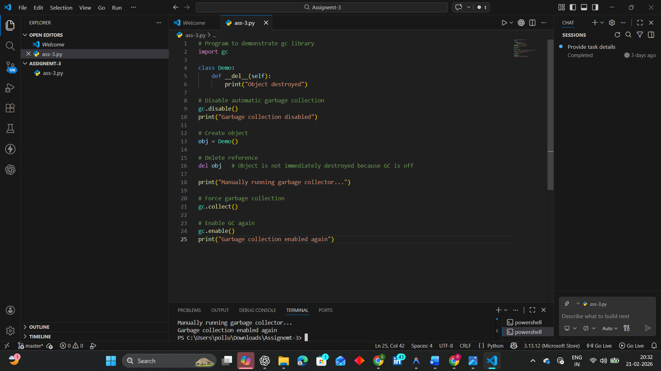
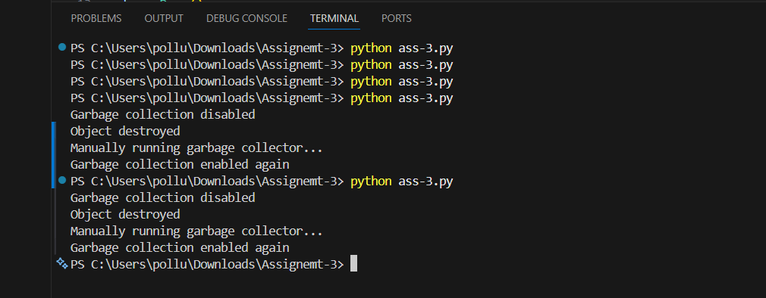

DAY-14
POS Tagging & Named Entity Recognition (NER)
1. POS Tagging (Part-of-Speech Tagging)
Definition:
Assigning grammatical tags to each word in a sentence.
Common Tags:
- NN → Noun
- VB → Verb
- JJ → Adjective
- RB → Adverb
- PRP → Pronoun
Purpose:
- Helps in syntax analysis
- Used in machine translation
- Useful in chatbots
- Important for NLP pipelines
Process:
- Tokenization
- Apply nltk.pos_tag()
Example Output:
[('Prajwal', 'NNP'), ('is', 'VBZ'), ('building', 'VBG')]
2. Named Entity Recognition (NER)
Definition:
Identifies and classifies named entities in text.
Entity Types:
- PERSON
- ORGANIZATION (ORG)
- GPE (Location)
- DATE
- TIME
- MONEY
Purpose:
- Used in fraud detection
- Information extraction
- Search engines
- Data analysis
Process:
- Tokenization
- POS Tagging
- Apply nltk.ne_chunk()
Required Downloads:
nltk.download('words')
nltk.download('maxent_ne_chunker')
3. Important NLTK Preprocessing Tools
Tokenization
Splitting text into words using:
word_tokenize()
Stopword Removal
Removing common words using:
stopwords
Stemming
Reducing words to root form using:
PorterStemmer
Example:
- playing → play
- running → run
Lemmatization
Reducing words to meaningful base form using:
WordNetLemmatizer

DAY-15
Supervised Learning
Supervised Learning is a type of Machine Learning where the model is trained using labeled data (input + correct output).
Formula:
f(X) → Y
Where:
- X = Input featuresd
- Y = Target/Label
Applications:
- Spam Detection
- House Price Prediction
- Disease Prediction
Common Algorithms:
- Linear Regression
- Logistic Regression
- Decision Tree
- KNN
- SVM
Unsupervised Learning
Definition:
Unsupervised Learning works with unlabeled data. The model finds hidden patterns or structures.
Algorithms:
- Hierarchical Clustering
- DBSCAN
- PCA

Classification
Definition:
Used when output is categorical.
Types:
- Binary Classification (2 classes)
- Multi-class Classification (More than 2 classes)
Examples:
- Spam / Not Spam
- Fraud / Not Fraud
- Pass / Fail
Regression
Algorithms:
- Linear Regression
- Decision Tree Regressor
- Random Forest Regressor
Reinforcement Learning
Definition:
A learning technique where an agent interacts with an environment and learns through rewards and penalties.
Key Components:
- Agent
- Environment
- State
- Action
- Reward

DAY-16
NLP (Natural Language Processing)

What is NLP?
Natural Language Processing (NLP) is a branch of Artificial Intelligence that helps computers understand, interpret, and process human language (text or speech).
Examples:
- Chatbots
- Spam detection
- Sentiment analysis
- Language translation
Steps to Implement NLP
1. Collecting the Data
- Gather text data from:
  - Websites
  - CSV files
  - APIs
  - Social media
  - User input
2. Preparing and Engineering Features
- Clean the text
- Remove unwanted characters
- Convert text into numerical format
- Apply NLP preprocessing steps
NLTK (Natural Language Toolkit)
NLTK is a Python library used for working with human language data.
It provides tools for:
- Text preprocessing
- Tokenization
- Stopword removal
- Stemming
- Lemmatization
- POS tagging
- Named Entity Recognition
Key Steps in NLTK
1. Tokenization
Breaking text into smaller parts (words or sentences).
Example:
"I love AI" → ["I", "love", "AI"]
from nltk.tokenize import word_tokenize
2. Stop Words Removal
Removing common words that do not add much meaning.
Examples:
- is
- the
- and
- in
- of
from nltk.corpus import stopwords
3. Stemming
Reducing words to their root form (may not be a real word).
Example:
- playing → play
- running → run
from nltk.stem import PorterStemmer
4. Lemmatization
Reducing words to meaningful base form.
Example:
- better → good
- running → run
from nltk.stem import WordNetLemmatizer
5. POS Tagging (Part of Speech Tagging)
Identifying grammatical role of words.
Example:
- Noun
- Verb
- Adjective
6. NER (Named Entity Recognition)
Identifying real-world entities from text.
Examples:
- Person names
- Locations
- Organizations
- DatesRequired Imports Used in Class
from nltk.tokenize import word_tokenize
from nltk.corpus import stopwords
from nltk.stem import PorterStemmer
from nltk.stem import WordNetLemmatizer

Assignment-4
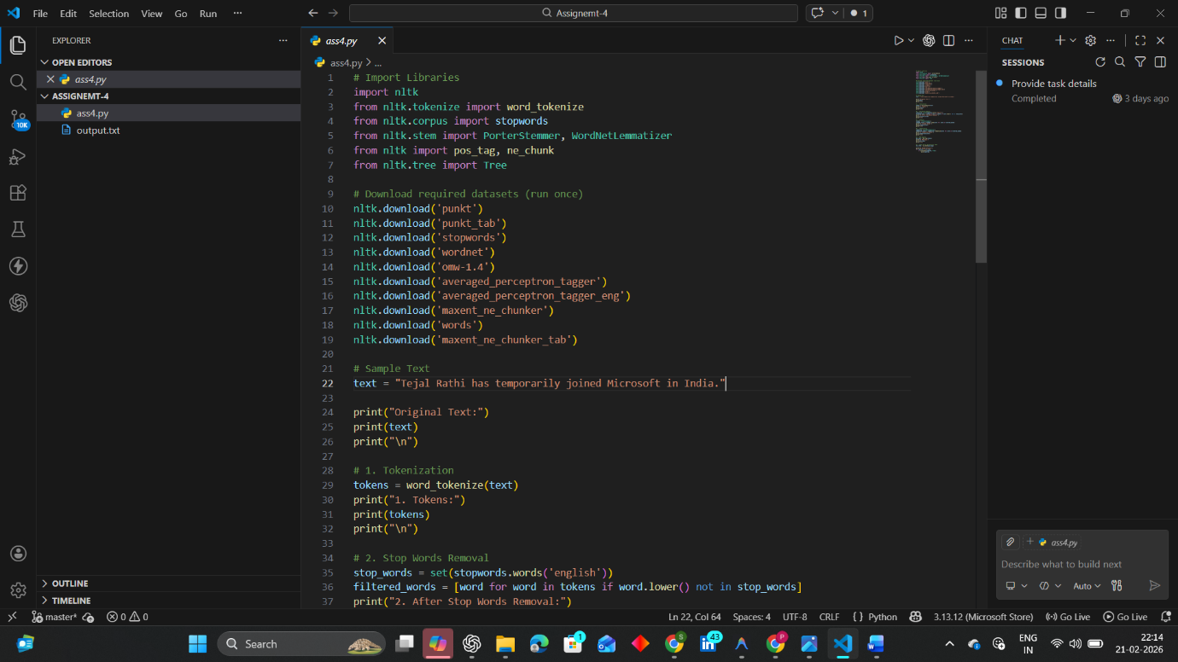

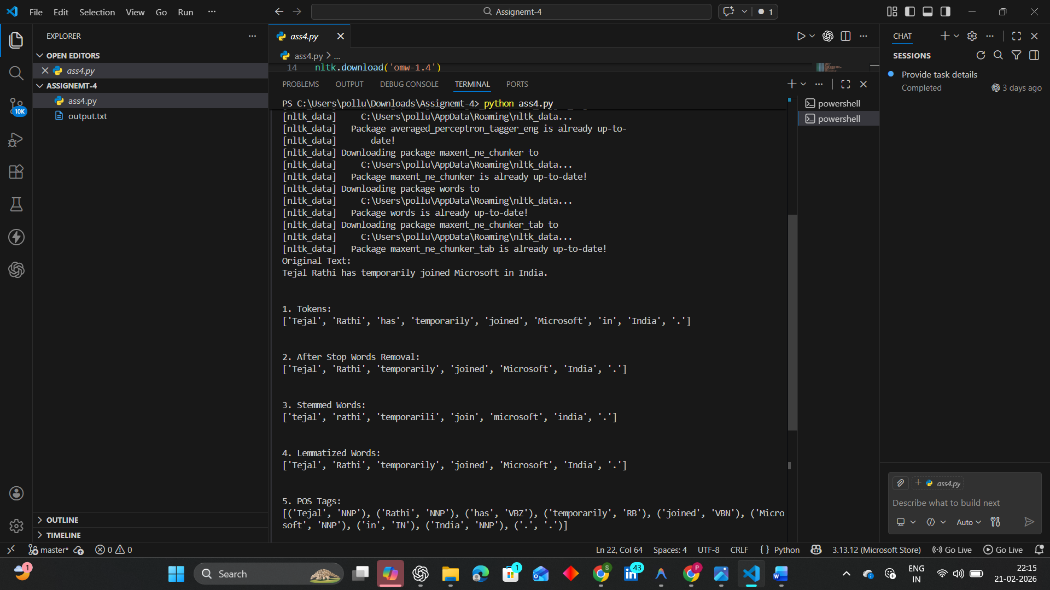
DAY-17
Project prepratation
DAY-18
Project prepratation
DAY-19-MILESTONE-2
DAY -20 MILESTONE-2

KNN
DAY 21 KNN
Type of Learning
Supervised Learning
Used for Classification & Regression
Not used for clustering (that’s K-Means)
Why KNN is Called a “Lazy Learner”
Unlike algorithms like:
- Decision Tree
- Logistic Regression
- Support Vector Machine
KNN:
- Does NOT build a model during training
- No equation is formed
- Stores the dataset
- Does work only at prediction time
That’s why it’s called:
Lazy Learning Algorithm
Distance Metrics in KNN
1. Euclidean Distance (Most Common)

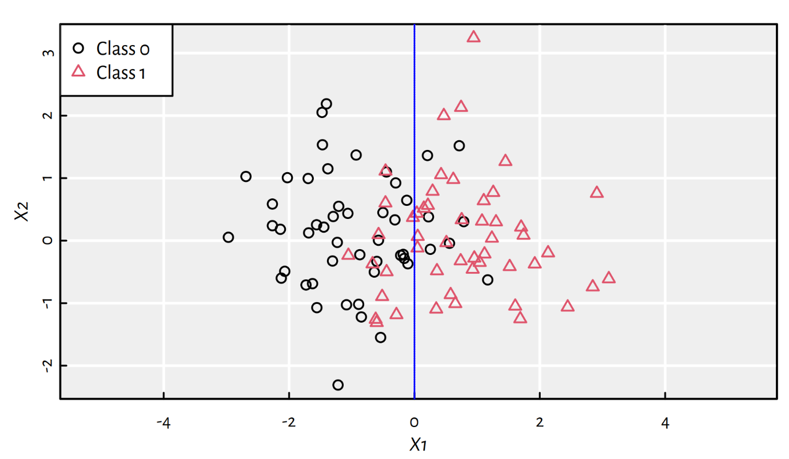
4
Formula:
$$\sqrt{∑(x_{i}-y_{i})^{2}}$$Used when:
- Data is continuous
- Features are numerical2. Manhattan Distance
$$∑∣x_{i}-y_{i}∣$$
Used when:
- Grid-like data
- High dimensional data
3. Minkowski Distance
Generalized form:
- p = 1 → Manhattan
- p = 2 → Euclidean
Choosing the Right K Value
This is VERY important for exams.
If K is small (like 1):
- Overfitting
- Sensitive to noise
If K is large:
- Underfitting
- Less flexibleCommon trick:
$$K=\sqrt{N}$$
Where N = total data points
Also use:
- Cross Validation

Classification Example (Step-by-Step)
Suppose dataset:
Height | Weight | Label
150 | 50 | A
160 | 60 | A
170 | 65 | B
180 | 80 | B
New point: (165, 62)
Steps:
- Calculate distance to all points
- Sort distances
- Choose K=3
- Majority vote
Result = A (if 2 A are nearest)

Regression in KNN
Instead of majority vote:
Take average
Example:
Nearest values: 10, 12, 14
Prediction = (10+12+14)/3 = 12
KNN in Python (Simple Code)
from sklearn.neighbors import KNeighborsClassifier
# Training data
X = [[150,50],[160,60],[170,65],[180,80]]
y = ['A','A','B','B']
# Create model
model = KNeighborsClassifier(n_neighbors=3)
# Train
model.fit(X,y)
# Predict
print(model.predict([[165,62]])

DAY-22-K-means clustering
What is K-Means?
K-Means is an Unsupervised Machine Learning algorithm used for:
Clustering
Not for classification
It groups data into K clusters based on similarity.
Why It Is Called “Unsupervised”?
Because:
- No labels are given
- Algorithm finds patterns by itself
Example:
If you give customer data, it will group customers automatically.
How K-Means Works (Step-by-Step)
Step 1Choose number of clusters (K)
Example: K = 2
Step 2Randomly initialize centroids
Centroid = center point of cluster
Step 3 Assign points to nearest centroid
Distance usually calculated using:
- Euclidean distance
Step 4 Recalculate centroids
New centroid = Mean of all points in that cluster
Step 5Repeat until centroids stop changing

Visual Understanding

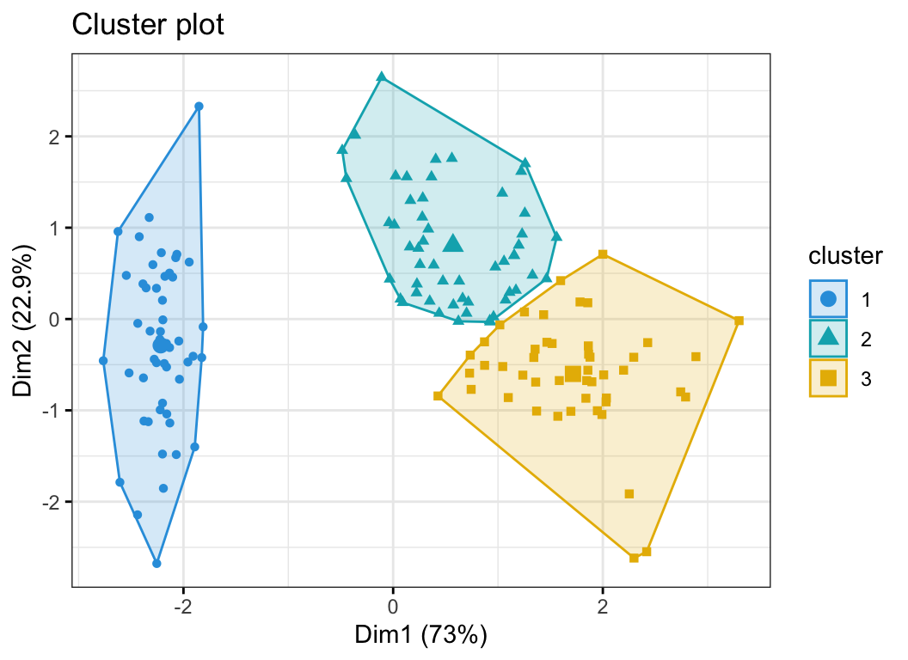

You can see:
- Points grouped into clusters
- Centroids moving
- Final cluster formationMathematical Formula
Centroid calculation:
$$\text{Centroid}=\frac{∑x_{i}}{n}$$
Objective function (very important for exams):
K-Means minimizes:
$$∑∣∣x_{i}-c_{j}∣∣^{2}$$
(Within-cluster sum of squares)

Exampl
Suppose points:
(1,1), (2,1), (4,3), (5,4)
If K = 2
After iterations:
Cluster 1 → (1,1), (2,1)
Cluster 2 → (4,3), (5,4)

How to Choose Best K?
Elbow Method
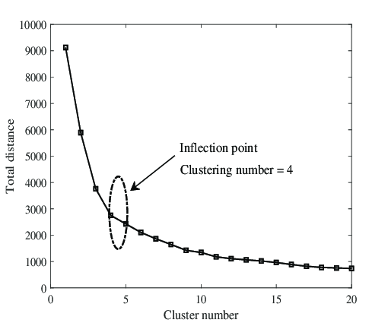
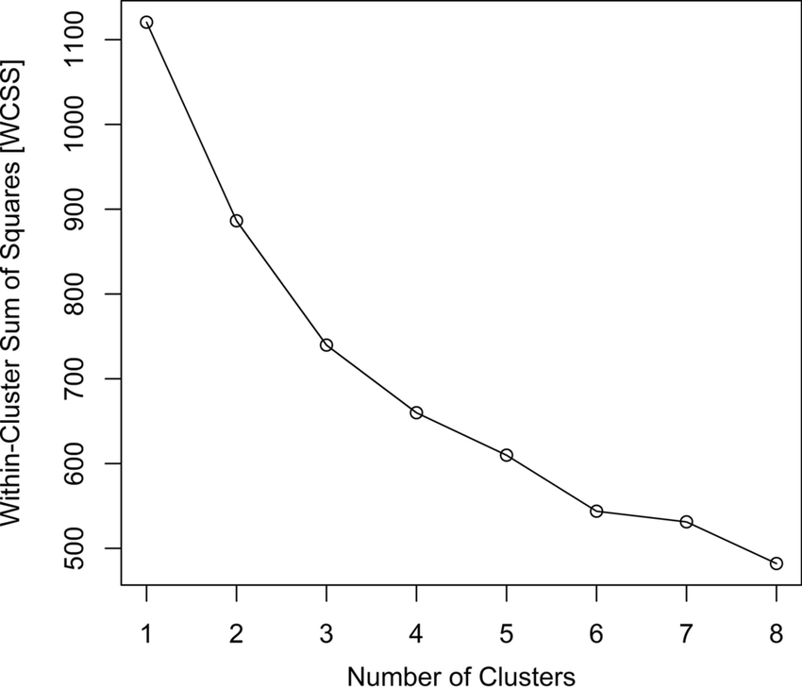

4
Look for “elbow point” in graph.
Simple Python Code
from sklearn.cluster import KMeans
import numpy as np
X = np.array([[1,1],[2,1],[4,3],[5,4]])
model = KMeans(n_clusters=2, random_state=0)
model.fit(X)
print(model.labels_)
print(model.cluster_centers_)

DAY-23-Backpropagation
Backpropagation is the algorithm used to train Artificial Neural Networks (ANNs).
It is mainly used with:
- Artificial Neural Network
- Multilayer Perceptron
What is Backpropagation?
Backpropagation is a method to:
Calculate error
Propagate error backward
Update weights to reduce loss
It works using Gradient Descent.
Why Do We Need It?
In neural networks:
- Inputs → Hidden layers → Output
- Output may be wrong
- We must adjust weights
Backpropagation tells:
How much each weight contributed to the error.
How It Works (Step-by-Step)
Step 1 Forward Propagation
Input → Multiply by weights → Apply activation → Get output
Step 2 Calculate Error
Error = Actual Output − Predicted Output
Usually using:
- Mean Squared Error (MSE)
- Cross Entropy
Step 3 Backward Propagation
Using Chain Rule of Differentiation, calculate gradient.
Step 4 Update Weights
$$W_{new}=W_{old}-η\frac{∂Loss}{∂W}$$
Where:
- η = Learning Rate
- ∂ = Partial derivative
Visual Explanation

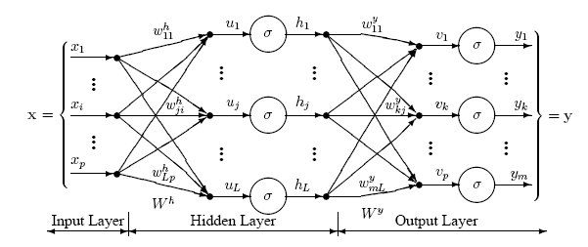
4
You can see:
- Forward pass
- Error calculation
- Backward flow of gradients

Important Mathematical Concept (Exam Level)
Backprop uses:
Chain Rule
If:
$$z=f(y),y=g(x)$$
Then:
$$\frac{dz}{dx}=\frac{dz}{dy}⋅\frac{dy}{dx}$$
This is how gradients move backward layer by layer.
Simple Example (Single Neuron)
Suppose:
- Input x = 2
- Weight w = 3
- Output y = wx = 6
- Actual = 10
Error = 10 − 6 = 4
Gradient tells how to change w to reduce error.
Simple Python Example (Conceptual)
import tensorflow as tf
model = tf.keras.Sequential(
tf.keras.layers.Dense(10, activation='relu'),
tf.keras.layers.Dense(1)
])
model.compile(optimizer='adam', loss='mse')

Day 24 – Milestone 3
Topics-TO WORK ON THE MILESTONE-3
- AI User Segmentation & Demographics Analytics
- Health Topics Classification & Search Trend Analysis
- Feedback Collection, Sentiment Analysis & Analytics Dashboard
- Chatbot Usage Monitoring & Reporting System
- Multi-Language Support & Language Preference Tracking
- Ethical AI, Privacy Protection & Emergency Response Framework
- Milestone 3: Advanced Analytics, Monitoring & Responsible AI Implementation Work

DAY 25- Continued project development
DAY-26 Continued project development
ASSIGNMENT-3
Assignment: KNN and K-Means Implementation
1. K-Nearest Neighbors (KNN)
- Type: Supervised Learning
- Used for: Classification / Regression
- Concept: Classifies a data point based on majority of its nearest neighbors
- Distance Metric: Euclidean Distance
Steps:
- Import dataset
- Split into training and testing data
- Choose value of K
- Train model
- Predict output
- Evaluate accuracy
2. K-Means Clustering
- Type: Unsupervised Learning
- Used for: Clustering
- Concept: Groups data into K clusters based on similarity
Steps:
- Choose number of clusters (K)
- Initialize centroids
- Assign points to nearest centroid
- Update centroids
- Repeat until convergence
Tools Used
- Python
- Jupyter Notebook
- NumPy
- Pandas
- Matplotlib
- Scikit-learn
