**20-12-2022**

**NNVL SAI SUMA – 221910310037**

**1.Program on componenDidMount()**

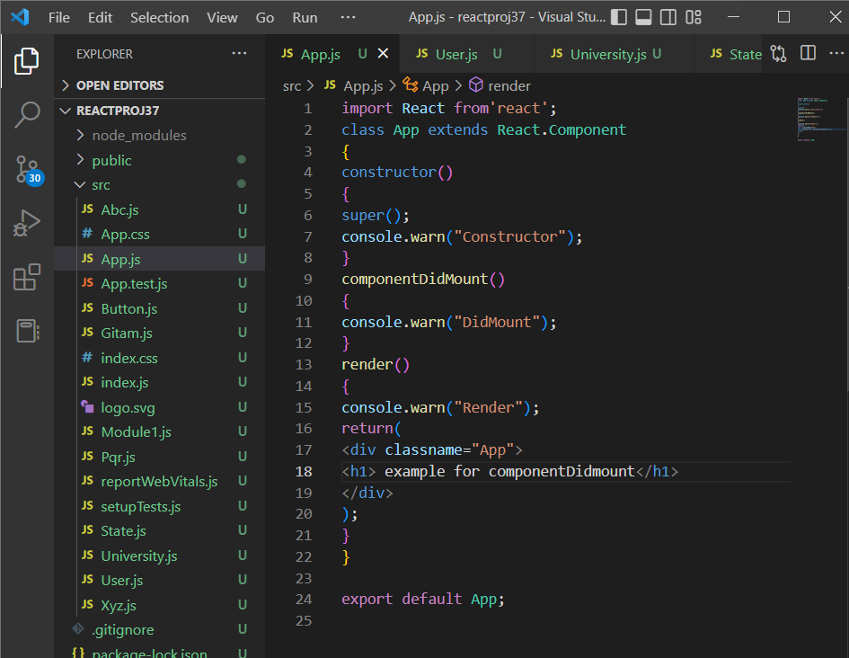

**Output:**

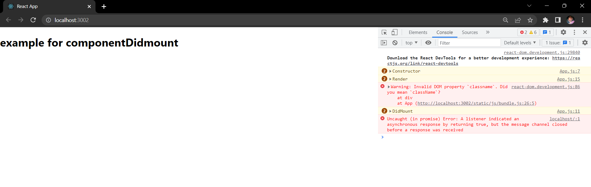

**2. Program on componentDidUpdate()**

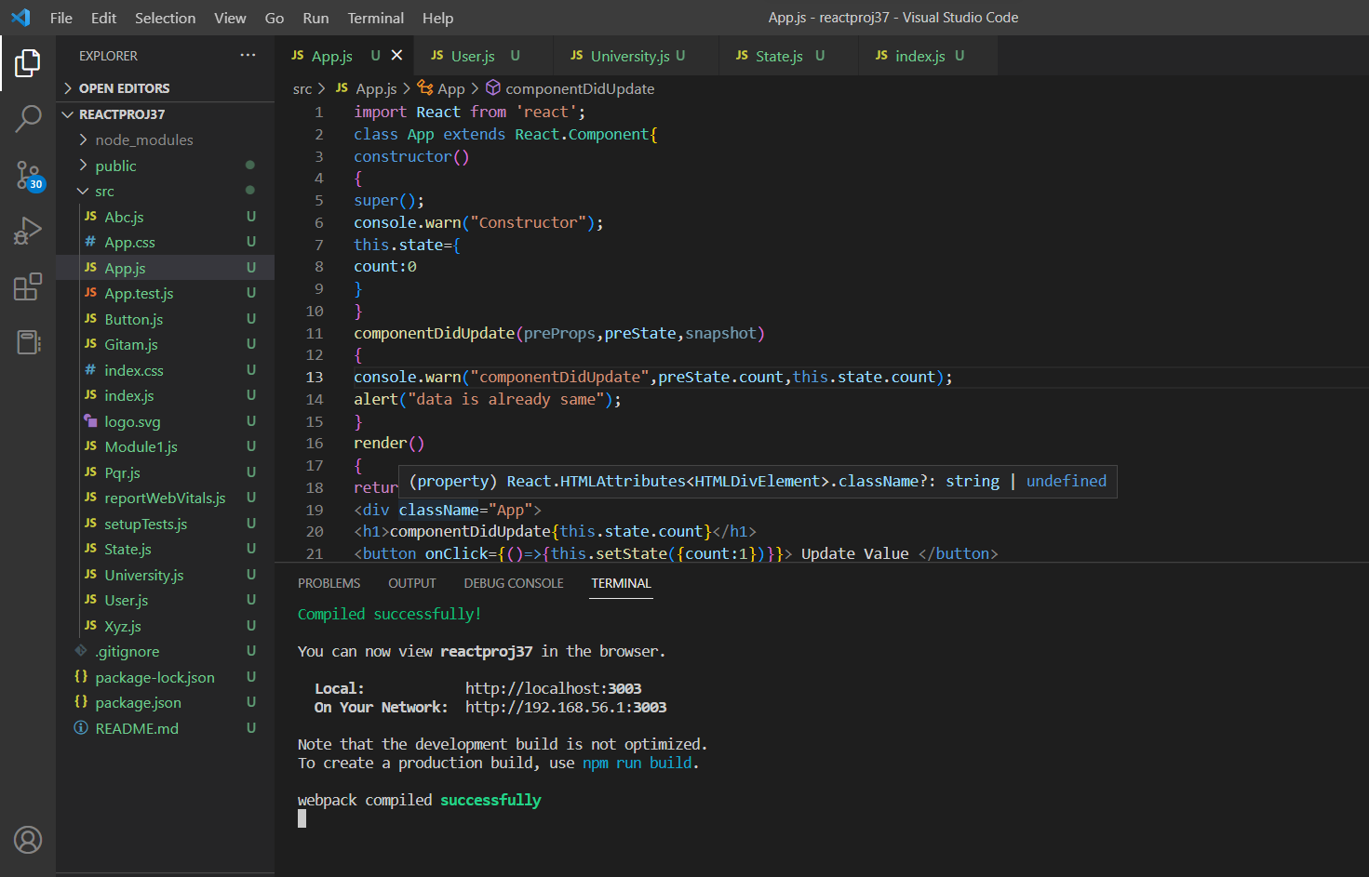

**Output:**

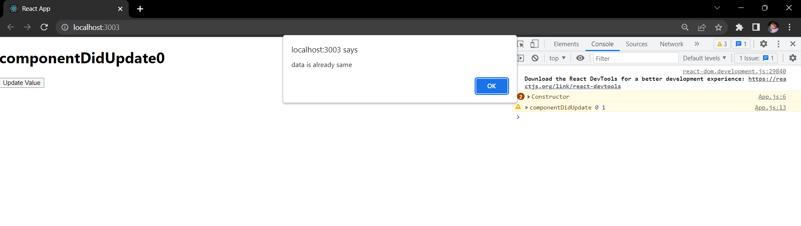

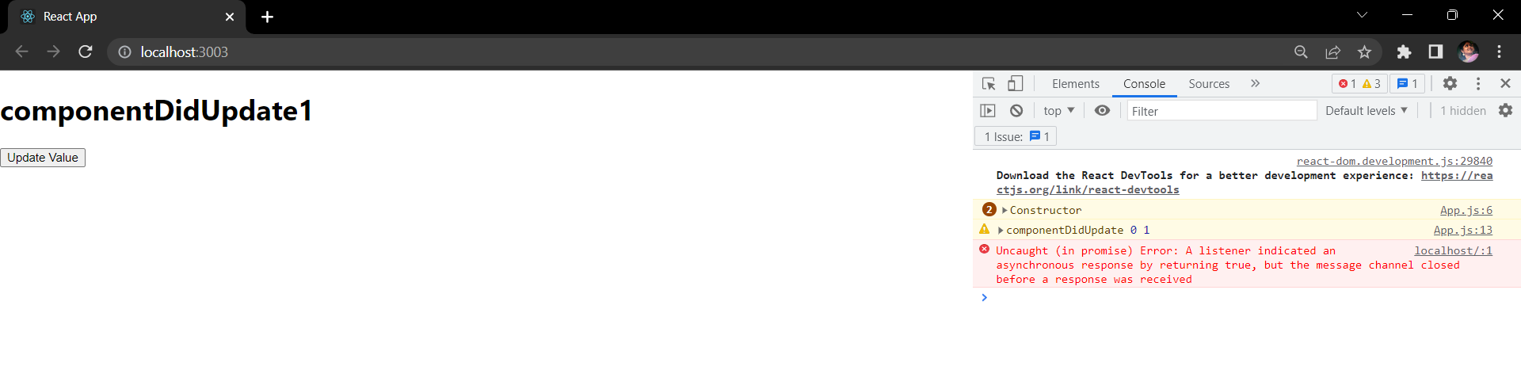

**3. Program on shouldComponentUpdate()**

**Code:**

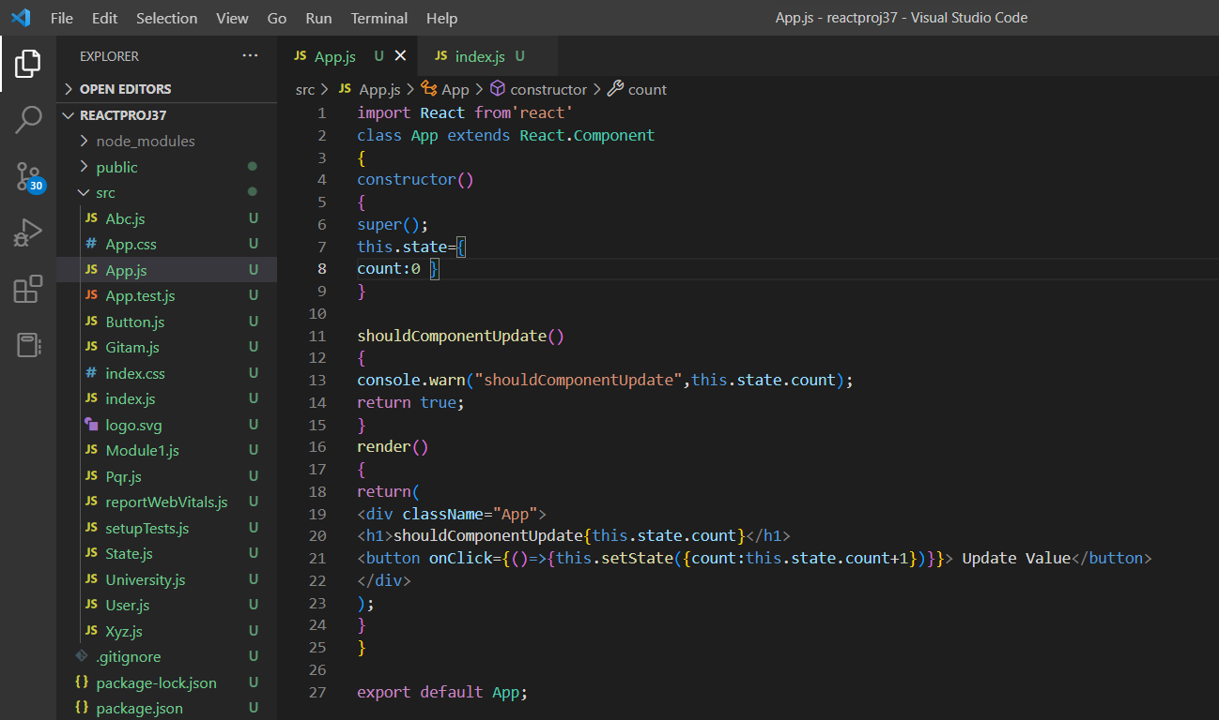

**Output:**

