**22-12-2022**

**NNVL SAI SUMA – 221910310037**

1. **useRef**

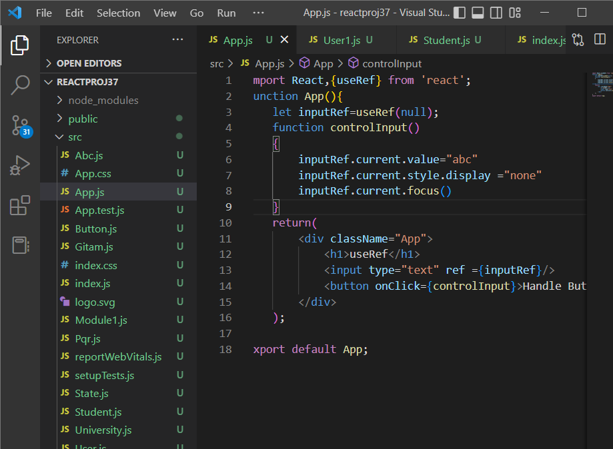

**Output:**

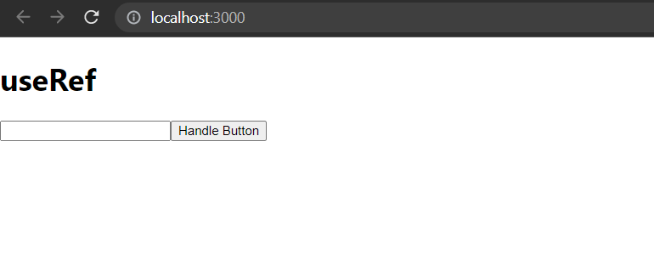

1. Create a class component with your name and in the class component the name of the state is display and if disaply is true, it need to call the class component orelse it need to display ur surname .
2. **Program on componentWillMount()**

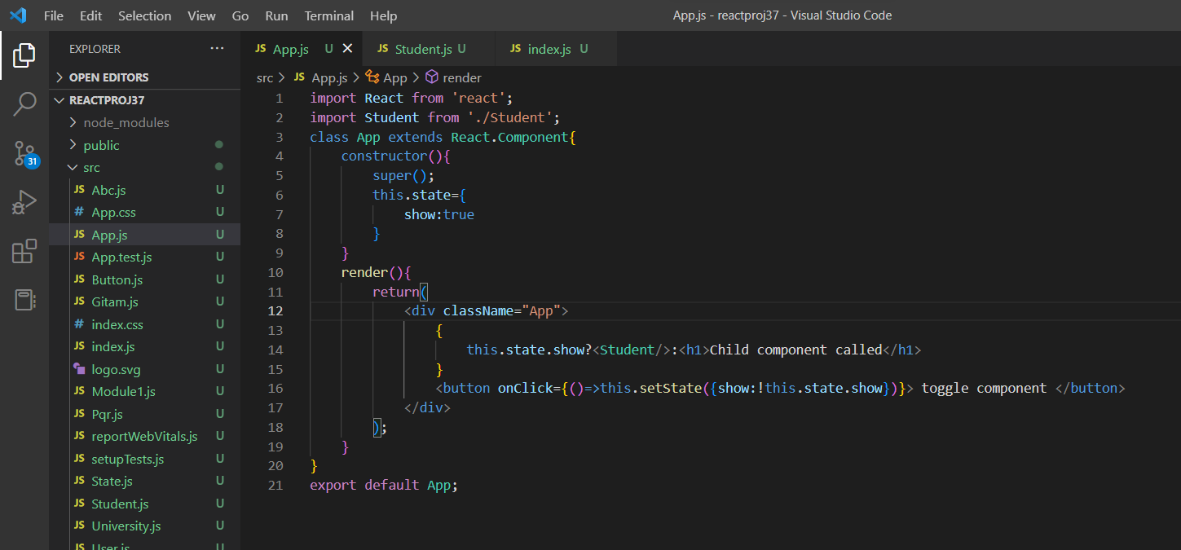

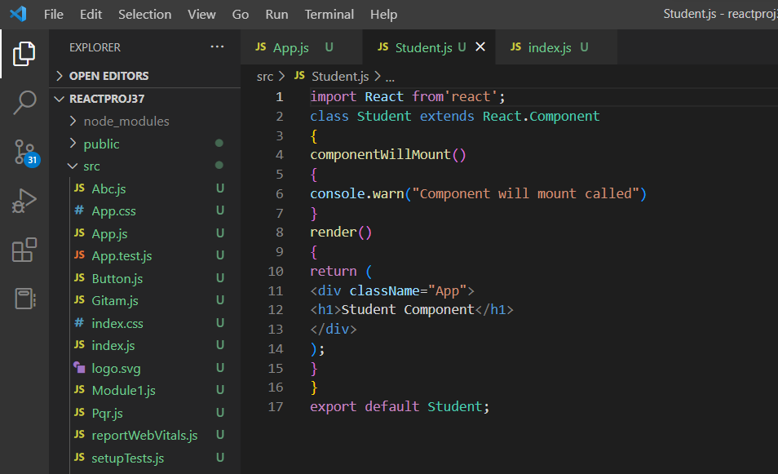

**Output:**

