NNVL SAI SUMA-221910310037

**Day 3 – (05/12/2022)**

1. **Program to implement a button (On Click event)**

**Button.js**

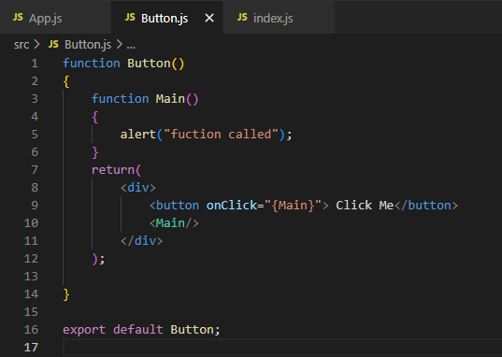

**App.js**

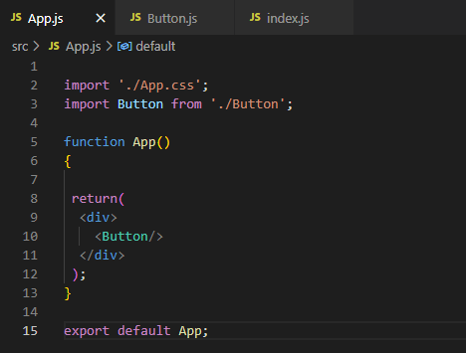

**Output :**

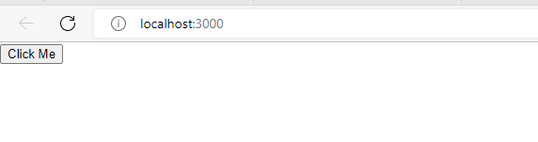

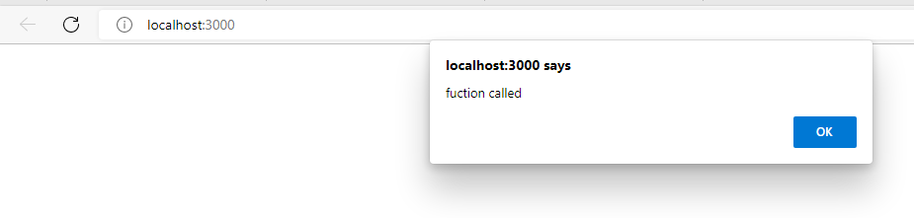

1. **Program to use the arrow function**

**App.js**

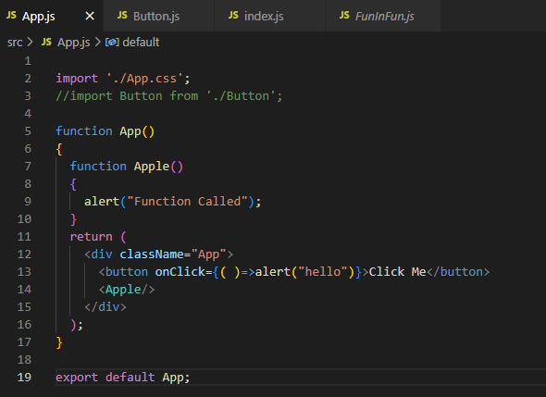

**Output :**

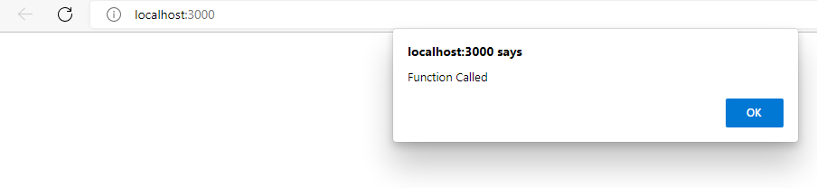

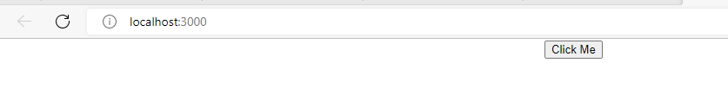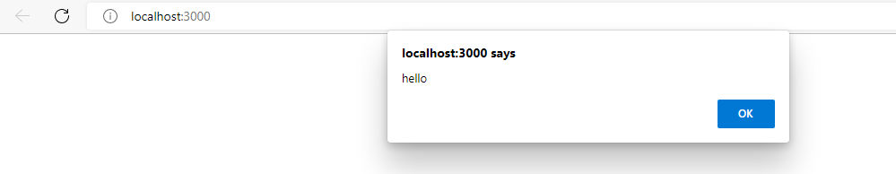

1. **Implementation of Class Component**

**University.js**

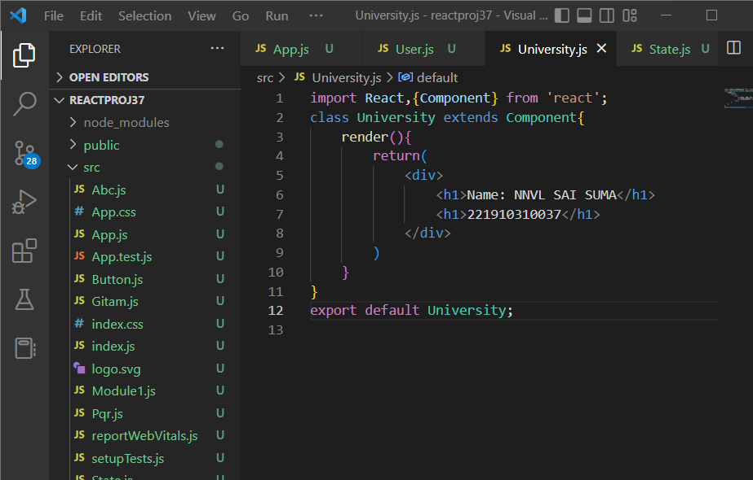

**App.js**

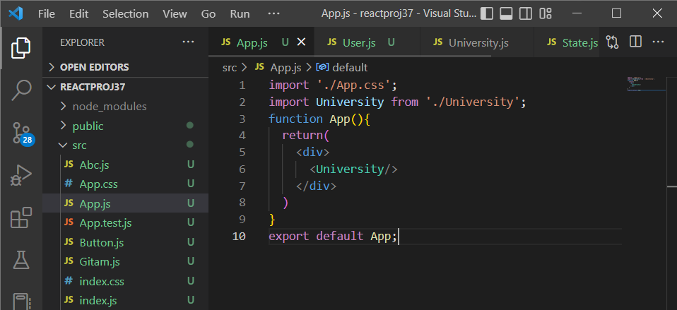

**Output:**

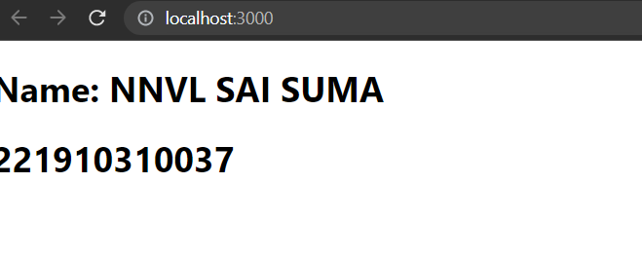

1. **Implementing the variables**

Use of the **let** keyword for declaring a variable

**App.js**

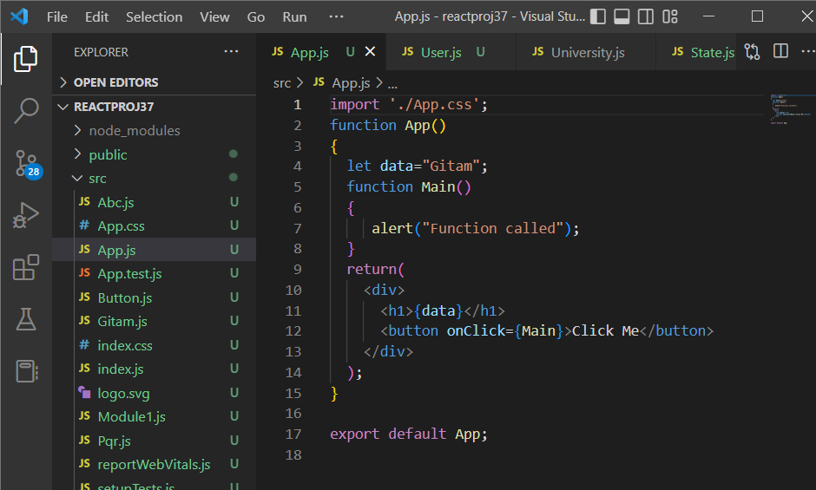

**Output :**

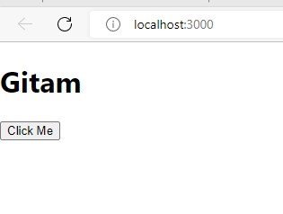

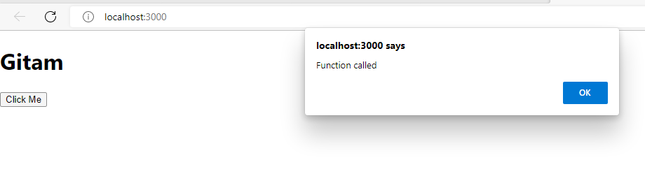

1. **Implementing the variables**

**The data will not be changed to the new value in the variables this is a drawback in the variables**

**App.js**

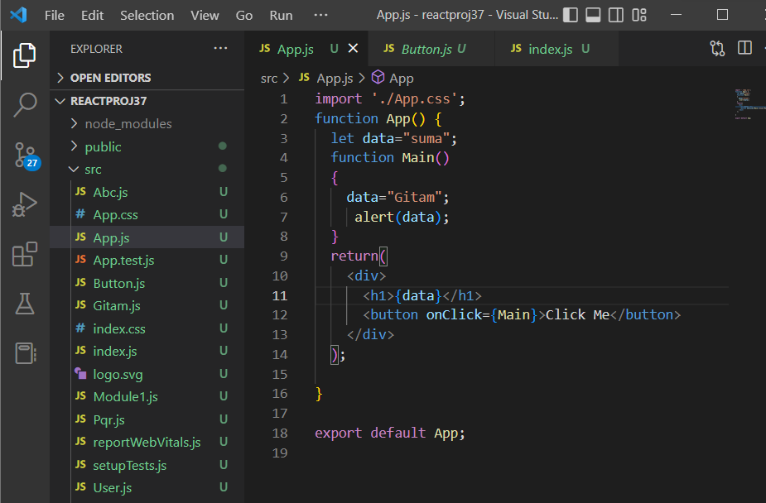

**Output :**

