**DAY 4**

**NNVL SAI SUMA – 221910310037**

1. **Program which explains the drawback of using Variables.**

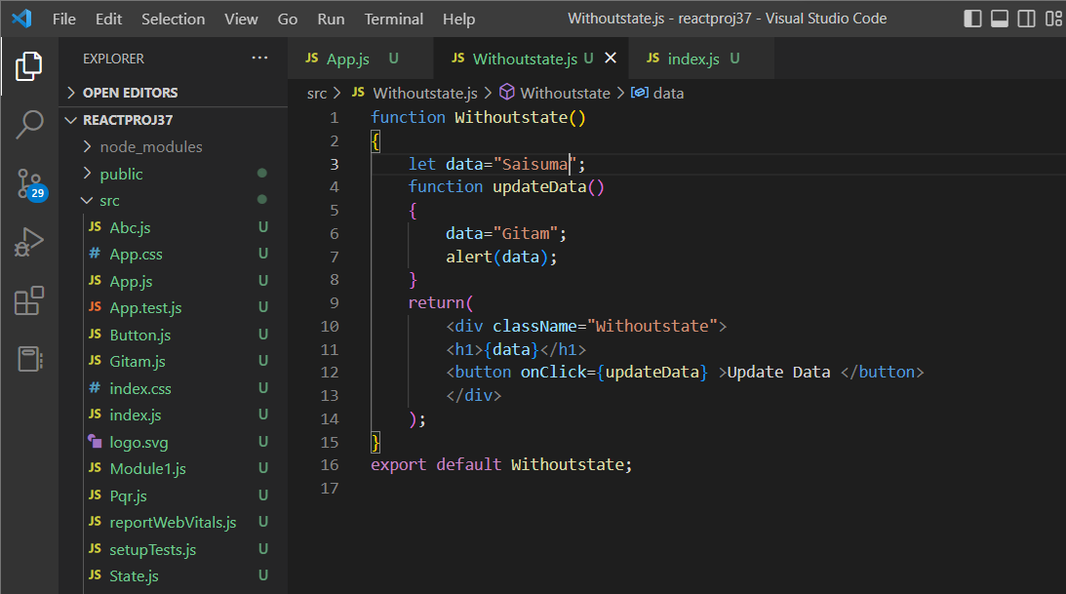

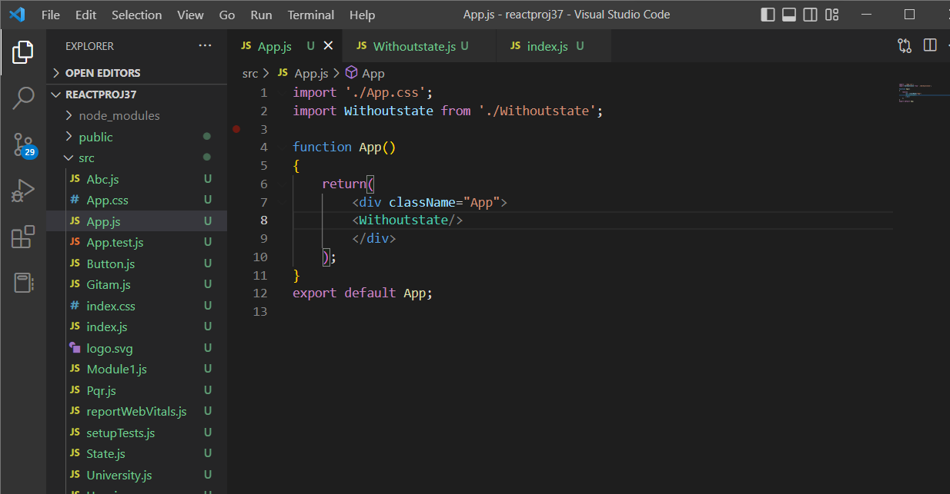

Output:

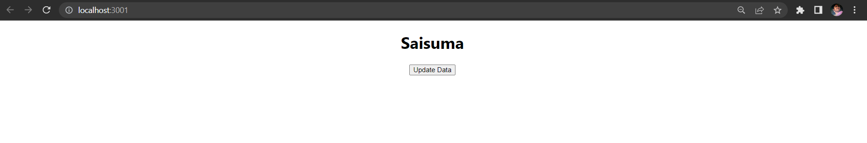

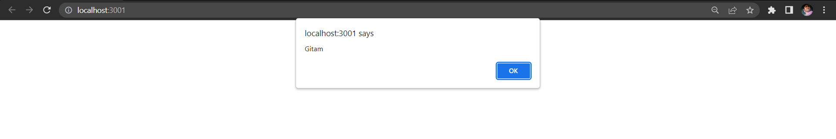

1. **Program to implement the state in functional component**

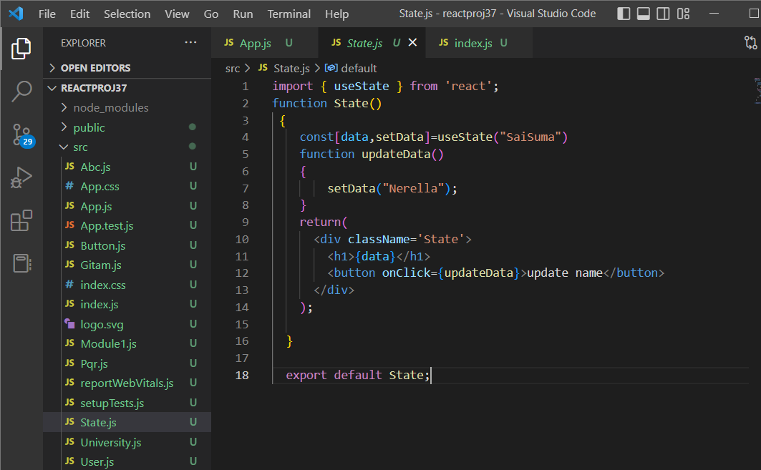

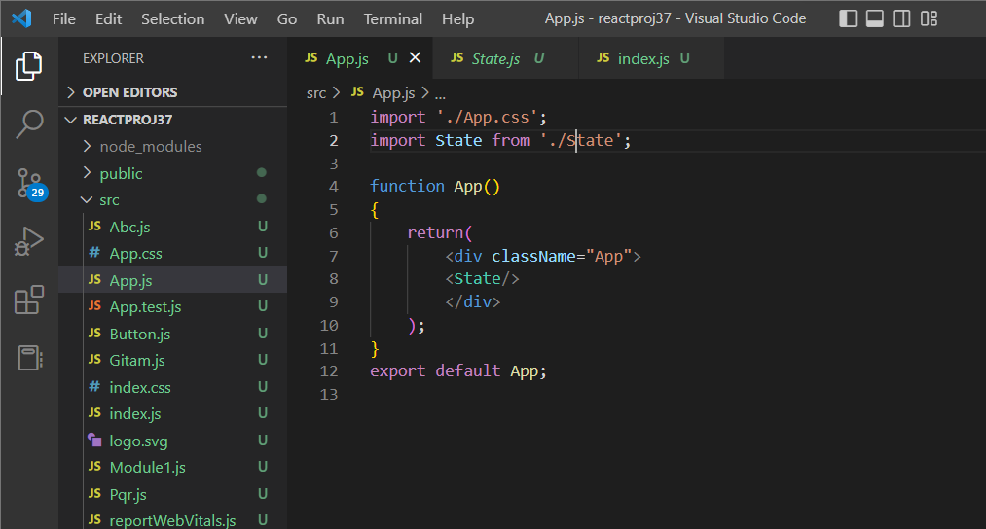

**Output:**

