**MACHINE LEARNING**

(Wine Quality Prediction)

Summer Internship Report Submitted in partial

Fulfillment of the requirement for undergraduate degree of

## Bachelor of Technology

In

## Computer Science and Engineering

By

## Paruchuri Sai Sumanth

## 221710312039

## *Under the Guidance of*

## Mrs. K. Neha

Assistant Professor



Department Of Computer Science and Engineering

GITAM School of Technology

GITAM (Deemed to be University) Hyderabad-502329

June 2020

**DECLARATION**

I **Paruchuri Sai Sumanth** submit this industrial training work entitled **“WINE QUALITY PREDICTION**” to GITAM (Deemed To Be University), Hyderabad in partial fulfillment of the requirements for the award of the degree of “**Bachelor of Technology**” in “**Computer Science and Engineering**”. I declare that it was carried out independently by me under the guidance of **Mrs. K. Neha**, Asst. Professor, GITAM (Deemed To Be University), Hyderabad, India.

The results embodied in this report have not been submitted to any other University or Institute for the award of any degree or diploma.

Place: HYDERAD **Paruchuri Sai Sumanth**

Date: **221710312039**



GITAM (DEEMED TO BE UNIVERSITY)

Hyderabad-502329, India

Date:

**CERTIFICATE**

This is to certify that the Industrial Training Report entitled **“WINE QUALITY PREDICTION”** is being submitted by **Paruchuri Sai Sumanth(221710312039)** in partial fulfillment of the requirement for the award of **Bachelor of Technology in Computer Science and Engineering** at GITAM (Deemed To Be University), Hyderabad during the academic year 2018-19

It is faithful record work carried out by her at the **Computer Science and Engineering Department**, GITAM University Hyderabad Campus under my guidance and supervision.

### **Mrs.K. Neha** **Dr.S. Phani Kumar**

Assistant Professor Professor and HOD

Department of CSE Department of CSE

**ACKNOWLEDGEMENT**

Apart from my effort, the success of this internship largely depends on the encouragement and guidance of many others. I take this opportunity to express my gratitude to the people who have helped me in the successful competition of this internship.

I would like to thank respected **Dr. N. Siva Prasad,** Pro Vice Chancellor, GITAM HYDERABAD

I would like to thank respected **Dr. S. Phani Kumar,** Head of the Department of Electronics and Communication Engineering for giving me such a wonderful opportunity to expand my knowledge for my own branch and giving me guidelines to present a internship report. It helped me a lot to realize of what we study for.

I would like to thank the respected faculties **Mrs. K. Neha** who helped me to make this internship a successful accomplishment.

I would also like to thank my friends who helped me to make my work more organized and well-stacked till the end.

**Paruchuri Sai Sumanth**

**221710312039**

## ABSTRACT

Machine learning algorithms are used to predict the values from the data set by splitting the data set in to train and test and building Machine learning algorithms models of higher accuracy to predict the values is the primary task to be performed on Cereals data set My perception of understanding the given data set has been in the view of undertaking a client’s requirement of overcoming the stagnant point of sales of the products being manufactured by client.

To get a better understanding and work on a strategical approach for solution of the client, I have adapted the view point of looking at ratings of the products and for further deep understanding of the problem, I have taken the stance of a consumer and reasoned out the various factors of choice of the products and they purchase , and my primary objective of this case study was to look up the factors which were dampening the sale of products and corelate them to ratings of products and draft out an outcome report to client regarding the various accepts of a product manufacturing , marketing and sale point determination

**TABLE OF CONTENTS**

|  |  |
| --- | --- |
| **S.No** | **CONTENTS** |
| **1.** | **MACHINE LEARNING** |
| **2.** | **PYTHON** |
| **3.** | **CASE STUDY** |
| **4.** | **MODEL BUILDING** |
| **5.** | **MODELLING** |
| **6.** | **CONCLUSION** |
| **7.** | **REFERENCES** |

**PageNo.**

5-9

9-18

19-20

21-42

43-56

57

58

**CHAPTER 1**

**MACHINE LEARNING**

**1.1 INTRODUCTION:**

Machine Learning (ML) is the scientific study of algorithms and statistical models that computer systems use in order to perform a specific task effectively without using explicit instructions, relying on patterns and inference instead. It is seen as a subset of Artificial Intelligence(AI).

**1.2 IMPORTANCE OF MACHINE LEARNING:**

Consider some of the instances where machine learning is applied: the self-driving Google car, cyber fraud detection, online recommendation engines—like friend suggestions on Facebook, Netflix showcasing the movies and shows you might like, and “more items to consider” and “get yourself a little something” on Amazon—are all examples of applied machine learning. All these examples echo the vital role machine learning has begun to take in today’s data-rich world.

Machines can aid in filtering useful pieces of information that help in major advancements, and we are already seeing how this technology is being implemented in a wide variety of industries.

With the constant evolution of the field, there has been a subsequent rise in the uses, demands, and importance of machine learning. Big data has become quite a buzzword in the last few years; that’s in part due to increased sophistication of machine learning, which helps analyze those big chunks of big data. Machine learning has also changed the way data extraction, and interpretation is done by involving automatic sets of generic methods that have replaced traditional statisticaltechniques.

The process flow depicted here represents how machine learning works

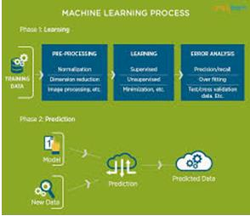

Figure 1 : The Process Flow

**1.3 USES OF MACHINE LEARNING:**

Earlier in this article, we mentioned some applications of machine learning. To understand the concept of machine learning better, let’s consider some more examples: web search results, real-time ads on web pages and mobile devices, email spam filtering, network intrusion detection, and pattern and image recognition. All these are by-products of applying machine learning to analyze huge volumes of data

Traditionally, data analysis was always being characterized by trial and error, an approach that becomes impossible when data sets are large and heterogeneous. Machine learning comes as the solution to all this chaos by proposing clever alternatives to analyzing huge volumes of data.

By developing fast and efficient algorithms and data-driven models for real-time processing of data, machine learning can produce accurate results and analysis.

**1.4 TYPES OF LEARNING ALGORITHMS:**

The types of machine learning algorithms differ in their approach, the type of data they input and output, and the type of task or problem that they are intended to solve.

**1.4.1 Supervised Learning :**

When an algorithm learns from example data and associated target responses that can consist of numeric values or string labels, such as classes or tags, in order to later predict the correct response when posed with new examples comes under the category of supervised learning.

Supervised machine learning algorithms uncover insights, patterns, and relationships from a labelled training dataset – that is, a dataset that already contains a known value for the target variable for each record. Because you provide the machine learning algorithm with the correct answers for a problem during training, it is able to “learn” how the rest of the features relate to the target, enabling you to uncover insights and make predictions about future outcomes based on historical data.

Examples of Supervised Machine Learning Techniques are Regression, in which the algorithm returns a numerical target for each example, such as how much revenue will be generated from a new marketing campaign.

Classification, in which the algorithm attempts to label each example by choosing between two or more different classes. Choosing between two classes is called binary classification, such as determining whether or not someone will default on a loan. Choosing between more than two classes is referred to as multiclass classification.

**1.4.2 Unsupervised Learning:**

When an algorithm learns from plain examples without any associated response, leaving to the algorithm to determine the data patterns on its own. This type of algorithm tends to restructure the data into something else, such as new features that may represent a class or a new series of uncorrelated values. They are quite useful in providing humans with insights into the meaning of data and new useful inputs to supervised machine learning algorithms.

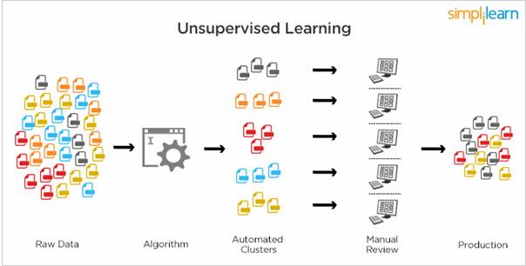

Figure 2 : Unsupervised Learning

Popular techniques where unsupervised learning is used also include self-organizing maps, nearest neighbor mapping, singular value decomposition, and k-means clustering. Basically, online recommendations, identification of data outliers, and segment text topics are all examples of unsupervised learning.

**1.4.3 Semi Supervised Learning:**

As the name suggests, semi-supervised learning is a bit of both supervised and unsupervised learning and uses both labeled and unlabeled data for training. In a typical scenario, the algorithm would use a small amount of labeled data with a large amount of unlabeled data.

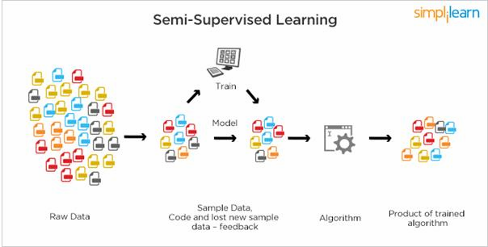

Figure 3 : Semi Supervised Learning

**1.5** **RELATION BETWEEN DATA MINING,MACHINE LEARNING AND DEEP LEARNING:**

Machine learning and data mining use the same algorithms and techniques as data mining, except the kinds of predictions vary. While data mining discovers previously unknown patterns and knowledge, machine learning reproduces known patterns and knowledge—and further automatically applies that information to data, decision-making, and actions.

Deep learning, on the other hand, uses advanced computing power and special types of neural networks and applies them to large amounts of data to learn, understand, and identify complicated patterns. Automatic language translation and medical diagnoses are examples of deep learning.

**CHAPTER 2**

**PYTHON**

Basic programming language used for machine learning is : PYTHON

**2.1 INTRODUCTION TO PYHTON:**

* + - Python is a high-level, interpreted, interactive and object-oriented scriptinglanguage.
    - Python is a general purpose programming language that is often applied in scripting roles
    - Python is Interpreted: Python is processed at runtime by the interpreter. You do not need to compile your program before executing it. This is like PERL andPHP.
    - Python is Interactive: You can sit at a Python prompt and interact with the interpreter directly to write yourprograms.
    - Python is Object-Oriented: Python supports the Object-Oriented style or technique of programming that encapsulates code withinobjects.
  1. **HISTORY OF PYTHON:**
* Python was developed by GUIDO VAN ROSSUM in early 1990’s
* Its latest version is 3.7 , it is generally called as python3

**2.3 FEATURES OF PYTHON:**

* + - Easy-to-learn: Python has few keywords, simple structure, and a clearly definedsyntax,This allows the student to pick up the language quickly.
    - Easy-to-read: Python code is more clearly defined and visible to theeyes.
    - Easy-to-maintain: Python's source code is fairlyeasy-to-maintaining.
    - A broad standard library: Python's bulk of the library is very portable andcross-platform compatible on UNIX, Windows, andMacintosh.
    - Portable: Python can run on a wide variety of hardware platforms and has the same interface on allplatforms.
    - Extendable: You can add low-level modules to the Python interpreter. Thesemodules enable programmers to add to or customize their tools to be moreefficient.
    - Databases: Python provides interfaces to all major commercialdatabases.
    - GUI Programming: Python supports GUI applications that can be created and ported to many system calls, libraries and windows systems, such as Windows MFC, Macintosh, and the X Window system ofUnix.
  1. **HOW TO SETUP PYTHON:**
* Python is available on a wide variety of platforms including Linux and Mac OS X.Let's understand how to set up our Pythonenvironment.
* The most up-to-date and current source code, binaries, documentation, news, etc.,is available on the official website ofPython.

**2.4.1 Installation(using python IDLE):**

* Installing python is generally easy, and nowadays many Linux and Mac OS distributions include a recent python.
* Download python from www.python.org
* When the download is completed, double click the file and follow the instructions to install it.
* When python is installed, a program called IDLE is also installed along with it. It provides a graphical user interface to work with python.

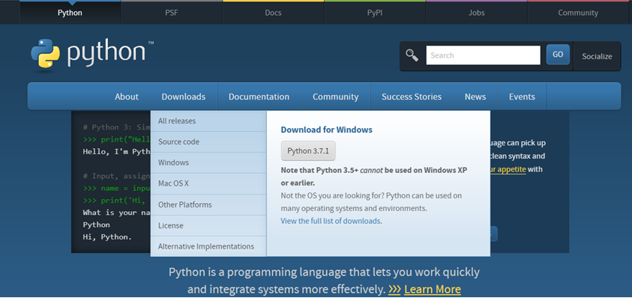

Figure 4 : Python download

**2.4.2 Installation(using Anaconda):**

* Python programs are also executed using Anaconda.
* Anaconda is a free open source distribution of python for large scale data processing, predictive analytics and scientific computing.
* Conda is a package manager quickly installs and manages packages.
* In WINDOWS:
* In windows
* Step 1: Open Anaconda.com/downloads in web browser.
* Step 2: Download python 3.4 version for (32-bitgraphic installer/64 -bit graphic installer)
* Step 3: select installation type( all users)
* Step 4: Select path(i.e.add anaconda to path & register anaconda as default python 3.4) next click install and next click finish
* Step 5: Open jupyter notebook ( it opens in default browser)

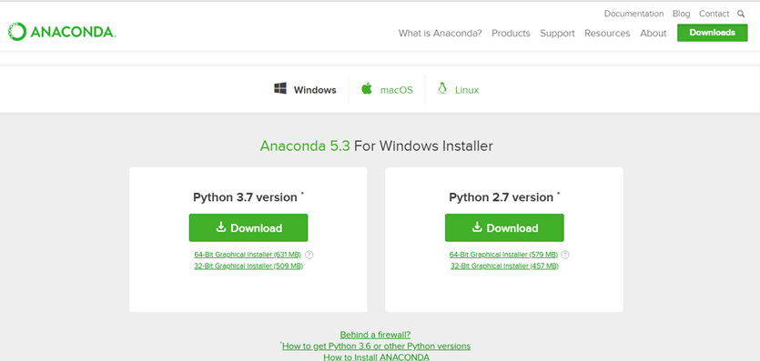

Figure 5 : Anaconda download

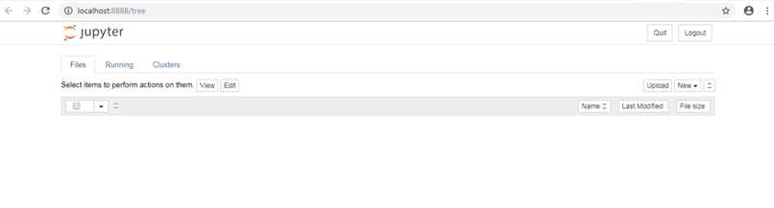

Figure 6 :Jupyter notebook

**2.5 PYTHON VARIABLE TYPES:**

* Variables are nothing but reserved memory locations to store values. This meansthat when you create a variable you reserve some space inmemory.
* Variables are nothing but reserved memory locations to store values.
* Based on the data type of a variable, the interpreter allocates memory and decides what can be stored in the reserved memory.
* Python variables do not need explicit declaration to reserve memory space. The declaration happens automatically when you assign a value to a variable.
* Python has various standard data types that are used to define the operations possible on them and the storage method for each ofthem.
* Python has five standard data types–
  + Numbers
  + Strings
  + Lists
  + Tuples
  + Dictionary

**2.5.1 Python Numbers:**

* + - Number data types store numeric values. Number objects are created when you assigna value tothem.
    - Python supports four different numerical types − int (signed integers) long (long integers, they can also be represented in octal and hexadecimal) float (floatingpoint real values) complex (complexnumbers).

**2.5.2 Python Strings:**

* Strings in Python are identified as a contiguous set of characters represented inthe quotationmarks.
* Python allows for either pairs of single or double quotes.
* Subsets of strings can be taken using the slice operator ([ ] and [:] ) with indexesstarting at 0 in the beginning of the string and working their way from -1 at theend.
* The plus (+) sign is the string concatenation operator and the asterisk (*) is the repetition operator.

**2.5.3Python Lists:**

* + - Lists are the most versatile of Python's compound datatypes.
    - A list contains items separated by commas and enclosed within square brackets([]).
    - To some extent, lists are similar to arrays in C. One difference between them is that all the items belonging to a list can be of different datatype.
    - The values stored in a list can be accessed using the slice operator ([ ] and [:]) with indexes starting at 0 in the beginning of the list and working their way to end-1.
    - The plus (+) sign is the list concatenation operator, and the asterisk (*) is the repetition operator.

**2.5.4 Python Tuples:**

* A tuple is another sequence data type that is similar to thelist.
* A tuple consists of a number of values separated by commas. Unlike lists,however, tuples are enclosed withinparentheses.
* The main differences between lists and tuples are: Lists are enclosed in brackets ( [ ] ) and their elements and size can be changed, while tuples are enclosed in parentheses ( () ) and cannot be updated.
* Tuples can be thought of as read-onlylists.
* For example − Tuples are fixed size in nature whereas lists are dynamic. In other words, a tuple is immutable whereas a list is mutable. You can't add elements to a tuple. Tuples have no append or extend method. You can't remove elements from a tuple. Tuples have no remove or pop method.
  + 1. **Python Dictionary:**
* Python's dictionaries are kind of hash table type. They work like associative arrays or hashes found in Perl and consist of key-value pairs. A dictionary key can be almost any Python type, but are usually numbers or strings. Values, on the other hand, can be any arbitrary Pythonobject.
* Dictionaries are enclosed by curly braces ({ }) and values can be assigned andaccessed using square braces([]).
* You can use numbers to "index" into a list, meaning you can use numbers to find out what's in lists. You should know this about lists by now, but make sure youunderstand that you can only use numbers to get items out of alist.
* What a dict does is let you use anything, not just numbers. Yes, a dict associates one thing to another, no matter what itis.

**2.6PYTHON FUNCTION:**

**2.6.1 Defining a Function:**

You can define functions to provide the required functionality. Here are simple rules to define a function in Python. Function blocks begin with the keyword def followed by the function name and parentheses (i.e.()).

Any input parameters or arguments should be placed within these parentheses. You can also define parameters inside these parentheses

The code block within every function starts with a colon (:) and is indented. The statement returns [expression] exits a function, optionally passing back an expression to the caller. A return statement with no arguments is the same as return None.

**2.6.2 Calling a Function:**

Defining a function only gives it a name, specifies the parameters that aretobeincludedinthefunctionandstructurestheblocksofcode. Once the basic structure of a function is finalized, you can execute it by calling it from another function or directly fromthe Pythonprompt.

**2.7 PYTHON USING OOP’s CONCEPTS:**

* + 1. **Class:**
* Class: A user-defined prototype for an object that defines a set of attributes that characterize any object of the class. The attributes are data members (class variablesand instance variables) and methods, accessed via dotnotation.
* Class variable: A variable that is shared by all instances of a class. Class variables are defined within a class but outside any of the class's methods. Class variables are not used as frequently as instance variablesare.
* Data member: A class variable or instance variable that holds data associated witha class and itsobjects.
* Instance variable: A variable that is defined inside a method and belongs only to the current instance of aclass.
* Defining a Class:
  + We define a class in a very similar way how we define a function.
  + Just like a function ,we use parentheses and a colon after the class name(i.e. ():) when we define a class. Similarly, the body of our class is indented like a functions body is.

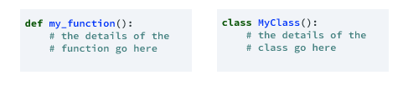

Figure 7 : Defining a Class

**2.7.2 __init__ method in Class:**

* The init method — also called a constructor — is a special method that runs when an instance is created so we can perform any tasks to set up the instance.
* The init method has a special name that starts and ends with two underscores:__init__().

**CHAPTER 3**

**CASE STUDY**

**3.1 PROBLEM STATEMENT:**

To predict the amount of purchases in Retail shop using Machine Learning algorithm called MULTIPLE LINEAR REGRESSION

**3.2 DATA SET:**

The given data set consists of the following parameters:

A - fixed_acidity

B - volatile_acidity

C - citric_acid

D - residual_sugar

E - chlorides

F - free_sulfur_dioxide

G - total_sulfur_dioxide

H - density

I - pH

J - sulphates

K - alcohol

L –quality

M- color

N- dtype: object

**3.3 OBJECTIVE OF THE CASE STUDY:**

To get a better understanding and chalking out a plan of action for solution of the client, we have adapted the view point of looking at product categories and for further deep understanding of the problem, we have also considered gender age of the customer and reasoned out the various factors of choice of the products and they purchase , and our primary objective of this case study was to look up the factors which were dampening the sale of products and corelate them to product categories and draft out an outcome report to client regarding the various accepts of a product purchases.

**CHAPTER 4**

**MODEL BUILDING**

**4.1 PREPROCESSING OF THE DATA:**

Preprocessing of the data actually involves the following steps:

**4.1.1 GETTING THE DATASET:**

We can get the data set from the database or

we can get the data from client.

**4.1.2 IMPORTING THE LIBRARIES:**

We have to import the libraries as per the requirement of the algorithm.

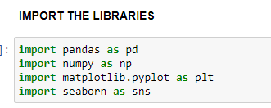

Figure 8 : Importing Libraries

**4.1.3 IMPORTING THE DATA-SET:**

Pandas in python provide an interesting method read_csv(). The read_csv function reads the entire dataset from a comma separated values file and we can assign it to a DataFrame to which all the operations can be performed.It helps us to access each and every row as well as columns and each and every value can be access using the dataframe. Any missing value or NaNvalue have to be cleaned.

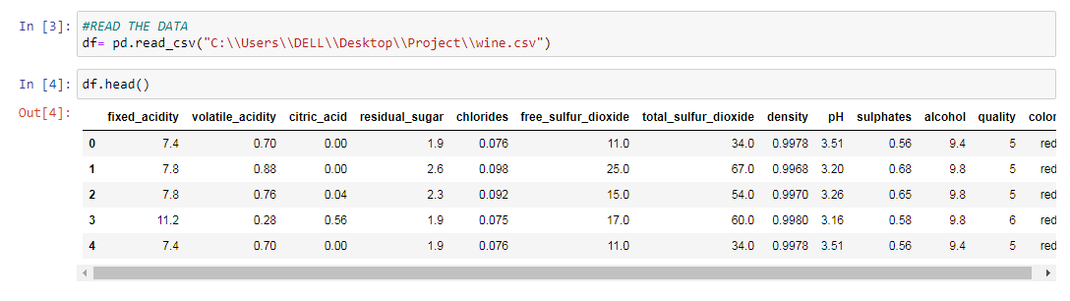

Figure 9 : Reading the dataset

**4.1.4 SHAPE OF DATA:**

This displays the no.of coloumns and no.of rows in the given data set

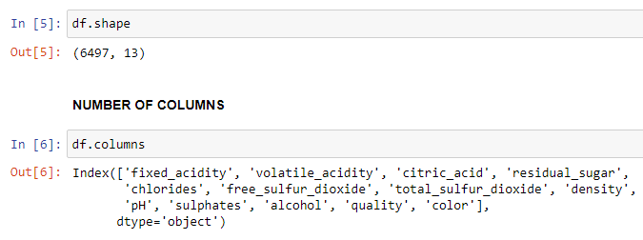

**DATA TYPES IN THE DATA:**

This displays the data types of the data in the given datset.From the given data we can observe that all are in integer type except the color

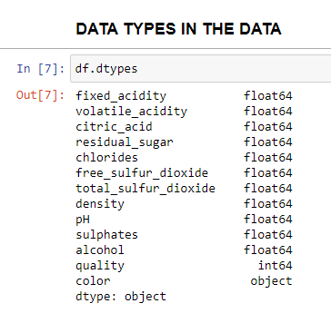

**CHECKING FOR ANY MISSING DATA:**

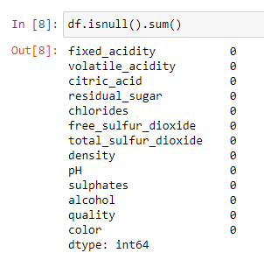

There are no missing values in the data we can observe from the data

**GETTING THE INFORMATION OF ALL UNIQUE DATA**

There are many unique values in the dataset

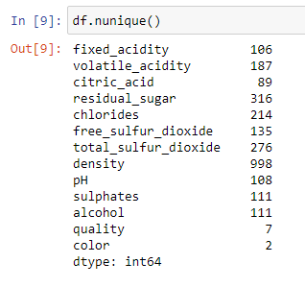

**DESCRIBE THE DATA**

From this describe function we can observe that that data is described in many ways

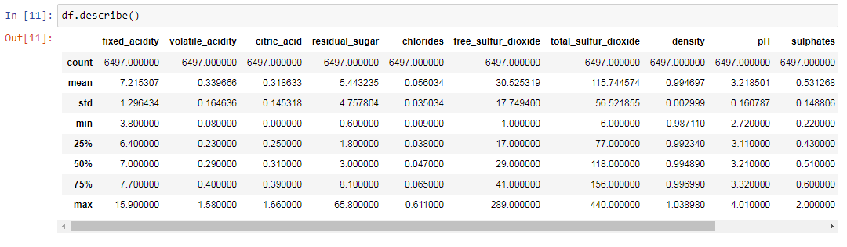

**CHECK THE NUMBER OF QUALITY RANGES**

From this we can observe the different number of quality of divided acoording to there quality content as we are taking quality content as the the main data to predict.

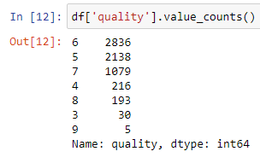

**NUMBER OF WHITE AND RED WINE**

Counting the number of white wine and red wine we can see there are many of the white wine

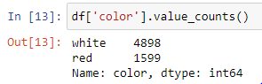

**PLOTTING NUMBER OF RED AND WHITE WINE ON GRAPH**

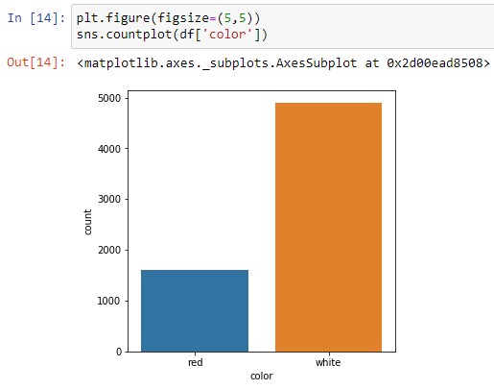We are then plotting the the number of red wine and white wine on the bargraph from good understanding

**PLOTTING QUALITY OF RED AND WHITE WINE ON GRAPH**

From this graph we can show thatquality 6 is having is highest number number of wine quality

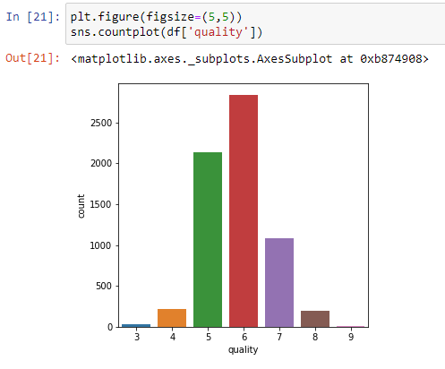

**KNOWING THE MISSING VALUES**

Checking for missing values by plotting missing graph

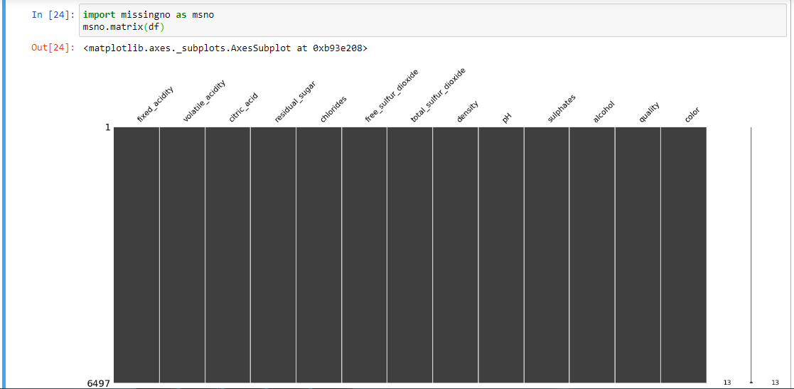

**MISSING VALUES ON BAR GRAPH**

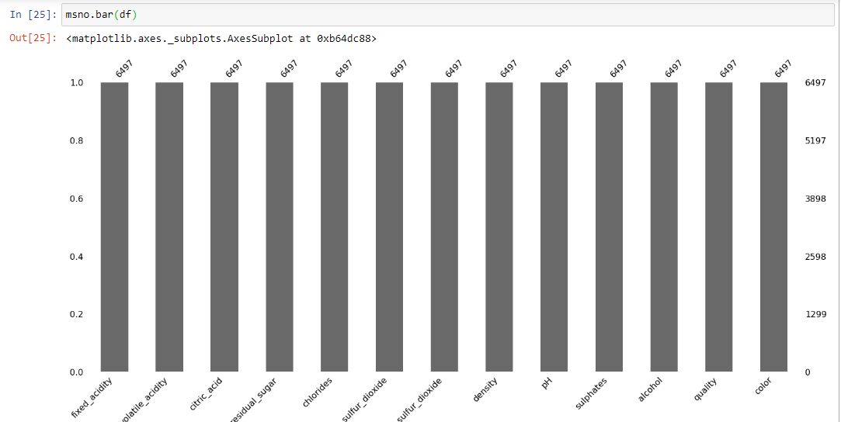

**GRAPH BETWEEN COMPARISION BETWEEN BOTH THE WINES**

Comparing between the quality by there color and white wine has more number quality wine

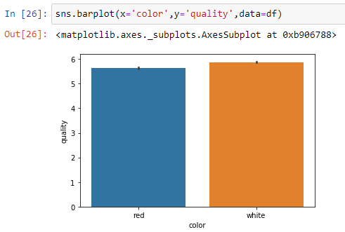

**SHOWING THE DATA ON GRAPH**

Plotting countplot between the number of quality on there color. As white wine is more it shows more number of count

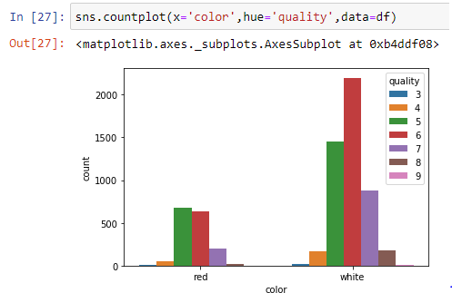

**DRAWING A HISTOGRAM**

Histogram is drawn to show the graph comparison between the all the other columns of the data

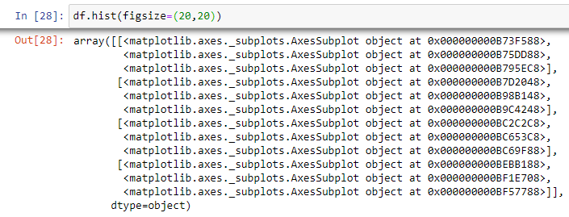

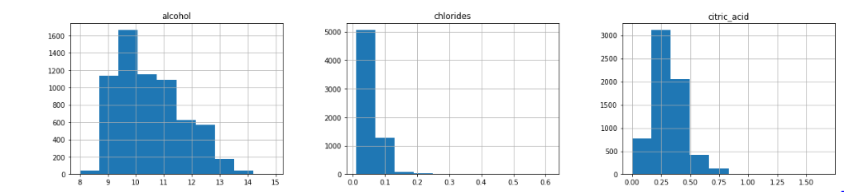

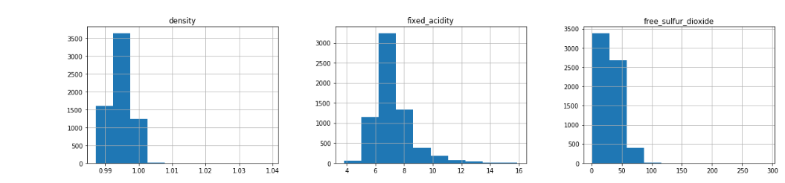

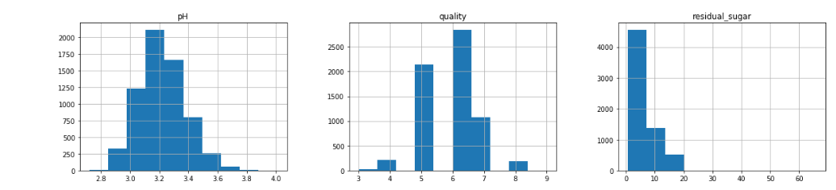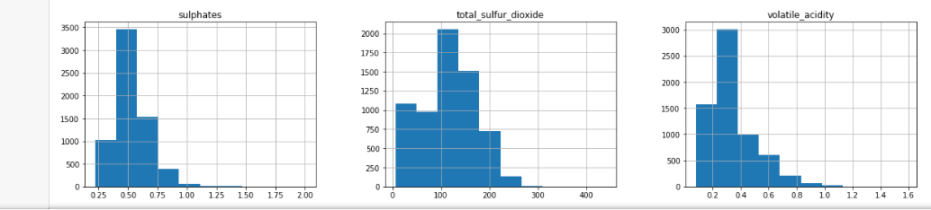

**HEATMAP**

It graphical representation of data where the individual values contained in a matrix are represented as colors

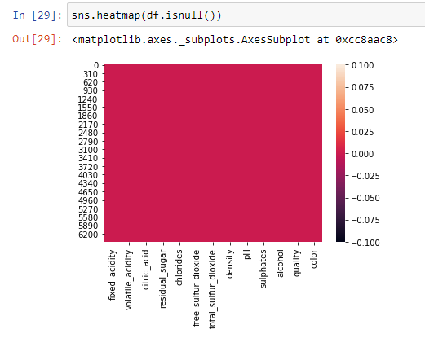

**4.1.5 CATEGORICAL DATA:**

* Machine Learning models are based on equations, we need to replace the text by numbers. So that we can include the numbers in the equations.
* Categorical Variables are of two types: Nominal and Ordinal
* **Nominal**: The categories do not have any numeric ordering in between them. They don't have any ordered relationship between each of them.Examples: Male or Female, any colour
* **Ordinal**: The categories have a numerical ordering in between them. Example: Graduate is less than Post Graduate, Post Graduate is less than Ph.D. customer satisfaction survey, high low medium
* Categorical data can be handled by using dummy variables, which are also called as indicator variables.

**HISTOGRAM OF QUALITY**

The quality of the data set is represented in the form of histogram

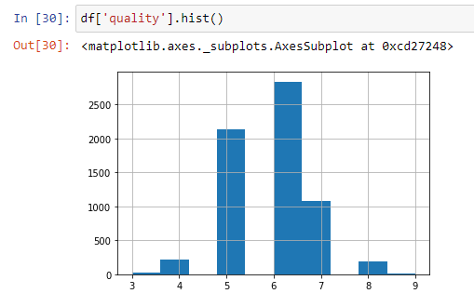

**DISTPLOT IS DRAWN TO KNOW THE QUALITY**

The values are plotted on the Distplot for the better understanding if the data set

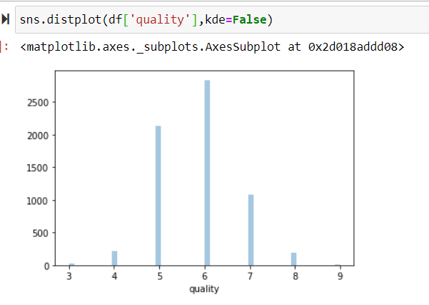

## USING THE HEATMAP TO GET THE BETTER UNDERSTANDING OF THE DATA

## WE CAN USE THE DATA TO COMPAIR THE VALUES

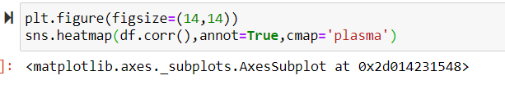

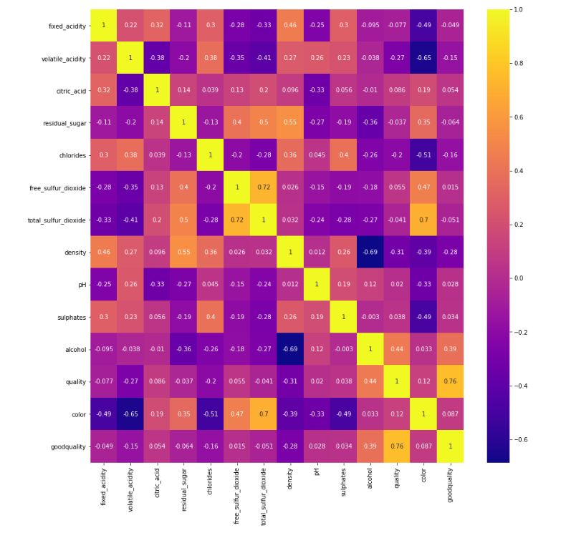

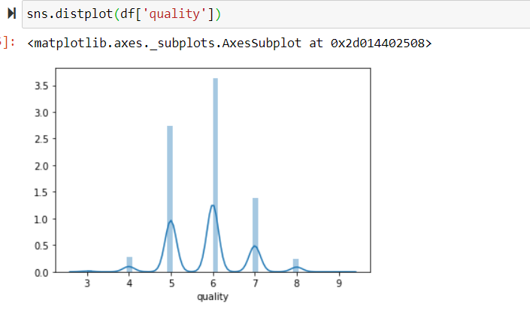

**CATPLOT BETWEEN COLOR AND QUALITY**

This plots show relationship between numerical variable and one or more categorical variables, like boxplot, stripplot and so

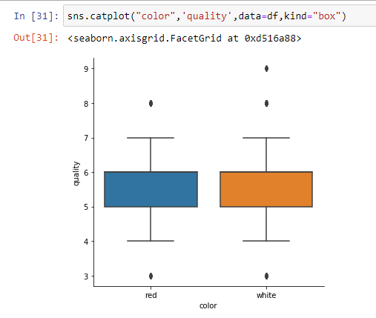

**CHECKING THE QUALITY MORE THAN 7**

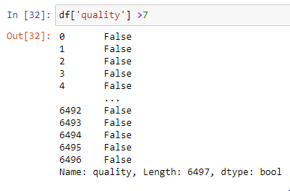

**DIFFRENTIATING THE DATA ON GOOD OR BAD**

We are here differentiating the data for better understanding.

So here I made good wine quality as more than 7 and bad less than 7 is bad. Here I made clarity of the data by giving checking them

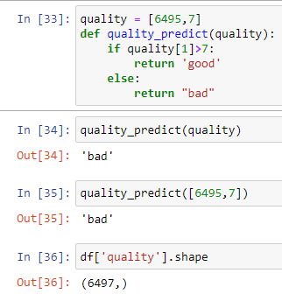

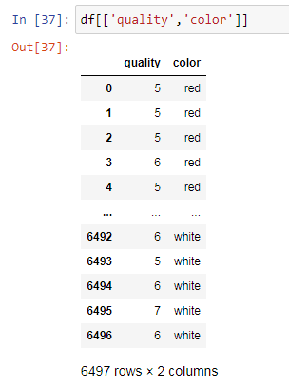

DIFFERENTIATING THE QUALITY

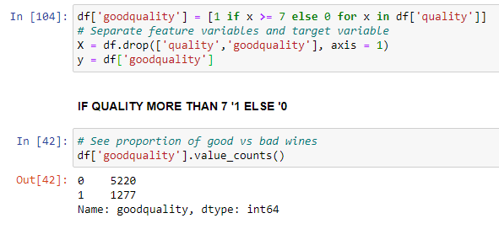

PLOTTING THEM ON PIE CHART

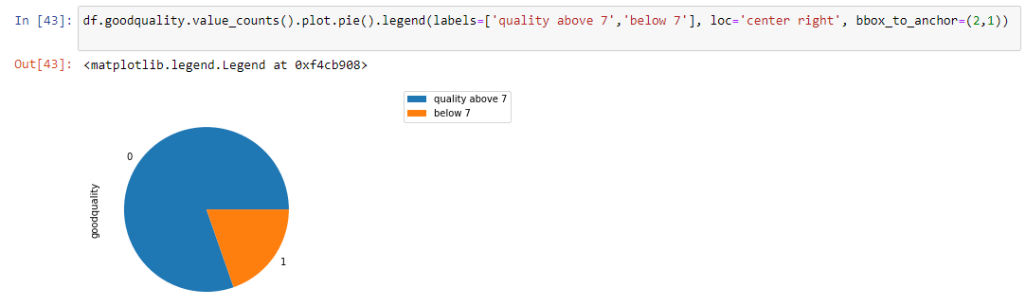

COUNT OF COLOR

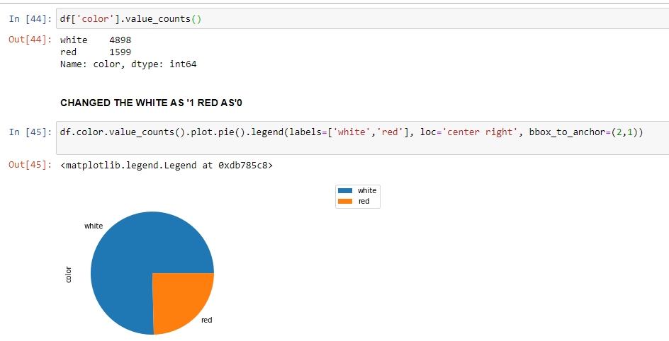

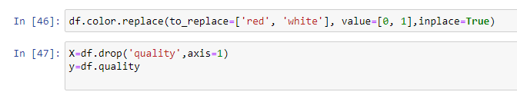

Here we made X and Y by dropping the quality and we use this to check

CHECKING THE DATATYPES

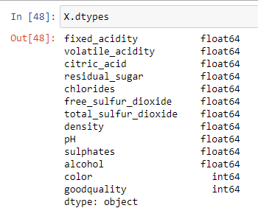

**4.2 TRAINING AND TESTING THE DATA MODEL:**

In this we are taking the data of quality in the data set.Here we didn’t make any differentiation between quality we are taking the whole quality and testing the data for our better understanding

* Import the train_test_split from model_selection package from scikitlearn library
* Then assigning the output to four different variables, before assigning we have to mention the train size or test size as a parameter to train_test_split. Then this method will split according to the size and assigns it to four variables.

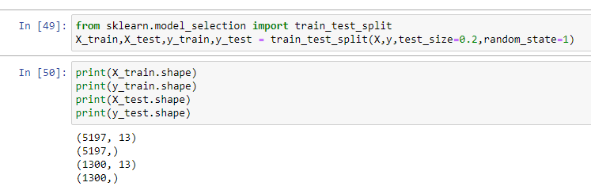

Here we are using decisiontreeclassifier and understanding the data here we gave criterion as ‘entropy’ and we are checking the classification report

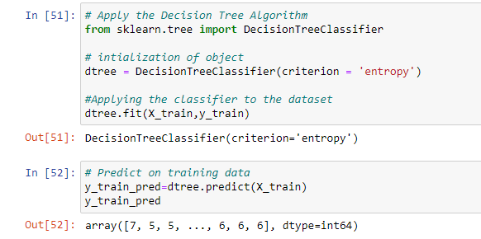



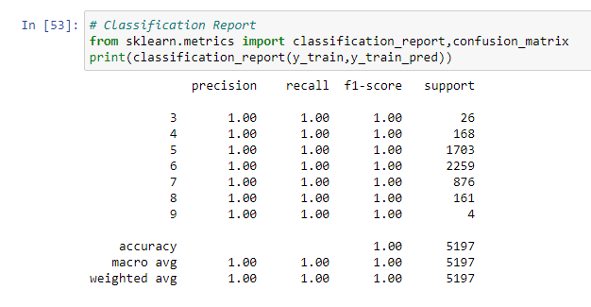

**From this confusion matrix we can check the number of correct and indirect predictions**

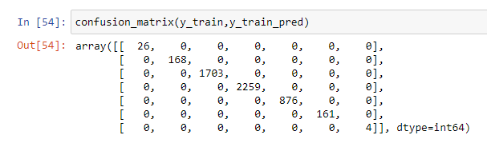

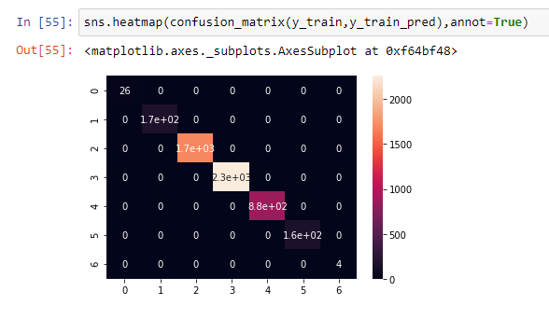

From this heat map we can observe that my data are predicted

**Preparing Data for Modeling**

**Standardizing Feature Variables**

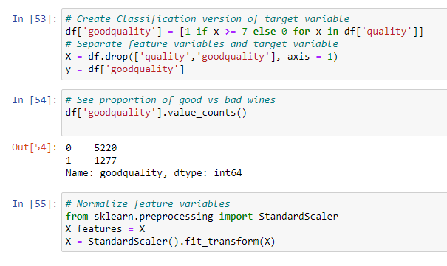

**Split data**

* Splitting the data : after the preprocessing is done then the data is split into train and test sets
* In Machine Learning in order to access the performance of the classifier. You train the classifier using 'training set' and then test the performance of your classifier on unseen 'test set'. An important point to note is that during training the classifier only uses the training set . The test set must not be used during training the classifier. The test set will only be available during testing the classifier.
* training set - a subset to train a model.(Model learns patterns between Input and Output)
* test set - a subset to test the trained model.(To test whether the model has correctly learnt )
* The amount or percentage of Splitting can be taken as specified (i.e. train data = 75% , test data =25% or train data = 80% , test data= 20%)
* First we need to identify the input and output variables and we need to separate the input set and output set
* In scikit learn library we have a package called model_selection in which train_test_split method is available .we need to import this method
* This method splits the input and output data to train and test based on the percentage specified by the user and assigns them to four different variables(we need to mention the variables)

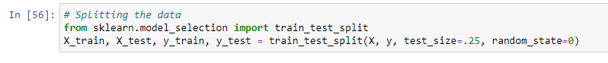

**MODELLING**

**MODEL 1-DecisionTreeClassifier**

We first use model 1 and check the classification report and we can choose weather is this model best for our prediction or no

* Then we need to import DecisionTreeClassifier
* We need to train the model based on our train set (that we have obtained from splitting)

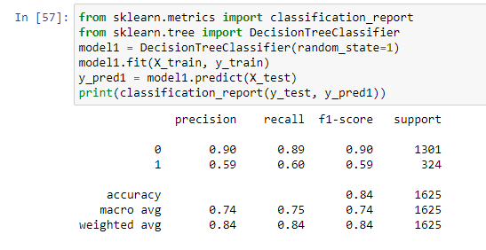

**FINDING THE TEST AND THE TRAIN SCORE**

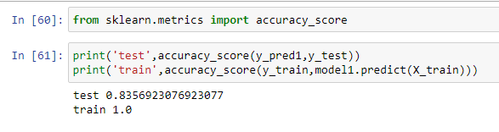

**FINDING THE SCORE AND THE F1 SCORE**

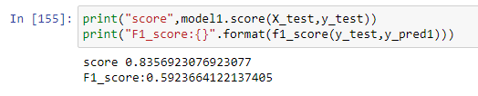

**FINDING THE MEAN SCORE**

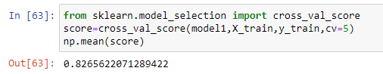

As we got the all the values of this model but we didn’t get the most nearest value so we should try different models for best score

**MODEL 2-RandomForestClassifier**

We first use model 2 and check the classification report and we can choose weather is this model best for our prediction or no

* Then we need to importRandomForestClassifier
* We need to train the model based on our train set (that we have obtained from splitting)

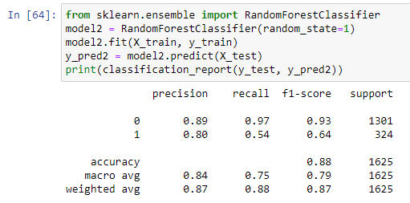

**FINDING THE TEST AND THE TRAIN SCORE**

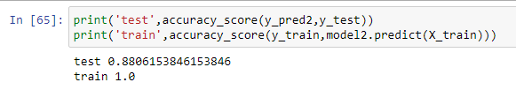

**FINDING THE SCORE AND THE F1 SCORE**

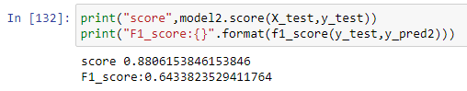

**FINDING THE MEAN SCORE**

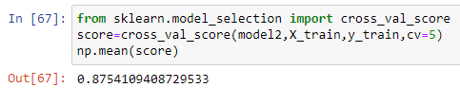

**MODEL 3-AdaBoostClassifier**

We first use model 3 and check the classification report and we can choose weather is this model best for our prediction or no

* Then we need to importAdaBoostClassifier
* We need to train the model based on our train set (that we have obtained from splitting)

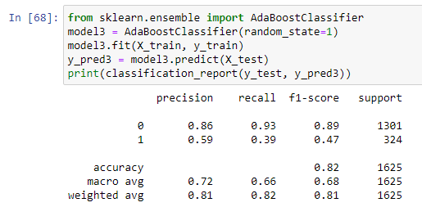

**FINDING THE TEST AND THE TRAIN SCORE**

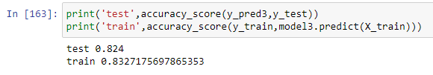

**FINDING THE SCORE AND THE F1 SCORE**

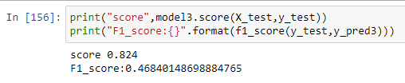

**FINDING THE MEAN SCORE**

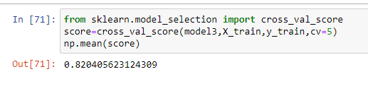

**MODEL 4- Gradient Boosting Classifier**

We first use model 3 and check the classification report and we can choose weather is this model best for our prediction or no

* Then we need to importGradient BoostingClassifier

We need to train the model based on our train set (that we have obtained from splitting

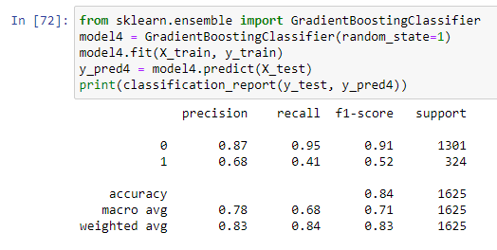

**FINDING THE TEST AND THE TRAIN SCORE**

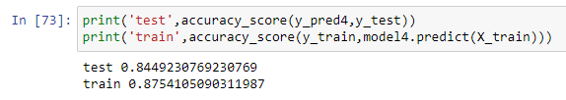

**FINDING THE SCORE AND THE F1 SCORE**

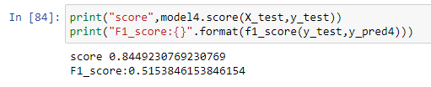

**FINDING THE MEAN SCORE**

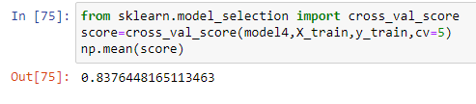

**MODEL-5-XGBClassifier**

We first use model 3 and check the classification report and we can choose weather is this model best for our prediction or no

* Then we need to importXGBClassifier

We need to train the model based on our train set (that we have obtained from splitting

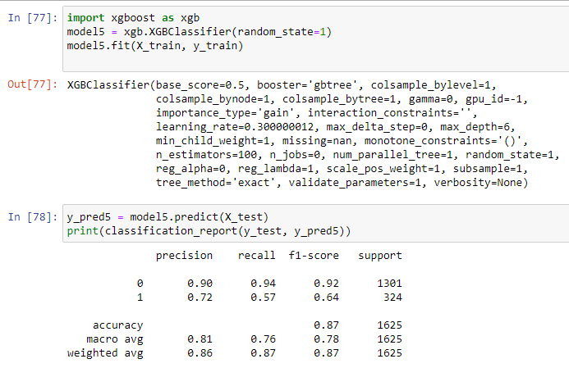

**FINDING THE TEST AND THE TRAIN SCORE**

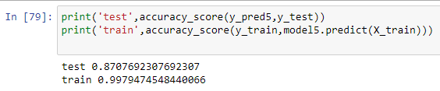

**FINDING THE SCORE AND THE F1 SCORE**

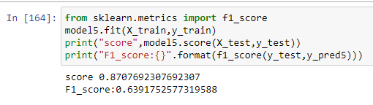

**FINDING THE MEAN SCORE**

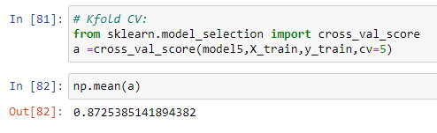

**AFTER GETTING ALL THE VALUES CHECKING THE BEST MEAN BY TAKING THE BARGRAPH**

**FROM THE BARGRAPH WE CAN OBSERVE THAT MODEL 2 WHICH IS RANDOM FORESTCLASSIFIER =0.875 HAS HIGHEST ACCURACY**

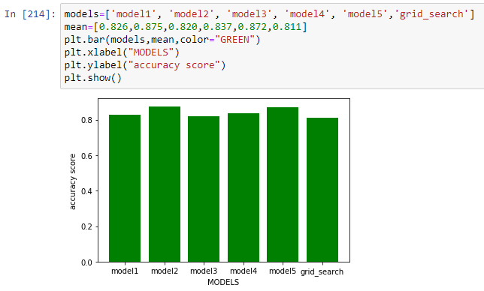

* **AS THE DATA IS UNBALANCED DATA WE SHOULD CHECK THE F1 SCORE AND CHOOSE THE MODEL**
* **AFTER GETTING ALL THE VALUES CHECKING THE BEST F1 SCORE BY TAKING THE BARGRAPH**

**FROM THE BARGRAPH WE CAN OBSERVE THAT MODEL 2 WHICH IS RANDOM FOREST CLASSIFICATION HAS HIGHEST F1=0.64**

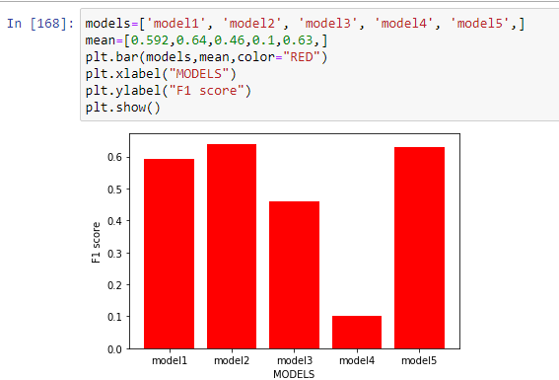

**APPLYING GRIDSEARCHCV TO INCREASE THE ACCURACY**

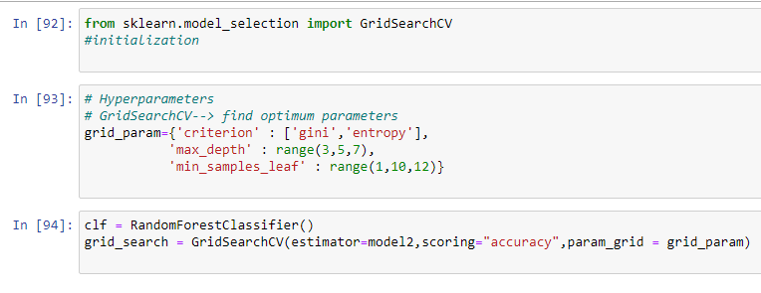

**APPLYING GRIDSEARCH ONTO DATA SET**

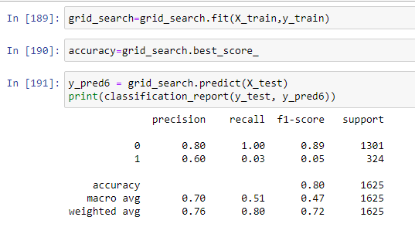

**THE ACCURACY WE OBSERVE FROM GRID SEARCHCV**

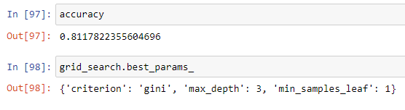

* Even after applying gridsearchcv the accuracy is not increased so we don’t need this

**THE TRAIN AND TEST VALUES**

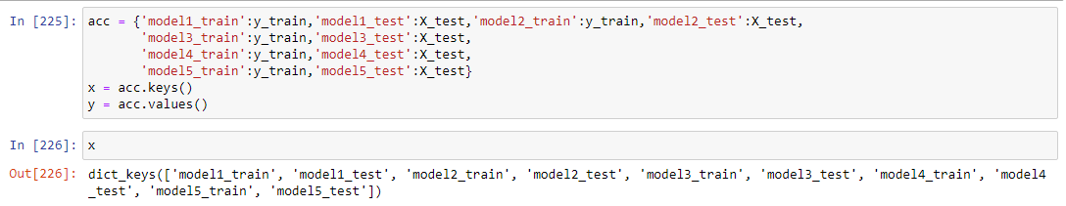

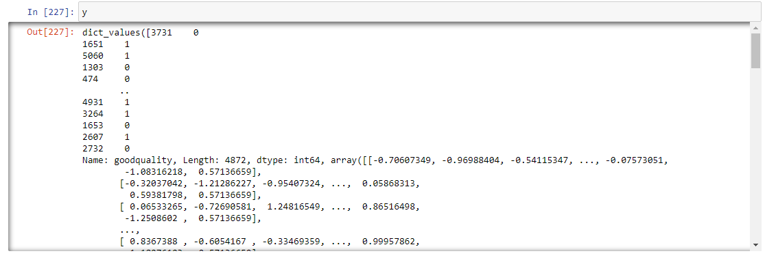

**We have to build the model with best parameters So we are using Random Forest Classifier**

From the comparison of the the f1 score we decide that random forest classifier is the best model to apply for the prediction

**Prediction on test data**

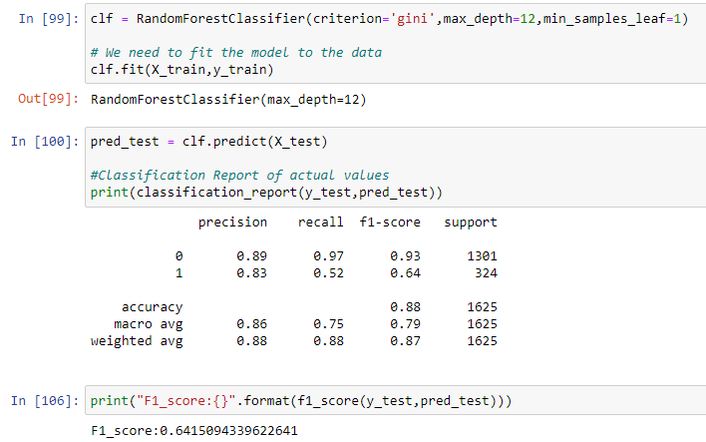

**Building a model using Random Forest Classifier**

After training the model, we need to test the performance of it with some unseen data.

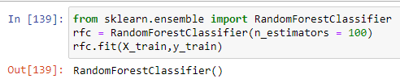

**PREDICTING THE DATA BY GIVING UNKNOWN VALUES**

We need to give all the new observations to check

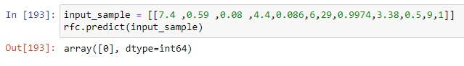

**CHAPTER 5**

**CONCLUSION**

It is concluded after performing thorough Exploratory Data analysis which include Stats models which are computed to get accuracy and also Heat maps which are computed to get a clear understanding of the data set (which parameter has most abundant effect on the study case) and its come to point of getting the solution for the problem statement being , that the retail shopkeeper should strategical plan on the marketing in such a way that he could offer complementary products on the purchase of that particular product and if in possibility of bearing expenses offer more quantity of the product at the same price.

**CHAPTER 6**

**REFERENCES**

[1] https://[www.kaggle.com/semakulapaul/cereals-dataset](http://www.kaggle.com/semakulapaul/cereals-dataset)

[2] <https://medium.com/code-heroku/introduction-to-exploratory-data-analysis-eda-c0257f888676>

[3] <https://en.wikipedia.org/wiki/Machine_learning>