**Assignment 6**

**Points 20**

**This assignment is for building a temperature conversion app where you will be designing two screens. In the first screen you enter a temperature in Celsius and on the click of convert button, screen should navigate to other view where you will be showing the temperature in Fahrenheit and Kelvin. You’ll also add a text label and an image in the navigated screen where you will be show related image and text based on the temperature.**

**Please click on the** [**link**](https://use.vg/NosZlw) **to see the demonstration of the assignment expected working.**

**Please follow the following instructions to complete this assignment.**

1. Open Xcode from the launchpad of your mac.
2. Click on create a new Xcode project. Select the iOS template and click on the App application.
3. Click on next which will prompt you to choose options for the project.
4. Provide product name as **Lastname_****ConvertTemperature** , “**nwmsu**” for organization identifier, “**storyboard**” as interface and swift as language.
5. Click on next and select an appropriate location to save your app and click on create. A project directory will be loaded.
6. From the project navigator click on “Main.storyboard” file, a blank mobile screen will be loaded where the required fields for an app need to be added
7. Click on the story board then select editor from the top pane options, click on embed in option from the list and select navigation controller.
8. Following image demonstrates the above step. Once the navigation controller is selected navigation controller scene should be visible in the storyboard.

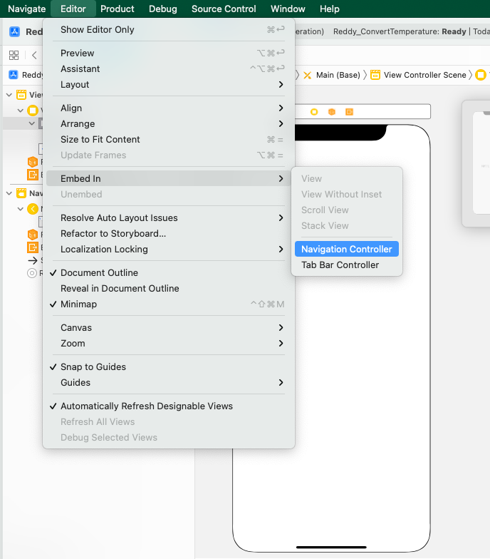

1. Now let’s add a text field to enter the temperature. Add a text field from the library and drag it to the view controller. Give appropriate width to the text field in the size inspector and make sure that the field is placed horizontally at center of the screen. Write **Temperature in Celsius** as the place holder text.
2. Add any of your preferred button type to the screen from library and name it as **Convert.** Place the button horizontally center as well. Please refer below screenshot for the reference.

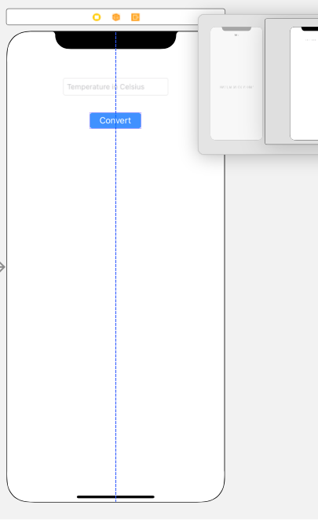

1. Select both the objects of the screen and embed them in a stack. Once embed is done, select the stack and make sure that distribution is set to fill in the attribute inspector. (To embed them in a stack select both the objects click on the embed in icon available at the bottom right corner of the storyboard)
2. Select the stack and click on Align icon from the bottom and click on align horizontally as shown below and then click on Add 1 constraint.

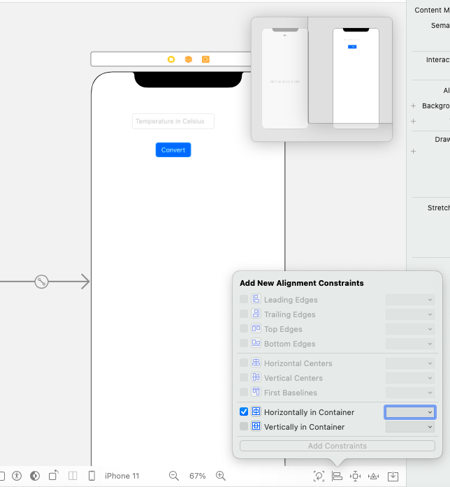

1. We have given the constraints for x-axis, now we have to give constraints for y-axis. Select the stack, click on constraints and give top constraint value as 20 from the safe area as shown in the image, once the value is given click on add 1 constraint.

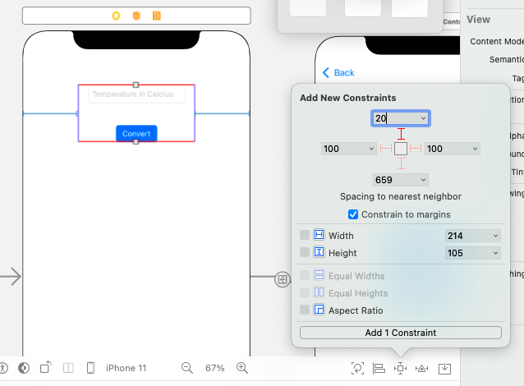

1. Let us also give the title for the navigation item, click on navigation item from the view controller scene as shown in the below image. (If the documents outline is hidden click on the highlighted button). Add the title as “Temperature converter”.

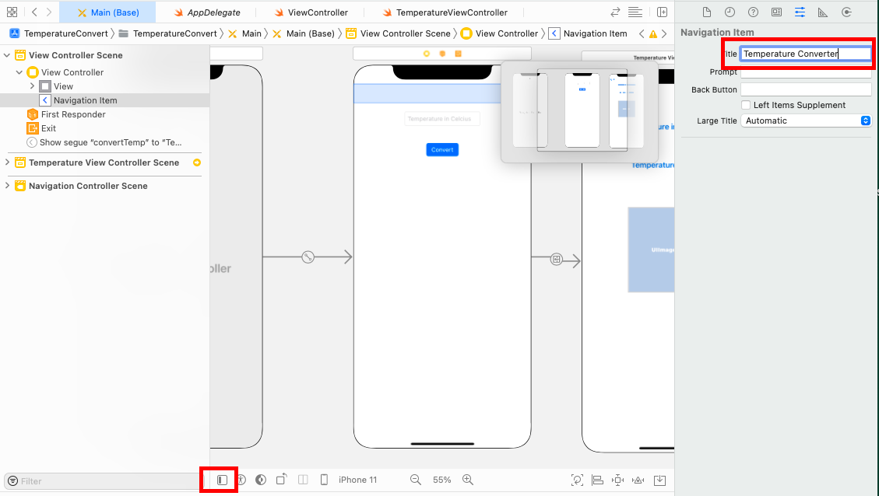

1. Let us add a view controller from the library, we will navigate to this view on the click of convert button, converted temperature is shown in this view along with other details.
2. Drag and drop a view controller from the library, control + click on the convert button of the first screen and drag it to the second view as shown below. After dragging a list of action segue options will be listed, we will be using the show segue in this app, click on show from list.

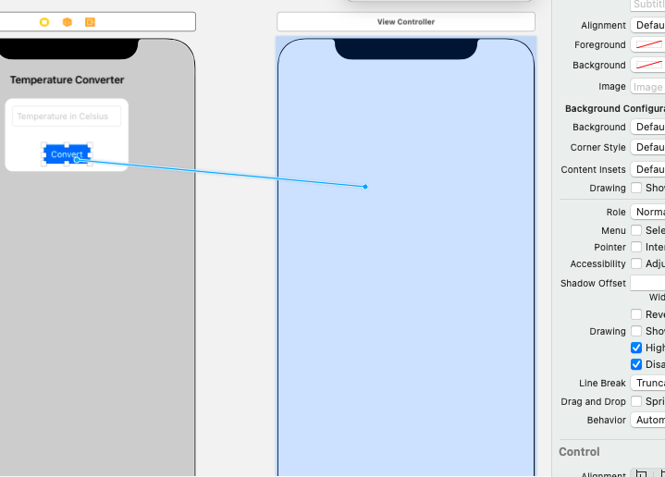

1. Once the above step is completed successfully, you should be able to see a segue connection between the two views. Click on the segue connection and then click on attribute inspector, you will see a field for mentioning the identifier. Give an identifier as “**convertTemp**” and click on enter.
2. We have successfully created a connection between the two views, now let us add the required fields in the second view.
3. Add two labels from the library to the second view which will be used to show temperature in Fahrenheit and kelvin respectively.
4. In the first label add text as “**Temperature in Fahrenheit: ”** and in the second label add text as “**Temperature in kelvin:** ”.
5. For all the added labels change the font type, color and size as you prefer.
6. Add one more label which will be used to show a text based on the temperature, remove the default text from the label and keep it empty initially. Make sure that all of the labels are horizontally center.
7. Add an image view to the screen, keep the height and width of the image view to 200 in the size inspector. Keep the content of the image as aspect fit.
8. Once these objects added to the screen, your screen should look something similar to the below image.

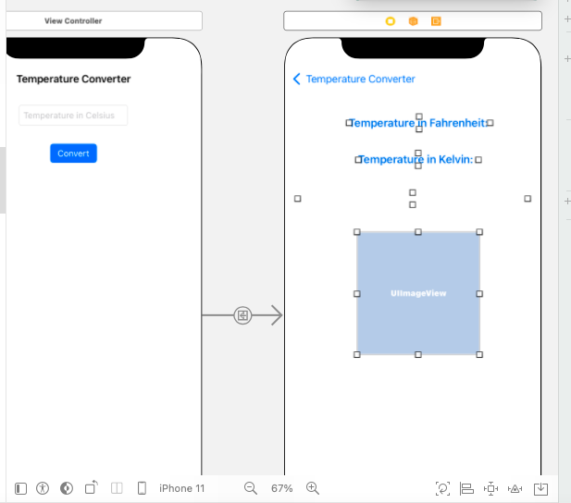

1. Now let us embed all these objects in a stack. Select all the objects and click on embed in option and select view.
2. Once embed in stack is done, select the stack click on align icon from the bottom and select check box for horizontally in container, vertically in container and click on add constraints. (you can refer to previous steps 11 and 12 for embed in and aligning horizantally).
3. Make sure that stack distribution is fill and, keep the spacing as required, here spacing of 40 is given.
4. Now click on image view and click on constraints icon, check the width and height boxes whose width and height is 200. Once checked click on add 2 constraints.

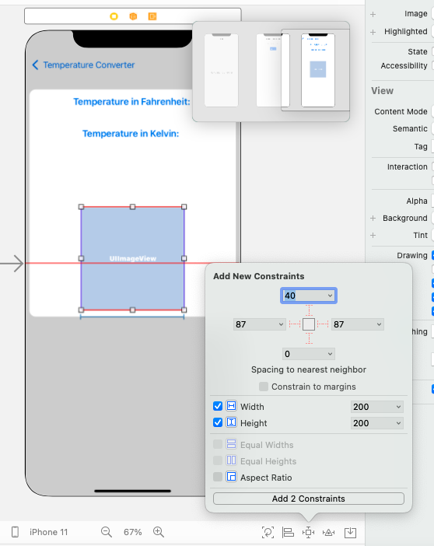

1. Your screen should be something like this once you are done with the above steps.

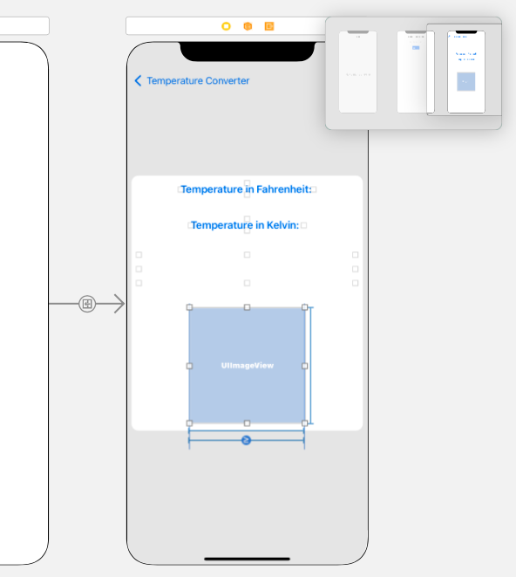

1. We are done with screen design, let us add a viewController for the second view.
2. Click on file from the top pane then New>File , select Cocoa Touch class template from the available templates then click on next. Give the class name as “**ResultViewController**” and sub class of “**UIViewController**”, click o next and create.
3. ResultViewController file should be added to the app files.
4. Now on main story board click on second view’s view controller, select the identity inspector from the inspectors and give the class name as “**ResultViewController**” as shown below. Click enter once the class name is given and select the inherit Module from target checkbox.

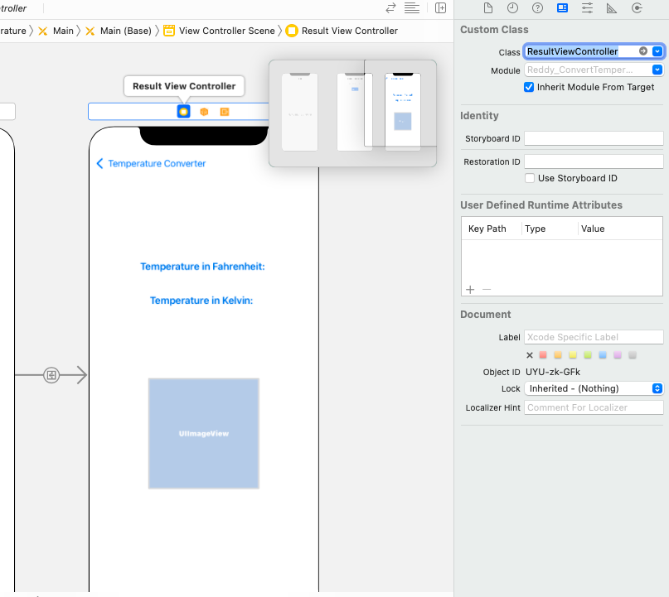

1. Link the first view objects text field and button to viewController as outlets with names **tempTextField** and **convertButton** respectively.
2. Add an IBAction for convert button with the viewController and name it as **convertButtonPressed()**.
3. Add an action from text field to view controller with event “**editingChanged**”. In this action we will be doing a validation to enable convert button only when user enters positive or negative integers. Button should be disabled if user enters anything apart from 0-9.
4. Now, let us add the second view components to the ResultViewController. Add the following components as outlets with the names given:

* Fahrenheit label: **fahrenheitLabel**
* Kelvin label: **kelvinLabel**
* Empty label: **textLabel**
* Image component: **imageView**

1. We are done with linking components. Now write a logic such a way that when user clicks on convert with a valid input, view should navigate to next view and the temperature should be shown in Fahrenheit, kernel(use appropriate formulae for conversion). Assign an appropriate text and image for the temperatures. Image should be shown with some animation. Use the following guide to assign appropriate text and image. Temperatures are given in Fahrenheit.

* Temperature less than 5: freezing.
* Temperature between 5 and 59 inclusive: cold.
* Temperature between 60 and 77 inclusive: pleasant weather.
* Temperature between 78 and 95 inclusive: hot.
* Temperature above 95: boiling hot.

1. You can use the [discount app](https://github.com/bandiajay/Fa21iOS-01/tree/main/AnimationDemo) , [animation demo](https://github.com/bandiajay/Fa21iOS-01/tree/main/DiscountAppMulControllers) app and [navigation controller demonstration](https://youtu.be/Fm9pf7Z3uzY) for your reference.

**Please submit your app as compressed file, your compressed files should contain Lastname_ConvertTemperature folder and Lastname_ ConvertTemperature.xcodeproj file. Please check your submission by downloading the submitted file and rechecking in xcode.**