**Assignment 7**

**Points 20**

**Please follow the following instructions to complete this assignment.**

1. Open Xcode from the launchpad of your mac.
2. Click on create a new Xcode project. Select the iOS template and click on the App application.
3. Click on next which will prompt you to choose options for the project.
4. Provide product name as **Lastname_****TableViewDisplay** , “**nwmsu**” for organization identifier, “**storyboard**” as interface and swift as language.
5. Click on next and select an appropriate location to save your app and click on create. A project directory will be loaded.
6. From the project navigator click on “Main.storyboard” file, a blank mobile screen will be loaded where the required fields for an app need to be added
7. Click on the story board then select editor from the top pane options, click on embed in option from the list and select navigation controller.
8. Following image demonstrates the above step. Once the navigation controller is selected navigation controller scene should be visible in the storyboard.

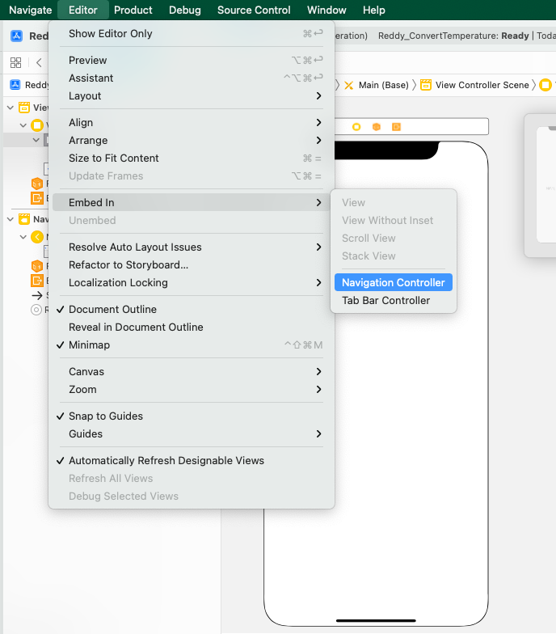

1. Now let’s add a Table View and set top, left, bottom and right constraints to 0. Now go to the attribute inspector of table view and select the prototype cell to 1. Now give the identifier to the cell as “**allProducts**”. Now while making a connection to the View Controller, give the name for the outlet as tableView.
2. Now from the library in the Main.StoryBoard add a new View Controller. Now right click on the project, create a new file, select Cocoa Touch Class and select next. Now select the class as ProductsDisplayViewController. Now in the identity inspector of the newly added view controller, give the name of the class as “**ProductsDisplayViewController**”. Drag a Table View and set top, left, right and bottom contraints to 0. Select the prototype cells to 1 and in the give the name of the identifier of the cell to “**showProducts**”. Now give a connection in the ProductsDisplayViewController for this table view and name it as “**productsTableView**”. Create a segue from the table view of View Controller and name the identifier as “**showProducts**”.
3. Now Create another view Controller and create a new Cocoa Touch Class and give the name as DisplayImagesViewController. In the identity inspector of the view controller give the class name as DisplayImagesViewController. Now add a image, button and a label. Now add your own constraints to all the objects so that the View is adjustable in all the mobiles. While making the connections, give the name of the image as imageView, button as getInfo (IBAction) and the label as displayLabel. Create a segue from the table view of **ProductsDisplayViewController** and name the identifier as “**displayImages**”
4. Now create an array named ListArray and add atleast 3 categories for example

var listArray = [“Fruits”,”Cars”,”Electronic Gadgets”]. Add these list array items to the rows of table in View Controller.

1. When ever we click any row, we need to get any 5 products related to the items in the next view controller.
2. When we click on any product it should navigate to next Controller and the image related to the product must be displayed. When we click on the button get Info we need to get the details related to the product in the label.
3. Find the sample images below.

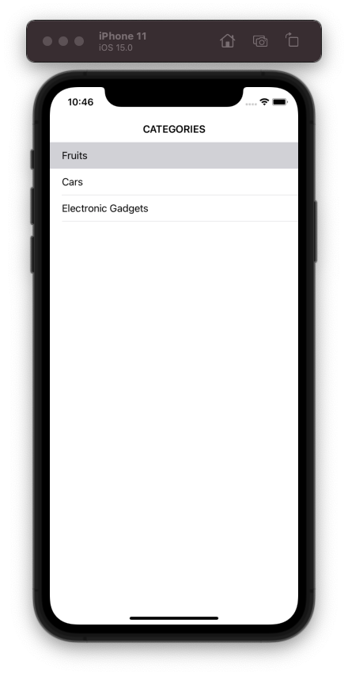

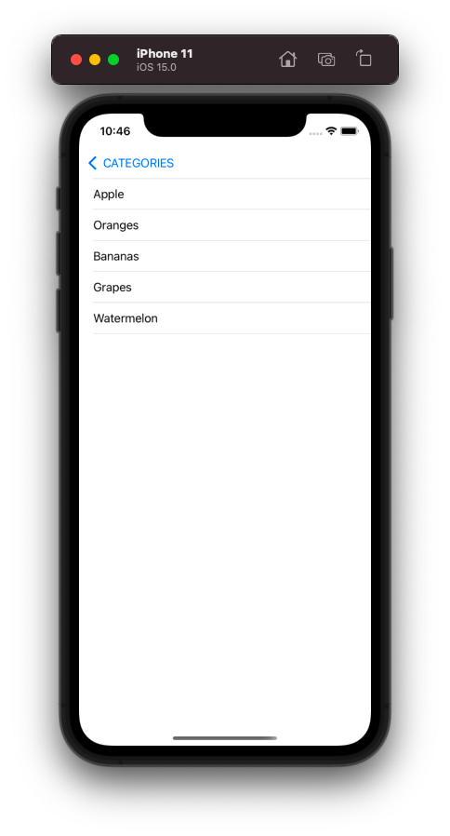

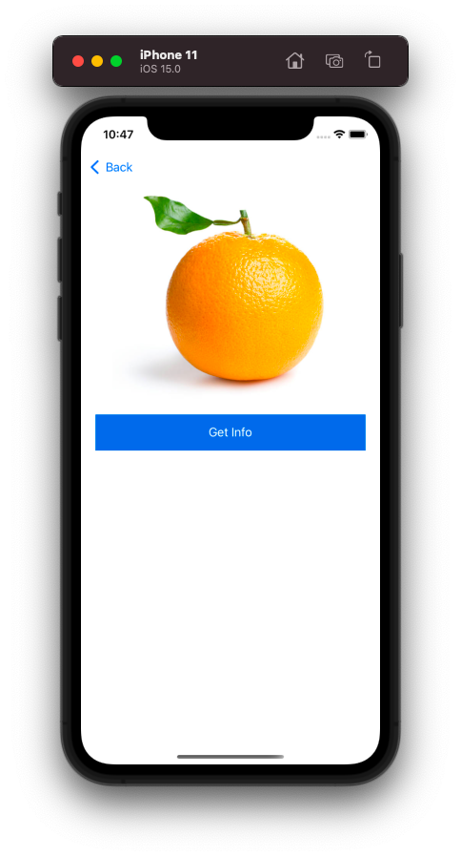

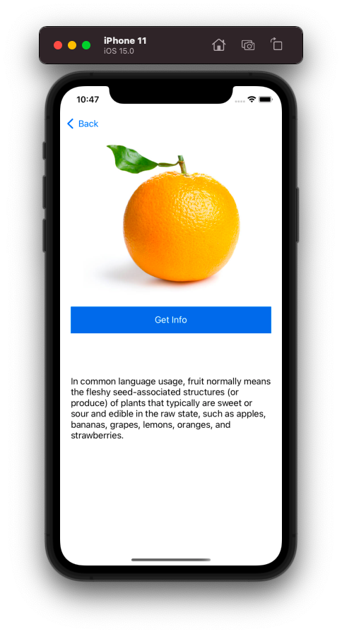

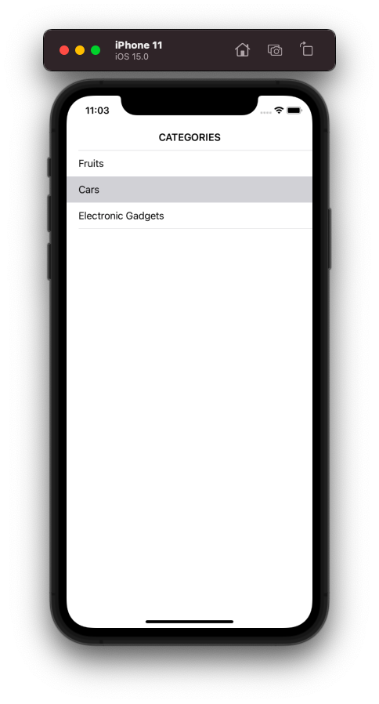

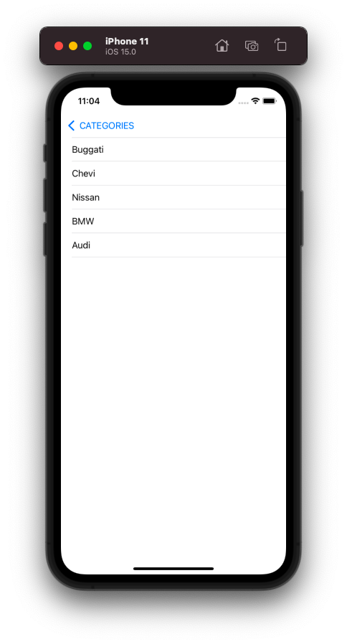

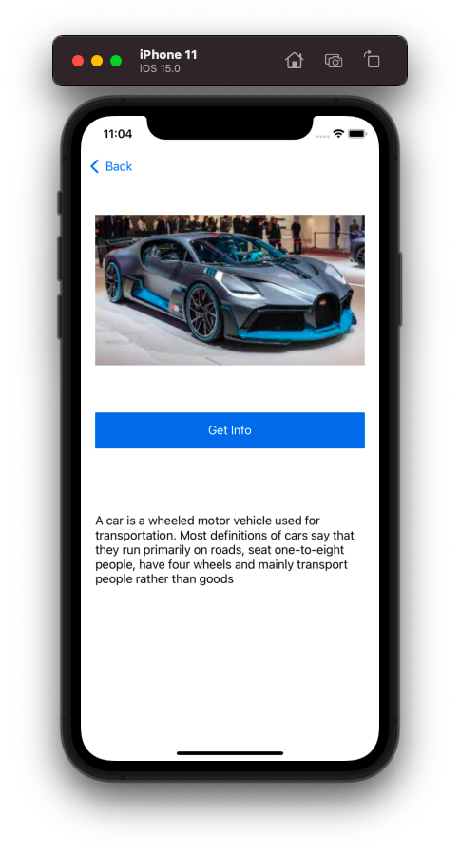

**Please submit your app as compressed file, your compressed files should contain Lastname_ TableViewDisplay** **folder and Lastname_TableViewDisplay.xcodeproj file. Please check your submission by downloading the submitted file and rechecking in xcode.**