**Assignment 2**

**10 Points**

**Please follow the following instructions to complete this assignment.**

1. Open Xcode from the launchpad of your mac.
2. Click on create a new Xcode project. Select the iOS template and click on the App application.
3. Click on next which will prompt you to choose options for the project.
4. Provide product name as **Lastname_FormatName** , “**nwmsu**” for organization identifier, “**storyboard**” as interface and swift as language.
5. Click on next and select an appropriate location to save your app and click on create. A project directory will be loaded.
6. From the project navigator click on “Main.storyboard” file, a blank mobile screen will be loaded where the required fields for an app need to be added
7. We require two text fields to store first name and last name seperately, Drag and drop the text field object twice to the screen from the library.
8. We need to label for the two text fields, drag and drop the label for the first text field and write the text as “First Name”, similarly drag and drop the label for the second text field and write the text as “Last Name”.
9. Align the labels with the text fields as shown below.

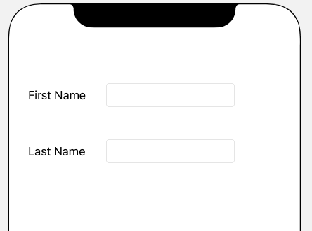

1. Drag and drop a button from the library, rename this button to submit, on a click of this button we will access the first name and last name text and show the formatted name in the label.
2. So, now we require a label to show the formatted name, drag and drop the label from the library and resize the label appropriately. Clear the text from the label so that it is hidden initially.
3. Let us also add another button with name Reset, on click of this button we will clear the text from the text fields and label.
4. After the completion of the above steps, the app should contain the objects in the below fashion.

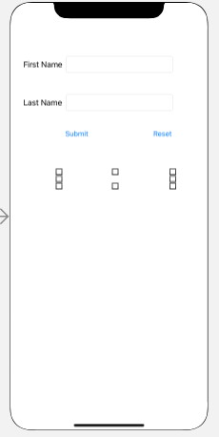

1. Now we are done with the design, let us insert the first name, last name, and display label objects as outlets to the view controller and name them as **firstNameTextField**, **lastNameTextField**, and **displayLabel** respectively.
2. To do that, ctrl+click on an object and drag it to the viewController, select the action as an outlet in the popup menu and give the name as specified in the above step.
3. We are now left out with adding button actions to the controller, ctrl+click on submit button and drag it to the viewController, in the pop-up menu select the connection as action, type as UIButton and name as **onClickOfSubmit**. Similarly, add the button action to the controller for the reset button with the name **onClickOfReset**.
4. In the function **onClickOfSubmit** of viewController, write a code to print the last name and first name in the following format at displayLabel:

**Last name, First name**

1. In the **onClickOfReset** function, write a code to clear the **firstNameTextField**, **lastNameTextField**, **displayLabel** and also set the cursor position at the **firstNameTextField.** Use **becomeFirstResponder()** methodto achieve that.
2. Now you are done with the app designing and coding, save the app and click on build.
3. An app simulator will be opened after few minutes, give your first name and last name and click on submit, it should print as shown in the below picture.

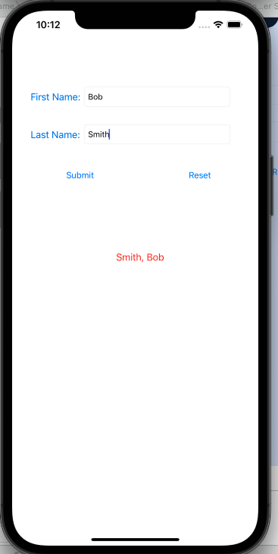

1. Now Click on reset, it should clear all the text and the app screen should be as follows:

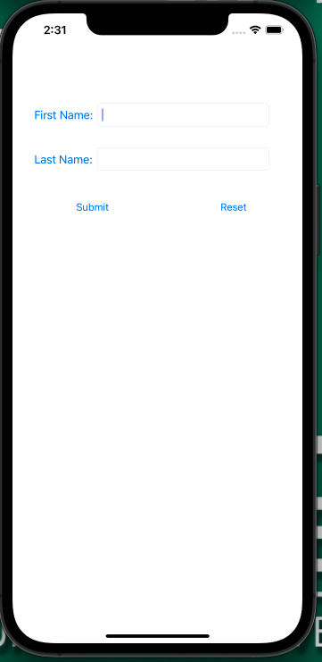

1. Congrats!! You are done with the app, play around with font color, font type and background colors.