**Saisumithra Jagarlamudi**

1. Write a brief introduction of your project

**ANSWER:**

This is a daily updated dataset of COVID-19 deaths around the world. This dataset contains data of 12 countries. Dataset contains data of the daily number of new cases and deaths, seven-day rolling average per 100,000 residents. The average reported of a week, average of the day reported. Collate detailed weekly breakdown from official sources around world.

1. The domain of the data set

**ANSWER:**

All weekly excess deaths.

1. The data file. You could link your data set in the MS Word document. Watch the below video on how to do it

**ANSWER:**



1. Data source

**ANSWER:**

<https://www.kaggle.com/dhruvildave/covid19-deaths-dataset>

1. Number of records and columns

**ANSWER:**

1. Records and 14 Columns
2. Visualization tools selected

**ANSWER:**

Tableau

1. Data cleaning strategies if any

**ANSWER:**

I have done two changes in dataset:

* One was change in attribute from start-date to Beginning-date.
* Another change was done in date type from Number to Date & Time type in end-date field.

1. Cleaned dataset, if any. You could link your data set in the MS Word document.

**ANSWER:**



1. The goals of your project and the charts generated for each goal
2. Write the story from each chart that you generated.

**ANSWER:**

**Goal 1:** To generate a report of non-covid death cases per a week.

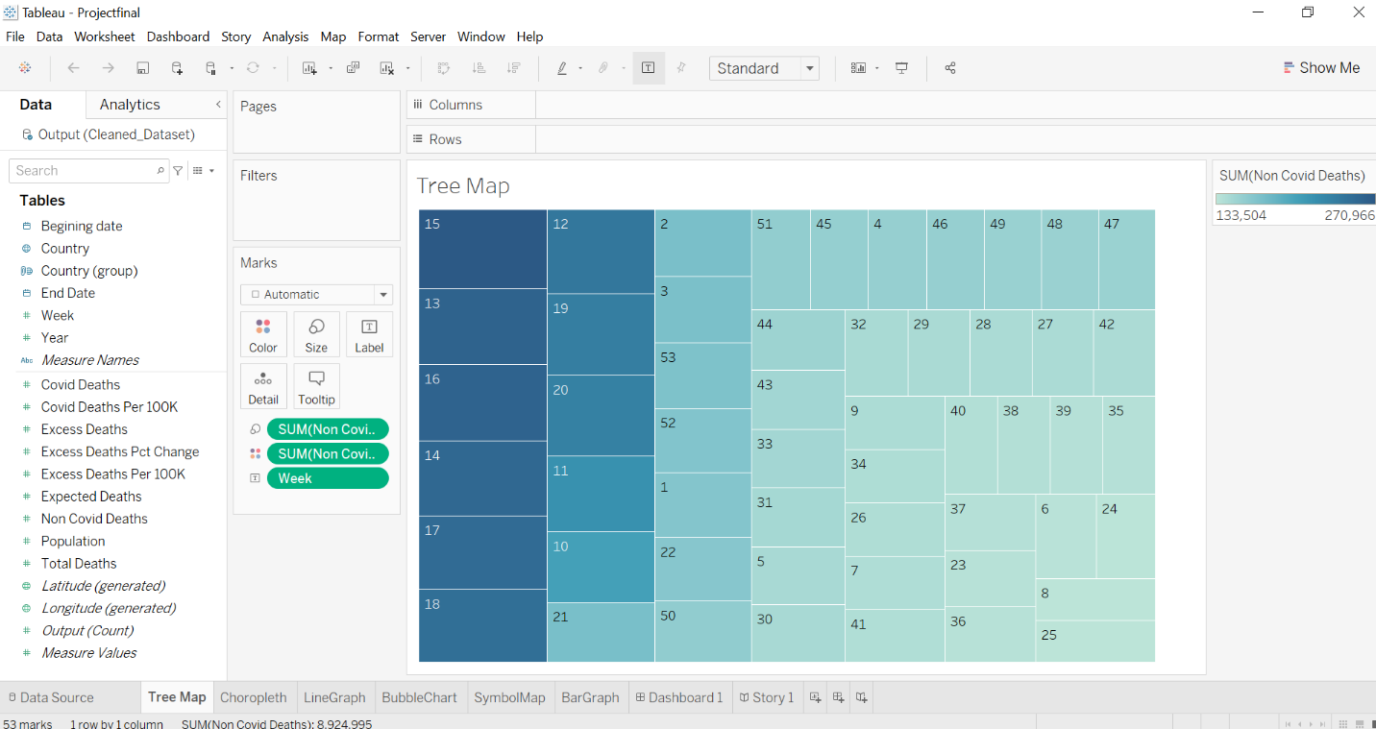

**Story 1:**

In the above Tree Map it describes us about the non-covid death cases per a week. It shows a record of 53 weeks non – covid death cases. Out of 53 weeks report 15th week has the highest rate of non-covid cases and 25th week report has low death cases.

**Goal 2:** To calculate covid death cases based on country

**Story 2:**

In the above map report was done to the covid death cases of some specific countries. United States have the highest death record with 589655 cases and Australia has the lowest cases with 901 records.

**Goal 3:** To compare covid death cases and non-covid death cases of a year

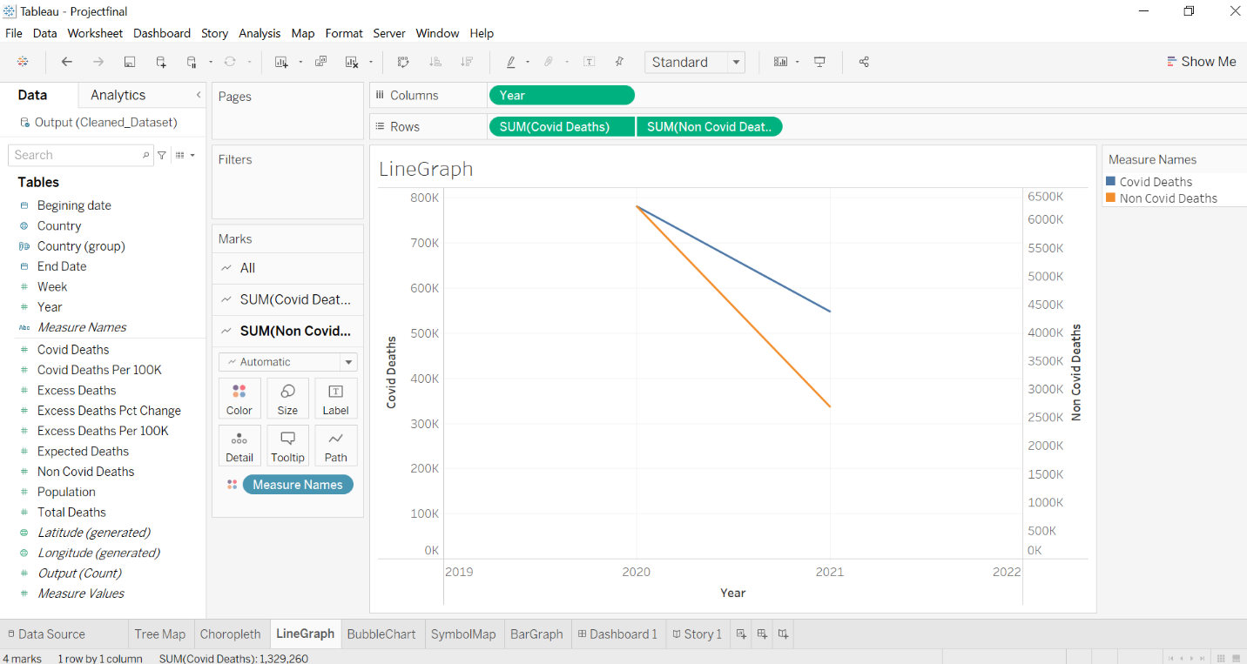

**Story 3:**

In the above Line Graph the report was done with covid death cases and non-covid deaths of different years. In the year 2020, 781075 covid deaths were recorded and 6232952 non covid death cases. In the year 2021, 548185 covid death cases and 2692043 non-covid death cases. Than covid deaths non-covid deaths were recored more in two years.

**Goal 4:** To recordtotal death cases of a country in different years

**Story 4:**

In this bubble chart it explains about the death cases of different countries in different years. United states has the highest record in the year 2020 and Denmark notes the least cases in 2021. While comparing the both years 2020 recorded high cases than year 2021.

**Goal 5:** To compare covid death per 100k in different countries

**Story 5:**

In the above Symbol Map it compares the covid death cases per 100k in different countries. Out of death cases per 100k Australia has 3.5 cases and Belgium recorded more cases with 219.4 cases.

**Goal 6:** To generate a report on expected death rates of countries.

**Story 6:**

In the above BarGraph it generates a report of expected death cases in different countries. Here we have grouped Australia, Denmark, Belgium and Switzerland countries. After we grouped some countries united sates has the highest expected death cases and Canada has low expected death cases.

1. Use Dashboards & storyboards to represent your charts and findings

**ANSWER:**

**DASHBOARD**

**STORYBOARD**

1. Overall conclusion for your analysis

**ANSWER:**

In this project we have used different maps and graphs to generate the report of covid death cases, non-covid death cases, expected death cases, cases per 100k and excess death per 100k in different countries with different years. Compile a weekly analysis from official sources all throughout the world.

**Link For Tableau**

